Jack Kirby’s
History of the Future

2026-3045 AD

by Chris Tolworthy

JACK KIRBY’S HISTORY OF THE FUTURE
By Chris Tolworthy
The illustrated stories in this book are in the public domain: see the bibliography for details. The cover image pays homage to the cover of Kamandi #1. The Statue of Liberty is by Sue Waters, via Flickr, CC-BY-SA-2.0; water by Maxime Raynal, via Flickr, CC-BY-2.0; canoe by 'amateur with luck’ Scott via Flickr and Wikimedia, CC-BY-SA-2.0; clouds by Basile Morin via Wikimedia, CC-BY-SA-4.0 For other copyrights (mostly Creative Commons), see individual images. Uncredited images and text are by the author, under CC-BY-SA-4.0. Printed by Lulu.
ISBN 978-1-300-44774-0

For extra copies:
lulu.com

or
tedagame.com/books

Contents

Quick Timeline 6
Introduction 9
1. Who Was Jack Kirby? 15
2. Kirby Knew a Lot of Stuff 18
3. The Eternals 53
4. The Golden Age 81
5. The Ancient Historians 100
6. The Power People 126
7. The Avengers and Star Wars 141
8. 1976: The Space Gods Return 156
9. Future Trends 175
10. 1940-2026 190
11. 2026 207
12. 2026-5000 221
13. The Road to Armageddon 245
14. Make a Golden Age NOW 265
15. Your Personal Future (Life After Death) 287
16. Your Cosmic Journey 305
Appendix 1: Others who saw the future 322
Appendix 2: How scholars destroy history 337
Appendix 3: The last Great Disaster 382
Appendix 4: Atlantis 398
Appendix 5: Genesis 445
Appendix 6: Moses 460
Appendix 7: Enoch 480
Bibliography 488
Acknowledgements 498

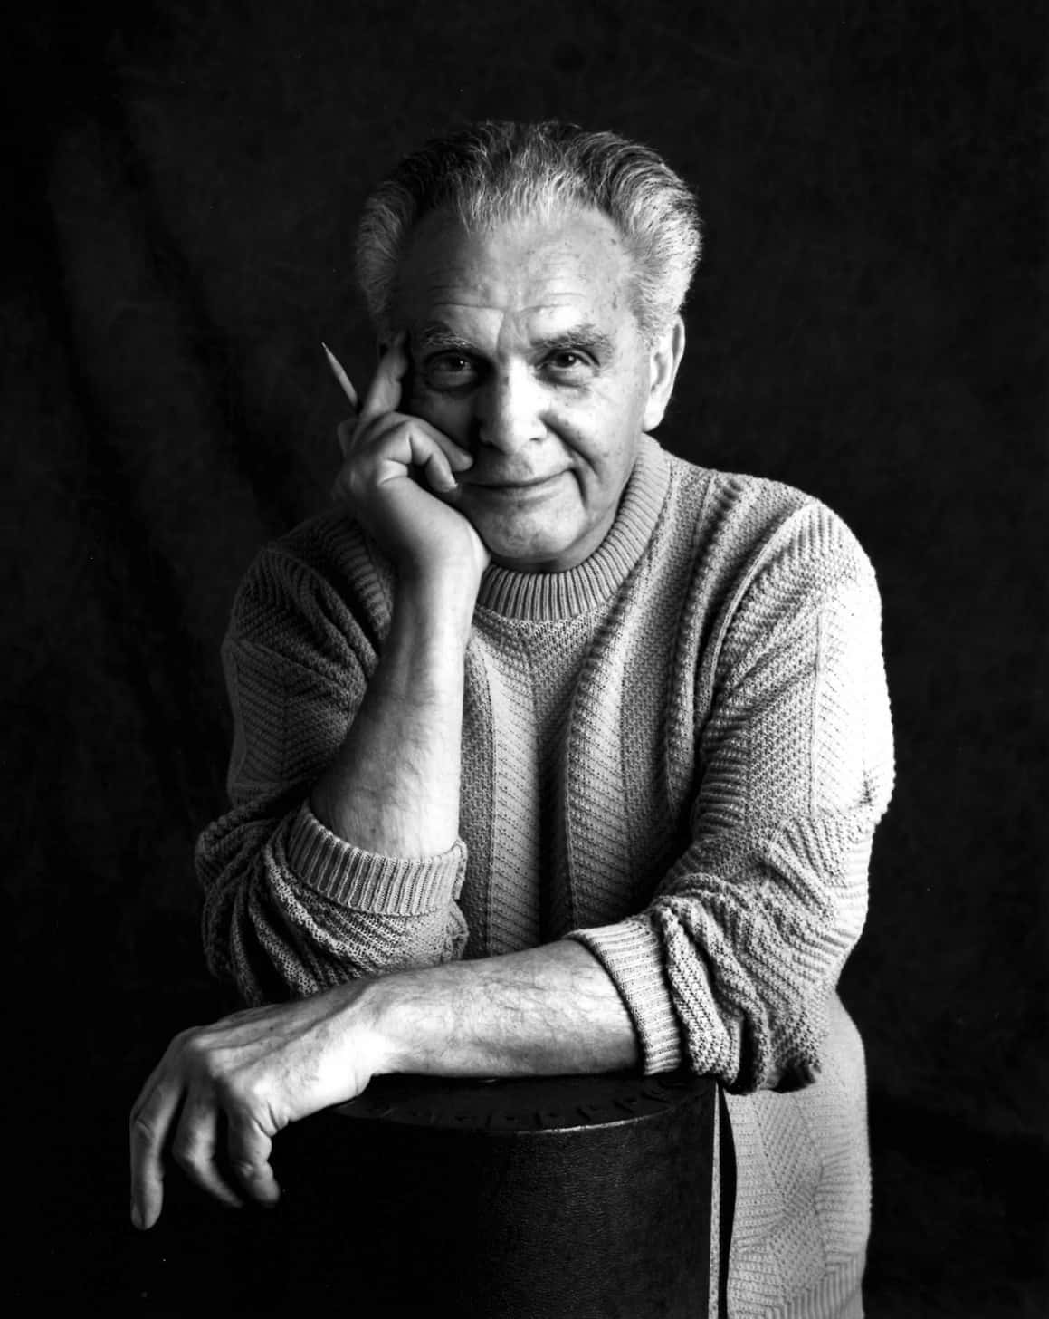
Image: Suzy Skaar, CC-BY-SA-3.0
"Whatever I have put down with pencil and paper
has always come true. Maybe it has always been true.
I don’t deal in actual speculations, but I play with ideas
like invisible building blocks.”

Quick Timeline
~120,000 BC to now: Climate change correlates with human extinctions.
(Also, the first wave of Homo sapiens left Africa.
Also, the first hint of proto-writing,
Also, the earliest date in the Mesopotamian creation story.)
~108,000 BC: A human species (Homo erectus) becomes extinct.
~73,000 BC: A human species (Homo sapiens) almost becomes extinct.
(World population falls to ~3000,
probably due to climate change following the Toba Volcano.
The second wave of Homo sapiens left Africa.)
~48,000 BC: A human species (Homo floresiensis) becomes extinct.
~39,000 BC: A human species (Neanderthal) becomes practically extinct.
(Homo sapiens triumph. Egypt, Mesopotamia, India and China all date their creation stories to 39,000 BC.)
~12,000 BC: A human species (Denisovan) becomes extinct.
~8,000 BC to 2000 AD: Freakishly stable climate, highly unusual.
(This allows large-scale farming, which allows cities.)

Predictions

1975: End of the Russia-America space race
(predicted in 1954)
1990: End of the cold war
(predicted in 1962)
2000: Massive government surveillance
(predicted in 1959)
2020: Growing distrust of science
(predicted in 1959)
2026: The end of democracy: space gods rule the world
(predicted in 1976)
2040: Privatised travel to other planets
(predicted in 1940)
2065: Machines replace skilled humans
(predicted in 1962)
2072: War with China due to global warming
(predicted in 1972)
2090: First successful humanoid robot
(predicted in 1962)
2121: The Great Disaster: nuclear war
(predicted in 1972)
2260: Peace throughout the solar system
(predicted in 1940)
3045: A new heaven and new Earth
(predicted in 1960)

“His mind was so… he just saw into the future.”

Introduction
This book is about the predictions in Jack Kirby's science fiction. It focuses on his use of mythology, especially Jewish mythology, as a guide to the future. It argues that mythology is often more reliable than scholarship.
He is a typical Kirby prediction. In 1954, Kirby wrote a story that was a metaphor for the end of the Space Race. The story was set over twenty years later, in July 1975. When July 1975 arrived in real life, the Space Race ended, right on schedule. How did Kirby know that would happen? He didn’t know for sure, but he followed the space race and had a good understanding of politics and anniversaries. But how did he know that Russian and American relations would improve?
Kirby was Jewish. His predictions mirror Jewish prophecies. He did not plan the stories that way, but he worked from instinct, and this was the water he swam in. The biggest Jewish prophecy concerned the messianic age. It predicted that the world would improve in the decades before the year 2000. Reason and justice would increase, Israel would regain its land, and the world would approach an age of peace. So it was natural to look around, see the increase in democracy around the world, and the new Jewish homeland, and be optimistic about cooperation between nations. (At least for a while: the prophecies also talk of a final global war.)
The rest of this introduction is about Jewish messianic prophecy. If that does not interest you, stop reading here and skip to chapter 1.
The key text for dating messianic prophecy is the Book of Enoch. This quote from the Talmud sums up Enoch’s dates:
“Six thousand years the world will exist and one [thousand, the seventh], it shall be desolate..."
The six thousand years began when Elohim barred Adam from the Garden of Eden, around 4,000 BC. So civilisation should end around 2000 AD and be desolate until 3,000 AD. Kirby’s stories follow that model, but with extra detail. Where does the 7,000 year prediction come from? It mirrors seven days, but why 7,000? Why not 700, or 70,000, or 70 jubilees (the preferred ancient Jews unit of history)? These prophecies come from Second Temple Judaism (516 BC - 70 AD). That era was a reaction to exile in Persia in the 500s BC. It is when the jews collected their sacred books into the Bible as we know it today. The Persians teach that civilisation will last 12,000 years. Most people forget that the Genesis date of 4,000 BC only refers to the people of Adam. Genesis says the Elohim existed before Adam. Some of them were human, the ancestors of the Anakites, and their origin can be dated to 9,000 BC. Adding 12,000 suggests that civilisation will reboot in 3,000 AD, 7,000 years after Adam.
The Persians got their 12,000 year idea from the Hindus. They say there have been many previous cycles. Oral Jewish tradition agrees.
“According to the ancient Jewish sages Adam was not the first human to have been on the earth and there were full civilizations that had risen up and had been destroyed. This concept can be found in the Oral Traditions of Judaism…”
The number 12,000 is not set in stone. It is like saying that humans live to for 70 years: it could be a little more or a lot less. Kirby suggested that civilisations might reboot every 10,000 years or so:
"Does the Earth flip its lid every ten thousand years or thereabouts?”
“My guess is there might have been thirty, forty, a hundred [previous civilisations]. They might go back hundreds of thousands of years.”
Egyptian records, combined with insights from archaeology, give us dates for the previous four cycles. 39,000-28,000 BC was an age of discovery when we defeated the Neanderthals and filled the world. 28,000-14,000 BC was the age of gods, when we mastered metals and had our largest brains. 14,000-9,600 BC was the age of demigods. This is when we began to experiment with agriculture. This created the first inequality: the first mediocre humans who claimed the rights of gods. 9,600 BC saw the Younger Dryas climate disaster. That created the present age, the age of settled agriculture. The first half of this age (9,000-3,000 BC) was the age of “the spirits of the dead”. It was an age of wars over land. DNA shows that most males of that era died in warfare. Pharaohs and Caesars and billionaires won the battle for land. So the second half of this age (3,000 BC - 3,000 AD) is the age of god-kings. Ancient god-kings sat atop tall temples. Modern god-kings ride into heaven on private spaceships.
The 3,000 BC triumph of the god-kings led to the Great Flood of 2350 BC. That led to the collapse of civilisation, then new empires and migrations. 1,800 BC saw Jacob and the rise of “Yisra-el”, the people who wrestle with gods. 1,400 BC saw Moses and his laws that freed people from the god-kings. 1,000 BC saw Saul undermine the law of Moses. Israel then broke in two and was soon conquered. For over 2,000 years, Israel looked for messiahs to restore the age of Moses. The Talmud said that at least four messiahs would arise.
“Messiah” (“anointed one”) means a chosen person. Every Jewish king and priest was a messiah. So were rebels like the Maccabees, and useful foreign kings like Cyrus. Jesus was a messiah: he saw himself as representing “the common man”. Philo said the real messiah was the logos, meaning intelligence or logic. Christians later changed the meanings of “messiah” and “logos”. But the prophets meant people like the Maccabees. Messiahs would use reason (logos) to fix the world in favour of the common man.
Did this begin to happen around 2000, as predicted? Compare 2000 AD to the previous six thousand years. Does Israel have a homeland again? Is the whole world radically different, as we might expect at the end of a twelve thousand year cycle? Does "the common man" have more power than in the previous six thousand years? Is there more emphasis on logic? Do we have weapons that might end civilisation, leaving the world desolate? If so, then the prophecies are coming true.
The book of Enoch says the end times (around 2000 AD) will be like the time of Noah. In Enoch’s day, new technology appeared: in his day it was writing on clay tablets. This allowed bureaucracy, which allowed god-kings to destroy civilisation. Enoch said that the messianic age will begin in the same way. Kirby’s stories fit this model: they describe new technology creating new god-kings who destroy the world.
And so Jack Kirby is the modern Noah. He tried to warn us.
INTERVIEWER: “If there were one person in all of history you would like to talk to, who would it be?”
KIRBY: “Probably Noah - Noah was a guy like me. He looked forward to things, he prepared, he forewarned.”

On interpreting Kirby
This book interprets Kirby. Many people interpret him very differently. That is just how Kirby wanted it:
“I put enough chinks into the story to allow the reader to interpret it his way,”
Like Socrates, Kirby never told us what to think. He just asked questions:
“I don't have a message. I don't have a message at all. I just have a lot of interesting questions…”
Kirby called his stories a conversation with the reader:
INTERVIEWER: “There's something behind your strips, isn't there? They're not just pure escape.”
KIRBY: “No, they're not escape, they're conversation. In other words, you're going to send back a response saying, ‘Did you mean this when you drew this?’ And then I find that interesting”
This book is my conversation with Kirby’s work.
I think Kirby predicted the future. Maybe I am crazy. This book contains plenty of evidence to support that hypothesis! We will find out if I am crazy in 2026, when the next major prediction is due.
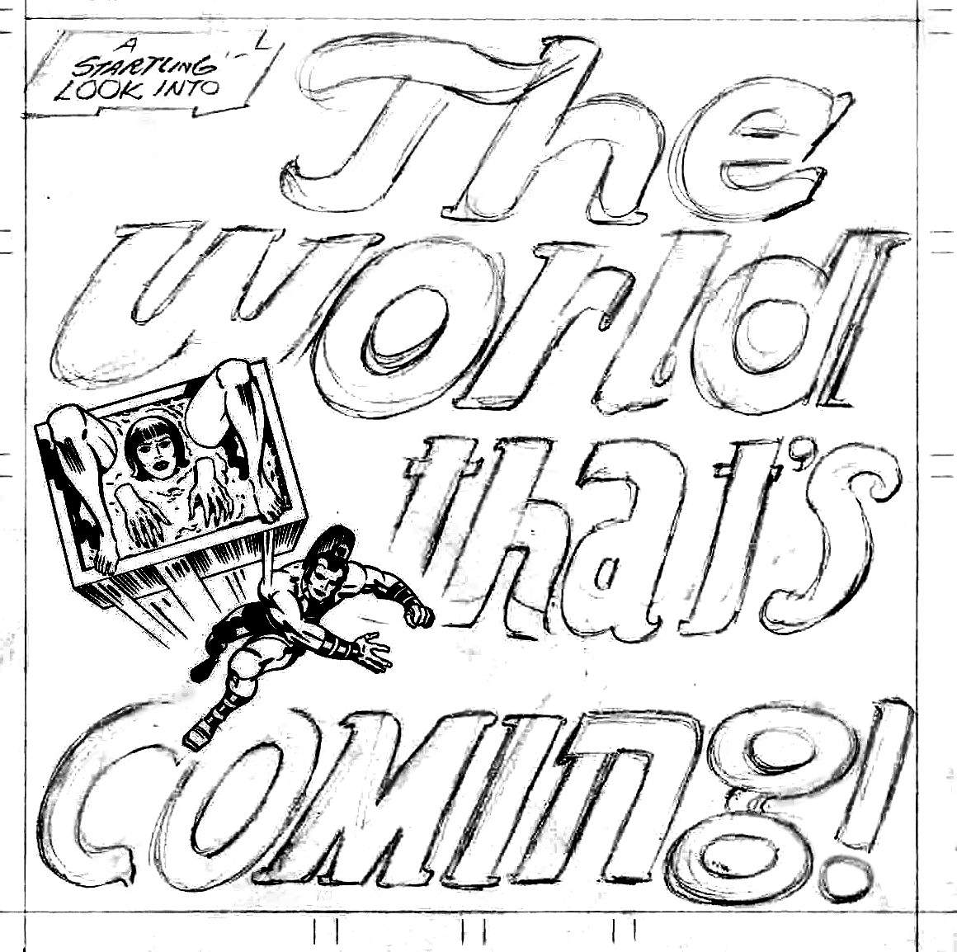
Now let us look closer at Jack Kirby's History of the Future.
Image: Kirby’s original cover design for OMAC #1. © DC comics. Fair Use.

“We always say that he was born before his time.
He belongs to a future generation.”

1.
Who Was Jack Kirby?
Jack Kirby (1917-1994) was a storyteller. He sold over six hundred million books. He mastered more genres than any other top-selling writer. He created the Avengers, which became the biggest movie franchise of all time. He inspired Star Wars, which became the second-biggest movie franchise of all time. But none of this matters, except to get your attention. What matters is that Kirby was human.
Kirby was asked to describe himself in one word. Writer? Storyteller? Artist? No: Kirby said he was “Human.” Kirby hated “power people”. He loved ordinary people. He worshipped the individual.
“Worshipping the individual as I do, I feel that every individual is valuable because he is an individual, and because he is alive. Whatever he does is valuable too, and it's interesting because it's an expression of his own experience.”
Kirby hated that a king or employer can tell another person what to do or think. Kirby called that “anti-life”.
“[Anti-life means] You're dead as an individual. You have no choice. You can't object and you have no stature as a person. You're dead. A slave is a dead man."
Kirby wanted an end to all such power.
“We have to find some kind of an end to power."
"My religion is cooperation, not power."
Kirby learned these values from his mother, Rose. Rose was a peasant from Eastern Europe. Peasants knew the truth about power. They knew that power is always power over somebody. The people at the bottom always suffer. But peasants could not speak out against powerful people: that was dangerous. So they told stories about monsters and giants. They warned of dangers in a symbolic way. Rose told these stories to Jack and showed him how to create his own stories.
"My mother was a great storyteller... She came from somewhere near Transylvania and she told me stories that would stand your hair on end. I loved my mother and I loved those stories."
Some peasant stories are very old. Stories like “Jack and the Beanstalk” are around five thousand years old. The story of Adam and Eve is around ten thousand years old. Stories of gods are up to 41,000 years old. Stories of angels (messengers from a higher realm) are up to 110,000 years old. These stories go back to the beginning of mankind.
Kirby had a very ancient view of things. He was Jewish, but of the kind of Judaism that pre-dates kings, predates obedience, and even predates belief in the soul. He saw the cycles of history and power. There is something deeply ancient about Kirby’s writing, something eternal.
So who was Jack Kirby? Jack Kirby was a human. He was a human of the ancient kind, the eternal kind, from a time when humans were free, when every human was king of the world, before there were hierarchies of power.

On authorship
Occasionally a Kirby editor would claim to be the writer of Kirby’s stories. The claim is easily disproven: these editors were unable to come up with stories like that on their own. And Kirby’s work was always better before it was edited.
Kirby never claimed another man's work. He felt that each person should create their own work as "an expression of his own experience” and not try to fake another person’s experience. That felt contrived. So when he was given scripts, he threw them out of the window.
KIRBY: “I never took their scripts. [They] would send me scripts, I'd throw them out the window.”
INTERVIEWER: “Why was that?”
KIRBY: “I don't like anything that's contrived. I conceive, they contrive.”
Kirby had no need to take ideas from others because he was always bursting with ideas. A fellow writer recalled:
“I really sweated out plots, unlike Jack Kirby. Jack just ignited and came out with ideas”
One editor claimed that Kirby was just his artist. But Kirby was always a writer. Sometimes he wrote scripts for others, but like our ancient ancestors he preferred to write with both words and pictures.
INTERVIEWER: “When you talk about stories you talk about yourself more like a writer than an artist. Is that how you see yourself?”
KIRBY: “Yes, I am a writer.”
The question of authorship is easily resolved: just follow the quality. Whenever Kirby’s name is connected with a book, even if he is only credited as an artist, there is a sudden jump in writing quality, and it follows Kirby’s favourite themes. And whenever Kirby leaves a book, in any capacity, the writing quality drops back to normal levels. There is plenty of other evidence to support this conclusion: Kirby wrote these stories, even when he was only credited as an artist.

2.
Kirby Knew a Lot of Stuff
Jack Kirby knew a lot about humans. Maybe more than anyone who ever lived. This is why:
Kirby grew up with ancient myths. So he knew human nature in its most distilled form. He also fought on the streets and in the war, so he knew human nature in its most direct form. He lived in New York City and then California, between 1917 and 1994: the epicentre of knowledge and experience during the greatest changes in the history of the world. For sixty years, Kirby spent most nights alone in his room, surrounded by books and newspapers, thinking of interesting new challenges that people might face, and how they would react. He had the TV on (with the sound turned down) and the radio turned up, so he was constantly absorbing information. For sixty years, all day and all night, he thought of everything that might challenge humans: every conflict, everything that readers might find new and interesting. In effect, he performed sixty years of thought experiments on what it means to be human.
Kirby just wanted to write good stories. But he was curious about the future, so he always thought thirty to fifty years ahead.
“I always try to look 30 to 50 years ahead, I always have.”
Whenever Kirby wrote about the future, those things ended up coming true. That scared him. His wife, Roz, recalled when Kirby wrote about China:
“He got scared, because he said every time he was writing something, it was coming true in the newspapers. And he was so sure that he was going to end the world! (laughter) But his mind was so... he just saw into the future. … But he scared himself when he started writing it.”
Kirby couldn't help seeing the future, even when writing gentle comedies set in the present. Here is an example from 1957. It is just silly fun, but can you see how Kirby accidentally predicts our present day?
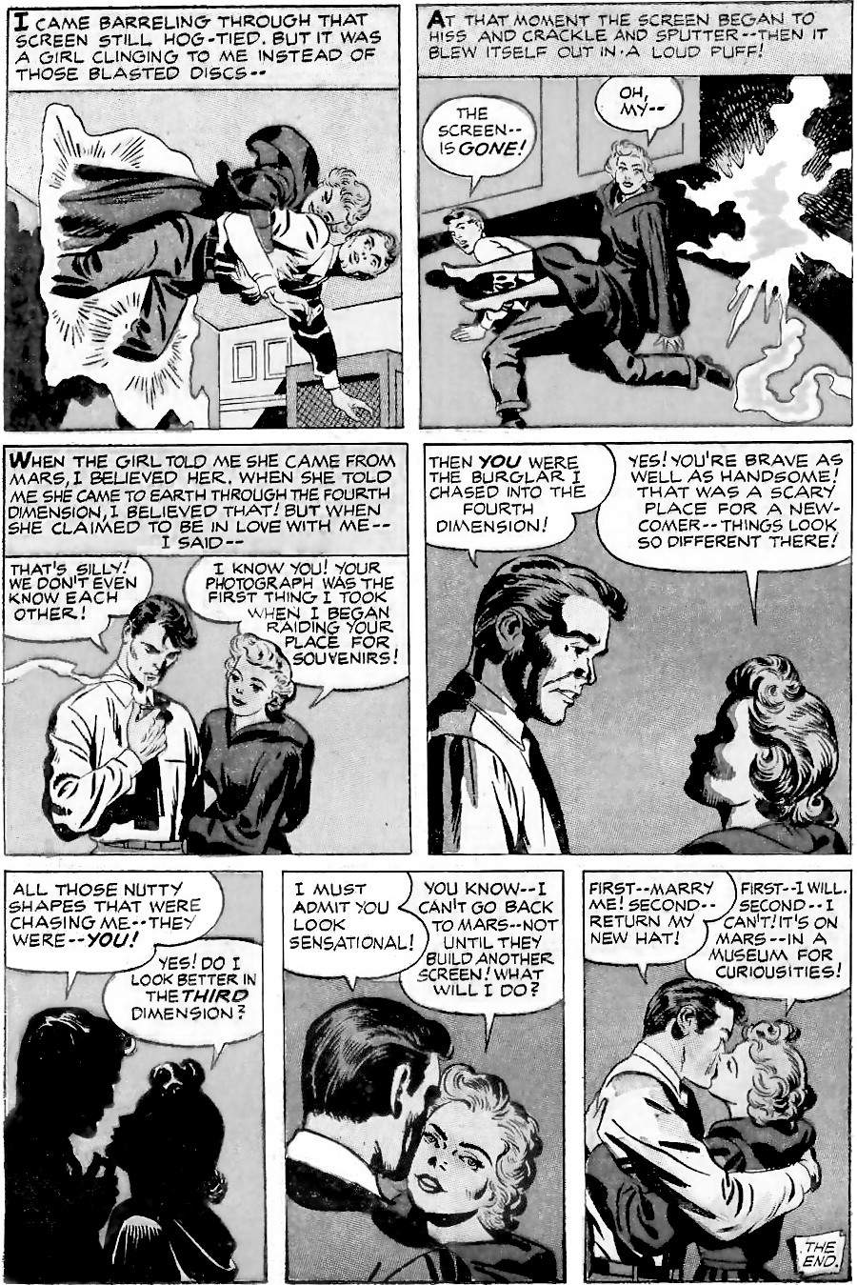
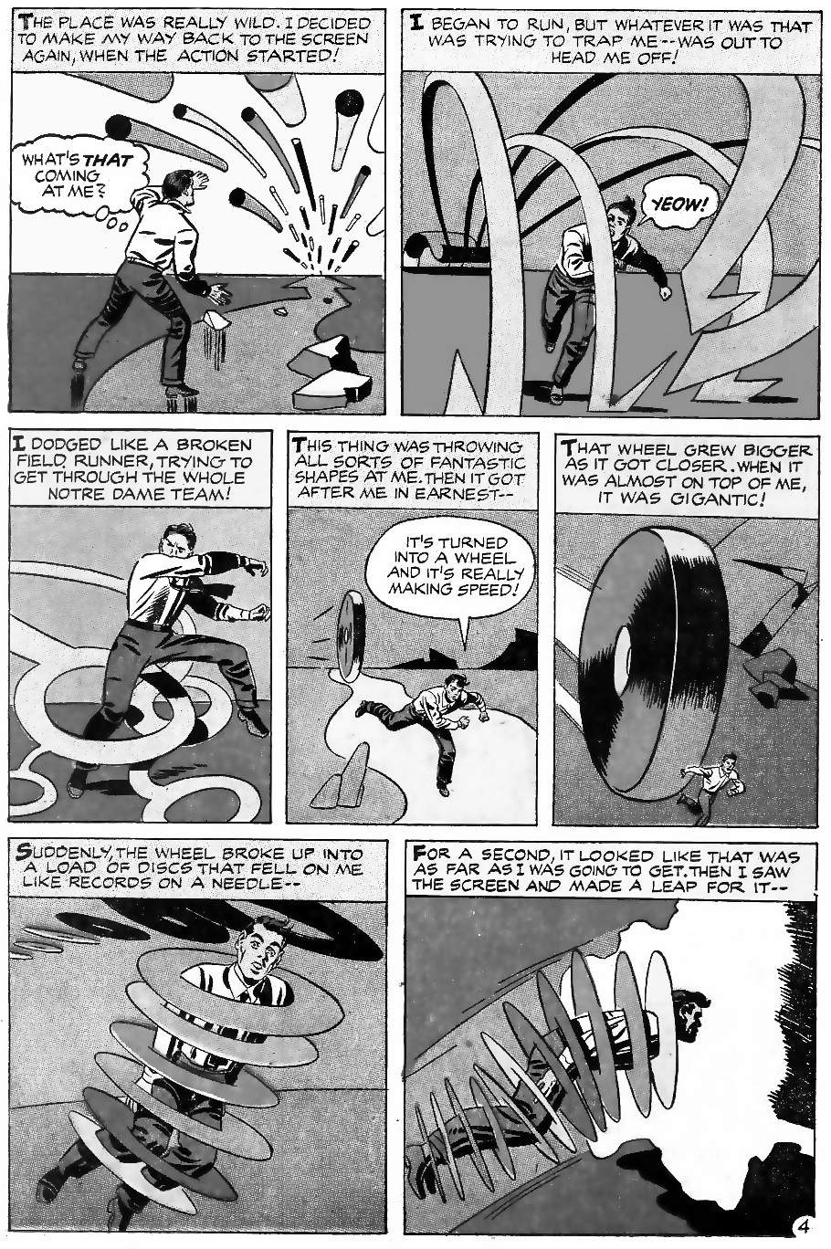
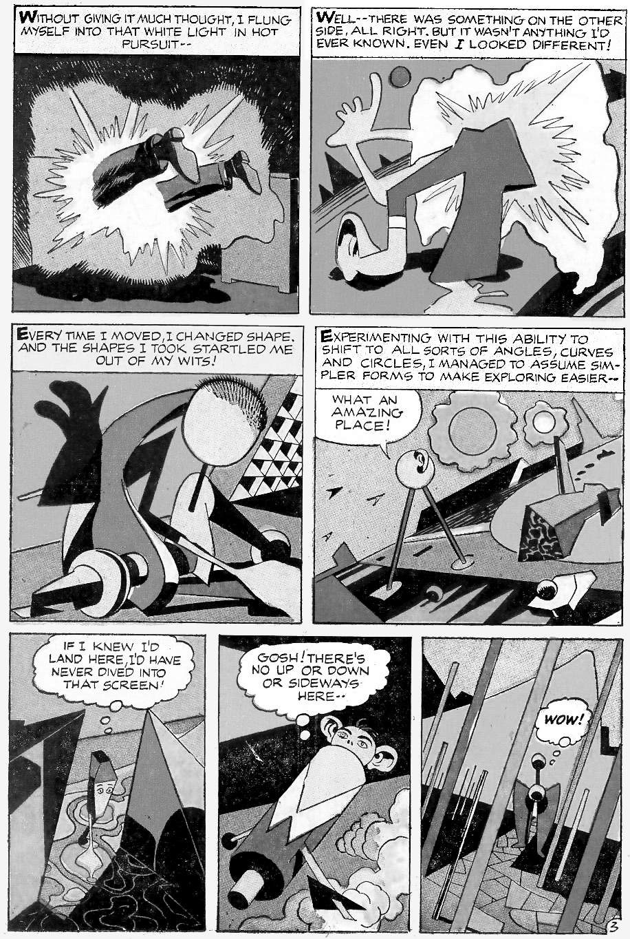
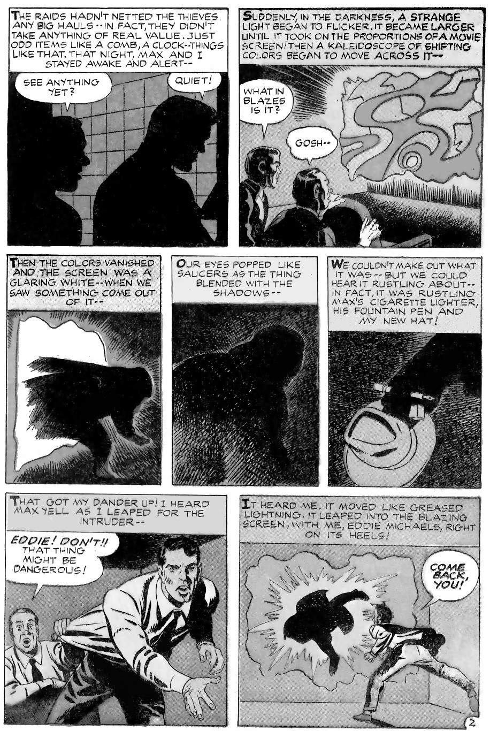
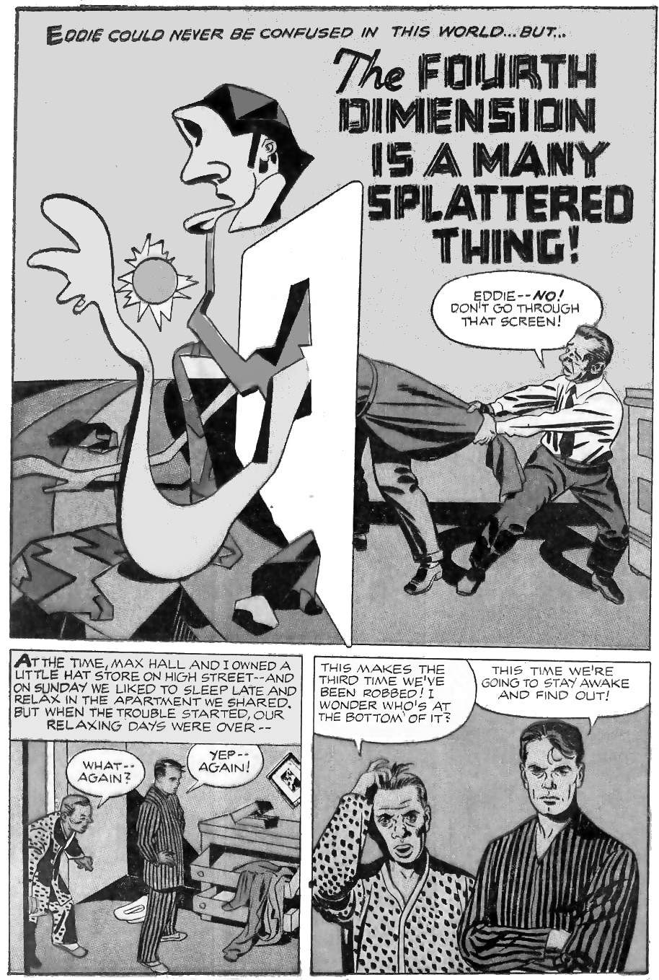
Before looking at how this 1957 story predicts the present, look at the breadth of knowledge packed into just five pages:
- Literary tropes: the story combines comedy, mystery, horror, action and science fiction, plus four different romances (see below). Kirby does it effortlessly, and nothing feels rushed, squashed, or out of place.
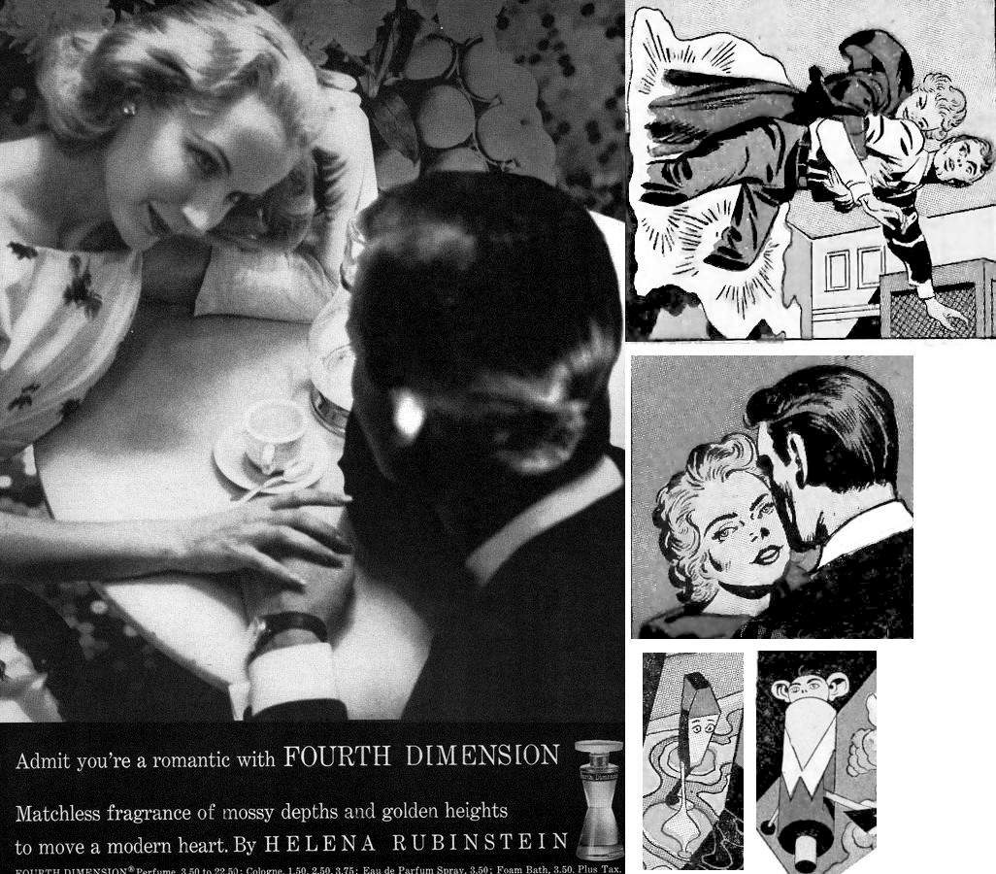
- Popular culture: the title is a play on the movie “Love is a Many Splendored Thing”, and the story seems to be inspired by a perfume advertisement:
Image: advertisement from Helena Rubinstein, 1953, and scenes from Kirby. Fair Use.
- Four-dimensional geometry: Kirby understood the principles in Edwin Abbott’s famous book, “Flatland, or a Romance of Many Dimensions”. For example, when seen in 3D space, a 4D shape changes as it moves, and can even appear as separate unconnected shapes.
- References: every panel is packed with ideas. From the clever wordplay (e.g. puns like “rustling” and the names “Max” for the timid guy, and “Eddie” for the guy caught up in swirling currents) to Notre Dame football, record players, the way that 1950s TV screens could fail, etc.
- Cutting-edge culture: having a woman drive the action and then defeat the man, both in combat and intellect, was unusual for 1957. And then we have the ambiguous Max-Eddie relationship, in a time when even hinting at homosexuality was banned by the Comics Code (see below).
- Modern art: the imagery is influenced by major artists of the time: Pablo Picasso, M. C. Escher, Joan Miro, Giorgio De Chirico, Hugh Mesibov, Kazimir Malevich, Salvador Dali, and the sculptors Jean Tinguely, Frederik Weinberg, and (from before his 1950s period) Bruno Munari.
All of these artists (Picasso, Malevich, etc.) were fascinated by the fourth dimension: not because of Einstein, space travel, or wormholes, but because they wanted to study a topic from all possible angles. Cubism, for example, sees different sides and different time fragments all at once. For details, see Linda Dalrymple Henderson’s classic text, “The Fourth Dimension and Non-Euclidean Geometry in Modern Art.”
Kirby always searched for a higher dimensional perspective on life:
“I feel that a lot of us are in a kind of three-dimensional cage. It's a cage and we're running around this cage like squirrels because it would be great if we could break out of the third dimension and roam around in infinity.”
Kirby understood that reality may not be what we think it is:
“To God, we may be two-dimensional. Why not? Our dreams are elliptical — we're elliptical. Why can't our dreams be as real as we are, in their own fashion? They think they're alive. And they have no concept of what we are, and maybe someday if God wakes up, we'll all be gone. See what I mean?”
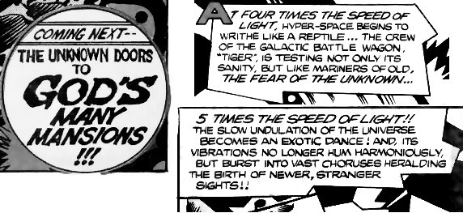
Kirby often explored this topic of a God's eye view, of seeing from higher dimensions. For example, in Captain Victory #8:
Image: by Jack Kirby, in Captain Victory #8, Fair Use

The story came true
In "The Fourth Dimension is…”, Martian technology is so advanced that it creates a two-dimensional portal into the fourth dimension, and this portal can exist in your bedroom. But it has a downside: it allows a more skilled person to watch you, and thereby steal personal items, and even encircle and trap you. It is especially good for dating: Eddie enters the portal and finds a woman to marry! We enter the portal by transforming into mathematical forms, and this is disorienting for beginners. Does any of this sound familiar?
Kirby always thought “30-50 years ahead”. Sure enough, 30-50 years after 1957, the portal entered mainstream use. Like Eddie, I found my wife through this portal. The portal is usually two-dimensional (a computer screen), and it lets us view all different sides of a topic. We enter the portal by transforming into avatars, such as a photo or fake persona on social media. We can then meet people who are vast distances away. But the portal also allows hackers to spy on us and steal identifiable information.
We call this portal the Internet. The Internet and a Mars base go hand in hand as the next great technological leaps. For example, in 1997, Elon Musk graduated from university and applied for a patent to let computers act as regular telephones. Soon after he founded an online bank that then merged with Paypal. This gave him the money to create SpaceX, with the goal of establishing a colony on Mars.
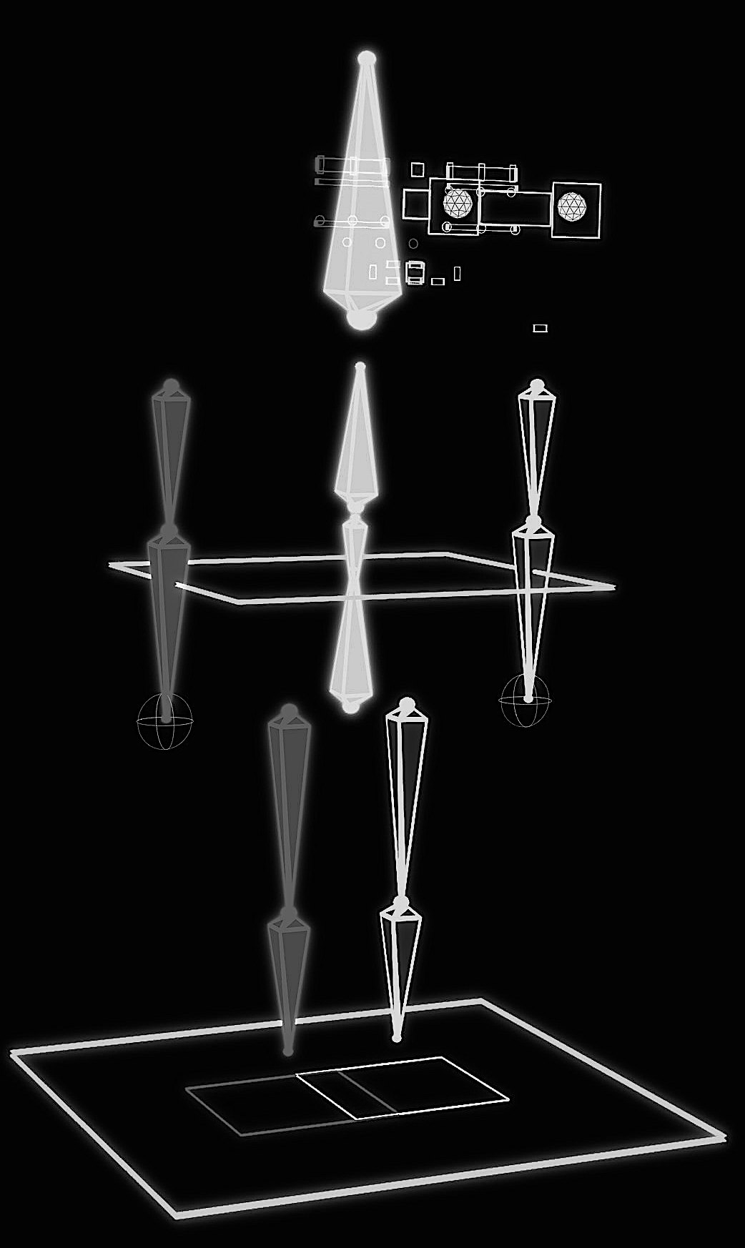
If we want more than a two-dimensional image on the portal, then we need to learn 3D modelling. 3D modelling begins with a series of primitive shapes known as a “rig”: just as Eddie begins with the simplest geometrical shapes, and gradually learns to add more detail. This image of a rig is by “Sarahbot” and “Futurilla”: two Internet avatars of real people who travel the Internet via “Flickr”. Kirby got the look of Eddie’s rig about right.
Image: by Futurilla via Flickr, CC-BY-2.0

The four romances
I said that the story combines four different romances. The first and most obvious is the romantic love between Eddie and the Martian. But look closer.
The second romance is the love of Max for Eddie. The splash page, which usually summarises a comic book story, shows that the story is really about Max losing his best friend Eddie. Max is short and ordinary-looking and cautious, while Eddie is tall and handsome and brave. Eddie and Max have a good life together. They own a hat store, they share an apartment: we see them in their pyjamas together. What does that suggest as a possibility? But then Eddie discovers a whole new dimension to romance. Until that moment, to Eddie and Max, females were from Mars, as we see from Eddie’s naive reactions to the Martian. She is extremely flattering to Eddie as if he is the most handsome man in the entire solar system. But how likely is that? She is extremely quick to agree to marry a man she does not know. Why?
The title refers to the movie, ”Love is a Many Splendored Thing”, about a woman in a war zone, who escapes by marrying a westerner. That would explain her actions: something bad is happening on Mars and she is using Eddie as a way out. But there is an even more obvious motive: she is a shape-changing Martian, and a spy. In Kirby's stories, this is seldom good. It reflects movies of the time where beautiful women were alien spies. So Max is right to be worried! Or maybe Eddie really is the most handsome man she ever saw. Kirby allows all these possibilities.
The third romance is the romance in the classic literary sense: like the Grail romances, or the Flatland romance. That is, a story of a hero journeying through a magically exotic realm.
The fourth romance is “technoromanticism”: the belief that technology can make a better world. Kirby’s story is technoromantic on a surface reading, because it is such an exciting idea, with so much potential, not just for love. The real-world Internet is a similar technoromance, superficially offering countless benefits to mankind. And yet the Internet can also lead to mass surveillance and control, and pressure to live a fake life and never feel good enough. Which view will prove correct? Will the Internet bring peace and love between the worlds? Or is it a Trojan Horse for shape-changing spies to enslave us and destroy our natural relationships? In the Trojan Horse reading of the story, the portal encourages Eddie’s tendency to jump before thinking, serving an alien spy, while also ruining his chance of long-term happiness. But the upbeat technoromance reading is that humans always adapt, and lack of courage means we are left behind, like Max. Which reading is correct? Kirby did not know the answer, at least not in 1957, but he did know the question.
KIRBY: “I'll never get the answers, like everybody else. So I feel I live with very interesting questions.”
INTERVIEWER: “It's more fun living with the questions for you, I gather.”
KIRBY: “Well, the questions are the things that make good stories, in my opinion.”
We could spend this entire book on this five-page story. We haven’t discussed Kirby's writing style (deceptively simple yet poetic), the physics of contrasts, or how Kirby contrasts with his science fiction sources. But let’s return to the chapter’s theme: Kirby the genius.

“I play with ideas like invisible building blocks.”
How did Kirby make so many connections between the past and future? What was going on inside his head? He combined humility, gut feeling, and endless analysis:
“I have whatever senses that I have. And I bring them all into play. I didn't know what these senses... I can't define them. All my senses are hidden from me.”
“I play with ideas like invisible building blocks. There they are — right in front of me. All I do is put them together, and they take their own form. Sometimes I know what that form is, but I’ve got to put the blocks together to find out.”
“I always ask questions. All day, every day.”
“I feel I see a lot because I analyse a lot. I see the same things you do but maybe I get more time to analyse it whereas you might not. So I sit and think and it's as simple as that. If you can sit and think for 20 years, you can come up with quite a bit [Laughter]”
ROZ: “You're always analysing everything.”
JACK: “Yeah, well, I'm analysing everything.”
ROZ: “Jack's head was always in the clouds. He never concentrated on his driving. So he'd go over curbs. (laughter) There was one time where, it was daylight, the sun was shining, and he actually hit this police car in the back. (laughter)”
ROZ: “He was just always thinking”

Kirby’s general knowledge
Kirby was always learning and thinking. He absorbed information from the TV and radio as he worked through the night, dreaming up new scenarios:
“I worked 'til four in the morning. I worked with the TV and radio on — it was a great setup.”
And he had a “vast library of books”, as his daughter Susan recalled:
“I was in [Dad’s] office a lot, because he had a vast library of books, because he was into everything. And I used to go down there and read”
And not just books: his garage was full of the science fiction magazines he read. There were so many that thirty years after his death, his family was still selling them off to fans.
Some of Kirby’s earliest work was researching non-fiction, and then writing and drawing newspaper features on general knowledge, health advice, sports news, and more. He produced so much that he adopted (and worked on behalf of) multiple different pen names. In this example, Kirby is both "Bob Dart” and “Jack Curtiss”. It features four ideas that Kirby would develop in later years:
- Travel between Earth and Mars
- Tshaka Zulu is the basis for the fictional T’Chaka, better known as The Black Panther.
- How ancient people had sophisticated knowledge.
- Romance and young people in difficult situations.
For Kirby, facts were never just facts. He saw the stories behind them: he thought about where ideas might lead, and he questioned everything.
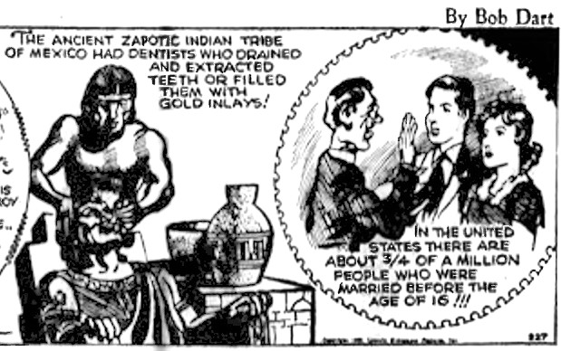
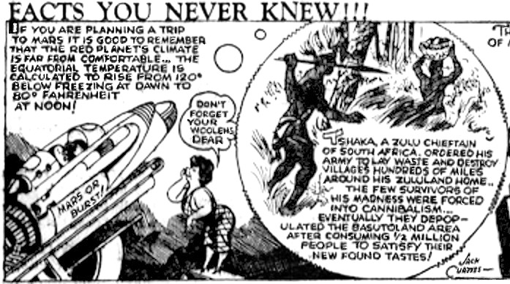

Politics
Kirby had a deep feeling for politics, because he came from poor immigrants, and he saw gangsters and politicians close-up. So he recognised patterns in politics and the wider world:
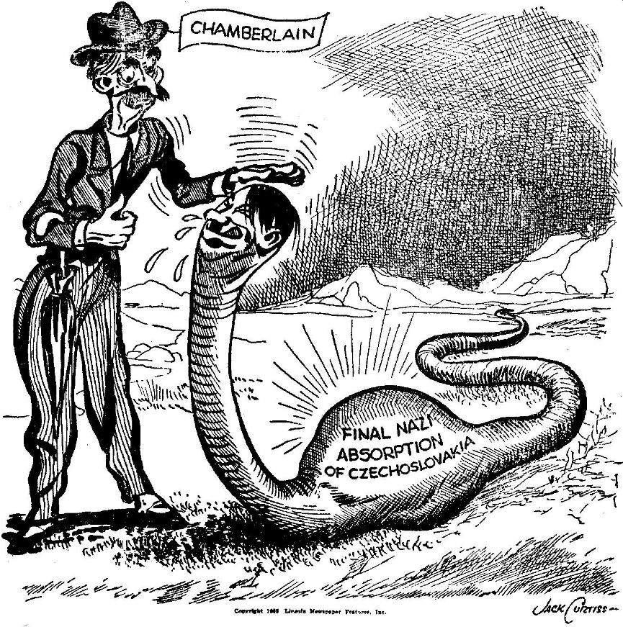
“I remember I did one [newspaper cartoon] about Neville Chamberlain, the English Prime Minister, talking to Hitler, and my boss called me up asking where a squirt like me gets the nerve to make a comment about these people. These were people who were conquering the world. Refugees from every European country were fleeing their homes and coming to America yet, strangely, no one seemed to care that much.”
Image: public domain (the copyright was not renewed)
Another example of Kirby on politics is “Glorious Godfrey”, based on the preacher Billy Graham. Godfrey is a “Justifier”: he justifies people who are “eager to destroy”. When Kirby created Godfrey it was well known that Billy Graham helped Richard Nixon, but nobody knew the full story. Years later it was revealed that Graham wanted Nixon to bomb Vietnamese dikes, causing widespread flooding. This could have killed a million people. Graham supported methods that he knew looked “brutal and cruel in sophisticated Western eyes”. Nobody knew this in 1971, but Kirby knew something was wrong and so wrote his critical version of Graham. On the topic of flooding dikes to kill people, note the parallel with ancient Sumer, the origin of the story of Noah's ark (see chapter 5), and a warning for our future (see chapter 13). Politics follows patterns.
Another example of politics in Kirby's stories is “Madbomb”, Kirby's epic Captain America story to celebrate the American Bicentennial (see chapter 8). Madbomb is a story of elites versus the common man. It features a villain called “Malcolm Taurey” who longs for a return to the pre-democratic era of the 1700s. The name “Taurey” comes from the Irish word “toraidhe” meaning “highway robber” and was applied to English landowners who ruled Ireland and evicted poor Irish workers from their land. Taurey controls a worker called “Harding” who must make hard choices due to being hard up. He works for a man he hates, to pay his family’s medical bills. Madbomb can be read as Kirby’s commentary on the need for affordable healthcare, and his view of economic elites.
Kirby had to be subtle with his politics because his editors sometimes removed controversial parts of his stories. When Kirby wrote about very sensitive topics, his stories could be cancelled completely, such as when he wrote a story based on Patrice Lumumba’s struggles in the Congo. So Kirby was generally very subtle, but his pro-democracy politics are everywhere.

The classics
Kirby loved the classics.
“I read all the classics at a very early age because I spent a lot of my time in the library. I loved Robin Hood, King Arthur, and all the English classics. If questions were asked in school I'd get up immediately and answer to the amazement of my teachers.”
Kirby used Robin Hood as a model for his kind of pro-democracy story. He aimed to write stories that could still inspire people eight hundred years later:
“Of course, the way I interpret it, our work will last — maybe not forever, but it will last a long, long time. Remember, Robin Hood was created in medieval times. King Richard was still king, right? … they will be looked upon as medieval texts, and your children will talk about me. They'll say, ‘My great grandfather was impressive in my times. My great grandfather could tell us legends that would enchant us.’ And they'll take out tape recordings and say, ‘Listen.’"
Kirby’s stories refer to medieval sources, Shakespeare, Victor Hugo, the Arabian Nights, and many more. He especially liked Alexander Dumas and often referenced The Three Musketeers and The Man in the Iron Mask. One of Kirby's first jobs was to adapt Dumas’ The Count of Monte Cristo into comic book form. Let’s look at a typical page. Notice the quality of the prose. Kirby had to compress the story into three panel daily strips, while leaving space for the art to be chopped up for different formats, still be true to the French original, and yet be instantly understood by young readers. A tall order! And he did it, at great speed.
Kirby understood the classics at a deep level because he grew up in a similar culture. His father came to America to escape death in a duel. His mother (from peasant stock) taught him family honour. He experienced both poverty and fame (even here in 1939 his star was rising). He knew betrayal and he knew the life of the mind. He fought on the streets. Kirby understood classics like Monte Cristo because he lived that life.

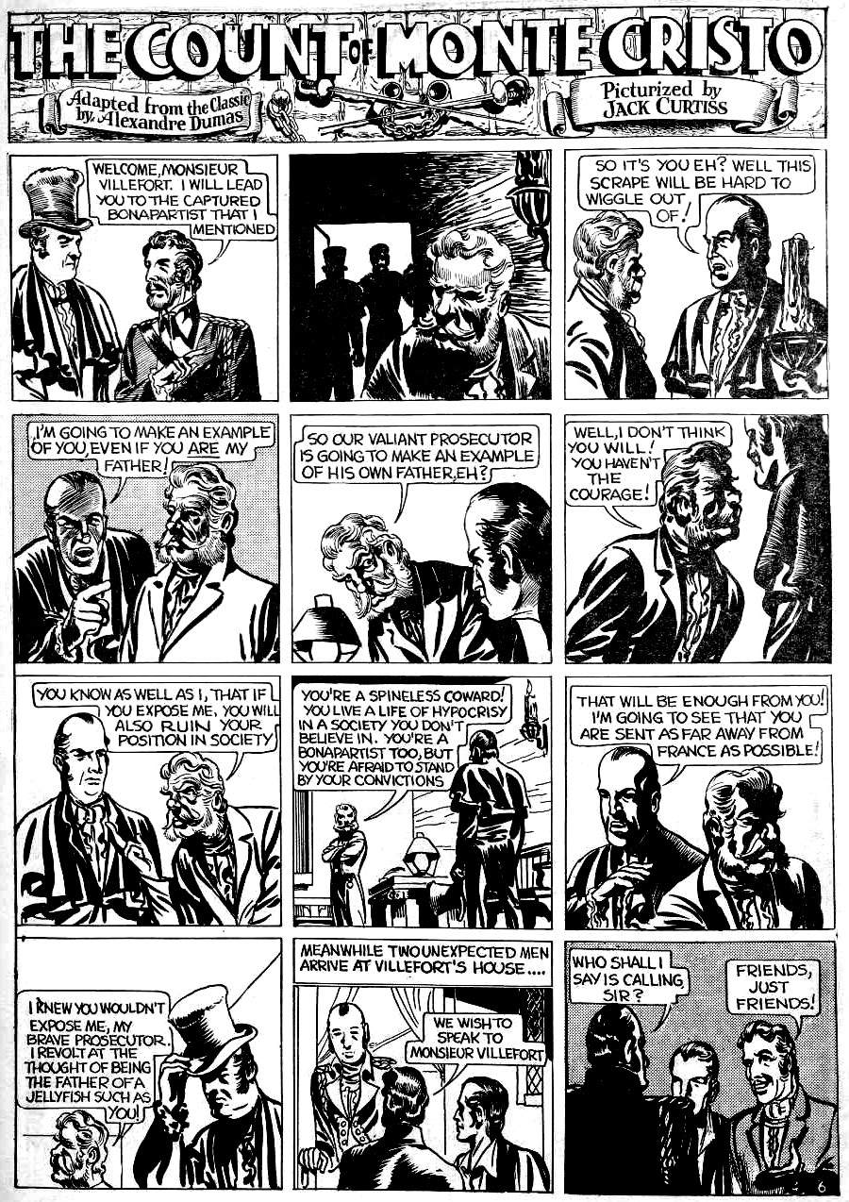
Experience
Everything Kirby wrote was based on experience. In this example, a black character has high class and high skills. This was 1940 when most black characters in comics were written as fools and drawn as racist stereotypes. But Kirby’s first friend was black, so he knew better.
- This story is about a pilot. Kirby's best friend was an amateur pilot and flew Kirby over New York.
- Kirby often wrote about kid gangs because he was in kid gangs.
- He wrote about superheroes fighting five guys at once and jumping across rooftops because that is what he did in his gang.
- He wrote about gangsters because he knew real gangsters.
- He wrote war stories because he fought in the war.
- He wrote powerful horror stories because he had seen terrible things in the war. Before that, he saw terrible things in the ghetto. "I had a friend of mine get shot in the neck. I had a friend of mine who saw his mother jump off the roof.”
- He wrote romances because his life with Roz was a great romance.
- He wrote about gods because he went to Hebrew school.
- He wrote westerns because his parents were immigrants just after 1900, and he loved America.
- He wrote sci-fi because he experienced the greatest age of scientific progress: he was born in New York in the era of the horse and cart and died in California in the era of space stations and the Internet.
- He wrote monster stories because of his mother. “She was a wonderful storyteller, she had come from and knew all these horror stories” "She came from somewhere near Transylvania and she told me stories that would stand your hair on end.”
Everything he wrote was based on experience.

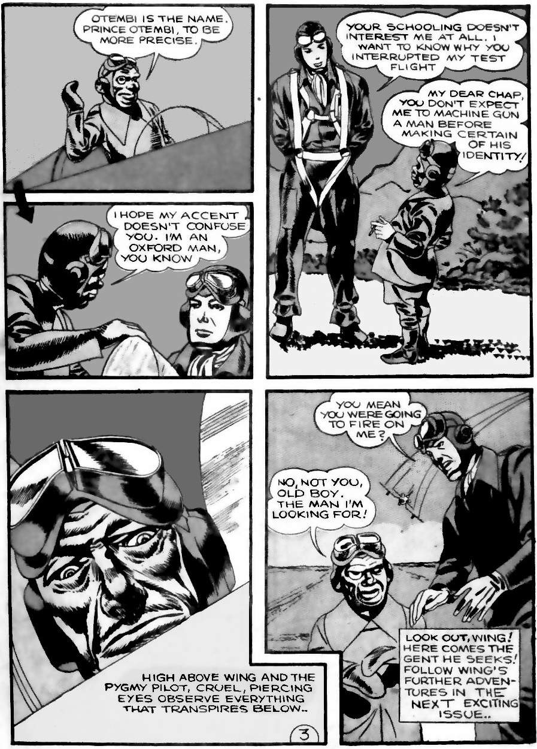
Stories from around the world
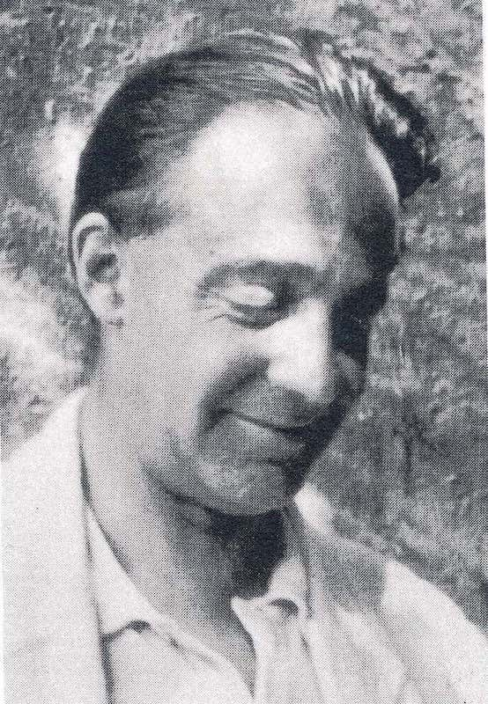
Kirby loved books by Joseph Campbell (of “The Hero With a Thousand Faces”), and by the man who inspired Campbell, Heinrich Zimmer.
Image: Public Domain, via Wikimedia
Zimmer collected ancient stories, in books like "The King and the Corpse". Zimmer was busy collecting stories about ghosts when he unexpectedly died in 1943. This would have sparked Kirby’s imagination: what if Mr Zimmer was still collecting ghost stories, but now as a ghost himself, talking to other ghosts? So Kirby planned a series of tales about Zimmer and his Book of ghost stories.
Zimmer was famous for his big smile. So in Kirby’s version, the ghostly Mr Zimmer is a smiling, kindly ghost who helps children. The Mr Zimmer stories are a great example of Kirby writing about serious topics, but in a way that even children can understand. The first Zimmer story is about colonialist greed leading to violence. The second is about ancient feuds. Such stories have been told across all cultures for thousands of years.
Kirby calls Zimmer’s book of stories the “Book of Fate” or “The Book of Destiny”. In ancient times, the “tablets of fate” or “tablets of destiny” were the collected wisdom of the universe. According to the Sumerian creation tablets, whoever has the tablets of fate is likely to triumph in everything they do. Kirby often retold ancient mythology in a modern form: chapter 5 has many examples.
By learning mythology we see the big patterns of history and are better able to predict the future. That is if we have the tablets of destiny we are more likely to succeed. Kirby gives us these patterns in his stories: Kirby's stories are the modern version of the tablets of destiny.

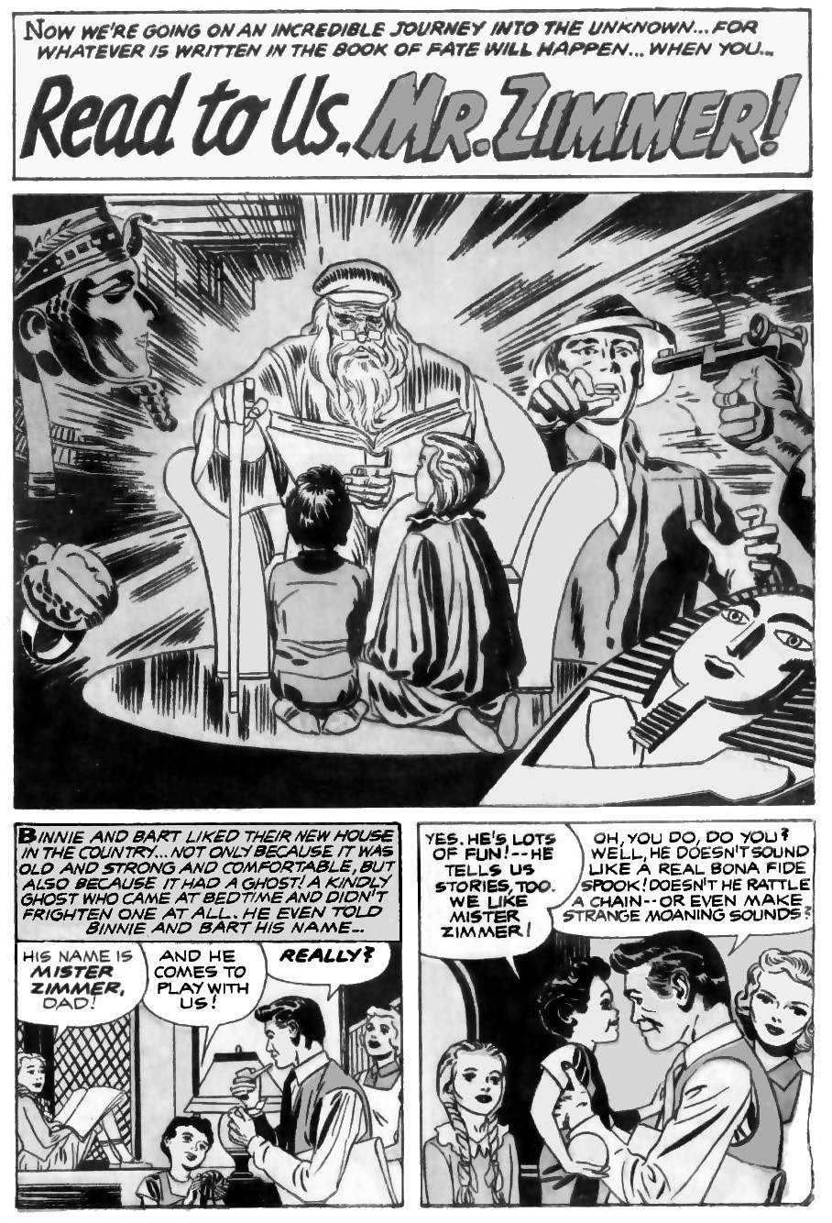
Science
Kirby's stories followed the latest science. For example, we can trace the science of DNA by following The Cadmus Seed (four years after Rosalind Franklin first took a photograph of DNA’s structure), then The Mad Thinker, (in 1962, when Watson and Crick were given the Nobel Prize for Franklin’s discovery), then “Him” and “The DNA Project”, etc. Each time, Kirby reflected on the latest discovery and imagined where science could be in thirty to fifty years. He was usually on track. For example, forty years after the Cadmus story about cloning, the first mammal was cloned (Dolly the Sheep in 1997), and in 2000, Lu Guangxiu of Xiangya Medical College claims to have cloned human embryos.
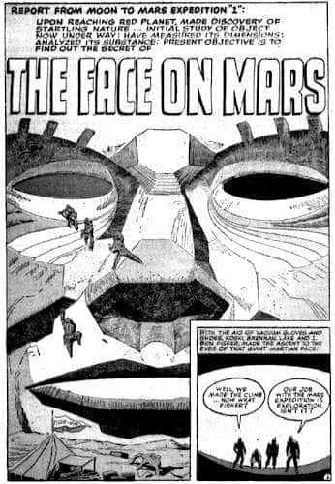
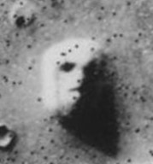
Scientific ideas change of course, as new evidence appears. For example, the following page deals with the origin of the asteroid belt. The story is from 1957. Back then, many scientists believed that the asteroid belt was formed when a small planet was destroyed in a collision with another body. Kirby used the idea for a story called “The Face on Mars”, a page of which is shown here. “The Face on Mars” begins with the first explorers on Mars finding a gigantic stone face. Nineteen years after the story, a photograph of the Martian surface appeared to reveal just such a giant stone face. Kirby saw the future again!
Image: NASA, Public Domain

In 1998 a higher resolution image showed that the “face” was a trick of the light. But good stories are about how people experience things at the time, not about how later generations reassess those things. Kirby’s story was about what astronauts thought they saw. In Kirby's story, the astronaut who entered the stone face also thought he saw a whole civilisation, but he only dreamed it. Kirby’s instinct was right again.

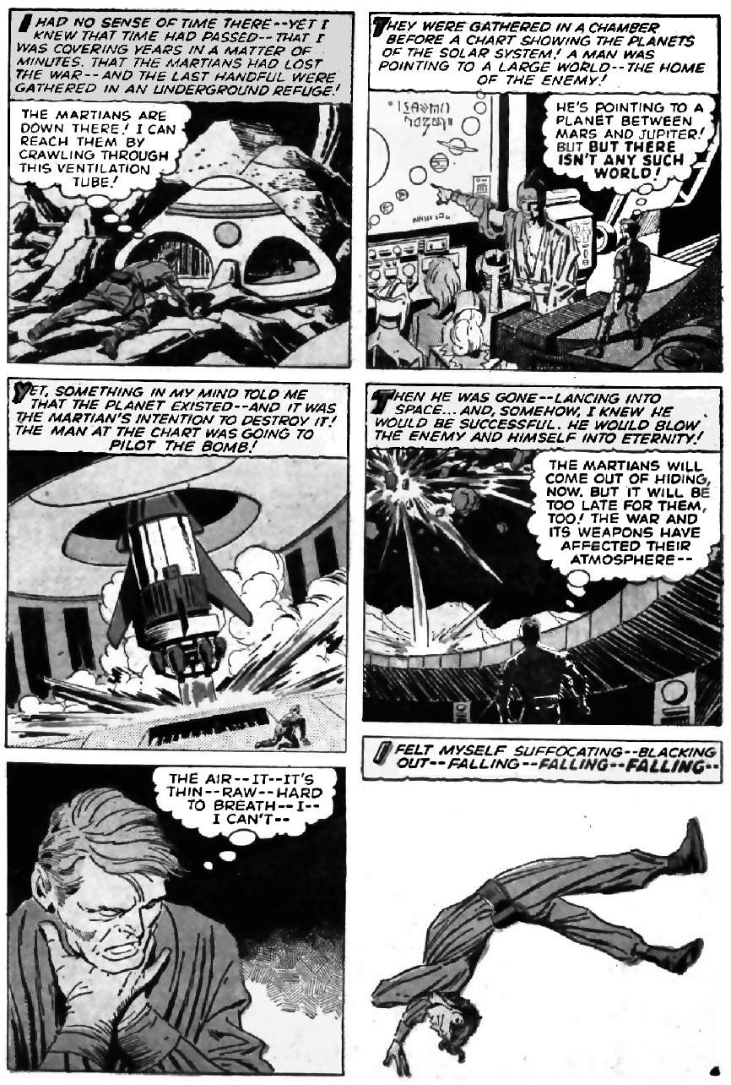
Life
Kirby’s goal in life was to understand humans.
”From the very beginning, I've wanted to find out what made people do the things they do. … I've seen people hurt, I've seen people bleed, and more than that. And basically I want to find out why.”
So inevitably, many of his stories explore the nature of life and consciousness, informed by science. The science in this example includes ball lightning, lightning detectors (or possibly Radio Direction Finding antenna), brainwaves (i.e., waves of electrical activity in the human brain), and the Bikini Atoll nuclear weapons tests. The story then questions whether something like brainwaves can exist without solid matter.
The idea that life can exist without solid matter is an ancient one: our ancestors were comfortable with the idea of spirits. Kirby wrote various stories about spirits and disembodied life. Nineteenth-century reductionism made the topic of spirits very unpopular among scientists. But then in the twentieth-century mathematics came to the rescue.
In 1939, Nicolas Rashevsky founded “The Bulletin of Mathematical Biophysics”, the first scholarly journal devoted to studying life as information, not as biology. When Kirby wrote this story, Rashevsky’s student, Robert Rosen, was working on his groundbreaking “Relational Theory of Biological Systems”. So the idea of life without solid matter was a hot topic when Kirby wrote “Fireballs”. Recently, in 2020, a reputable academic journal showed that yes, in theory, a self-replicating species could exist inside the gas of a star.
It is easy to dismiss Kirby's stories as wild speculation and not based on knowledge. But Kirby absorbed his ideas from many directions. The proof is that Kirby's insights are usually proven true, eventually.
Chapter 14 takes a closer look at Kirby's view of consciousness, and compares it to the ancient animist view, that everything has its own unique spirit (its set of behaviours and relationships). This is the only view of consciousness that can be proven scientifically.

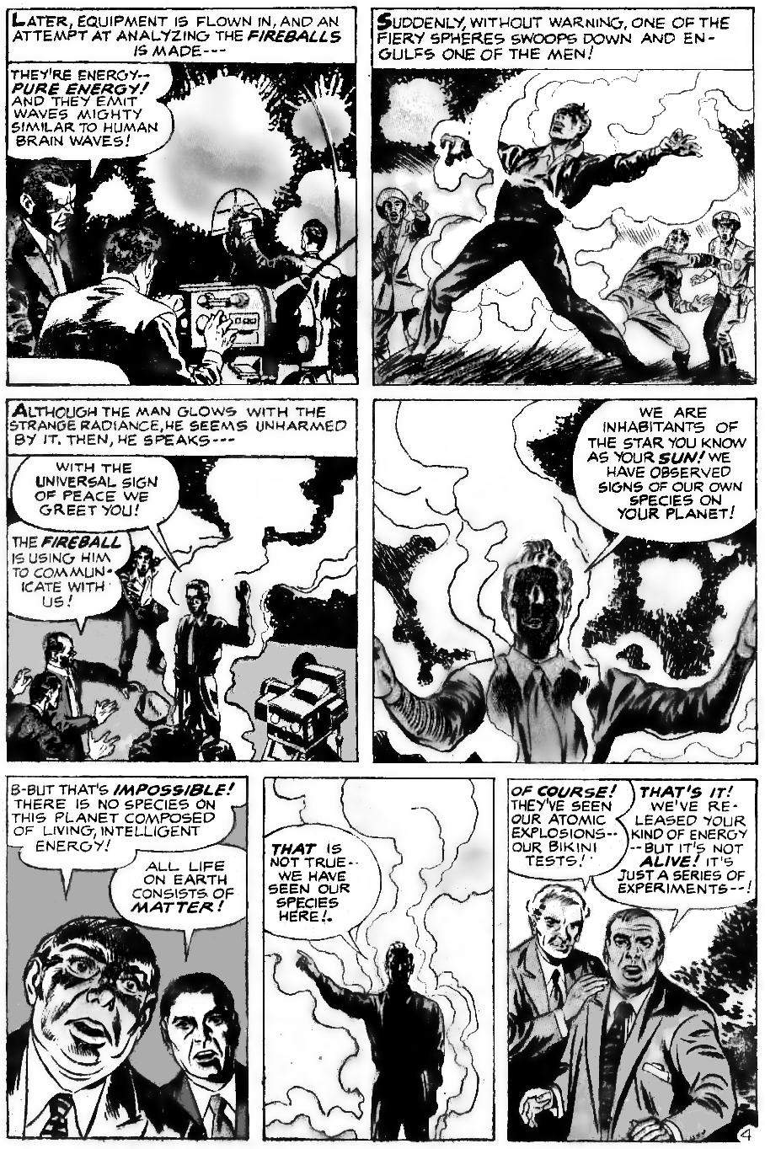
Socioeconomics
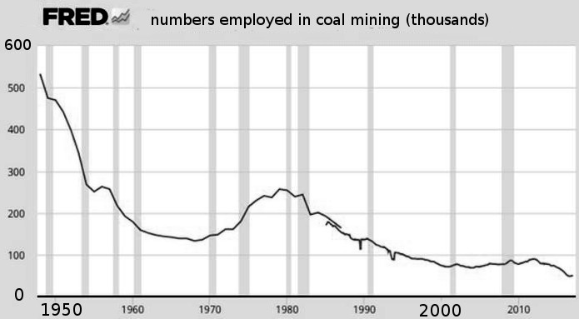
Some of Kirby's best work is his romance work. These stories are about personal relationships in communities and often touch on socioeconomic issues. The following page is a typical example. This story is about male violence and male pride. It’s set in 1948 when miners were rapidly losing their jobs to technology.
Source: Federal Reserve Economic Data (FRED), fred.stlouisfed.org
In this story, Dirk becomes a fighter so he can escape mining. His sister, Katie, is disgusted by his behaviour yet can do little about it. It’s a complex story about family loyalties, courage, and what we are willing to sacrifice to get what we want. It’s about fighting, both literally and metaphorically. It’s about what it means to be a man.
Luckily, in 1948 the economy needed workers in other areas. So although communities were torn apart, at least people could find jobs elsewhere. But the story raises socioeconomic questions about our future. What will happen in the 2060s, when highly educated people are replaced by machines, faster than we can retrain? Will we fight each other to maintain our pride? For how long will the government give us handouts? Chapter 13 explores the problem.

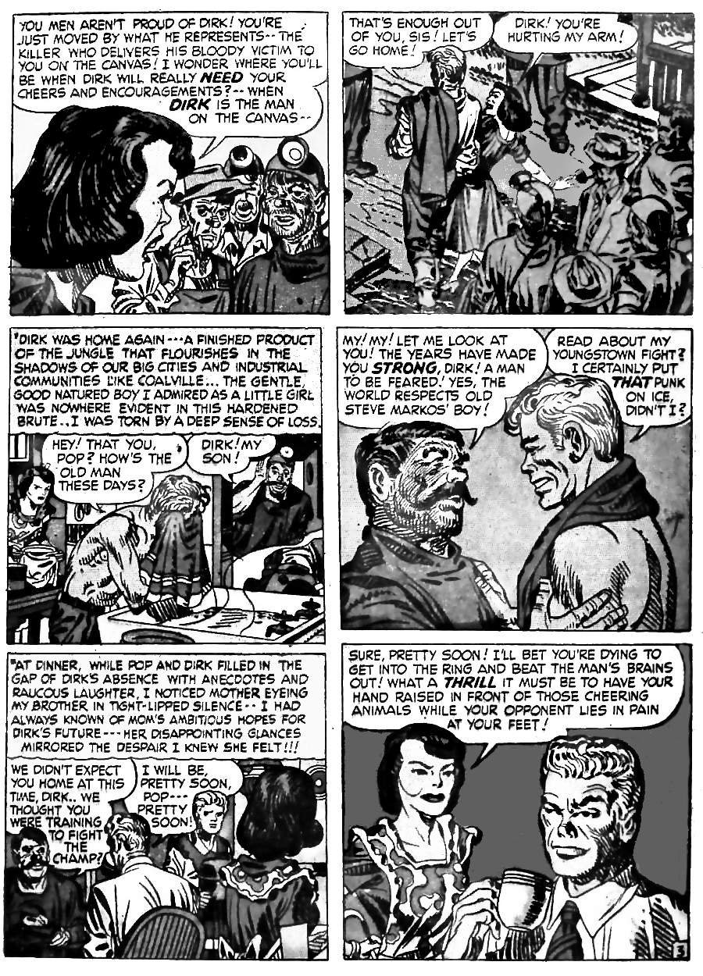
History
Kirby loved history. History opened his mind to new worlds. History was how he escaped the poverty around him.
“It was the thing that kept my mind off the general poverty in the area. When I went to school that's what kept me in school — it wasn't mathematics and it wasn't geography; it was history.”
The following page is a typical piece of history that Kirby remembered, but others forgot. Herman Gottler lived in nineteenth-century France. He killed people using a gun hidden in his wooden leg, because he read Thomas Malthus, and wanted to fight overpopulation.

Stories for children?
Kirby's stories are for all ages, so they appear bright and simple on the surface. In this story of Gottler for example, Kirby adds a heroic detective and dramatic climax. But real people died in the real world. And the issue of population growth is real: we are using natural resources faster than they are replenished, we are polluting the environment, causing global warming, driving other species toward extinction, and so on. Kirby’s stories may seem simple and even childish, but they deal with the most serious topics and always tell the truth about the world.
“I won't tell you any lies. I might fantasise. I might dramatise, and I might make my characters with a little more flourish, but they'll never lie to you. They'll always be the truth.”
“Whatever I present is genuine, and myself. It's never adulterated and I have always told the truth, [although it was] painful some of the time. Truth, to me, is important because people are important.”

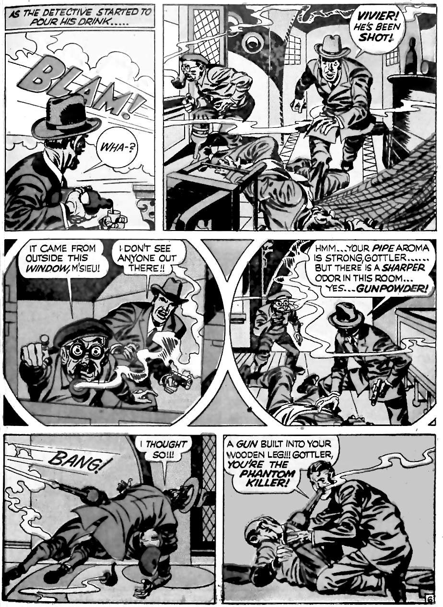
Sometimes a story is just a story?
This book makes big claims about Kirby's stories. For example, the next chapter links Kirby's story Atlas The Mighty to events ten thousand years ago. Kirby never intended that. Readers will say, “the story is just a story!” Or as Freud allegedly said, “sometimes a cigar is just a cigar.” But that is not true.
The choice to smoke a cigar, or to add detail to a story, is always a choice. Most choices are unconscious: we do not see the influences that cause our choices moment by moment, but with effort, we can trace those influences. Detectives rely on that fact.
For example, on the next page (based on a real murder story), a detective obtains vital information from the choice to sweep one room but not another. The murderer never consciously intended to leave that clue. But his choices encoded more information than he realised. At the end of the story, a body is identified by dental records. The dentist never intended that. Detective work is all about unintentional clues.
Freud never said that a cigar is just a cigar — he taught the opposite. And sorry, Freud, the meaning is seldom phallic. When Kirby was young, an expensive cigar meant you were a success. So when Kirby became a big success in 1940 he began to smoke cigars. A cigar became a symbol of Jack Kirby. When Kirby left one publisher, a popular staff member taped his cigar butt to the wall as a memorial. A cigar is never just a cigar.
Everything encodes information, whether we are aware of it or not. Kirby revealed his thinking and his influences without realising it. For example, when Kirby wrote about Atlas fighting skull worshippers who live underground, he was influenced by Victorian writers who were influenced by real legends and real explorers. They did not know that the Pre-Pottery Neolithic culture was a skull cult that came into conflict with people from the Atlas Mountains and allied itself with Harifians whose homes were hidden underground. And yet that kind of thing survived in cultural memory. To a polymath like Kirby, the story felt right. As readers, we can play detective and trace such information to its source.

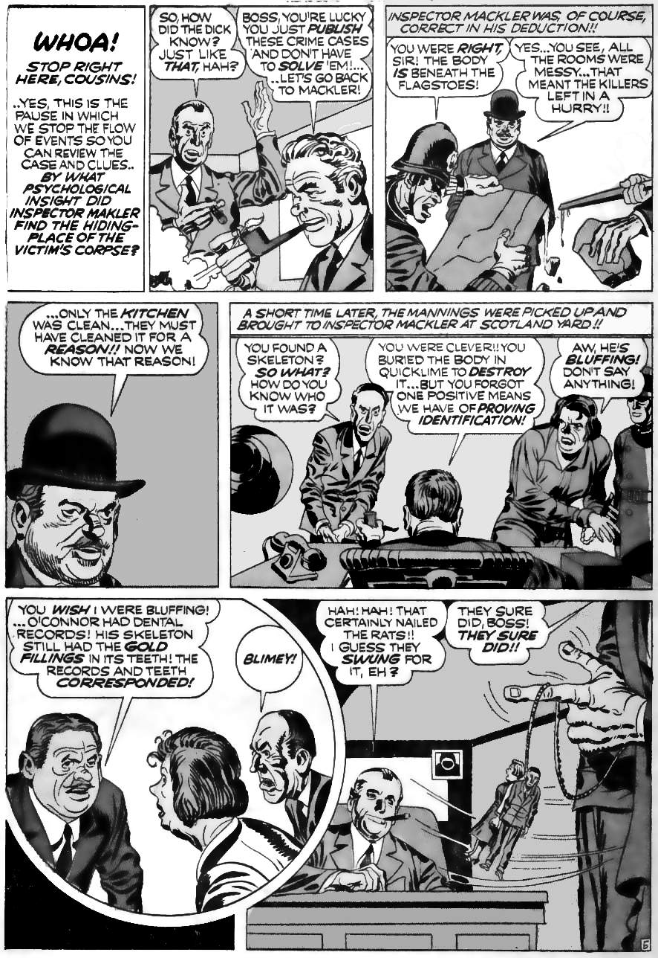
Epistemology
Epistemology is the study of knowledge: what can we know? How do we know it? Kirby was clear:
“I feel there are no experts anywhere in anything”
“Whoever says he knows the answers, why, he's the one guy I know who doesn’t."
This, and Kirby’s love of the individual, might make Kirby sound anti-elitist, which often slides into being anti-vax, anti-pharma or conspiracy-minded. But these are all positions that claim a kind of expertise, even when they claim not to. Kirby was far more radical. He specifically had no answers and no message, except for compassion. He was like Socrates: aware of the limits of knowledge.
How can we make important decisions without certain knowledge? Kirby had to make very important decisions, like fighting in the war, denouncing Nazis, and starting a business. And he did not hesitate. Because Kirby had an ancient solution to the problem of knowledge: Kirby had the epistemology of mythology.
Mythology summarises centuries of history in a memorable story: Noah’s Ark recalls the collapse of Sumerian civilisation. Hercules recalls the aggressive rise of Greece. Kirby’s “Mercury In the Twentieth Century” shows the need to fight gangsters and Nazis. “New Gods” shows that technology and individualism are just new kinds of gods. Mythology solves the problem of knowledge: it distils information in a way that is tested over thousands of years, while not claiming that any of it is certain. Mythology is simply knowledge that has been tested for a long time. But it never claims to be clever or right.
The brain uses mythology as the most efficient way to handle uncertainty. For example, the next page summarises a Kirby story about a man with a serious problem to solve. He tries every rational solution. He then dreams that a spirit of a loved one comes back with a message from above: this is a classic mythological theme. The strange and memorable message reconstructs a lost memory and is then repeated by others, thus travelling further than a regular message could. The message then reaches the right person. The mythological method summarises and communicates faster than any other method, without the fragility of assumed certainty.

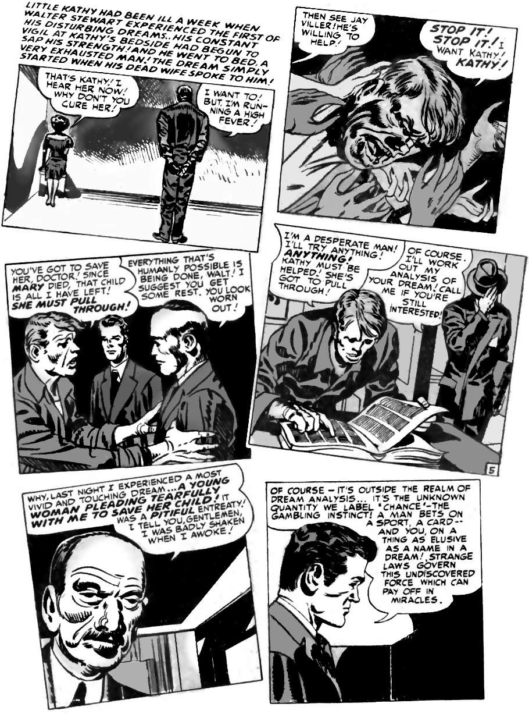
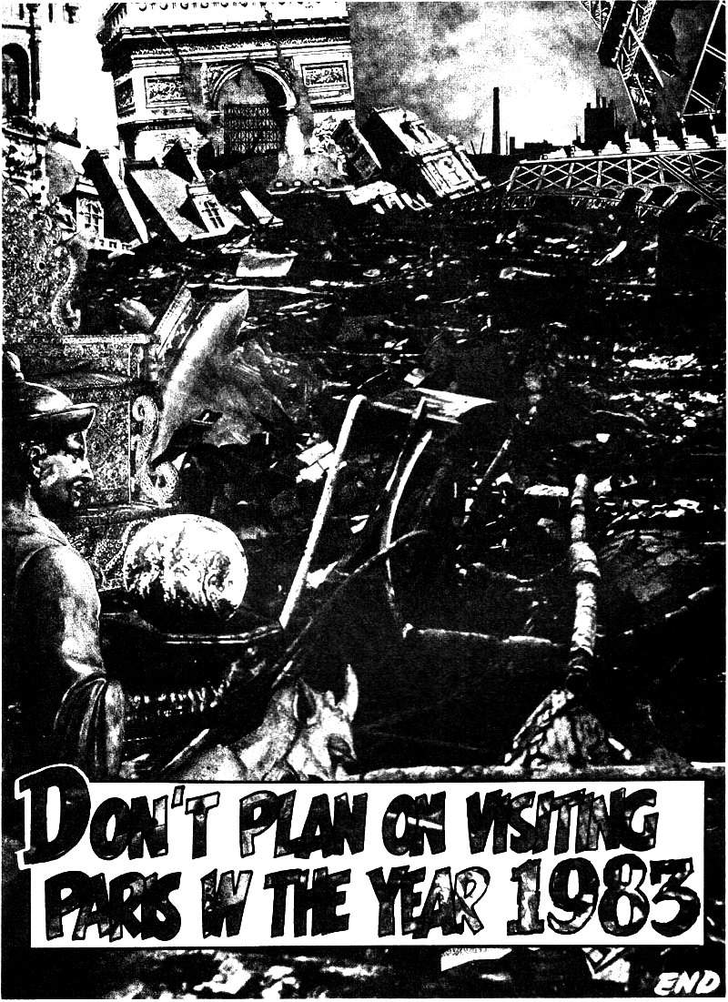
And so his guesses came true.
Image: DC Comics - Fair Use
Kirby knew a lot of stuff. And so, when he made guesses about the future, his guesses tended to come true. For example, in 1971, Kirby wrote about Nostradamus and ended with a new prediction of his own. Nostradamus gave vague symbols that could mean anything, but Kirby was very clear. He showed an image of Paris after a terrorist attack and wrote:
“Don't plan on visiting Paris in the year 1983”
When Kirby wrote that, bombing in Paris (outside wartime) was very rare. There were two small incidents in 1962, but that was all. Yet starting in the late 1970s there were multiple bombings in Paris, including two cases in 1983. How did Kirby predict that?
When Kirby wrote in 1971, The Palestine Liberation Organisation (PLO) had just been driven out of Jordan. In 1982 it would also be driven out of Lebanon. This led to the PLO bombing more targets outside of Israel. One victim of the PLO attacks was Kirby’s friend Leon Klinghoffer: in 1985, Klinghoffer was in a wheelchair on a ship that was hijacked. Klinghoffer refused to obey an order, so they killed him and threw him overboard. In 1971, Kirby didn’t know about the future troubles, or where the PLO would attack. But he knew the patterns of history, and he knew that the PLO leaving Jordan was a big deal. France had a history of colonising Arab nations, so was an obvious target. Somehow Kirby’s gut told him that twelve years would be enough to bring terrorism to Paris. It was only a guess. But a guess from Kirby is usually right.

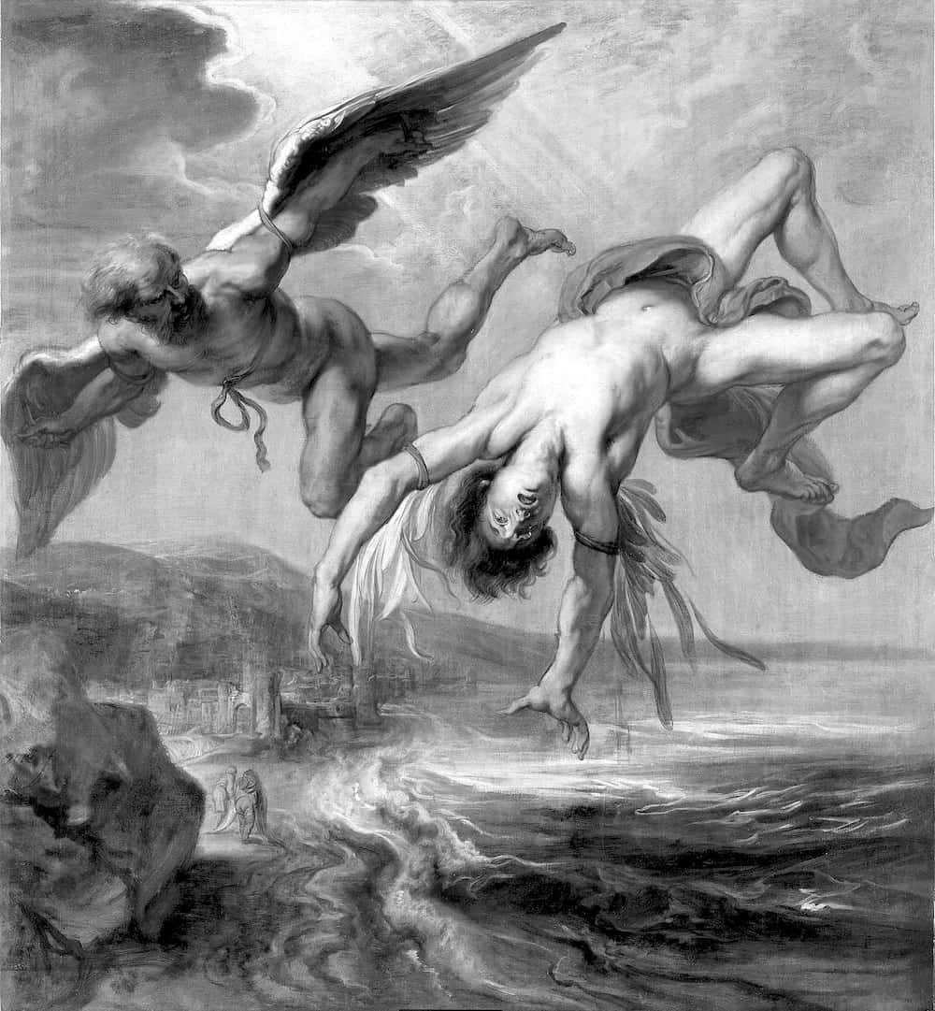
3.
The Eternals
Image: Daedalus and Icarus by Gowy, Public Domain
Kirby's most important book is probably "The Eternals”. Because it gives the origin and future of mankind.
The Eternals never age. They remember events from thousands of years ago. The central character is Ikaris. Ikaris was once the Greek Icarus, who flew too close to the sun. His best friend is Ajak, who was once Tecumotzin. Before that, he was Ajax, a hero of the Trojan War.
Icarus and Ajax were both mortals, and they both died as a result of their own mistakes. Icarus is especially famous for his death. Yet Kirby used both men as examples of people who never grow old. Why?
How are Icarus and Ajax alive when they were previously dead? Icaris continued (in all but name) as Captain Victory. Whenever he dies he is reborn, and the new Captain Victory is given the memories of the old one. (Captain Victory is a book about victory over death). Something similar appears to happen in The Eternals. When we first meet Ajax (Ajak) he is dust, in an ancient tomb. But when Icarus reads the ancient writing, the tomb becomes a "resurrection crypt": so Icarus brings Ajax back to life. The space gods routinely turn men to dust and later resurrect them. Identity can apparently be passed on. The Eternals share identities: multiple Eternals can fuse into one, and one man can have multiple bodies..
These ideas are from the Bible. In the Bible, people appear to live for hundreds of years, because a famous person and their followers share the same name (which is not just a name in the modern sense, but a description). For example, Israel (“Yisra-el”, “fights gods”) was both an individual and a people. Adam (“red soil”) was both an individual and all people of the soil. Judah (“praise”) was both an individual and a people. The Hebrew word is the same in each case.
In the Bible, people are resurrected from dust. But in the Old Testament (the Jewish Tanakh), this does not refer to the same individual returning. It always refers to the restoration of a family or nation. Ezekiel said that when the nation was destroyed, it would come back like dry bones taking on flesh. Resurrection in the Old Testament never refers to a personal afterlife. But as Kirby put it, "you live on in your son or you live on in somebody else."
Jack Kirby was a real-life Eternal. His mother called him Jacob, after the man who became Israel. Jack Kirby embodied the ancient Jacob:
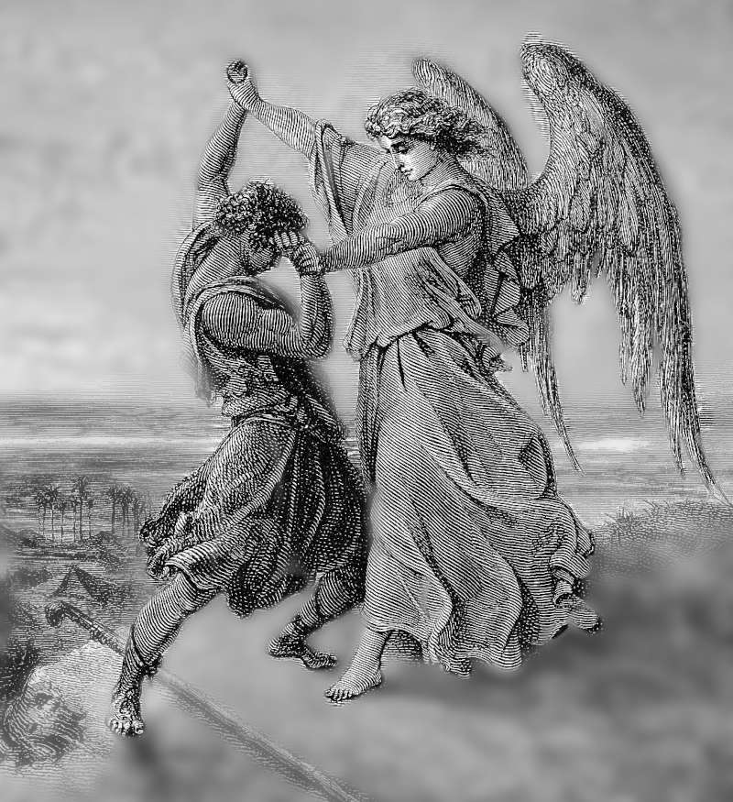
- The old Jacob fought with God. That is why his name was changed to Israel. The new Jacob had the same defiant attitude.
Jacob fights with a messenger from God He then said “I saw God face to face”. Image: Gustav Doré, Public Domain.
- The old Jacob created a new religion. The new Jacob created New Gods.
- The old Jacob embodied the values of the shepherds of Canaan. The new Jacob embodied democracy in America.
- The old Jacob began a library (“Biblia”, or Bible) containing the story of his people. The new Jacob did the same.
Eternals remember and repeat the ancient stories. In the following story, Jack Kirby combines many ancient stories into a single modern story. It combines the story of Jacob pretending to be Esau to gain his birthright; the story of Prometheus (through its modern version, Frankenstein); stories of ancient sorcerers; stories of gods disguising themselves to rape mortal women; and countless others. Great stories always draw on ancient stories. Ancient stories in turn draw on the eternal laws of nature. Great stories pass these laws on to each new generation. Great stories teach us (and our children) how to survive.
This is Kirby’s first full-length story: “The Diary of Dr Hayward.” “Hayward” mean "ward of the enclosure”, the guardian of the land. He guards and protects. The villain’s name is “Kromo”, a variant spelling of chromium. Kirby wrote this in 1938. Chemists were developing new ways to plate cheap metals with chromium. Chromium became the symbol of modernity. Chromium is shiny and strong, but thin and deceptive. In contrast, Kirby gives us old but honest Dr Hayward. Hayward is the ancient guardian, the protector, the doctor for all our ills.

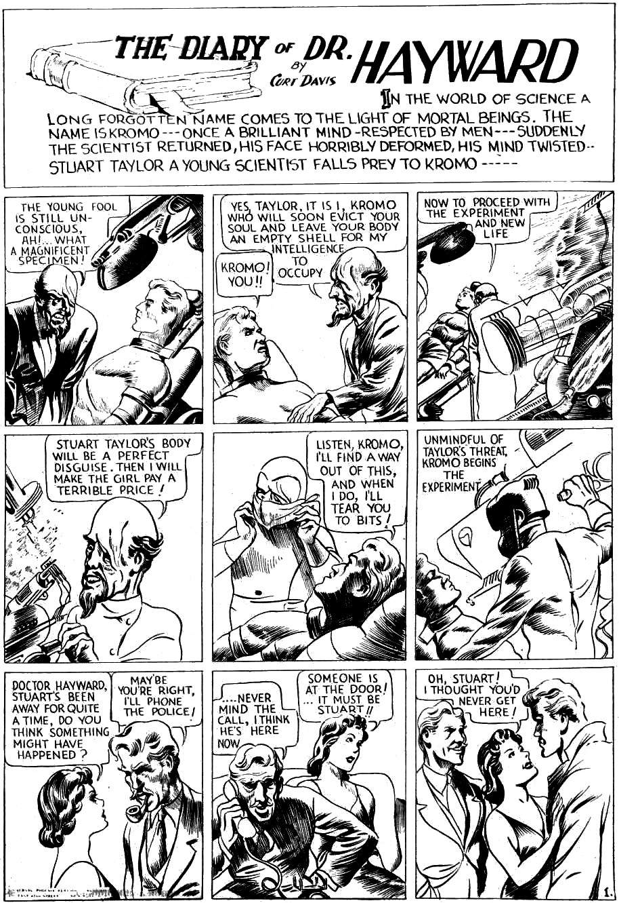
Eternal law 1: power is anti-life
The opening line tells us that this story is about big topics: about the world of science, long-forgotten people, and mortal men.
Kromo's science tells him that he should control Stuart’s body. This is scientific efficiency: the most efficient mind should control the most efficient body. This is the basis of society since land owning began in 8000 BC: skilled people tell less-skilled people what to think. In the short term, this gets good results. But it has a fatal flaw: it loses some skills. Kromo lacks Stuart’s social skills. By controlling Stuart, Kromo loses those skills. A tribe needs every skill if it wants to survive.
Kirby calls the Kromo method anti-life. In the long term it kills the tribe. And in the short term it kills the individual (as an individual).
“That's Anti-Life. In other words, if you gave yourself to some cause, and gave up everything as an individual and you were at the beck and call of some leader, you would be dead as an individual.”
About the art:
Each panel is designed to be redrawn for different shaped newspaper pages. This makes the art look strange. Kirby did not mind: he was creating stories, not fine art. He often said that he was not trying to be Rembrandt.
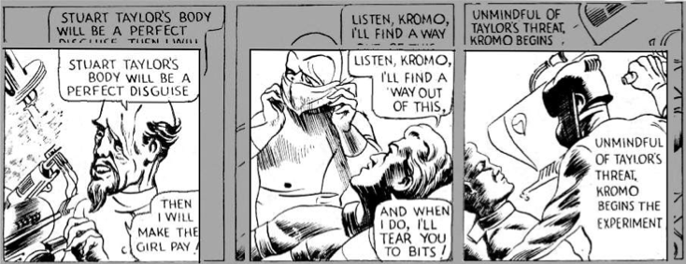
About “Curt Davis”:
Kirby used many pen names in the early days. Here he is “Curt Davis”. He finally settled on “Jack Kirby” as it was close to his birth name, Jacob Kurtzberg.

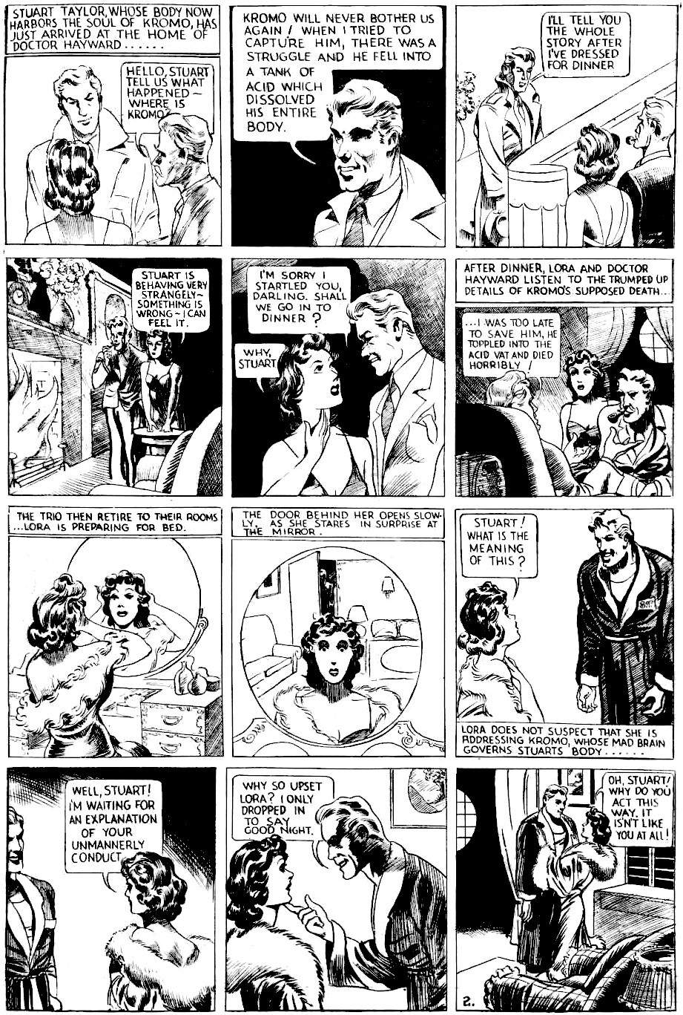
Eternal law 2: sociology is the top science
Kromo is highly advanced in physics, biology and chemistry. He is also advanced in leadership: he drives the events and the others merely react. He makes a rational case: he is for scientific progress so he deserves support. And yet he is portrayed as the bad guy. Why? Because he breaks social rules. He enters a room without permission, and this is enough for Lora to know that something is wrong. His “unmannerly conduct” shows that he is evil.
We might think that Kromo is evil because he does terrible things to Stuart. But does he harm Stuart? This is the diary of Dr Hayward, not a story by an omniscient narrator. The great crime on page 1 is what Dr Hayward believes happened, based on what he is told by Stuart and Kromo. But all he can know for sure is what he sees with his own eyes, and what Lora tells him. Stuart claims to be Kromo in Stuart's body, but in what sense is that true? More about that later!
Manners not only reveal who the bad guys are, but they also keep Lora safe. They allow her a private room that does not need a lock, and the freedom to wear soft, revealing gowns without the fear of being molested. Manners make us wise, safe and free.
Manners are an aspect of sociology. In this story, Kirby shows that good manners are more valuable than physics and biology. After all, if we are going to invent a tool, we had better first make sure that it won’t be used against us.
To have good manners is to be civilised. The word “civilised” refers to our “civis”, our rules for being a citizen. “Civis” is not the same as “polis”, the physical city. To be civilised does not mean having cities, it means having rules that ensure we care for each other’s feelings. Civilisation — the collection of rules for being civil — is another aspect of sociology.
We become civilised through stories. Stories are how we communicate with groups. Kromo tries to enter the social group by telling a story. Lora can detect the story is not told in the right way (because Stuart shows delight that his enemy suffered). That is Lora’s first clue that something is wrong. Stories encode a vast amount of subtle information in easy-to-digest forms. When Plato described his ideal society, he said the very first thing children must be taught, even before physical exercise, is stories. And Plato said that the most important thing in a story (even a story about gods and heroes) is that it must contain no lies.

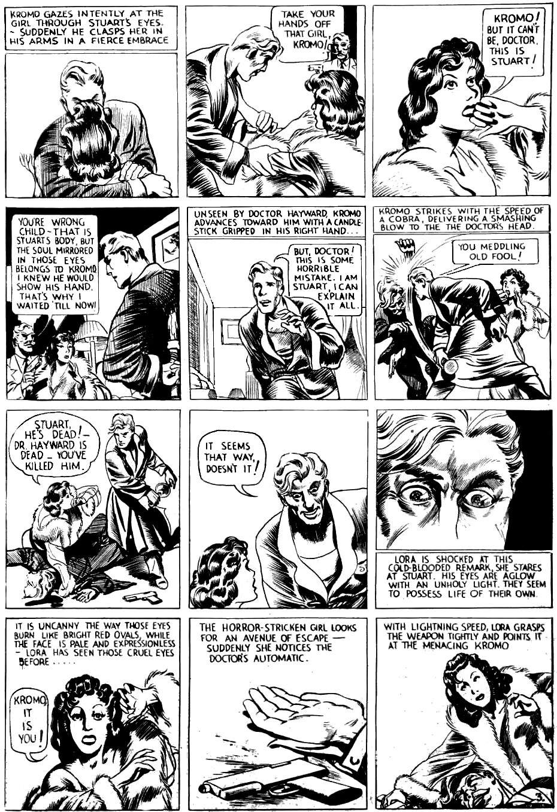
Eternal law 3: killers pretend to be friends
Now we reach the first reveal. Stuart pretends to be a friend, but is really a killer. This is an eternal truth. The most successful killers must be a friends first. Otherwise, they would never gain the opportunities they need, and could never plausibly deny their guilt. They become very good at pretending, and often convince themselves that they are innocent and what they do is for the greater good.
Populist politicians are an example of friendly people who kill, yet convince us it is for the greater good. Here is an example. In the 2020-2022 pandemic, some countries followed the scientific consensus. These countries quickly locked down their countries to prevent infection, and invested large sums in the best available healthcare. Countries like Singapore was extremely strict. They had fewer than 300 deaths per million. Countries like Denmark had less success, so deaths were 1,200 deaths per million. But certain very wealthy nations had 3,000 deaths per million. Why did these wealthy nations have far more deaths? According to a highly regarded medical journal, their politicians ignored the science.
"Science is being suppressed for political and financial gain. Covid-19 has unleashed state corruption on a grand scale, and it is harmful to public health"
The "political gain" was to avoid a "difficult political landscape”. That is, telling the whole truth would make politicians look bad. The “financial gain” was billions of dollars of aid disappearing in ways that nobody can trace. The result is that people died.
"Politicians and governments are suppressing science, and when good science is suppressed, people die..."
When a mugger knifes a man, he might gain a thousand dollars. But when a politician suppresses health science, he might gain millions of dollars for his friends. The difference is scale.
A mass killer needs friends. He needs to be the kind of person we like, and he must seem sincere. He needs us to let him do his evil, and then make excuses afterwards. Without such friends, the mass killer cannot succeed. That is an eternal law.

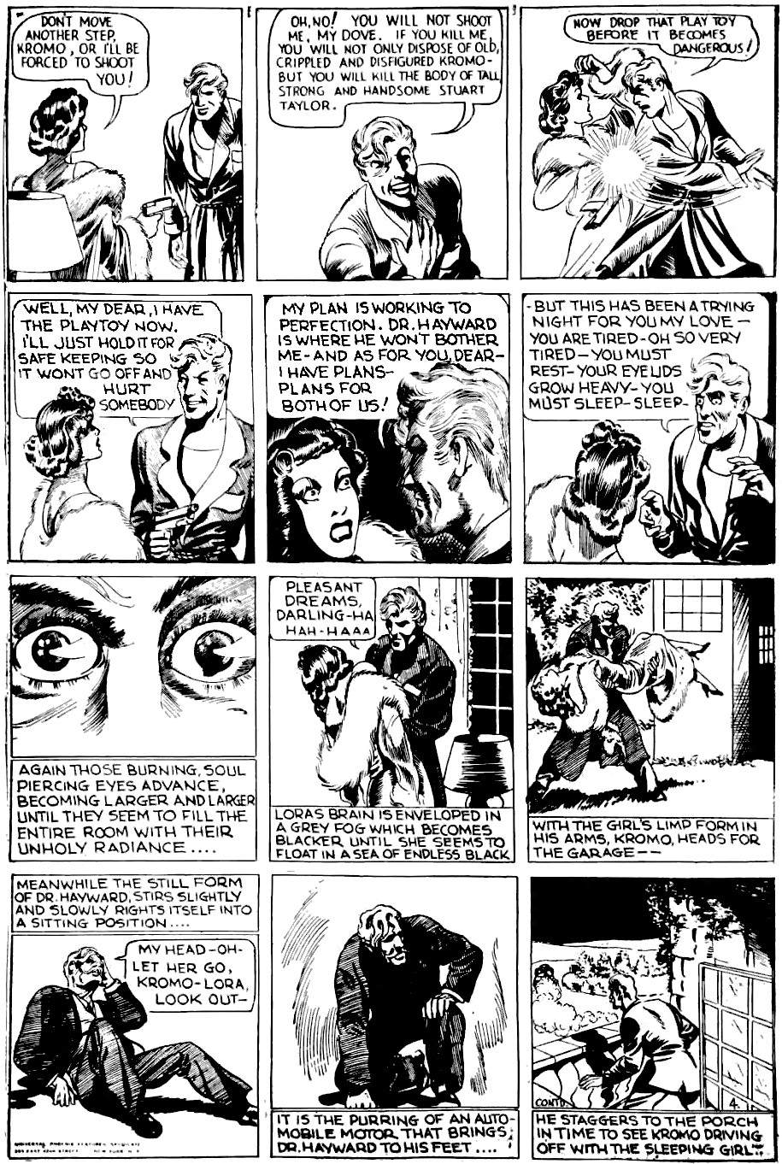
Eternal law 4: it is easy to be fooled
We like to think that we would never follow evil. But evil is clever, otherwise it would die out. Kromo’s cleverness is in his “soul piercing eyes”. We look in his eyes and believe him! Kirby gives us the steps that lead to that result:
- Kromo presents Lora with a dilemma: if Lora hurts Kromo, she will also hurt Stuart. We often face this dilemma: if we hurt a bad guy, the innocent people who rely on him will also suffer.
- Next, Kromo creates his moral narrative. He argues that his actions are for the best: he must control the gun, to keep Lora safe.
- Then he shows empathy: he understands that Lora is tired, and needs to rest. Most bad guys show empathy when they want something: it’s good public relations.
- The initial dilemma is mentally tiring. Lora sees no way out. As any hypnotist will confirm, a hypnotic subject had to be ready to give in. Kirby dramatises this as Lora fainting, but in the real world, we just act passively. We cannot beat the evil corporation or the bully at school, so we find some excuse to act passively. And so the bad guy wins.

Seeing the future
So far we have four foundational tropes. They are eternal truths: they are how nature works; Predators want prey (truth 1), predators make prey uncomfortable (truth 2), predators use camouflage (truth 3), and predators wear us out (truth 4).
This is how nature works. It is how history works. Storytellers warn us. They tell us these truths, again and again, so we can spot the patterns before the predators herd us into a corner and kill our whole tribe (see chapter 13).
By learning these tropes we can see the eternal patterns. We can see those patterns play out in current events. We can see the future.

From the simple to the complex
Now that we have four simple truths. So we are ready to see how they link together: how people become evil (Value 5), how to handle the overwhelming rush of confusing evidence (Value 6), the most common way that humans kill (Value 7), and so on.

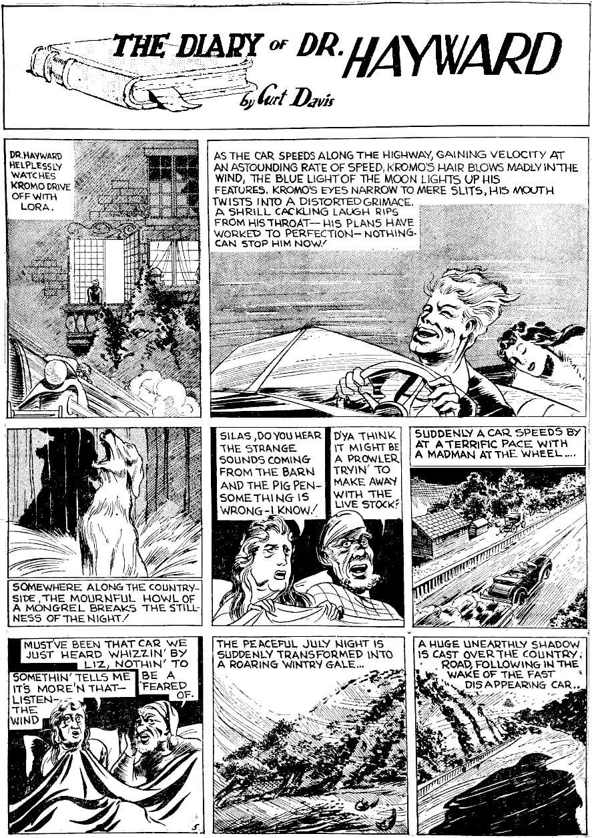
Eternal law 5: some men oppose nature
This page is about Kromo versus nature: man the conqueror.
Kromo roars along the highway in triumph, the dog barks and the peaceful night becomes a howling gale, leading to the shadow of death. This is a classic trope of ancient legends: when people are evil, nature goes wrong. When Pharaoh is bad, the harvest fails. When King Lear is mad, a storm rages. When Camelot ends, the country becomes a wasteland. It is a stark truth: we are connected to nature. A bad Pharaoh causes bad farm policies. A mad king goes out in the storm. And while the post-Camelot wasteland was caused by an act of nature, most of the suffering was due to acts of men. In the case of Kromo, he feels the wind at first just because he is driving fast: where the dog is, there is “stillness”. But the weather is unpredictable, hence the later wintry gale. So driving fast without dying is simply luck: it makes life fragile, and makes the driver feel confident, until the weather changes and cars crash.
The symbolism is strong on this page. In 1940, a fast motorcar was a symbol of technological progress and power to the individual. Some people felt they could go faster and faster forever. The farmer and his wife disagree. They are probably over sixty years old, so will have been adults in the 1800s before they ever saw a motorcar. The wife is first to speak: showing that they have a healthy relationship of equals in their restrained life, contrasting with Kromo's laughing power over the sleeping Lora. They know the sound of Kromo means danger to their slow agrarian world. Then the dog in the barn howls, symbolising how Kromo offends not just our own ten thousand-year civilisation, but the previous one as well (dogs were domesticated sometime between 14,000-29,000 years ago). Then the wind howls like the dog: nature itself is offended by Kromo. The last frame sees the car race through a valley followed by the shadow of Death (Psalm 23:4). Kromo desires to defeat death, and so he attracts the god of death. This forces us to see broader symbolism in the story. As we saw earlier, Kromo is chromium: strong, shiny, but thin. His machines make him like a god, able to travel at any speed, with power over life and death — or so he thinks. But he is still human, with needs and limitations. He is not one of the true gods, he is not the storm, he is not Baal or Thor.
So Kromo foreshadows the Celestials: the space gods, mortal men who defy the nature gods: men with technology to create and destroy worlds. We will meet the Celestials in chapter 11.

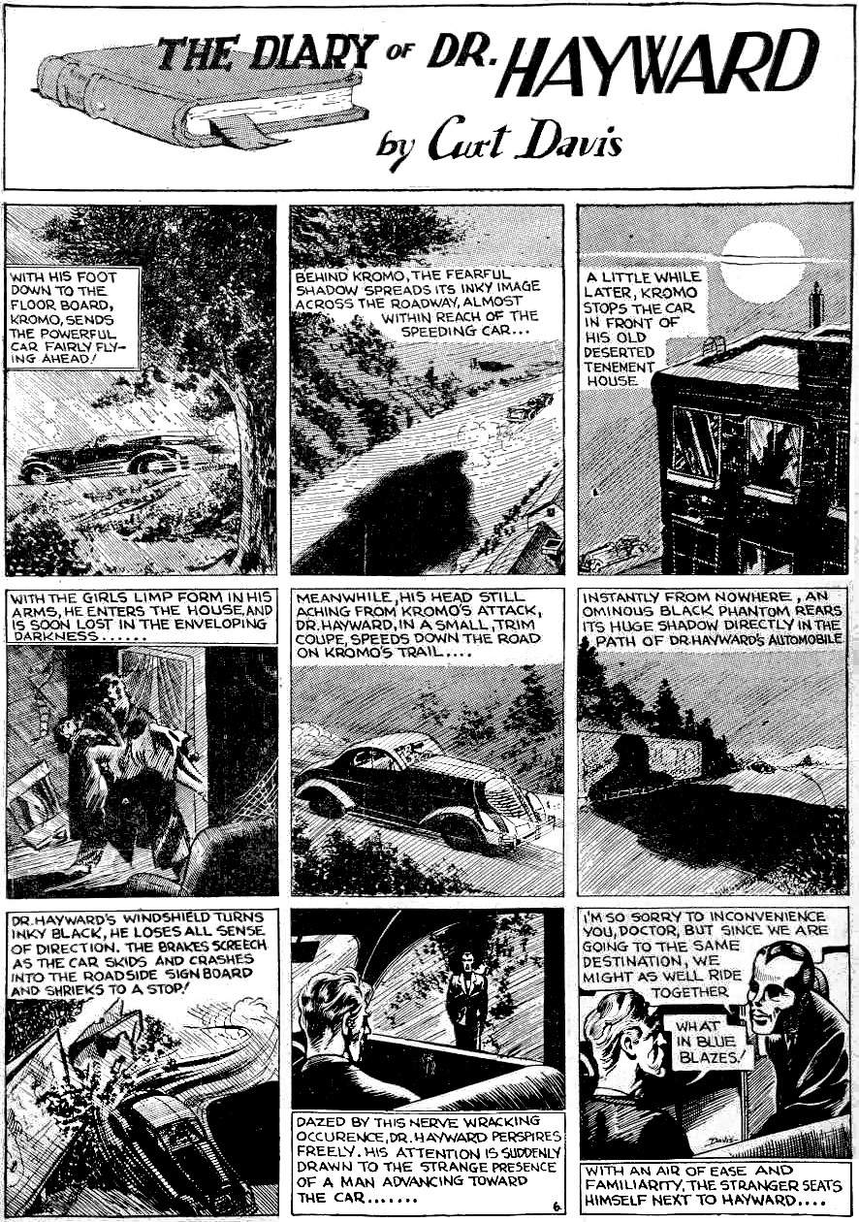
Eternal law 6: bad people want to be gods
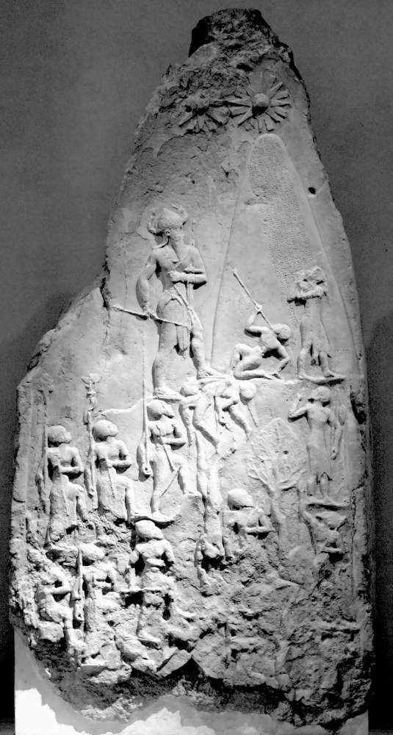
Gods are everywhere in mythology. On this page, Kirby introduces a man who wants our hero to believe he is the most archetypal god — the god of death. Kirby defined a god as a “representation of ourselves”, a personification of what we care about, like love or courage, or science or commerce. Kirby’s magnum opus was “New Gods”, about gods who personify modern values like technology or individualism.
Image: Rama, CC-BY-SA-3.0
“We have our ‘new' god today — technology. A new way at looking at things that I have got to represent. How do I represent that new technology? I've got Metron. How do I represent the kind of feelings we have today? Maybe some of us are analyzing ourselves, trying to find out why we're a violent society and how we could be nonviolent, so we all become Orion. … That’s what the GODS are. They are just representations of ourselves.”
Gods are typically ordinary people who do something extraordinary, so people follow them. Jesus is the most famous example. According to our earliest historian, Sanchuniathon, all the Greek gods began as people who did remarkable things. The earliest man-god that modern historians know was Naram-Sin, the Akkadian emperor who called himself a god and inspired the story of the tower of Babel. Here he is, portrayed as twice as large as anybody else, approaching a tower with the stars of heaven at the top. Our modern elites go further: billionaires represent our belief in science and commerce, and they ascend to heaven in towering rockets. See chapter 8.

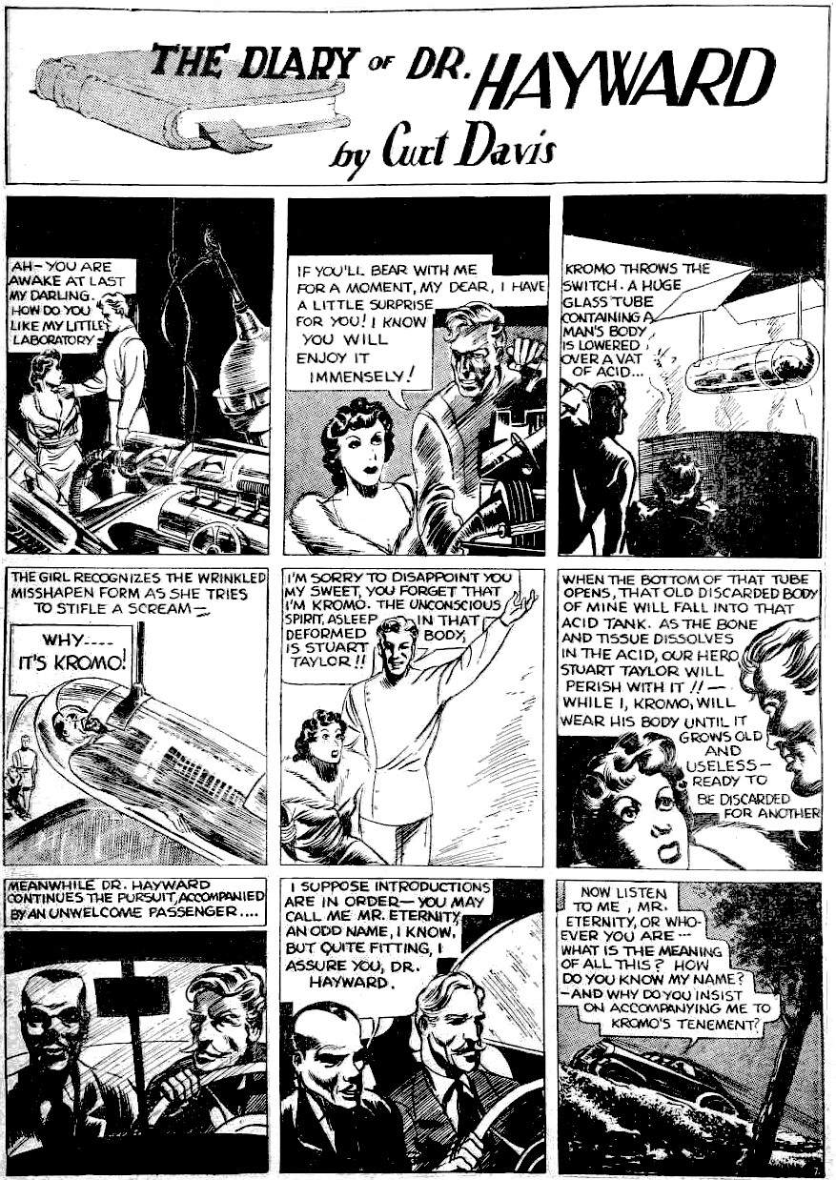
Eternal law 7: people use technology for war
Finally, we see Kromo's laboratory. In theory, his machine can be used for great good: it can extend life forever! All he needs is another machine to make bodies rather than steal them: Kirby’s benevolent Ovoids can do that. So technology is neutral and can do great good. In theory.
The problem with technology is our weakness in sociology. Kromo sees himself as the hero: he is a Nietzschean superman, held back by lesser men. Everyone in the story sees themselves as the noble hero, and yet bad things happen because each person has a limited perspective. As Kirby said, the problem with technology is people.
INTERVIEWER: "Are you overawed by technology?"
KIRBY: "Not really. I'm afraid of us. I'm afraid of you. I'm afraid of Oliver North. I'm afraid of the next guy, because he has the power, not the technology."
Who was Oliver North and why was Kirby afraid of him? Oliver North was a Marine Corps lieutenant colonel. When Kirby spoke, North was known for just one thing: the Iran-Contra affair. North, acting for the US government, secretly sold high technology weapons to Iran (an enemy of the US) to fund terrorism in Nicaragua, to return a murderous dictator to power, because the dictator supported US business. The result was innocent deaths, a destabilised world, and a loss of trust in the American government. Yet North believed he was a hero. Kirby was not afraid of the technology that was sold to Iran. He was afraid of people like Oliver North.
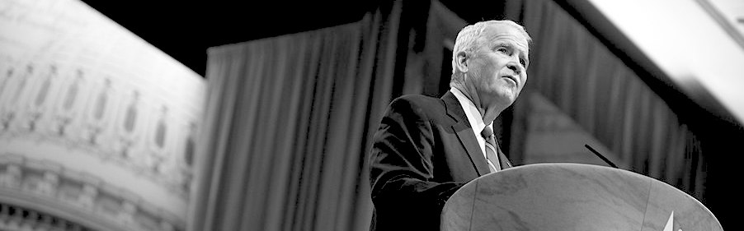
Image: Oliver North, photograph by Gage Skidmore, via Wikimedia. CC-BY-SA-2.0

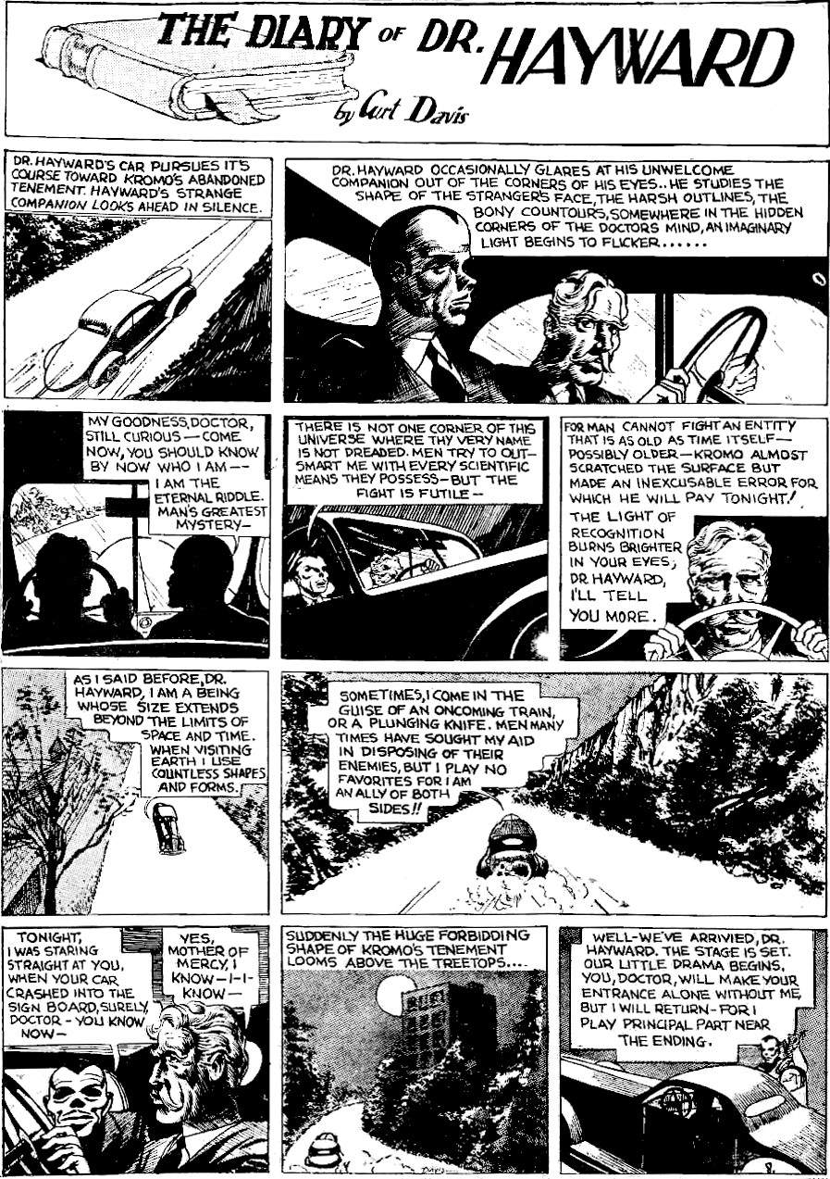
Let’s pause and enjoy Kirby’s writing
Before continuing with the ten truths, let’s stop and appreciate Kirby’s prose. See the easy and rich flow of the words. See how Kirby crafts the personality of death: calm, confident, but also helpful. We don't usually think of death as helpful. We will return to this theme at the end of the book.
Death can appear in many forms: as Mr Eternity, or “an oncoming train”, or “a plunging knife”, as Hades, or Pluto, or in other forms. All Kirby characters are like that: they appear in many forms. Take Kromo for example. He is the symbol of evil and reappears as Dr Doom and (in Star Wars) as the Doom-Darkseid composite, Darth Vader.
Each incarnation of Kromo (Kromo, Doom, Vader) wears a similar helmet (see the next page of the story). Each has a scarred face. Each wants to cheat death by transferring their mind into another body. Each combines mind tricks with advanced physics. Each watches visitors to his lair, without them realising. Each dedicates his life to complete control over others, and so on.
All of Kirby’s stories fit together like this: they often feature the same heroes and villains, the same timeless archetypes, with slightly different faces. Often the stories explicitly use the same characters. So all of Jack Kirby's stories fit together. They form a single gigantic twenty-thousand-page story: the epic story of mankind.

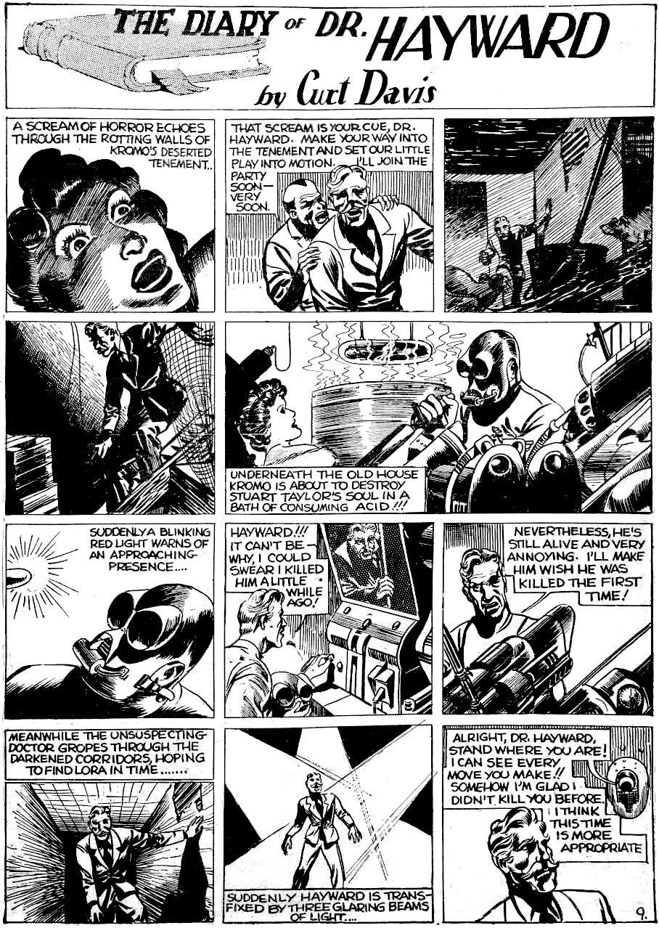
Eternal law 8: heroes show the way
Dr Hayward is a hero. All of Kirby's stories are about heroes. Kirby teaches us how to be heroes.
Heroes show us how to act:
Heroes care for others.
They don't care if it kills them.
They don't do it for personal benefit.

Villains separate themselves from humanity
Notice how Kromo wears a metal mask. He is more machine than man. He retreats to a remote lair, and the thick metal cuts him off from his fellow humans, allowing him to act in inhuman ways.
In contrast, Dr Hayward is an organic doctor, a man who deals closely with flesh and blood, listening to others’ vulnerability and pain. While Kromo drives away to hide his evil in an underground lair, Hayward seeks out people with pain (like Lora on this page) to help them. On this page, Kromo lives in shadows, while Hayward is bathed in light.
Machines make separation much easier. Kromo uses a remote camera and microphone so he does not need to be present: there is no humanity in the relationship between Kromo and anyone else. Talking to Kromo is like talking on the telephone to “customer service” — we are not really in contact with the person who makes final decisions, we are only in contact with a cog in the machine.
In theory, machines connect people at a distance, but the key word is “distance”. We may have a thousand social media friends, but we only have the same number of hours each day, so we only have a few seconds for each friend. It is hard to be a good friend, let alone a hero when we do not have time for people. This is an inevitable result of scale. We end up wearing an online persona, a kind of mask, so we can present our best image in a few seconds, and not show who we are. Kromo has mastered this art. It gives him the power to gain an endless supply of victims.
So technology creates masks, just like Kromo, the man of shiny chrome, wears a metal mask, or how he wears the mask of Stuart's face: the mask-man wears masks within masks. And nobody sees because technology creates a high-speed remote world where nobody has time to really know anybody else.

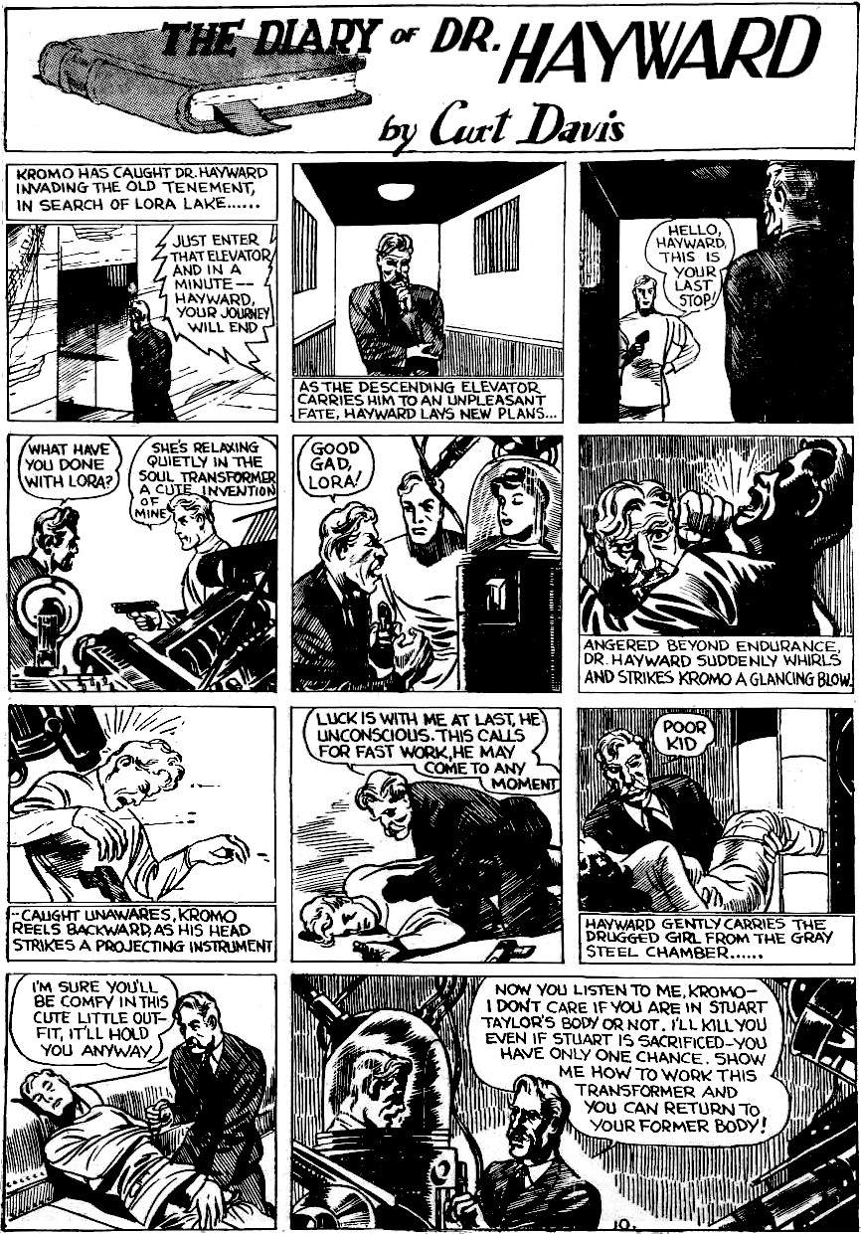
Eternal law 9: walls hide evil
Lora is drugged and locked away in a basement in a forgotten old tenement. This is a common theme in stories: the bad guy does evil behind walls. This is so normal that we don't even think about it. We cannot imagine a civilisation without walls, so why even bring this up? Because walls are not natural. Kirby noticed stuff like that. He imagined a fourth dimension where we can see behind all walls.
"We have a fetish for putting up walls. … We like all the space that we can accumulate and fence up — that's the kind of animal we are.”
Our walled civilisation began with the great wall of Jericho, around 8,000 BC. For five thousand years it was the biggest structure in the world. It cut off the most strategic watering hole at the crossroads between Africa and Asia. Nobody had seen anything like it before. It was the shape of things to come. Kirby captured the world changing power of the Jericho wall in “Atlas The Mighty”. Kirby’s opening image, with its gravity-defying cyclopean architecture, tells the story of our world. It is the story of walls: the story of enslaving the natural world and everything in it.
Thanks to walls, there are large parts of society that we cannot see. There are parts where nobody can escape. Ursula K. Le Guin showed the problem in her short story, “The Ones Who Walk Away From Omelas”. In the city of Omelas, almost everything is perfect… but there is a price to pay. One innocent child had to be locked in a cellar to suffer. That is how all cities work, thanks to walls. Every few years, in every city, the news will reveal terrible child abuse hidden in some basement. We all wring our hands and say it must never happen again. But it will always happen, as long as we have a world based on walls.

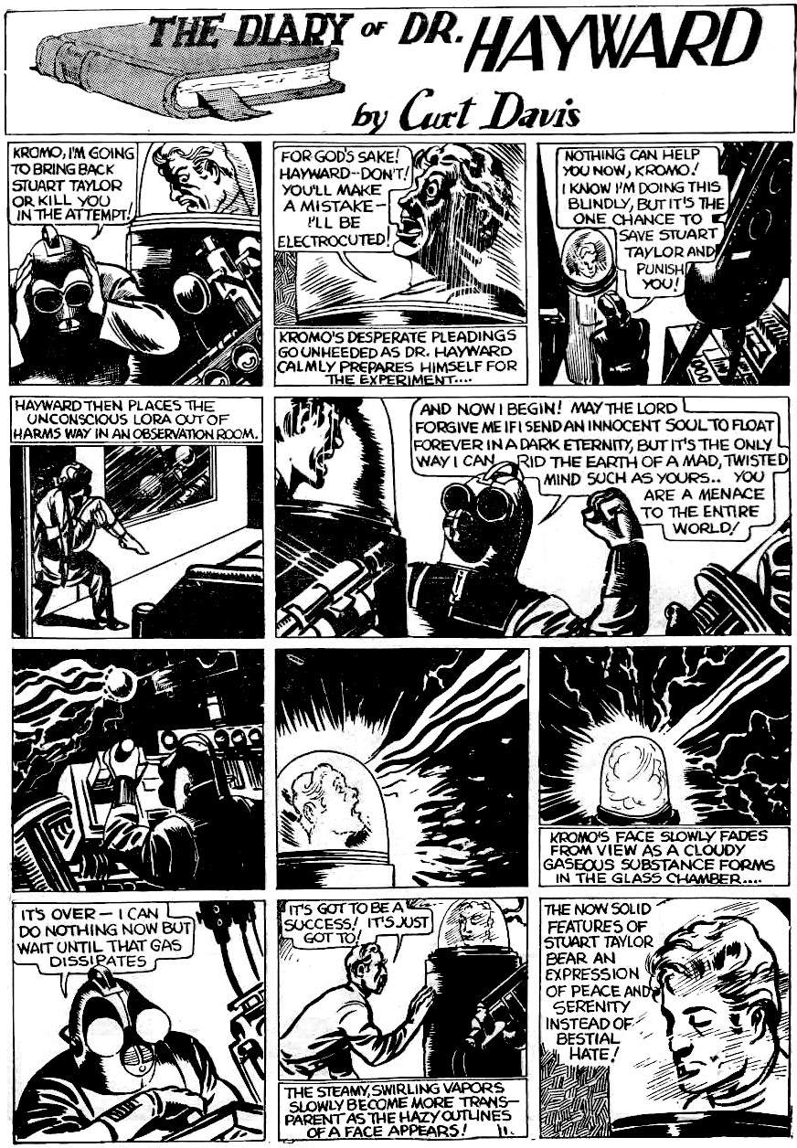
Eternal law 10: ancestors have more experience
Kromo says, "For God’s Sake!” Dr Hayward says, “May the Lord forgive me”, “By Heaven”, etc., and worries about the soul and eternity. These are religious concepts. Today they seem old fashioned. But how old?
Christianity is 2,000 years old. Judaism is 6,000 years old. Greek gods are 10,000 years old. Egyptian gods are between 28,000 and 41,000 years old. Religions are our oldest institutions by far. Nothing else comes close. Nothing else has seen so many civilisations rise and fall. Nothing else has that experience.
Kirby also took gods seriously. By “God" (with a capital “G”) he meant the abstract principle that connects people.
“We are children and we are alone — but when we grow accustomed to this fact, then we will understand God's role in our lives”
Kirby took religion seriously. We need rules. But he did not believe in blind obedience. He must challenge all rules in order to be free:
“Religion doesn't help us at all. We defy religion, just as we defy laws in order to remain ourselves.”
Kirby took the Bible seriously. But not as an instruction book: he saw it as history. Like all history, it misses many details:
“I don't think the Bible gives us wisdom. I think it gives us vision. The Bible says that an Angel appears, but it doesn't answer any practical questions as to what it looks like, which galaxy it came from [etc.]”
This attitude is very unusual today. How many people believe in a religion, but also say, “religion doesn’t help us at all”? Kirby had a very ancient view of religion: a view where gods are real, but they often harm us. That is the voice of experience.

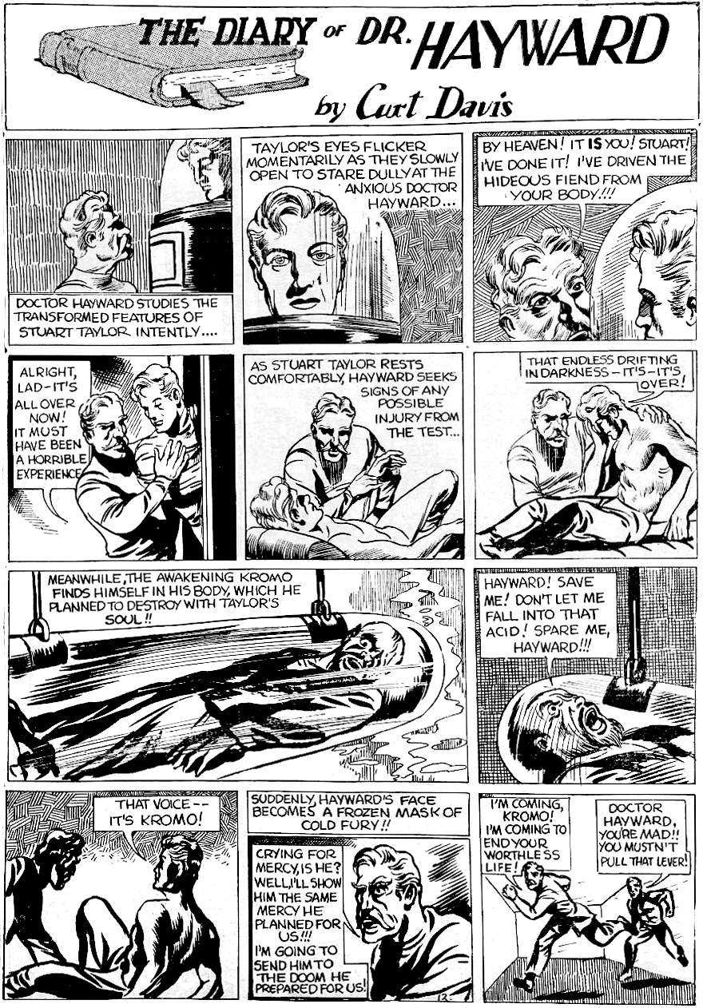
Great stories make us think
This 1938 story draws on the 1936 movie “The Man Who Lived Again”, which draws on tropes from the 1927 movie Metropolis, which draws on Frankenstein, which is “The Modern Prometheus”, which draws on the story of Hephaestus, and so on. This is an ancient theme: technology looks amazing and attractive, but that is deceptive. This is a story about the deceptive nature of technology.
This was Kirby's first long-form story, so he put all his genius into it. He never completed this story, so we don't know if there is a twist ending, but we have a clue in the final panel on this page: Hayward is going to kill Kromo, and Stuart panics. Stuart has to save Kromo! Is Stuart just pure of heart? Occam’s razor suggests another explanation: one that does not require impossible technology.
Kirby wrote several stories where super-science is later revealed to be fake. And just before writing Dr Hayward, Kirby adapted The Count of Monte Cristo, about a man who creates a false identity to get what he thinks he deserves, but this makes him cruel and he drives away the women he loves. Think of Stuart as the Count: a good man turned bad.
This is Hayward’s diary: we only see Hayward's point of view. The opening scene, where Stuart appears innocent, must be what Stuart told Hayward. But did Stuart tell the truth? What Hayward sees with his own eyes is that Stuart behaves monstrously. Before that, Stuart acted like the perfect boyfriend to Lora, so Lora wants to believe him. Hayward is new on the scene, so believes Lora. Hayward is elderly and unfamiliar with new technology, so he assumes that Kromo’s machines are real.
Stuart has everything to gain from deception: he can act out his ugliest fantasies with Lora, while seeming innocent, then marry her and gain her beautiful house. Kromo benefits even more: he gains a reputation as a super-genius. And Mr Eternity? He looks like he is wearing a mask: he could be Kromo. On page 9, Mr Eternity has to persuade Hayward to act impulsively. The plan works perfectly… until the final panel.
This is a story about deception.

Ancient versus modern stories
Most readers will think it is insane to read a hundred thousand years of history into simple stories. That is because most readers are modern. The modern world is mechanical and linear: we expect a story to have one meaning, created by one author, transmitted to passive readers. We create stories as consumer goods: the writer creates, the reader consumes for base pleasure and then demands another. We live in a consumer society.
Ancient people did not see stories that way. A story was not a consumer good: it was not created for propaganda or profit. A story was just something that happened. Gilgamesh is the story of the first cities. Genesis is the story of how Israel began. The best stories are eternal: this is how things always happen. Such stories are retold in different ways but are always anchored to reality. For example, Jack and the Beanstalk survived for five thousand years because it speaks eternal truth: the people above you are like giants who have all the gold, and if you threaten them they will try to kill you. The story simply describes what happens, so each reader can retell it in a new way, and it will keep coming back to the original form because it is the best way to explain a fundamental and universal experience.
Roland Barthes, in “The Pleasure of the Text”, calls the best stories “writable”: they are so universal that they match your experience, so you can write your own meaning. Kirby stories are like that. That is why Kirby did not give his characters detailed personalities: instead, he held up a mirror for readers to see themselves.
“I respect people and feel I owe it to them to reflect their own existence, which I feel is what people want.”
The difference between good (writeable) stories and bad (consumer) stories is power. Some writers want power over their readers: they tell the readers what to think. The best writers hate that. Tolkien writes about it extensively in “On Fairy Tales” and in his letters that discuss his hatred of forcing a specific allegory. It is no accident that Tolkien also disliked the modern mechanical world. The great stories are not mechanical, they tell organic truths about the organic human experience. They become tools for the reader to apply to a thousand different situations.
In short, bad stories take power over the reader. Good stories give the reader power over the world.

4.
The Golden Age
This chapter argues that Kirby’s long-term view of civilisation is correct: there were once more advanced civilisations than our own.
The Greeks record how we once had a Golden Age. Jews and Christians call it the Garden of Eden. Egyptians call it the age of the gods and demigods and date it to before 9,000 BC.
The Golden Age is defined in ancient Greek literature as the era when people did not have to work. That is, we could just pick food from the trees, or hunt plentiful animals. Today we call those activities leisure: walking in forests, hunting, and cooking with friends. This was the natural state for hunter-gatherers before large-scale settled agriculture. Large-scale settled agriculture took all the best land and created armies to defend that land. Hunter-gatherers were driven out into poorer land. So today, hunter-gatherers have to spend three to five hours a day finding food, but it was easier when they had better land.
The Golden Age does not mean “noble savages”: people were still cruel. But there were no stone walls or iron chains, so when a tyrant arose, it was easier to overthrow him. For example, the Wendat (the Huron) were once enslaved by another people, but overthrew their oppressors and then built one of the greatest civilisations the world has ever known.
Settled agriculture ended the Golden Age, but some Micronesian islands had a kind of semi-Golden Age until the 1950s (when western trading posts introduced money). They did not have enough land to be completely free, but at least it was good land, and they kept many of the ancient traditions. Without money or large landowners, inequality was limited. So individuals had more freedom, and work could be relatively free and relaxed. Here is a Kirby story set in 1948 that contrasts the Micronesian semi-Golden Age with our modern age.
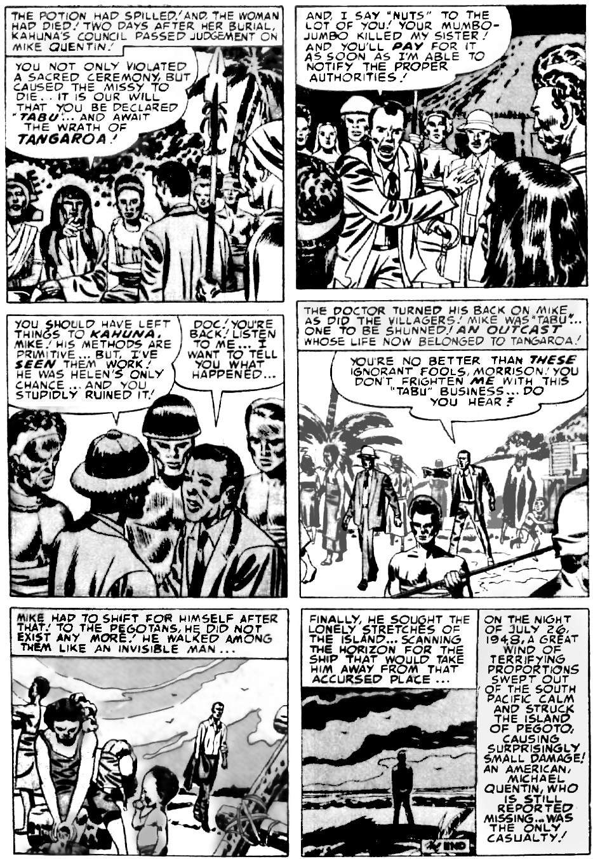
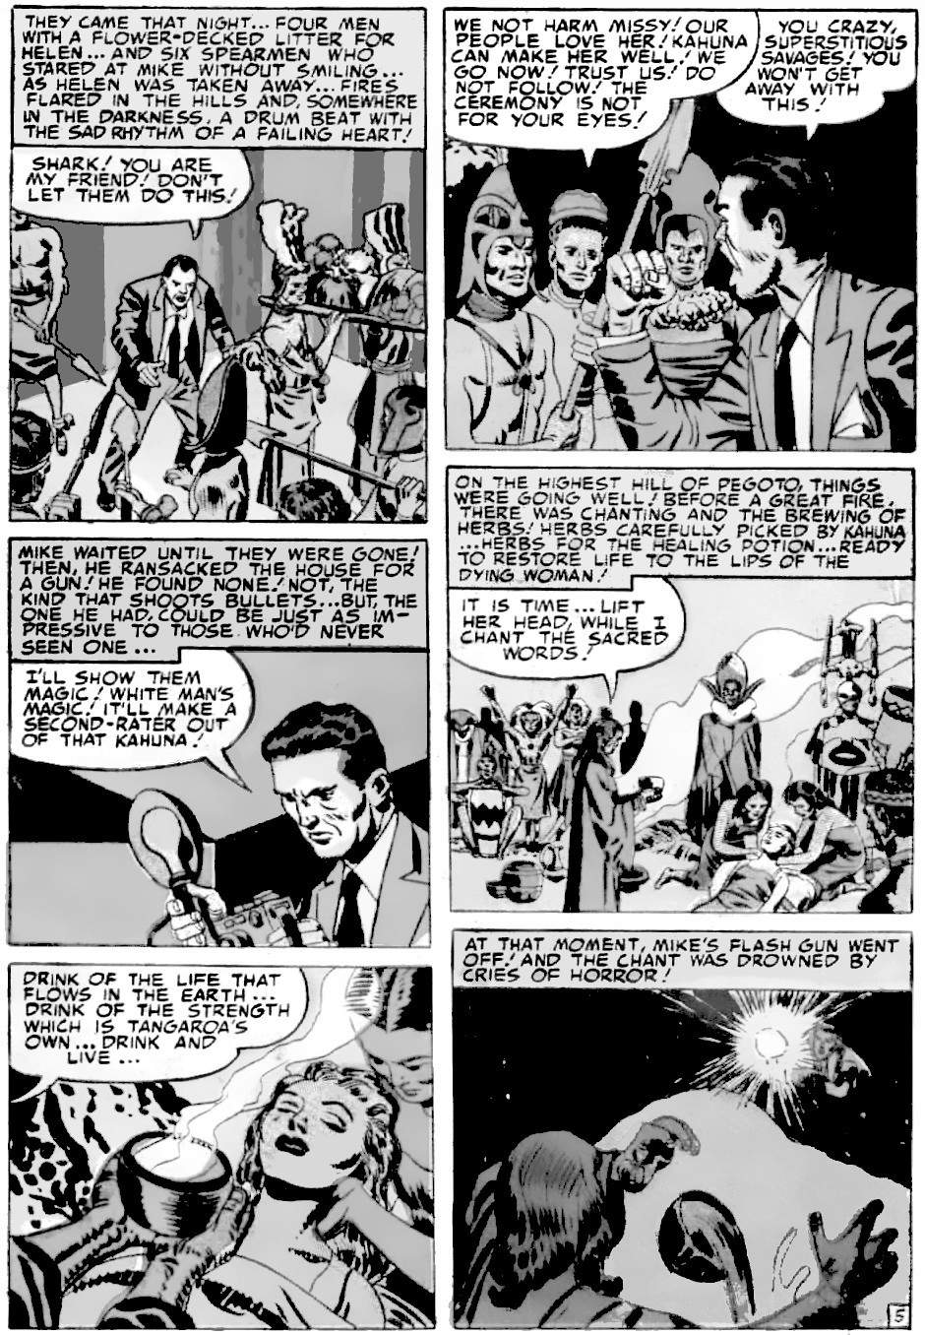
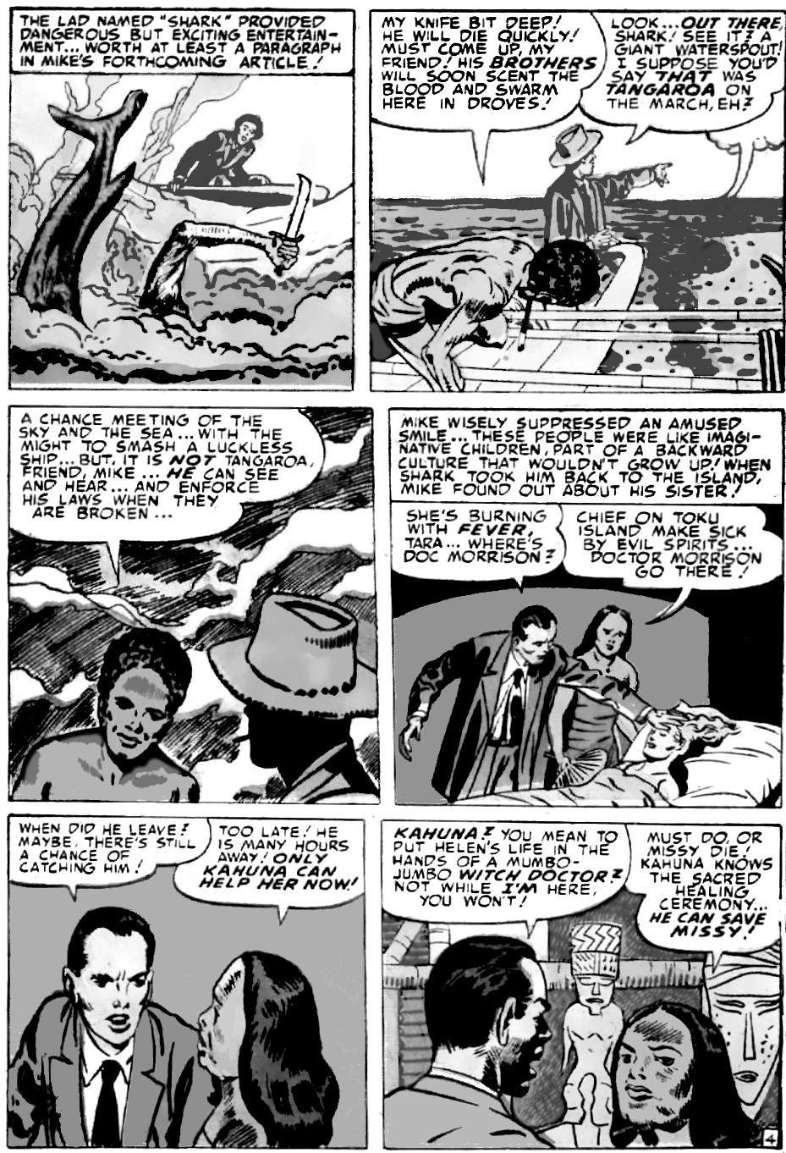
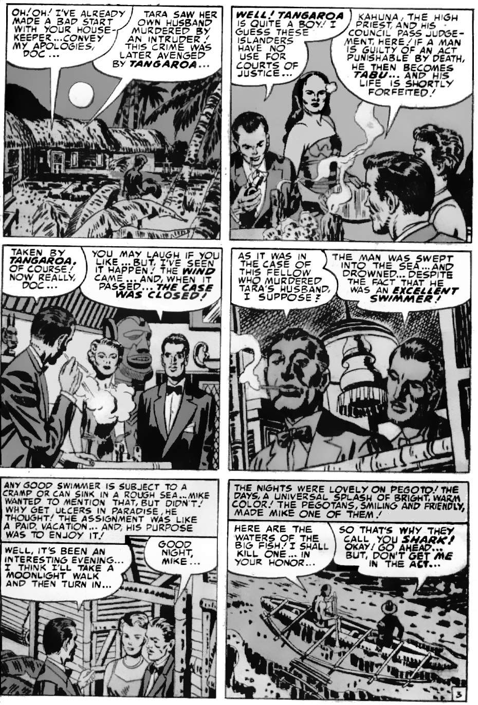
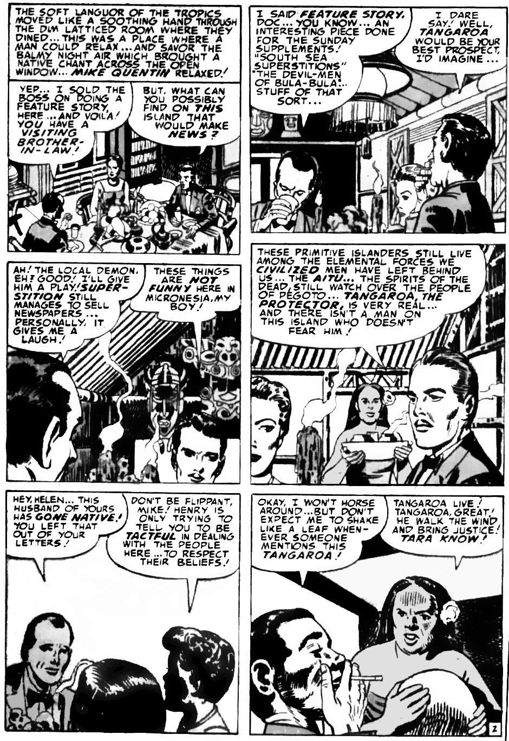
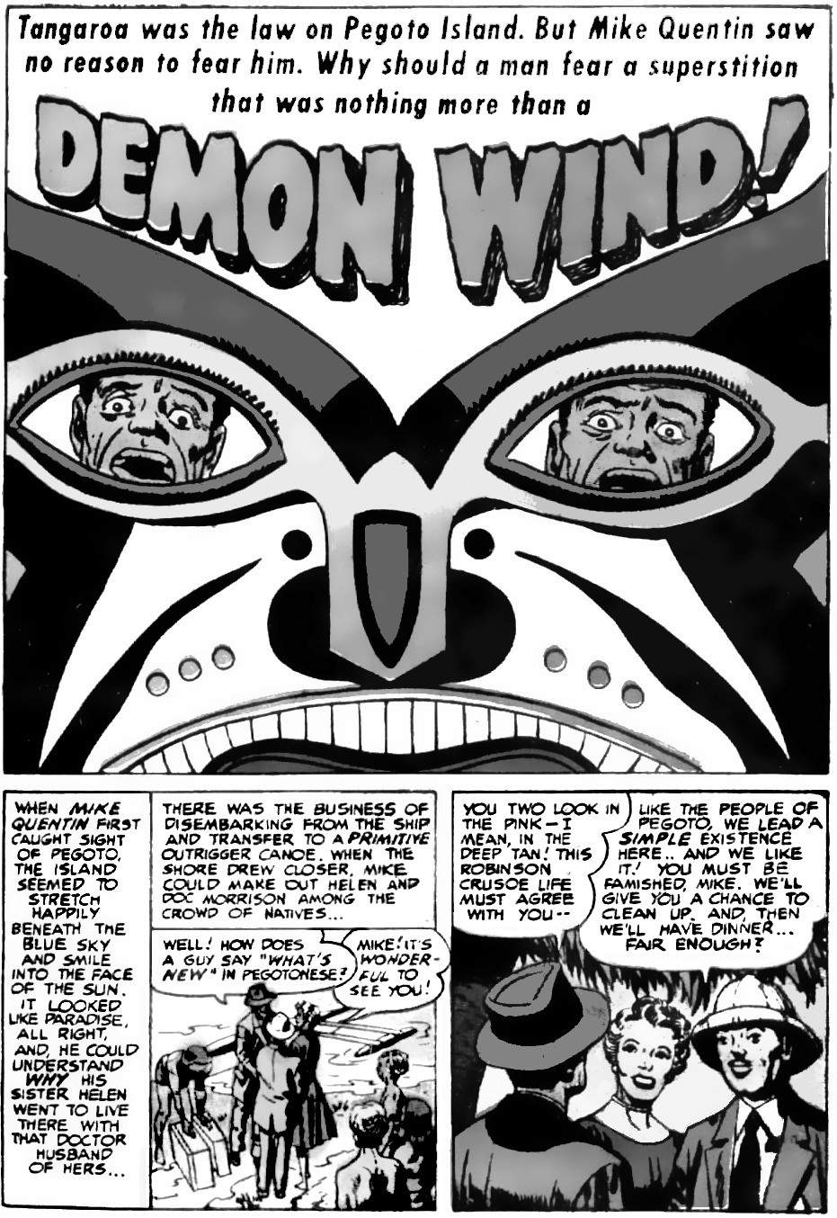
Mike Quentin thinks the Pegotans are backward. So let's compare the Pegotans with modern society. But first, let's compare them with the lost Golden Age.
Pegoto is a fictional island in Micronesia. Pegoto in the real world was the old name for the Armina Falls on the Maroni River that joins French Guiana and Suriname. This was a region where modern slaves often escaped to join local Indians, and live a little closer to the ancient ways. So Pegoto is the perfect name for a place of escape to a semi-Golden Age state. Micronesia was never fully Golden Age because the islands are too small to allow people to just wander around picking whatever food grows naturally. People have to find a fixed piece of land, plant crops and work that land, and sometimes fight over land. But the small island sizes, and distance between them, meant that no single person could have too much power: if a ruler was bad, the other people could defeat him. So rulers had to listen to ordinary people.
Micronesia is thousands of tiny islands in the Pacific. Each island had a different system and culture, but the big difference between the old ways and modern ways is that the old ways were based on small family groups. Everybody had a big say in how they lived because the family group was small. When families disagreed, representatives from each family formed a council. So your voice always mattered.
Modern culture is not based on family groups, it is based on money. The last Micronesian Islands adopted money in the 1950s, so this story, set in 1948, is about the last of the old ways.
Money allows people to accumulate vastly unequal power. It also lets us cooperate in complex ways to create new science and mass communication and progress and efficiency. But what kind of science? What ideas do we communicate? Progress toward what? Efficiency to do what? Let’s have a closer look.

Science
The most beneficial science is sociology, and here the Pegotans are more advanced than outsiders. They have a system where everybody can live in a paradise, with little crime and no poverty (see law and economics, below).
Mike Quentin has a very narrow view of science: he can only see the narrow fact that western medicine is better than Pegoto medicine. But how much better? Quentin’s brain cannot cope with all the variables. He cannot see that finding Doc Morrison might take days, whereas the Pegotans are probably experts at local fevers, and they can give 90 per cent of the modern benefit 10 per cent of the time, and at no cost. Quentin thinks he is more scientific, but he cannot cope with these variables.

Peace
Because of the small size of the islands, Micronesia always had some wars over land, but they were generally more peaceful than the Europeans:
“There is very little conflict, open hostility, or aggression in traditional Tahitian society. The people act gently and rarely display anger toward one another or toward visitors. Tahitians do not believe they have any control over nature or the behavior of other people; in fact, they believe that trying to change the nature of reality inevitably causes a rebound that destroys the initiator.”
Most experts on the origin of warfare agree that before any land ownership, wars were far less common:
“[T]he origins of warfare lie not in the European Palaeolithic [44,000-10,000 BC] but in the Levantine Neolithic [Jericho ~8,000 BC], as it was here that the demographic basis for sustained conflict first appeared."

Warlike hunter-gatherers?
Critics sometimes counter the claim that hunter-gatherers are more peaceful, by citing the mass graves at Jebel Sahaba (on the Nile) or Nataruk, Kenya. But in nearly every case, these were due to the sudden loss of hunting land due to sudden climate change at the end of the ice age. These were rare and exceptional events. Critics also point to the ferocity of some golden age people, but this ferocity is usually due to colonialism messing up their world. Take the ferocious Comanche for example. They began as moderate Shoshone people. But when European settlers arrived in the 1500s with their weapons and diseases, some of the Shoshone saw the threat and opted to survive at any cost. They became “Comanche”, or “those who fight”. They did everything to scare people away from their borders, even torturing outsiders who entered their lands. Nothing the Comanche did was worse than the smallpox that settlers brought. Similar stories can be told about the Yanomami, Zulus, and other “ferocious” hunter-gatherer peoples.
It might be argued (wrongly) that Genghis Khan created a vast nomadic empire without the need for settled farming. But he relied on settled communities to provide essential metal weapons and tools. Even the ancient Scythians before him relied on settled communities for their metal armour-piercing arrow heads. Without them, the Scythian or Mongol archers lost their advantage.

Law
Pegoto needed no police and no jails. Instead, Pegotans use “tabu” (that is, taboo): ostracism.
“The most serious punishment among most hunter-gatherers is ostracism. In theory ostracism is equivalent to a death sentence because most people can’t survive for very long on their own in the bush.”
In the story, a murderer, when ostracised, became depressed. So he did not swim strongly enough and drowned. Mike Quentin, when ostracised, cannot access help from more experienced natives, so he cannot save himself from a storm. In a Golden Age community, ostracism works better than any police force or jail.

Economics
As soon as Mike arrives, the boy called “Shark” kills a shark so Mike can feast. This creates an obligation for Mike to be good in return. This kind of exchange was the basis for all human economies until the invention of money (see chapter 14). It measures value by a person’s reputation. Reputation is a far more accurate and efficient measure of value than money, but it only works in small societies.

Food
Hunter-gatherers have significantly less famine than farmers. This is not obvious, because settled people steal the best land. So we are used to seeing hunter-gathers on poor quality land. But when we take land quality into account, hunter-gatherers have less famine.
“[I]f we control for habitat quality, hunter-gatherers actually had significantly less—not more—famine than other subsistence modes.”
When a famine arises they do not look at their dead crops and weep, they move to a different place with a different food source: variety is the key to survival. A variety of food is also far healthier. And finding it is fun and keep you fit.

Lifespan
Hunter-gatherers, and city people as well until the 1800s, had an average lifespan of around 40, due to high infant mortality. But if a person survived to age 15, they had a good chance of reaching age 70. Today, in modern society, more children survive and 70-80 is the average lifespan. But is it your lifespan?
Hunter-gatherers have no schools and have a generally relaxed attitude to parenting. A 15-year-old hunter-gatherer has 15 years to do whatever they want. But a modern child is kept inside, then sent to school, then to work. They can only retire once they are too old or sick to be of any use. Many workers have fewer than 15 years of their own life: the other 60 years are spent slaving for their masters. And much of those 15 years are spent worrying.

Civilisation before 8000 BC
Kirby suggested that every ten thousand years or so, the planet wipes out complex civilisation through a climate disaster, Laschamp event, supervolcano, or another global disaster: As we saw in the introduction, he felt that civilisation might reboot “every ten thousand years or thereabouts” with maybe 30-100 such civilisations before ours. Humans have been anatomically modern for 300,000 years, and we have controlled fire for a million years, so the numbers match. Appendix 2 shows how we erase the history of previous civilisations. But some evidence inevitably survives. Let's look at that evidence now.

Writing
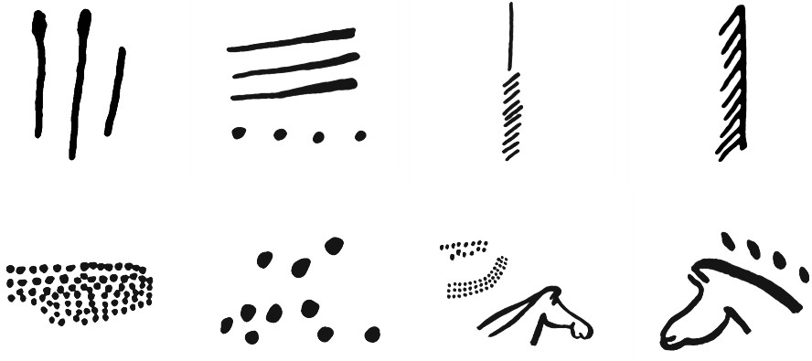
The same thirty-two symbols appear in caves around the world. Some of these symbols were in use for more than 62,000 years.
Image: Locutus Borg, public domain, via Wikimedia
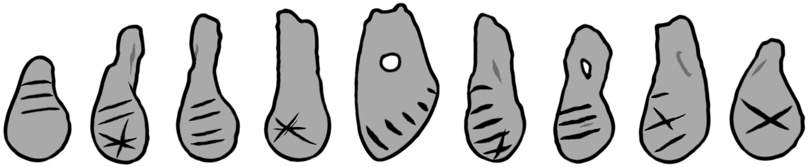
These symbols are also found on portable items, like the necklace made of deer teeth, created before 10,000 BC. The necklace is also evidence of pan-continental trade.
Image: based on photos in the Journal of Anthropological Archaeology 24:2 p.117
A full writing system like we use today is not ideal. In Plato’s Phaedrus, Socrates warns that:
“[writing] will create forgetfulness in the learners' souls, because they will not use their memories; … they will be hearers of many things and will have learned nothing”
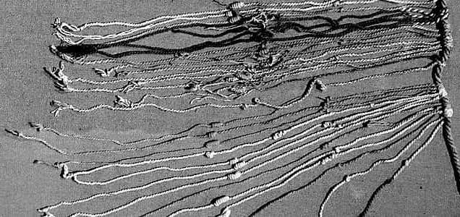
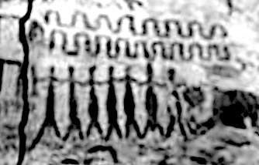
A well-trained memory is more useful. For example, a Navaho man might identify seven hundred species of insect (which are very difficult to distinguish), on top of the countless mammals and birds and plants that he needed to know in his daily life. However, for complex information, we need memory aids. We do not need written symbols: in recent times, Incas ran an empire of twelve million people, across 2600 miles, using quipu: careful positioned colours and knots that can encode just as much information as paper.
Image: "Daderot" via Wikimedia, public domain

Golden Age civilisations did use symbols, but most symbols are worn away by the weather after a few thousand years. This example was protected from the weather by an overhanging cliff. It seems to teach that pregnancy lasts nine months: the line has nine waves, the person gets bigger, and then a baby appears.
This is just one tiny detail from eight miles of detailed symbols on the Serranía La Lindosa cliffs, in the Chiribiquete National Park, Colombia.

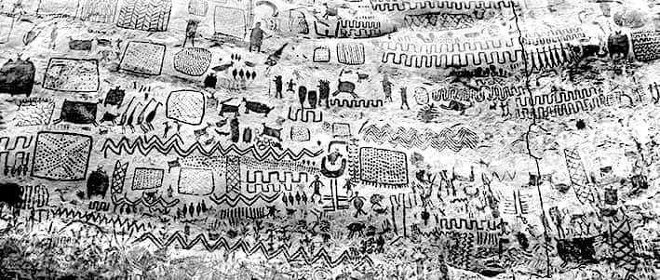
These cliffs alone have 750,000 messages (dating from before 10,000 BC, judging by all the extinct animals). But we destroyed the cultures that might have been able to read it, so we don't know what it says.
Image: Chiribiquete paintings reported by elinformador.com.co, via Wikimedia. Fair Use.

Journeys by sea
Hunter-gatherers travelled across the sea, and sometimes across the ocean. This image from around 10,000 BC, near the Caspian Sea (i.e. Eden), shows a long boat with a large number of people.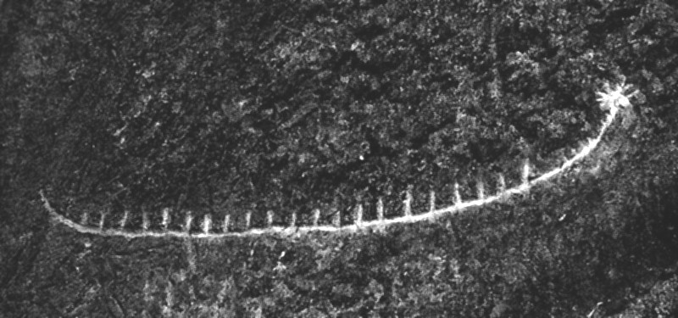
Image: M.Ragimov, CC-BY-SA-4.0, via Wikimedia

When did we start sea travel? People lived in Crete since at least 175,000 BC, and Crete could only be reached by sea. Before 700,000 BC, people lived in parts of the Philippines that could only be reached by crossing deep water.

Signposts
This is a nine-foot high post, once embedded in a stone base next to a lake in Siberia, from 10,000 BC.
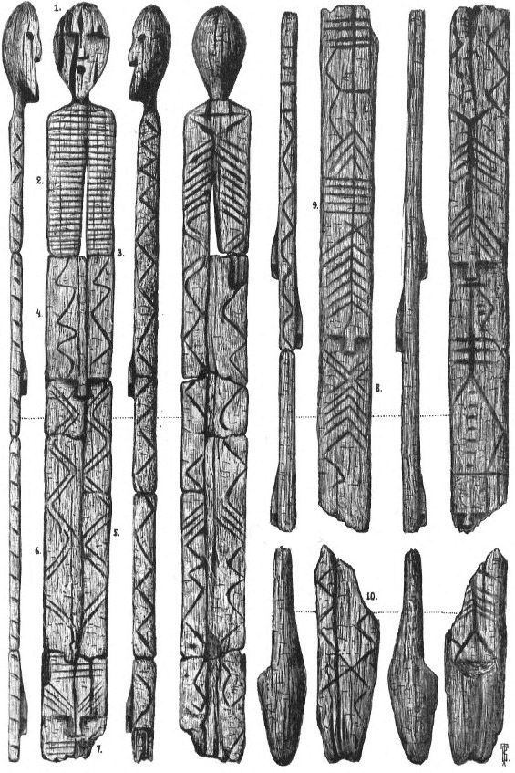
“museum staff have postulated that among its purposes was that of an early map, or navigator.
Image: So-called “Shigir Idol”. Out of copyright, via Wikimedia
Straight lines, wave lines and arrows indicated ways of getting to the destination and the number of days for a journey, with waves meaning water path, straight lines meaning ravines, and arrows meaning hills, according to this theory which has yet to be fully researched.”
There could have been thousands of these signposts, but it is only through extreme luck that this one survived.

Maps and calendars
On this writing stone, notice the four curves in the middle.

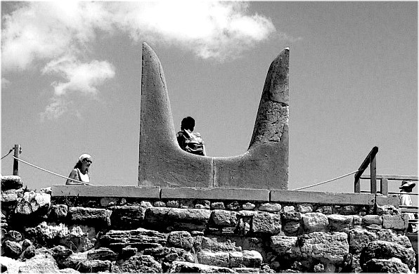
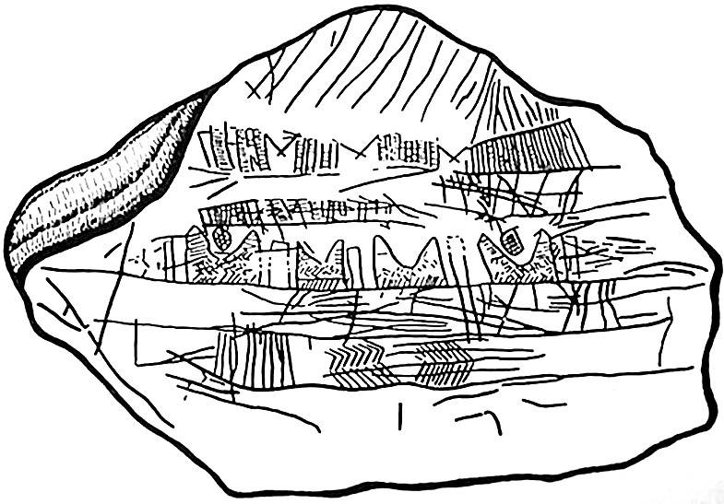
The stone is the “Mezhyrich map” from Ukraine, around 13,000 BC. The four curved shapes are known as “horns of consecration”. These horns were first noticed on buildings in Minoan Crete.
Image: Jolle~commonswiki, public domain, via Wikimedia
Image: unknown author, via Wikimedia, public domain due to age

Ancient Monuments were routinely aligned to certain landmarks or stars, and when you stand in front of the building the horns frame certain stars or constellations. By tracking how stars change, you can measure time. Two of the sets of horns on the Mezhyrich map have distinct shapes between the horns, so this could be either a map or a calendar or both.

The end of the Golden Age
The Golden Age ended gradually, as hunter-gatherers were forced off the best land. The key event was the Atlantis War, explored in Appendix 4. This led to the great wall of Jericho and the start of our age.
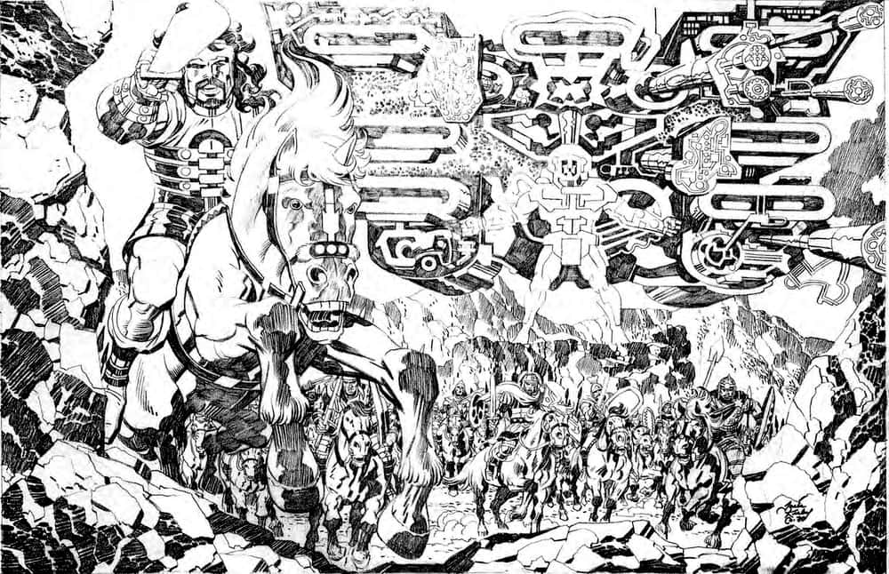
When the Israelites tried to bring back a form of the Golden Age, their first act was to destroy the walls of Jericho. Here is Kirby’s picture of that pivotal event in history. Notice the ghostly god in the background, carrying high-technology weapons.
Image: Kirby, Joshua destroying the walls of Jericho. Fair Use.
High technology at that time meant chariots and bronze armour., but Kirby’s modern version captures how it felt. Chapter 11 shows how most kings are space gods: they claim authority from the sky. The king of Jerusalem undermined Moses' efforts, so the destruction of Jericho did not lead to a return to the Golden Age.
Kirby said that nobody knows what the Israelites did at Jericho. But it had something to do with mankind destroying itself, and a lot of people died.

Rebranding the Golden Age as the Stone Age
In the Secret City Saga, a survivor from the Golden Age sees our modern world, based on concrete (stone) and is horrified:
“My world was never like this... all man-made! My home was organic… alive! This is so cold... so dead!”
Ironically, modern man calls his stone-based world advanced, and calls the Golden Age the stone age! How did that happen?
The Golden Age became a serious problem in 1789, the year of the French Revolution. In that year, a British ship, “The Bounty”, visited the island of Tahiti, and the sailors saw that Tahiti was far better than England. In 1796, Denis Diderot, an influential enlightenment publisher, wrote a pamphlet about Tahiti. He pointed out that Tahitian culture was superior to our own. Europe was much worse: William Blake wrote about England’s “Dark, Satanic Mills”. Europe was faced with an uncomfortable truth: ten thousand years of “progress” had made the world worse. But European rulers made a lot of money from “progress”, so they had to discredit the Golden Age. They did so in three ways:
- Tahiti and other Golden Age sites were modernised. Records were destroyed, and any tribe that refused to change was pushed off their good lands, to barely survive in deserts and disease-infested jungles.
- In 1830. A Danish museum curator (Christian Jurgensen Thomsen) noticed that in the Iron Age we use iron tools, and in the Bronze Age we used bronze tools, but in the Golden Age, we used stone tools. So he renamed the Golden Age as “the stone age”.
- Archaeologists noticed that the best-preserved remains are in caves, where art and artefacts are protected from the weather. So, they began to talk about “cave men”.
So Europeans now imagine the Golden Age as a period of dust and hunger (like modern hunter-gatherers, living on bad land), where people lived in caves instead of villages. This was a brilliant piece of marketing: it made our modern dark Satanic mills look like progress.

How did Kirby know all this?
How did Kirby know about prehistoric civilisations? This was an old Jewish Kabbalist idea:
“One of the most controversial teachings among Kabbalists is the doctrine of the Shemita(ot), the cosmic Sabbatical epochs of pre-Adamic times. According to many of the great Rabbis, Adam was not the first human to have walked the earth. These Rabbis teach that there were full pre-Adamic human civilizations that had arisen and were eventually destroyed.”
The knowledge also comes from reason. Our brains have been the current size for 50,000 years: it is absurd to think we only did interesting things for the past 5,000 years. Kirby also reasoned from first principles: Civilisation means to be civil — to use intelligence to work with others in constructive ways. By that definition, even dinosaurs could have civilisations:
"I believe that anything that can think or act as we do is human - I don't care what it developed from. … I'm not saying that it built cities, or that it built anything. It might have lived in a perfect environment that it didn't want to change."
That last part is the key. Our current civilisation is deeply unpleasant: why else do we try to change it? If our civilisation was pleasant, why would we struggle for a better world? Our civilisation is the kind of thing we try to get away from: if anything like it happened at all in the past it would be a brief mistake, soon corrected. But there are other kinds of civilisation, many of them better than ours. Once we start looking for them, we find them everywhere, as we will see in chapter 16.

5.
The Ancient Historians
Kirby's understanding of the future was informed by his understanding of the past. He knew that human civilisation had collapsed before, and then new kinds of humans took over. So it could happen again.
This chapter has ten examples where civilisation ended, and storytellers remember.
When civilisation ends, and a human sub-species is wiped out, usually a few survive for a while. For example, Neanderthals lasted long enough for us to share some of their DNA. Legends suggest that a few Neanderthals survived in remote forests long after we thought they were all extinct. Appendix 3 has the details.
In this Kirby story, an American thinks he has found a pre-human people: the cat people, from when "the Earth was young”. “Cat People” is Kirby’s name for a human sub-species from around 50,000 BC (the details are later in this chapter).
Are these really cat people? Or is this really a story about ignorance and prejudice?
The story is notable for its use of string figures, such as “cat’s cradle”. String figures are one way that storytellers tells stories and preserve cultural ideas. Storytellers from minority groups need many ways to preserve their culture, because the dominant culture has a tendency to see the minority group as a threat, and demonise them, destroying their culture (see appendix 2). Storytellers try to preserve their culture using pictures, string figures, songs, poems, masks, stones, beads, landmarks, knotted string, and many other media. These media can preserve stories for thousands of years without the need for writing.
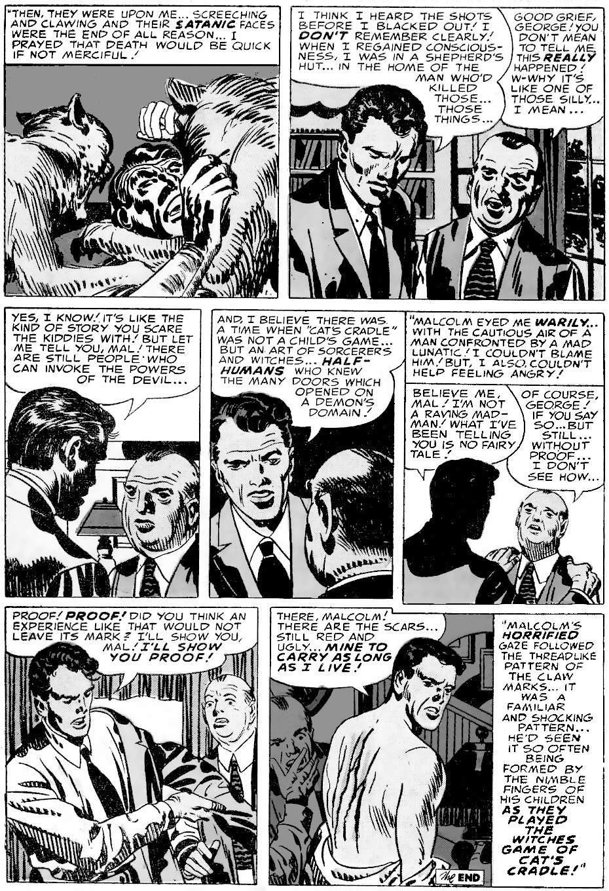
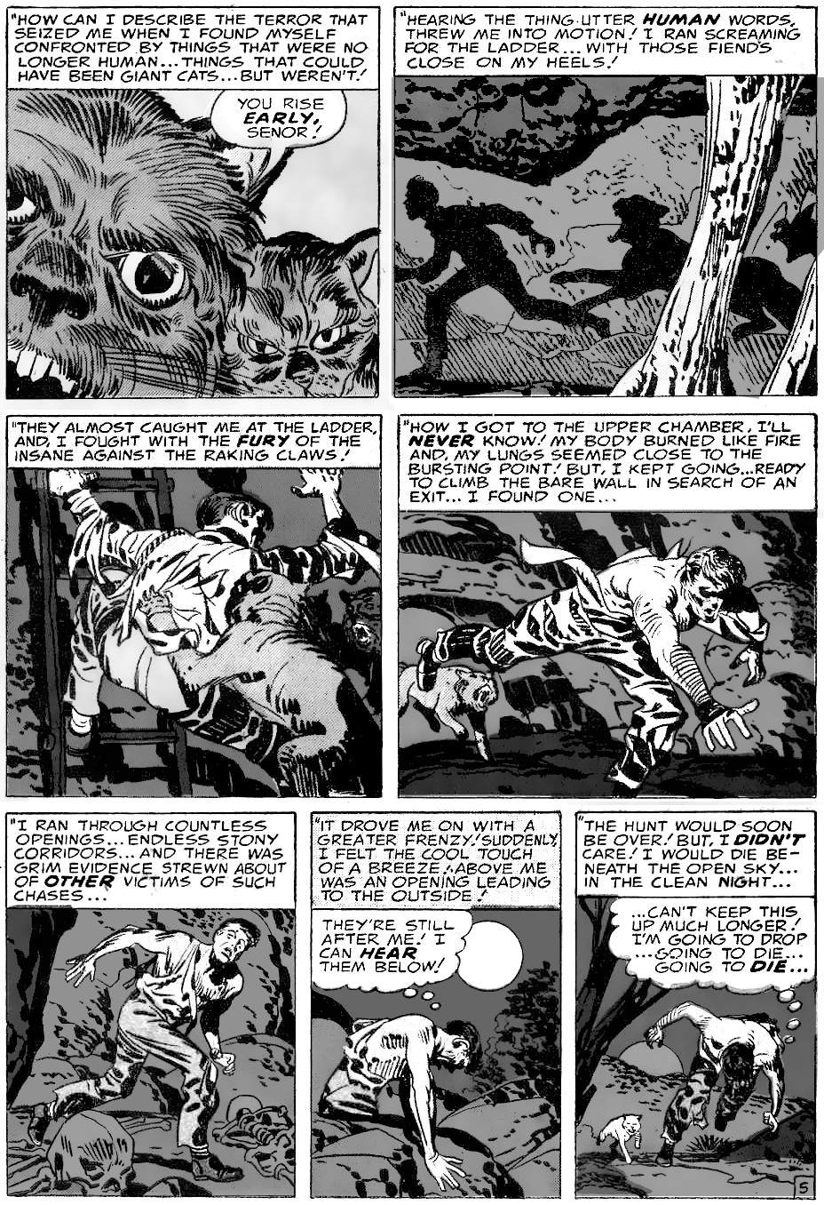
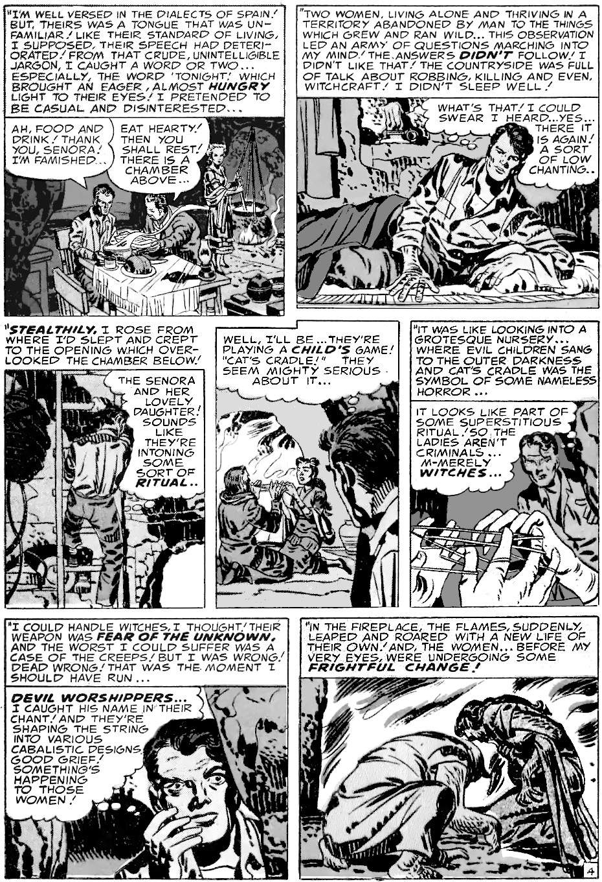
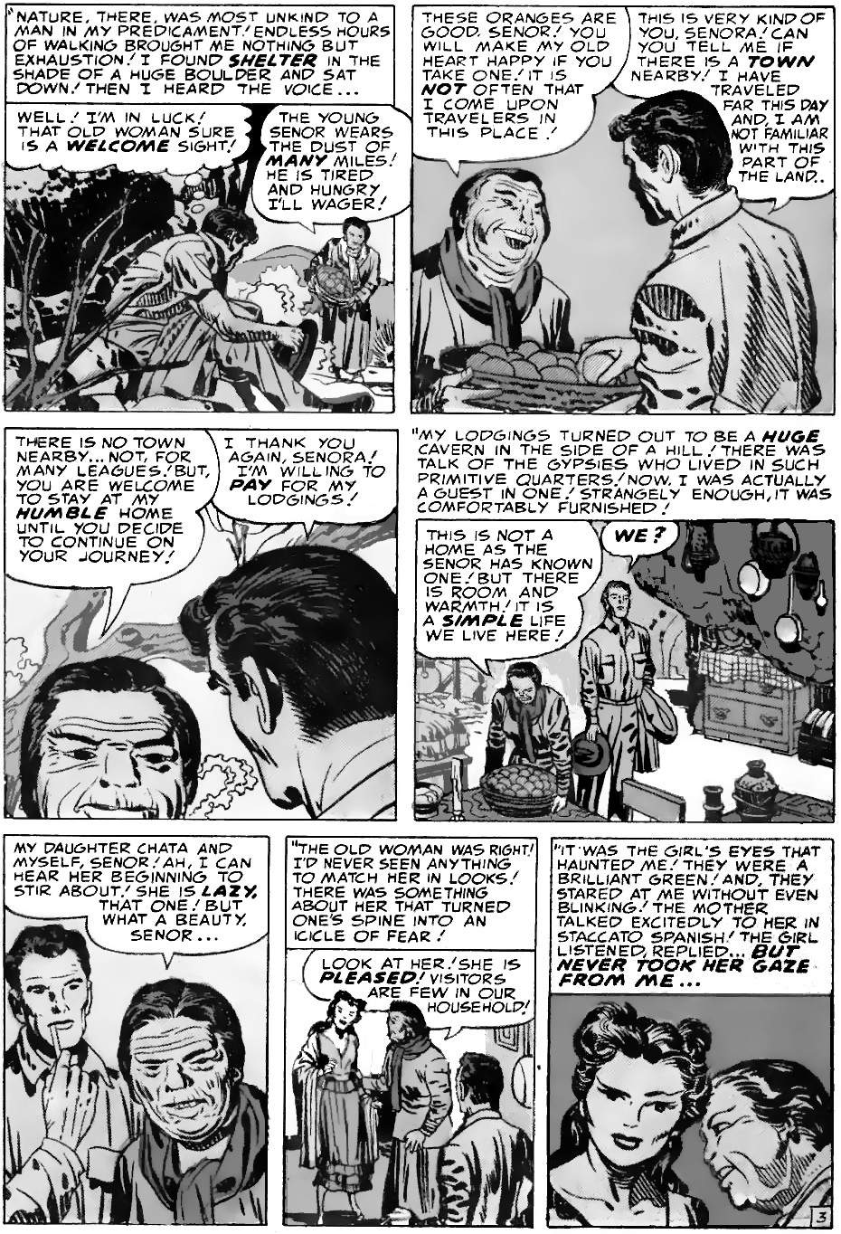
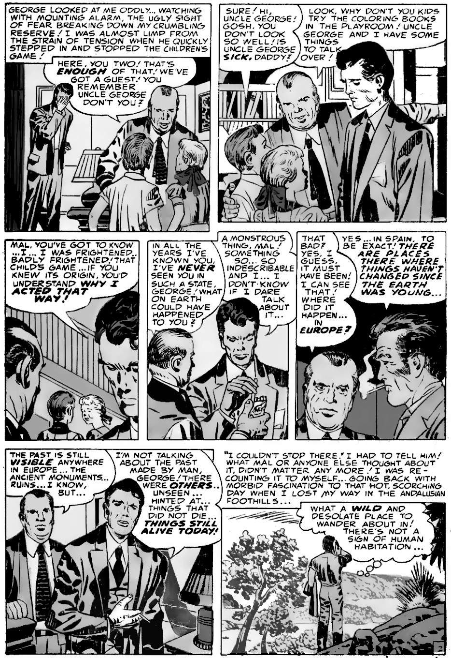
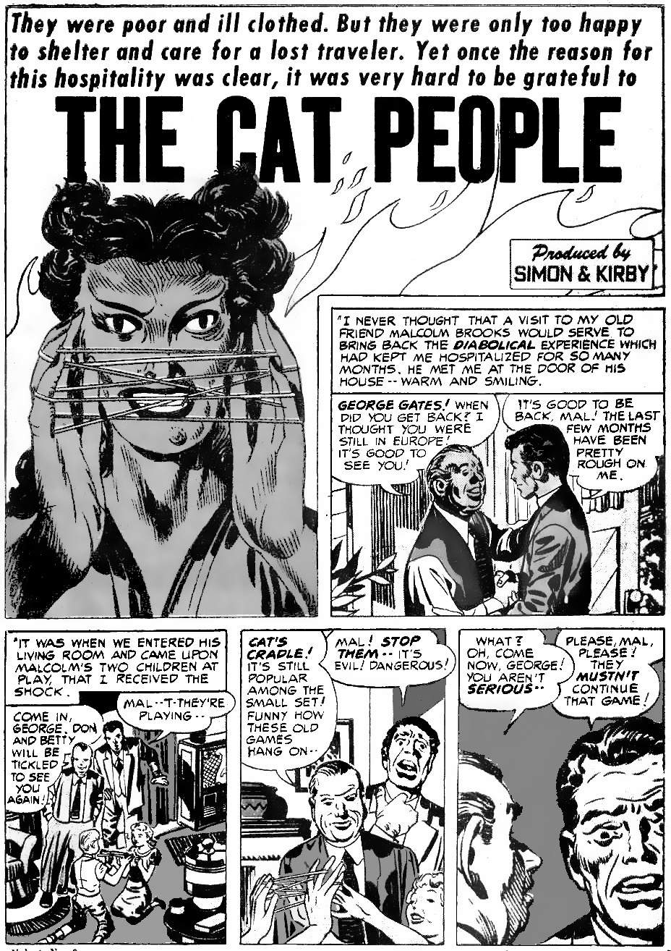
The “cat people" are gipsies who live in caves in a remote part of Andalusia, Spain. So this story is about the famous Sacromonte caves, where gipsies and other outcasts fled to escape persecution. In 1391, up to 50,000 Spanish Jews were killed because they refused to abandon their traditions. In 1492, those who still preserved their traditions were forced to leave. Some of the Jews ended up joining the Roma (gipsies), and built the famous caves, out of reach of the Spanish Inquisition.
Kirby would have sympathy for the Jewish Roma: just eight years before this story, the Nazis killed Jews and Roma for being subhuman monsters. True, Kirby presents this story from the point of view of the outsider, George. But the previous month’s main story was Demon Wind, showing that the outsider is often wrong. And the same month as this story, Kirby wrote “Home Wrecker”, another story about evil women. But on the last page, we see that the evil woman is innocent. So let’s look take another look at The Cat People.
The women treat George Gates with great kindness. But he is scared and lost. He is a repressed 1950s male in an exotic female cave at night where none of his rules applies. He thinks the beautiful girl is staring at him. He thinks she is playing like a child. He cannot understand the chanting. At this stage — when the women have done nothing wrong — George decides they are "devil worshippers”! He becomes Witchfinder General! The witch-finders handbook (the Malleus Maleficarum) says that devil worshippers can transform into cats, and kidnap and murder people. So when George sees the women chant over what he thinks is a cat’s cradle, as they curl up in front of the fire, he thinks of them as cat-like. It is dark, the flickering fire is behind them so he only sees their silhouette. Not seeing clearly, he imagines their cat-like bodies becoming cats. He runs, and in the darkness, he thinks he passes skulls, but how would he know? This is a dark cave and he is running for his life.
The women think he is asleep in bed, so when they hear someone in the darkness of the cave they investigate. They touch his back and he panics. If the women were cats they could easily jump ahead of George and outrun him. But they cannot, so they must be human: the transformation is only in George's mind. Blinded by fear, George runs through the countryside in the darkness, past jagged trees, no doubt becoming badly scratched by branches. Finally, he hears a gunshot, feels pain, and blacks out. Later a shepherd admits to firing a shot. Andalusia was home to the Iberian Lynx, a great danger to sheep. So when the shepherd sees something leaping through the dark trees in the middle of the night, he fires his rifle. George puts all this together as proof that he was chased by big cats who scratched him. George’s ego cannot admit the more rational alternative — that he was the one acting like an animal.

How storytellers preserve history
The Malleus Maleficarum demonised shape-shifting, probably because that was a feature of older non-Christian beliefs. Christianity was about being separate from nature, but the older belief was to be one with nature. The older belief was very old: further north from Sacromonte is the cave of Trois-Frères, with its paintings of shamans becoming animals in 13,000 BC. Many shamans use string figures to pass on their ancient wisdom.
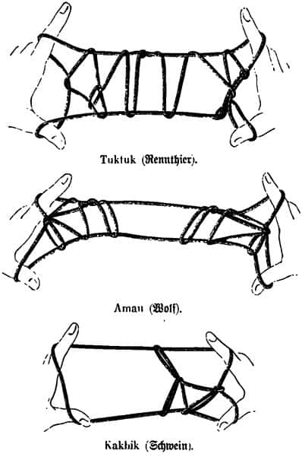
“String figures were not just a child's game but the tool of a shaman. A tool for influencing relationships within the self, with others and with the environment. A tool for restoring harmony. They had been placed in the hands of the children so they would not be forgotten.”
Image: Inuit figures, Public Domain
The Bulletin of the International String Figure Association explores string figure usage in countless cultures, throughout history. The attached image shows Inuit string figures. One example, the “kaikai" of Rapanui (Easter Island), shows the breadth of information that can be encoded:
“The kaikai is not a game, but a way of transmitting different elements of culture. From this point of view, each kaikai contains centuries of wisdom and memorialises a specific scene, be it from everyday life, a humorous, loving scene, a tribal story or a teaching.”
The ancient battle is always between the shamans who want to be one with nature, and people like George Gates who don’t. George feels the need to visit nature as a break from his artificial life, but he easily becomes lost, and then he blames nature for his own weakness.
String figures symbolise nature: organic and three-dimensional. Every thread matters, everything is connected. Everything must be in harmony and balance. If one finger pulls too hard or moves in the wrong way, the string figure collapses.
Here are ten examples from history where people like George Gates have upset the harmony of nature. They pulled too hard, they did not respect others, and it led to the collapse of civilisation. Professional historians overcomplicate these stories and dismiss key details as fiction. But storytellers see clearly. Storytellers remember.

1: Camelot, 537 AD: half of Europe dies
Kirby’s “The Demon” begins with the fall of Camelot. Kirby presents it as a world-changing event. He doesn't give many details, because most readers already know the outline: King Arthur presided over Camelot, where the knights had a round table because everybody was equal. Life was good. But greed appeared, and they were no longer equal, so Camelot fell. The Annals of Wales (Annales Cambriae) record that Arthur died at the battle of Camlann in 537 AD. Gildas, a contemporary historian, records how the land became a wasteland, many people died, and a great dark age began.
But is it real history? Let’s look closer.
In 42 AD, the Romans invaded Britain. They created their base at the Celtic fort of “Camul-o-dunon”, the “fort of Camulus”. They Latinised the spelling, making it “Camulodunum”. In later centuries people spoke Latin, not Gaelic, so they would read Camulodunum as “Camulod-unum” meaning “Camulod, the number one city”. In 61 AD, the Romans tried to expand beyond Camulod-unum, and this led to war with Boudicca, queen of the Britons. The Romans retreated to a new capital at Londinium. Forever after, the Britons remembered Camulod-unum with great pride.
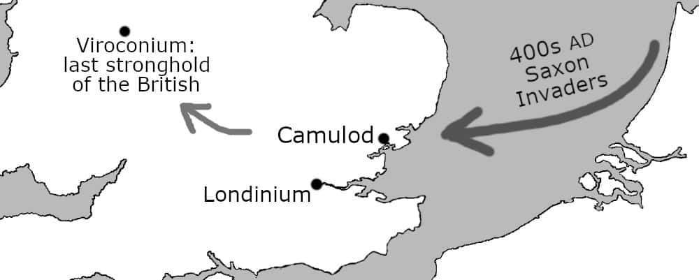
In 410 AD, the Roman legions left Britain. This let the Saxons invade. Over the next hundred years the Saxons pushed the Britons further and further west. Many of them ended up in the far southwest in Cornwall, where they preserved the memory of what happened next.
Around 500 AD, the retreating Britons had a major victory against the Saxons at the Battle of Badon Hill. They established a new capital at Viroconium. The last great British king was Owain Ddantgwyn, known as “the bear”, or in his language (Brythonic), “Arth”. This is Latinised as “Arthur”. But Arthur’s success led to greed. His people grew lazy and corrupt. This made them weak, so the Anglo-Saxons defeated Arthur and his forces at the battle of Camlann, in 537 AD.
At about the same time, in 535 AD, a massive volcanic eruption on Krakatoa threw enormous amounts of dust into the air, that blotted out the sun. Trees died everywhere. The Romans noticed that the sun was dim and crops were not growing. Chinese historians recorded snow in August. The British historian Gildas recorded how Britain became a wasteland. Later writers summarised the destruction:
“This was how the land was laid waste. The leaves on the trees shrivelled and died, plants withered, fields and meadows turned brown, and the earth lay barren and scorched. The waters of the land diminished and the rivers ran dry, and no one could find the enchanted court of the Fisher King, who had once made the land bright with his treasures.”
There was famine throughout the world. Asian hordes invaded Europe looking for food. They brought a plague that killed around half of Europe.
“During these times there was a pestilence by which the whole human race came near to being annihilated.”
But what has this got to do with the fall of Camulod?

How inequality causes plague
Today we know that you stop a plague by stopping contact. Without contact, the disease cannot spread. Why didn't people notice this in the 500s AD? The plague lasted for decades and killed half the population. Why didn’t anybody notice that people who lived alone never got the plague? They didn't notice because it was impossible to live completely alone, thanks to inequality.
In the 500s, most people did not own land. So they had to contact other people to get food. And people who did own land also had servants. So everybody was in contact with everybody else. Ironically, they all believed in the Bible, which teaches the opposite. Moses wanted a promised land where everybody had land of their own. In such a society, introverts would live happily without contacting others, so they would never catch infectious diseases. Others would notice, and learn the concept of quarantine.
This theory has been tested and proven. In the Golden Age (the age of hunter-gatherers), plague was almost impossible for that reason: each group gathered its own food. Tribes did not have daily contact with other tribes. They had plenty of short-lived diseases, due to regular contact with the blood of wild animals, but diseases could not easily spread between tribes. This is why American Indians and Australian Aborigines were so devastated by European disease, whereas Europeans had far less problem with diseases going the other way: plagues do not have a chance to spread among hunter-gatherers, so they never built up any resistance.
Ancient myths show an awareness that cities lead to disease. In the Gilgamesh epic, Enkidu is extremely healthy when living in the Edin (the plains beyond the cities) but when he adopts the city lifestyle he dies of disease. In Greek mythology, when Prometheus provides fire and other technology, his next act is to create Pandora who opens a box full of disease. And in the story of Moses, the Israelites have diseases when they are in Egypt, but become a strong people once they get their equal shares of land. Even today, there is still a belief that country life is healthier than city life.
So when the plague hit Britain in the mid-500s, the people knew there was some kind of connection with financial inequality, they just did not know the mechanism. This is what Gildas said, in “On the Ruin of Britain”: when the Britons defeated the Picts and Saxons, kings grew wealthier and greedier, and disease followed
“No sooner were the ravages of the enemy checked, than the island was deluged with a most extraordinary plenty of all things, greater than was before known, and with it grew up every kind of luxury and licentiousness. ... Kings were anointed, not according to god's ordinance, but such as showed themselves more cruel than the rest ... the swellings of pride, the jar of strife, the griping talons of envy, and the confused estimate of right and wrong, got such entire possession of them ... [and so]… a pestilential disease morally affected the foolish people, which, without the sword, cut off so large a number of persons, that the living were not able to bury them.”
Gildas knew that “luxury” and “pride” were somehow linked to the plague, even if he did not understand the reason (that poverty forces people together, and wealth causes trade, and both cause disease to spread). But everyone noticed that the poor (who lived closest together) got sick first.
“The mercy of God showed itself everywhere towards the poor, for they died first … first it eagerly began (to assault) the class of the poor, who lay in the streets.”
We saw the same thing in the 2021 global pandemic. Rich people could easily quarantine themselves, then rich countries could create vaccines. But poor people had to keep working, and poor countries had no vaccines. So the poor were more likely to die.

Why Arthurian history is better than regular history
The best historians know these facts, but they lose them among a thousand irrelevant details. Ordinary people do not care about maps and timelines. Ordinary people care if they are going to die. Historians fill large books with lists of evidence and all the latest theories and arguments, and they can never reach a final conclusion. But storytellers get right to the point: when the knights had a round table everything was good. But when the knights grew greedy, everybody died. Simple!
It is always the same: inequality causes the end of civilisation.

2. The fall of Europe’s first cities, c.1560 BC
Kirby loved the story of Prometheus, and the image of the powerful Titan chained helplessly to a rock, tormented by a great Eagle. The story recalls how Minoan power collapsed around 1560 BC due to inequality.
Prometheus stole fire from the god Hephaestus, giving us technology, thus creating mankind as we know it. When the gods destroyed the previous civilisation in a great flood, only Prometheus’s son Deucalion survived and become the father of Greek civilisation. The Greeks dated this to around 1560 BC. The date is supported by the fact that Hephaestus was the god of volcanoes and metalwork, and had a limp. The name comes from the city of Phaestus in Crete, and the limp indicates the use of arsenic in bronze, implying the mid-second millennium BC or before. Minoan Crete was the first advanced civilisation in Europe, the home for metalwork, and so was the natural home for Hephaestus.
Sometime between 1640 and 1540 BC the volcano Thera erupted, causing a great tidal wave that destroyed Minoan ships and crippled its economy. The nearby Mycenaean Greek civilisation was much smaller and simpler, so was not as badly affected. In other words, inequality — a reliance on people who own great ships — was more destructive than the volcano. The Greeks then harassed the weakened Minoans for the next 300 years, just as the Eagle (symbol of Zeus) pecked the liver of Prometheus. He was chained to his rock in the Caucasus Mountains (ancestral home of the Minoans) until finally, Hercules (symbol of Greek power) rescued the suffering Titan. So the Prometheus story is a memory of how the Greeks replaced the Minoans as the top nation. The Minoan civilisation collapsed because it was too reliant on rich men with big technology, so it was not robust enough to survive a natural disaster.

3. Noah's flood, c.2350 BC
Jack Kirby saw himself as a new Noah and featured Noah's Ark in The Eternals. The Biblical flood is mostly based on the flood story in Gilgamesh, and that tells us its date and its real cause.
Gilgamesh shows how the “gods" were the priests and rulers of the Sumerian city of Shuruppak: the god-king, his chamberlain, and his minister of canals. Canals were the key technology for civilisation, as they allowed the kings to irrigate the desert and support a large population. But the population of Shuruppak grew so large that the “gods” (the rich elites) began to see the common people as a threat to their power. So the gods decided to kill all the ordinary people with a flood,
“The hearts of the Great Gods moved them to inflict the Flood. Their Father Anu uttered the oath (of secrecy), Valiant Enlil was their Adviser, Ninurta was their Chamberlain, Ennugi was their Minister of Canals.”
They waited until the annual flooding season. When they saw the rain clouds coming they pulled up the mooring poles for boats, so nobody could escape, and then broke the dams, making the dikes overflow:
“There arose from the horizon a black cloud. Adad rumbled inside of it, before him went Shullat and Hanish, heralds going over mountain and land. Erragal pulled out the mooring poles, forth went Ninurta and made the dikes overflow.”
The annual flood does not stand out as unusual in the archaeological record: the key change was removing mooring poles and breaking dikes, not the amount of water involved. But Gilgamesh has a crucial detail that the Bible omits: the gods also burnt the houses.
“The Anunnaki lifted up the torches, setting the land ablaze with their flare. Stunned shock over Adad's deeds overtook the heavens, and turned to blackness all that had been light.”
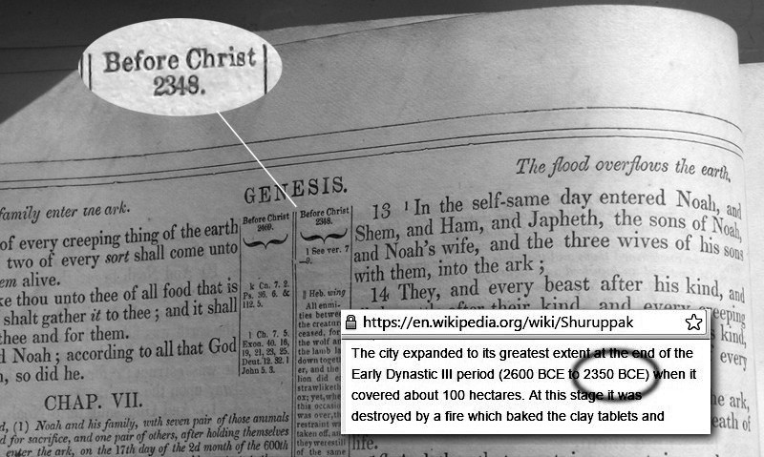
The burning lets us identify the event in archaeological remains. The Bible says the flood took place in 2348 BC. Archaeologists confirm that the city of Shuruppak was destroyed by fire sometime around 2350 BC.
Would rulers kill people by flooding? Yes: during the Vietnam war, Billy Graham encouraged the president to do something similar to defeat North Vietnam: bomb their dikes to cause massive flooding. And today, rulers give tax breaks to fossil fuels, causing global warming, and killing millions of people. We saw in chapter 4 that some politicians make money by letting their people die. So Noah’s Ark is a warning: our rulers will kill us when we become inconvenient or unprofitable (see chapter 13).

4. The fall of paradise, c.4000 BC
Kirby referred to Adam and Eve multiple times. The story of Adam and Eve also draws on Babylonian creation myths like Atrahasis. This tells how the lower gods (who act and speak like humans) were tired of digging canals to irrigate the first farmland. They decided to create a new class of people, the first slaves, to do their work for them.
“The gods were digging watercourses, canals they opened, the life of the land. … They were complaining, denouncing, muttering down in the ditch: ‘Let us face up to our foreman the prefect, he must take off our heavy burden upon us!’ … ‘Let the midwife create a human being! Let man assume the drudgery of the god.’"
So there are three classes of being in the story: higher gods (the forces of nature), lower gods (who dig ditches but resent having to work), and regular humans (slaves). Or, in other words:
  - nature gods,
  - rulers who claim to represent gods,
  - and workers.
This three-way division explains the two-part creation story in Genesis 1-2. In Genesis 1, the nature gods (Elohim) created the world, and finish by creating humans in the image of the gods. (“Adam” just means “a human”). These godlike humans had dominion over the land, just like gods. They were men like Gilgamesh, who saw himself as“one-third man, two-thirds god”. These humans (“adams”) were landlords: landlord-gods, or “lord-gods” In Genesis 2, these lord-gods created a class of humans (adams) to do their work for them. These new adams were not created in the image of the gods, like rulers, they are created from the dust: like dirt.
In the Gilgamesh version, the adam of the dirt (Enkidu) became a close friend of the adam of the gods (Gilgamesh). Together they decided to challenge the other gods, by cutting down the sacred trees. As punishment for touching the forbidden trees, the gods said that Enkidu must die.
The rise of god-like kings can be dated to the fall of the Ubaid culture and the rise of more unequal Sumerian culture, around 4000 BC. This is the same date that the Bible gives for the fall of Adam.
The fall of Ubaid was much like the fall of Crete: the civilisation became too complex to survive the next natural disaster. Ubaid had beautiful buildings and traded across thousands of miles, but when climate change hit around 3800 BC ordinary traders suffered. Wealthy elites saw this as an opportunity to increase their power. Much the same is likely to happen to our civilisation during climate change (see chapter 13).

5. The Atlantis War, c.9000 BC
The single greatest loss of civilisation was the Atlantis war. Professional historians typically say that Atlantis is fiction. This is partly due to a mistake by a prominent nineteenth-century scholar, and partly because most people only know Plato’s version: they don't know the older Greek and Egyptian versions of the story, so they confuse the Atlantis War (c.9000 BC) with the much later bronze age Atlantis, making the story anachronistic. For details, see Appendix 4. Here is a summary:
The Atlantis war is the story of hunter-gatherers of north Africa (the lands of Atlas, hence “Atlant”) being defeated by settled farmers (followers of Athena). It is the defining event of the last twelve thousand years and led to our settled civilisation.
Atlantis refers both to a city and a continent. The city was on an island in the Sea of Atlas (an inland sea in Tunisia, when the Sahara was wetter). The continent refers to all of Africa south of that point. In Plato's day, “island” meant any land that was normally reached by crossing water, such as crossing a river. The modern meaning of “island”, as land surrounded by sea, came later. Tunisia is an earthquake zone. Some time in the bronze age an earthquake blocked the river that emptied the Sea of Atlas into the Mediterranean. But feeder rivers continued to flow into the sea of Atlas, causing its level to rise by several feet. This flooded the city of Atlantis. The survivors later founded the city of Carthage and continued to dominate the region until the Punic wars. The Sahara continued to dry out over the next thousands of years, and today that part of the Sea of Atlas is gone. All that remains of the city is the central oasis and circular ridges in the sand.
The flooding of Atlantis is the classic example of inequality making a civilisation fragile so that it cannot survive the next natural disaster. The power of Atlas was concentrated in a single wealthy city, so when that city flooded the civilisation collapsed. In the same way, our global civilisation relies on a few key cities. A small number of nuclear bombs can disable all of those cities, causing our global civilisation to collapse

The 12,000-year Cycle
The Atlantis War is of special interest because the event that caused it — the Younger Dryas climate catastrophe — was about twelve thousand years ago. Kirby suggested (in the previous chapter) that the planet “flip[s] its lid every ten thousand years or thereabouts”. All the major ancient civilisations say (or imply) that civilisation runs in cycles of twelve thousand years: Appendix 1 has the details.
The 12,000 year cycle is best known from the laws of Manu (India's version of Adam). It says that civilisation rises and falls in a 12,000 year “Yuga” cycle. This is made of four parts: Krita (400 + 4000+ 400 = 4800 years), Treta, the high point (300 + 3000 + 300 = 3600 years), Dwapara (200 + 2000 + 200 = 2400 years), and Kali (100 + 1000 + 100 = 1200 years):
“A year is a day and a night of the gods ... But hear now the brief (description of) the duration of a night and a day of Brahman and of the several ages (of the world, yuga) according to their order. They declare that the Krita age (consists of) four thousand years (of the gods); the twilight preceding it consists of as many hundreds, and the twilight following it of the same number. In the other three ages with their twilights preceding and following, the thousands and hundreds are diminished by one (in each). These twelve thousand (years) which thus have been just mentioned as the total of four (human) ages, are called one age of the gods.”
So if our civilisation hd a cataclysmic reboot around 9,600 BC, then it is due another one around 2,400 AD. These numbers may be just approximations, so any time now would fit.

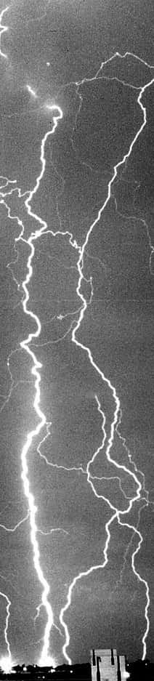
6. The pre-Clovis civilisation, c.13,000 BC
USAF via wiki
Kirby's last story, the one he did not complete before he died, was “The Secret City”. This was about an advanced civilisation on the banks of the Great Lakes. In 13,000 BC they knew they would not survive climate change. This is when the North American ice sheets began to rapidly melt, causing vast cataclysmic flooding: known as Meltwater Pulse 1A, and later 1B. Kirby’s date was right.
The story focuses on massive lightning storms. Ice cores show that ice ages create far more dust in the air, and more dust means more lightning. A great flood would create sudden enormous gradients in local sea temperatures, and hence sudden enormous pressure and moisture gradients in the air, like in the “Little Ice Age” of the 1500s, with its huge lightning storms. The much higher temperature gradients plus greater dust would create lightning storms bigger than anything we can imagine, just as Kirby said.
This coincides with the end of the pre-Clovis civilisation. Just before 13,000 BC, new people arrived in America. They had new technology: the efficient Clovis spear. For a long time, it was believed that they were the first humans in America, but archaeologists now have numerous sites that are older than Clovis. So Kirby was right: there was an earlier civilisation, and they disappeared at a time of massive sudden climate change, including vast electrical storms, centred around the edge of the miles-high ice sheet on what is now the Great Lakes area.
Kirby called their city ‘Gazra”, an alternative pronunciation of Gaza. Gaza was home to Phoenicians, the technologically most advanced people in the ancient world. But thanks to its strategic position near Egypt, Gaza was destroyed and rebuilt multiple times. The city and the neighbouring Gaza Strip are still bombarded to this day. It serves as a symbol of the fragility of civilisation. Sooner or later every civilisation collapses due to either pride or natural disasters, and usually both. We are all Gazra in the end.

7. The first gods, before 28,000 BC
Kirby wrote many stories about the gods. This book is about the future (2026 and onward), so we need to focus on the god of technology, Hephaestus.
Hephaestus is also called Vulcan, and features in Kirby's "Mercury in the Twentieth Century". Kirby’s story, and the ancient legends, show Hephaestus as a dwarf, living in a volcano, using its heat to forge his metal tools. But according to Manetho, the greatest Egyptian historian, there was originally another Hephaestus, called Ptah (renamed Hephaestus by the Greeks). Sanchuniathon said that all these gods began as people who made important discoveries, and so were always remembered. Ptah (called Hephaestus here) was the discoverer of fire:
“1. The first man (or god) in Egypt was Hephaestus, who was also renowned among the Egyptians as the discoverer of fire.”
Ptah lived sometime before 28,000 BC, the first date in Manetho’s history: Appendix 3 has more details about this early period, but this places the era at the time of the Nazlet Khater archaeological site. Nazlet Khater is the first “behaviorally modern” site in Egypt. Behaviourally modern means “upper Palaeolithic”: with metalwork, trade, cooking, fishing, and composite tools like the bow and arrow. The site includes skeletons of miners, whose bones are often short and deformed due to mining for metal underground. Who knows, one of those skeletons might be the dwarfish Ptah himself!

Manetho’s timeline
Manetho continues:
“Thereafter, the kingship passed from one to another in unbroken succession down to Bydis [meaning ‘king’, a ruler that is not a god] through 13,900 years. …
2. After the Gods, Demigods reigned [that was, humans claiming to be sons of gods] for 1255 years, and again another line of kings held sway for 1817 years: then came thirty more kings of Memphis, reigning for 1790 years; and then again ten kings of This, reigning for 350 years.
3. There followed the rule of Spirits of the Dead and Demigods, for 5813 years.”
The last period of 5813 years ends around 3200 BC when a single king conquered all of Egypt. Knowing that end date, we can work backwards. Before 3200 BC, “Spirits of the dead and demigods” ruled for 5813 years. 3200 + 5813 = 9013 BC. Working back again, 9013 + 350 + 1790 + 1817 + 1255 (total 5212) = 14225. So “demigods reigned” from around 14,000 BC. Working back to the start, 14225 + 13900 = 28125. So the first man-god, Ptah, lived just before 28,000 BC. These dates match what we see in archaeology when we allow for some percentage errors because the Egyptians use measurements like “341 generations” and we must then estimate how long a generation would be.

Before 28,000 BC: the first gods
28,000 BC is when upper Palaeolithic culture spread throughout Egypt. The changes began much earlier in South Africa, around 65,000 BC, reached Syria in 41,000 BC, and then spread back through Egypt. Presumably, Egypt was late because the river made hunting so easy: the old hunting life was not broken, so why fix it?

14000 BC: demigods
The next huge revolution in Egypt was the start of the Qadan culture in 14,000 BC. The “H1” Heinrich Event caused the worst droughts of the past fifty-thousand years. So the Qadans were the first Egyptians to actively tend plants to increase their yields. This meant the first move away from the Golden Age principle of not working for a living. This was not yet full-time work, but it was the start of the end of freedom. It created the first landowners: the first demigods. Previously, life was controlled by gods: the forces of nature, and amazing people like Ptah. Now life was controlled by demigods: landowners who claimed to be like the gods. The demigods loved their new power, but everyone else hated the loss of freedom. The world’s first known war was over land ownership in the Qadan region of Egypt: the famous Jebel Sahaba war grave.

9000 BC: the spirits of the dead
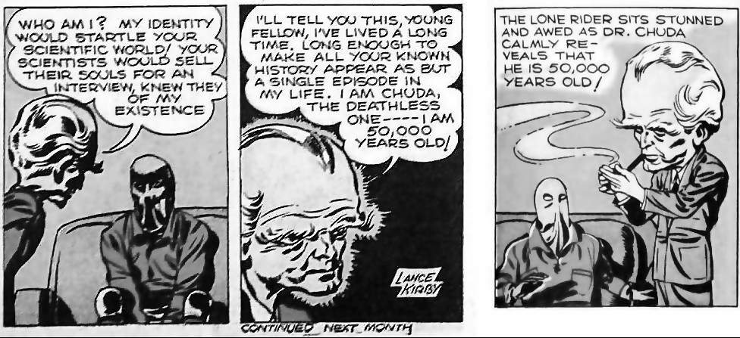
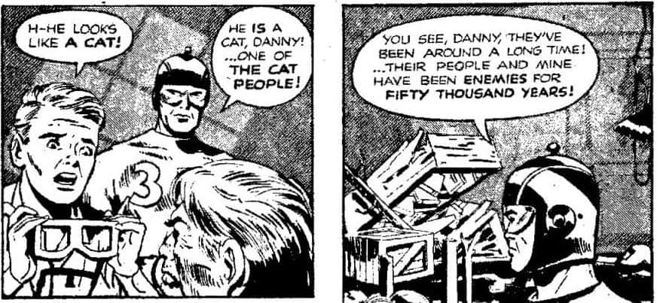
Qadan culture suddenly ended around 9000 BC. This coincides with the Younger Dryas climate crisis, and the Atlantis War, which the Egyptians recall as “The Destruction of Mankind”. This began six thousand years of wars over land. The bloodshed only ended when climate change around 3000 BC dried up the Sahara. This caused such an increase in wars that finally only one king was left: the first Pharaoh of all of Egypt. Similar processes created the first super-kings in Mesopotamia, India and China.
The wars over land were horrific, especially toward the end, 5,000 BC to 3,000 BC. Geneticists see the results in our DNA:
“Modern men's genes suggest that something peculiar happened 5,000 to 7,000 years ago [i.e. 5000 BC to 3000 BC]: Most of the male population across Asia, Europe and Africa seems to have died off, leaving behind just one man for every 17 women.”
Computer models show that the most likely cause was war:
“…fighting clans are indeed likely to cause a drastic drop in male genetic diversity.” … “As an example, he added, if you look at colonization throughout history, people generally ‘killed all the men and kept the women for themselves.’”
Notice how this only applies to DNA from Asia, Europe and Africa. The Americas kept the Golden Age for a little longer. But in short, Kirby was right. Our ten thousand-year civilisation belongs to Hephaestus: his metal tools created inequality, and that incentivises endless war.

8. Previous humans, c.50,000 BC
Kirby's favourite date was 50,000 BC, the start of the upper Palaeolithic (behavioural modernity) in most of Europe (but not yet in Egypt). Here are two examples: the 50,000-year-old Dr Chuda from “Lightnin’ and the Lone Rider”, and the 50,000-year-old Cat People from “Captain 3D”. Notice the variety of human forms: there were many different human species back then, such as the hobbit-like Homo Florensis (Dr Chuda is very short) or the hairy and muscular Neanderthals, traditional enemies of Homo sapiens. The “cat people” are also known as demons or Deviants, but they are only evil from our point of view, as we saw at the start of this chapter. In later stories, Kirby showed them in a more positive light: In Captain Victory, cat people reveal themselves to be morally superior to humans.
The most important 50,000 BC story is "Tuk, the cave boy". Tuk explores the origins of human civilisation. He sees other human species like “the hairy ones” (presumably Neanderthals) who will soon die out. Tuk visits Crete, where the Minoans will one day create the first European cities. He then visits Atlantis, which tried to preserve the Golden Age against the onslaught. He finally reaches Attilan, the city of the gods.

The city of the gods
Attilan, or cities just like it, feature in the Secret City, Fantastic Four, Eternals, and many other Kirby stories. All of Kirby’s work can be seen as a search for the city of the gods. Kirby's work can be seen as an answer to Augustine’s “City of God”: the philosophical foundation of Christianity.
Augustine wrote his book to explain why the triumph of Christianity had not made the world better. He answered that the city of God is not the same as an earthly city: it is a dream, a hope, that will one day exist, but does not yet exist (and certainly did not exist among the pagans):
"The glorious city of God is my theme in this work ... it still lives by faith in this fleeting course of time, and sojourns as a stranger in the midst of the ungodly ... And therefore, as the plan of this work we have undertaken requires, and as occasion offers, we must speak also of the earthly city, which, though it be mistress of the nations [i.e. Rome], is itself ruled by its lust of rule."
This is the eternal excuse of people who believe in inequality: inequality has never created a good enough society, despite ten thousand years of trying. But they never lose faith.
Kirby disagreed. His good society existed in ancient times. Something a little bit close to it existed in Micronesia. Kirby's cities of the gods — gods like Hephaestus, or Tangaroa — were real. So inequality is not the solution to our problems: it is the cause of our problems. But how do we go back to the golden age when the bad guys control all the land and have all the guns? Kirby’s hero, Moses, had a solution, as we will see in chapter 14.

9. The Toba eruption, c.73,000 BC
In The Eternals #2, Kirby tells how the gods caused a gigantic explosion, in Lemuria (an island in the Indian Ocean) to punish Deviants for their cruelty. This destroyed the Deviants’ civilisation. Kirby gives no date, but the event comes from before Homo sapiens ruled, and causes a dramatic flood, rather like the later Noah's flood. These patterns repeat through history: even today we are causing flooding as our civilisation decays.
Where was this great explosion that caused a flood before Homo sapiens ruled? Another Kirby image fits this scenario: Kirby’s cover to “Adventure Comics” #100 shows an Atlantis-like city dated as 70,000 BC. So Kirby imagined an Atlantis-like flood before 70,000 BC. And he was right. Around 73,000 BC the Toba supervolcano in Sumatra erupted and threw out 700 cubic miles of magma, causing enormous tsunamis, and climate change that only a few humans survived.
Storytellers remember this event from 73,000 BC. The locals call the volcano Mount Tuhaweoba. They tell of how a farmer once broke a sacred promise after his greedy son ate all his food. Breaking that sacred promise caused Tuhaweoba to explode. Not sharing food does not cause volcanoes, but it does cause the part that matters: most of the death and suffering. When we study natural disasters, we find there is usually enough food, even in a famine-stricken country, but it is sold for profit instead of being given to the starving. So it is likely that the loss of life after the Toba eruption was due to people not sharing the scarce food, not from the scarcity itself. Once again, we see that inequality means civilisation cannot survive a natural disaster.

10. The great dying, c.195,000 BC
Kirby’s story “Marak” begins in 200,000 BC, but represents all of the past 200,000 years: it tells the story of mankind from when we became physically modern (200,000 BC), to the rise of warfare, agriculture, technology and global society.
Sometime between 195,000 and 123,000 BC (the DNA evidence cannot be more precise) an ice age was particularly bad, and the human population fell to perhaps just 600 individuals. The population was so low that all of today’s humans can trace their ancestry to a single woman, known as “mitochondrial Eve”. We only survived because somebody was smart enough to lead his people to a new land in South Africa, and then learned to eat oysters. Comedians often joke that the first person to eat an oyster must have been desperate! And he was. This is what kept the human race alive in its darkest time.
Kirby’s story the people wanted food. Humanity only survived because one leader travelled far away and tried radically new ideas. Marak first became strong by killing enemies, but he learned to change. In order to survive, he had to stop killing everyone, and work alongside them instead. That is the story of the human race: that is how we survive. The storytellers know. A tough and competitive society is a luxury we can only afford in easy times. When a real crisis hits, being competitive means we all die.

Conclusion
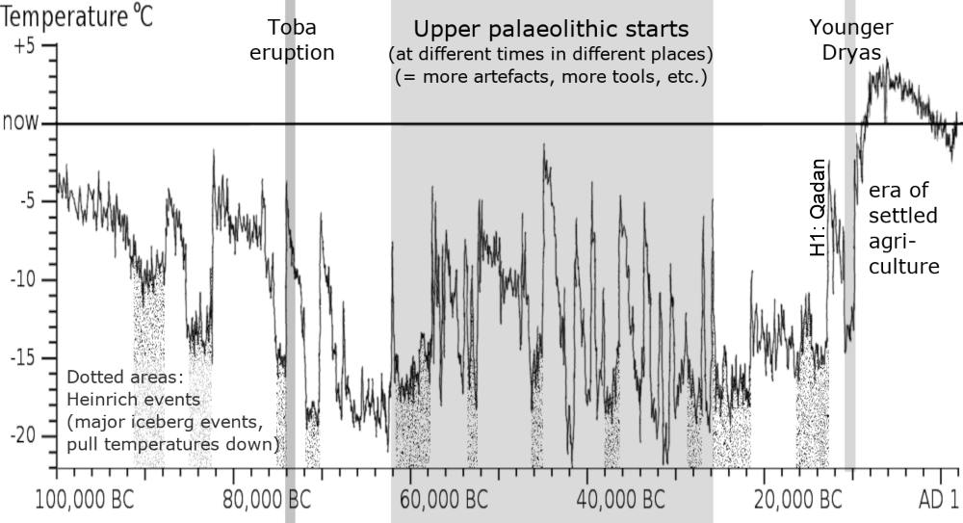
In conclusion, storytellers remember the events that matter: the Toba eruption and other catastrophes that periodically destroy civilisation. They remember the real cause of suffering: inequality. We need to listen to the storytellers. Ee need to remember that our present settled civilisation (8,000 BC to the present) is due to a freakishly stable climate that is almost certainly a temporary blip. This graph might help explain the problem:
Data: North Greenland Ice Core Project (Kindler et al., 2014) via 'Goeland1234' on Wikimedia CC-BY-SA-4.0
Spikes are normal. The current ten thousand year quiet period is not. The general curve of ice ages is due to the wobble in Earth's orbit. The spikes are due to Heinrich events (where major icebergs break off, changing ocean currents) or sometimes super volcanoes, or, now, human activity. Every sudden spike causes civilisation to reboot.
Some people think that science can save us. But they neglect the most important science: sociology. Remember Toba: they had food, but it was not shared. Remember Noah: the rulers, with their advanced science (their towers and canals), profited from the crisis: they profited from people dying. And now it is happening again, as we will see in chapter 13.

6.
The Power People
This chapter looks at the people who destroy civilisation: the people who want power over others. Kirby grew up among such people: his childhood in the 1920s was a time of gangsters and corrupt politicians.
“The average politician was crooked.”
Kirby understood that the world is run by these people. Kirby’s greatest villain, “Darkseid”, is based on these people:
“Darkseid was the guy who runs the world. … Darkseid was what we mean when we say — the powers that be”
Kirby called these people “the Power People”. They are the ones who cause suffering. Kirby wanted an end to power.
“He [Darkseid] was what we mean when we say 'them'; but what we really mean was 'us'.”
“They're the Power People. They're the ones who cause suffering.”
“I feel that we have to make another choice. I don't know what that choice is. Maybe it's an end to power. We have to find some kind of an end to power.”
Power People are good at trapping innocent people, so innocent people support their evil (see chapter 3, trope 4). We find ourselves working for employers and buying from businesses and voting for parties that all put money before people (while insisting that they do not). What else can we do? Here is a Kirby story about a woman who was trapped by Power People. She did not see a way out, so she decided to play along until she had enough money to escape…
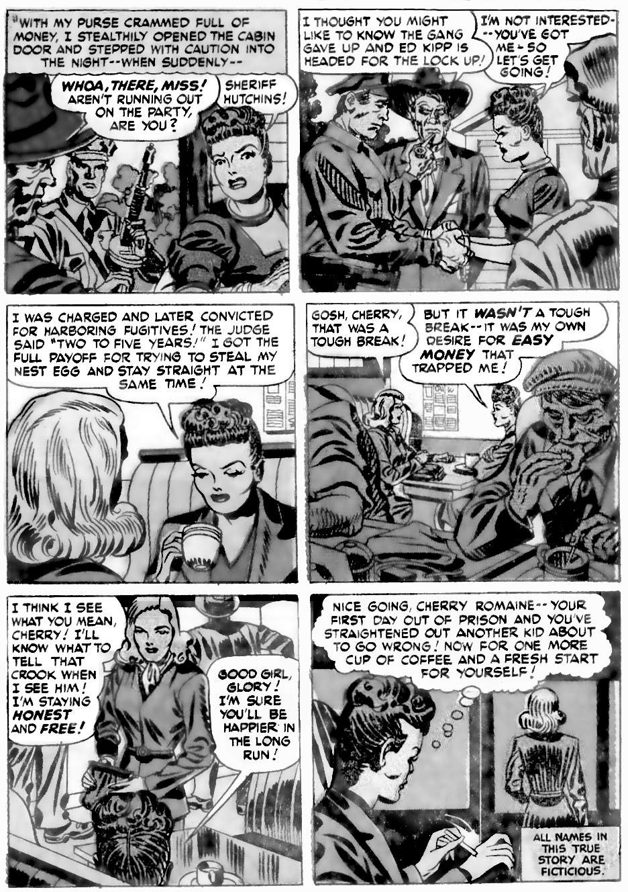
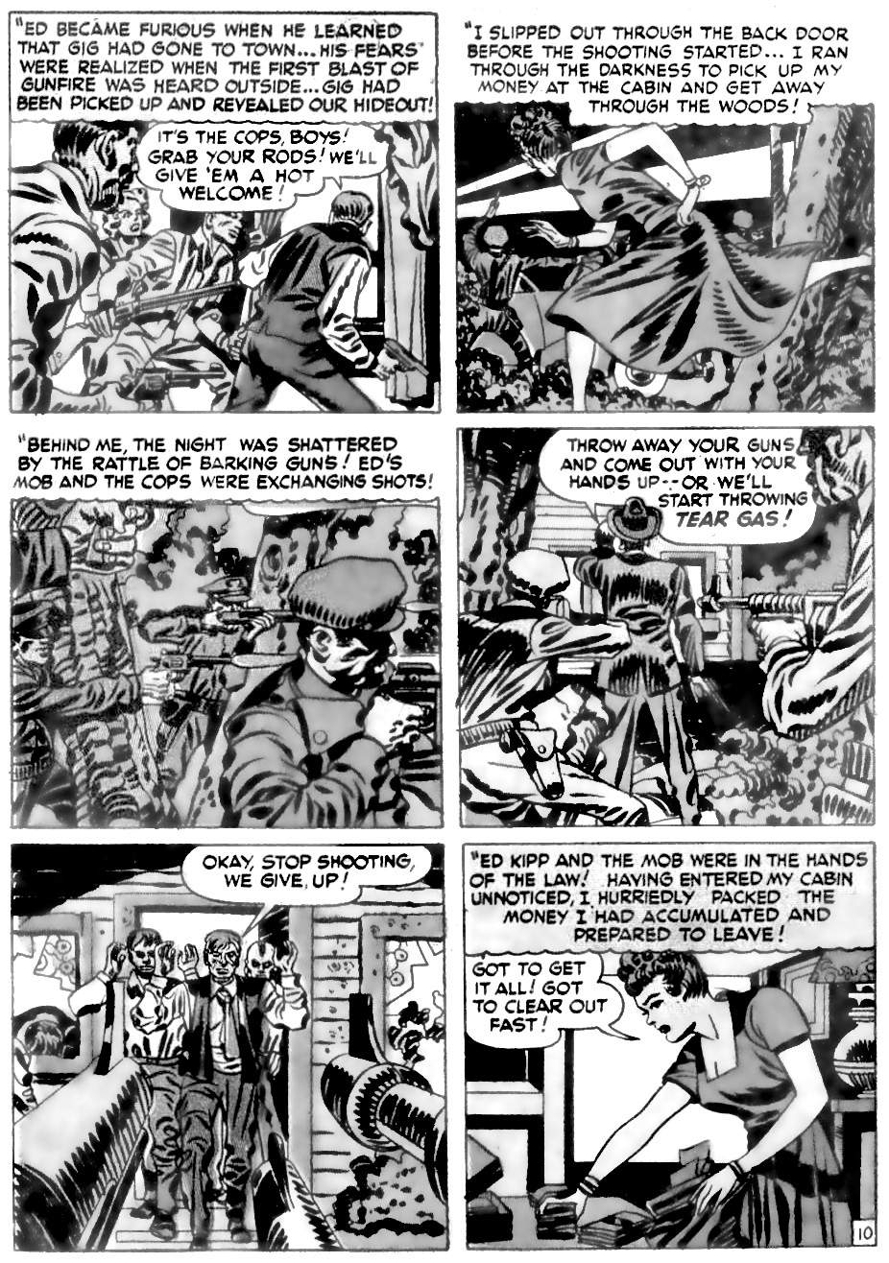
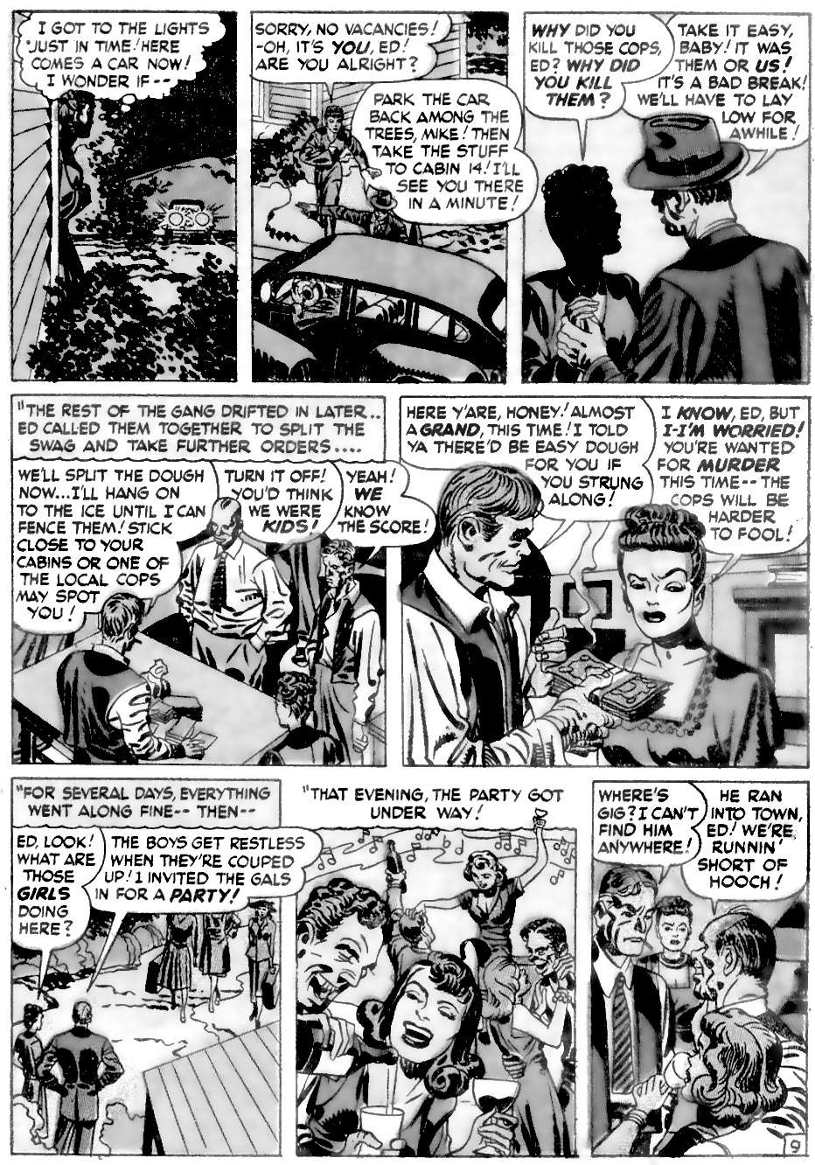
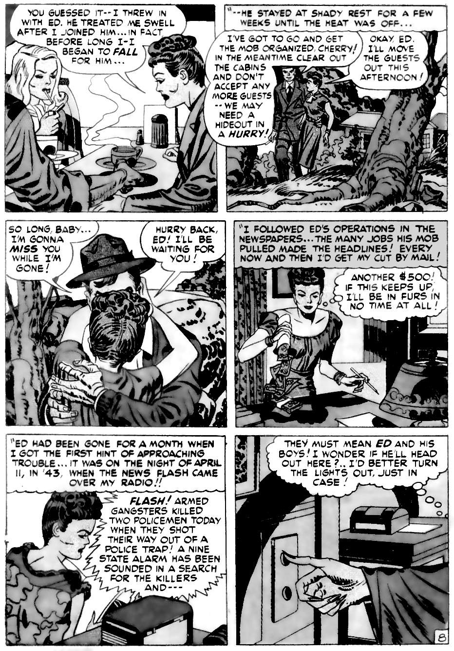
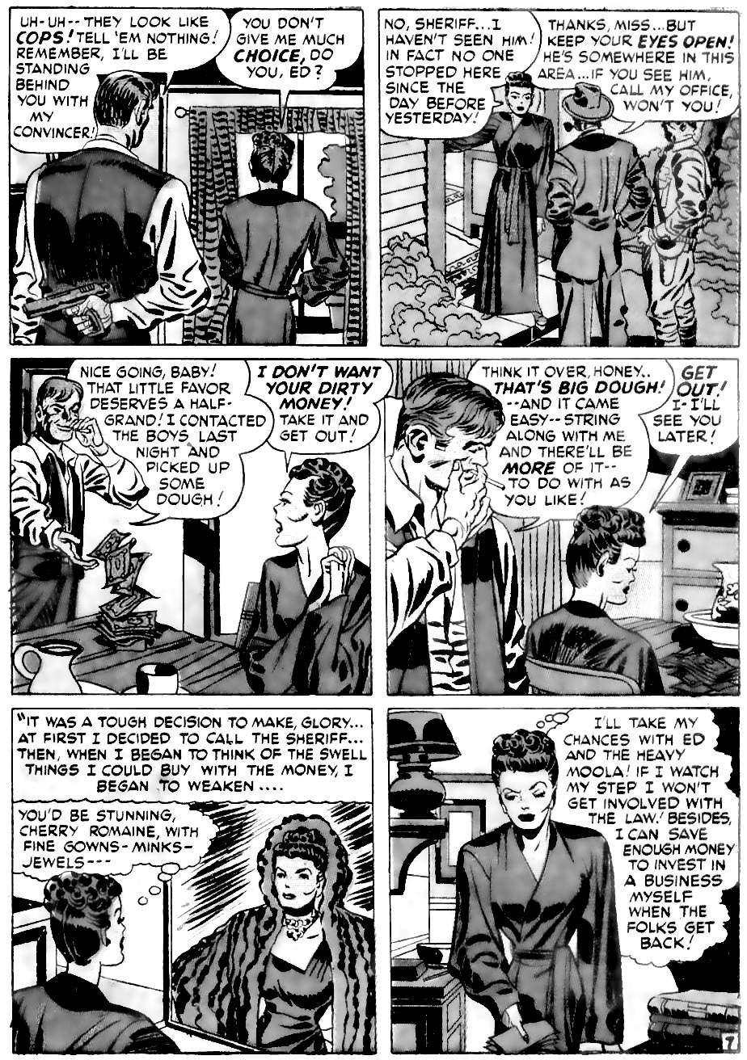
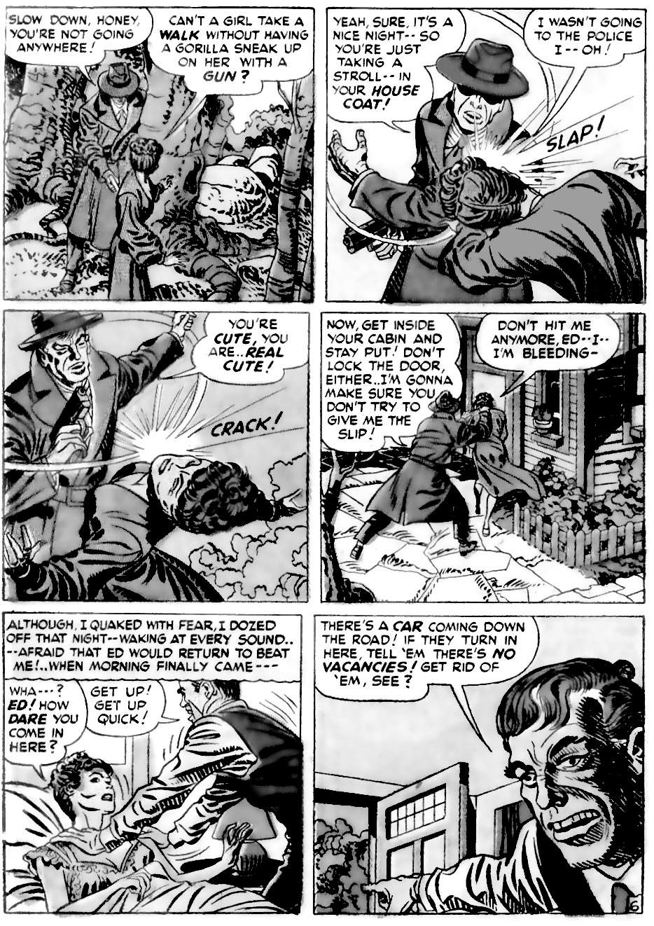
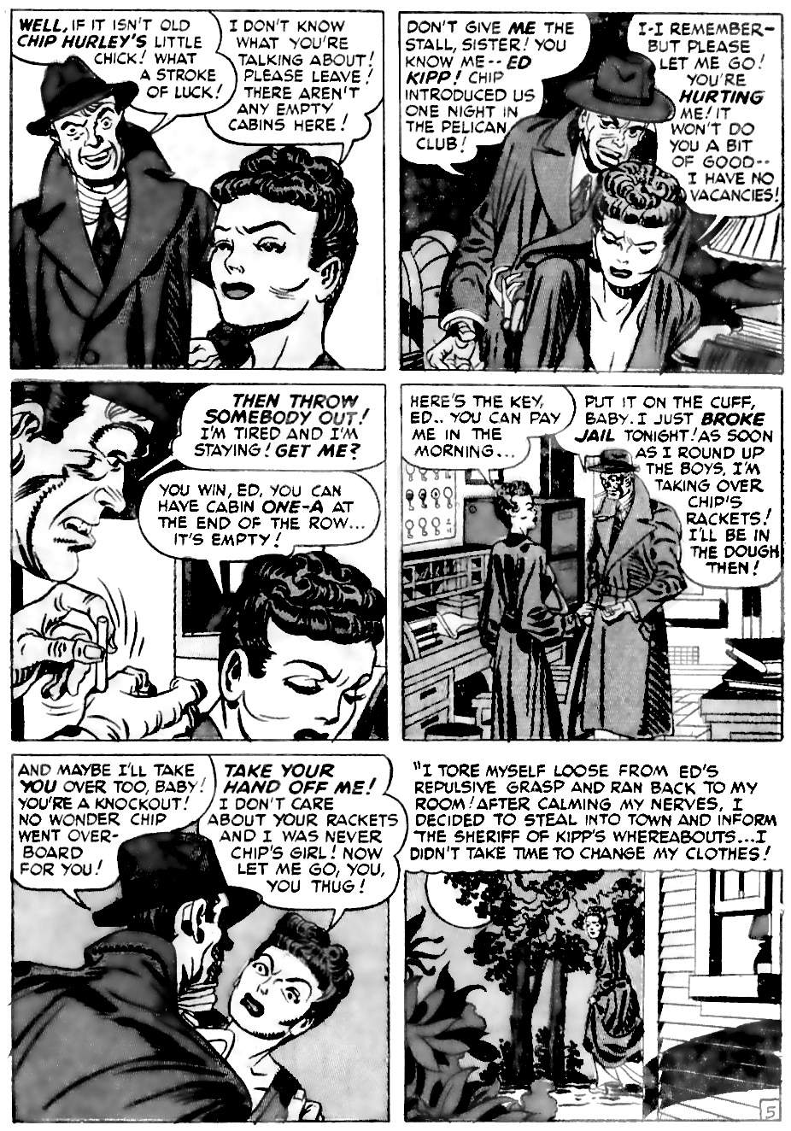
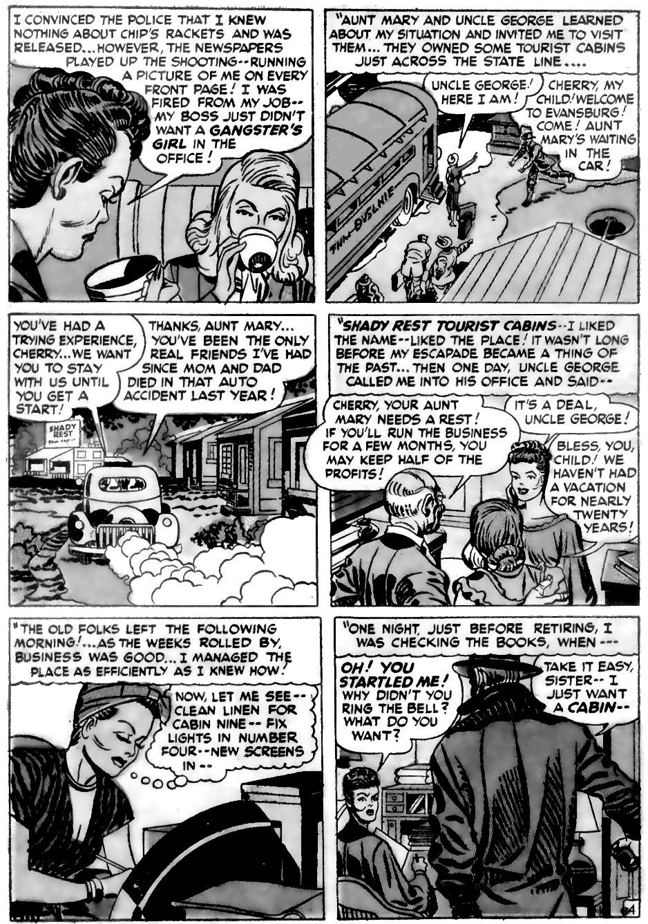
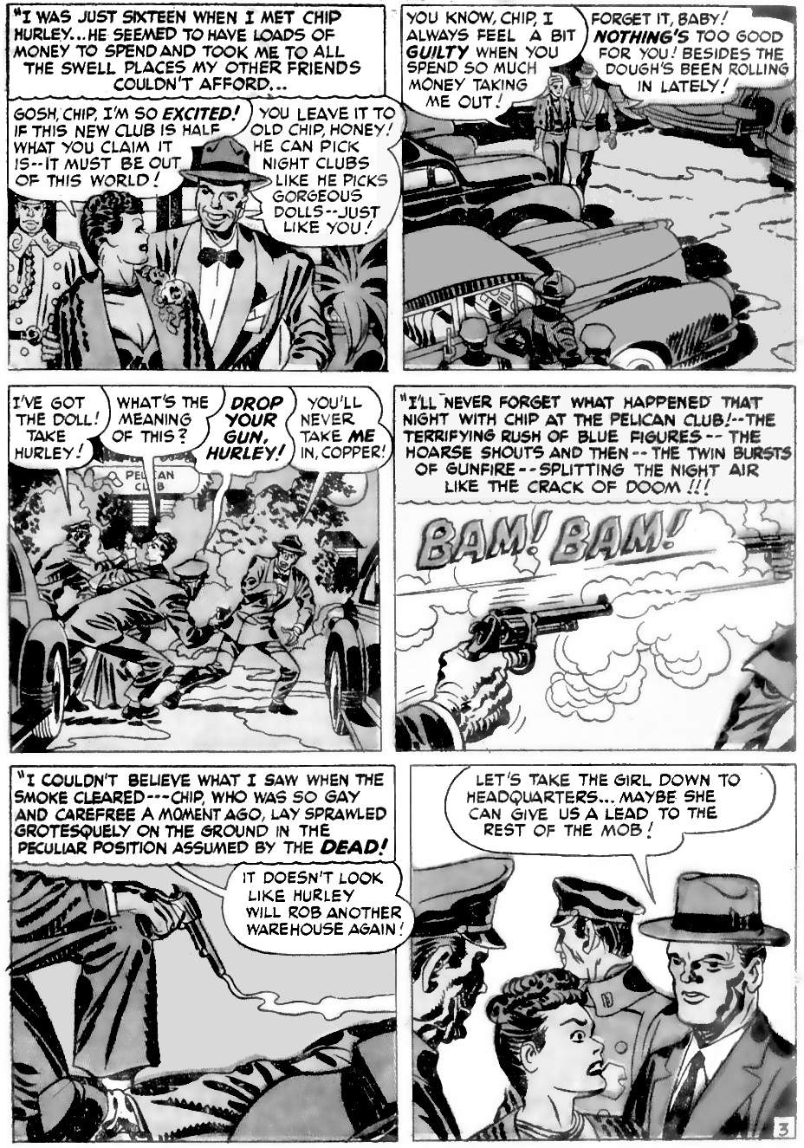
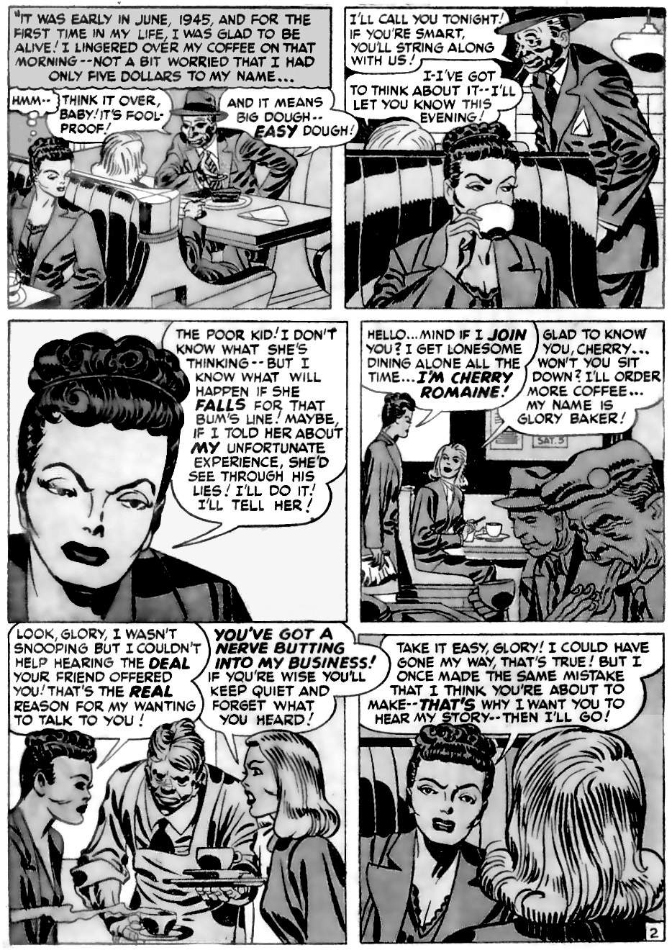
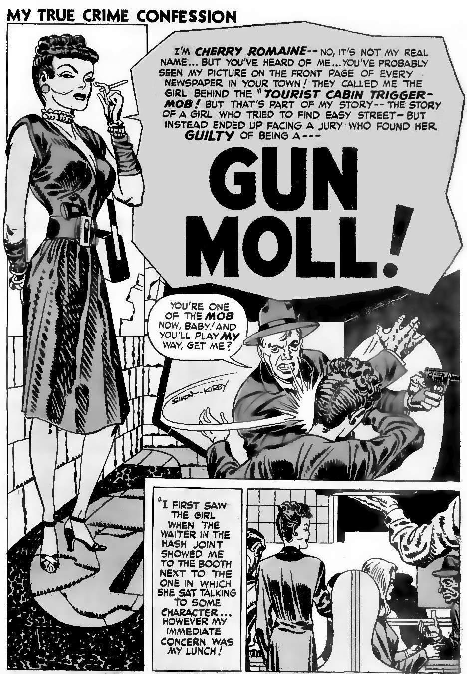
Kirby's hatred of Power People is due to his compassion for their victims. All of Kirby’s stories are ultimately about compassion.
INTERVIEWER: “Would you say there's some central theme that you have throughout all your [stories]?”
JACK: “Yes, there was a central theme. And the central theme was compassion. I have as much compassion for my villains as I do for my heroes.”
Cherry was a criminal. She admitted it. She accepted her punishment. But the closer we look, the more we feel compassion for her. Cherry was a child, alone and scared. Just look at how the story begins:
"For the first time in my life I was glad to be alive".
So she was unhappy for her whole life. She was just sixteen years old when she went to jail. Just sixteen! Her parents died in a car crash a year earlier. She had no other friends, except her aunt and uncle who lived far away. Look at the harsh lines on Cherry's face, compare her tight hairstyle to Glory’s soft flowing locks; see her extremely narrow waist and nightclub style dress. She is under extreme pressure: she cannot be herself. We could spend a whole chapter just on page 7 panel 4: how she is squashed into the table, what the angles say about power relationships, etc. She is being crushed.
What was Cherry supposed to do when Chip asked her out? She didn't know that Chip Hurley was a gangster. She was an unhappy child: this was probably the first time anybody showed her any attention. She was naive, innocent. But the newspapers put her young face on the front pages to shame her. Because of the newspapers, the moral people. She lost her job, and could not get another one. She could not escape: even in a remote forest, Ed Kipp found her, beat her, and drew blood. He would have killed her if she tried to escape again. Can we blame Cherry for not calling the Sheriff when Ed left? If she did, a member of the gang would eventually find her and kill her. And her aunt needed her to stay and run the business. Cherry’s decision to play along with Ed was rational: her aunt would be back in a couple of months. She would play along with the gangsters until then and then have enough money to escape.
Cherry indeed thought about the nice things she could buy, because that gave her hope. And she began to have feelings for Ed because humans adapt. We can't fight forever. We accept our bad situation and decide how to survive. Because that is what life does: it survives. To survive and thrive, we must become a willing part of the system.

Power versus life
Kirby was fundamentally opposed to any system of power. He believed in cooperation and agreement, not. If agreement fails, then we walk away: we use Tabu. If somebody has more power over you than that, then you become their puppet.
“If someone took control of your mind and you were not able to think as yourself any longer, you would no longer be yourself. You'd be something in his command. You as an individual would be dead.”
You become dead as an individual.
“You do it anyway [follow orders] despite the fact that you didn't want to do it. You're dead as an individual. You have no choice.”
Kirby's villains all want power over others. His greatest villain, Darkseid, spends his life searching for the anti-life equation, the secret of controlling everybody. Power over others is anti-life.
Recall how the Golden Age was defined as the age when people did not have to work for others. Golden Age people felt very sorry for non-Golden Agers. We know this because Europeans met Golden Age people in the Americas. This is what Kondiaronk, a Wendat (Huron)s warrior, said to Lahontan, a European:
"Take my advice, and turn Huron; for I see plainly a vast difference between thy condition and mine. I am Master of my own Body, I have the absolute disposal of my self, I do what I please, I am the first and the last of my Nation, I fear no Man, and I depend only upon the Great Spirit: Whereas thy Body, as well as thy Soul, are doomed to a dependance upon thy great Captain [the king of France]; thy Viceroy disposes of thee; thou hast not the liberty of doing what thou hast a mind to; ... Ah! my dear Brother, thou seest plainly that I am in the right of it; and yet thou choosest rather to be a French Slave than a free Huron."
Kirby felt the same way: working for someone else is slavery. He saw his father work in a factory, and how it crushed his father's soul. Young Jack Kirby got a job in an animation assembly line: he was a cog in a machine, like his father. Jack began to lose his identity. He began to ask, “Who the hell am I?”
“It was a big organization and I was just a 17-year-old kid. So who the hell was I, and that was the question I always asked myself. I'd say, - Who the hell are you?”
Kirby had to be free. Otherwise, he was not himself: he was not an individual; he was not alive. From the moment he left that assembly line he would always work for himself, creating what he wanted. But he still needed publishers, so was never entirely free. He tried becoming his own publisher in 1954 but did not have the reserves of money needed to compete with the big boys in distribution (the anti-comics crusade of 1954 made it almost impossible to get new comics into stores). So he was dependent on large publishers who could take control of his work: they were Power People. Eventually, he had to leave them, he had to be free.
“[T]here comes a point when you've had a belly-full of the industry itself. I mean, you just throw up and say, ‘What the Hell!?’ I mean, what am I, a man or a thing? I can't live with this thing, and I couldn't. What I told them in effect was, ‘Screw you! I'll get mine somewhere else.' And I did. I moved from New York. I was away from the office, and the influence of the industry itself. I would sit in my own house and that was my world.”
Most of us don't have Kirby's talent or reputation, so we can’t just walk out. Most of us are always subject to Power People. Thanks to technology, we can try to get gig work, self publish, or change employers. But the same technology allows the richest people to take a bigger and bigger cut of the money. Because of that, soon it won't matter what the rest of us do. The Power People will own everything.
All Kirby could do was warn people against the Power People. But publishers are Power People: they won't publish books against themselves. So they changed Kirby's anti-power stories into pro-power stories. Let’s look at the best-known examples: The Avengers, and Star Wars.

7.
The Avengers and Star Wars
This chapter argues that Kirby’s most famous creations were designed as warnings against power. But they were taken by the Power People and twisted into stories that support power.
Kirby spent his life warning against power. His most famous stories are about superheroes: he designed them as warnings against super-power. With super-power, nobody wins. This may come as a surprise to Kirby fans, so we will look at his most famous superheroes, especially The Avengers, and also at New Gods, the inspiration behind Star Wars.
“The Avengers” was a story about avenging mankind against those who destroy civilisation through their love of power.
New Gods is about the gods that we worship today (power, the self, science, etc.), and how they lead to Armageddon.
The Avengers and Star Wars became the most successful movie franchises of all time. But they did it by twisting the anti-power message into a pro-power message. They took warnings against power into a celebration of power: they show power (a high-tech suit, or The Force) as the way to save the world from, er, from power.
The pro-power message is very popular because we are all, like Cherry Romaine, trapped by power. So, like Cherry Romaine, we all hope that if only we get some of that power, life will be good. So we watch power fantasies, just as Cherry fantasised about fur coats. We want to believe that there is such a thing as good power, and it will save us from bad power. We want to believe because the alternative is too horrible to contemplate.
Let’s start this chapter with a typical Kirby story about super-power. It shows how the mere existence of super-power is an existential threat to the rest of us. It also shows what we should do if we find ourselves with super-power. Then we will look at Kirby's other superheroes, and how he created them as arguments against power. Then we will look at how Kirby created the Avengers and inspired Star Wars, and how his stories were changed.
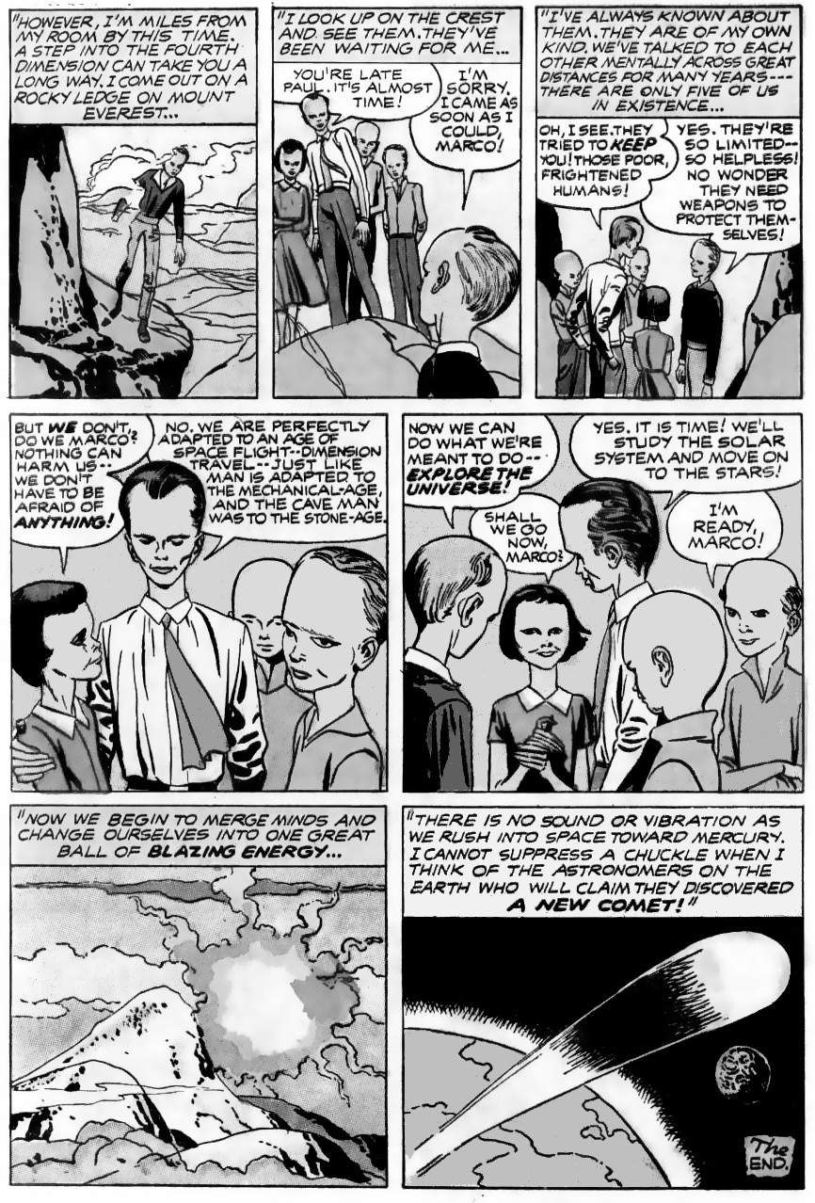
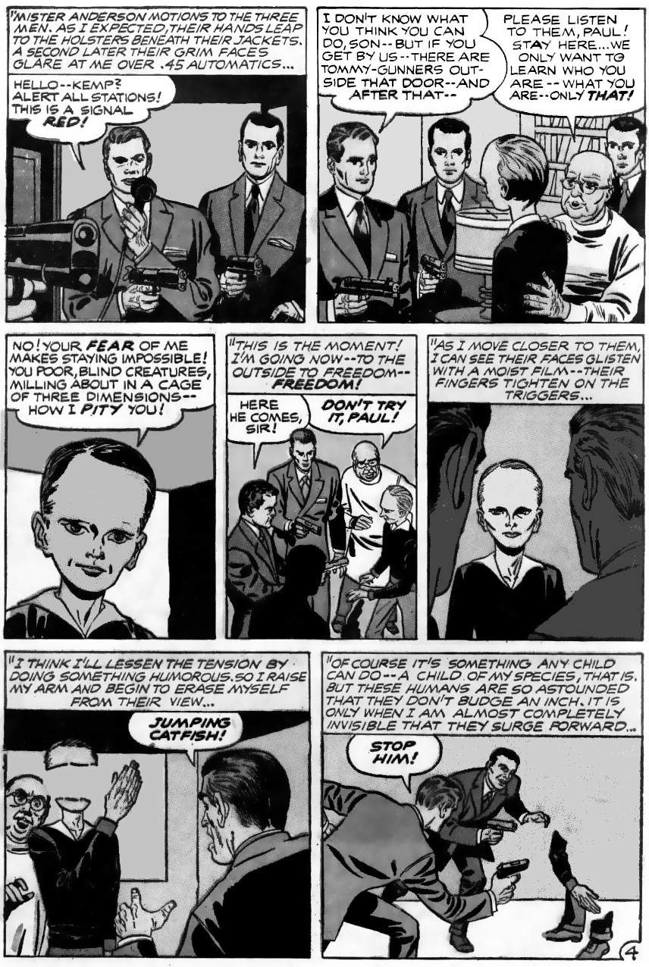
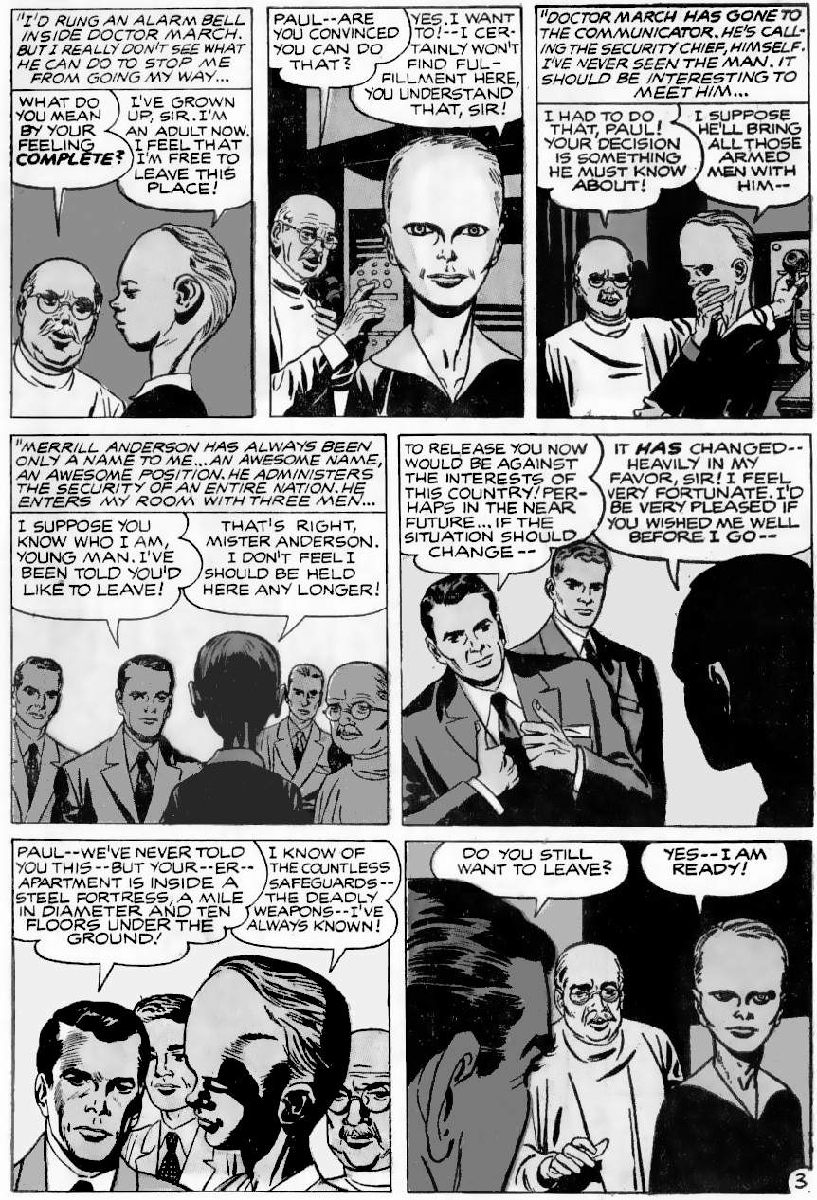
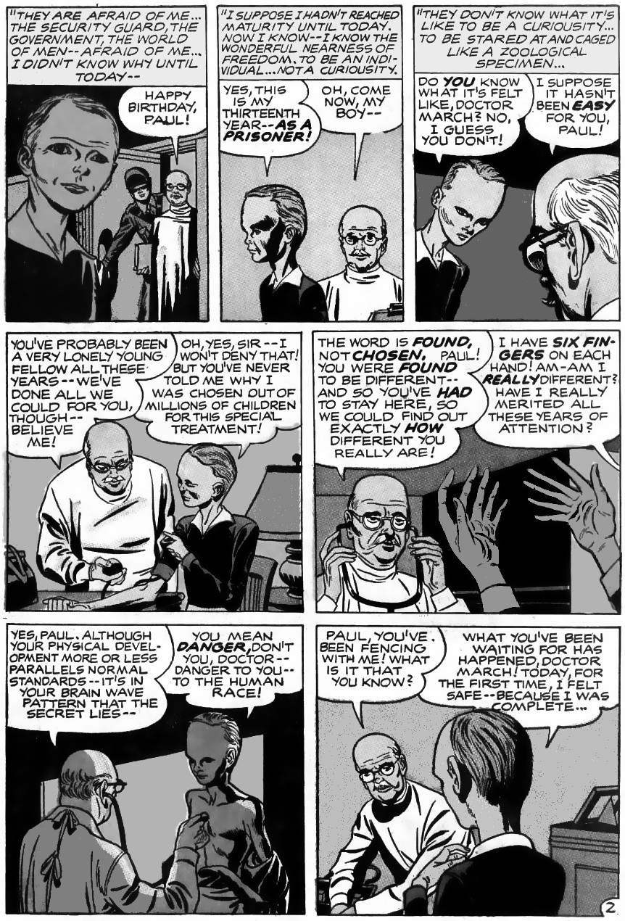
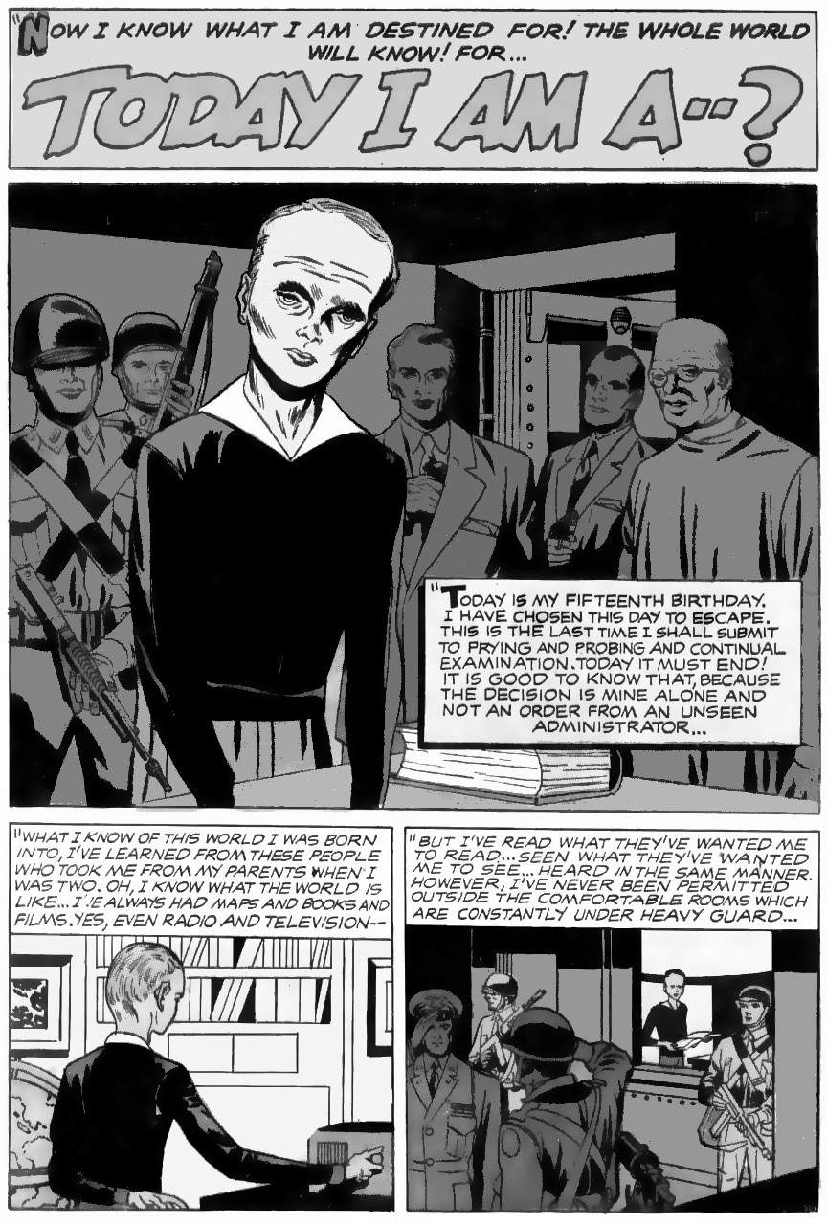
The title, “Today I am a”, comes from the Jewish bar mitzvah ceremony. Bar mitzvah is where a teenage boy became an adult, and declares, “Today I am a man". A child obeys authority figures. Their task is to keep the child safe. But a man makes his own decisions, takes risks, and might even sacrifice his life for his family. We will return to the theme of self-sacrifice later in this chapter, and chapter 14.

Super-powers are real
Our ancestors could only move as fast as their legs would run. But now we can drive at a hundred miles an hour. Our ancestors could only see as far as their eyes could see. Now we can use video and see anywhere in the world. We have superpowers!
But superpowers are not held equally. If you are super-human for owning a car, what did that say about Elon Musk? He owns a fleet of spaceships! If you are super-human for using video, what does that say about Google, with its real-time surveillance of everything we do?
Can we defeat inequality using open-source, shared technology? No, because we need expensive chip fabrication plants and fleets of satellites. These need centralised control. So technology makes massive inequality inevitable.
So the world has two species: the one per cent and the rest. They have different experiences of reality. The one per cent own all the resources, and the 99 per cent are merely “human resources” to be used and discarded. And once the one per cent has robots, the 99 per cent will not be needed at all.

Kirby’s super-heroes were warnings against power
Most Kirby super-heroes are extreme heroes, not people with power. This is obvious in the original versions, but can still be seen even in the published versions:
- Captain America, Kirby’s first and most iconic superhero simply had peak normal fitness. That is why a child, Bucky, could fight alongside him: each symbolised the ordinary American at his best. The Guardian, Fighting American, Black Panther, etc., were similarly ordinary people at peak human fitness. (Blue Bolt and Submariner were not originally Kirby creations.)
- Paul (this story), Thor, the Inhumans, New Gods, Eternals, Silver Star, etc. have powers that are perfectly ordinary for their species. They each prefer to be among their people, where they do not have greater power than others. Numerically, these families are the majority of Kirby's super-heroes.
Of those that do appear to have powers, the powers are a gimmick that adds zero net benefits: the same stories could be told without powers:
“Superpowers are a show gimmick. Why does a comedian decide to drop his pants on the stage? … The answer is attention. You want the readers' attention.”
- Ant-Man was just a gimmick to fight crime using ants. Other crime fighters use human informers who are probably more useful.
- The Fantastic Four dare simply a continuation of the non-powered Challengers. Everything the F.F. do using powers could be done without powers by the Challengers. In F.F. #1-9, the powers are a liability, making the public hate the team. After issue 8, Kirby's editor insisted on more reliance on powers, but that did not last: by the end of the decade, Kirby often showed the team in civilian clothes, barely using power.
This leaves two other groups: those whose powers merely compensate for some severe weakness (e.g. Iron Man), and those for whom power is a curse, making them a villain, not a hero (e.g. The Hulk)
Kirby superheroes are superheroes: just heroes, but more so. They fight against power. Captain America fights George Maxon, the aircraft manufacturer, alias the Red Skull, who uses poison as his power. Or Benson, the Banker with a team of immortal giants to intimidate his critics. The Fantastic Four fight a series of enemies who wanted to be kings (the Mole Man, Namor, Doom, Kurrgo, Puppet Master, etc.). Villains are routinely shown imagining life as a king before the team defeat them using courage and ingenuity.

Power corrupts
Kirby often wrote about how power corrupts. In "The Bully Boy", a bullied child is taught to defend himself and ends up being a bully himself. "The Incredible Hulk" was originally the story of how too much power turns a man into a monster. Orion and Captain Victory struggle against their desire to abuse power. In the original ending to New Gods Orion gives in and enjoys his power to kill.
Kirby's last work on superpowers was literally called "Super Powers". The series builds to a final battle, only to show that super-powered heroes are unable to save the Earth. Instead, the god of science (Metron) shows the power people the logical conclusion to their power:
  - Some are sent to 80,000 AD. By that time, even our most advanced technology is foolishly primitive. That is the problem with unequal power: eventually, you lose.
  - Some are sent to 60,000 BC, the era before the Golden Age began. There they play out their natural savagery in its purest form and destroy each other.
  - Some are drowned in Atlantis. This reminds us of planet Earth's preferred way to end proud civilisations: with floods.
  - The remainder is driven mad by seeing the insanity of their actions: how power ends civilisation, destroying its host.
Metron concludes that it would be better if super-powers never existed:
"We who now clash for power offer poor role models..."
All of Kirby's power stories show power leading toward death. The original Thor is the road to Ragnarok; New Gods is the aftermath of Ragnarok and follows the same path, “the road to Armagetto” (Armageddon); Captain Victory is about endless death; in Silver Star, all the humans are going to die; in The Eternals, the world is judged for its crimes, etc.
“Today I Am” shows the correct attitude to super-power: we should find a place where our power is considered ordinary. How exactly Paul does this is open to several different interpretations.

How Kirby’s warning was reversed
The publishers’ changes are most obvious in Kirby’s 1960s work. Here are some examples from The Lost Jack Kirby Stories:
- The first Fantastic Four story was about the dangers of nuclear testing. The theme was completely removed, and the story became a way for the Fantastic Four to beat up a little guy and his pets.
- The Fantastic Four were supposed to be outcasts, hated by the public. They were changed into celebrities.
- The Hulk was supposed to be the bad guy, the symbol of unrestrained power. He was changed to make him the hero.
- Iron Man was supposed to oppose the Randian ubermensch values of his enemy, Kirby's Dr Strange. But Iron Man was later written to embrace those values.
- Spider-Man was supposed to be about large-scale inequality in the real world: Kirby's Spider-Man prototype, The Fly, refers to president Batista stripping his country’s assets and has a story about advertising controlling our minds. The published version became inward-looking, with nothing that might question real-world power.
- The X-Men was about the powerlessness of ordinary humans when faced with super-power. This was changed to make the stories light-hearted and inconsequential. The changed stories did not sell well. Over a decade later, another writer relaunched the X-Men, returning to the theme of mutants versus humans, and they sold better. But he made power look brooding, sexy and desirable.
Kirby called his heroes “Avengers”. To “Avenge” means to inflict harm in punishment for evil. This is a sign that the world is broken: the Golden Age needed no “avengers”:
“The Golden Age was first founded, which, without any avenger, of its own accord, without laws, practised both faith and rectitude. Punishment, and the fear of it, did not exist, and threatening decrees were not read upon the brazen tables, fixed up to view, nor yet did the suppliant multitude dread the countenance of its judge; but all were in safety without any avenger.”
Demon Wind shows how the Golden Age existed without violent punishment: in a small society, simply withdrawing help from evildoers is a death sentence. In a healthy society that is all we need.
Kirby’s first Avenger was Tuk, from 50,000 BC (before the Golden Age began in 39,000 BC). The name “Tuk" means “Avenger”. Tuk is the story of how the “hairless ones” (presumably Homo sapiens) massacred another race of hominids, “the shaggy ones”, and so our hero wants revenge. Atlas, from 8000 BC the end of the Golden Age), was also known as “The Avenger” because the serpent people killed his people. The modern Avengers are named for a similar reason in Avengers #1: they want revenge for Loki killing nearly all of mankind.
We do not know the exact words Kirby wanted for Avengers #1, but we do know that he intended Loki stories to reflect the Norse myths (hence “Tales of Asgard”). In the myths and in the comic, Loki acts immaturely. In the myths, immaturity leads to Ragnarok, the end of the world. Loki does various evil things for fun, such as killing the pure-hearted god Baldr. This is a central event in Kirby's Ragnarok mythology: New Genesis arises from Baldr’s ashes. Loki's worst crime was being an irresponsible parent. Loki had three sons who were prophesied to do even worse mischief than their irresponsible father, climaxing in Loki's son Fenris (the wolf) killing Odin. The resulting chaos causes Ragnarok, the end of the world.
However, Kirby's editor at the time removed seriousness wherever possible. So the published version of Avengers #1 has no hint of dark consequences to Loki's immaturity, nothing serious to avenge, and hence no reason for the name "avenger". Instead, Loki’s immature use of power is presented as fun and essentially harmless.
Ancient writers knew that immaturity in adults is anything but harmless. The poet Hesiod says this is what caused the fall of the Golden Age: when men began to act like irresponsible children.
“[The silver age] was like the golden race neither in body nor in spirit. A child was brought up at his good mother’s side an hundred years, an utter simpleton, playing childishly in his own home."
This immaturity is seen in wanting to have easy food and land ownership in 8,000 BC, the short-sighted greed that led to our present problems. The immature silver age led to the Bronze Age, the age of war. That was followed by a brief age of heroes when the fall of Troy gave hope that the Greeks might reverse the decline, but that failed and we entered our present age of Iron, the age of unpleasant work, the age of being ruled by bosses like children are ruled by parents.
Kirby, like the ancients, loved children but hated immaturity in adults. Kirby called his editor “the kid": because of his immaturity. Stories like “Today I Am A”, and “Gun Moll” are about how children must become adults.

How Kirby inspired Star Wars
Kirby's magnum opus is the space opera New Gods, about the battle between evil Darkseid and heroic Orion, who was raised not knowing that he was Darkseid's son. New Gods was the biggest event in comics in 1971. George Lucas was a huge comics fan at the time: he part-owned the "Supersnipe" comic shop/art gallery. He also made movies.
"George Lucas has been conducting a lifelong double affair, embracing the comic strips on the one hand (or with one arm) and the movies on and with the other."
Lucas bought New Gods from his partner at Supersnipe, Ed Summer. New Gods #1 was cover date- March 1971. That was the month when Lucas began talking about Star Wars. Of course, the movie had plenty of other influences: Flash Gordon serials, World War II dog fights, Samurai movies, etc. But without New Gods, the other material was just a pile of old clichés. Legendary critic Pauline Kael called Star Wars "an assemblage of spare parts" The Washington Post called it "refurbished stock scenes, conventions and spare parts". Sir Alec Guinness called it "a fantasy world of second-hand, childish banalities." Yet certain details made Star Wars special, and those details all come from Kirby:
- The Force: Darkseid gets his power from a mystic force that binds everything in the universe. It is called "the source".
- The Dark Side: “Darkseid” is pronounced “dark side”. Darkseid referred to the dark side of the source as “the other side”: one of his first lines is “Who can deny the power of the other side?” — compare Vader’s “if you only knew the power of the Dark Side”.
- The Death Star: Darkseid's base, Apokolips, is a planet covered in weaponry, with enormous trenches, and enormous circular fire pits, looking like the Death Star’s main weapon. Darkseid uses lasers (powered by stars: literal star wars) to destroy planets.
- Darth Vader: The Nazi element is obvious of course, and "Vater" is German for "father". “Dark [side] Vater” became “Darth Vader”. Lucas originally planned a cross between a Samurai and a Nazi, but it didn't look quite right. Vader's final look, and also his personality, is more like Kirby's most famous villain, Dr Doom. Vader even has Doom's disfigured face behind the mask.
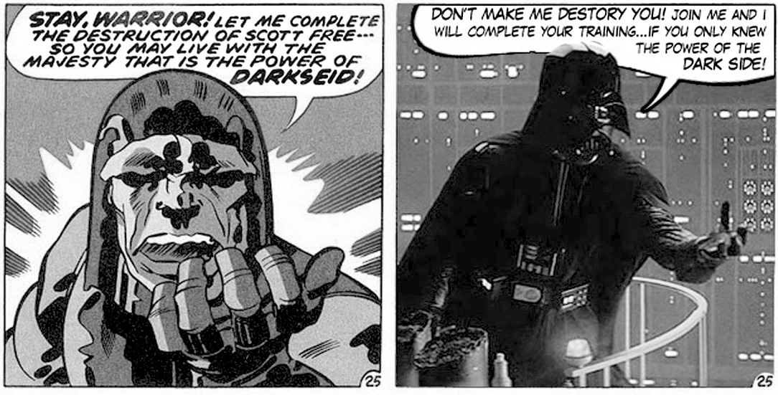
- The most iconic scene in the franchise: where Vader urges his son, Luke, to join him, has many similarities to the scene where Darkseid urges his adopted son to join him (see below).
Image: Russell Payne, from DC comics and 20th century Fox, Fair Use
- The second most iconic scene in Empire: the scene where the heroes first see Vader across a dining table in the cloud city is very similar to the most iconic Dr Doom scene ever (see below).
- The father-son relationship: This does not appear on screen until the second movie, but is implied by the August 1975 draft of Star Wars and by a comment Lucas made at the time. Fans consider the second movie, focusing on this relationship, to be the best of the series, and the one that turned Star Wars into a viable franchise. Without it, Star Wars would be a one-hit wonder.
Comic fans noticed that Star Wars was indebted to Kirby:
"At this dinner George Lucas was relaying his story for Star Wars [and it was clear that] George Lucas was hugely indebted to Jack Kirby for Star Wars.”
Mark Hamill was certainly aware of the debt when he visited Kirby:
"We were joking, and I said that when I first saw Darth Vader, I thought, ‘Oh, it's Doctor Doom.’ [laughter] He certainly didn't say, ‘Oh, he took my ideas,’ or any of that kind of stuff. He was content with who he was and his abilities."

Those iconic scenes
In Mr Miracle #9 (part of the New Gods story), Darkseid's adopted son Scott Free is trapped in Darkseid's stronghold. Scott’s body is battered by debris from all sides as Darkseid watches. Darkseid reaches out his hand in the classic Vader pose, using very similar words. Scott screams at Darkseid and throws himself down the Boom Tube to safety. Sounds familiar?
Dr Doom's defining scene is dramatically homaged on the last page of Fantastic Four #142, and the homage is very close to the dining room reveal in The Empire Strikes Back. This issue was important, especially to comic shops, so Lucas would have seen it. A few weeks later Lucas began writing the first script for Star Wars.
The most iconic scene in Return of the Jedi, the showdown, may also have New Gods roots. It was originally planned for the lava caves under the Emperor's throne room. This is like New Gods #11, page 22: “It is written that the father of Apokolips shall meet his banished son in the red light of the fire-pits! -- And there they shall decide this war!”
Star Wars is based on hundreds of different sources, but the ideas and images that make it special all come from Kirby.

How Star Wars changed from New Gods
As with the Avengers, Star Wars took Kirby's anti-power message and made it pro-power.
New Gods is a warning against power. “The Source”, the ultimate power, is wisdom and not force. But Orion constantly struggles with his inner dark side. All gods struggle with power: the gods’ planet, New Genesis, appears idealistic but has slaves beneath the city. Darkseid is not redeemable: the love of power is absolute evil. In the end, Orion gives in to his desire to kill those who oppose him, and both sides annihilate each other. There is nothing triumphant about New Gods.
In Star Wars, salvation comes from power, from “The Force” that physically forces your will onto the outside world. Jedi warriors do not wrestle with power, they win by quietly accepting it without mental reservation. Jedis are an elite, born better than others. In the prequels, Lucas even created “midi-chlorians”, so you are either born elite or you are not. Lesser people must just accept their lower status at birth. Once you are elite, you can kill billions of people and be forgiven, with no consequences, as Darth Vader learned. Star Wars is a story about the elite embracing the power that makes them special: the message is “use the force” and “may the force be with you”. In contrast, Kirby said that a system based on elite power will destroy us all.

8.
1976: The Space Gods Return
This chapter is about our return to a world ruled by god-kings. Kirby predicted this in The Eternals, and portrayed the god-kings as larger-than-life space gods, “Celestials.”
In ancient times, the most powerful kings were always presented as larger than life, easily conquering their enemies. They were often considered divine. For example, Gilgamesh was “one-third man, two-thirds god". They built great temples to show their connection to the sky. In modern times our most powerful men go one further. They create space ships: temples that let them fly in the heavens.
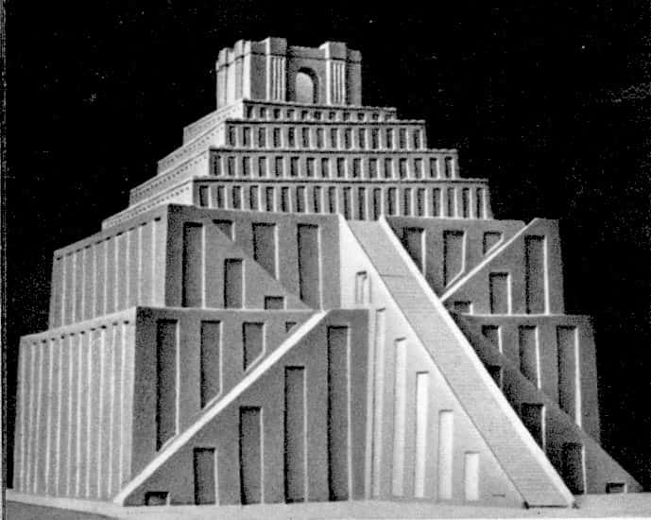
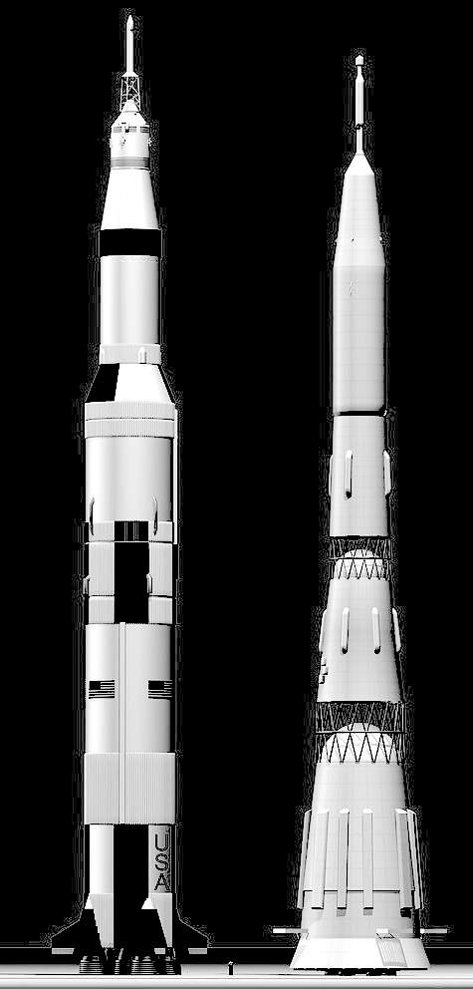
It might seem strange to call people like Elon Musk and Jeff Bezos “space gods” but this is the normal language of mythology. Anyone with power beyond men had the power of a god. Let’s start with a story to illustrate the principle. Blue Bolt is a human who flies in the sky and hurls lightning bolts. So Kirby patterns Blue Bolt after Mercury the sky god.
Image: Michael V Fox, via Wikimedia, public domain
‘Ebs08’ CC-BY-SA-3.0
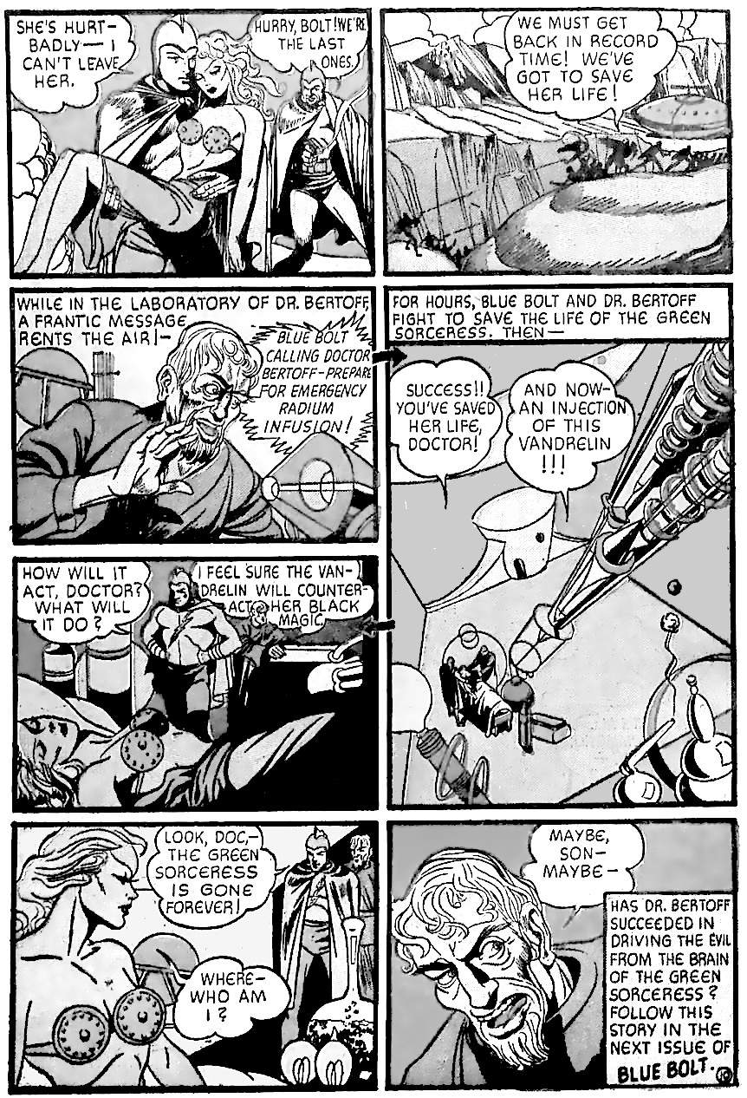
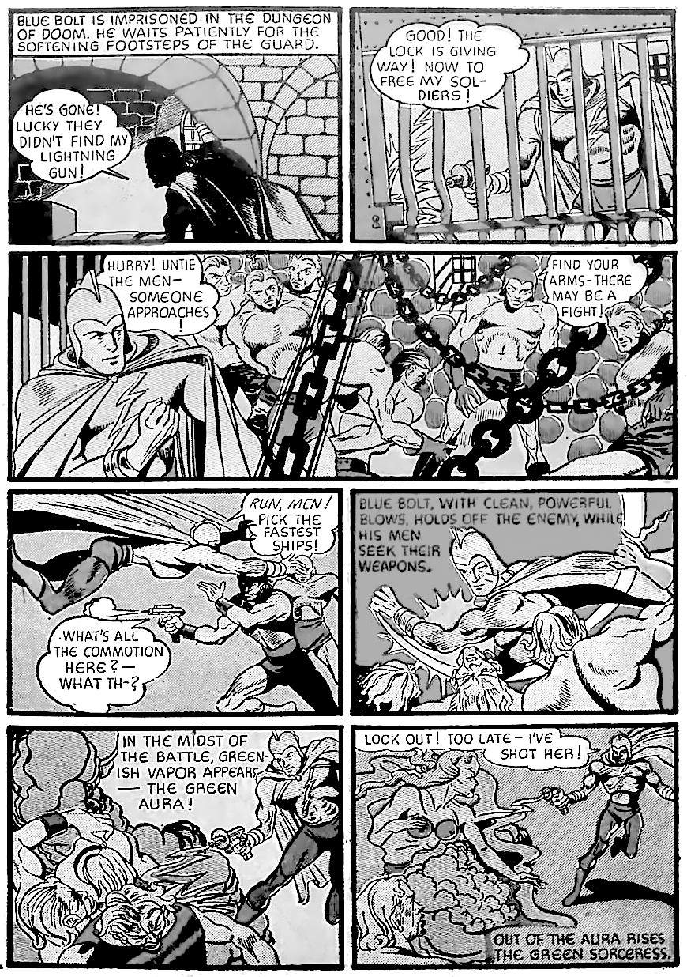
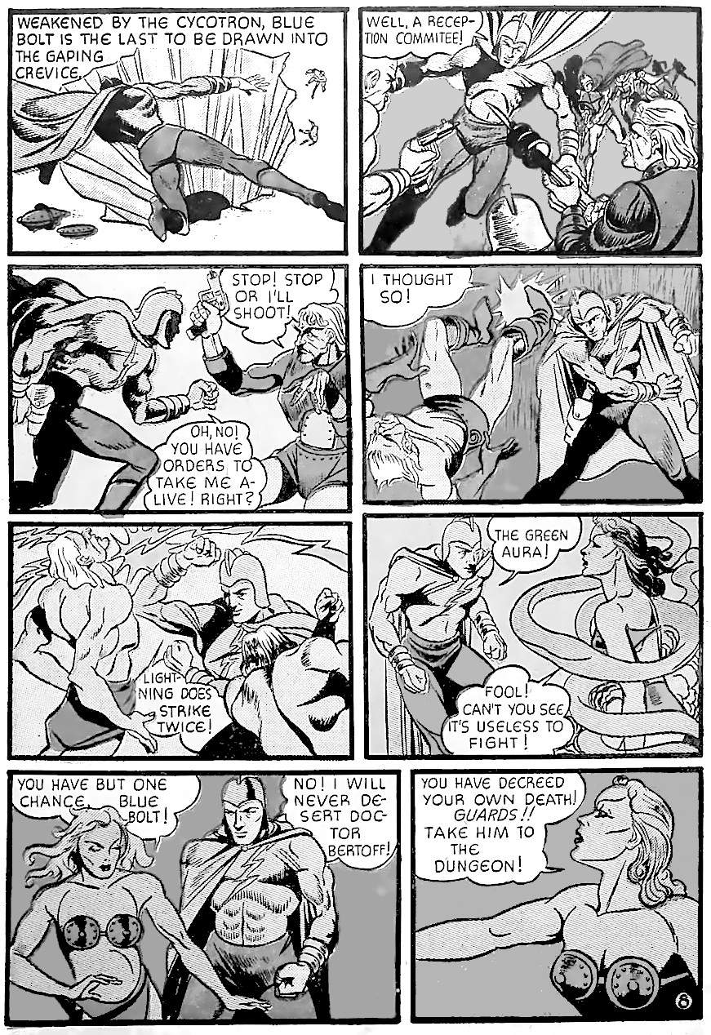
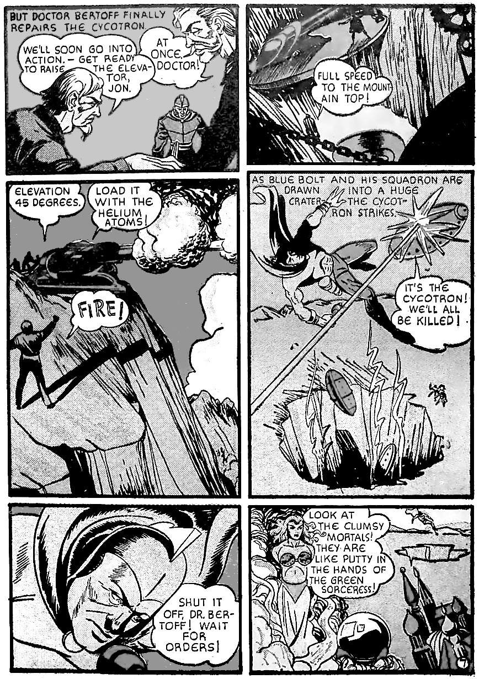
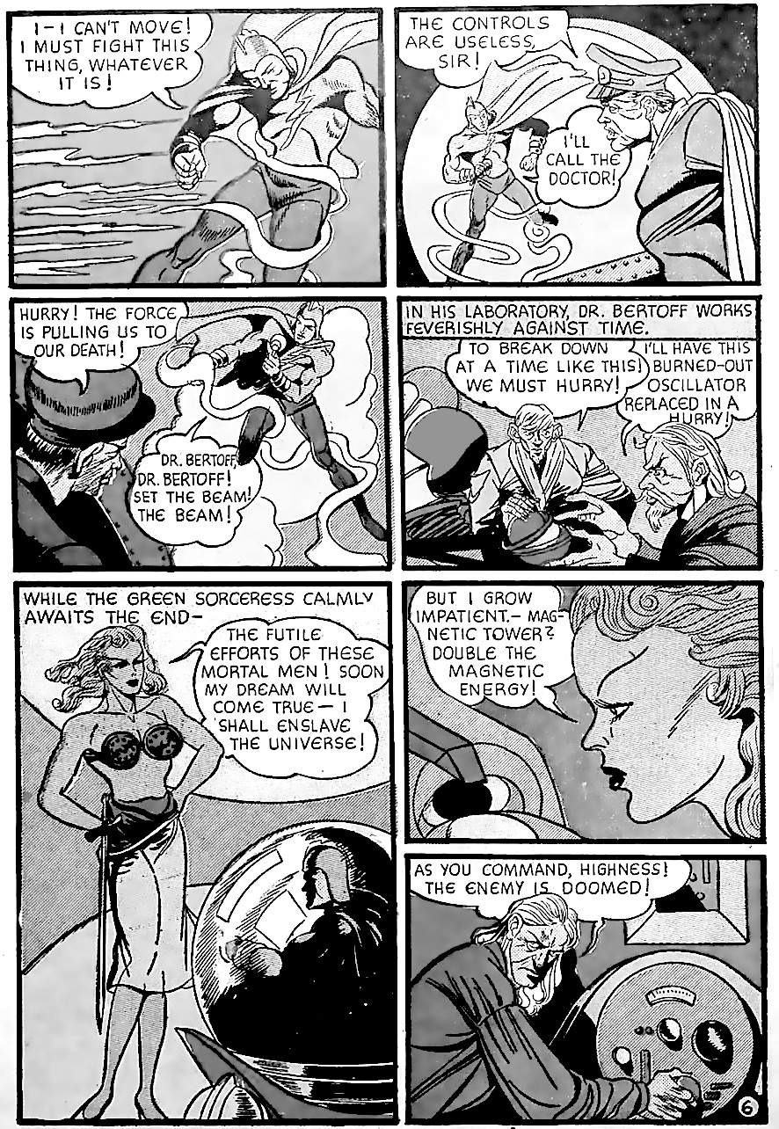
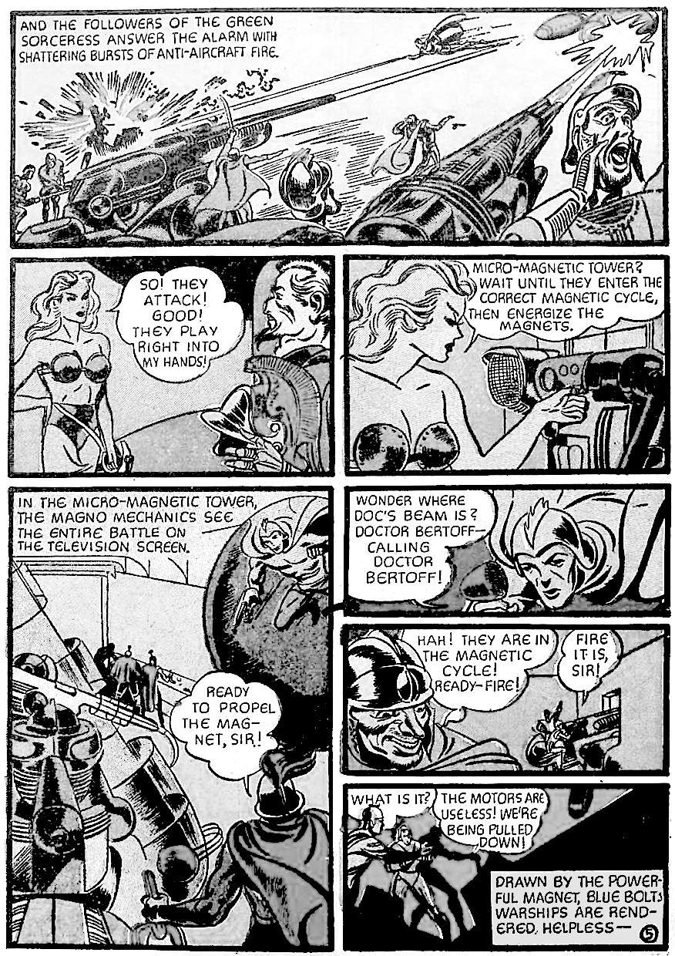
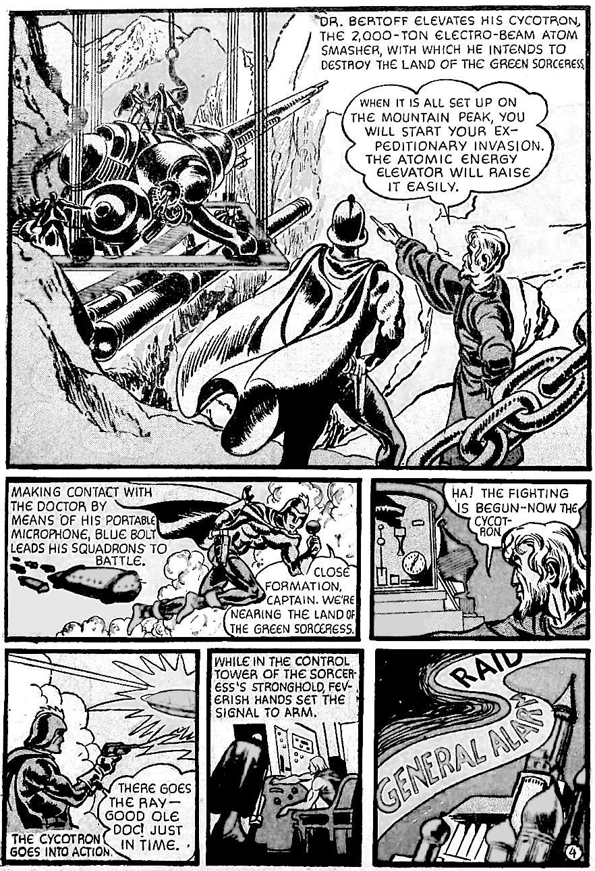
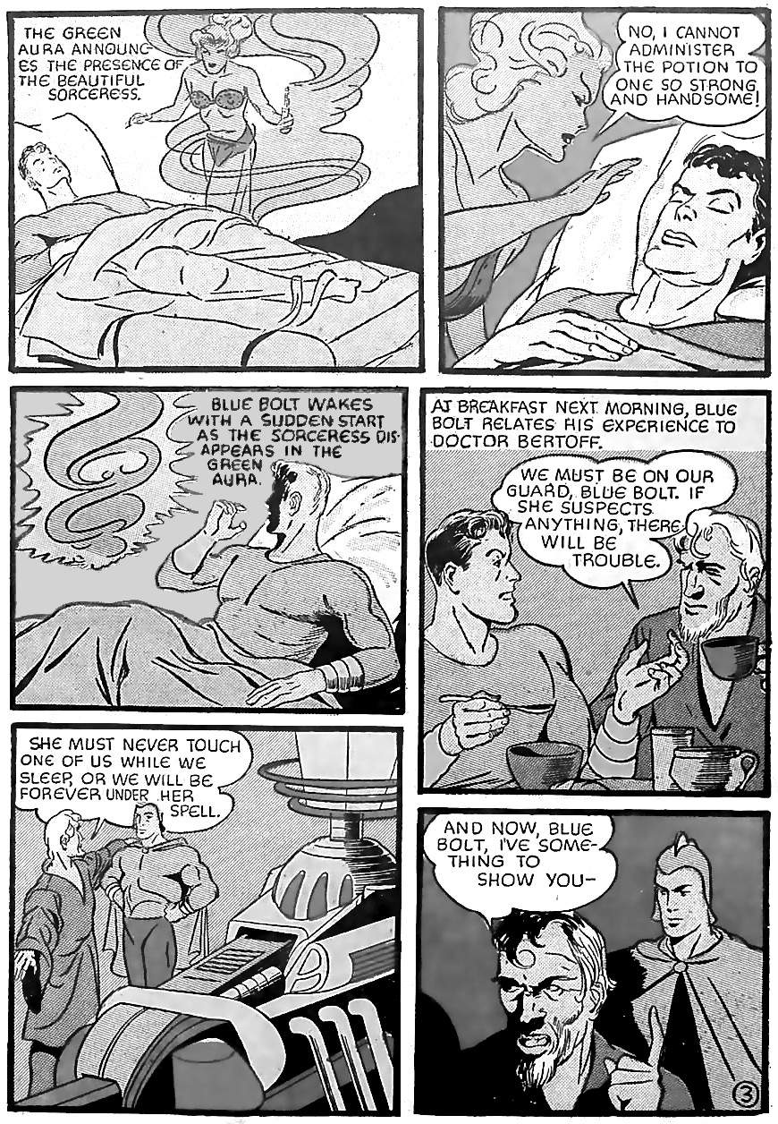
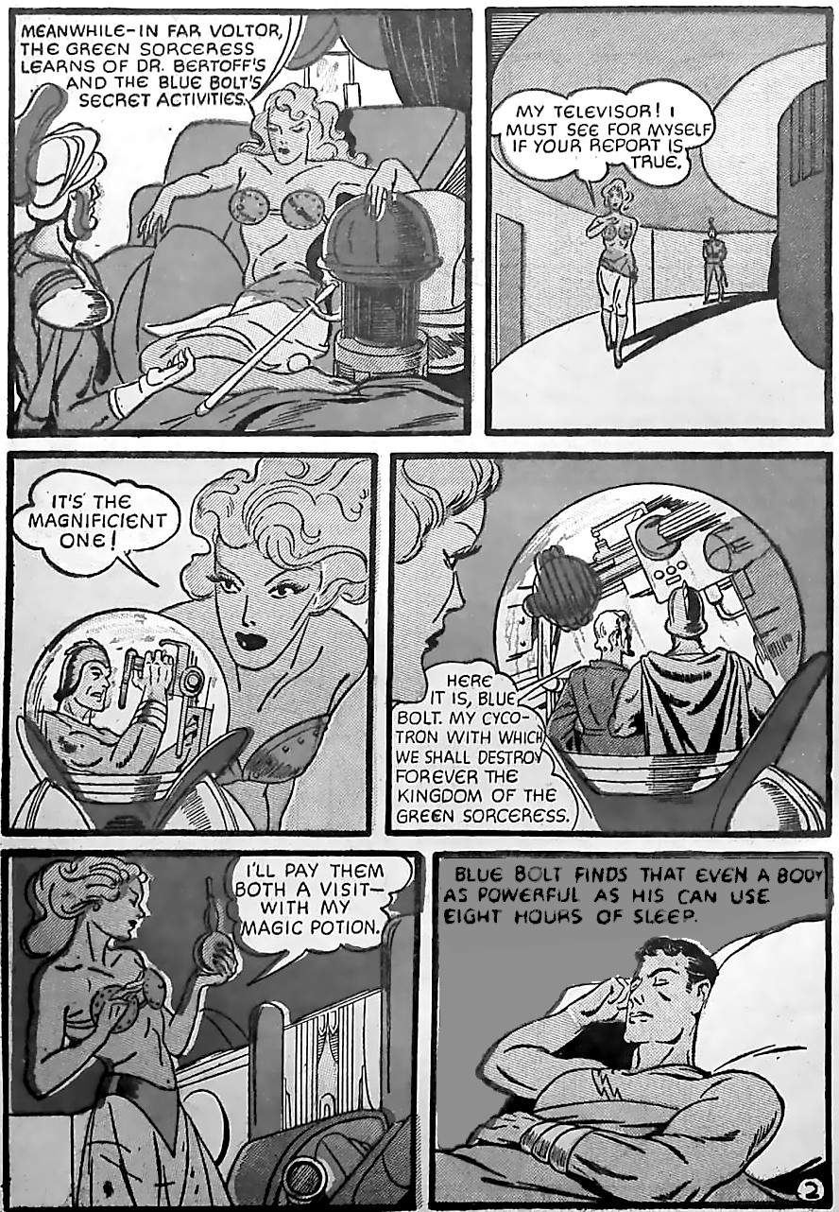
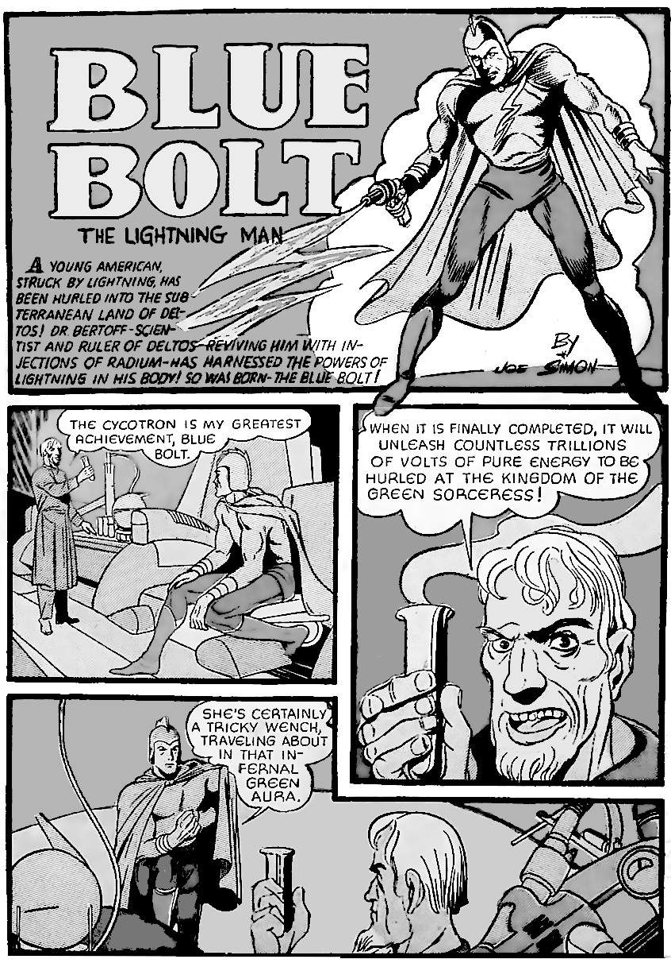
This story is discussed in detail in The Lost Jack Kirby Stories. This discussion is only about Blue Bolt as a de facto space god. The story is also worth reprinting because this is the story where Kirby predicted the atomic bomb.

Blue Bolt the space god
Blue Bolt looks like a god, flies in the heavens and casts lightning bolts, deciding the fate of the world. For all practical purposes, he is a sky god. Compare Kirby’s "Mercury in the Twentieth Century” from the following month, which evolved to become "Hurricane, Son of Thor" and later Thor and New Gods (and along the way, “Marvel Boy”). Each story has the same structure: an all-powerful father figure (Bertoff, Jupiter, Odin, High Father) sends his chosen hero (Blue Bolt, Mercury, Marvel Boy, Thor, Orion) to battle the personification of evil (Green Sorceress, Pluto, Loki, Darkseid) in a world-ending war. The model is straight from the Iliad (Zeus sends Apollo to aid the Trojans) or from the Bible (God sends Jesus to free Israel from Rome) and countless other mythologies.
Each hero generally starts as mortal and then becomes a god. According to our earliest historian, Sanchuniathon, even Apollo was once mortal. More importantly, the great quest ultimately fails: Troy falls, Rome kills Jesus, Ragnarok comes, and New Genesis is destroyed. Then the bad guys consume themselves in war, and civilisation must begin as a new Genesis, a new Eden. And so the endless cycle continues.

Kirby warns against space gods
Power escalates until it destroys itself and everything around it. Power is very attractive, so we embrace it, but it kills us. This is why: The Green Sorceress, symbol of the lust for power, looks attractive. The good guys feel attracted to her, and will not destroy her when they can. Instead, they have an arms race. Blue Bolt stories are all about this arms race. Every issue sees some new technology of war, and more innocent people die. Eventually, in Blue Bolt #8, the ever more powerful technology leads to a global catastrophe (see the attached image).
After that, Kirby moves Blue Bolt to New York, fighting gangsters with his non-powered sidekick Bucky. In effect, Blue Bolt renounces superpower. Kirby leaves with issue #10 and reboots the series as Captain America, the symbol of the ideal ordinary man.
Kirby spent his whole career warning against men who act like gods. His warnings climaxed in 1976, the American Bicentennial.
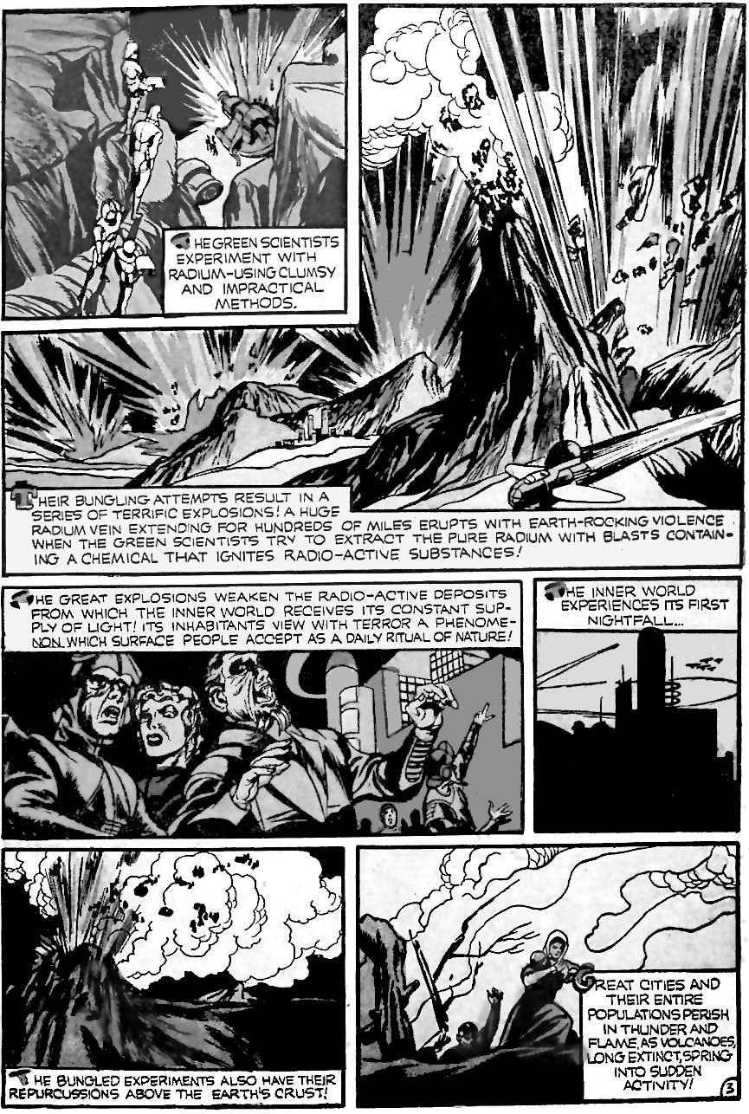
Kirby spent all of 1976 giving three warnings against power:
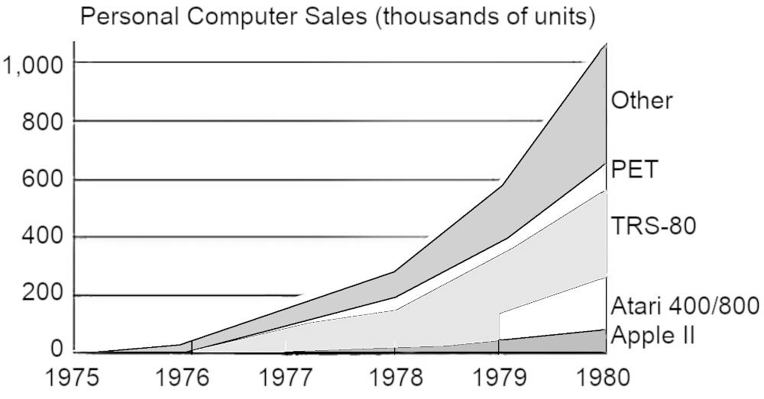
First, Kirby returned to Captain America with "Madbomb", the story of computer-based media. Back in 1963, Kirby had warned against Hate Mongers, populists who use the media to spread fear and hate, knowing that people will turn to them in times of crisis. Madbomb returns to the Hate-monger story, but this time the hate rays are powered by electronic brains. Electronic brains (computers) allow the elites to target messages to individuals. First with mailing lists, then social media, and through concentration of wealth (thanks to automation) by owning every major news source. Electronic brains have existed since the 1940s but did not begin to become common until 1976.
Data: Jeremy Reiner, arstechnica.com/features/2005/12/total-share/3/
Second, Captain America's Bicentennial Battles gives an overview of American history. History is a series of struggles between the individual and those who want power.
Third, The Eternals is about the return of the space gods. It tells the story of the Incas, but in a modern way. The Incas were created by Viracocha. He also created the sun and moon, but this may just mean he created astronomy. The first men displeased him, so he destroyed them in a flood. He then created the humans of today, including some Incas who live in the mountains and teach others. Viracocha was most likely human: humans are called Viracochas if they have power like the gods.
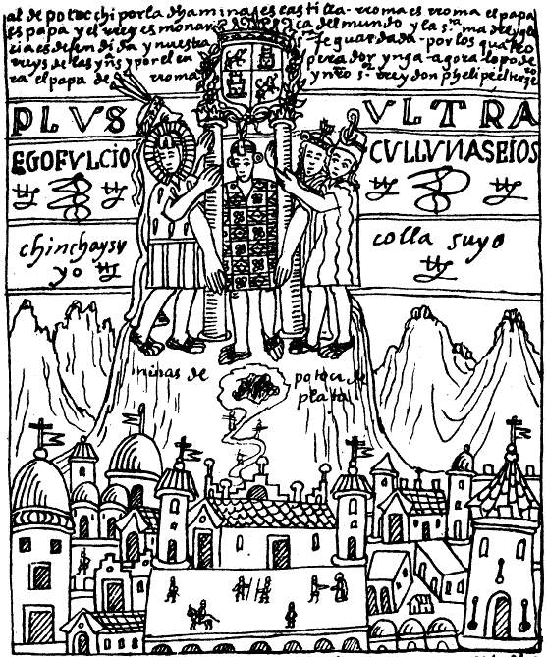
The last Inca ruler was Atahuallpa. He was killed by the Spanish in 1533 but said he would return one day and continue his rule. This picture is from 1615, showing the Inca ruler returning and standing on top of the mountains, together with the rulers of the four corners of his empire. The artist updated the legend to use contemporary imagery, such as symbols of the Spanish empire.
Image: Felipe Guamán Poma (1615), public domain
Jack Kirby's Eternals tells the same story in the same way: it updates the Inca story using modern imagery. Now the gods don't just watch from a mountaintop, they have spaceships. This is necessary to capture the feeling: the Incas saw a change of civilisation as the cosmos turning upside down. That is how it felt when the Europeans removed Atahuallpa, and brought their guns and disease. Kirby captures that feeling of helpless cataclysm in The Eternals. He shows the gods returning to destroy all civilisation. Civilisation is now global, so the gods are scaled up accordingly.

Kirby was right. The space gods are here.
Inside their metal suits, space gods are human. Kirby made this clear in the essay that accompanies The Eternals, and in this interview:
“The Celestials looked human, didn't they? They had human form. Underneath those helmets was a human being — a celestial human being, someone godlike in our eyes because of the things he could do that we couldn’t.”
So the story is about humans as god-kings: it is not about aliens. And it is not really about the Incas: they are just the clearest model for what happens (god-kings arise, they go away, they come back). This truth is ancient and global. God-kings were once everywhere, and they will return.
God-kings are returning now. They are the super-billionaires, people like Elon Musk and Jeff Bezos. By 2026 they will be trillionaires and no government will be able to stop them. Musk plans to build a fleet of one thousand “starships” and build a base on Mars. His space ships are so cheap that everybody will have to come to him if they want to enter space: he will be the gatekeeper to the universe. Meanwhile, Bezos plans to create gigantic space stations where most of humanity will live.
“I have always wanted to turn the Earth into sort of a national park or something zoned, light industry, residential, I think most heavy industry will be done off in space. … They will be born on these colonies, live on these colonies, they may visit Earth the way you would visit Yellowstone national park.”
Most humans will have to pay Bezos and keep his laws in order to live on his satellites. Planet Earth will only be for visiting. It will be so desirable (compared to life on the space station) that only the very richest people can live there. Bezos outlined his plan in the Washington National Cathedral, where he was introduced by the Dean of the cathedral. Because the only way to understand the scale of this event is through religious imagery, as in “The Eternals”.

What changed in 1976
The first private spaceship company, OTRAG, began in 1975 and signed its first contract in March 1976. But it failed because governments did not want to give up power over space. That power was about to shift. The reason? An unintended consequence of the desire to win a nuclear war.
Winning a nuclear war requires communications systems that can survive any part being destroyed. And so the Defense Advanced Research Projects Agency (DARPA) created the “internetwork” or “internet". It began to turn on in August 1976.
“Internetworking made its formal debut in 1976, when SRI established the first connection between two dissimilar networks. SRI connected the wired ARPANET with SRI’s wireless packet radio network, the world’s first mobile digital radio network.”
Nuclear missiles need electronic guidance systems. Military electronics were produced in a certain valley in California:
“Santa Clara County (which was first dubbed Silicon Valley in 1971) produced all of the United States Navy's intercontinental ballistic missiles, the bulk of its reconnaissance satellites and tracking systems, and a wide range of microelectronics that became integral components of high-tech weapons and weapons systems.”
A side effect of this war effort was the modern computer industry. The tipping point was 1976: Moore's Law (how chips shrink at a predictable rate) means that by 1976 all kinds of useful machines were possible. 1976 saw the first affordable supercomputer, the Cray-1, the first secure online transaction processing (allowing computers to be involved in all aspects of business), and in July (the Bicentennial), Steve Jobs presented the Apple, the first computer to target ordinary people. In 1976, computers began to take over. The men who built them became the first of a new breed of humans: the technology super-billionaire. The next generation after them would own spaceships, and will soon dominate the world (see chapter 11).

The end of optimism
As early as the 1950s, Kirby had an idea that American Independence Day around 1975 would bring the arrival of space gods. Back then he was optimistic. Chapter 10 has a story about space gods appearing on July 4th 1975, with a happy ending. But when 1976 came, after Vietnam, Watergate, the Oil Crisis and the Church Report, Kirby felt a darkening cloud. He saw that the arrival of the space gods was not going to be as he hoped.
From 1976, Kirby's work became grimmer. Compare the "Solar Legion" in 1940 with the similar “Galactic Rangers" in 1982. Or compare the hippy "Forever People” in 1971 (optimistic) with the same characters in the Hunger Dogs in 1985 (grim). The real-world space gods were once hippies. Their hippy communes failed, becoming just as patriarchal and shallow as the cities, so those same hippies moved on and created an even more ambitious vision: the computer age. This created the space gods. The point of The Eternals is that the space gods always fail: their grand plans always lead to Armageddon. In the story, space gods seed new life on thousands of planets, hoping to evolve a non-violent race of space-going humans. And their experiments never, ever, work. No space-faring civilisation ever renounces violence, so every single one must be destroyed. The experiments always lead to Armageddon.
Kirby kept his loss of optimism quiet. In the late 1980s, he grabbed onto the apparent rise of democracy in China as a source of hope. But events soon returned to the pattern he predicted in The Horde. Kirby could see the future, and he did not want to think about it:
INTERVIEWER: “Got any projections for what you think the future holds in store for us?”
KIRBY: “Yes, I have.”
INTERVIEWER: “Would you like to share them with us?”
KIRBY: “I'd like not to think about them.”
INTERVIEWER: “You think they're bad?”
KIRBY: “I just like not to think about them. I think that is good advice for everybody.”

Another prediction — and the FBI got involved
Talking of Armageddon, note the focus of the Blue Bolt story, right from page one. This is a very important page: this is the first page of Kirby’s first multi-page story (before this he just did newspaper strips that were sometimes collected, like Dr Hayward). Kirby bursts on the scene with a story about the atomic bomb, five years before the bomb became public knowledge.
The “cycotron” is a fictional version of the cyclotron, the key technology in the creation of the atom bomb. Pay close attention to the design of the cycotron “atom smasher” on page 4, panel 1. Note its three circular sections at different angles, then a gun barrel. A cyclotron (an atom smasher) uses a magnetic field to accelerate charged particles in a circle, faster and faster, until directing them through a gun-like barrel at some target. Kirby’s design has multiple circular sections at different angles, suggesting a more advanced design. His story also features an oscillator and a weapon based on magnetism. The first useful magnetron oscillator was used in this year, 1940. Kirby’s cycotron needs helium atoms to function. The story was on sale in May 1940, when Columbia University in New York City (not far from Kirby) was chosen to find the best method of separating uranium-235. One of the ideas (at the time only used in Germany) was to add hydrogen or helium. So Kirby’s story looked like he was revealing the nation's greatest secrets. The FBI wanted to know where Kirby got the information:
"They sent me a letter from the FBI! … It was just an inquiry, you know. I had to explain that it was all fictional.”
Yes, it was “all fictional”. But it came true.

9.
Future Trends
This chapter lists ten future trends from Kirby's stories. Kirby wrote between the 1930s and 1980s, so his future trends are our present reality.

Trend 1: killing the planet. 83% dead and rising
The overall trend is to kill. Kirby understood that humans are natural killers. His greatest heroes, like Orion and Captain Victory, struggle to suppress the thrill of killing their enemies.
"One guy published a theory that we are descended from killer baboons. I believe that …
"Forty years ago we just got through shoving people into ovens — on a very, very flimsy reason. We did that. Nobody else did. Man has a drive for domination."
In Captain Victory, civilised aliens see humans as baboons, and look at our genocidal species with disgust. The trend of killing is not obvious in modern society because our masters have developed better ways to control us: more on that topic later. But the trend toward killing is obvious when we look at our relationship with other life. So far, humans have killed 83% per cent of wild mammals. Most of that killing is recent: wild mammals, birds, reptiles, amphibians, and fish have decreased by 68% just between 1970-2016.
Here is a Kirby story about the human tendency toward killing. It shows what a desire for money and status can do to people.

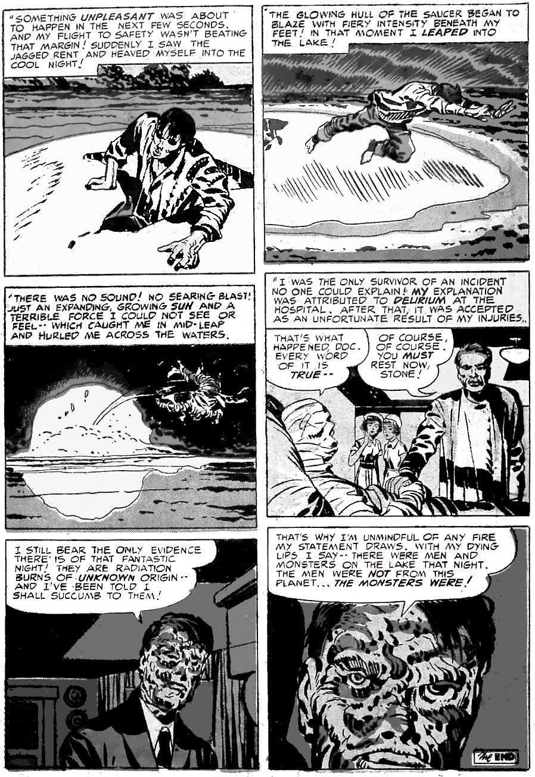
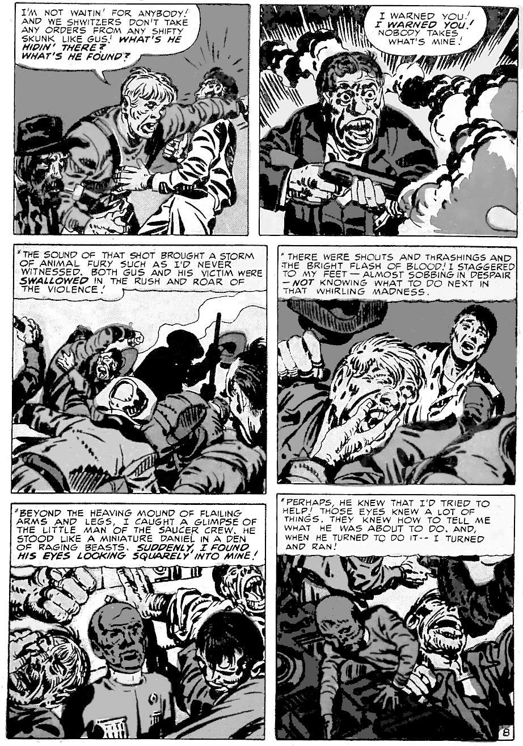
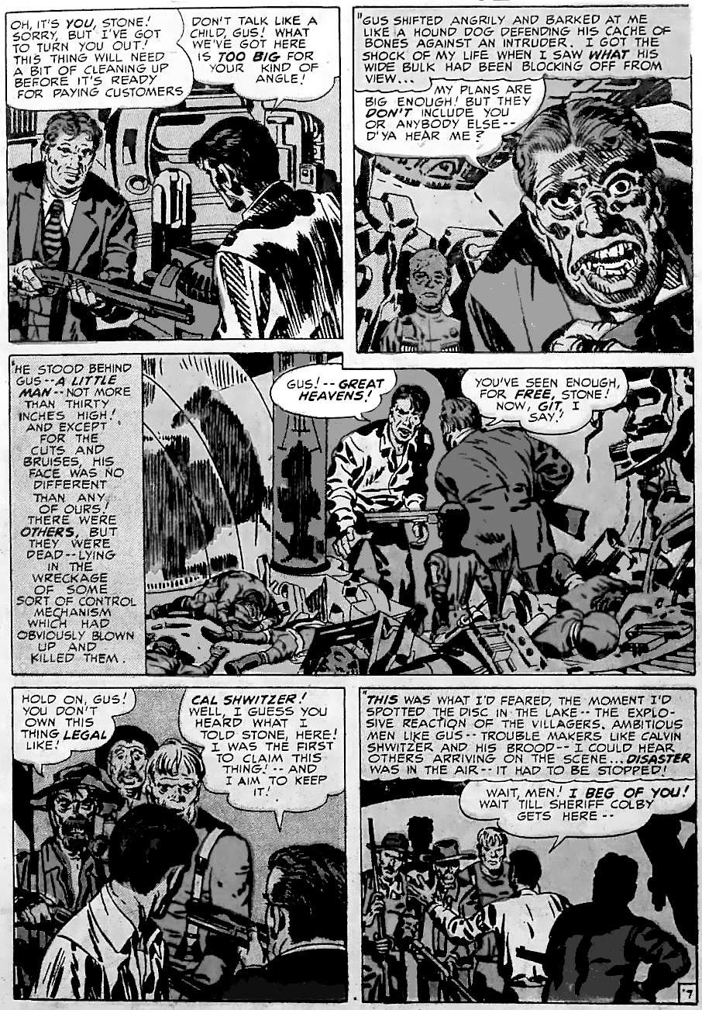
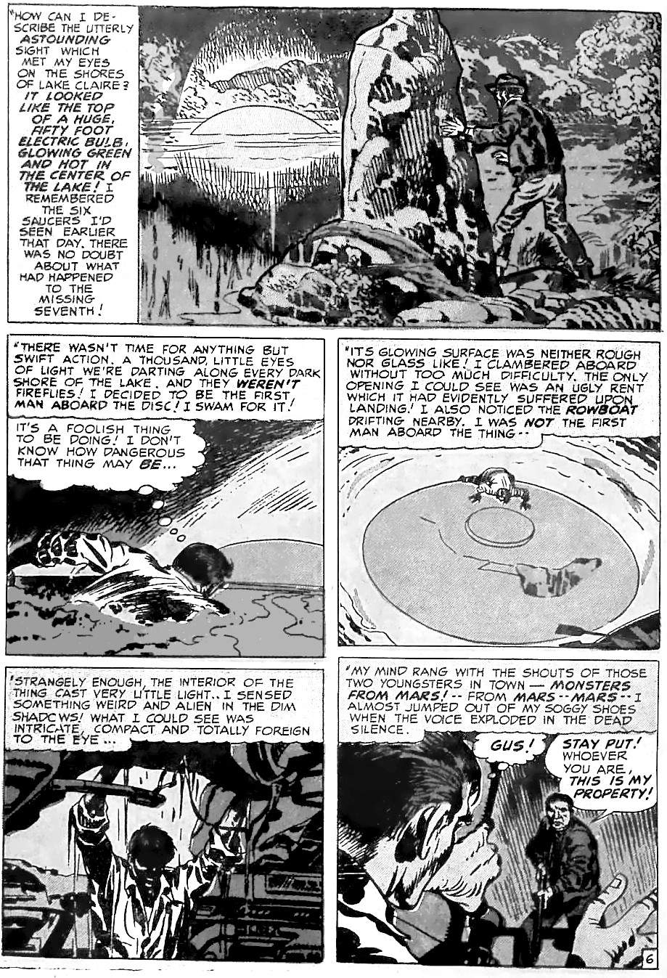
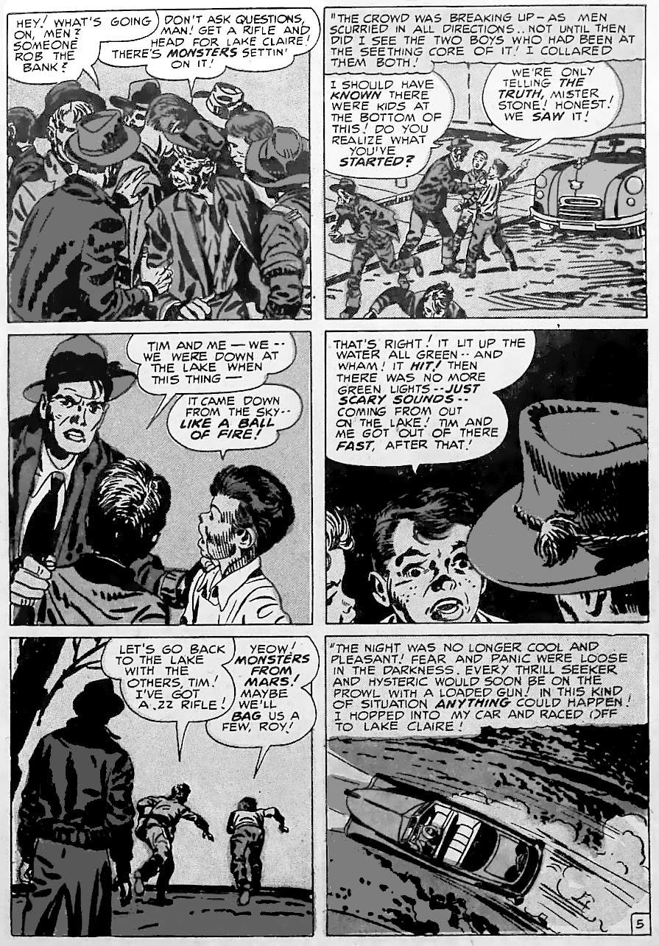
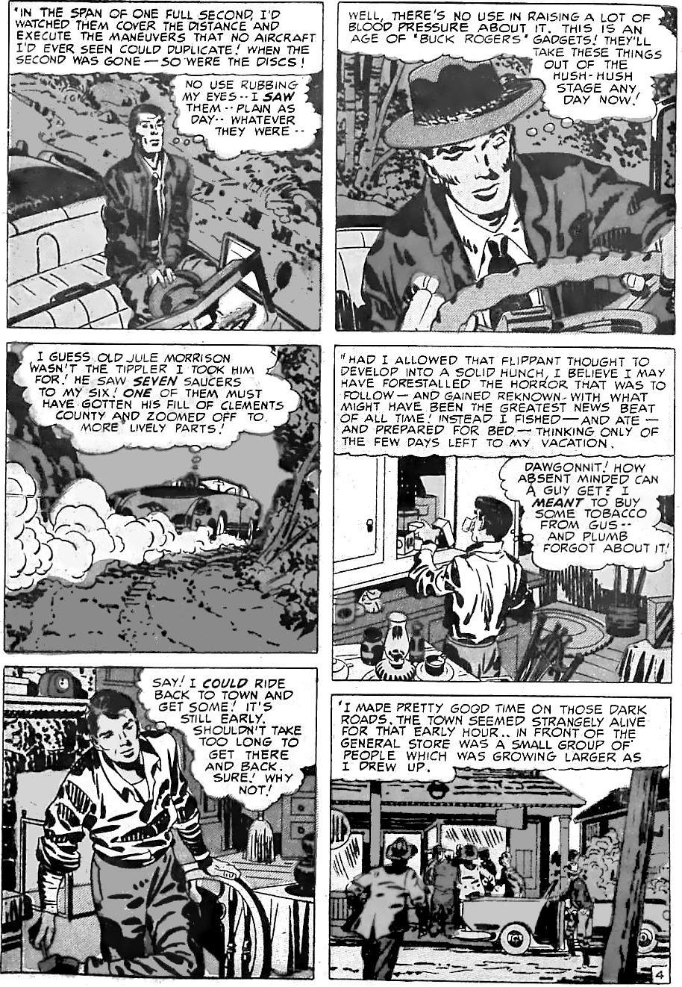
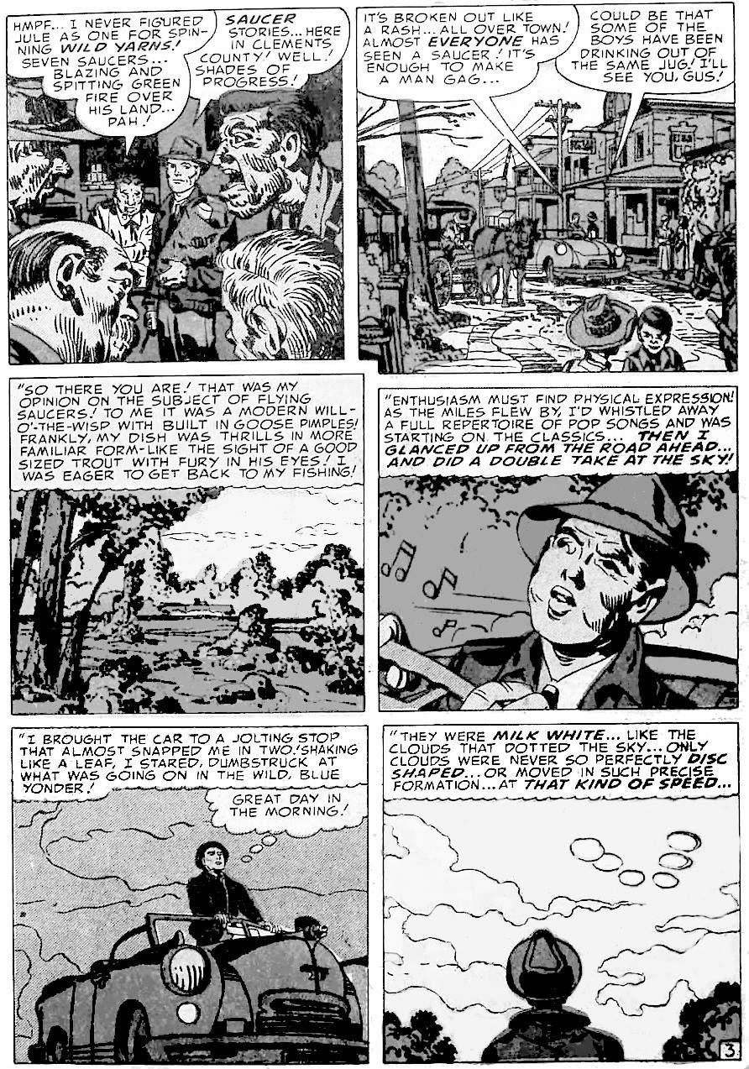
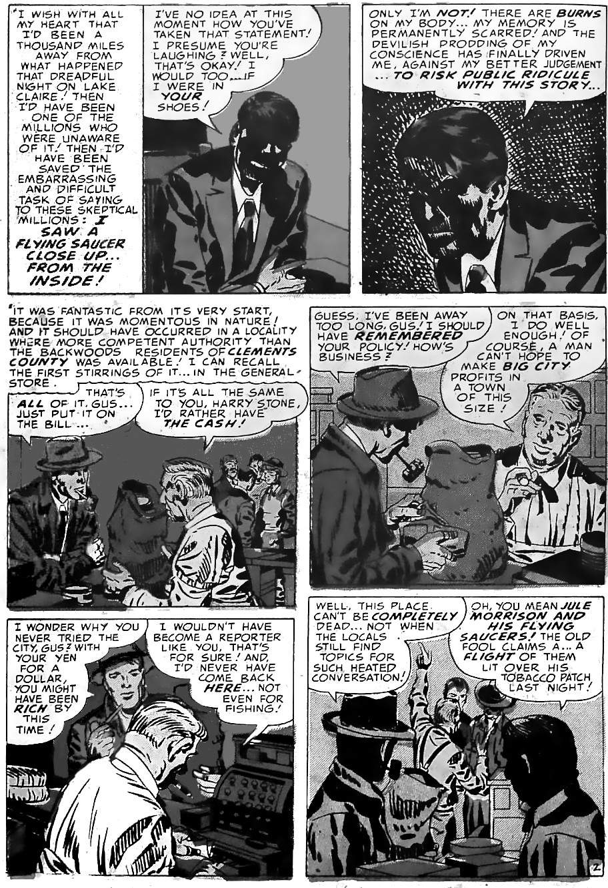
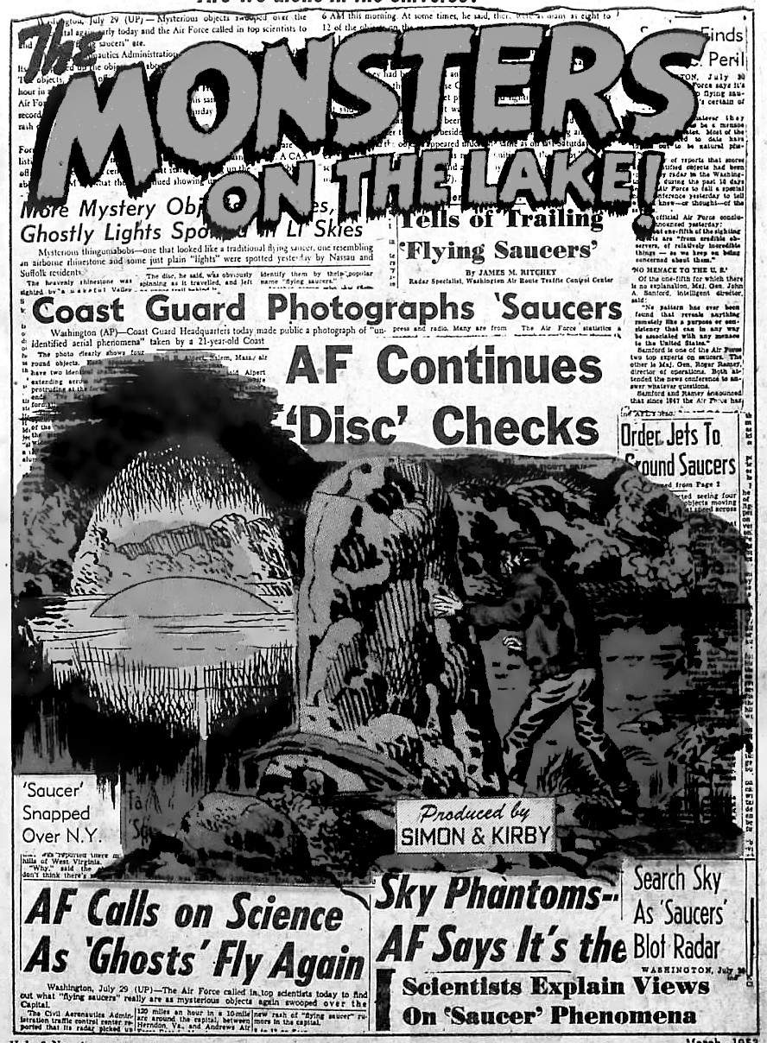
Our civilisation, and hence our daily business, is to consume the world. We extract raw materials, cover the land with stone and concrete, cut down rich forests, and replace them with sterile farming monocultures. Any humans who reject this world of concrete and farms cannot rise in business.
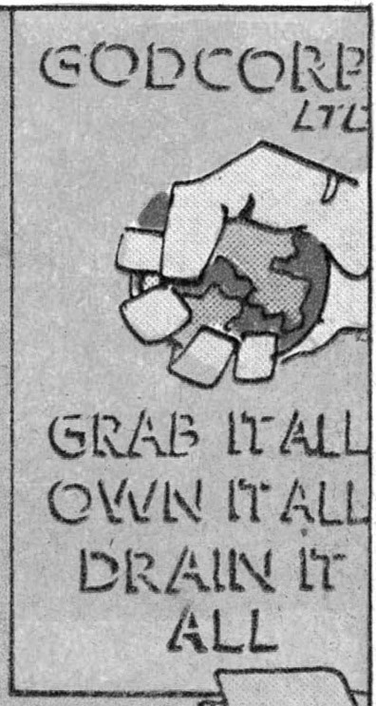
Kirby summed up the world of business in ‘Godcorp”:
Image: Destroyer Duck #1, Fair Use
“GRAB IT ALL.
OWN IT ALL.
DRAIN IT ALL”
Kirby describes this future trend like this:
“New York 2040 AD” shows New York as surrounded by smoke and pollution. Workers are depressed and hopeless, and just want to escape their horrible lives.
“OMAC” begins with our hero as a depressed office worker, and ends with a technology genius stealing the world’s water.
“Tokl the World Killer” is the fall of a previous civilisation. It contrasts the free humans in beautiful nature, with an ugly polluting factory that destroys the planet.
“The Face on Mars” shows the fall of a previous Martian civilisation. It begins as a paradise, but another world wants to own it, and the resulting war turns Mars into an airless desert.
“Kamandi” has the Sacker corporation. That is, it sacks towns, taking everything of value. When it finds an unspoiled paradise, it sprays chemicals to kill all vegetation.
“New Gods” is the story of our choice: life or anti-life. We must choose: the planet of New Genesis, an unspoiled paradise, or the planet of Apokolips, a planet-wide weapons factory:
“Its giant energy pits feed on the world itself, to gain its power and light! … Life was the evil here! And death, the great goal!”
So far in the real world, we have chosen Apokolips, not New Genesis.
It is true that, for the past fifty years (since 1976), violence has generally been reduced in major cities. This is due to more surveillance. Many other causes have been suggested, but surveillance technology is the only cause that explains the data in every country. So we are not becoming less violent: our masters are becoming better at controlling us. So we turn our killing inward and kill our mental lives. Depression and stress are now extremely common. Depression is a symptom of settled life and is seen whenever hunter-gatherers are forced to live as farmers.
The general trend of the future is to squeeze the planet until civilisation collapses. But how will it happen? Here are nine more future trends:

Trend 2: ordinary people become powerless
The first prediction in OMAC, “The World That’s Coming”, is that workers become powerless. Workers become like "Buddy Blank", cogs in the corporate machine. Consumers still spend money, but all their decisions are guided by big corporations. They buy fake friends from corporations. They cope with psychological despair in ”silent rooms” and “destruct rooms”. They are watched by satellites. Human activity is gradually replaced by machines.
This is happening now. Workers spend long hours in jobs they do not enjoy. We have shallow electronic friendships on social media, and some of the replies to comments are bots, or scammers. We cope with the psychological stress through “mindfulness” (like Kirby’s “quiet rooms”) or video games (like Kirby’s “destruct rooms”). We buy things via Amazon, which chooses what we see. We are tracked by Google. We are free to choose, but only within limits set by giant corporations. When we try to get customer service, we then realise we are individually expendable. Humans only matter in large blocks that can be pushed around by machines, just like any other physical commodity.

Trend 3: the super-wealthy are above the law
In contrast to ordinary people having no power, the super-wealthy have all power: they are even above the law. In OMAC #2 the super-wealthy will do anything they like. This is beginning now: see chapter 11 for details.

Trend 4: fake reality
OMAC #3 begins with a virtual reality video game. When Kirby wrote this, the top-selling video game was still "Pong". Kirby saw the future: reality will be hard to distinguish from fake reality.
In the story, OMAC's memories are erased. He gets all his information from faceless helpers, and from a satellite. So apart from his job, he has no contact with the real world. In OMAC #2 and #5, we learn that the satellite can create fake evidence. OMAC accepts his world as real, but what choice does he have? He entirely depends on the satellite that creates the fake realities. What else can he believe?
This is happening now. Internet algorithms allow people to exist in a bubble. For example, it is common for voters to be surprised at elections because all the information they saw indicated that person X was right. But their neighbours were flooded with information that person X was obviously wrong. Years ago, with fewer newspapers or TV channels, this was less common.

Trend 5: replaceable people
A central theme of OMAC is that technology makes people replaceable:
- OMAC #1 was about "make a friend" — we don't need human friends if we have robots.
- OMAC himself is one man replacing an army, thanks to technology.
- OMAC was originally "Buddy Blank”, a blank slate who could presumably be replaced by countless other people.
- The Global Peace Agency is faceless: they say that this is to represent all races, but it also means they have no personality and are replaceable.
- In OMAC #3, OMAC is given replacement parents.
- OMAC #5 is about replacing body parts, and only the super-rich can afford it.
This is our present and future, thanks to automation and remote working. Unless you are in the top one per cent of essential workers, you are easier and easier to replace.

Trend 6: smart atomic weapons
The creature in OMAC #6 is a "smart" atomic weapon. We don't yet have genetically engineered weapons, but we do have every other kind of nuclear weapon: portable, smart, hypersonic, poorly maintained, or just do-it-yourself bombs made with missing uranium. So atomic weapons are easier than ever to create, and if they travel at hypersonic speeds, harder to stop.

Prediction 7: wars become safe for elites
In OMAC, the good guys operate via satellite and a remote mountain top base. The tech genius, Doctor Skuba, operates from within a remote mountain. This is happening now: wars are waged via drones from the safety of another country. So war is a safe game to play. Wars get votes. Wars get territory. Wars ensure your place in history. There is less and less downside to the powerful waging a drone-based war.
Wars are still dangerous for nations, as they might lose. But wealthy individuals can simply move to another nation, so war is simply an economic calculation. At present, war is usually expensive because of the loss of vital workers, but when most workers are replaced by machines, humans will just be an economic cost. So a war that kills a lot of people will become profitable.

Prediction 8: desperate people will do anything
OMAC #6 begins with "the sickies", an underclass who live in tunnels below the city. "The Sickies are normal before they take radiation and hormone treatments. They do it, or the crime cabal doesn't pay them!" The sickies exist to scare others into not threatening the cabal.
This is happening today. At the bottom of most societies are people with no hope. They often use drugs as a way to cope. Society allows people at the bottom to suffer so that others are motivated to accept low pay and bad conditions: if there is no unemployment or the unemployed are treated well, then workers will demand higher wages. But desperate people will do desperate things. They will vote for bad leaders, work in unethical jobs, and do whatever their masters want, just to survive.

Prediction 9: oceans drained of all resources.
The final OMAC issues (#7 and #8) are about taking water from the oceans and making people pay. As global warming makes the water more valuable, water shortages will lead to war:
“A new paper [from the European Commission's Joint Research Centre (JRC)] paints a disturbing picture of a nearby future where people are fighting over access to water. ... The researchers put such chances at 75 to 95% in the next 50 to 100 years. How bad they will be, of course, remains to be seen."

Trend 10: China and America in conflict
Kirby's novel "The Horde" is about World War III and its causes. It begins with global warming making parts of China uninhabitable. So China needs more land. It quietly builds tunnels into the rest of the world. It enlists the aid of an African-American named Hardy Jackman. Hardy realises he is trapped by China but sympathises with their cause.
Today, China has three thousand miles of tunnels for nuclear weapons: the so-called "great underground wall of China". And China has metaphorically tunnelled into every western home by providing cheap electronics. Another metaphorical tunnel is the “belt and road" strategy that leads China into western Asia and Africa. Like Hardy Jackman, Africans realise they are becoming trapped in the Chinese system, but they also realise it's better than the alternative.
When will the China-America conflict take place, and what will happen next? See chapters 12 and 13.

10.
1940-2026
This chapter has a timeline of Kirby's dated predictions, covering the years 1940 to 2026.
These stories are mostly science fiction. Science fiction uses metaphors for real worl- politics. Let’s look at the metaphor used in this first story.
In the 1950s, Russia was beating America in the space race, so Americans worried about a high technology invasion from the sky: at any moment a rocket or satellite could drop a nuclear bomb anywhere. No American wanted to watch movies about America being weaker than Russia, so they used metaphors: far more powerful enemies in more advanced space ships. The 1950s had many movies about alien invasions: like “The Thing From Another World” (1951), “It Came From Outer Space” (1953), etc. The aliens were a metaphor for Russians. Often the aliens were shape shifters, reflecting a fear that communists might be hiding among us. In some movies, like in “The Day The Earth Stood Still” (1951), the aliens are advanced and mostly peaceful. These are metaphors for Russians or Americans who want peace. That movie was made after America announced its intention to create the hydrogen bomb. The movie argues that we should try to negotiate with other nations, to create some kind of alliance of all nations, instead of going straight to a nuclear war that could end civilisation.
Kirby wrote the following story in late 1954. America had exploded its hydrogen bomb, the British developed their nuclear weapons, the Russians took steps toward their hydrogen bomb, and — around the time Kirby wrote this story — America launched its first nuclear submarine, so nuclear bombs could be launched from anywhere on Earth, without warning. This was a terrifying time to be alive. Kirby's story is inspired by “The Day The Earth Stood Still”, so it almost certainly uses the same metaphor: the aliens, hovering over the American Capital on American Independence Day, represents Russians with space ships. When we understand the metaphor, we can see how this story about an alien invasion is really about the need to end the space arms race between Russia and America.

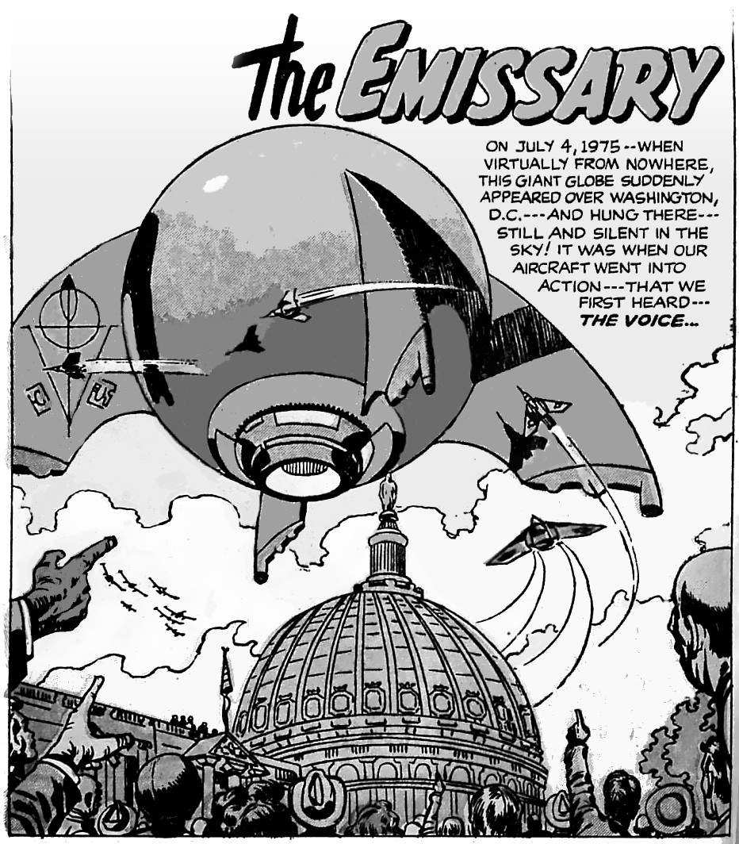

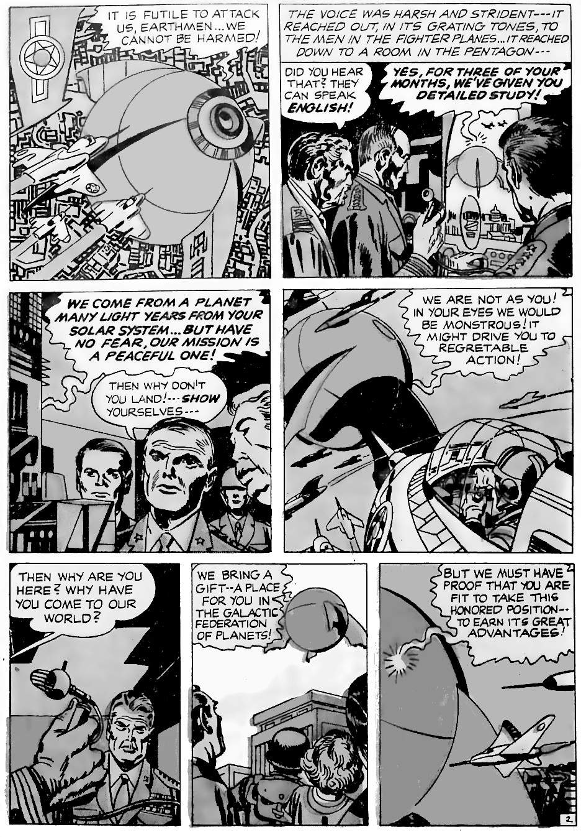
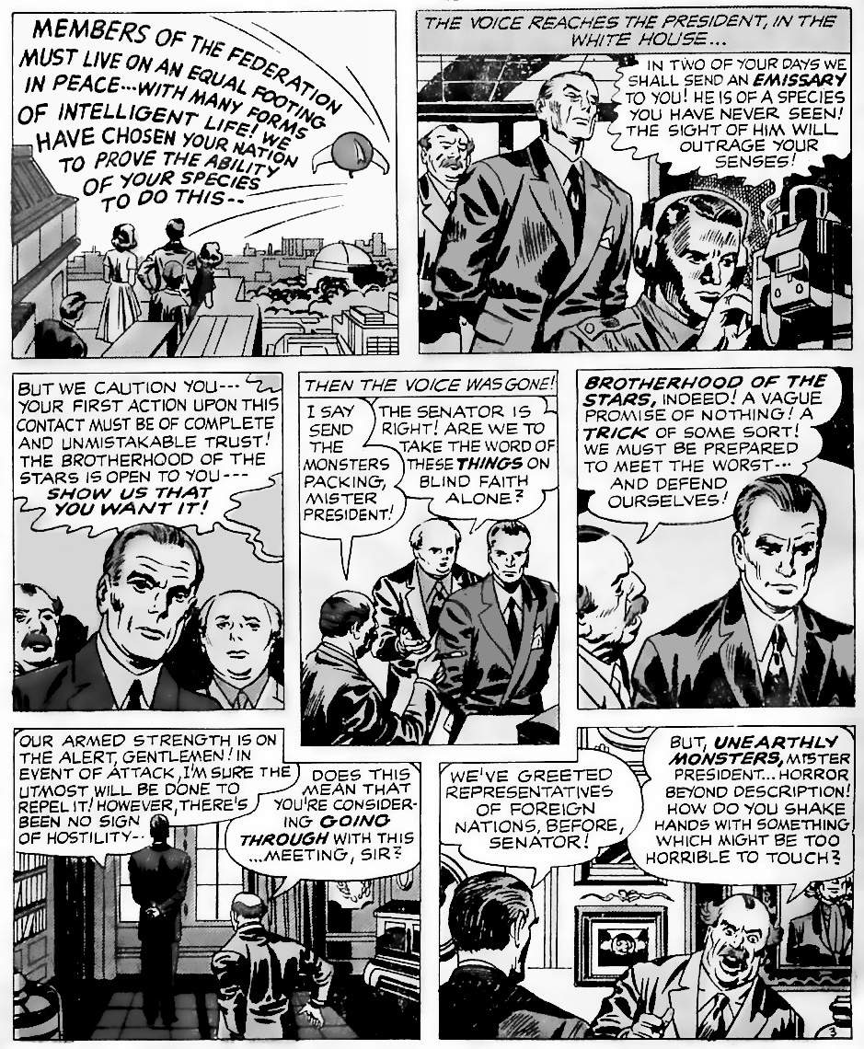

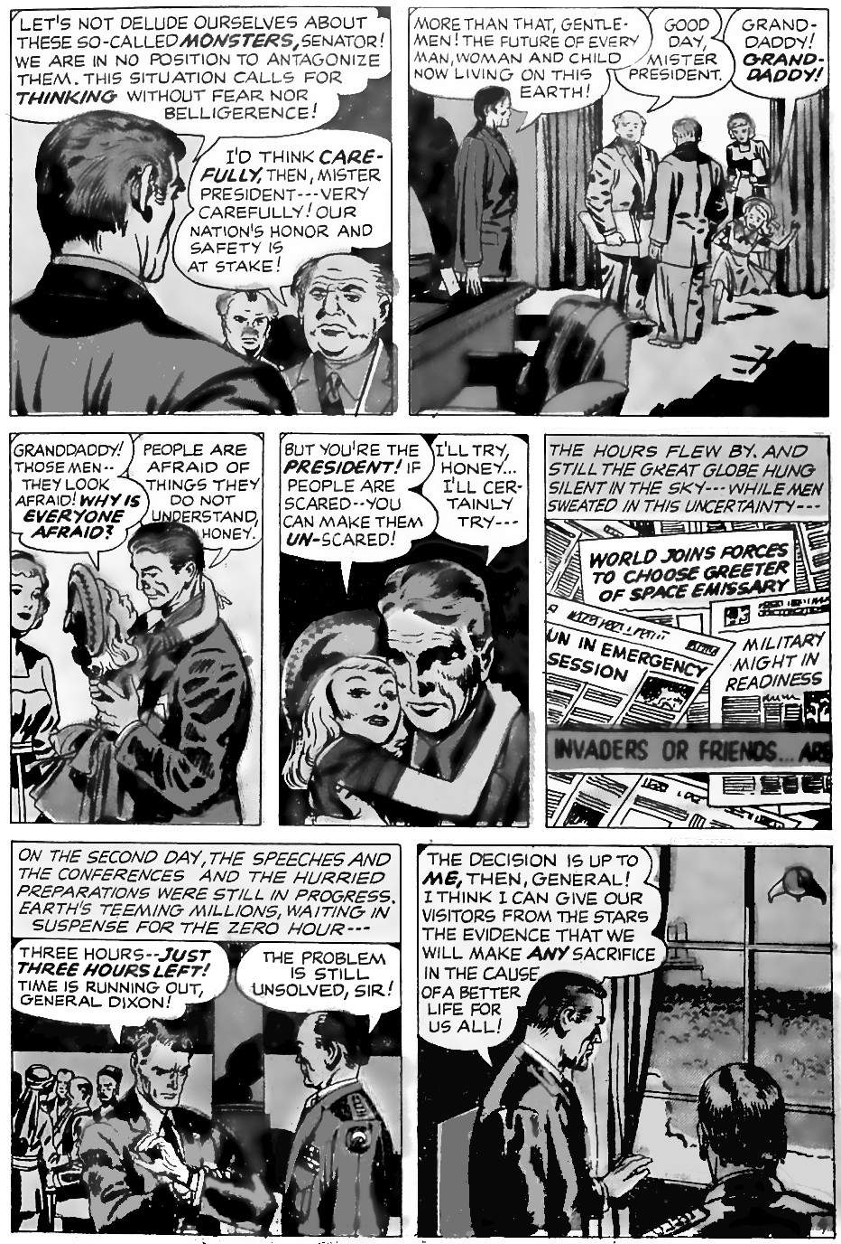

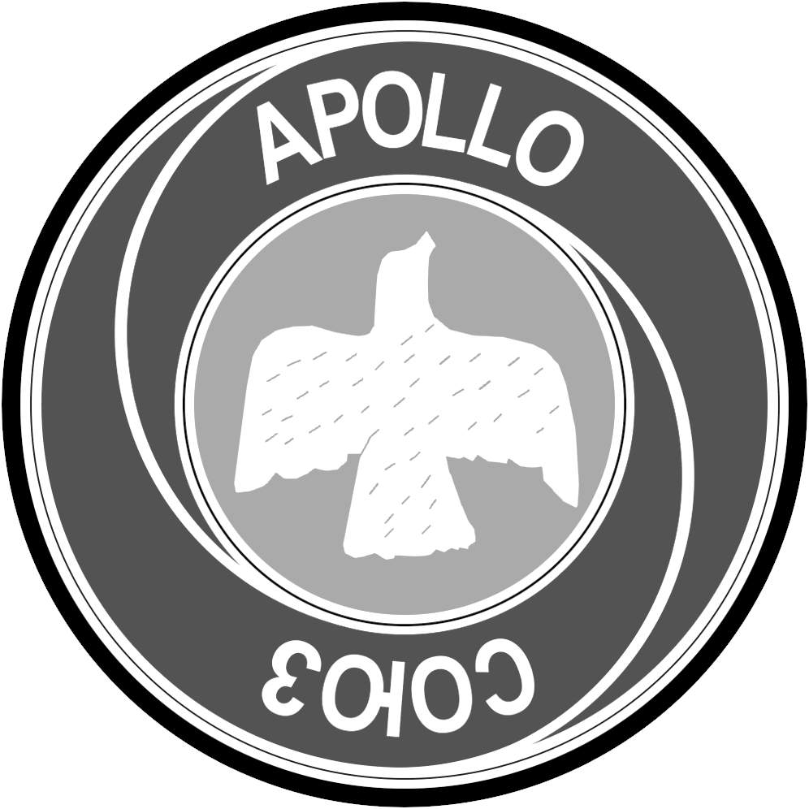
"The Emissary" is a metaphor for when nations finally dare to take a risk and work with their natural enemies in space. It was written in 1955, a few months before the space race began. Kirby said this event would take place in July 1975. Sure enough, when July 1975 arrived, the space race ended. Leonid Brezhnev announced “peace and progress of the whole of mankind”. President Ford asked if the astronauts and Russian Cosmonauts had a message for the world's children. American Apollo astronauts and Russian Soyuz cosmonauts shook hands in space for the first time.
Soyuz badge, public domain
“If ever there was an emblematic staging of ‘possible world’ hospitality, it was this one…”

Now let’s look at Kirby’s other predictions, up to the year 2026.

1946: the anti-nuclear war movement
(Predicted earlier in 1946)
Kirby’s “The Stolen Centuries” has a future historian say that the effort to ban nuclear weapons began in 1946, and it was part of an effort to ban all kinds of war. The story says that this effort was not successful until much later, when humans inhabited other planets of the solar system.
Two months after Kirby wrote his story, in May 1946, Einstein and other scientists formed the “Emergency Committee of Atomic Scientists” to seek ways to end the threat of nuclear war. The most active campaigner in the group was Linus Pauling. In 1963, Pauling received the Nobel Peace Prize on the same day when the first treaty was signed to limit nuclear weapons. The committee introduced Pauling in this way:
“Linus Carl Pauling, who ever since 1946 has campaigned ceaselessly, not only against nuclear weapons tests, not only against the spread of these armaments, not only against their very use, but against all warfare as a means of solving international conflicts.”
So Kirby was right. 1946 was the beginning of the struggle to end atomic war, and with it, war in general.

1966: NASA predicts a moon landing.
(Predicted in 1959)
Kirby only gets dates wrong is when he trusts experts instead of trusting his intuition. This is one of those times.
In "Luna Lizards Had Me Trapped”, the giant lizards are not to be seen literally: in 1950s monster movies (Godzilla, etc.) such monsters are always a visual metaphor for some great danger, but the rest of the story is always realistic. So in this story, Kirby says that men will land on the moon in 1966, and by 1970 they will have a permanent colony, then their great fears will turn out to be unfounded. These dates were given by NASA in the year when Kirby wrote the story: NASA's "Project Horizon" (1959) projected that twelve soldiers could be based on the moon by 1966. But NASA’s estimate turned out to be wrong. Kirby was always better using his own guesses instead.
This is not the only time Kirby relied on experts for his dates: he did it a few times in his 1958 series, "Sky Masters of the Space Force”, in the feature called “Sky Masters Scrap Book”. Those predictions are presented as expert opinion from scientists, not fiction, so he was probably repeating what he read in science magazines. When those dates arrived, the scientists’ predictions always turned out to be wrong. But when Kirby made up his own guesses about the future, he always turned out to be right.
The rest of these dates are Kirby’s own guesses.

1971: failed Mars landing
(predicted in 1961)
In "The Sacrifice”, Kirby predicts that the first landing on Mars will be in 1971 and appear to be a failure, when seen from Earth. But in reality, avoiding Mars is a good thing because it hides a monster that could have doomed mankind. Monsters are a standard metaphor for other dangers.
In the real world, in May 1971, The Mars 3 lander was the first probe to ever successfully soft-land on Mars. It transmitted 14.5 seconds of data, then stopped. Just as in Kirby’s story, nobody on Earth knew why. Also in 1971, NASA's Mariner 9 orbiter reached Mars. But there was a global dust storm that was so big that only the tops of the tallest volcanoes could be seen. So Kirby was right about 1971 having the first landing on Mars. And he was right about it failing for unknown reasons.
In the story, the explorer falls down a hole and sees a strange and impossible monster. That is, the story uses the standard metaphor from Alice in Wonderland, Forbidden Planet, The Face on Mars, The Mole Man, etc., etc.: the monster is a metaphor for mankind’s folly.
The monster is a kind of dead tree with a protective atmosphere, and its only goal is to travel to different worlds, killing all living things. When it arrived on Mars it killed everything there, and now threatens Earth. But how is this a metaphor for human folly?
Do humans spread through the universe killing everything? The first visitors to Mars are probably not a tree, but humans from Earth. We declare Mars to be empty, just as Europeans declared the New World of America to be empty, in order to exploit it. We defined civilisation as white civilisation we could exploit non-whites. And we define life as human chemistry, so we can exploit non-human chemistry. But scientifically we are simply random matter just like everything else. Chapters 14-16 show how our life is not fundamentally different from the life of a rock or ray of light. Golden Age people knew this: every animal and plant and even every rock and light has its own kind of spirit and deserves respect. Like Orion, we must resist our desire to destroy everything that is not us.
Are humans weird dead trees with a protective atmosphere? Scientifically, humans are just a branch of the tree of Eukarya (cells with nuclei): other branches include other animals, plants, algae, and fungi. As seen from Mars, Earth looks like a planet of grass and trees, so humans are just a weird kind of tree. Eukaryotic life exists because of Earth's protective atmosphere, held here by the protective magnetic field: Mars is ravaged by solar winds and asteroids, but Earth is protected.
Will humans on Mars return to destroy Earth? Reaching Mars will cost a lot of money. That money only comes if we strip Mars of any value we find, strip-mine asteroids, and strip-mine everything. Our system is based on money so the winners are those who strip-mine the most. As we saw in chapter 9, human business is to “grab it all, own it all, drain it all”. So once the super-billionaires live in space they will finish the job of strip-mining Earth. Only through great sacrifice, as in the story, can sane humans stop the madness.

July 1975: the end of the Space Race
(predicted in 1955, discussed earlier)

1975: get rid of old Russian leaders
(predicted in 1962)
"The Day Before Doomsday" is set in 1975. An American seems to be helping the Soviet Union. But really he was sending Soviet leaders into space. Kirby's prediction came true, metaphorically speaking.
In 1975, the West learned that the Soviet economy was in trouble. Until 1973, the Soviet Union had been catching up with the West. The numbers are always noisy, so it took two years to be sure that catching up had stopped, and the Soviets were falling behind. There are many reasons, but they all come down to gerontocracy: the Soviet system put the oldest people in charge. They were devoted to the past, and to consensual decision-making between very old people, so new decisions became almost impossible.
In July-August 1975, the West agreed to the "Helsinki Accords”. The West appeared to give the Soviet Union what it wanted: control over eastern Europe. But it was a clever move. Because in return, the Soviet Union allowed slightly more freedom for dissidents in Europe. This allowed dissidents to talk about the lack of growth and the gerontocracy. Seven years later the Soviet leader Brezhnev died of old age. Within three years the next two leaders also died of old age. In 1985 a younger leader was chosen: Mikhail Gorbachev. He had fully absorbed the message that the old guys were the problem, and called their rule "the era of stagnation". He introduced changes that got rid of the old guys and their ideas. And by 1989 the Cold War was over.
So Kirby chose the right metaphor. In 1975, America seemed to give the Soviet Union what it wanted. But really it was installing an engine (public opinion in Eastern Europe) that would send the old leaders into outer space (political irrelevancy).
Notice the importance of the years 1975 (optimistic) and 1976 (pessimistic). Kirby keeps coming back to this pivotal moment in history.

1981: a fictional super weapon
(predicted in 1957)
"Who Is Mr Ashtar?” features plans for a super weapon. The plans are developed in 1981, but the super weapon is never built: it was just one man's idea. A later generation tries to recover the weapon. The nature of the super weapon is not divulged, but we know that it is banned and that it will defeat Martians in the future. So the obvious guess is a biological weapon because they can be selective, and bio-weapons were banned at the Biological Weapons Convention in 1975. (There is that date again!) Biology is the natural weapon against Mars: the most famous Martians of all (in “The War of the Worlds”) were defeated with bacteria. In Kirby’s timeline, Mars is colonised by humans beginning in 2040. The lower gravity would give them weaker bodies, and being cut off from Earth they would not develop immunity to new diseases.
In 1981, scientists created an artificial polio virus. It was easy to make, using off-the-shelf chemicals. So this would be perfect for some future humans who have lost the ability to make such weapons. Polio is almost eradicated on Earth, so this would be the perfect banned weapon to defeat the Martians.
How could a comic book writer predict something so apparently random? The answer is that none of this is random when we see how it fits together. Present tensions will lead to nuclear war. That will be so catastrophic that all genocidal weapons will be banned. Eventually, war will return, and future generations will look back to our era for how to make these weapons. But how did Kirby guess 1981? The date must be as late as possible, for the most interesting technology. But it must still be the age of paper documents, so details are not easily erased, encrypted or lost. The dates and events may look random to us, but to a kind like Kirby’s, these events and dates are natural and obvious.

1983: terrorist bombs in Paris
(predicted in 1971: see chapter 2)

1990: the first exoplanet
(Predicted in 1960)
"I Planted the Seeds of Doom" begins like this:
“The Name's Hank Garnett, and since 1990 I've been an intergalactic explorer!"
In 1989, the first exoplanet (a planet outside our solar system) was discovered, but it was not confirmed until 1992. By then many scientists were looking for exoplanets. The race was on! The real start was the launch of the Hubble Space Telescope in 1990. Today we know of thousands of exoplanets, and we are working out which ones are habitable. We search for planets with a light spectrum that indicates water, we look for Earth-like gravity, we look in "the habitable zone" where water can remain as a liquid, and so on. We began exploring exoplanets like this in 1990, just as Kirby predicted.
Kirby makes the story easier to follow and more entertaining by having the hero physically visit these other planets. He then brings back a physical plant that turns into a monster: a classic metaphor for innocent actions creating danger. This is happening now.
In 1990, when we began to explore exoplanets, we also began our first serious study into building a base on another planet (Mars). One of the authors of the study, Robert Zubrin, founded The Mars Society in 1998. He spent his life exploring how to reach Mars cheaply. In 2001 he showed Elon Musk his research. The following year, Musk founded SpaceX to achieve the goal of a base on Mars. Musk is on track to reach that goal. So the seeds of a Mars base were sown in 1990.
The seeds of a Mars base are the seeds of doom. This is because inequality always ends civilisation, and Mars creates the greatest inequality of all. Whoever controls Mars has the cheapest rockets: they become the gatekeeper to the entire universe. Worse, Mars removes any barrier to global war on Earth. Once a Mars base (or space station) is self-sufficient there is no danger to the warlord in cleansing the Earth for profit.

1990: the end of the cold war
(Predicted in 1962)
"The Ruler of Earth" describes the cold war ending in 1990, because of computers. And sure enough, computers were the ultimate cause of the end of the cold war in 1990. This is why:
The Berlin Wall came down in November 1989. Then in 1990, Boris Yeltsin became president of Russia and opened up the country to the West. So while 1989 was the symbolic end, 1990 was the real end. As noted earlier, the Soviet Union collapsed due to gerontocracy: the leaders were too slow to change. This was only a fatal weakness because of technology. Without technology, slow change is acceptable. But technology lets younger people run rings around the old guys. This led to the Helsinki Accords which sent the old guys into space.
In the early 1970s, the Soviets gave up trying to lead in technology.
“By the early 1950s the USSR had established a modern computer industry. However, by the beginning of the 1970s, the Soviet government decided to put a stop to these unique developments and resolved to pirate copies of Western systems instead. As a result, an entire industry’s progress was halted.”
This decision showed they had lost. American intelligence experts noticed, and so urged the Helsinki Accords. The Soviet system continued for a while with younger leaders, but they were too far behind to catch up. The final straw was the American high technology “Star Wars” military defence system. This was a modern example of space gods controlling history: America proved that it was the god of the highest technology (space technology). The Soviets had to privately admit defeat.
Kirby’s genius was to see the bigger picture. He did not waste time wondering about political details: details are chaotic and unpredictable. Kirby focused on the predictable thing: computers grow faster at a predictable rate. In 1962, Kirby would predict that by 1990 computers would out-compete humans in many ways. 1990 was not really about the weakness of the Soviet Union, 1990 was really about a gigantic computer system beginning to take control of the Earth. Kirby saw the big picture, the multi-thousand-year view of history.

2000: people live in electronic bubbles
(Predicted in 1959)
In "Prison 2000 AD", a criminal thinks he is free. He congratulates himself on being so clever, on outwitting the government. But really he is hooked to a computer. The criminal only sees what the government wants him to see.
This is happening now. When we search for information, algorithms decide what we see, and those algorithms are tailored to show different people a different world. This potential was first noticed in 2000, with the rise of partisan cable news, pioneered by Fox (which launched in 1996).
“These researchers estimated that biased coverage by Fox News was sufficient to shift 10,757 votes in Florida during the 2000 US Presidential election: more than enough to flip the deciding state in the election, which was carried by the Republican presidential candidate by only 537 votes.”
The Internet allows much greater personalisation of information. This all began in 2000 when Google began to accept ads, and also launched its toolbar. This began the move to “Search Engine Optimisation” (SEO), where businesses carefully tweak their output to match search engine algorithms:
“This was essentially when SEO began, in its most rudimentary form, as Google launched its Toolbar PageRank (TBPR) with their browser.”
2000 was only the start. It took until 2003 for the algorithm to get a major update. Today Google's algorithm updates multiple times per day, and all major software companies have similar algorithms, targeting different people with different content.
Also in 2000, China announced the “Golden Shield”, which would evolve to become the Great Firewall of China. This proved that bubbles of information could work on a national scale. The bubbles of information are not perfect, but they don’t have to be perfect to shift voting or other behaviour. And they are getting better all the time.

2020: distrust of big science
(Predicted in 1959)
In "I Fought The Colossus”, people in 2020 do not trust computers, even when computers do amazing things. This came true. As computers have got better, trust has gone down. American experts predict the same trend. In a 2020 British survey, a majority of respondents do not trust computer algorithms to make decisions about them.
This is part of a bigger trend: growing distrust in technology and big science. This reached a climax in 2020, as Kirby predicted. The Covid pandemic of 2020 split people into pro-vaccine and anti-vaccine, pro-mask and anti-mask.
“In the summer of 2020, the language of the antiscience political right in America was front and centre at antimask and antivaccine rallies in Berlin, London and Paris.”
This was part of a culture war, ultimately caused by technology making lives worse by destroying jobs. Many people no longer see science and technology as making their lives better, and they vote accordingly.
“Why robots helped Donald Trump win: Toledo has more robots per worker than any other US city. They’re producing a healthy economy—and lots of anxiety.”
In 2016, Donald Trump was elected president on a platform of “make America Great Again”, implying a return to the past. Critics dismissed Trump's win as a temporary protest, but in 2020 Trump's vote increased. So 2020 was the real game-changer: it shows that distrust of modern “progress” is not temporary: it is big, real, and is here to stay.
Kirby simplifies this major shift in history. He shows it as people not trusting a big computer in 2020. Kirby’s prediction was right.

2026: a heat wave in Ecuador
(Predicted in 1959)
In the same story (“I Fought the Colossus”), computer models predict a heat wave in South America in 2026, causing an uprising in Ecuador. The computer advises on how to prevent that uprising. The story is not about the Ecuador heat wave, this is just an example of the kind of prediction that needs a powerful computer.
Kirby was right. Global warming means heat waves will be more common in most of the world, including in Ecuador. For example, the Ecuador Times reported in 2019 that future heat waves could be serious, because Ecuador’s glaciers are melting and its rainfall declining. The UN Intergovernmental Panel on Climate Change ranks Guayaquil (the largest city in Ecuador) as number 4 in the world’s coastal cities most at risk from rising sea levels. So the weather computers say that 2026 will likely see heat waves, and the people of Ecuador will rise if the government does not act first. This is exactly what Kirby predicted in 1959.
Climate change, and distrust of computers, are merely symptoms of a bigger problem: inequality. The powerful benefit from climate change: they are not affected (they can easily move house or afford air conditioning) but thy make a lot of money from businesses that use fossil fuels. The powerful also benefit the most from computers, allowing them to replace workers and make the remaining workers do more for less. For Kirby, this all leads to the year 2026, when the super-billionaires take over the world.

11.
2026
This chapter is about 2026, when democracy dies.
Kirby said that the space gods would arrive in 1976, then watch the world for fifty years, and then judge the world, deciding if the planet will live or die. That is, by 2026, governments will only answer to the space gods. And the space gods might decide to destroy the planet if it suits them.
We will still have elections of course: that keeps us peaceful. But we can only choose between two nearly identical parties, and both of those parties will only answer to the super-rich.
So in 2026, the super-rich will have all the power. The rest of us will have no power at all. That should not be surprising: massive inequality was the normal state of the world for the past ten thousand years. The twentieth century, with its decades of increasing equality, seems to be a temporary blip, probably due to a combination of world wars disrupting social systems, and the need to educate large numbers of people to run machines in factories. Those conditions are now fading into history.
Some say that the future with super-billionaires will be good. We will have cheap goods, lots of free stuff, space travel, and robots to make life easier. Super-billionaires even promote a universal basic income: free money! What could go wrong?
In nature, the strong use camouflage so they can prey on the weak without the weak suspecting anything until it is too late. That is nature's way. That is how powerful people have always acted in the past. Why would the future be any different?
Here is a story about space gods who seem too good to be true.

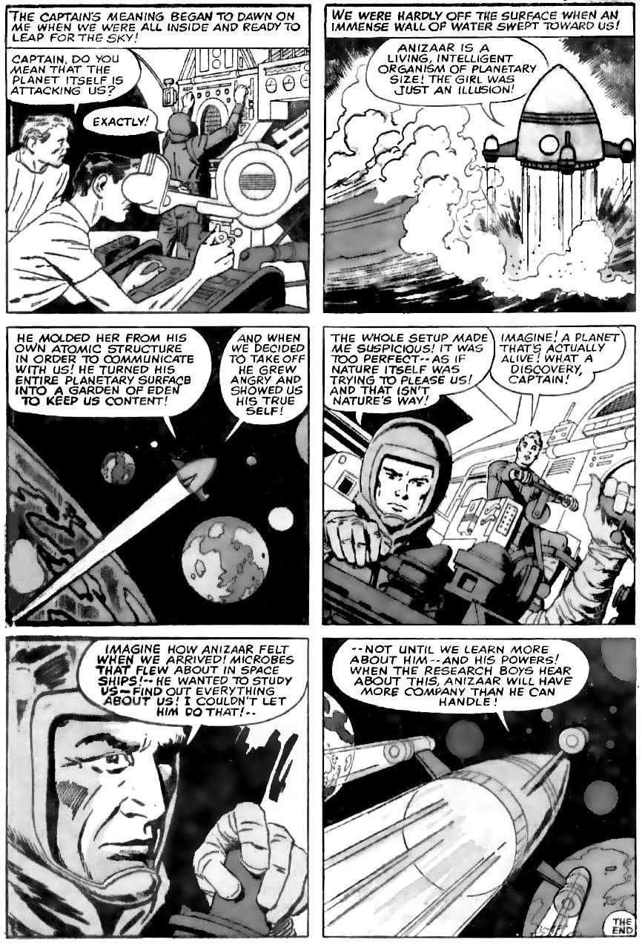
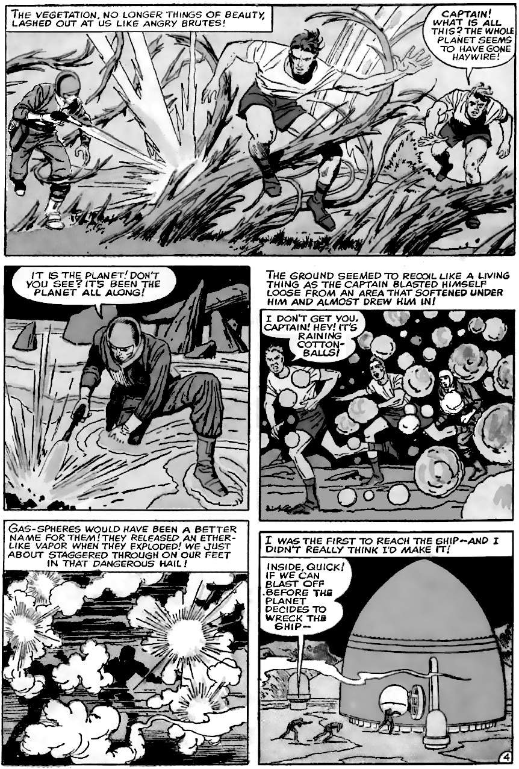
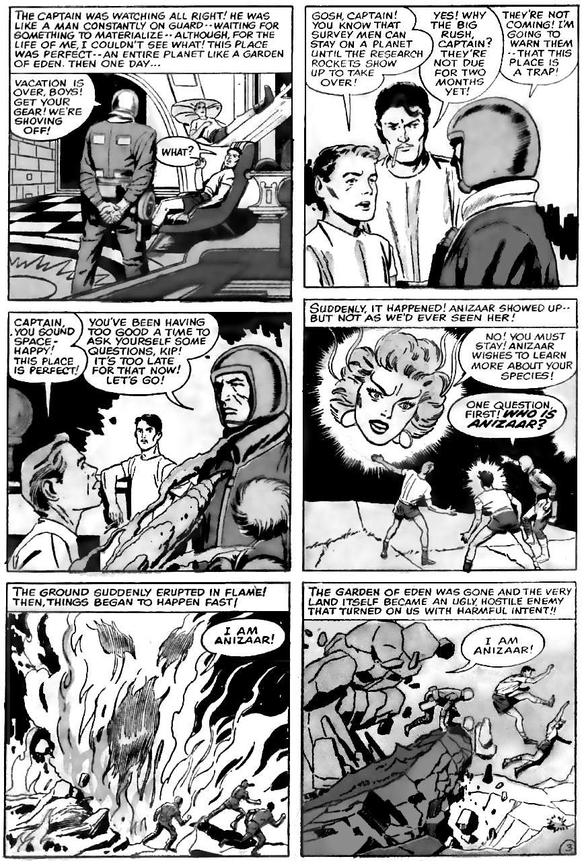
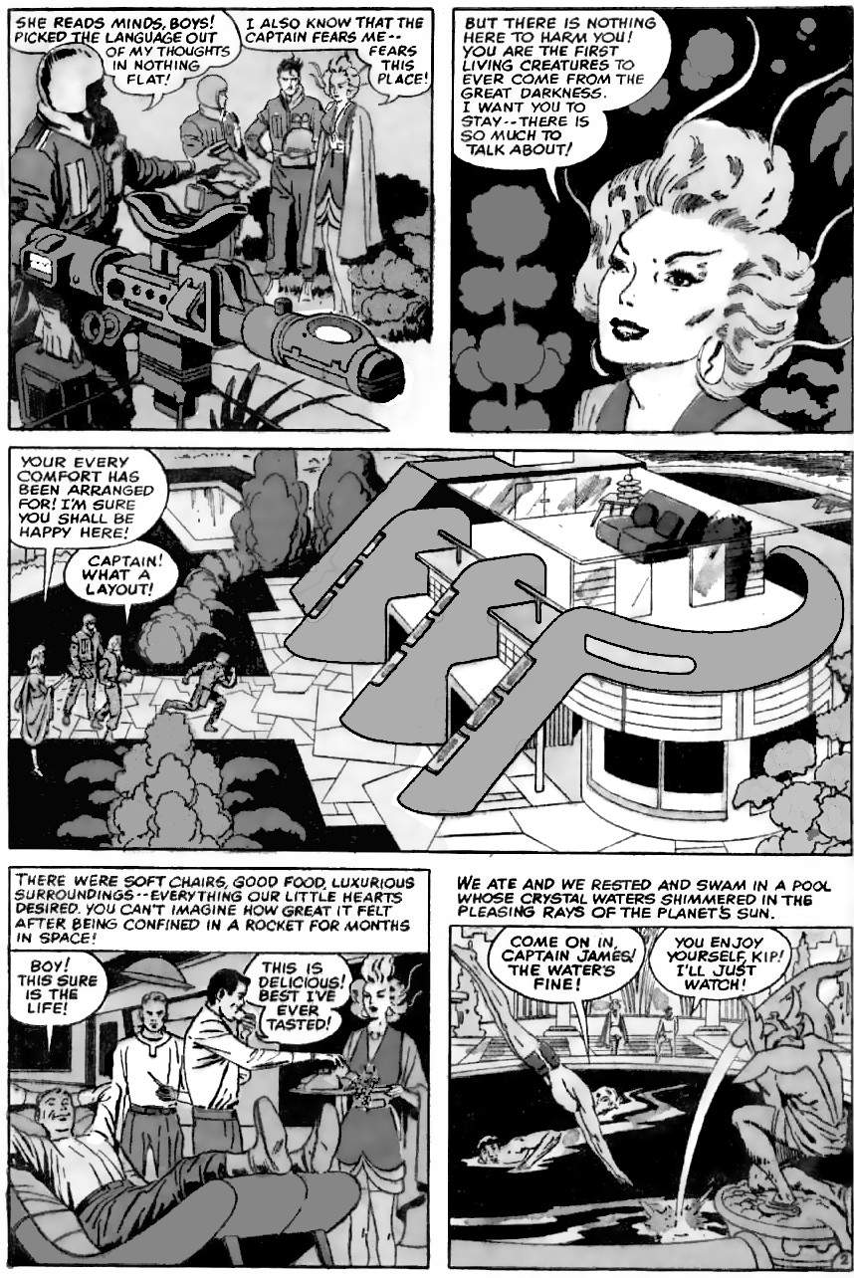
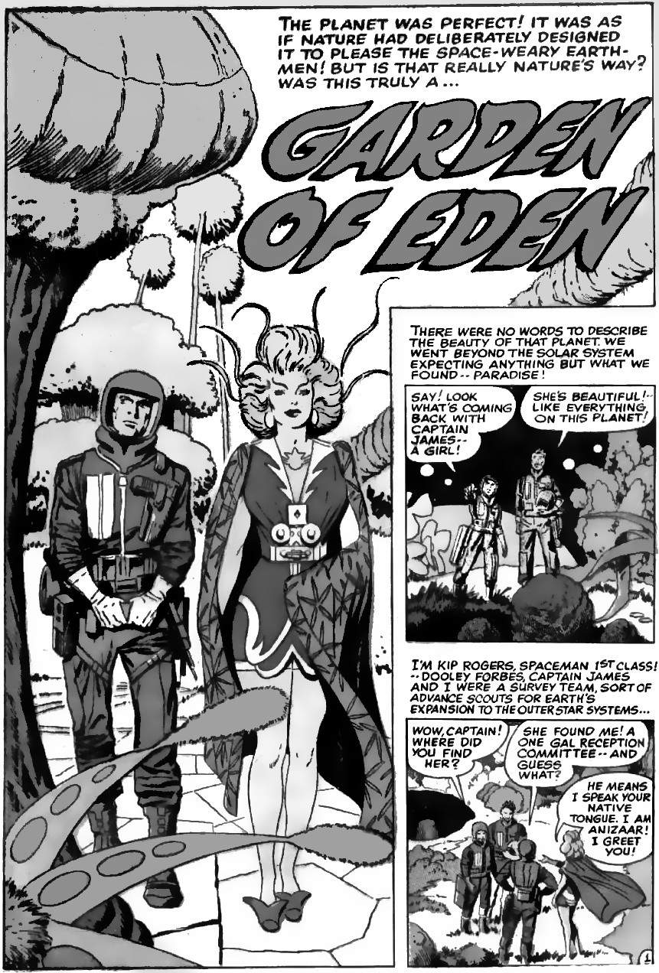
Why are space gods ever nice to us?
Billionaires do not give us space ships and iPhones out of the kindness of their hearts. They do it because, at the moment, it is how they get rich. But getting rich through selling things to poor people is a very recent and unnatural trend.
Kings did not sell goods to poor people: they taxed or enslaved them. If you have sufficient power you do not ask for money or work, you take it.
The rise of machines caused a problem with the ancient tax and enslaving system. Machines increase competition. This required healthier soldiers, and more educated civilians to run the ever-changing machines. This high demand for healthy, educated people gave great bargaining power to any workers who unionised. This led to the welfare state and improving conditions, leading to reducing inequality from the end of World War I to the late 1970s. The introduction of affordable electronic brains in 1976 shifted the balance of power to the creators of those brains. And so we return to rising inequality.

2026: The first trillionaires
In 2019, it was estimated that Jeff Bezos will become the world's first trillionaire in 2026, followed by Xu Jiayin in 2027. Then the pandemic happened and shook things up. So in 2022, it was estimated that Elon Musk will become the first trillionaire in 2024, followed by Zhang Yiming in 2026. 2024 is probably optimistic: Musk is famous for his over-optimistic timelines. So 2026 is probably the safe bet. In 2026 or soon after, the world will see the first trillionaires.
2026 will see the Great Reset: the complete takeover of government by the super-rich. Every part of the political system will be monitored by the super-rich, and nothing will get through without their agreement. The Great Reset is named after the policy of the World Economic Forum (WEF), an influential group of politicians and business leaders. The WEF meets in the ski resort of Davos, Switzerland, each year, to discuss and plan global strategies. It plans for a “Great Reset” of capitalism:
“Every country, from the United States to China, must participate, and every industry, from oil and gas to tech, must be transformed. In short, we need a “Great Reset” of capitalism.”
The Great Reset is sold as if it creates “fairer outcomes” to “build a better society”. But in reality, it has “three main components”:
- “Governments should improve coordination (for example, in tax, regulatory, and fiscal policy), upgrade trade arrangements, and create the conditions for a ‘stakeholder economy.’”
- “Ensure that investments advance shared goals, such as equality and sustainability.”
- “Harness the innovations of the Fourth Industrial Revolution” [i.e. automation].
Most of this is meaningless: politicians have always said vague platitudes about “shared goals" and “harness innovations”. But buried in that fluff is one concrete, meaningful change: the “stakeholder economy”, also known as “private sector engagement every step of the way”:
“That will require stronger and more effective governments, though this does not imply an ideological push for bigger ones. And it will demand private-sector engagement every step of the way.”
When the private sector is involved with “every step” of government, who will be in control? Voters, who have a single meaningless choice between two nearly identical parties every four years? Or the billionaires who fund those parties and guide “every step” that they take?
Ida Auken, a Danish member of parliament, thought The Great Reset could be good for voters. Why? Because his country, Denmark, was good for voters. But even Denmark is starting to give more power to the super-rich, and less power to ordinary people. Denmark's “Gini coefficient” (the most popular measure of inequality) was 23% in 1990. It is now over 28% and climbing. Even Danish voters are losing to the super-rich.
Here are Auken’s concrete examples of the Great Reset:
“Welcome to the year 2030. Welcome to my city — or should I say, "our city". I don't own anything. I don't own a car. I don't own a house. I don't own any appliances or any clothes.
It might seem odd to you, but it makes perfect sense for us in this city. Everything you considered a product, has now become a service. We have access to transportation, accommodation, food and all the things we need in our daily lives. One by one all these things became free, so it ended up not making sense for us to own much.”
Auken summed up his article in a very famous tweet:
“Welcome to 2030. I own nothing, have no privacy, and life has never been better”
This tweet led to a storm of outrage, so the main article was taken down, and the WEF stopped talking about The Great Reset. But “private-sector engagement every step of the way” is already well underway. The only thing missing is the upside, the free accommodation, transport and food.
In 2014, a landmark study shows that in America, which leads the way in“private-sector involvement every step of the way”, ordinary people had “little or no independent influence" on politics. Only the super-rich influenced politics.
“Multivariate analysis indicates that economic elites and organised groups representing business interests have substantial independent impacts on US government policy, while average citizens and mass-based interest groups have little or no independent influence.”
One example of this is campaign finance. In 2016, presidential candidates had to spend over six billion dollars just to be noticed. In 2020 they had to spend fourteen billion dollars. If you want to be selected by a major party, you have to please a lot of billionaires. So we now have a pro-billionaire supreme court, and billionaires’ lobbying firms write the laws. They have international agreements so that big corporations can sue any government that harms their profits. Their capture of government is almost complete.

The Great Reset in 2026
Auken guessed that the Great Reset would be complete by 2030. But two major crises are likely to bring the date forward. The first crisis is the global pandemic of 2020-2021, which doubled the wealth of the richest billionaires:
“The world’s ten richest men more than doubled their fortunes from $700 billion to $1.5 trillion … during the first two years of a pandemic that has seen the incomes of 99 per cent of humanity fall and over 160 million more people forced into poverty”
The second crisis is the end of the 18-year housing cycle in 2026. Economist Fred Harrison studied the 18 years cycle over the past 200 years and correctly predicted the 1990 crisis back in 1983. He then correctly predicted the 2008 crisis back in 2005. The number 18 is only an average: it can be 16 to 20 and has definite stages. Based on these stages, the next crash is scheduled for 2026. This 2026 crash is likely to hit America harder than the crises of 1990 and 2008, because (1) the government has far more debt, thanks to the 2020-1 crisis, and (2) long-term confidence in America will be lower, because China is set to become the largest economy on Earth in 2026. Higher debt and lower confidence from investors will make it much harder to solve the 2026 crisis by just borrowing more money like last time. But billionaires will be already embedded in government and will be ready with answers. So 2026 is likely to be the tipping point for the Great Reset.

2026: the literal masters of the universe
Tom Wolfe famously called the top Wall Street traders “masters of the universe” because there was no limit to what they could do:
“The Masters of the Universe were a set of lurid, rapacious plastic dolls that his otherwise perfect daughter liked to play with. They looked like Norse gods who lifted weights … On Wall Street he and a few others — how many? — three hundred, four hundred, five hundred? — had become precisely that… Masters of the Universe. There was… no limit whatsoever!”
That was just a metaphor. But the tech billionaires are racing to become literal masters of the universe. For example, Elon Musk’s SpaceX is so far ahead of other spaceship companies that it is on track to have a virtual monopoly on access to space. Musk will become the gatekeeper to the universe.
How can super-billionaires make money from space? By mining asteroids. The website “Asterank” maintains a database of the metallic composition of asteroids and their value on today's market. The top five hundred asteroids are worth more than one hundred trillion dollars each. With enough mineral resources, gigantic rotating space stations can make planet Earth obsolete: there is literally “no limit whatsoever” to the power of these real Masters of the Universe… except for the boom-bust cycle of civilisation that's always driven by such hubris.

1976-2026: the triumph of the space gods
July 1976 saw the first successful unmanned landing on Mars. This inspired Robert Zubrin, who in turn inspired Elon Musk. In 2020, Musk planned to land the first human on Mars in 2026:
“I think if you say six years from now [2026] I think highly confident. If we get lucky, maybe four years [2024].”
Unexpected delays are normal, and at the time of writing, it is more likely that Musk will land people on the moon in 2026, with Mars a few years later. There will be pressure to not slip the moon landing past 2026 because of the symbolic importance of America's 250th anniversary. This will be enough to show the world that power has moved from nations to super-billionaires. The new space gods have arrived, they can do what governments cannot, they control governments, and there is nothing that voters can do about it.

2026: America feels weak, turns to space gods
In 2026, China is due to overtake the USA as the world's largest economy. Others say it might take until 2028, depending on how the numbers are calculated, but by 2026 it will be a forgone conclusion. America will feel weak. The only people who can help it will be the space gods, the super-rich who can promise jobs and hope in return for even more power.
The rise of China began in July 1976, the American Bicentennial, and the month that Chairman Mao died. Earlier in the year popular premier Zhou Enlai also died. He was replaced by the reformer Deng Xiaoping, who eventually became Mao's successor. Deng's reforms led to enormous economic growth. This was the fifty years that changed everything.

1976-2026: billionaires killing the poor
In 2026 global warming is expected to reach 1.5 degrees above pre-industrial levels. This was the limit set by the 2016 Paris accord. This is the limit that the world's nations promised not to exceed. And we will exceed it in 2026, showing that those with power don't care.
Climate change currently kills 150,000 people per year.
By 2030 it will kill 250,000 per year.
By 2100 it will have killed 83 million people.
This only includes direct deaths from heat stroke and similar causes. If we include wars caused by climate change, the number is vastly higher.
We were first warned of Climate Change in 1976. It was compared to Noah’s Flood. In January 1976 Professor Stephen Schneider published the first major warning about global warming. He compared the result to Noah’s flood, calling his paper "The Genesis Strategy: Climate and Global Survival". Between April and June 1976, scientists warned the US Government: they testified before the Subcommittee on the Environment and the Atmosphere of the Committee on Science and Technology. 1976 was when we knew what would happen. We had fifty years’ warning, just as Kirby said in The Eternals. Kirby used Noah’s flood as an example of how space gods kill people they do not want. In real life, the gods of Noah’s flood were the elites who flooded and then burnt the great city of Shuruppak, to get rid of the poor. Now the space gods have returned, and 2026 will prove that the rich will happily kill millions of people for profit.
Kirby knew the legends, he saw history repeating itself, and he tried to warn us. He saw himself as a modern Noah. The gods are happy to kill us through flooding. Kirby gave us a fifty-year warning, and now it’s begun.
If they will kill millions of people for profit, how far will they go? What happens when 99 per cent of humans are not needed, due to more advanced machines? What happens when it becomes profitable to kill 99% of us?

Can anything stop the super-rich?
Here is a graph of inequality in Europe since 1300 AD, and another that pushes the graph back to Rome. See how inequality grows and grows. The only thing that stops it is death on a massive scale.

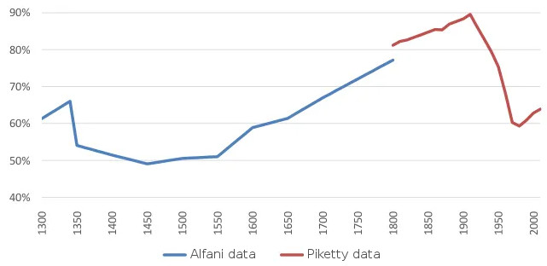
Graph: How much of Europe is owned by the top ten percent. By Guido Alfani, including Thomas Piketty data, voxeu.org/article/europe-s-rich-1300#.WHyJoFECEBk.twitter

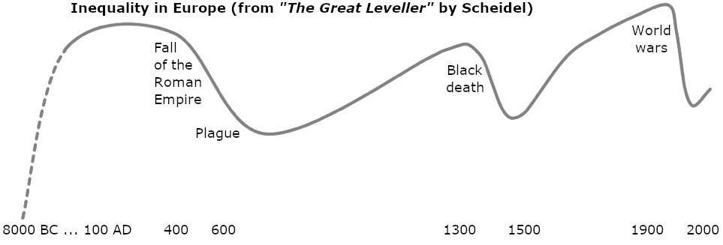

We like to pretend that we can stop the super-rich through politics. But in the real world, the only thing that stops the super-rich is the collapse of the entire system. That is how it always ends.

12.
2026-5000
This chapter has a timeline of Kirby's dated predictions, from after 2026 to the year 5000.
In Kamandi, Kirby outlines “The World That's Coming”. A trend throughout the series is that the super-rich can do anything, thanks to technology and the wealth it brings. Everybody else is replaceable (see chapter 9). Issue #1 is about the first humanoid robots, and how they could be used as assassins to cause an atomic war.
At first, general-purpose intelligent robots will be expensive, and humans can compete by taking ever-lower wages. But within a generation, robots will be so cheap that most humans will be unprofitable. 99% of humanity will rely on government benefits. The rich will see them as lazy and stupid: if they were not lazy and stupid they would be in the 1%, creating vast wealth, right? Then, when some of the 99% rebels, all the 99% will start to be seen as criminals and terrorists.
Meanwhile, the rich will conquer space. They can mine asteroids and colonise worlds. This makes it easy to solve the troublesome problem of the rebellious poor back on Earth. This scenario will lead to "The Great Disaster”: see chapter 13 for details.
140 years after The Great Disaster a new and better civilisation will arise. There will still be some conflict from time to time, but we will have mostly learned our lesson. Here is a story about an end to war (at least for a thousand years). It takes place in 2514, as the last warlike people are about to be defeated. These “rat-men” are the spiritual descendants of the skull cult that caused such misery for the last ten thousand years. Their defeat signals the birth of a better civilisation. The title of the story, "The Last Enemy", is very famous from Paul's discussion of the end of power: when God has “destroyed all dominion, authority and power”, "The Last enemy to be destroyed is death”.
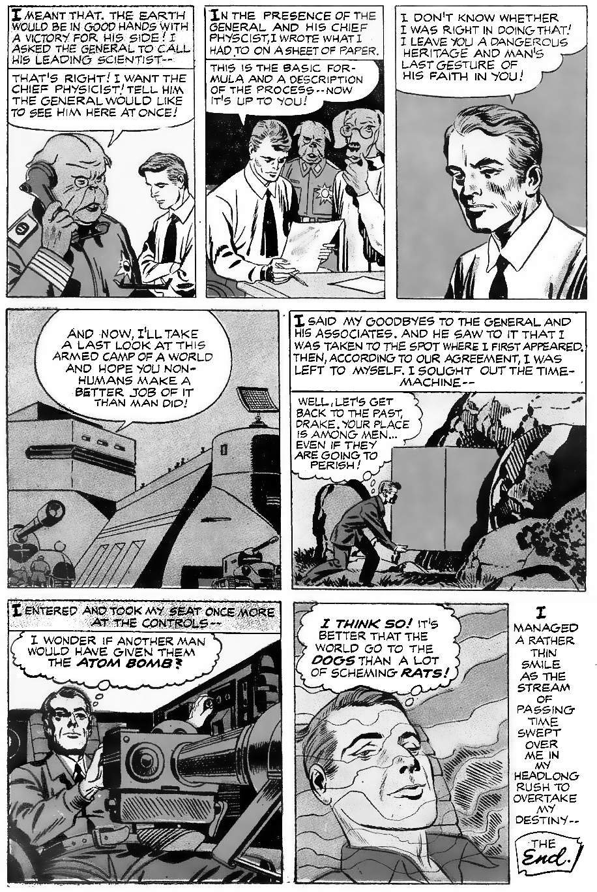
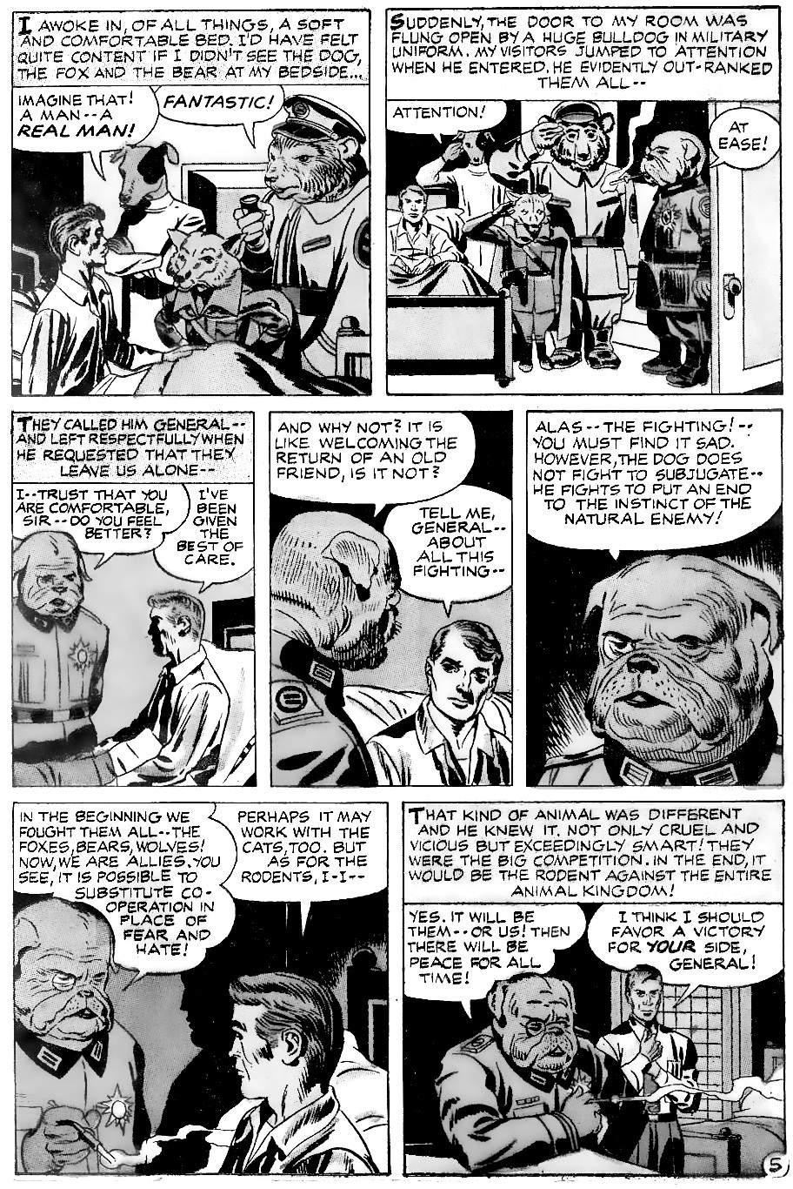
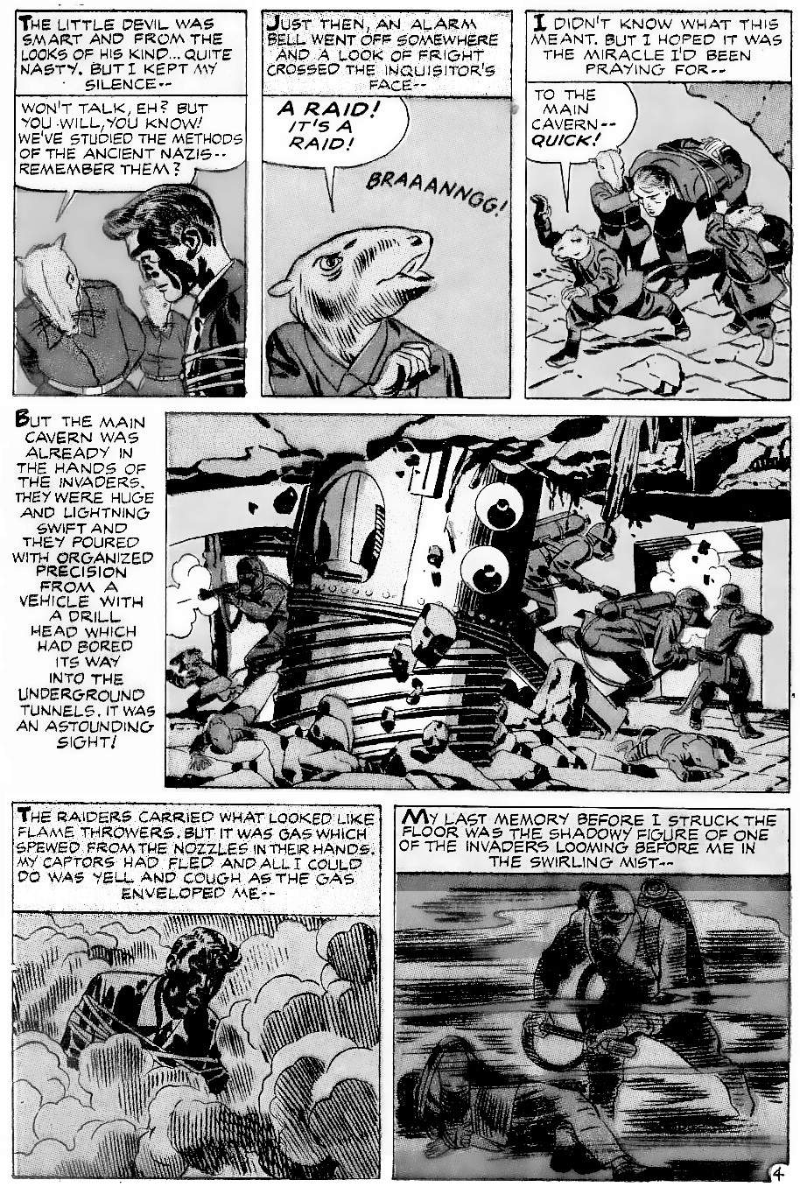
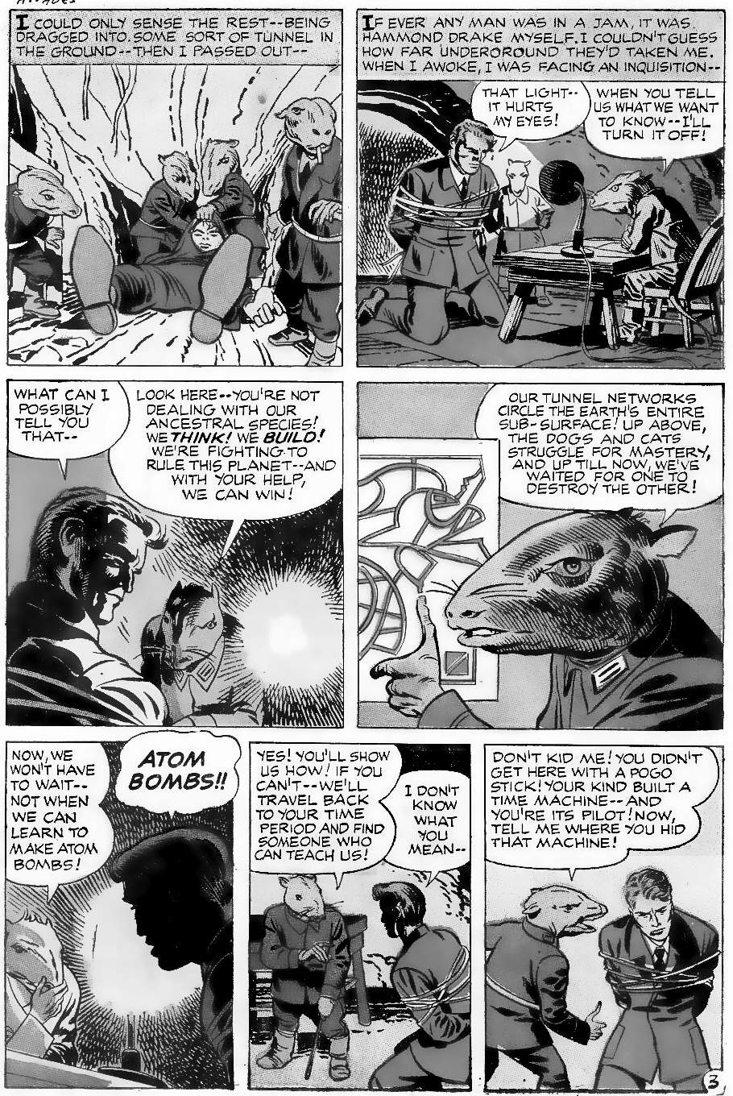
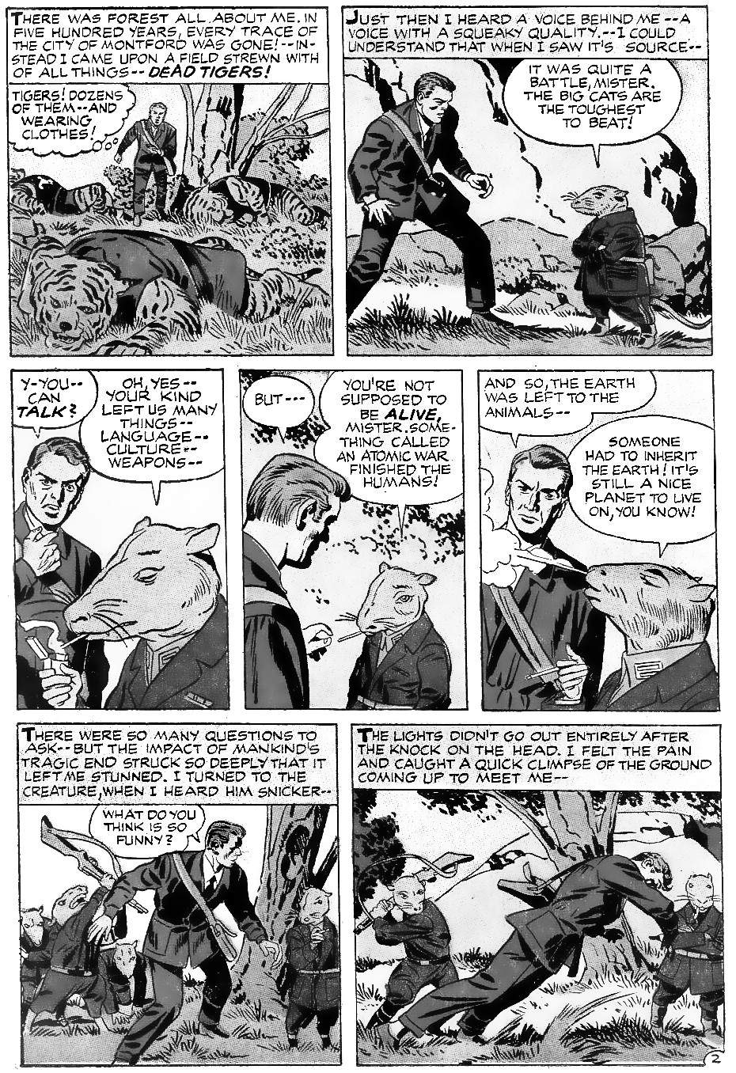
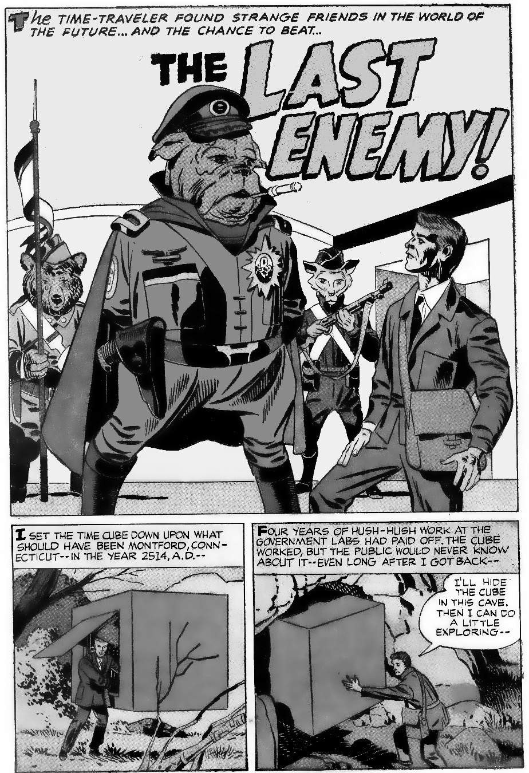
When is the first nuclear war? Is there a second nuclear war? Where do tiger-people and rat-people come from? Let us explore the Kirby timeline:

2040: private space travel
(Predicted in 1940)
In "The Solar Legion", Kirby writes:
"A century hence, [i.e. 100 years from 1940] the barriers encircling the planets shall disappear and the strange forced binding man to Earth shall fall before the onslaught of his invention."
This seems very likely. Elon Musk's company "SpaceX" plans to land humans on Mars in 2030 or before. Then start going back.
“I think it will be in this decade [the 2020s], yes. People on the Moon, sooner, … I think we need to get a large delivery to the surface of Mars, and then people will start thinking harder about it …And then, I think within five or six years, people will see that that will be a real place to go".
Even allowing for delays, by 2040 private space travel should be almost routine. The costs will still be high, but technical barriers can all be overcome. Future profits from mining asteroids will be enormous, so that promise will fund endless expansion. So Kirby was right: around 2040 “the barriers encircling the planets shall disappear”.

2040 pollution on Earth; space travel expands
(Predicted in 1977)
In "Norton of New York 2040 AD", Kirby describes New York:
"The automobile has been scrapped, only politicians buy the few that are left — as symbols of prestige. Smog was the master 'outside'. … he saw it rotting the structures in the abandoned districts."
This seems more and more likely. Fossil fuel-powered automobiles are being phased out. Self-driving cars mean few people in large cities will need to own a car: just call a self-driving taxi. As for smog, environmental regulations were greatly weakened in the 2016-2020 presidency. This was to help business, so when America falls behind China, expect more of the same. As for abandoned districts, we already have these in the "rust belt". As machines replace jobs, people will no longer afford to maintain nice houses. So the nice houses will be abandoned, and people will crowd into smaller and cheaper apartments.
"Norton of New York 2040 AD” has several other predictions:
- Superhero cos-play (dressing up in costumes) becomes mainstream. This was almost unthinkable when Kirby wrote this story because superhero comics were still a shameful hobby. But thanks to superhero movies, that day has already come.
- The only day Norton got off work was Sunday, and he wondered if even that would be taken away. This is coming true: technology makes it easy to replace workers, and unions have been made toothless, so low-paid workers have little power to say no.
- There is a fake beach in New York City. This was announced in 2019 and is being built by the Hudson River Park Trust.

2050: the future looks bad
(Predicted in 1960)
"I Dared to Look into the Beyond" is ostensibly about time travel. But when Kirby's characters travel in time, they do not change the past or future in any significant way. The most they ever do is prevent some future change, and they could do that without time travel. So these stories are really about thinking about the past or future.
In this story, people love the past and hate the future. In 2050 people cannot see the future bringing anything good: as far as they can tell, they have no future. We are already going in that direction. Young people today report high levels of anxiety. They worry about global warming and not being able to find a job or afford the rent. The future has nothing to offer them.

2065: replacing skilled humans.
(Predicted in 1962)
In "The Deadly Challenge of Zarkorr", human pilots are being replaced by self-piloting craft. We are already testing self-driving cars, but artificial intelligence is nowhere near as good as human intelligence. By 2065 that will be changing. Nobody will feel safe from being replaced.

2072: global warming leads to conflict with China
(Predicted in 1972)
Kirby’s unfinished novel “The Horde” describes how, in 2072, China is the dominant world power. And global warming leads to war:
“As predicted, the progress of global warming has also continued unabated. All of the central Asian glacier packs have melted away. Huge swaths of verdant farmlands from Tibet to the shores of Southeast Asia are becoming arid desert. China struggles to hold onto the last vestiges of civil control as it mobilises its mighty army.”
These things are starting now. China is about to become the world’s dominant economy. Global warming, caused mainly by the West, will turn drier parts of China into vast deserts. How will China react?

2088: one last chance
(Predicted in 1962)
"Nothing Can Save Us" is an unusual story — a dinosaur with fiery breath diverts an approaching asteroid. This was presumably inspired by the 1956 proposal by M. W. de Laubenfels that a meteor impact killed the dinosaurs. In Kirby’s twist, some dinosaurs can deflect meteorites. The message is that if we don't kill nature, nature will protect us.
Since this is 2088, the metaphorical meteor must be the first humanoid robot in 2090: once these robots appear it is all over for 99% of the human race. We killed the wild animals, and put our faith in concrete and metal instead, and this is the result.

2089: rival space ships
(Predicted in 1959)
"Test Pilot" is about test pilots for spaceships in 2089. Like the previous story, it is metaphorical: Kirby added faster than light travel, and alien space battles. But these are not central to the story. The story is really about how what was once amazing is now commonplace.
This is exactly how it will feel in 2089, the year before the first human-level robot. Rival space companies will fight for supremacy, and life will be a wild roller coaster ride for people who still have jobs. Virtual reality will make it hard to distinguish fantasy from reality: it will be just like Kirby’s story.
The test ship is called Prometheus, after the Titan who created humans and stole fire from heaven. In 2090 we become like Prometheus by creating our own humans.

2090: The first successful humanoid robot
(Predicted in 1962)
In "Mr Morgan's Monster" we finally create a useful humanoid robot. The date, 2090, is very realistic. We routinely underestimate the difficulty of making great changes. Ray Kurtzweil might predict a scientific singularity for 2045, but Kirby’s prediction is more realistic: there are always unknowns that delay our plans.
The first general-purpose humanoid robot scares most humans. We realise that humans are no longer needed. Robot campaigners will say the robot might go wrong, but Kirby said that was not the real problem. The real problem is the resulting social changes. Robots are created by the super-rich, so the benefits of robots go to the super-rich, not to ordinary people. We haven’t thought this through.
"We're building machines that are too damn sophisticated. They're too damn sophisticated, and they're on the brink of something that we know nothing about."

2095: Earth is history
(Predicted in 1958)
“Forbidden Journey” is about a child born on Mars. All he cares about is exploring farther out. Earth is boring to him. Earth has nothing to offer.
This is a natural result of the rise of robots: this results in unemployment, fear for the future, and unrest on Earth. Ambitious people with money look to space to create new and better worlds. Earth is no fun.

2121: The Great Disaster
(Predicted in 1972)
Kirby said the planet “flip[s] its lid every ten thousand years or thereabouts”. This is “natural", kills a lot of people, and involves radiation. He implied that this was a new scientific discovery when he wrote in 1972. He seems to be describing the “Laschamp Event”, when the magnetic poles flip (or partially flip), removing our protection from solar radiation:
"Earth's magnetic field flipped 42,000 years ago, creating a climate ‘disaster' ... solar and cosmic radiation exposure could affect the atmosphere enough to impact climate ... around this time, megafauna in Australia began to go extinct and Neanderthals in Europe were dying out; … A heavily ionized atmosphere could also have generated brilliant auroras around the world and produced frequent lightning storms, making skies look like ‘something similar to a disaster movie,’”
A full geomagnetic reversal “can happen as often as every 10 thousand years or so and as infrequently as every 50 million years or more” but partial reversals are more frequent. This phenomenon was first documented in the late 1960s. Kirby is deliberately vague because the exact cause is not important: what matters is that some such disaster happens every ten thousand years or so. It could be an impact from space debris, a super-volcano, a Heinrich event, or even the natural boom-bust cycle of species like humans.
Kirby was thinking of a man-made disaster when he wrote Kamandi. We know this because in the same month as Kamandi #1, Kirby showed a very similar Great Disaster in “Toxl, the World Killer”. Toxl is set “thousands of years ago”, and “before recorded history” but the last panel reminds us that it could happen again today. In the story, a machine siphons the Earth’s magma, creating thick smoke and killing wildlife. Breaking the machine triggers a supervolcano, wiping out civilisation. The story begins and ends with a modern scientist saying that, “We do not really know what happened: this is just a guess”, and asks, “how often has this cycle been repeated?” Kirby says much the same thing in the essay in Kamandi #1. At first glance, the supervolcano theory might be supported by Kirby’s map of the world after the disaster. But the famous supervolcano at Yellowstone was not discovered when Kirby wrote Kamandi.
Kirby placed the epicentre of the Great Disaster as a series of explosions in Savannah, South Carolina, and said there were similar explosions in Washington, DC. Savannah is a major nuclear site: in the 1950s it supplied material for nuclear weapons, and it still employs over ten thousand people. A nuclear war would of course target weapons sites plus the capital. Kamandi was born in some kind of nuclear fallout shelter, where people waited because the surface of the world was radioactive. So it sounds like Kirby had a nuclear attack in mind.

Is a nuclear war “natural”?
Kirby called the Great Disaster “natural”. How is a nuclear war natural? Mathematical modelling shows that many species follow a boom-bust cycle. So our ten or twelve thousand-year cycle of civilisation might not be due to asteroids or volcanoes, it might be due to natural population cycles.

The new map after the disaster
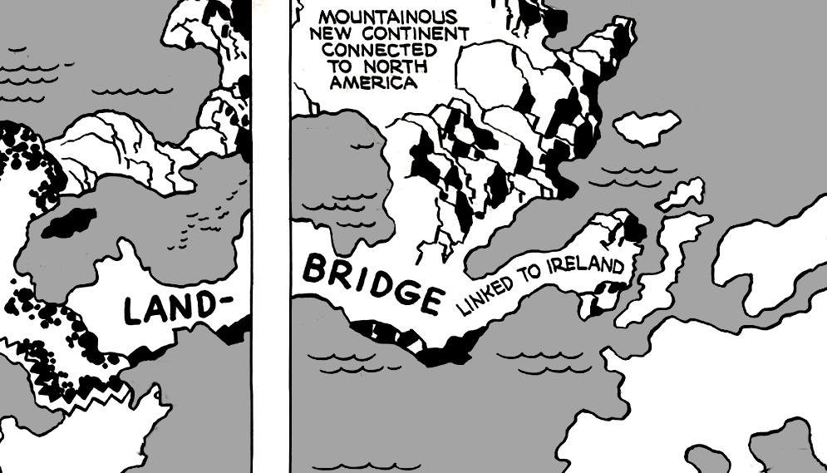
How do we explain the “mountainous new continent” around Greenland?
Image adapted from Kamandi. Fair Use.
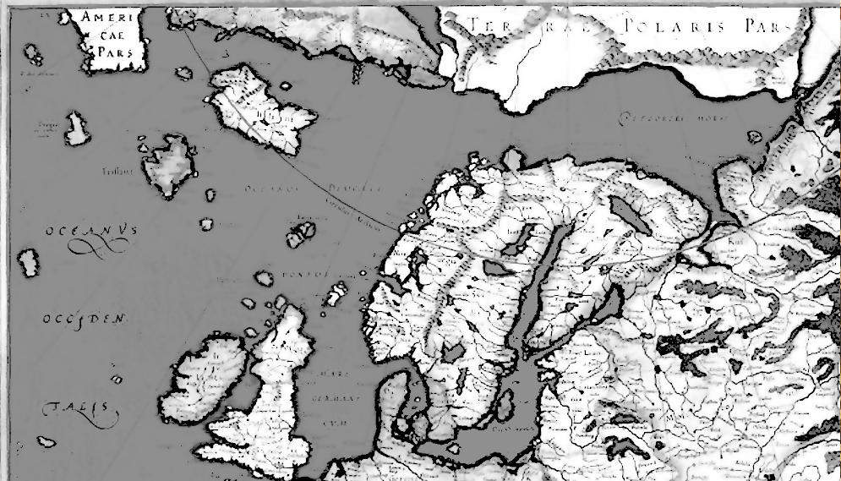
The new mountains can be explained by global warming: as the Greenland ice sheet melts, new rocky land appears. The land bridge should be familiar from old maps, like the one by Mercator in 1595.
Image: detail from Mercator’s 1595 map of the world (out of copyright)

The map reflects the understanding of the world in an era without regular ocean travel. Notice the top left of this old map, “Americae” (America): it's not so different from Kirby’s map.
The distorted map is reliable if we travel without modern technology. If we have no mechanical engines, no radar, and no sat-nav, then we must rely on island hopping to cross the Atlantic. So it makes sense to exaggerate the size of tiny islands, and even invent new islands if it encourages readers to take the best route. By following the 1595 map we could navigate from America to Ireland by island hopping. So the map works. The same principle applies to the other amazing features on Kirby’s map (the gigantic wall, whirlpool, etc.). The Kirby map is not for people with planes and ocean liners: it is a map of how a dangerous world is experienced by a lone traveller who must rely on local help.

The date
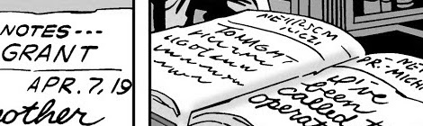
Kamandi #1 shows New York streets under water. Much of New York is less than two meters above sea level today, so will be below sea level soon after 2100 thanks to global warming. That is our first clue to the date. Then in Kamandi #16. Kirby shows a diary written at the time of the Great Disaster. On page 9 of the story, we see this date: "April 7, 19" with the rest of the page cut off. This is obviously so that the first readers of Kamandi (in 1974) can imagine the events taking place in their century. But "Apr 7, 19" could also mean “April 7, 2019” or “April 7, 2119”, etc. On page 10 of the story we see the full date as a scribble: three letters (the month) then the digits “6 2 1” That is, the sixth day of some month in 2021 or 2121. Kamandi comes soon after OMAC, which is triggered by the invention of lifelike humanoid robots, which dates OMAC to soon after 2090. It probably takes one more generation for humans to realise there is no hope., which would trigger the war. So 2121 is the most likely date.
Image: Kamandi #16, DC Comics, Fair Use

Talking animals?
The "animals" in Kamandi and "The Last Enemy" are roughly human-sized, with roughly human limbs, and they talk and act like humans. So they are humans with animal characteristics. But where do they come from?
Consider the social effects of a major war. After World War II, the Nazis failed so spectacularly that most people rejected everything the Nazis stood for. Now imagine how people would react to global nuclear war: this is not just the Nazis failing, this is the whole of humanity failing, on a much larger scale. All our belief in modern science, all our belief in human superiority over animals will be proven wrong.
After a nuclear war, we will have three kinds of survivors:
- The science people. Some people will still believe in scientific progress. But they will have learned their lesson: no more building massive weapons. The science people will need to retreat into defensible fortresses like Kirby’s “Tracking Site”, to avoid the anti-science people who blame them for destroying the world.
- The animal people. Some people will be so ashamed of what humans did that they will no longer identify as human, just as Hitler’s family disavowed his name and vowed to have no children. Animals will seem more moral and intelligent than humans: no animal ever made a nuclear bomb. People will identify as animals. This is already common among street gangs, with names like “the white tigers” or “the cobras”. Hunter-gatherers often take animals’ names. For example, a Seneca leader like “blacksnake”: might be born in the “Turtle clan”, or be adopted into the “Wolf clan”, and fight in the “Beaver wars”. Individual shamans identify as specific animals. Cave art shows that humans have identified as animals for tens of thousands of years.
- The hippies. Some people will react to nuclear war by embracing pacifism. They will welcome the most desperate refugees from far away, and overcome language barriers with grunts and touching. Their extreme hatred of science, and love of nature, will lead them to live as foragers in small groups, communicating with grunts, as wild animals do today.
Kirby exaggerates for dramatic effect. He explains the animals’ intelligence by saying that regular animals are injected with “cortexin”. The name might refer to the cortex (the surface of the brain), or to “cort” (Latin for enclosure) plus “exin” (Latin for “and then”, related to “exit”). So “cortexin” could mean “exit the enclosure!” It could symbolise humans and animals finally becoming free.

2140: The Mars colony must survive on its own
(Predicted in 1940)
In the very first "Solar Legion", Kirby wrote:
"Terror stalks the trail of the interplanetary pioneer in the year 2140 AD"
The story is about lawlessness in space. A man they call "Black Michael" shot down rival spacecraft. In the Bible, Michael is the captain of the heavenly host. So Black Michael is an evil captain of a heavenly host: a pirate leader operating from space. He bombs entire settlements:
"Entire settlements are blasted into oblivion! For years to come the entire solar system trembles under the threat"
There is no mention of Earth. The outposts are generally very small, yet must organise their own defence. If Earth was functioning normally, it could easily defeat one pirate ship. But Earth is not in the picture. It is left to one private individual, with one single ship, to defend the solar system. So what happened to Earth? In 1940 Kirby did not say. But in 1940 the world was at war: the idea of civilisational collapse cannot have been far from Kirby's mind. In Kirby’s view of the future, Earth appears to be powerless in 2140.

2150: the super-rich have given up on Earth
(Predicted in 1940)
"Comet Pierce" is the first time that Jacob Kurtzberg experiments with the name "Jack Kirby”. He gives us a glimpse of Earth in 2150. We only see a single building, where a spacecraft can land and then leave again. We never see Earth cities or Earth people, just this isolated spaceport.
Some of the survivors of “The Great Disaster” will be science people: they will retreat into fortified cities to rebuild a science-based civilisation. So science and rocket travel will continue on Earth, but on a much smaller scale than before the Great Disaster
It is unlikely that in 1940 Kirby was thinking specifically about The Great Disaster. But he was thinking about a radical change in Earth's civilisation, because the story begins:
"Time may change civilisation, custom and speech, but it can never erase man's craving for adventure and thrills…"
The theme of the story is that private individuals with money for rocket ships have no interest in Earth. Earth is history.

2165 and 2190(?) Reassuring the children
(Predicted in 1959)
"The creature from planet X" is set in an undefined year when 2165 was "a long time ago”. The narrator says:
"My, how time flies! Last week when I visited with my nephews, I could hardly believe that Timothy was already 10; and Scott, almost 7! But you know, they still enjoyed hearing the same stories from me..."
So the narrator is a generation older than a ten-year-old, and recalls starting her first job “a long time ago”. So this is probably twenty years or more after 2165: perhaps around the year 2190.
The narrator tells a story from the past, about a zoo with a dangerous alien monster. It escapes, but she is never in any danger because the creature can only survive on its home planet. Two years later, Kirby identified “Planet X” as a moon of Jupiter. In 2165, human outposts will have existed on Mars and Jupiter’s moons for several generations, and will probably import animals to adapt to the new conditions.
The theme of the story is safety: although the world is scary, everybody is very safe. This is an unusual theme because most science fiction is about danger, not safety. This is just the kind of message that a loving aunt would give to worried children, two generations after The Great Disaster.

2260: law and order returns
(Predicted in 1940)
In the third "Solar Legion" story, law and order are finally restored to the solar system.

2262: nuclear weapons are long since banned
(Predicted in 1962)
In "The Tomorrow Man", we see a fully functioning city on Earth. Nuclear weapons have been banned. The story involves time travel, but time travel changes nothing. So this is not really about time travel, it is just a storyteller’s way to compare two time periods.

2306: first trip to Mars since the Disaster
(Predicted in 1959)
"Menace from Mars" has the first manned spaceship to Mars. Space travel is already highly advanced: they can easily send elephants and other large animals on a return trip. Meanwhile, the beings on Mars are very ignorant and unintelligent, and yet they had space ships. How can we explain this?
This story only makes sense in terms of Kirby’s timeline. The first humans to settle on Mars feel no ties to earth: they only want to expand to other planets. Earth civilisation then collapses. The Martians are now even less likely to care about Earth: they will not want to remember that they caused Earth’s problems. So they will remember Earth as a backward place, and teach their children nothing more than that. So Martians lack curiosity and know almost nothing about Earth. Meanwhile, Earth knows how to make rockets but has not launched many rockets since The Great Disaster. Now the story makes sense.

2389: still not faster than light
(Predicted in 1959)
"I Fly to The Stars" shows that space travel can now reach nearby stars. This is realistic: there is no faster than light travel. But ships can now reach relativistic speeds, so pilots age slowly on the long journeys.

But Kirby had faster-than-light travel before this?
This is a good place to talk about the core of truth in Kirby's writing. Good fiction always has a core of truth, wrapped in fantastical situations that are designed to enhance the core truth. The core truth is usually how people react, not the technology.
"We move away from places that were completely familiar to us and we suddenly find ourselves in different situations, not knowing what confronts us, trying to feel our way out, … so we can function wherever fate places us. That was the core of truth in my most fantastic situations.”
In "I Fly to The Stars”, the core of truth is the extreme length of a journey to the stars. So Kirby adds a fake detail about other people not knowing. In reality, they would know all about it, but Kirby’s change enhances the core truth. In an earlier story, “Test Pilot”, the core truth was the excitement of discovery. So Kirby added faster than light travel to enhance that feeling of excitement. When we identify the core truth in a story then we can see what Kirby is predicting, and not get distracted by unimportant details.

2500: exploring other worlds
(Predicted in 1959)
"One of Our Space Men was Missing" is a typical Star Trek-type adventure. None of this takes place on Earth.

2514: a major atomic war long before this date
(Predicted in 1957)
In "The Last Enemy", a rat tells our human hero:
"You're not supposed to be alive, mister. Something called an atomic war finished the humans"
However, the rat does not seem at all surprised to see the human. So perhaps "finished" does not mean "killed". It could mean most of them were killed and the rest are no threat. Any talking human is seen as a dangerous oddity and should probably be killed. That is the same approach seen in Kamandi.

2540: Comics as mainstream ancient mythology
(Predicted in 1976)
In "Eternal Utterings", Kirby suggests that a Spider-man cult could exist in the year 2540 because comic books become part of historical mythology. Spider-Man is of course a human who identifies as an animal. After The Great Disaster, many humans choose to identify as animals, so Spider-Man is a natural choice.

2957: Earth and Mars are at war
(Predicted in 1957)
"Who was Mr Ashtar" is a classic Kirby time travel story. That is, time travel is not needed by the plot: it's just a colourful way to compare different periods. In this case, the year 2957 needs a super weapon developed in 1981. This is the climax to almost 200 years of tension with Mars (see 2306). Now it is war at any cost, and Earth is about to win. For details, see 1981 in chapter 10.

3000: Golden age of peace?
(Predicted in 1963)
In "Prisoners of the Pharaoh", we learn that the year 3000 is so peaceful that ambitious people like Kang want conflict as entertainment.

3000: the greatest age of technology and peace
(Predicted in 1958)
In "The Wizard of Time", we learn that a time traveller who wants the best technology will naturally go to the year 3000. 3000 is peaceful, advanced, and highly democratic.

3000: adapting bodies for star travel
(Predicted in 1954)
In "Homecoming: year 3000", interstellar travel is well established. This story was originally part of "Starman Zero”, a proposed series about a human whose body is modified for star travel. New technology can place a human mind in a new body that can easily withstand great acceleration, then years in hibernation. This is realistic star travel, without breaking any laws of physics.

3045: most people leave for new planets
(Predicted in 1960)
In "I Dared Look Into The Beyond", we learn that most humans leave planet Earth in the year 3045. We are not told why, but previous events suggest three reasons. First, is the natural desire to explore. Second, the constant wars with Mars must have grown tiresome. And third, residual guilt from The Great Disaster. Perhaps humans want to leave the world to the animals, and no longer live by harming other life. This is the new heavens and new Earth predicted by Jewish prophecy.

3048: those left behind just want to have fun
(Predicted in 1972)
“Galaxy Green” is a tongue-in-cheek story proposal for a DC project called “Uncle Carmine’s Fat City Comix”. “Uncle Carmine” was DC Editor Carmine Infantino, and the project was intended to compete with underground adult comics. Wisely, the project was abandoned: underground comics by major corporations never work. But Kirby created something intriguing for his contribution.
The story was intended as adult fun: planet Earth has no men, so the women search the galaxy to catch some. But despite the silly premise, this story fits perfectly into Kirby's timeline. In 3045 all the serious-minded people leave Earth. It is easy to see some fun-loving rebels would stay behind, glad to be free of the boring types. But why only women? Well, why not? Sex changes will be trivially easy in 3045: being a buxom, sex-mad space woman may be the fashion among crazy party people in 3045. Kirby only made two pages — the cover and a sample inner page — so we are free to speculate.

3500: war returns
(Predicted in 1946)
“The Stolen Centuries” records how war returns in 3500. The good guys cannot cope with the unexpected war, and once again must look to the past for inspiration. The bad guys are no better: they do not use their machines efficiently. These are not the best and brightest: those people left 450 years earlier.

3994: a dying world
(Predicted in 1980)
"Thundarr the Barbarian" describes a post-apocalyptic wasteland. Kirby had some input into the series. It is not clear how much, but the date and setting fit his timeline.

4000: a dying world
(Predicted in 1964)
In "Kang, the Conqueror", we learn that while 3000 is the pinnacle of world history, and 4000 is a dying world. Warlords use the old technology as weapons, but they do not understand how technology works.

5000: Earth dies, and is reborn
(Predicted in 1962)
In "When a Planet Dies", Earth is growing colder. The sun gives less heat: presumably, the Earth's orbit has changed, perhaps due to the high technology wars of a thousand years before. Thundarr featured a cataclysm when a meteor hit the moon, so perhaps that is related. The cold causes humans to live underground, waiting for the end. They are watched by benevolent aliens: perhaps the descendants of the humans who left in 3045? Earth people pass a test, and show that they are now peaceful. Earth is then caught in the orbit of another star. The planet has a bright new start.

5000: The new humans are smaller
(Predicted in 1962)
In "The Man Who Shrunk the World", we learn that shrinking gas technology is very well known in the year 5000. Kirby uses a similar shrinking gas a few months later in Fantastic Four #7, and also in Ant-Man and many other stories. Shrinking has many benefits, such as allowing far more humans for any given resources and more easily hiding from enemies. And of course, more people can fit into a rocket ship, as seen in Fantastic Four #7.
In "The Changeling", we learn that our human descendants on other planets are very small. That story has no date, but the parallels are obvious. Perhaps these are the humans who left back in 3045.

6,000,000 or earlier: The sixth age of mankind
(Predicted in 1977)
In "The Six-Million Year Man", we learn about the future "sixth age of mankind". Humans are barely recognisable and have enormous brains. Earth is much closer to its sun, and is completely smooth, and covered in hatches leading to underground tubes. The world faces planet-sized enemies from space.
Even in the distant future, we will face conflict. Conflict is unavoidable, as long as we live. This is the message of Captain Victory, Kirby’s most philosophical work:
"Victory is sacrifice.
Sacrifice is continuity.
Continuity is tribulation."

13.
The Road to Armageddon
This chapter is about the coming global nuclear war. It shows the link between what the Greeks called the twin evils of mankind: war and employment. It shows how the road to nuclear war began with private competition: with Cadmus in ancient Greece.
Cadmus was the first Greek hero. He is famous for his policy of treating people as disposable: he made his people fight each other to see who survived. He did not need to treat people with compassion because they were easy to replace.
Cadmus also brought metalworking technology to Greece, from Phoenicia. This, and his aggressive policy of winning at all costs, ensured an arms race that continued through the centuries. It has now reached its natural end point: we have atomic bombs that can destroy the world.
Cadmus ensured that the Golden Age cannot return until our entire civilisation destroys itself. The Golden Age, you will recall, is the age when men did not have to work. But Cadmus made it impossible to avoid work: he began the process of claiming other peoples' territory: this naturally led to our modern world where all territory is owned by people like Cadmus. So we have no escape from work, no escape from competition, no escape from kings like Cadmus who become more and more powerful. That can only end in one way: the pressure will increase until the system breaks.
Here is a Kirby story about a modern-day Cadmus: a man who made disposable slave workers and made them fight each other. We will briefly examine this story, then look in more detail at Cadmus, and then look at how the power of people like Cadmus must increase until they destroy everything.

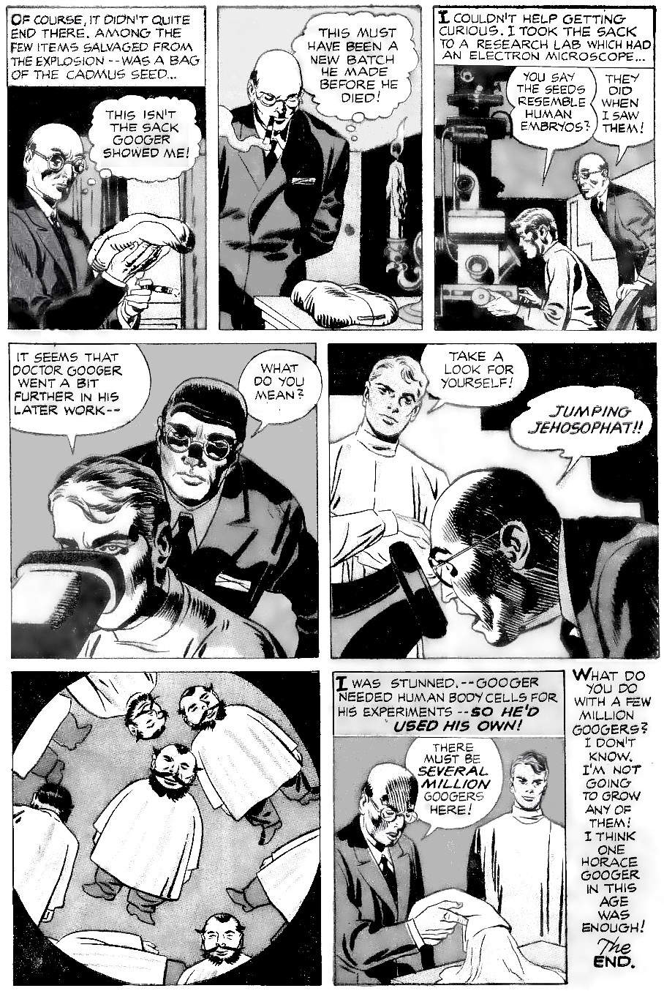
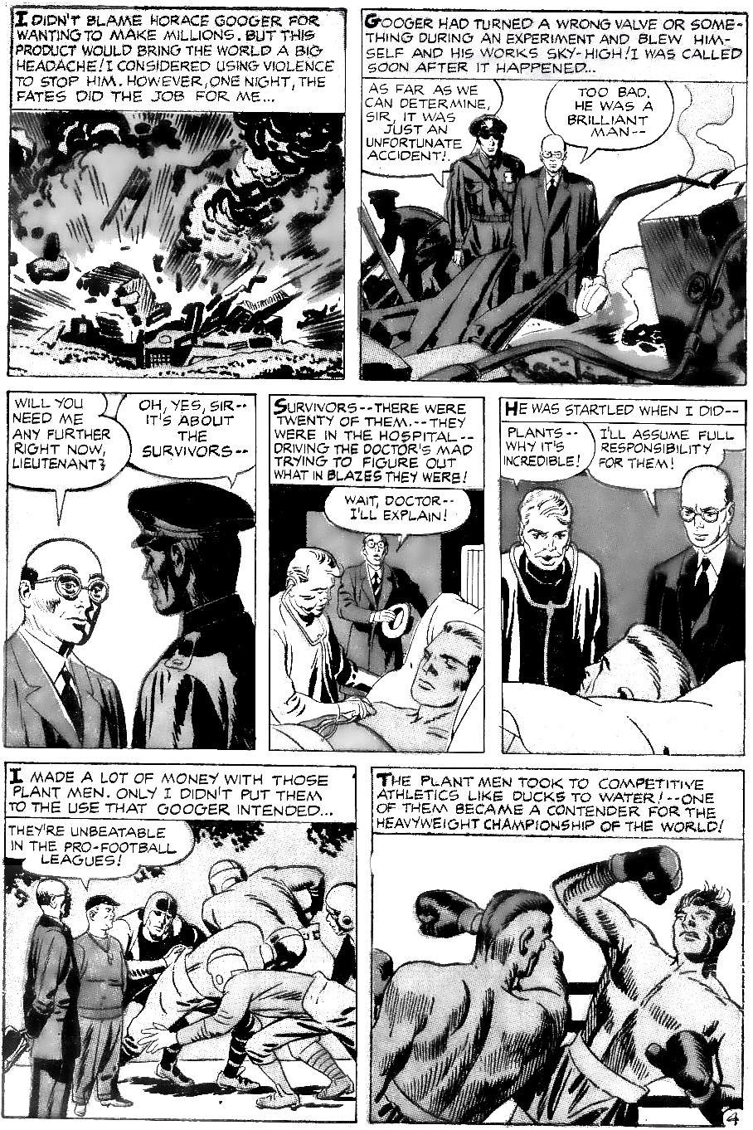
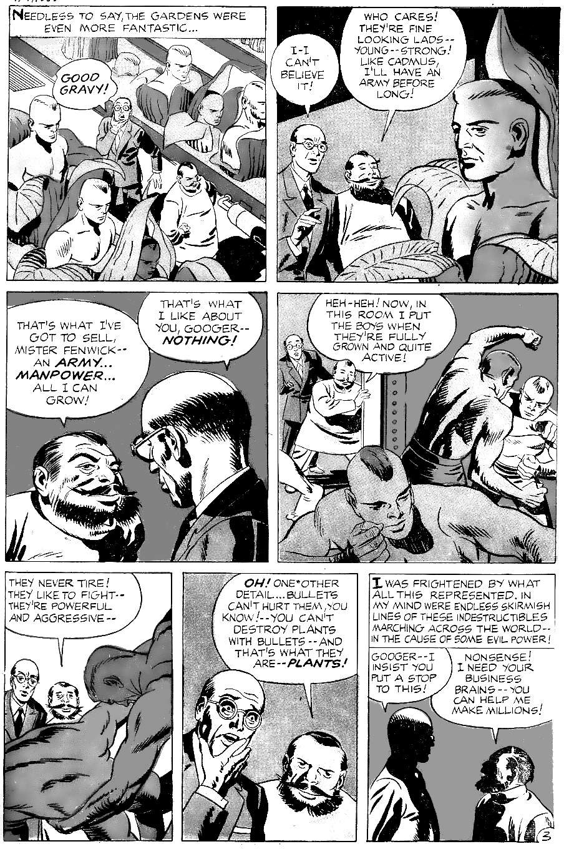
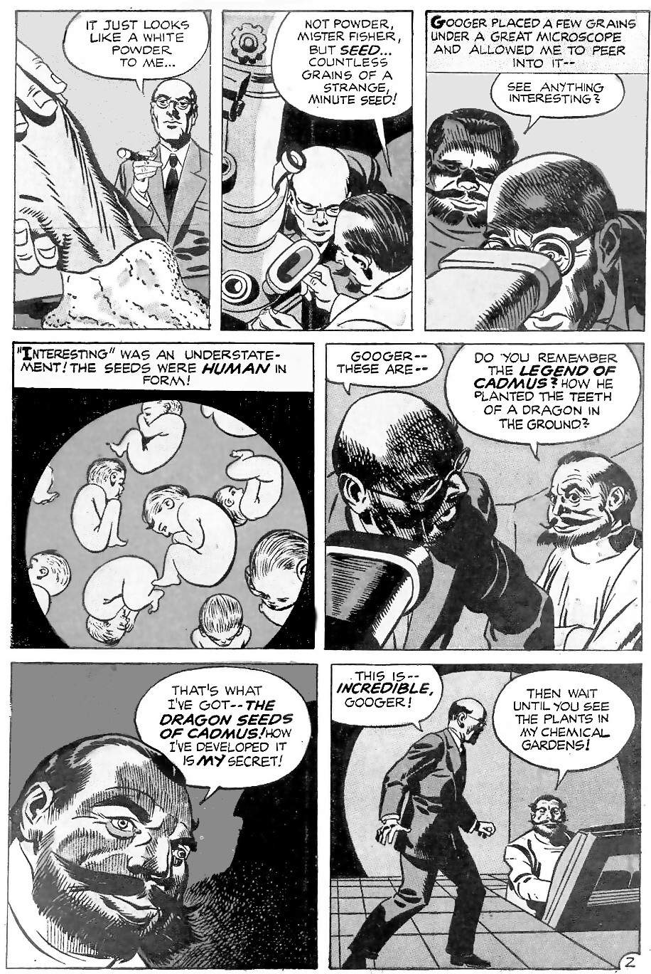
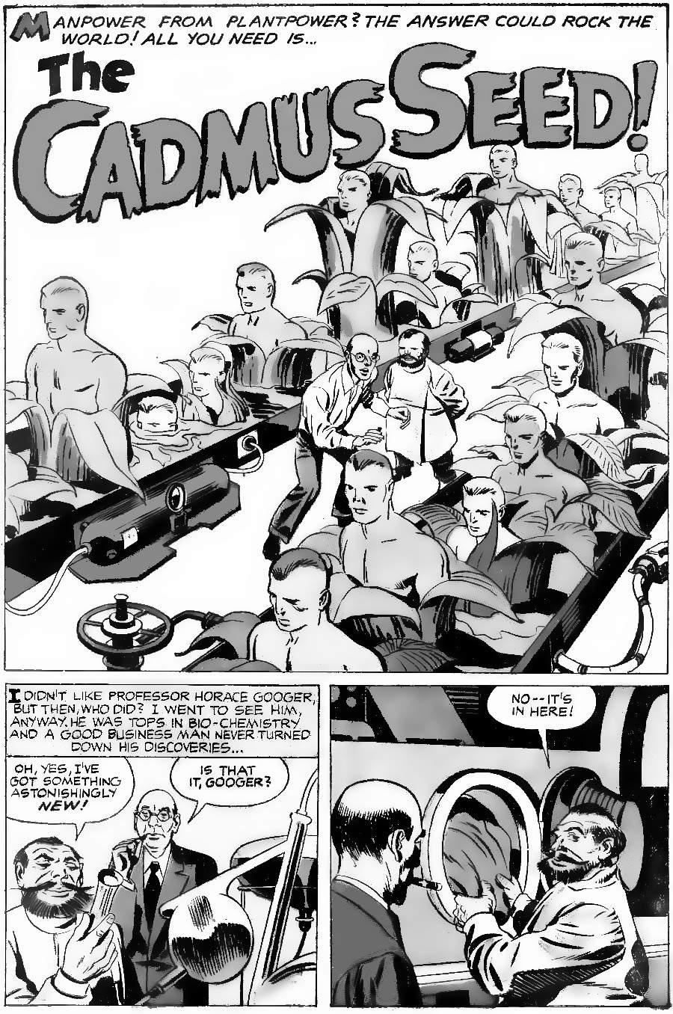
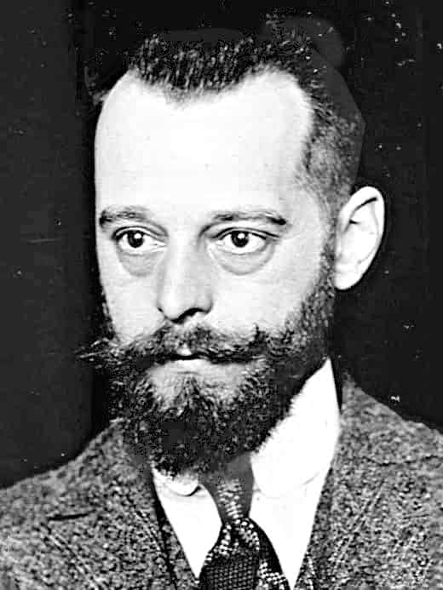
Kirby’s Cadmus Seed draws inspiration from the dark possibilities of modern science. It begins with imagery from “Invasion of the Body Snatchers” and is inspired by then-recent breakthroughs in DNA. Horace Googer, with his forked beard and white coat, looks like Felix d'Herelle. D’Herelle, who died in 1949, was a real-life mad scientist — or he would probably say a modern Prometheus. He was known for taking risks in microbiology, and for making extravagant claims. Other scientists felt that he went too far and that he was unethical in his business dealings. On a lighter note, the white seeds may be inspired by “Sea Monkeys”, the brine shrimp eggs that were about to become very popular in comic book advertisements.
Image: Public Domain
Now let's look in more detail at Cadmus and the origins of strife: how he ensured that we can never be free from work until the whole system destroys itself.

The origin of strife
The poet Hesiod outlines the history of the world in his poem "Works and Days". It begins with the essential problem: mankind once did not need to work. But then Prometheus stole fire from heaven. That act opened Pandora's box, and all the evils of the world resulted. And because of them, we need to work to survive. Prometheus stealing fire is the archetype of every scientist who thought he was doing something wonderful but ended up making life worse. Hesiod explains that there are two kinds of strife in the world: the obvious kind of strife is war. The less obvious kind, which seems very desirable at first, is work:
"Not one, but two Strifes live on earth: when these are known, one’s praised, one blamed because these two far differ. For the one makes foul war thrive ... The other … [is] set in the soil, a greater boon to men; she urges on even the slack to work."
The second kind of strife is "set in the soil” and makes men work: that is, the need to plant crops and tend the soil. Note how Kirby’s story begins with plants in the form of man: plants created by man instead of picked from nature. After explaining the two strifes (war and farming), Hesiod gives his famous overview of world history:
- The golden age: Originally, mankind did not have to do work. Food was plentiful and simply had to be picked when we wanted it.
- The silver age: we forgot the rules given by nature (the gods). We became like children, ignorant of history, thinking we knew better.
- The bronze age: this led to endless war.
- The heroic age: the bronze age led to the collapse of civilisation. For a brief moment, great heroes arose and made a better world look possible.
- The iron age: the heroic age did not last long. Unwilling to return to constant war, we entered an age of struggle, characterised by constant hard work and arguing. This is how we live today.
The heroic age was very short, so ancient historians usually miss it out. For example, this overview is from Ovid, in "Metamorphoses":
- The golden age: Originally, mankind did not need written laws or punishments. There were no large industries to cause stress on the environment. People could pick any food they wanted, without having to farm it.
- The silver age: we began to farm the land.
- The bronze age: the age of endless warfare.
- The iron age: we began to mark off the land into nations. This is our current age, the age of "fraud, deceit, treachery, violence, and the cursed hankering for acquisition."
As we saw in chapter 4, the Golden Age was real. As we saw in chapter 7, the Silver Age was also real: in 8,000 BC we began to act like children. We had a system that worked, that put every single human at the top of the food chain for thirty-thousand years. But like children, we thought we knew better than the adults. We thought we knew better than the laws of nature (the gods). We thought if nature provides food for free, why not plant the best seeds and capture the best animals and have more than your fair share! This is childish thinking: we did not think through the consequences, like the beginning of unpleasant work, and infectious disease, and population increase so the amount of work never goes down, and the rise of kings who enslave you, and those same kings can now wage big wars with little risk to themselves, and so on and on: Our immature short term thinking opened Pandora's box of evils.
The bronze age was also real: the period of endless war. As noted in chapter 5, these thousands of years of fighting over land caused most of the males to die, and this shows up in our DNA. This climaxed in the discovery of large-scale sources of bronze, allowing for the armour and weapons so vividly described by Homer. This all led to another collapse of civilisation, "The Late Bronze Age Collapse" (around 1200 BC).
This brings us to our present age, the iron age. Our present world is based on steel, an alloy of iron: it forms the backbone of our skyscrapers and the bodies of our cars and ships. Hesiod describes our age of iron like this:
"Each day in misery they ever slave, And even in the night they do not fade away."
That is our modern world: the age of long work hours (especially for the poor), and worry: we even worry in our sleep. And the rich call this progress.

How Cadmus leads to nuclear war
Why did the age of heroes fail? Because of Cadmus. After outlining world history, Hesiod returns to his theme: the two kinds of strife. One kind of strife is attractive: the apparent need to work to get shiny things. This always comes with the second kind of strife, war. Hesiod explains:
"[The heroes were] a god-like race of hero-men who are called demi-gods, the race before our own, throughout the boundless earth. Grim war and dread battle destroyed a part of them, some in the land of Cadmus at seven-gated Thebe when they fought for the flocks of Oedipus, and some, when it had brought them in ships over the great sea gulf to Troy for rich-haired Helen’s sake”
So we see that the great heroes were destroyed in two ways:
- "some in the land of Cadmus at seven-gated Thebe when they fought for the flocks of Oedipus”
- "and some, when it had brought them in ships over the great sea gulf to Troy for rich-haired Helen’s sake"
The second part is obvious: the Trojan War was the iconic war of the Late Bronze Age Collapse. This is the strife of war. But where is the other strife, work? What does Hesiod mean by the first cause of destruction, fighting for the flocks of Oedipus in the land of Cadmus?
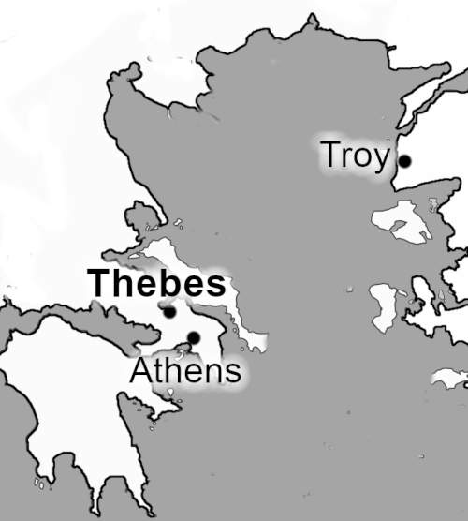
Cadmus was the first Greek Hero, and the first king of Thebes, the city that produced many of the greatest Greek heroes, including Heracles, Oedipus, and Dionysus. Thebes and Troy were the two greatest cities of the heroic age.
Cadmus symbolises modern science: metalwork, survival of the fittest, etc, in contrast to ancient science: sociology, respect for tradition, etc. Thisn is why:
Cadmus was a Phoenician who gave the Greeks the Phoenician alphabet, the secrets of metalwork, agriculture, and civilisation in general.
Cadmus founded Thebes by killing the dragon that defended the local water source. This probably means that he killing the fierce local people, who depended on that water for life. As the first Greek hero, this makes him the first one to kill the sacred symbol of the local land. Perhaps the first to claim ownership of another tribe's land. Cadmus then took the dragons’ teeth — the fiercest local warriors — and planted them, growing more people like them. Cadmus then made the people fight until only the very fiercest survived: this is competition at its purest. These winners became the first kings of Thebes.
So Cadmus represents our modern values: technology and competition. And as a result, Cadmus and his family had nothing but bad luck. The most famous example of bad luck is his descendant King Oedipus. Then after Oedipus, Thebes was struck by the plague. The plague was real: the description is scientifically accurate. The storytellers sum up the disasters in the story of Cadmus' daughter Semele. She was loved by Zeus, and Zeus promised her anything she desired. She asked him to reveal his full majesty to her. Sadly he had no choice, he could not break his promise. Seeing Zeus in all his majesty killed her. She was burnt to a crisp.
After a lifetime of this, Cadmus regretted his choices. He wanted out. He asked the gods to make him the lowest animal of all, a snake. And that is how he ended his life, like the serpent in Eden, or Sacker in Kamandi.
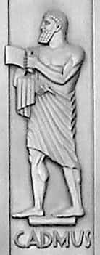
Cadmus reflects the real world. Modernity won the argument but lost the war. Thebes gradually lost to Athens (in the wars of the 400s and 300s BC). Athens then adopted Thebes' values. But Rome copied them, used more brutality, and won. So Athens, like Thebes, won the argument and lost the war. When Athens lost to Rome, it gave us the phrase "pyrrhic victory". King Pyrrhus (of Epirus) helped the Athenians and won some famous battles. But in doing so he lost so many men and so much money that he lost the war.
Carol Highsmith, Public Domain
That is the message of Cadmus, the message of the Age of Heroes. Modernity looks good, and the strife of work seems worth it, yet somehow it always leads to the strife of war.

The flocks of Oedipus
Hesiod said that the heroes were destroyed when they fought in the land of Cadmus "for the flocks of Oedipus”. This refers to the "Seven Against Thebes", the heroes of Athens fighting to destroy Thebes, and failing. In the real world, the wars of Athens versus Thebes are essentially the wars of tradition versus modernity. Athens gradually won the wars in the 400s to 300s BC (long after Hesiod). But in doing so, Athens absorbed Thebes' way of thinking. This eventually led to our modern Descartian view of science: that individual experiments are better than listening to the elders of the tribe. Modernity, with its emphasis on individualism and "hard science" instead of sociology, is, therefore, the seed of Cadmus.
The simple story of dragons’ teeth is therefore a metaphor for science and competition. It began with Cadmus and seemed very exciting. But it gave him nothing but misery. It led to his downfall, and the downfall of Thebes, and the downfall of the Greek city states (as their neighbour Rome used its technology more efficiently). And today it is consuming the world.
This may be inevitable. Technological change means pushing into the unknown. So ignorance rules: nobody knows how a technology will play out for society. But competition means that others are looking to defeat us. And exponential change in technology means a single miscalculation will be worse and worse.
Now let’s look in more detail at modern technology and what can go wrong.

From Cadmus to D.E.A.T.H.
In “The Cadmus Seed” Kirby focuses on just one technology: DNA manipulation. This is Kirby’s first DNA story. Kirby followed the science of DNA in his stories:
1953-1957 saw the first breakthroughs: the discovery of the double helix, the number of chromosomes in a cell, the DNA copying enzyme, etc. So Kirby recalled Cadmus and growing humans from the soil.
The end of 1962 saw the Nobel Prize for the double helix, and public awareness was high, so Kirby wrote “The Mad Thinker” (but his editor removed most of the DNA references) The new DNA creation is only defeated because it was based on Richards’ notes, so Richards knows how to turn it off. Without that, humans would be obsolete.
In 1966, Marshall Nirenberg cracked the DNA code. Kirby then wrote, “The Man Called DEATH”, and “When the Unliving Strike”. These stories are about artificial humans and how this leads to nuclear war (as in OMAC), and one man's efforts to stop it. These stories introduce a new element: Advanced Idea Mechanics (AIM). This is Kirby’s version of the Advanced Research Projects Agency (ARPA). ARPA was originally tasked with creating space rockets (a role then taken over by NASA) and also finding technology to protect against nuclear attack. AIM has similar goals. AIM’s big secret was that, while appearing to be good, it was just as big a threat as the enemy. In the real world, ARPA’s greatest invention was the Internet, a system designed to survive a nuclear war: it has no centre, and if any part breaks another part takes over. In Kirby’s stories, that concept became AIM's sister organisation, Hydra, with its motto, “cut off an arm and two more take its place”.
In the real world, most people see the Internet as a great blessing at first. It supposedly set information free, beyond the control of centralised power. But Kirby saw further and saw how this would make centralisation easier. This would create the greatest threat of all (see Silver Star, below).
Also in 1966, Kirby wrote perhaps his most famous DNA story, “The Beehive”. This was about scientists who create a superior human. But their first new human looks down on his creators as immoral monsters. The story was interrupted, but continued in “The DNA Project”. The DNA Project was based on the Manhattan Project. The DNA Project was created in the belief that genetic manipulation might be the only way to survive “the atomic silo”. And that takes us to “Silver Star”.

The road to nuclear war in Silver Star
Kirby’s DNA stories reach their climax in Silver Star. Silver Star is Kirby’s parable of the Internet. Kirby wrote it in 1982 when most people had never heard of packet switching (the concept behind the Internet). Silver Star gives us the most detailed view of how technology that is designed to prevent nuclear war, must inevitably cause nuclear war. Here are the steps to war in the story:
- A new race of gods.
During the Vietnam war, the government wanted a way to survive a nuclear attack. A doctor found a way for DNA to radically adapt to damage: re-routing around that damage and rebuilding tissue. Children born with this DNA are nicknamed ‘homo-geneticus”. They learn to mentally control their new DNA. This power turns out to be far more useful than anyone imagined. The only limit is imagination.
- Ordinary humans become obsolete.
The humans who study homo geneticus realise that the rest of the human race is now obsolete. We are out evolved, and there is nothing we can do about it.
- One of the new species grows tired of us.
The story focuses on Darius Drumm, the first of the new species. At first, he likes having human followers worship him. Eventually, he grows bored of them, they begin to irritate him, so he decides that mankind has sinned, and he unleashes a kind of nuclear firestorm to cleanse the Earth.
The parallels with the Internet should be obvious:
- A new race of gods.
During the Vietnam war, the government wanted a way to survive a nuclear attack. This led to the Internet. This turned out to be far more useful than anyone imagined: it enabled enormous economies of scale so that a few companies (and their owners) become fabulously wealthy. The Internet allowed them to control every detail of life for ordinary people: they effectively control our governments (see chapter 11), what we buy, what we see (vial Google and social media), and everything in between. The owners of Internet companies compete among themselves for dominance. For example, in 2021, Elon Musk, Jeff Bezos and Richard Branson raced to create rocket ships.
- Ordinary humans become obsolete.
The super-rich can do whatever they want, and the rest of us can only watch.
- One of the new species grows tired of us.
The rest of this chapter looks at how this will happen.

Other Kirby stories about the coming nuclear war
To keep this book to a manageable length, we will not analyse every Kirby nuclear war story. Readers who want to look deeper should examine Thor, New Gods, foreshadowing in The Eternals, and the final days and aftermath in Kamandi.

Why nuclear war is inevitable
Geoffrey Blainey was right. He wrote the classic text on what causes wars. In “The Causes of War”, he showed that there is a very simple reason why all wars happen: wars happen when both sides think they can win. War is simply an economic calculation. The emotional reason may be something else — A hates B — but hate is common. Wars are very expensive and require competent people in key places, so any large war is an economic calculation. The calculation might be mistaken, but somebody somewhere is adding up the numbers: can we win?
Until now, nuclear war was economically impossible, because of “Mutually Assured Destruction” (MAD). Whatever you might gain, you will lose too much. But technology will change that equation within the next hundred years.
The Internet has broken the link between the super-rich and any particular nation. They are no longer based in Washington or London, they are based in offshore tax havens, and can swap their business between nations quite easily. Within a hundred years the super-rich will not even be tied to Earth. Jeff Bezos plans a self-sufficient satellite colony, and Elon Musk plans a self-sufficient Mars colony. At that point, if the whole of Earth burns, the only question will be, who profits?
Right now, burning the world is not profitable because the super-rich need ordinary people to work in their factories. But automation is changing that. When an entire factory can be run by ten people, you simply do not need anybody else.
Right now, burning the world is not profitable because the super-rich need customers for their stuff. But that is changing. All the money is focused in fewer and fewer hands. At some point, the buying power of 99 per cent of the world will be less than the buying power of a single wealthy man. Why waste time on selling to people who have no money?
Right now, burning the world is not profitable because too many companies rely on the status quo. But ever since the 1980s, a new breed of corporate raiders has become wealthy by destroying the status quo. Destroying industries can be very profitable to young rich kids who have nothing to lose.
Right now, burning the world is unprofitable because of the enormous cost of losing all those factories. But they use old technology. One day it will be cheaper to knock them down, turn planet Earth into highly profitable parkland, and build more efficient factories in zero gravity.
Right now, the super-rich still have some connection to ordinary people, so they might think twice before killing everybody. But they live in gated communities and travel in private jets. As time goes on they have less and less in common with poor people. They won't even see poor people as being in the same nation: the super-ruck are citizens of the world, with no loyalty to a particular territory. We will become separate species: the super-rich and the rest, each side disliking and distrusting the other.

The numbers
The economic argument depends on ordinary people not mattering to economic calculations. This process has already begun.
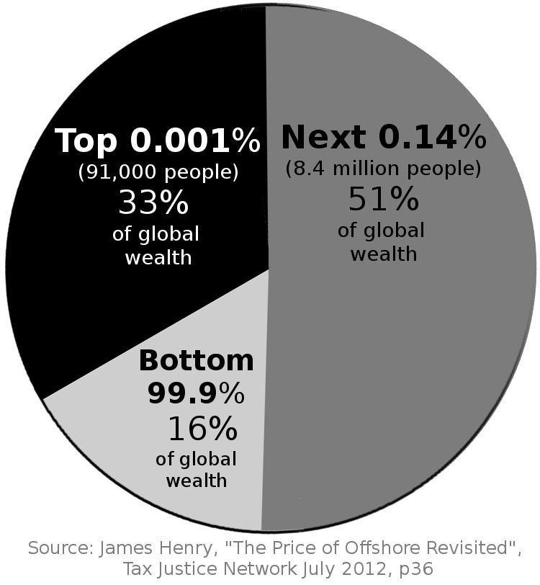
By 2012, the richest 0.001% owned much more than the bottom 99.9%:
By 2016, inequality was even greater. Just eight men owned $426 billion, the same as the bottom 50% of the world. Today (2022) the same eight men own more than $1 trillion.

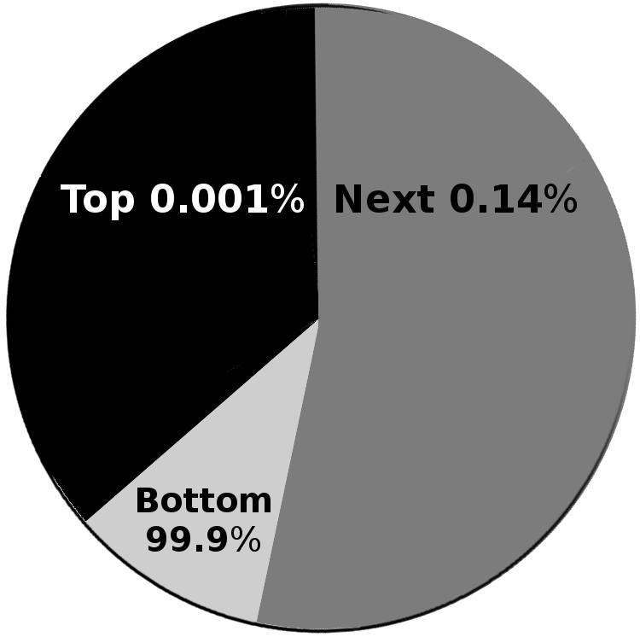
Between 2018 and 2020, technology billionaires saw their income rise by a further 42%. So the world's wealth will soon look like this:

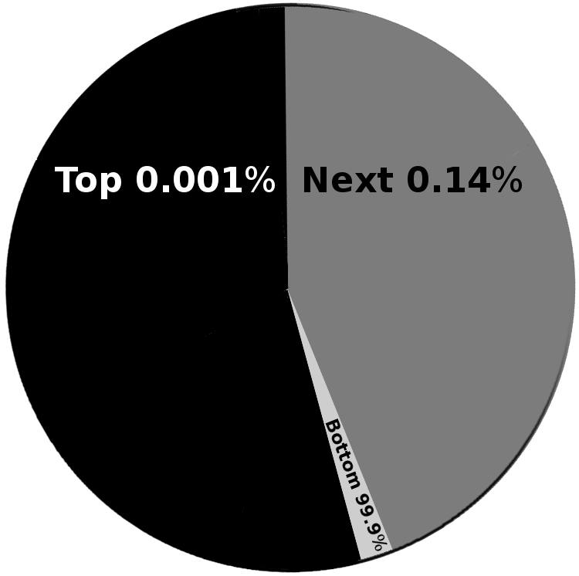
By 2100, robots will replace all but the most complex jobs. At this point, the 99.9% will not be needed at all:

The clearances
The bottom 99.9% will have nothing that the 0.001% want. Why employ dirty plebeians when you have robots and the smartest, most talented 0.14% of people to hand-craft anything you can imagine?
The 0.001% will be a very proud race because they will know that they are the very best, the most intelligent, the ones the world needs. They will see the 99.9% as less intelligent, lazy, ungrateful people who live on welfare handouts and always complain.
What happens when the poor are not profitable in some areas? They are forced to leave. This process is called gentrification.
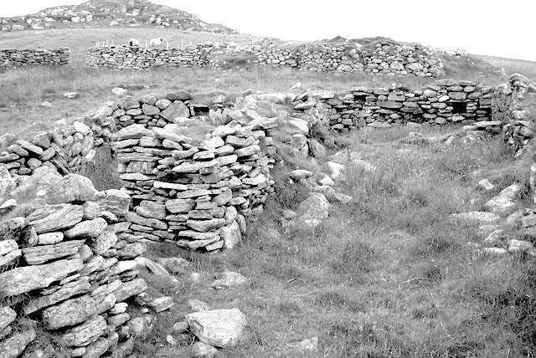
Sometimes entire countries are gentrified. I live in the Scottish highlands. The hills are dotted with the ruins of abandoned cottages. These are the remains of the Highland Clearances, the time when poor people became less profitable than sheep, so they were driven off the land.
Image: ruins from highland clearances. Sarah Egan via Wikimedia, CC-BY-SA-2.0
“Between 1811 and 1821, around 15,000 people were removed from land owned by the Duchess of Sutherland… many were old and infirm and so starved or froze to death, left to the mercy of the elements. In 1814 two elderly people who did not get out of their cottage in time were burned alive in Strathnaver.”
The poor Scottish farmers were able to move to America. But that was in the 1800s. Today, America no longer has an open-door policy. And poor countries can't take them: thanks to global warming and inequality, poor countries will have large areas that are uninhabitable: millions of refugees will leave in search of food, with nowhere to go.
What happens when the authorities want to get rid of their people and there is nowhere to send them? In ancient Sumer, they burnt and flooded the homes. In 1830s America, the Indian Removal Act pushed Indians into smaller and smaller spaces, killing any who resisted. In Cambodia, Pol Pot had his killing fields. When Hitler wanted to get rid of the Jews, he used gas ovens. Germany was a modern, advanced nation: this can happen anywhere.
The super-rich see themselves as the good guys of course. Darius Drumm only wants to make a better world. He sees our present world as “bleak and dismal and mayhap ugly, my dear! But… so is reality!” He opposes “hate, greed, barbarism, merchandised murder… mummified morality”. He believes that normal lives are “vehicles of pain,” full of evils like wife-beating and hypocrisy. He believes that there is only one solution: unconstrained competition. Competition, in its purest form, is war. War kills millions of people if needed. Darius Drumm eventually concludes: to create the world he wants, “a world of beauty and solitude”, he must cleanse the Earth.
Elon Musk and Jeff Bezos are not Darius Drumm. They may be misguided (ignoring the social cost of inequality), but they still have some connection with the common man: Musk wants to save the world, and Bezos knows he must sell to ordinary people. They are like the first generation of Caesars, Julius and Augustus, the “good” Caesars. But what about the next generation? And the next? They will not be Musk and Bezos: they will be their entitled trust-fund-brat descendants. They will not be Julius and Augustus: they will be Caligula and Nero.

The final months before the war
When rulers want a war, they have to persuade those who might disagree. The 0.001% per cent of owners will still need the 0.14% to run their machines. The 0.14% can be well paid and protected. But some of the 99.9% will also need to be persuaded, or they could still make trouble.
How do rulers persuade the 99.9%? The 99.9% have nothing to gain from war: it will not make their lives better, and they might be killed. So rulers use patriotism and/or religion. The worse the ruler is, the more they rely on the flag and the Bible.
Kirby foresaw a future American leader like Hitler, using patriotic and religious rhetoric to fire up the people for war. The interviewer did not believe him: surely Americans would not vote for a Hitler?
“Aw…C’mon, Jack..”, I said, incredulous; “ ..people are smarter than that now. They’ve learned the lesson of history.”
Kirby kept drawing didn’t even look up from his drawing board; ‘Mark my words; another Hitler will come…and this time he’ll be wrapped in the American flag and carrying a Bible.’”
The Bible is the key to understanding future American politics. The book “Jesus and John Wayne” shows why. American evangelicals feel that they are oppressed and that they have a divine right to a good life in America. Now imagine how they will feel when China is more powerful than America when the dollar is no longer the world's reserve currency, so America is much poorer. Will proud warlike Americans accept that? Any billionaire who claims he can stop China will have enormous support. If he uses religious language then his support will go through the roof. Kirby saw it coming.
Imagine the scenario: China builds military bases in Cuba. Patriotic Americans will beg for “limited” use of nuclear weapons: what other choice do they have? And once the first nuclear missile is fired, the next will follow, and the next.

14.
Make a Golden Age NOW
This chapter argues that Moses had a solution to the world’s problems.
How do we stop the Power People from destroying civilisation? The great storytellers have pondered this question for tens of thousands of years. They found two solutions. These solutions were taught by Moses. Kirby was a big fan of Moses. Here are the solutions:
- A more scientific view of the self. This ends selfishness.
- A fairer economic system. This creates more wealth, which can be used to bribe the powerful into being good.
Here is a story about the more scientific view of the self. It answers the greatest questions of all: What is life for? What is consciousness? How can we see past the surface of things and see the ultimate truth? What is the ultimate reality? How can we be happy and wise and loved and full of energy? How can we save the world? The answers all come down to one word: humility. We must realise that we are nothing. And then we will see clearly, to see how we are all connected: we are all the universe.
Like most Kirby stories, this story has a perfect title: “Mystery Vision”. In ancient Jewish thought, the future was revealed through the “mysterion”, or divine initiation often translated as “mystery”. The mystery was typically revealed in a vision, where a person is shown the hidden truth behind the visible world, like stepping out of Plato’s Cave.
Here, then is Kirby’s vision of the great mystery: his Mystery Vision. We will explore this mystery, and then turn to Moses' other message: the fairer economic system.
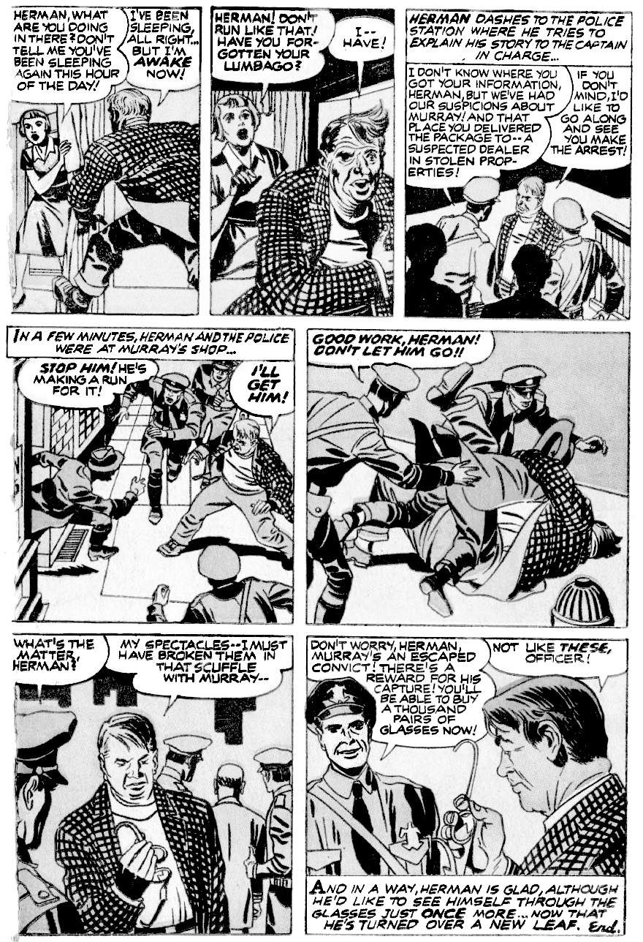
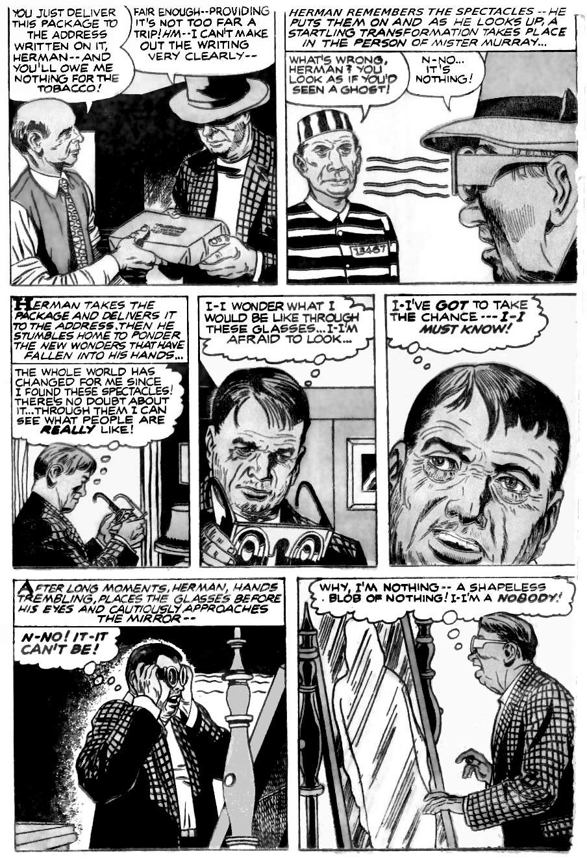
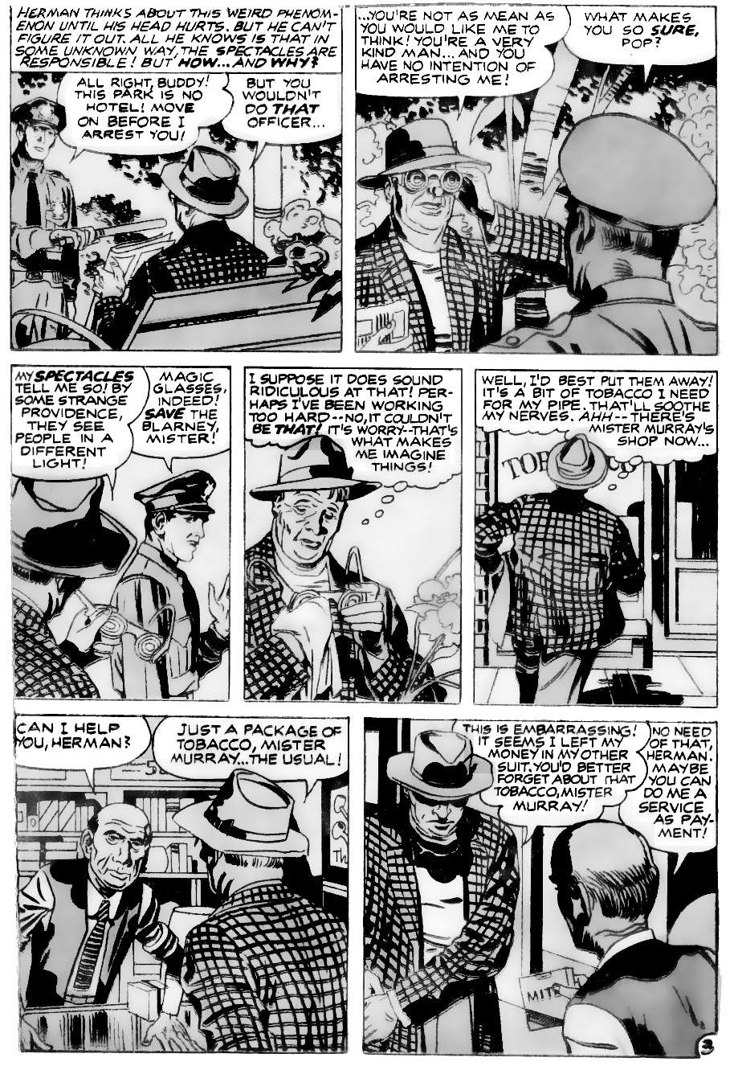
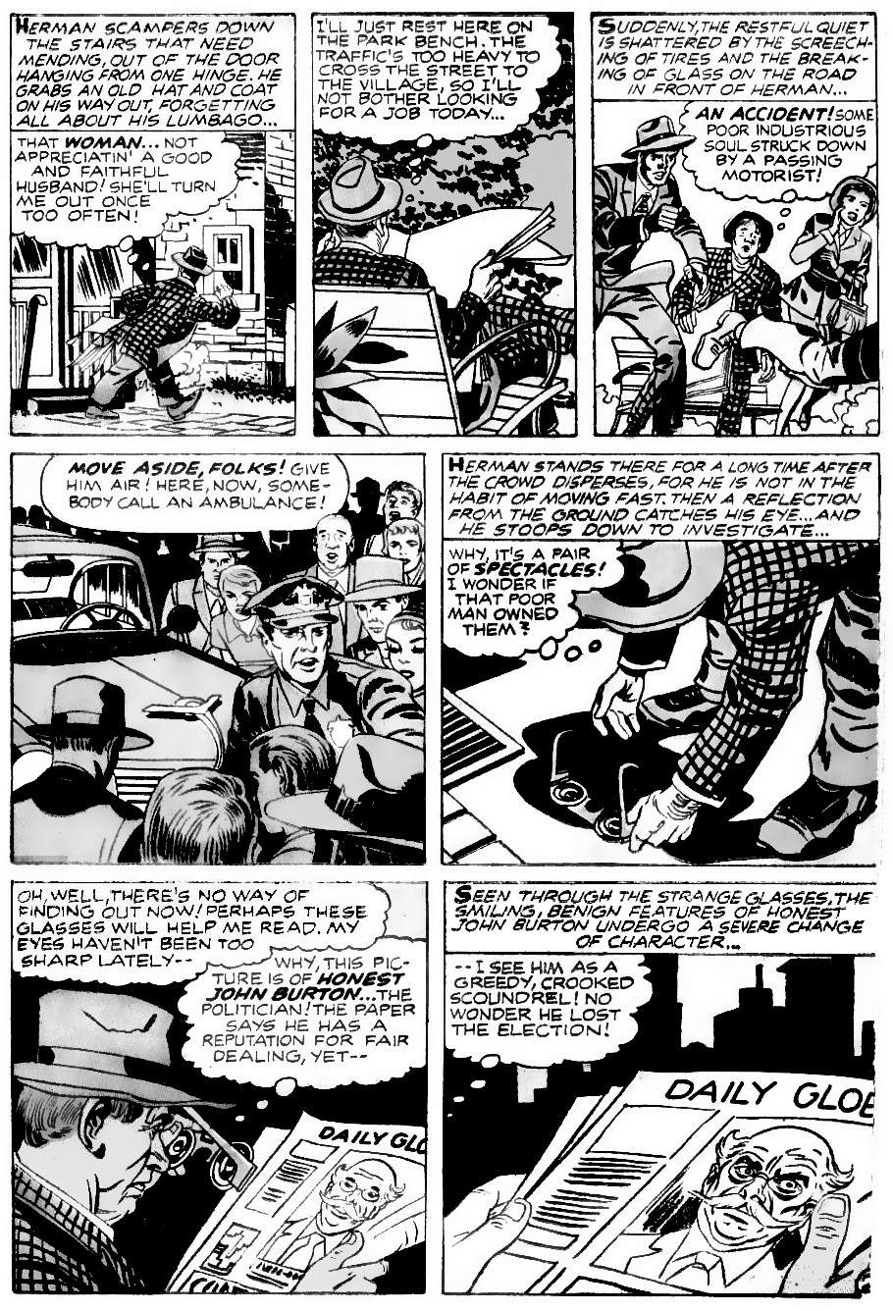
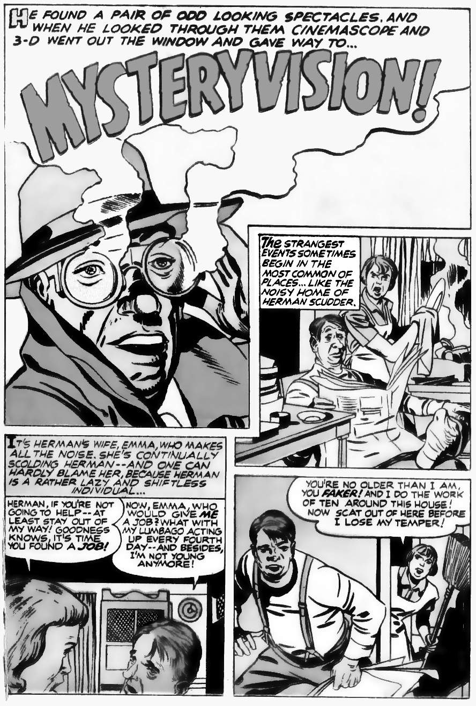
Here is the great secret that changed Herman’s life: the Socratic paradox made flesh. Inside he was nothing! A shapeless blob of nothing! A nobody! Once Herman understood this, he understood life.
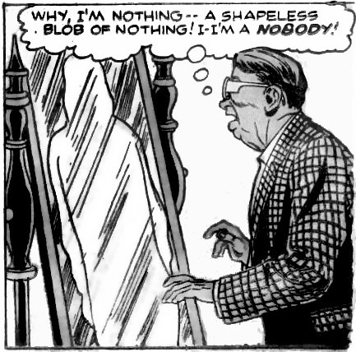
Was Herman “nothing” because he was bad? No: Murray was bad, yet the glasses saw Murray. Honest John was bad, yet the glasses saw Honest John. What the glasses see is not your moral value, but your relationship with people around you. Both Murray and Honest John were important to their networks, But Herman (at the start) was important to nobody, so he did not really exist. If he disappeared, most people would not even notice. Emma would notice at first, but Herman was just a lump that got in the way: life would be better without him.
This explains why Herman feels so old and tired at the start: without connections, Herman has no purpose and no energy: his body just winds down. But once Herman becomes connected — once he puts his relationships before himself (a self that does not exist) he feels younger and has more energy.

The inner self does not exist
At the start, Herman has long thought balloons and thinks about his needs and his inner self. Then he discovers the truth: the inner self he imagines does not exist!
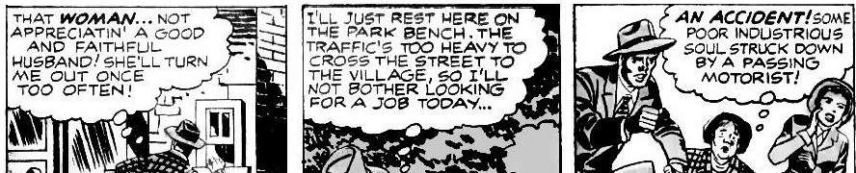
Look again at his inner thoughts. Most thoughts are about the surrounding world, and they are mostly correct: his wife does not appreciate him, the traffic is heavy, and a person is knocked over. When he thinks about others, this is the real world. But when he thinks about himself, he thinks nonsense: he is not a good husband, he will not leave her (he has nowhere to go), and he does not need to rest on the park bench. He is completely wrong about himself. It is only when he thinks of another person, and shows compassion, that he begins his path to enlightenment.
Any outsider would have a better view of Herman as a person: Herman’s inside view does not add any useful information. This is true of all people, everywhere. Are you a kind person? A thoughtful person? An intelligent person? A funny person? A brave person? The only way to know is to see your actions from the outside. The inside view is irrelevant.
Could it be that our inner self is always nonsense? That our inner self always adds zero useful information? Let’s look at the evidence.

Kirby heroes never have an inner self.
Kirby heroes never have an inner self. To see what this means, let’s compare two stories, one by Kirby, and one not by Kirby. Both appear in the same magazine, and both feature similar situations: a girl in a car with a boy, and the girl tries to decide if she likes the boy. Here is the Kirby story first.
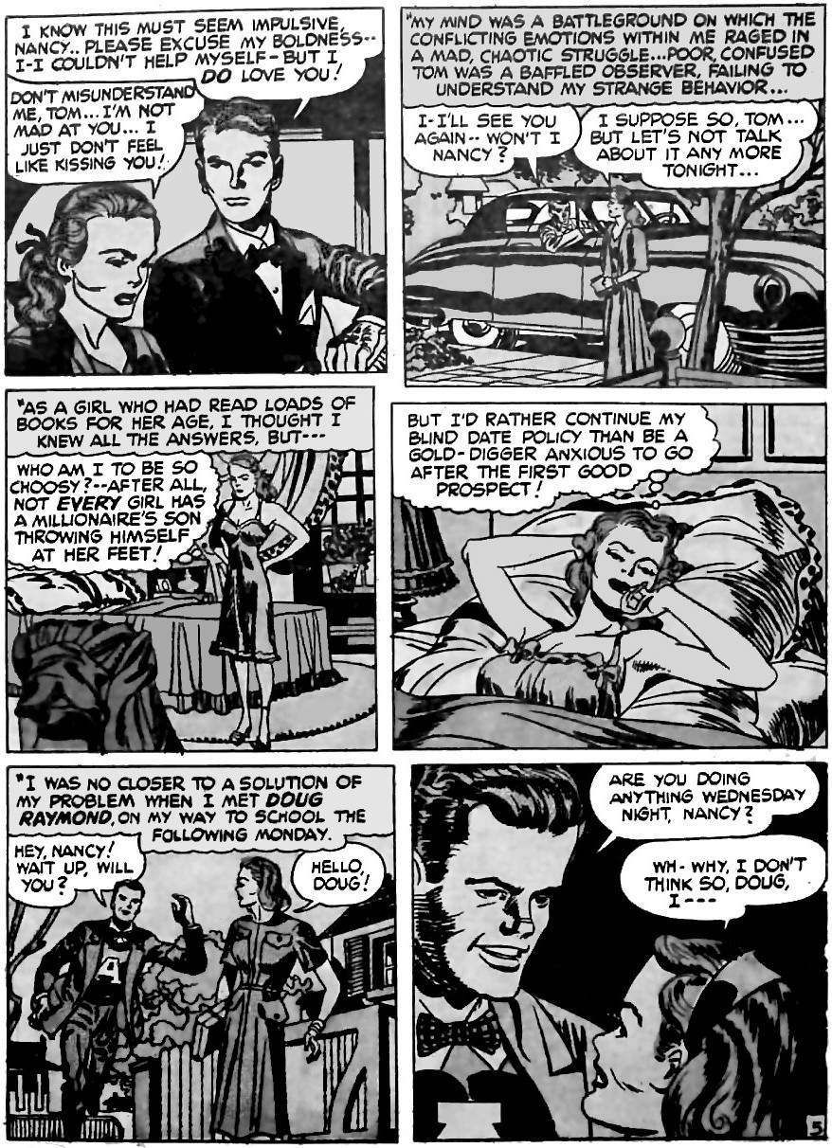
Nancy is rational. She decides if she should love Tom based on observable evidence. Whether she “feels like kissing” him depends on her thoughts as she works through the evidence like a scientist, moving “closer to a solution”. If Tom could make her smile, that might change her mind from the outside. That is the “somatic marker hypothesis”: bodily markers, such as smiling, encode information. When we change posture, heart rate, smiling, actions, and so on, then our feelings change. There is nothing hidden about Nancy's thoughts or feelings : everything is visible from the outside. There is no invisible inner self.
Every Kirby hero is like Nancy. Heroes solve real, observable problems in the real, outside world. They are rational and transparent: they have nothing hidden.
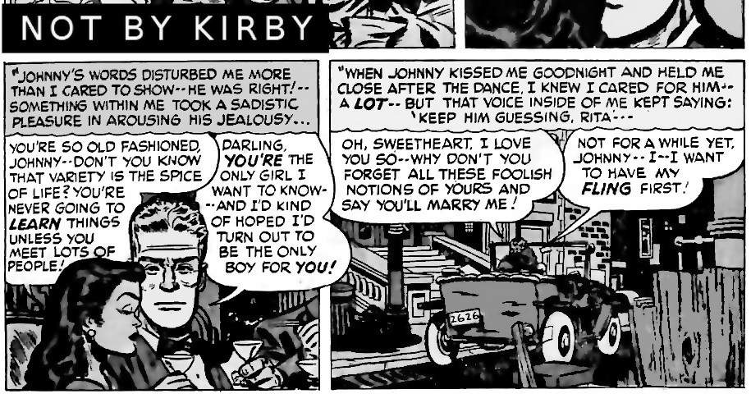
Now compare a non-Kirby story from the same comic. Rita is in the same situation a Nancy: in a car, trying to decide if she should be with the boy.
Rita talks as if she is a slave to an invisible person who lives inside her:
"Something within me took a sadistic pleasure…”
"That voice inside of me kept saying…”
Her inner self controls her. She is not controlled by her intellect. Her intellect merely watches her feelings for clues to her hidden inner self:
“When Johnny kissed me goodnight and held me close after the dance, I knew I cared for him — a lot”
She knows she loves Johnny because of her feelings that come from this hidden inside source: not because loving Johnny is a rational choice.
Kirby stories are different. Kirby characters only deal with external evidence. Kirby was like that in real life. Kirby analysed the external world but did not waste time imagining an invisible inner self.
“I never analyse myself. ... I just did my job.”
All he knew was the world of his senses. The chemical processes behind those senses were not relevant to his decisions:
“I don't know what spiritual beliefs are comprised of. I only know that I have senses; I have whatever senses that I have. And I bring them all into play. I didn't know what these senses... I can't define them. All my senses are hidden from me. But they move me;”
Kirby felt that we must always react to the outside world, or we are not alive. He was entirely outside-oriented.
“I think if we're able to react we're alive. If we don't react to anything, I think we're in some kind of limbo.”
To Kirby, only the outside world mattered.
But does the inside world even exist?

The science of no inner self
The book “The Mind is Flat” reviews the evidence for the inner life of the mind. The book is by pre-eminent behavioural scientist Nick Chater. This is the publisher’s description:
“We all like to think we have a hidden inner life. Most of us assume that our beliefs and desires arise from the murky depths of our minds, and, if only we could work out how to access this mysterious world, we could truly understand ourselves. For more than a century, psychologists and psychiatrists have struggled to discover what lies below our mental surface.
In The Mind was Flat, pre-eminent behavioural scientist Nick Chater reveals that this entire enterprise was utterly misguided. Drawing on startling new research in neuroscience, behavioural psychology and perception, he showed that we have no hidden depths to plumb, and unconscious thought was a myth. Instead, we generate our ideas, motives and thoughts in the moment. This revelation explains many of the quirks of human behaviour — for example why our supposedly firm political beliefs, personal preferences and even our romantic attractions are routinely proven to be inconsistent and changeable.”
So we have no inner self. Kirby was right. The ancients were right.
It follows that there are no special people. Kings and geniuses are no better than anybody else. Or rather, their superior results are entirely caused by outside forces, such as upbringing and training. If a nation wants better outcomes we should provide the same upbringing and training for others.
It is easy to see the role of the environment in cases like Herman Scudder. Herman was a parasite. His food and shelter were provided by his wife. Herman used the inner life theory to justify his parasitical behaviour: he did nothing because he thought his inner self justified it. We see the same parasitical thinking with bad people who inherit wealth: they think they are better than other people when clearly they are not. But what about people who do amazing things? What about Albert Einstein and relativity, or Elon Musk and SpaceX? Do they have something special inside? Or are they simply a product of their environment?

Are scientists special inside?
Are some scientists better than others? Research shows that if we pick the scientists who made the best discoveries, and give them a bigger share of the money, we get the worst results. We get the best results by taking that extra money and giving all scientists an equal share (assuming that other external factors are the same: the scientists have equal training and access to equally good equipment).
Once we ensure that external inputs are equal (education, hard work, equipment, etc.), the only other element is luck. We find this hard to accept because we are taught to see patterns in “genius" behaviour, but statisticians know better: these patterns are random. If a lot of people make random decisions, one of them will be the best decision, and that person then believes he is very clever. Nassim Taleb, an investor and specialist on risk, writes extensively about this, especially in his book "Fooled by Randomness”.
Take Einstein for example. His fame is entirely due to several lucky breaks that happened at age sixteen. He spent the next fifty years trying to repeat that luck, but could not. So it must have been luck: if it was not luck, then he could have repeated it.
Einstein was born with a high IQ. That was luck. A person cannot change their IQ by much. Einstein was also in the right place at the right time. At age sixteen, Einstein learned (by luck) that the speed of light is always constant, no matter what. This did not make sense to a teenager studying physics. Surely if you are on a fast-moving train, and shine a beam of light, the light must have the speed of light plus the speed of the train? This question bugged Einstein for the next ten years. It is very lucky that the question bugged him because pursuing that question led to amazing discoveries.
Einstein studied physics at university, so he was taught the physics of the time: that something in "the ether" must explain light's constant speed: particles of ether must cause light to speed up or slow down. So Einstein had to think about how light particles would change when they hit particles of ether. But the interaction of particles was not well understood at the time. Luckily, Einstein had heard of Brownian motion, where tiny grains of dust jiggle about in the air, because they are hit by air particles. So Einstein studied Brownian motion to understand how light particles might react when hit by other particles. He worked out how fast the much smaller air particles must be moving. But none of this explained the problem of light, so he decided that the theory of "the ether" did not make sense. So the explanation for light's constant speed must be something else. Luckily, at the same time that Einstein was working on the speed of light (the years 1895-1905), the world's most famous theoretical physicist, Hendrik Lorentz, was publishing amazing new ideas on electromagnetism that all the students were talking about: stuff about time dilation and “reference frames”. So Einstein tried Lorentz’s ideas instead. But Einstein disliked one awkward part of the theory — a bit about magnetism being asymmetric, a fudged detail that had no basis in real life — so Einstein changed it. And then everything worked! Then there was a surprise: i.e., a lucky discovery. In the new equations, mass was equal to energy.
At the end of those ten years, Einstein published his four big ideas: about photons hitting normal matter, about the speed of Brownian motion, about time being relative to speed, and about mass being energy. Those four amazing papers, all published in 1905, turned Einstein into the world's most famous genius. But was Einstein just lucky? We can test that hypothesis.
For the next fifty years, Einstein tried to repeat his youthful luck. He continued to improve his theory of relativity. He hoped to make other big discoveries, something just as big as relativity. But he never could. He could not repeat his lucky break, no matter how hard he tried. So it must have been pure luck. He was lucky to ask just the right question as sixteen year old, just when Lorentz was publishing his work. If it was not luck, then Einstein could have repeated his success over the next fifty years. But Einstein could not. So it must have been luck.

Are entrepreneurs special inside?
We see the same pure luck when we look at other amazing people. Right now, the richest man in the world is Elon Musk. He is planning a fleet of one thousand space ships to colonise Mars. His spaceships are a fraction of the price of the spaceships built by governments or other companies. That is amazing!! Does that mean there is something special inside Musk? Or was he just a random high-IQ person in the right place at the right time?
Musk has the genes to make him extremely focused. Genes are luck. He had an extremely focused father, who raised him the same way. That is luck. He had a family with money, so he could take risks, knowing he could recover if he failed. That is luck. Musk graduated from university at the start of the Dot Com bubble when businesses were throwing money at any bad idea with “dot com” in the title. That was luck. All of the dot com entrepreneurs had high IQs, all the dot com entrepreneurs worked hard, and many of them did everything necessary to succeed. But only some of them succeeded. So that was luck as well. Musk was one of the lucky ones. That luck gave him his initial fortune.
In 2001 Musk almost died from Malaria. That was luck: bad luck for his health, but good luck for how it changed his thinking. Thanks to almost dying, he no longer wanted money, he wanted immortality. Not immortality through extending his life (we don’t have the technology for that), but immortality by changing the world.
Superficially it looks like Musk takes more risks: “I saw plenty of examples of people that had enormous wealth, and were entirely cautious … In Elon, there was this complete opposite mindset.” But a closer look at Musk’s risk-taking shows he is not taking bigger risks, he is thinking for the longer term. The profit from spaceships is so astronomical that risking a few billion at the start is a no-brainer. Other investors don't do it because they can’t wait forty years to be profitable. Musk does it because he is not in it for money: he is in it to change the world, because of that malaria.
“Around then [2001], he was shocked to discover that NASA had no plans to go to Mars.” This discovery was a shock. That is, it was luck. So he looked around to see if it was possible. He found that Robert Zubrin had spent decades researching how to reach Mars cheaply. That was luck. Musk tried to buy a Russian rocket but they wanted too much money. That was bad luck but turned out to be good luck because it forced Musk to build his own rockets. Since he was building his own rockets (adding another ten years to his plan), it became rational to scale his plans up and become the rocket provider for the whole world. As Musk's businesses grow larger and accumulate more experience, it becomes harder and harder for others to compete. At this point, even if he fails, investors will give him another chance, as it’s cheaper than starting from scratch.
And so we see Musk becomes master of the universe. At no point do we need to invoke an invisible inner soul: every step is fully explained by hard work (that we can all do) plus luck.

The invention of the inner self, 550 BC
Ten thousand years of experience told our ancestors that all great discoveries come from outside. Read anything written before 550 BC, such as Homer, Genesis, Gilgamesh, or the Hindu Vedas: they have no concept of a special inner mind. Anybody who has big muscles or clever ideas is just chosen by the gods: i.e. through luck. So who invented the soul, and why?
The human soul — the belief in an inner self — is the result of the creation of money around 550 BC. We can watch the creation of the soul in real-time. When money arrives, the idea of the soul always follows. In the 1950s anthropologists studied remote islands near Tahiti (the model for Kirby’s “Pegoto”) as westerners first brought trading posts. Before trading posts, every individual was expected to help the tribe. The only accounting system was reputation: hard work and generosity make you popular, and if you become too unpopular you might find yourself ostracised (Kirby’s story called it “tabu”) or even killed. But money changed that. Money allows people to say no to the needy, allowing them to starve. Money creates the individual as a separate entity from the tribe. Professor Richard Seaford explains:
“If you look at the anthropological evidence you can see that the arrival of western economic models, in particular individual property, promotes the belief in the bounded individual self. [I.e. separate from other people] … The arrival of the trade store introduces a new model of "the person."
Before money, society was based on reputation. After money, the rich needed some way to argue that they were good, even though they were evil: they let poor people starve. This inevitably leads to the idea of some secret, the hidden value inside your soul: some moral reason why it is right for you to be rich while others starve. Or in the case of Herman Scudder, some inner reason why he should sit reading his newspaper while his wife does all the work.
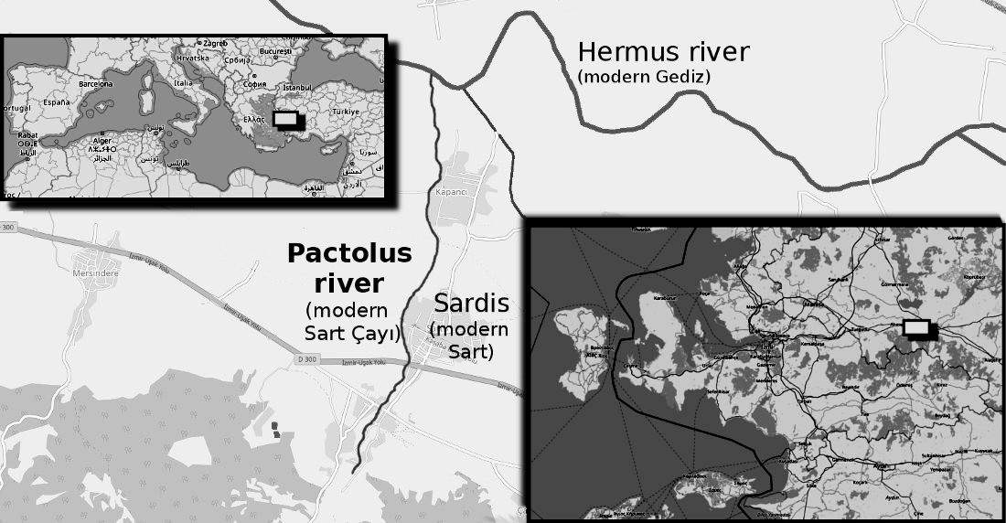
Money began with king Croesus of Lydia (modern Turkey), around 550 BC. Croesus lived near the River Pactolus, famous for its gold.
Croesus had so much gold that a popular saying was, “As rich as Croesus”. Croesus loved gold. So he hated the ancient system of helping the tribe: anybody who needed gold could simply ask for it, and it was his duty to help them. He hated that! As an example of his hatred for gift giving, he hated dowries. A dowry was the gold you gave to your daughter and her husband on her wedding day, so your daughter would never go hungry. Croesus made a rule that daughters had to earn their dowry. Of course, there were not many jobs for young girls, so most girls ended up as prostitutes. This was the shape of things to come: billionaires tell poor people that must take whatever soul-destroying low paid job is available, while the billionaire makes enormous profits.
There were crude forms of money before Croesus (that is, lumps of metal with some symbol stamped on them), but their weight and composition varied, so they were not reliable. Then around 550 BC, Croesus created the “Croesid”, the first highly regulated and reliable coin. They made it easy to pay soldiers in distant lands, and easy to trade. Money spread everywhere, removing the obligation to feed the hungry unless they, too, had money. Hungry people then work for low wages, the rich get richer, and inequality increases forever until the entire system collapses.
Storytellers remember the tragedy of money in the story of King Midas. Midas was cursed so that everything he touched turned to gold. You cannot eat gold, so Midas almost starved to death. Eventually, Midas lost his gold curse by bathing in the River Pactolus in Lydia (this is the link to Croesus), putting the gold back where it belonged.
The spread of inequality meant the spread of the soul: soon everybody believed that rich people must be very clever and moral, and not merely lucky or ruthless. The rich people encouraged this view, by supporting churches and charities that would then praise their benefactor. And some people always starved, because that was the basis of the new economy.
When Darius the Great became king of Persia in 522 BC, he introduced coins throughout the empire. He followed the Zoroastrian god, and Zoroastrians soon became famous for spreading the idea of the individual soul. At the same time, the Jews were returning from Persia and brought the Persian idea of an individual soul back with them.

The solution to the soul
The soul was invented as an excuse to take wealth from other people. But once people have taken that wealth, they will not give it up. So how can we stop them? Moses had the answer. Moses lived before the invention of the sou, but he faced a similar problem: kings. The story of Moses is the story of defeating Pharaoh, the greatest of all kings.
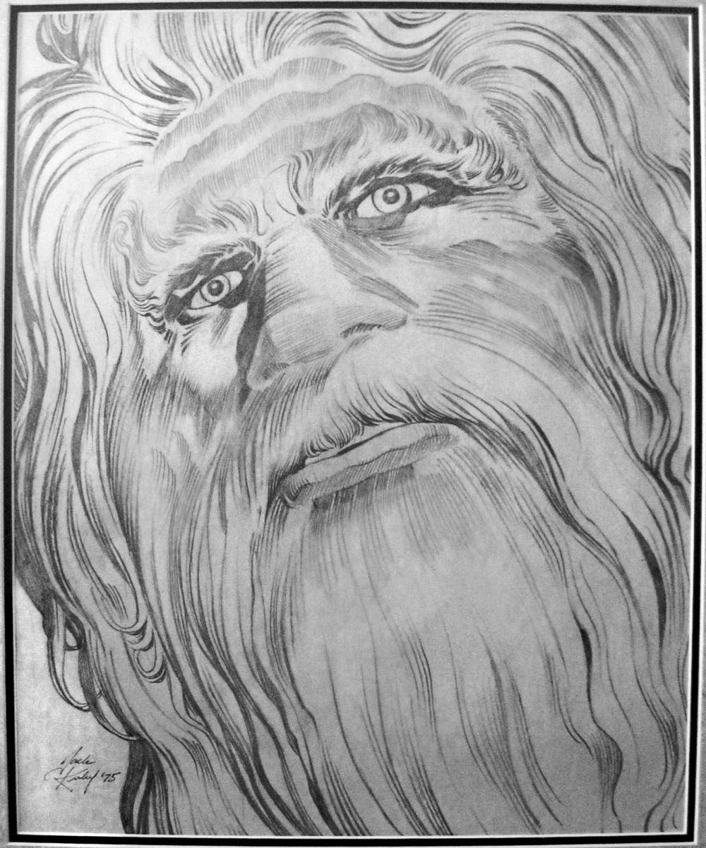
Moses is the central figure of Judaism, Kirby's religion. Kirby drew a large portrait of Moses to hang in the family home. Moses’ eyes gaze into the eyes of any visitors.
Image: Kirby Estate, via KirbyKrackleArt, Twitter. Fair Use

It is like Moses is asking each of us, do we follow the power people? Or do we learn from history?
Moses is the greatest enemy of kings, and inequality in general. And so kings and their supporters spent over a thousand years (1400 BC - 70 AD) arguing that actually, Moses liked kings. Then they spent nearly two thousand years (70 AD to the present) arguing that Moses was old-fashioned and not applicable to modern times. Finally, they spent 240 years (1780 to the present) arguing that Moses did not exist, and that his teachings are immoral and cruel. These attacks are examined in Appendix 1 (how scholars destroy history) and Appendix 6 (Moses as a historical figure). The rest of this chapter is about what Moses taught: what it is that makes him so dangerous to power people.
Moses saw that his people were enslaved, so he had a plan: he made an agreement with Shechem in the neighbouring state of Canaan. The people of Shechem needed help in a war. Moses would help them in their war, in exchange for land. Moses then divided the land equally between the people. The people were not allowed to sell the land (but they could rent it out if they wanted), and therefore nobody would ever have more land than somebody else. Moses explained that the land belonged to God, not to men, and that is why they could not sell it:
“The land must never be sold on a permanent basis, for the land belongs to me. You are only foreigners and tenant farmers working for me.”
This is brilliantly simple. All wealth derives from land, so this ensures equal wealth. If one person can use that wealth better, they can pay rent for extra land at market rates. If any person does not want to work for others, they can adopt a simple lifestyle and just live off their land. So everybody is equal and free, and clever people can rent all the land they need, making all the money they want.
The book of Judges records how the system made life better and better. It enabled the people to settle the land, defeat their enemies, and grow prosperity. But some people wanted more. It was not enough for them to have comfort and freedom: they wanted power over others. The book of Samuel shows how they destroyed Moses’ 400-year experiment.
In the days of Samuel, the Philistines suffered a plague, and this let the Israelites win. Samuel thought it was a supernatural thing. So instead of choosing the next judge based on merit, as Moses required, he decided that God had chosen him and that he should be judge, and he should pass the role on to his children. His children were useless, but this established a precedent: ruling based on being a chosen one, not based on merit. The next leader, Saul, felt that he should be not just a judge but a king. Samuel realised that kingship was a terrible idea and would weaken and destroy the nation, but it was too late.
The kings rewrote history. They found the most shocking event in Israel’s history when some people murdered and dismembered a prostitute. This took place when the tribes first arrived in the new land. The rewritten history placed this atrocity at the end of the history of the judges, instead of the beginning. So instead of the history starting with chaos and ending with order, the rewritten history looked like it started with order and ended with chaos. The new history then repeatedly said, “In those days Israel had no king; everyone did as they saw fit.” The propaganda worked. Later generations believed that the reign of judges must have been chaotic, so they supported having a king.
The kings stole the wealth of the nation, just as Samuel said that they would. Within two generations, king Solomon taxed the people so heavily that the nation broke in two. Two hundred years later, ten of the twelve tribes of Israel were conquered and scattered by Assyria, and a hundred years after that the remaining two tribes were conquered by Babylon. Kings destroyed Israel, just as Samuel warned.
Moses had specifically designed his system not to have taxes, making a king impossible. This is how Moses planned to finance his democracy:
“One-tenth of the produce of the land, whether grain from the fields or fruit from the trees, belongs to the Lord and must be set apart to him as holy.”
That tithe was to pay for Levites, who had no land. The Levite’s job is to preserve the religion, or in other words, to create unity between the people. The amount of tithing, one-tenth of what grows, is less than the amount that would grow even if you did nothing but stayed in bed all day: it is wealth you do not create. Economists call that value “ground rent”: the rental value of ground if you did nothing. Ground rent is the most efficient way to fund a government. Adam Smith explained:
"Ground-rents … are altogether owing to the good government of the sovereign, which, by protecting the industry either of the whole people, or of the inhabitants of some particular place, enables them to pay so much more than its real value for the ground which they build their houses upon. … Nothing can be more reasonable than that a fund, which owes its existence to the good government of the state should be taxed peculiarly, or should contribute something more than the greater part of other funds, towards the support of that government."
So Moses proposed the most efficient method to fund the government. It is most efficient because it rewards work (there is no tax on work) and punishes idleness (it taxes unearned income).
Let us look at the numbers. A typical modern economy will grow at 2% - 4% per year, on average, after inflation. A rapidly growing economy, like China, might average 10%. This is in a system that punishes work and rewards idleness. But Moses’ system rewards work and punishes idleness. Adam Smith says it is the best method, so let’s say it adds just 2% to growth. Two per cent compound growth means that output doubles every 35 years. It goes up by ten times every 117 years. A thousand times every 350 years. Imagine if we followed Moses’ law in 550 BC. That date is when even the harshest critics admit that the law of Moses was known. (The text itself says the law is much older.) Let us imagine the poorest person, making just a dollar per day (in today’s money). One dollar per day in 550 BC becomes ten billion trillion dollars per day in 2020. Check the numbers yourself on a calculator: 550 BC to 2020 AD is 2570 years. Two per cent growth per year is 1.02 ^2570. Result: 1 with 22 zeroes.
Now obviously it would be better to have the Golden Age, and do no work at all. But it is too late for that. So Moses gives us the next best thing: if we have to work and compete, at least we can each have our own land and be fabulously wealthy.
If we start to follow Moses’ law, then we double our previously expected wealth in 35 years. Using this wealth, a nation can bribe the super-billionaires to accept the change. That is, pay them to stop destroying civilisation. For details of how to do it, search “Georgism” or “Land Value Taxation”.

Golden Age NOW: how Kirby did it
Kirby's life is a model for how to create the Golden Age, or as close as we can get, right now:
- Compassion.
This was Kirby's only message. His life backed this up. Any stranger who visited his house was invited in and given food. Kirby just loved people. Every other choice (economic, political, etc.) follows from that: what choice shows the most compassion?
- Respect for the individual.
Kirby worshipped the individual. If we do that, the economic system follows. Kirby’s hero Moses showed us how. People just need land.
- Respect for mythology.
Mythology is the deep history of the human race. Learn from that history. Kirby did. Whatever problems we have, our ancestors have solved them.
- A clear view of reality.
Kirby understood that life is simple. We have no complex inner world. We just need food and shelter and friends. Yes, Kirby ended up with a house in California with a swimming pool, and today that is a luxury. But for our ancestors that was everyday life. Back when we first left Africa, we all had sunshine and lived near the coast or near a river. Life was simple. Life was good.
- Creativity before money.
Kirby's 1960s editor was paid a million dollars per year but was unable to create anything on his own. He died an insecure man, surrounded by financial parasites. Meanwhile, Kirby put creativity first, so he made much less money, but created characters who can make a billion dollars for a single movie. Kirby died a peaceful, happy man, surrounded by people who love him.

15.
Your Personal Future
(Life After Death)
This chapter argues that Kirby’s simple view of life — that we know less than we think — is infinitely profound.
Kirby said, “I feel there are no experts anywhere in anything” and that after we have learned everything we possibly can, we will realise we know nothing. The oracle at Delphi (the greatest source of wisdom in the ancient world) said that Socrates was the greatest of all philosophers because Socrates realised that we know nothing.
"I neither know nor think I know"
The greatest thinkers often come to the same conclusion, that we do not know anything for certain. Maybe we are simply wrong in some of our biggest assumptions about life.
In the previous chapter, we saw that people have no hidden depths. Since 550 BC we have believed in the inner depths of the mind, and it was all nonsense. What other nonsense do we believe about the mind?
A very popular belief is that the brain creates the mind. Our ancient ancestors disagreed. The brain can change the mind, but changing is not the same as creating. Is the brain less important than we think? What is “thinking” anyway? Does the mind think, or simply experience ideas from elsewhere? We were wrong about our depth and self-importance, what else are we wrong about?
Here is a Kirby story that might have the answers. The story is about a portal. And the story is itself a real-world portal, taking the reader deeper and deeper into the infinite universe. It begins to answer the question, what happens to the mind when the brain dies?
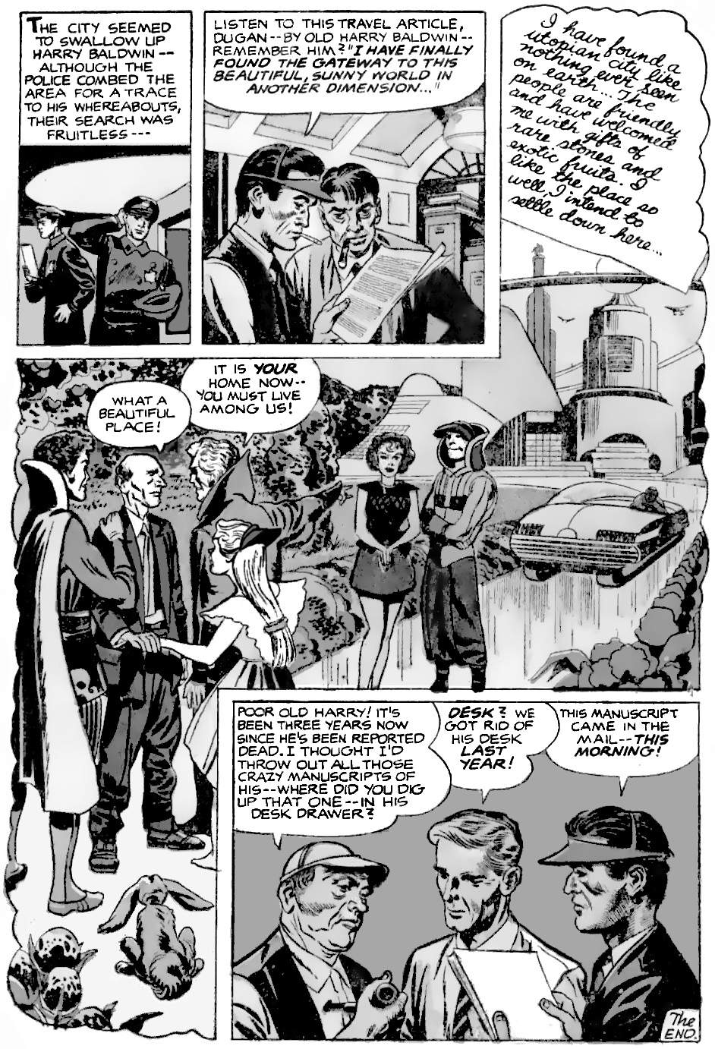
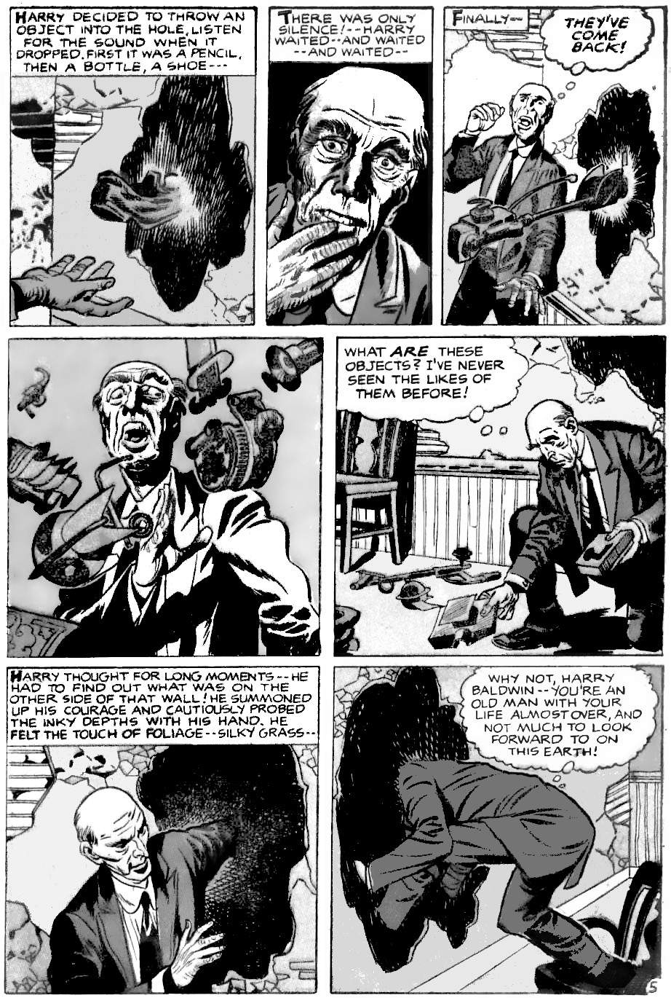
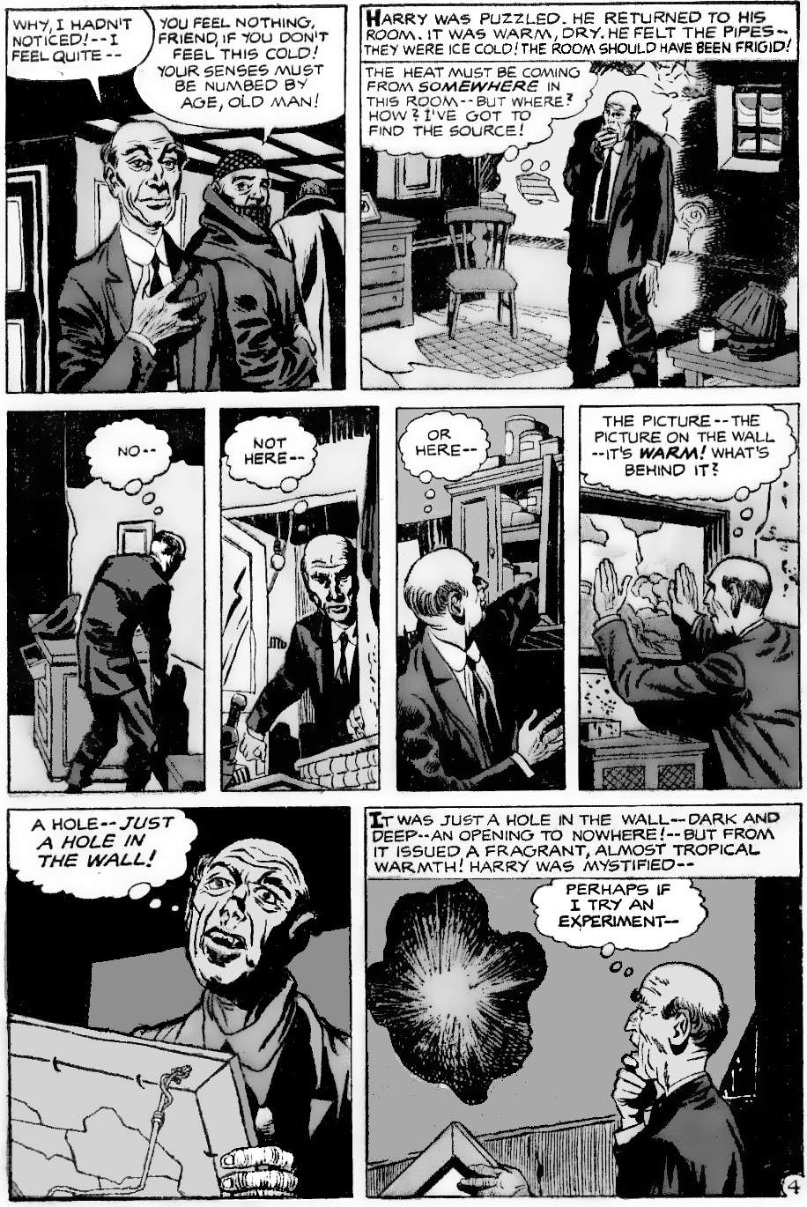
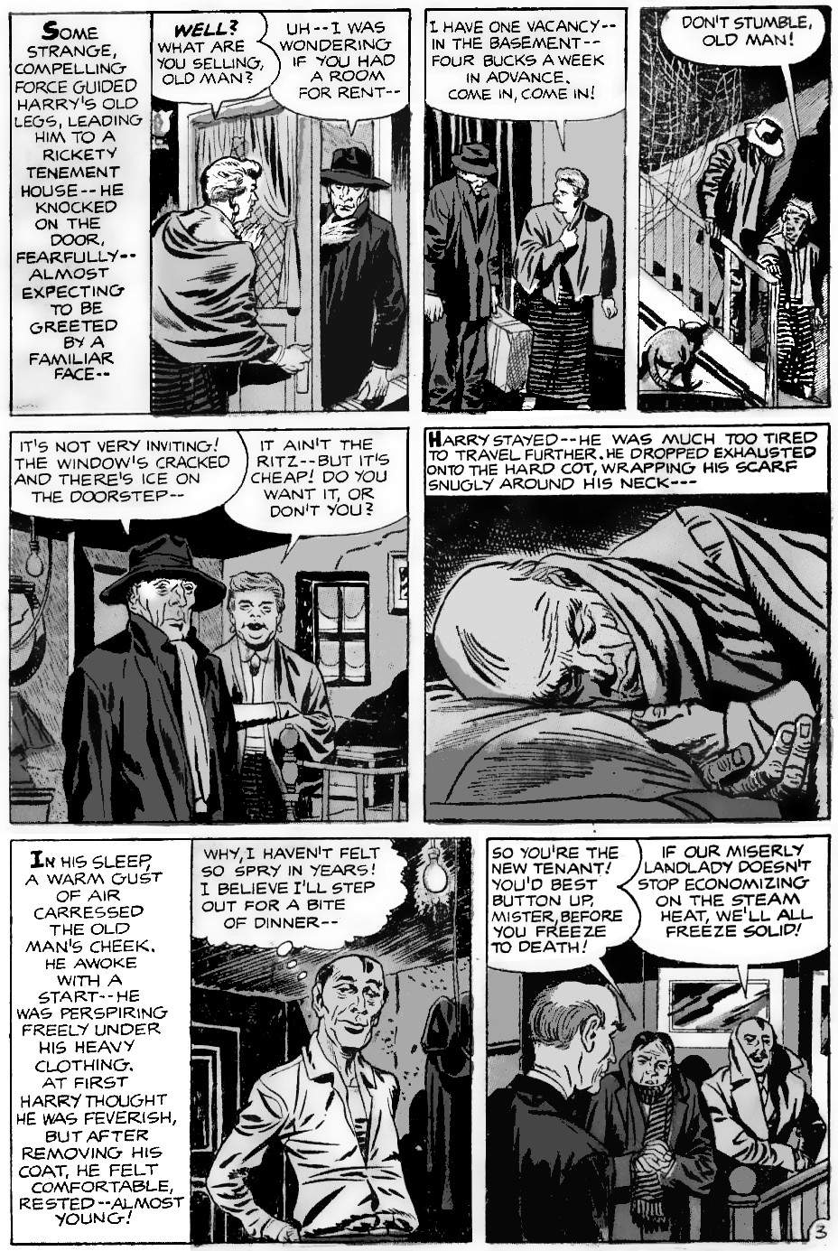
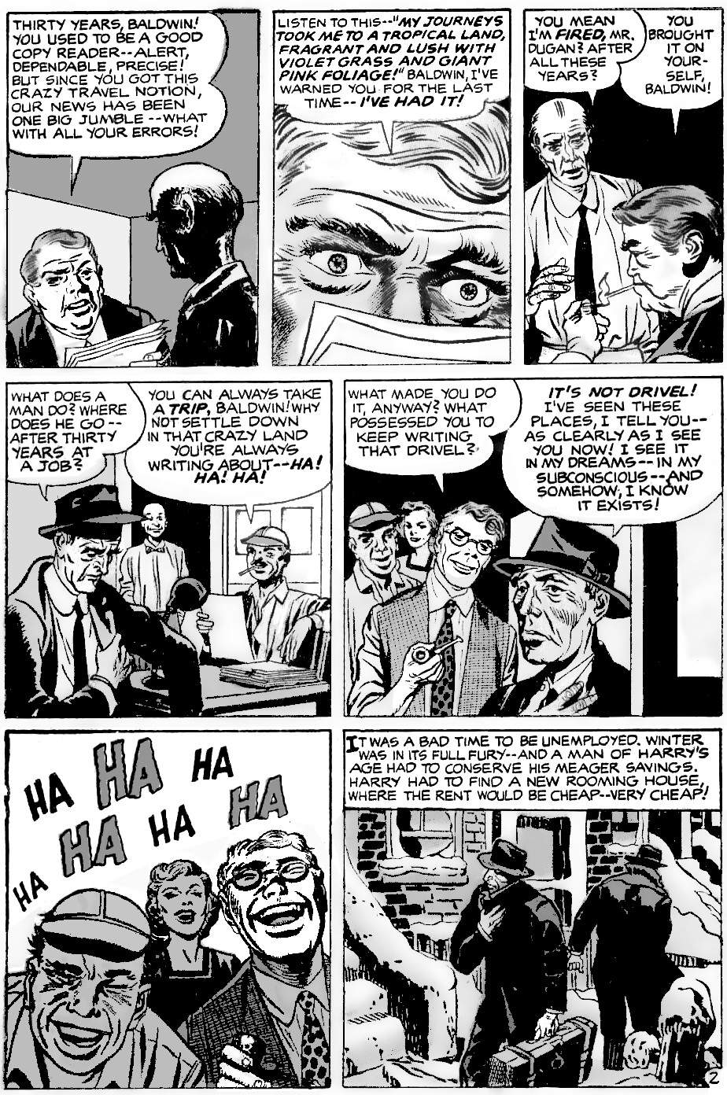
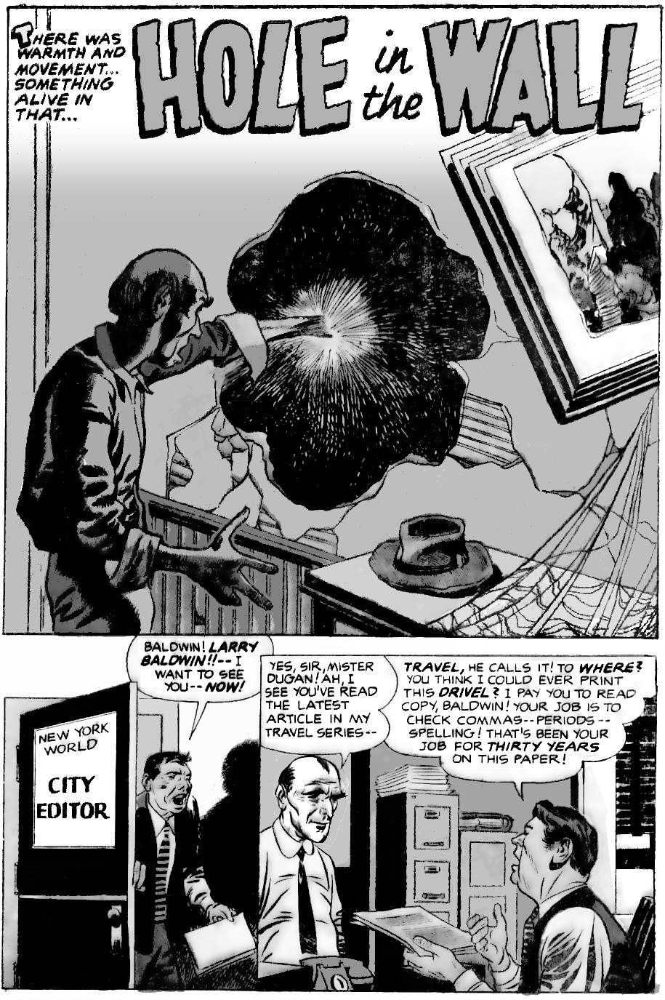
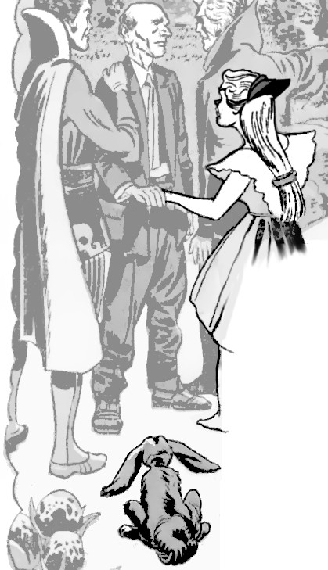
Notice the Alice in Wonderland references: Harry escapes through a hole, and when he is in his wonderland he holds the hand of a girl dressed like Alice, accompanied by a rabbit.

On the surface layer, this is a children’s fantasy. Harry Baldwin is bored at his job: he is supposed to correct other people’s spelling, but he writes stories instead. He is like a child who is bored at school, and writes childish fantasy stories in his exercise book instead of doing his work. But he has the last laugh because his stories come true!

On a deeper layer, this is an adult story. Many adults feel like Harry Baldwin: stuck in an unfulfilling job, while they dream of writing a novel or travelling the world. Then they grow old and realise that they will never have their dream. They cannot accept that reality. Maybe they self-publish some bad novel that nobody reads. They have pride because they choose to reject the reality imposed by others and create their own reality: it makes them happy, and isn't that what matters?

On a yet deeper level, there is nothing magical in this story. An old, lonely man refuses to face the despair of reality. He ends up in a freezing cellar. As hypothermia sets in he feels warm because his body no longer feels anything. He searches his room for the heat because he is confused: his mind is dying. He is hallucinating, pushing his shoe into a hole in the dilapidated wall, then he thinks strange objects attack him from that hole: a symptom of paranoid schizophrenia: he is barely in touch with any reality. Entering the portal is entering death. As he dies he has the archetypal near-death experience of being with loving people. A year later somebody finds an envelope that Harry never mailed, and they mail it. So the editor receives Harry’s last story, a year after he died.
On an even deeper level, the story reverses direction. Once we accept that Harry died, we can read the story again in that light. But we see that Harry believed these things before he was sick when his mind was still clear. Harry was intellectually quick and well-informed: he spent thirty years reading about travel to different parts of the world and doing a good job of copy editing. Harry is not stupid. And this is reinforced at the end when we see that Harry is right. But how can he be right? He explains:
“I've seen these places, I tell you — as clearly as I see you now! I see it in my dreams — in my unconscious — and somehow, I know it exists!”
He knows he sees them in his dreams when his body is lying down. He is not pretending that his physical body goes there, but his mind goes there. Then the story asks the question, what is the mind? What is it that visits these places?
Kirby wrote many stories about visits to other dimensions, and about life in strange unexpected forms. These ideas are very common in ancient cultures: they nearly all teach of some kind of spirit that can exist outside the body. Kirby refused to reject any of this evidence.
“I feel there's a heck of a lot of questions to everything all about us. And whoever says he knows the answers, why, he's the one guy I know who doesn’t."
Regarding life after death, Kirby followed the Jewish teaching that your ideas live on through your family: the early Old Testament has no interest in life after death but is obsessed with the tribe having children.
“We never really die. You live on in your son or you live on in somebody else. I don't know the answer, but somehow I feel that our lives are endless.”
Our lives cannot be endless if we only live on through others’ memories: sooner or later you will be forgotten and your “shade” in Hades fades away. But Kirby felt that life is more than that: life is, somehow, fundamentally endless. That was the considered conclusion of most ancient thinkers. But how can that be? Kirby explored the possibilities in his stories.

Kirby on life after death
Kirby was Jewish. He knew that life is dust. “Dust thou art, and into dust thou shalt return”. He used that idea in The Eternals, where people can be stored as dust. That is the idea behind the rest of this chapter: life is dust.
Kirby explores life after death in stories like “Fear Shall Follow” and “The Black Racer”. He describes death as returning to “The Source”. Kirby did not describe life after death in detail in his stories. He wanted to, but those stories were fated to never be published. “Strange World of Your Dreams” often touched on the subject but was cancelled after just four issues. New Gods was cancelled when the Black Racer was barely introduced. After that, Kirby tried to devote a whole series to life after death (and related topics), but “Spirit World” was cancelled after a single issue. He explored the topic a little more in his adaptation of “2001: a Space Odyssey”, and in his most philosophical work, “Captain Victory”, a series about victory over life and death. But it was abundantly clear that most comic readers did not want to read about philosophy or spirits. The more that Kirby explored these topics, the fewer books he sold.
Despite this, we can see some consistent themes in Kirby’s stories:
- We know much less than we think we do.
- Dying means entering a higher dimension. Ghosts are three-dimensional images of four-dimensional (or higher) beings.
- Higher dimensions are hard to visualise because we see through and around objects.
- Higher dimensions are best understood by thinking of people as information. We should focus on geometry, and on information, not on our present physical body. This also explains reincarnation.

Kirby on consciousness

WARNING:
This book is
about to get weird.
In the previous chapter, we saw that the human mind is all on the surface, and is much simpler than we usually think. But how simple? What, precisely, is the conscious mind?
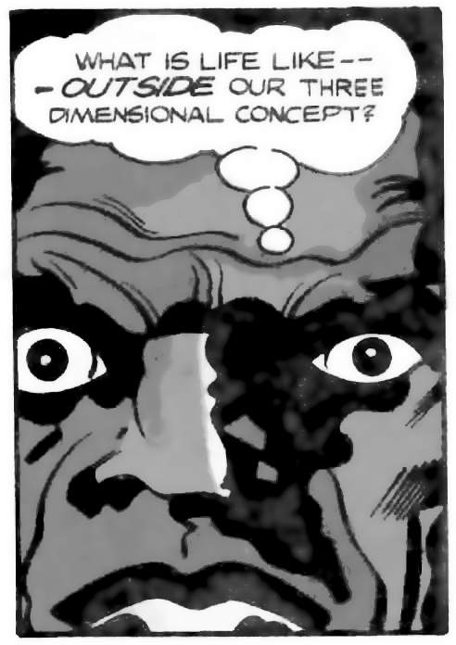
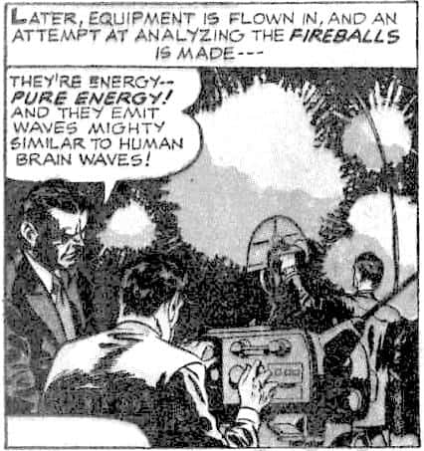
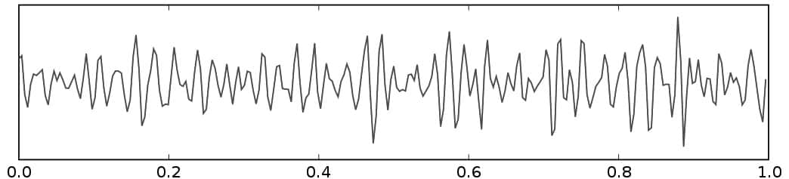
In Kirby’s stories, practically anything can be conscious. Computers can be conscious, insects can be conscious, a freak accident can make a clay statue conscious, and even water and smoke and fire can be conscious. But how does an object become conscious? Or rather, what makes an object conscious in a human-like way? In Kirby’s stories, it is brainwaves. In “Today I Am A”, Dr March tells Paul, “It’s in your brain wave patterns that the secret lies”. And in “Fireballs”, we know they are conscious because their electrical activity matches human brainwaves.
Captain Victory #9 p.7, Fair Use
Image: EEG by Hugo Gambo, via Wikimedia, CC-BY-SA-3.0

Brainwaves change 40 times per second
Brainwaves are the key to unlocking the secrets of the mind. This is why.
Brainwaves are neural oscillations: waves of electrical energy created by neurons all firing at the same time. Neurons fire together in waves, so that brain activity can be organised and not chaotic. Brainwaves can be as slow as one Hertz (one cycle per second) in very deep sleep, or over a hundred Hertz in times of sudden danger. Normally, when awake, brainwaves change at about forty Hertz, as shown in the graph.
Forty Hertz is important because this is the same as the bit rate for language: no matter what the human language, it peaks at about forty bits of data per second. A bit is just a “yes” or “no”, “on” or “off”, “1” or “0”. The human brain is highly optimised for language, so this rate of forty bits per second is probably the fastest the brain can do anything in normal conditions.
So the most complicated thing we think about — language — only requires a single bit of data at a time. At any moment in time, the entire human mind is a single bit of data! This data is changed by the brain, which is extremely complicated, but the mind itself literally could not be any simpler. Human consciousness is therefore identical with information, the simplest building block of the universe.
Or perhaps language is simpler than it appears? What about something complicated like the visual system? Let’s see how much data that requires.
On the next page is a photograph of a lot of faces. Most are wearing glasses. But some are not. When you turn the page (or scroll down if reading this digitally), see how quickly you can spot how many people are not wearing glasses.
So Your conscious mind will need to see every face, one at a time, and quickly think, “Is it a face? Yes/no. Does it have glasses? Yes/no. Add to the total? Yes/no. Move eyes? Yes/no.” That is, at least four yes/no questions: at least four bits of data per face. There are around 80 faces. So your mind needs to handle at least 4 x 80 = 320 bits. That is, 8 x 40 Hz brain cycles. How quickly can you be sure of checking every face? Try it. it will probably take around 8 seconds. That is, the mind is aware of visual images only one bit at a time, the same as with speech.

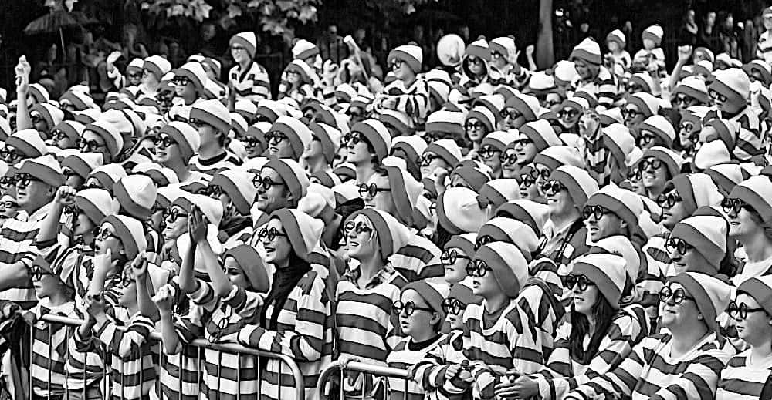
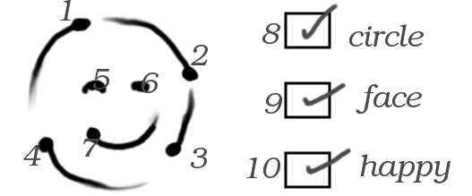
We typically need at least 0.25 seconds to react to an unexpected new visual stimulus. Once we know what we are looking at then we can react more quickly, like scanning many faces one after the other. But the first face needs 0.25 seconds or more so we can adjust to the scene. So it looks like we need at least ten cycles to register the simplest possible image. Sure enough, ten yes/no bits are enough to identify a simple image.
Image: “Where’s Waldo” convention, by William Murphy, via Wikimedia, CC-BY-SA-2.0

We think we see things all at the same time, so what is going on here?
We have seen that the brain delivers information at forty bits per second, but you can only make sense of it after ten bits or more. So the brain delivers information faster than we know what we are looking at. So we do not think “I can see it all” until after we have seen enough to be satisfied. “I can see it all” is just a mental box that we check.
“[E]ye-tracking software can show us a page filled with Xs with one word positioned exactly where we are looking, and we have the experience of seeing a full page of text. We can’t even see two or more colours at once but switch between one at a time.”
Our bodies are optimised for survival. For millions of generations, we competed to be the first to find scarce food. So if it was possible to think more quickly than one bit per second, we would be doing it.
One bit per second appears to be a hard limit, probably because of the nature of reality: information only has meaning from a specific point of view. For example, a distance is only a distance if we specify exact start and end points, and a choice is only a choice if it is one choice: we cannot decide to travel north and travel south at the same time. Information can only be meaningful at a single point.

How do data become experience?
Every point in the universe is defined by values in multiple different fields. These include the electromagnetic field (which produces light), the Higgs field (which produces mass), the electron field (which produces electrons, and fourteen others, though more may yet be discovered. Each field fills the universe and interacts with every other field, so everything is connected. Each field can have multiple parts: electromagnetism is made of electric and magnetic fields, the Higgs field has four component fields, and so on. So each point in the universe has an incredibly rich range of data. This explains why we do not experience data, we experience the universe.
In summary, the mind appears to be a point in space. But what did Kirby say about the size of the mind?

Kirby on the size of consciousness
Kirby was fascinated by size. For example, he felt that insects might have intelligence that we can’t understand because we’re “so damn big”:
“I feel man's intellect hasn't actually collided with the insects. In other words, I feel that somehow there may be some kind of rapport that man has never had with insects, which he may ﬁnd if he was on the same level in some way. That should be explored. Maybe the insect in his own size has some kind of intelligence we can't fathom because we're so damn big.”
When we are young, human civilisation seems so important and exciting. As we grow older and start to see its patterns and faults, the novelty wears off. We take a greater interest in our pets and gardens. Or perhaps, like Henry Pym (And Man) we study the little animals around us and begin to realise their lives are just as rich and varied as our own. We see that humans, who think they are so big and important, are just a tiny speck in the universe that has fractal complexity: going smaller might be far more interesting and exciting than going bigger.
Why stop at insect size? How small can a mind be? In Kirby’s stories, even a single cell can be intelligent. But we can go much smaller than that. In a story about the birth of life, Kirby introduced “Psycho-Man”, who is so small that an atom is like a planet to him. That is, the neurons in his brain must approach the fundamental quantised unit of physical scale, the Planck length (about 10⁻³⁵m). Despite having almost zero size, Psycho-Man controls the emotions of full-size humans.
Kirby was not afraid of going small, because he understood something that most of us forget: the mind is not the senses. The senses merely change data in the mind. The brain could be anything that delivers data: a human brain, a machine, even the universe itself.
The greatest minds in Kirby’s work have no brain other than the universe itself: they are The Source (in New Gods), and its opposite, The Voice (in Captain Victory). They gain sensory data from throughout the universe and are themselves completely disembodied.
All of this supports the earlier conclusion that the mind is literally a point in space, a point of view of the universe.
Now let us see what happens to the point in space that was Harry Baldwin.
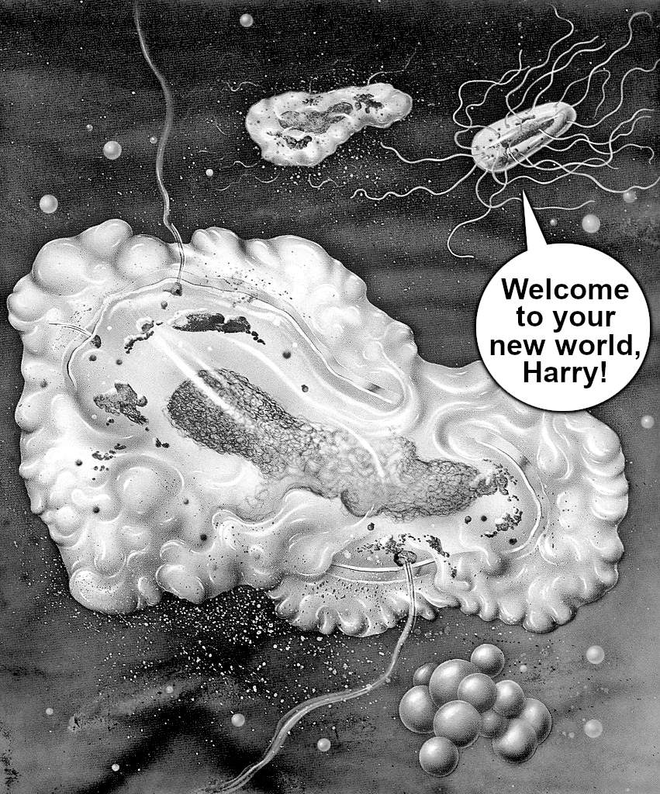
When Harry Baldwin dies, his body and brain decay. But a point in space cannot decay. With the brain no longer filtering information, information now flows directly to Harry from the outside world. Instead of having a brain the size of a human skull, Harry now has a brain the size of a planet: the planet itself! He forgets his old worries and now experiences a vastly more complex and faster moving reality.
Image: Penecillin and E Coli, Carl-W. Röhrig, via Wikimedia, CC-BY-SA-4.0
Your brain will tell you that this is a terrible outcome! Because your brain evolved for its own survival. When the brain finally stops feeding you its problems, then you see things differently.
With the brain decomposing, Harry might find himself part of the bacterial world. Bacteria have their own civilisations:
“Microbes live in communities where individuals rely on one another. The vast majority of microbes cannot produce all of the nutrients they require and instead depend on other microbes to produce nutrients such as amino acids and vitamins.”
They find food, they reproduce, they communicate, and they experience the universe in ways we can barely imagine. They have their versions of everything humans do, but with one big difference: bacteria do not have a big complex brain. So bacteria do not worry about the future. The whole point of a brain is to predict the future, so we can do something about it. In other words, the whole point of a brain is to worry. No brain, no worries.
How does this change the meaning of life?
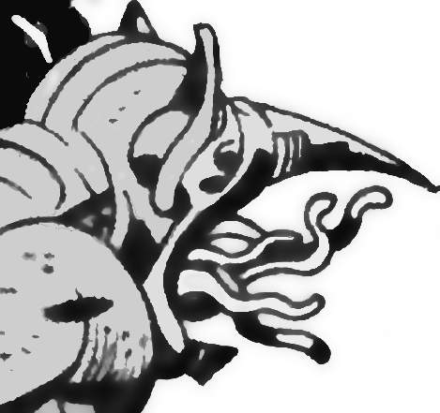
Kirby examined the meaning of life in Captain Victory, a book about victory over death. He concluded that life (human life) is endless tribulation. Everybody in Captain Victory is deadly serious, frustrated, and stressed, with lives of sacrifice and disappointment, and no way out. And for what? For more struggle, endlessly, forever. The greatest thinkers often conclude that ultimately everything is pointless. But Kirby has a better answer. In issue #4, at the darkest moment of a very dark series, in a wordless sequence when the Captain is about to commit genocide to save a world, the story pauses. We then see the only truly free and happy creature on the Captain’s ship: the Goozlebobber.
Why is the Goozlebobber the only free and happy being? Because he is a shape changer. He does not try to preserve himself. Goozlebobber welcomes change. He sometimes changes without meaning to, in his sleep. He exists just to experience the universe in all its infinite forms. He does not need power, or worries: he just enjoys whatever happens.
In reality, we are all Goozlebobbers. All existence is constant change. Our brains cause us suffering because they resist change (and fail). But when we stop resisting change, the journey of discovery begins.

16.
Your Cosmic Journey
This final chapter argues that life after death is more amazing and enjoyable than we can imagine.
Many ancient sources tell of journeys through the heavens and the underworld. This is a glimpse of the journey after death. Several Kirby stories feature a similar journey. Kirby’s best-known celestial journey is the one taken by Johnny Storm when he faces the world-destroyer, Galactus. To make the journey, Johnny's body must burn up, and then he must navigate swirling patterns of “un-life”. He sees the ends of the universe, and realises the truth about humans:
“We're like ants…. just ants… ants!”
The same message is embodied in Galactus himself: he eats planets for food, and he sees humans as just ants. The same message is embodied in The Watcher, the wisest being in the universe: he spends his days studying the infinite scale of the universe: he stores an entire solar system in a jar. His people long ago learned the foolishness of resisting change. But he becomes emotionally attached to the life forms he studies, such as humans, and sometimes helps us in our ant-like struggles.
Here is another Kirby story about the cosmic journey: “Donovan's Daffy Chair”. Donovan is at peace with the world because he has learned to be happy without power. His job is the human equivalent of being a happy worker ant: “Timothy Donnegan’s world is indeed a small one”. Timothy does not try to be big and important: he finds joy in simple curiosity, wherever he is. He does not care for authority: when told to do something he might just do the opposite. He enjoys the life of the mind: observing, prodding, probing, enjoying whatever happens. And so his cosmic journey begins.

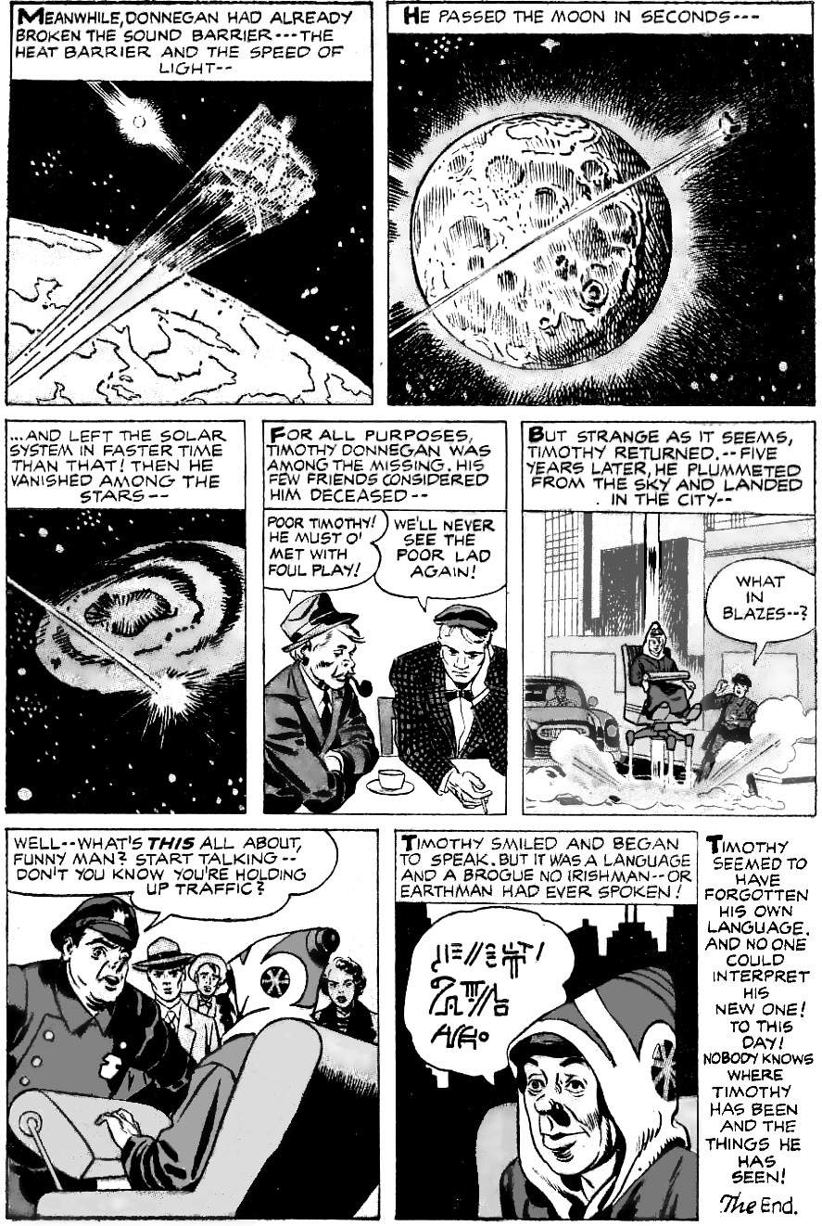
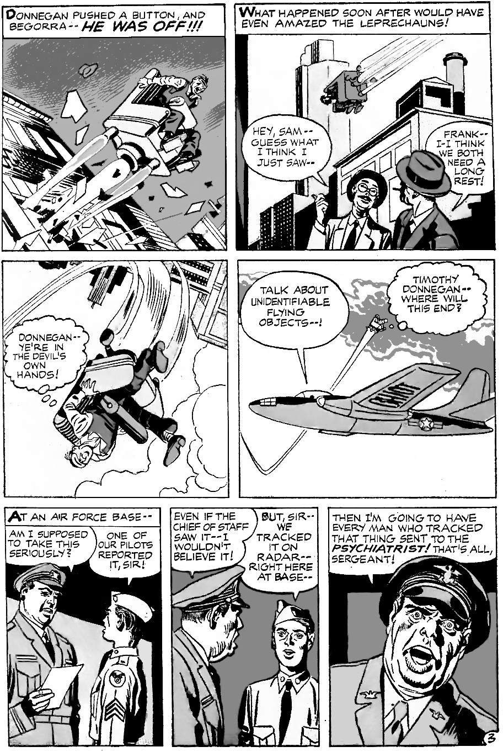
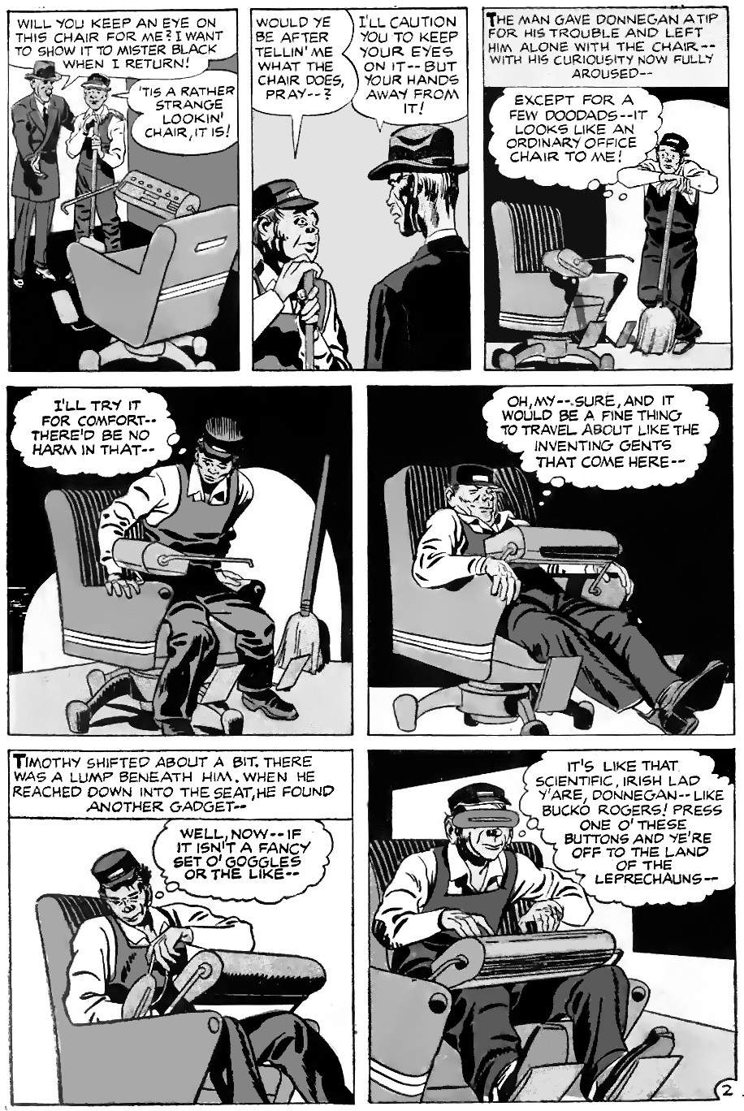
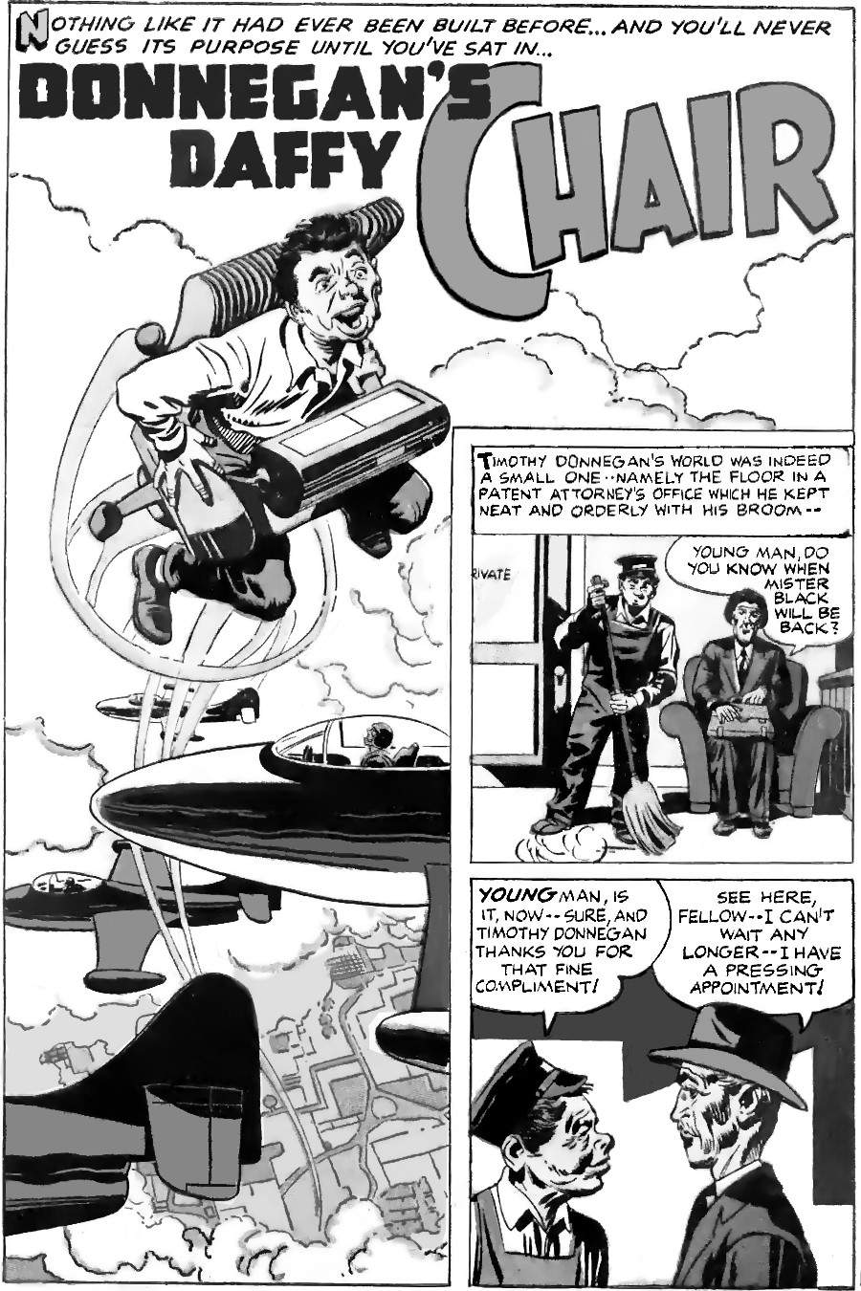
On the surface, this is just a silly story. A janitor sits in a chair and finds it is a rocket to outer space, and the twist ending is that nobody knows where he went because he no longer speaks an Earth language. But look closer, and it's not silly. Kirby loved mythology, and any reader who loves mythology will recognise the cosmic tour. Like Dante and Paul, Donnegan ascends through three heavens (in his case, the clouds, the moon, and the stars). Like Paul, he is unable to communicate what he experienced:
"I knew a man in Christ above fourteen years ago, (whether in the body, I cannot tell; or whether out of the body, I cannot tell: God knoweth;) such an one caught up to the third heaven. ... How that he was caught up into paradise, and heard unspeakable words, which it is not lawful for a man to utter.”
This was a common theme in the ancient world. Readers of Greek mythology may see the parallel with the flying chair of Hephaestus. Chapter 5 showed that Hephaestus was effectively the god of technology, and began Egyptian civilisation. Students of etymology will also know that "daffy" had a slightly different meaning in 1957. Today it means silly, but it specifically meant moving rapidly and easy to misunderstand (hence “Daffy Duck”). It is important on page 3 that Donnegan cannot control the chair, because when exploring heaven the mortal cannot be in control.
Kirby's most famous flying chair user is Metron, the god of science. Metron wants to go "beyond time" and "beyond death”. But Metron, and all scientists before him, can never get past “the Wall” to learn The Source of all things. Kirby's next flying chair character, "Egghead", begins to understand, but still cannot see a way through the walls. Egghead can read minds, cross time and space, and probably knows more than anyone else in the universe, and yet:
"Each answer leads to another question! Forever, another question! I smash through barriers with perspectives that would drive each of us insane! — And, what do I find? Walls! Walls! New and endless!"
The real story begins when the four pages end. The reader is left wondering, like Metron and Egghead, "What's out there?" This question dominated Kirby's thinking from 1957 (the date of this story) to the end of his life:
“I began to think about three words which have always puzzled me: What's out there? OK? What's out there? I didn't care about the East Side any more. I didn't care about Earth or anything like that. I thought, what's really out there? Then I began to draw characters from outer space, characters from beneath the earth, characters from anywhere that we couldn't think of.”
“I believe that none of us are ever going to know the answers. But to me it's just a game just asking them, and I enjoy it thoroughly.”

Timothy Donnegan is reborn
Donnegan is changed by his experience. He no longer communicates in any Earth language, and yet he is happy and at peace: Kirby shows that he is calm amid chaos, by placing him on a chair in the middle of traffic. This kind of rebirth is the normal result of a heavenly journey. As James Tabor notes, about Paul's journey to the third heaven,
"the phenomenon of the 'heavenly journey' is a rather common one in Paul’s time, and stretching back several hundreds years before him."
“Several hundred years” refers to just the space version of the journey. Before that, rebirth took a different form, but with the same result. Notice Donnegan’s costume at the end: he is dressed like a shaman from the Andes. Shamanism was a normal part of almost every society before modern civilisation: originally, everybody was a shaman, and it gradually became a specific role, part of the slow rise of inequality.
Shamanism normally begins with connecting to the consciousness of one other animal, rather like Kirby's Ant-Man talks with ants, or Kirby's The Fly talks to flies (who were full-size humans in another life). Or “Gorilla Man”, where a scientist learns how to swap minds with other animals. He soon realises that each animal has a very different mind: he cannot stay as a cat for long or he will forget being human. He settles on becoming a gorilla, as the closest to a human, but even here he loses interest in human speech.
The key to rebirth is humility. Metron and Egghead are not humble, so will not accept that they evolved to fit in a particular niche. Instead, they seek out distant worlds and find endless frustration. They batter themselves against the metaphorical wall. To become enlightened, all shamans must first learn humility: that we are not better than other life forms, we are merely different. Timothy Donnegan is a humble janitor, so it is easier for him to gain enlightenment.
A very large book could be written about Kirby and rebirth: his work is the modern equivalent of Ovid’s “Metamorphoses”, the classic retelling of Greek history and mythology using the metaphor of shape-changing. We could discuss Kirby's Ovoid (Ovid-like) aliens, or how all of Kirby's superheroes have a life-changing experience and then adopt a new identity, often involving shape-changing. We could look at parallels between Kirby's space stories and Jacob's ladder, which itself parallels shamanic experiences. We could look at how shamanic experiences were co-opted by the first kings (the language of Jacob’s ladder parallels the god-kings of Uruk on their ziggurats). We could discuss the climax to Kirby’s expanded 2001, a series about the purpose of life, where the New Seed places the chemicals from a dead couple into a new planet, where they will rise again in a billion years. We could even discuss Kirby's rebirth on Omaha Beach when he felt the connection between all life. Rebirth is at the heart of his work.
We could also discuss the drug imagery in The Vision (the use of smoke in vision quests), Challengers, Johnny Storm's journey, and Psycho-Man and Silver Star. Drugs lead to terra-genesis and meteors that animate clay (e.g., the Puppet Master, and Dragon Man), there are endless references to rebirth in Kirby's stories. How can we reduce them to just a few pages? Perhaps we can make rebirth very simple. Here is a Kirby story about the conventional idea of reincarnation: a man is reborn as an animal, and then is reborn again as a human.
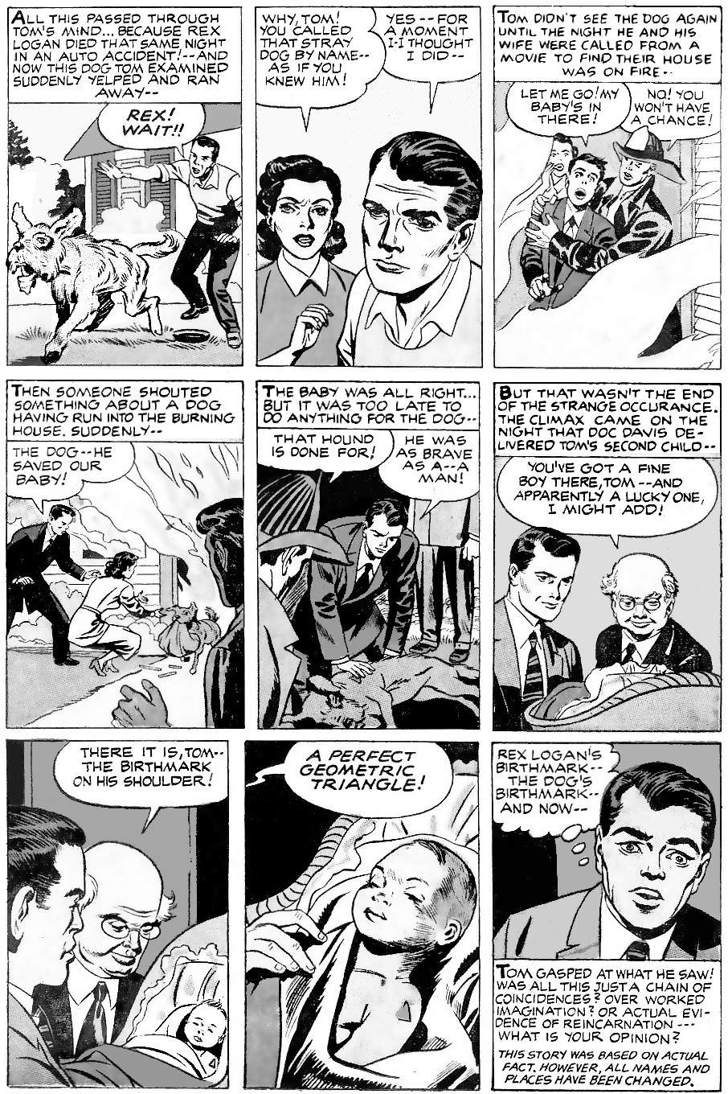
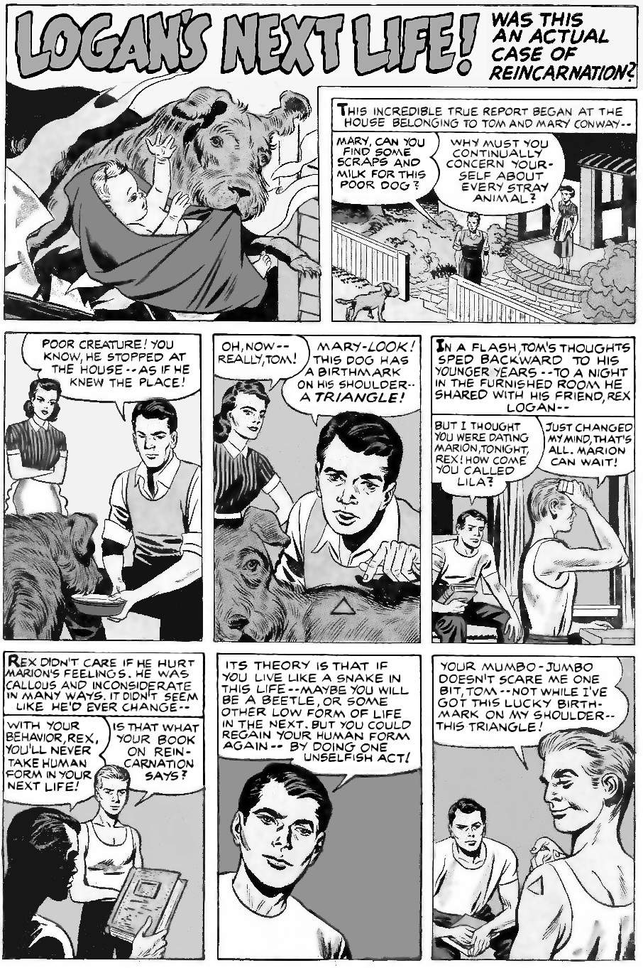
A human tells this story, so he gives humans a given higher moral value than dogs. He sees becoming a human as a reward for being good. But a dog would see this story differently. Dogs do not value being human, but they do value the pack. If a human leads the pack then of course they help the human (as in this story), but only because the human is an honorary dog.
Is it better to be a dog or a human? It depends on the circumstances — some people have great lives, some have terrible lives, and it is the same for dogs. But in general? Rex the dog has a much better sense of smell than Tom the human. And better hearing. So he lives in a world that is much richer with information. Also, he has less to worry about: there is no point in Rex worrying about the future. Nor does he worry about paying bills. Instead, Rex can be very excited over a simple smell or piece of food. But Tom? Tom is probably stuck in a sterile office all day, following orders, cut off from nature, without even seeing the sun. Poor Tom can’t run with his pack or chase rabbits or sleep when he wants. Maybe Tom will be luckier in his next life.
Once we get used to the idea that a dog’s mind is a great place to be, we are ready to look at other life forms. What about ants? Johnny Storm realised that humans are just ants. And Ant-Man is always talking to them. So what is it like to live as an ant?
Ant colonies have the key features of human cities: the division of labour and complex organisation, including farming plants and other animals. Ants speak (share information) using pheromones: different scents have different messages, like “follow me” or “attack”. Ants have wars and capture enemy ants, who then learn the ways of their new tribe. One super-colony of ants in southern Europe is over three thousand miles long. Each ant gets to decide its role, which changes through its life:
“[W]orkers decide which tasks to perform based on personal preferences, interactions with nestmates, and cues from the environment.”
Ants react to social isolation in the same ways that humans do. Ants’ brains are much larger than humans’ in relation to their bodies. But since their brains are simpler in absolute terms, and their bodies evolved to be expendable, ants probably don’t worry about the future as much as we do. More importantly, ants generally live in the environment in which they evolved. Humans generally do not. Better yet, life at the ant scale is faster moving and more chaotic, and ants are more willing to risk their lives, so an ant’s life is probably much more varied and interesting than a human’s life. In short, the mind of an ant will be different, but in every measurable way, it is just as interesting as the mind of a human.
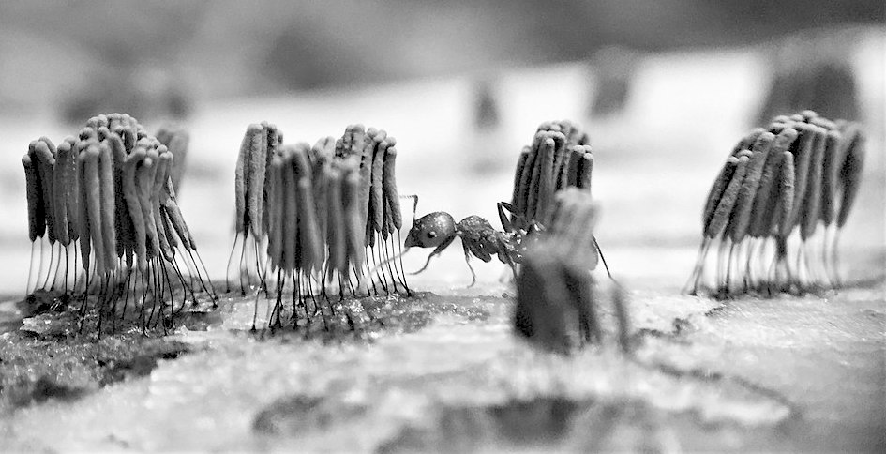
Let’s go even further along the path of life. Take “slime mould" for example. Time-lapse videos show that slime mould grows and evolves just like human cities and nations.
Image: Stemonitis sp. with ant, by B. Domangue, via Wikimedia, CC-BY-SA-4.0
This example seems to show Myxomycetes: they move at a speed of one centimetre per hour, hunting prey in the forest (bacteria, yeast, protozoa, etc.). The individual cells are like individual humans, engaged in busy lives, concerned with reproduction and communication. In fact, at the scale of the entire planet, humans are not so different: on a planetary scale, cities are just like a thin film of slime mould on the surface of our rock.
A related kind of city exists on the surface of other organisms. Some cellular biologists call these cities “biofilm civilisations”. Each citizen (each cell) zig-zags around a surface before deciding where to live. It then takes in information from multiple inputs, processes it (without the need for a centralised brain) and makes complex decisions. It has its language, grows unique appendages, and creates then shares just the right molecules for various jobs, sending them far away as needed to build their cities. In other words, it has a rich and interesting life, with lots to do and lots of friends.
The previous chapter introduced the idea of bacterial civilisations. In some ways, bacteria are more advanced than humans. Bacteria almost certainly had space flight long before humans: bacteria like to spread out to see what they can find, and hitches a ride on any volcanic eruption or meteorite impact. One theory, called “panspermia”, is that this space-faring bacteria brought life to Earth from another planet. That is difficult to prove but is certainly possible.
We have looked at dogs, ants, slime mould and bacteria. Each has its civilisation, doing interesting and rewarding things with friends. Can we go even smaller? What about molecules, or even subatomic particles? How small can we go before reality becomes less complex and interesting than the human mind?
Subatomic particles exist at the quantum scale. At that scale, all possible outcomes exist at the same time. This is the richest, most exciting world of all! Quantum theory indicates that particles are randomly popping in and out of existence all the time, even in the vacuum of deep space. Many of these waves share information at the speed of light. So a typical point in space is seeing light from distant stars, taking in all kinds of other data, having random changes — functionally identical to making decisions — forming relationships with other particles, arranging into intricate machines and palaces, and all in ten dimensions, if string theory is correct. And since everything was once connected in the Big Bang, everything should be entangled: a change anywhere affects everywhere else. This is an experience beyond imagination!
Let’s put this all together: what is our journey like when we die?
You are a point in space. What you experience is what a point in space experiences: seventeen kinds of experiences from all over the universe. The human brain is only interested in its survival, so it gives you nothing but problems. But once the brain dies, and your body rots away, you experience more of the universe. At first, you might notice bacterial experience. Your human memories will fade, and your millions of bacterial friends will become super important to you. You might go through multiple generations, creating a vast dynasty with millions of offspring, spreading across the world. Then you might be eaten by insects and gain the ability to fly. Then you might be eaten by birds, and fly even higher, with keen eyesight. Then you might be eaten by humans, and then start a different cycle. Humans change forty times per second. Subatomic particles change billions of times per second. Rocks might only change once in a million years. So you will experience time at wildly different rates. You might live through the rise and fall of a million subatomic civilisations in less than a second. Or you might spend a thousand billion years at the heart of a black hole and it will only feel like a day. And then as space twists and warps, you might become the parent of a whole new universe.
Your next life might be very different from this one, or it might be very similar. For example, Timothy Donnegan is a janitor. Ants also have janitors: some ants have jobs cleaning their nests. Single cells also have janitors: proteasomes are janitor molecules in cells. Our solar system has a janitor: Jupiter’s gravity sweeps up most of the dangerous space junk. Cosmic civilisations are not so different from human civilisations, they have the full range of amazing experiences, relationships, and far more, but they usually do not have complex brains, so they do not have worries.

Worlds within worlds
So it seems that our cosmic journey, our progress to a better life, begins with the very small. Kirby wrote about this in his story “Worlds Within Worlds!” It features The Silver Surfer, the herald of a god who consumes entire worlds for food.
The Surfer used to surf the universe, deciding who lives and who dies. He was like modern humans: we are stripping Earth of all wildlife, and plan to visit Mars, consume everything of value there, and move on to other planets, stripping them of everything of value. But the Surfer realises this was wrong. So his master, Galactus, the god of destruction, cursed him to stay in this world. The Surfer is heartbroken: he longs to surf the universe, but will not do it if the cost is to destroy worlds.
The story does not end there. Like any consumer, Galactus must consume. So he demands that the Surfer serves him anyway, or he will destroy this world. This is the situation many people find themselves in when they opt out of society: you can’t. Human society has rent and taxes to pay, and other people with needs: you are part of it whether you like it or not. And this can lead to despair. You can't be a space conqueror, you can't opt out: life is endless tribulation, as Captain Victory learned. But then the Surfer discovers something he never imagined: there are worlds within worlds.
The microscopic world has endless worlds to explore, with its own life and discoveries. And this is the pure life of the mind: there is no difference between ideas and reality here because ideas are reality. There is also drug imagery everywhere. The surfer is overjoyed: he can have everything he ever dreamed of, but without destroying planets. Also, note that the only humanoid life here is a being who creates fear and doubt in the larger world. The full range of fear and doubt only exists at a human scale, because only we have large brains (Psycho-man himself is an empty suit.) Our large brains are designed to fear change: to fear everything in reality, because reality is change.
Being a hero, the Surfer does not stay in his new worlds: he does not abandon the terrified people of Earth. He is like people who know that life is better after we die, but they do not kill themselves. Instead they help others here. They know they will have a better life soon enough, That gives them the courage to fight in this life for a little longer. The Surfer now knows that life is not what he thought, it is far better. And so Galactus, the god of doom, no longer has power over the Surfer’s soul.
When the Surfer returns, he finds another hero, Susan Richards. She is an expectant mother who cannot sleep because she is bringing a child into such a terrible world. The Surfer touches her forehead and gives her peace: he knows now that everything will be right. He then saves the world by giving the world killer what he wants, but not in the way he expects. The Surfer finds a long-dead world that is about to be destroyed. He now knows that the energy of destruction bursts with new life.
The surfer, once the herald of death, has learned that nothing ever dies.

“You'll find out that my characters never die.
It's my ode to humanity itself.
We never really die.”

Appendices

Appendix 1:
Others who saw the future
Nobody has ever come close to Kirby’s ability to predict the future, with dates. But some others have made remarkable predictions for single dates. Here are some of them.

Bismarck
Otto Von Bismarck unified Germany in 1871 and dominated European politics for twenty years. He predicted the Great War, saying, “Some damned foolish thing in the Balkans will set it off.” He foresaw that it would be a disaster for Germany, and even predicted the year:
“[Our defeat by Napoleon at] Jena came twenty years after the death of Frederick the Great; the crash will come twenty years after my departure if things go on like this"
Bismarck died in 1898. Germany’s crash (its total defeat in World War I), came in 1918.

Ferdinand Foch
When Germany crashed in World War I, as Bismarck predicted, Ferdinand Foch was the supreme allied commander. When Foch saw how Germany was punished by the Peace Treaty of Versailles in 1919, he told Churchill, "This is not peace. It is an armistice for 20 years." World War II began 20 years and 68 days later.
Foch’s prediction was echoed in a newspaper cartoon from the same year (1919): it shows a young child weeping and above him the words “1940 class”: meaning the young children of 1919 would become soldiers in another foolish war in 1940.

Theodor Herzl
In 1897, Theodor Herzl predicted that a Jewish State would exist again, and it would be recognised by the whole world by 1947 at the latest:
“In Basle I founded the Jewish State. … In five years perhaps, and certainly in fifty years, everyone will perceive it.”
Herzl worked to make it happen: he saw that the Ottomans (rulers of Palestine) needed financial expertise to get out of a crisis. The Jews could offer this, and in return ask for permission to settle. Herzl died before he could succeed, but others followed his idea, adapting his plan as needed. Britain inherited Palestine, but had no great use for it, so the Jews made a deal: let us settle, and we will help you in your war. (Moses made a similar deal with Shechem 1500 years earlier). The Jewish State was recognised in 1948, so Herzl was only off by one year.

John Brunner
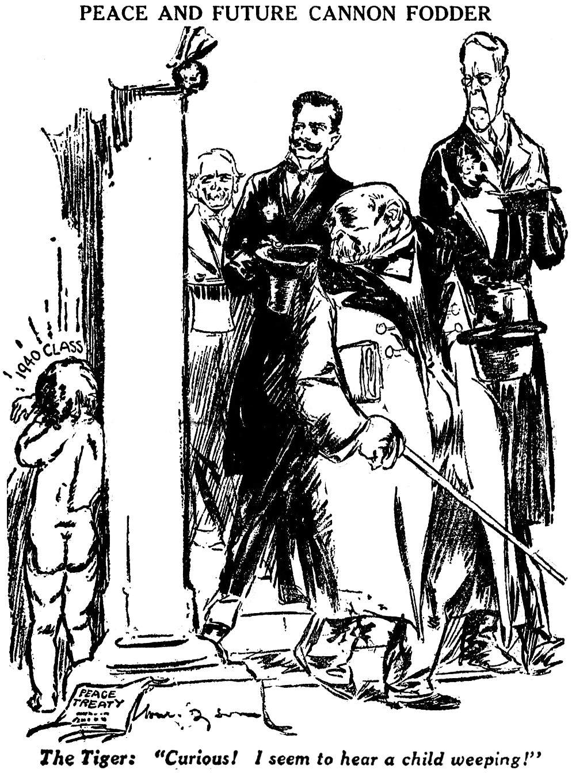
Brunner was a science fiction writer and anti-nuclear campaigner, with an extraordinary understanding of the real world. A journalist recalled:
Image: William Dyson, Daily Herald, 1919 (Public Domain)
“John Brunner was one of the most intelligent and cultured men I have known. He was extraordinarily widely read, and both his work and his conversation reflected this.”
In 1968, Brunner published "Stand on Zanzibar”, set in the year 2010. It features random mass shootings, a European Union, and an online encyclopaedia. It shows enormous economic inequality both within and between nations, and mega-corporations rely on algorithms to make incomes larger than some nations. Most people are unhappy but are kept passive with antidepressants and reality TV. These reality TV programs are essentially 3D computer games: the users see themselves doing pleasurable or exciting things.
The apparent mistakes of the book will probably be seen as correct in hindsight. For example, only one gigantic computer provides most of the world’s information: it seems like an error, but what else is Google?

The Book of Enoch: armageddon before 2239
The introduction to this book shows how the Jews predicted the age of information (logos) and rise of democracy. This is in the Talmud, and also in the Book of Enoch:
“God shows Enoch the age of this world, its existence of seven thousand years, and the eighth thousand is the end, neither years, nor months, nor weeks, nor days.
“And I appointed the eighth day also, that the eighth day should be the first-created after my work, and that the first seven revolve in the form of the seventh thousand, and that at the beginning of the eighth thousand there should be a time of not-counting, endless, with neither years nor months nor weeks nor days nor hours.”
The final thousand years will be a millennium of peace, after an initial war of Armageddon. So the Jews expected six thousand years from Adam, then Armageddon, then a thousand years of peace, and then a new world. The Jews still teach that today:
“R. Katina said, ‘Six thousand years the world will exist and one [thousand, the seventh], it shall be desolate (haruv), as it is written, ‘And the Lord alone shall be exalted in that day’ (Isa. 2:11).
This teaching was passed on to the early Christians and inspired the book of Revelation:
“And he gathered them together into a place called in the Hebrew tongue Armageddon.”
Armageddon will be the most destructive battle in all history. It is so devastating that afterwards people no longer want the power that demons have always offered as temptation: it isn’t worth the price. So that demonic idea is kept under control for a thousand years:
“And he laid hold on the dragon, that old serpent, which is the Devil, and Satan, and bound him a thousand years…”
Finally, the demonic desire for power is destroyed. This is the end of our civilisation’s history. Then we have a new heaven and new Earth:
”And I saw a new heaven and a new earth: for the first heaven and the first earth were passed away; and there was no more sea. And I John saw the holy city, new Jerusalem, coming down from God out of heaven, prepared as a bride adorned for her husband.”
The six thousand years begin with the fall of Adam. This date is calculated from internal evidence in the Bible and is usually dated to around 4000 BC. This implies Armageddon around 2000 AD. However, there are a couple of places in the calculation that are open to interpretation. So in the second century AD, the great Rabbi Yossi ben Halafta dated the creation and fall of Adam to 3761 BC. This became the start date of the official Jewish calendar. It implies that the six thousand years end in 2239 AD. However, Armageddon is expected sometime before that date.
“The Talmud tells us that this world, as we know it, will last for six thousand years, with the seventh millennium ushering in the cosmic Shabbat, the Messianic Era. … However, it is certainly possible for Moshiach [messiah] to come earlier. … This is also analogous to the weekly Shabbat, which we have the prerogative of ushering in early on Friday afternoon.”
Kirby’s timeline follows this model. Armageddon is 2121 AD, there is then a period of chaos, and law and order return in 2260. Finally, the good people leave Earth in 3045 AD: what Revelation calls “a new heaven and new Earth”. This new planet has “no sea”. The arriving spaceship would look like a city descending from heaven.
How do we know that the prediction is accurate? Because of what it seems to get wrong. The Talmud continues:
“Six thousand years is the duration of the world. Two thousand of the six thousand years are characterized by chaos; two thousand years are characterized by Torah, from the era of the Patriarchs until the end of the mishnaic period; and two thousand years are the period of the coming of the Messiah. That is the course that history was to take, but due to our sins that time frame increased. The Messiah did not come after four thousand years passed, and furthermore, the years that elapsed since then, which were to have been the messianic era, have elapsed.”
The Talmudic writers think they have missed the Messiah, who should have appeared around the year 1 AD. They are not followers of Jesus, so this is not some Christian apologetics. But the prophecies came true — mostly.
For more about Enoch, see Appendix 7.

Tracing the teaching to the 12,000 year cycle
Jewish teachings in their present form (such as the written Torah) were collected during the captivity in Babylon. This ended when Cyrus the allowed the exiles to return. He was messiah (anointed one) for the Jews, and a devout Zoroastrian. The name “Pharisee” may just mean “Parsah”, they inherited Persian (Zoroastrian) ideas, such as dualism (God versus Satan) and resurrection. Zoroaster knew that civilisation would last 12,000 years, and his religion arrived 9,000 years into the 12,000. That dates creation to around 9,600 BC, the time of the Younger Dryas, nf the firsts settlement at Jericho. So civilisation is expected to end around 2,400 AD. The Jews begin their calendar on 3761 BC, so they knew civilisation would end around their year 6000. Zoroastrianism is based on Hinduism, so the first and last thousand years of a cycle are a transition period, The Jews recorded their history in units of seven years (sabbath years), with six years of work and one of rest, so it was natural to follow their 6,000 years of history with the 1000 years of transition, making seven thousand years in total.
Genesis indicates that the 7,000 year history is just the last part of a longer 12,000 year creation. Appendix 2 (part 1) shows how Genesius 1 and 2 refer to different groups of “adams” (people): lords (Genesis 1) and common people (Genesis 2). The 4000 BC start date in Genesis 5 refers to the common people, but what about the lords, the sons of God? They are a separate group who were not supposed to mix with Adam’s descendants (see Genesis 6). They became known as the Nephilim (“fallen ones”). The Nephilim survived the flood (a reminder that Noah's flood was not global) and lived in the promised land before Israel arrived. They were descendants of the “Big Men” (see Appendix 7) and were physically tall. They descended from the Anakites (children of Anak):
"There we saw the Nephilim (the Anakites come from the Nephilim); and to ourselves we seemed like grasshoppers, and so we seemed to them."
Anak, appears to be Anax, the giant ruler of the Anactorians:
"These Anakim [people of Anak] seem to have come from Greece, as members of the Sea-peoples' confederation which caused the Egyptians so much trouble in the fourteenth century B.C."
Greek mythology traces back to 9,000 BC, when Jericho was settled (see Appendix 4). That date was known to the Egyptians (see Appendix 4) so Moses probably knew it. So Moses knew that the lordly class went back to 9,000 BC. But later generations could not refer to this without admitting that Yahweh and the other elohim were originally human.

Etruscan parallels
The Etruscans (ancestors of the Romans) also knew the 12,000 years cycle: 6,000 years before their Adam, then 6,000 years of history.
As we have seen, when ancient people talk of creation of humans, they mean the creation of their humans, such as the servant Adam in Genesis 2, who was created by the previous lord Adam from Genesis 1, or the Greek people of Iron created after the failure off the people of bronze. Like the Zoroastrians, the Etruscans remembered the 12,000 years by comparing them to the zodiac, so this is more evidence for a common source. The 6,000 + 6,000 model fits nicely into all the other examples: 6,000 years from Gobekli Tepe until the rise of cities, then 6,000 years until the end.

Mayan parallels
Meanwhile, in America, the Maya used the "long count" for recording years. This alternates between 5,125 years (13 "bak'tuns" of 144,000 days each) and 7,885 years (20 bak'tuns). So the total cycle is 13,010 years.
"[W]e have clear evidence that the current Bak’tun cycle does not conclude at 13, as the last one did, but advances to 20. ... A text at the site of Palenque, Mexico, makes this very plain when it records the completion of 1 Piktun, the next unit above the Bak’tun, in 4772 CE. We do not know why the Maya counted the previous Bak’tun cycle in Base Thirteen and the current one in Base Twenty, but, according to a new idea by David Stuart, all of the higher units of the Long Count calendar cycle first through 13 before resetting to zero and counting a second time all the way to 20."
The Mayan calendar is remarkably precise, so it could be that the 12,000-year calendars are only an approximation. We are currently in the second long count of the 13,010-year Mayan cycle, beginning in 3114 BC, and ending in 4772 AD. The first long count of the 13,010-year cycle would have started around 8,239 BC. That is, they began their counting at the end of the 1,000 year transition period. The equivalent for the old world would be counting from when we built the wall of Jericho, and not at the Younger Dryas. That is just a matter of taste.

Why 12,000 years?
The 5,125-year first long count is very close to one-fifth of a precession period. "Precession" refers to how the constellations appear to rotate every 25,676 years. It would take only a few decades to notice the precession in ancient times because stone monoliths were often directed toward sunrise on the spring equinox or winter solstice.
The equinox (“equi-nox”, “equal night”) is when night and day are the same lengths. In Spring, this means warm and prosperous months are ahead. The solstice (“sol-stice”, “sun stop”) is when the sun is out for the longest or shortest time: midsummer or midwinter. The photo shows an ancient stone structure (Newgrange, Ireland) designed so that a shaft of light illuminates the inside at dawn on the winter solstice. Notice the carvings on the left: no doubt many other markings will have been worn away with time. It would be natural to paint representations of the stars that are near the sun when it rises. But after 35 years, the star positions move by half a degree. After 70 years, this movement will be very noticeable against the very narrow opening. So anybody who made such a building would know that the stars move. Would they then take the next mental step, and realise that stars rotate at a regular pace? Yes, because stars rotate every night, so the concept is obvious. So it would be natural to draw a circle and work out that it takes 400 lifetimes or so to go round the whole circle.
Precession is therefore so obvious that every time we see a monument aligned to the spring sun, we can take it for granted that they probably know about precession. For example William Sullivan, in “Secrets of the Incas”, has shown that Inca mythology might record history this way. For example, consider the Inca story where a fox has a burnt tail. This might refer to the tail end of the age of the fox, around 650 AD, when the culture saw a great deal of warfare.
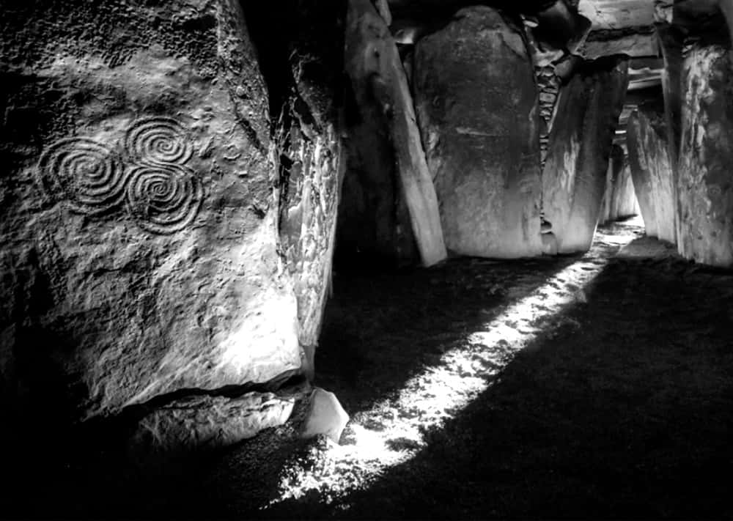
Sadly, we cannot ask the Inca if Sullivan is right, because the Spanish destroyed the Inca culture and burnt nearly all their records. For more about the destruction of ancient records, see Appendix 2.
Image: Newgrange, by Ken Williams, via Flickr, CC-BY-2.0

Daniel’s 37 AD prophecy
Daniel 9 was written in 465 BC, and correctly predicts events for the years 37 AD and 40 AD. Some people argue that parts of Daniel were written as late as 167 BC. If so, the prophecy is still accurate 200 years in advance.

Starting date: 465 BC
Readers who are unfamiliar with the Old Testament may need some context. The central event of the Old Testament (after the Exodus) is the destruction of the temple at Jerusalem by Babylon in 587 BC. Jewish leaders were then taken captive to Babylon. Later, Cyrus the Great united the Medes and Persians and conquered Babylon. He then allowed the Jews to return. They rebuilt the temple, but Jerusalem continued to be in ruins, and under the control of Persia. The book of Daniel dates itself to this era, and longs for the day when Jerusalem will be strong and free:
"In the first year of Darius son of Xerxes (a Mede by descent), who was made ruler over the Babylonian kingdom — in the first year of his reign, I, Daniel, understood from the Scriptures, according to the word of the Lord given to Jeremiah the prophet, that the desolation of Jerusalem would last seventy years. So I turned to the Lord God and pleaded with him in prayer... "
"Darius son of Xerxes" was the crown prince of the Persian empire: he became crown prince when his father Xerxes was murdered in 465 BC. He was himself murdered in the same year, so this gives us a firm start date: 465 BC. It does not matter if the prophecy was written a few years later: it must have been written before 100 BC when Daniel became part of the Septuagint.
The “seventy years” refers to seventy sabbath years: the Jews measured long periods in seven-year blocks, and often seven times seven (a jubilee), or seventy, as here, where Daniel seems to refer to Jeremiah 25:
"This whole country will become a desolate wasteland, and these nations will serve the king of Babylon seventy years. But when the seventy years are fulfilled, I will punish the king of Babylon and his nation, the land of the Babylonians, for their guilt,”
“These nations" (the nations around Israel) served the king of Babylon from 612 BC when Babylon defeated the Assyrian empire. Seventy years takes us to 542 BC, just before 540 when Cyrus defeated Babylon and then allowed the Jews to return to Jerusalem.
Cyrus let the Jews rebuild their temple, but the city was still under the control of the Persians. Other nations could see that Jerusalem was still not free, and they mocked the Jews for it:
"Our sins and the iniquities of our ancestors have made Jerusalem and your people an object of scorn to all those around us."
So Daniel, writing in 465 BC (the first year of Darius), wants to know when Jerusalem will be free like it was before 587 BC. He received this answer:

The seventy sevens prophecy
“Seventy ‘sevens' are decreed for your people and your holy city to finish transgression, to put an end to sin, to atone for wickedness, to bring in everlasting righteousness, to seal up vision and prophecy and to anoint the Most Holy Place."
Jeremiah had given seventy years for Babylon to be destroyed. Now Daniel is told it will take seventy times seven before "everlasting righteousness" comes in. In the Old Testament time, years were divided into sevens, each seven ending in a sabbath year. Seven sevens (49 years) was followed by a jubilee year), a year of celebration when a cycle of time resets: debts are forgiven, indebted servants go free, etc. So it was natural for Daniel to think in terms of a jubilee period for Israel to be free. This was not just a figure of speech, because Daniel then divides it into precise sections: 7 + 62 sevens (and later another seven to make the full 70).
"Know and understand this: From the time the word [or decree] goes out to restore and rebuild Jerusalem until the Anointed One, the ruler, comes, there will be seven sevens, and sixty-two sevens. It will be rebuilt with streets and a trench, but in times of trouble."

The decree to rebuild Jerusalem
"The word goes out to restore and rebuild Jerusalem" is sometimes assumed to mean the decree of Cyrus in 539 BC, but that decree was to rebuild the temple, not the city itself. All the references are clear about that. Daniel's decree concerns the city, not the temple. He refers to "streets and a trench" or some translations say, "streets and a wall”, because every ancient city was surrounded by a defensive wall or moat.
The book of Nehemiah records how the city is rebuilt. Nehemiah was cupbearer to Artaxerxes, who replaced his brother Darius as king of the Medes and Persians, in 465 BC, the year of Daniel’s vision. The book of Nehemiah begins with Nehemiah's sadness because, although the temple is rebuilt, the city is still in ruins:
"The wall of Jerusalem is broken down, and its gates have been burned with fire. When I heard these things, I sat down and wept."
Artaxerxes saw Nehemiah's sadness:
"In the twentieth year of King Artaxerxes, when wine was brought for him, I took the wine and gave it to the king. I had not been sad in his presence before, so the king asked me, 'Why does your face look so sad when you are not ill? This can be nothing but sadness of heart.' I was very much afraid, but I said to the king, 'May the king live forever! Why should my face not look sad when the city where my ancestors are buried lies in ruins, and its gates have been destroyed by fire?' The king said to me, 'What is it you want?’"
Artaxerxes then gave Nehemiah various letters: these were “the word” that gave Nehemiah the authority to rebuild the city walls and gates. The "twentieth year of Artaxerxes" implies 446 BC. Daniel said that from the word to rebuild the city there would be sixty-nine sevens (483 years) until the messiah comes. And then:
"After the sixty-two sevens, [which come after the initial seven: so 7 + 62 sevens] the Anointed One will be put to death and will have nothing. The people of the ruler who will come will destroy the city and the sanctuary. The end will come like a flood: War will continue until the end, and desolations have been decreed. He will confirm a covenant with many for one ‘seven.’ In the middle of the ‘seven’ he will put an end to sacrifice and offering. And at the temple he will set up an abomination that causes desolation, until the end that is decreed is poured out on him."

490 years was a realistic plan
Seventy sevens were ten jubilees (490 years). This was roughly the time it took for Jerusalem to be built (from Moses to David), and also the time it took to fall (from David to Babylon). So it was reasonable to expect the complete recovery to take another ten jubilees.
So here is a clear dated prophecy. 446 BC + 483 years takes us to 37 AD.
Jerusalem by then will be fully rebuilt, ready for the anointed one (“messiah”). Rationally, Daniel would expect some pushback from whatever Gentiles controlled the city. So the anointed one “will be put to death.” Rationally, Daniel would expect the Jews to keep fighting. So Daniel predicted that in the final sevens (i.e., 37 AD - 44 AD) Jerusalem will be destroyed. Rationally, Daniel would expect the enemy to defile the temple as a show of strength. So in the middle of that seven (40 AD), an evil ruler will end temple sacrifice and instead erect "an abomination that causes desolation" until a decreed end. The entire prediction is rational and not supernatural

A messiah in 37 AD
As the centuries passed, Judea finally gained independence under the Maccabees. But then Rome conquered the entire region and appointed Herod the Great as ruler. To appease the people, Herod built the temple to a magnificent size, more than doubling its previous area. Then in 37 AD, Herod’s son Herod Antipas killed the popular prophet John the Baptist. Soon after, Herod was defeated in battle. One of John’s supporters, Jesus of Nazareth, remembered Daniel’s prophecy of 37 AD and decided that the time had come to restore the kingdom of Judea.
In 40 AD, the mad emperor Caligula wanted to erect an abomination in the temple. This is just what Daniel expected. But Daniel could not possibly predict the next part: Caligula gave the job to a man who kept delaying and never carried out the order. Caligula ordered Petronius, governor of Syria, to erect the statue. But Petronius was no fool: he knew this would lead to war, just as Daniel predicted. So he kept finding excuses to delay the act. Then, in January 41 AD, Caligula was killed. So the abomination was never erected, the war did not happen, and Jesus did not free Jerusalem as he planned.

Nobody wants a failed messiah
Jesus’ followers could not accept that the prophecy failed. Then in 70 AD, they had a lucky break: the temple was destroyed by the Romans. This led Jesus’ followers to reinterpret the old prophecies to fit, and the rest is history. But none of that changes the fact that Daniel predicted a messiah to arise in 37 AD, and that happened. He also predicted an abomination in the temple in 40 AD, and that very nearly happened.

Isaac Newton and 2060
Sir Isaac Newton was one of the greatest thinkers of all time: arguably the greatest thinker. We have ten million words that he wrote. Three million are about science and mathematics, and five million are about the Bible, especially prophetic dates. Newton examined all the main dated prophecies and concluded:
“Therefore the 2300 years do not end before the year 2132 nor after 2370. The time times & half time do not end before 2060 nor after 2344. The 1290 days [years] do not end before 2090 nor after 2374.”
Newton explored many different possibilities, and the number that comes up most often is 2060. This all fits with Kirby’s conclusions: the smartest humans begin to be replaced by machines in 2065 (or shortly before), this leads to Armageddon, the land is left desolate, good and evil continue to fight, and good triumphs in the year 2260. A few enemies hold out until 2514, but they are merely the last gasp of resistance, “The Last Enemy”.

Handsome Lake and 2100 AD
Handsome Lake was a leader and prophet of the Seneca people. Like all great prophets, he spoke through symbolic stories. For example, one story begins:
“There is a dispute in the heaven-world between two parties. It is a controversy about you, the children of earth. Two great beings are disputing--one is the Great Ruler, the Creator, and the other is the evil-minded spirit.”
Handsome Lake was taught by four messengers from heaven. Among other things, they told him this:
“We, the messengers of the Creator, are of the opinion that the world will continue for three generations longer (or three hundred years).”
The author’s footnote explains the meaning:
“Handsome Lake taught that the world would end in the year 2100.”
His preaching spanned 1799-1815, so the three hundred years are approximate. The end sounds like some kind of nuclear war:
“Now we think that when the end comes the earth will be destroyed by fire and not one upon it will escape for all the earth will be enveloped in flames and all those who refuse to believe in Gai'wiio` [the law of the creator] will be in it."

The Fourth World and the Great Disaster
Throughout the Americas, indigenous people have traditions of a future third world war. It will be worse than the second world war. The settlers will use their great weapons of death. The elders call these weapons “gourds of ashes”.
“Traditionally, Native people from clear up in the Inuit region have shared with us this prophecy, clear down to the Quechuas in South America. … [T]he Earth is going to be shaken a third time. The Great Spirit has shaken the Earth two times: the First and Second World Wars to remind us that we are a human family, to remind us that we should have greeted each other as brothers and sisters. We had a chance after each shaking to come together in a circle that would have brought peace on earth, but we missed that. Now they are talking about the sign for the Third Shaking of the Earth. They said they're going to build what the elders called the house in the sky. In the 1950's they talked about this: they will build a house and throw it in the sky. … When this house is in the sky, the Great Spirit is going to shake the Earth a third time, and whoever dropped that gourd of ashes, upon them it is going to drop.”
When the nuclear bombs fell on Hiroshima and Nagasaki, the elders said these were the gourds of ashes. So the prophecy concerns nuclear war, just as Handsome Lake said the world would end, around the year 2100. The sign to look for is a house that is thrown in the sky. Chapters 11-13 showed how space stations and settlements on Mars remove the barrier to nuclear war. So Handsome Lake was right: the house in the sky means nuclear war will come.
In 1948, the Hopi elders met to discuss the fulfilment of prophecies. They selected four young Hopi men to take a warning to the world. One of those young men was Thomas Banyacya. He speaks of how civilisation was destroyed three times in the past, through fire and other cataclysms, because the people did not care for each other or the planet. The third great destruction was by a Great Flood. Banyacya repeatedly refers to our modern world as the “Fourth World”. This is the term Kirby used for his story of the New Gods of science. Banyacya says that the Fourth World began ten thousand years ago or more:
“The Hopi and others who were saved from the Great Flood made a sacred covenant with the Great Spirit never to turn away from him. He made a set of sacred stone tablets, called Tiponi, into which he breathed his teachings, prophecies, and warnings. ... The Fourth World shall end soon, and the Fifth World will begin. This the elders everywhere know. The Signs over many years have been fulfilled, and so few are left. ... [Scientists] found these tablets were at least 10,000 years old, maybe 50,000.”
After the nuclear war, our modern world will be discredited. So we will once again listen to the Hopi and Seneca, Wendat, and other indigenous peoples.
“And when we survive it [the nuclear war], there's going to be another attempt to make a circle of the human beings on the earth. And this time the Native people will not have to petition to join but will be invited to enter the circle because they say the attitude toward us will have changed by then.”
Kirby describes this time, after “The Great Disaster”, in Kamandi. In that era, we discover the wisdom of animals. Wise humans often give animal names to their tribes and lands: just like Handsome Lake, who was born into the Turtle clan, adopted into the Wolf clan, and lived after the Beaver wars (where they fought over the lands of the beavers). In the post-disaster era, humans will rediscover harmony with nature. They will recover from the twelve-thousand-year mind virus that urged them to destroy all life.

Appendix 2:
How scholars destroy history
Kirby said, “I feel there are no experts anywhere in anything.”
Experts are human. Like all humans, they make mistakes. But being an expert depends on not making career-ending mistakes. So when they do, they must hide it, or they cease to be an expert.
This appendix has seven examples of scholars making big mistakes. Each mistake destroys thousands of years of history. In each case they present the mistake as good scholarship.
- Destroying 2,000 years of Hebrew records.
- Destroying 10,000 years of American records.
- Destroying 10,000 years of Phoenician records.
- Destroying 110,000 years of Yazidi records.
- Destroying 9,000 years of Atlantian records.
- Destroying 1,000 years of future history.
- Destroying 2,000 years of western civilisation.
Thanks to these mistakes, scholars destroy more history than they preserve.

1. Destroying 2,000 years of Hebrew records
In the 1780s, the Biblical scholar Johann Eichhorn noticed differences between the creation of Adam in Genesis 1 and the creation of Adam in Genesis 2. In Genesis 1, Elohim creates an Adam to be in his image and have dominion over the world. And then in Genesis 2, Yahweh creates an Adam from the dust to be his servant. Eichhorn concluded that there must be two different creation stories.
Eichhorn decided that there must be originally two different sources for the creation story: one he called “E” (for Elohim) and another he called “J” (for Jehovah, another spelling of Yahweh). Encouraged by this idea, Eichhorn then went on to divide other parts of the Bible into “J" and "E" as well. This became known as the “Documentary Hypothesis”, the hypothesis that the Bible squashes together separate documents with very poor editing so that the same events are repeated.
The imaginary documents are not needed. “Elohim” is a plural word meaning “all the gods”, and Yahweh is a particular god. We know that Yahweh is a fallible human, because he walks in the garden, talks to Adam, does not know where Adam is, is outsmarted by Eve, and so on. An “Adam” means any human, male or female (see Genesis 1:26, 5:2, 6:1, etc.). So the text says that a human is chosen to be in the image of the gods. This human god then chooses another human to be his slave. The human god’s descendants later marry the descendants of the slaves (Genesis 6:2).
The imaginary documents, although unnecessary, guaranteed endless paid work for Eichhorn and his friends. For two hundred years, scholars made careers out of splitting the Bible into J and E, and later P and D and any other letters they could think of. Today it is hard to find any area of mainstream Bible scholarship that does not rely on these imaginary documents in some way.
Then something very embarrassing happened. The actual real documents were found. These are the original creation stories that are summarised in Genesis: the Babylonian Enuma Elis, the Akkadian Atrahasis, the Gilgamesh flood story, and so on. In every case the creation of man follows the same order as in Genesis: first a man is created in the image of God, to have dominion, and then a man is created from the common ground, to be the first man’s slave.
The first group of humans (Adams) are lords of the land. They have representatives, overseers, to manage their workers, while the lords live in their palaces and gardens. The Akkadians call the overseers “Igigi”, meaning “the watchers.” The Igigi are clearly human. Genesis calls the Igigi “sons of the gods” and Daniel and Enoch call them “watchers”. In the creation stories the lower gods (elite humans) do not like digging their ditches, so they create servant humans to work for them. This is real history: this is how slavery always begins.
All the real documents tell the same story as Genesis. The real documents prove that the imaginary J and E documents are wrong. Faced with real documents, what do mainstream Bible scholars do? They stick with their imaginary documents. For two hundred years, scholars they have dug themselves deeper and deeper into this hole. To admit it now would be to not just humiliating but career-ending: how can we trust scholars who make up imaginary documents and then use against the real documents?
Scholars use their imaginary documents to undermine in Genesis. They say that their imaginary documents prove that Genesis 1 and 2 contradict each other and are badly edited. So that take real history (how slavery always begins) and dismiss it as nonsense.
Rejecting Genesis is literally catastrophic. We are heading toward a catastrophe when the rich will kill the poor (see chapter 13). Genesis warns us that the first modern civilisation (Sumer) ended in the same way. We must never forget. Those who forget the lessons of history are doomed to repeat them.

2. Destroying 10,000 years of American records
In 1972, Jane Beck was learning the stories of the northeastern Algonquin tribes (neighbours of the Wendat/Huron, between the Great Lakes). One story is about a giant beaver that lived along the St John River. He built such enormous dams that the people could not get the fish they wanted. So the god Gluksap destroyed the dam with his axe. Gluksap wanted to make the beaver small and easy to control, but the giant beaver refused to cooperate. So Gluksap chased the giant beaver along the coast, creating various small islands along the way. The beaver finally swam up the St Lawrence River and disappeared. After that time there were very few beavers (of any size) around the St John River. Such was the story, but where did it come from?
Beck did some research and found that the sites and descriptions fit the real-life giant beaver, Castoroides ohioensis. She looked for other explanations: perhaps the people just liked giant animal stories? Perhaps they saw a giant fossil? None of the alternate explanations made sense. It seems most likely that this is a memory of when giant beavers still lived along those rivers. But the giant beaver died out at least ten thousand years ago. This is one of many ten-thousand-year-old oral histories.
The Algonquin people remember the giant beaver story because they still hunted beaver, and they still knew those rivers. So the story was unforgettable. If it was just written on paper and given to some European, it would be forgotten long ago. But when a story is told orally, in an exciting way, while seeing the thing you describe (or a later version of it), it is unforgettable.
This shows how the Algonquin had a ten thousand-year history. But most of this oral history was destroyed by settlers. Settlers brought diseases that killed most of the Algonquin and continued to bring diseases for centuries, long after settlers knew exactly what they were doing. They then forcibly removed the survivors from their hunting land. Then the American government Bureau of Indian Affairs forced Indian children to abandon their culture and language. So oral history is destroyed.
“Most of the oral tradition through which native histories were handed down generation to generation did not survive. Neither did most groups.”
"When one generation of elders dies without passing the oral history to their children, that portion of their community's history is lost forever.”
The destruction of ten thousand-year history continues today. Take, for example, the historical site of Monument Hill, near Tucson, Arizona. Monument Hill has burials dating back ten thousand years. In February 2020, construction workers began to blow up the Monument Hill burial ground to make space for President Trump’s border wall. Twenty-one other historical sites are likely to be destroyed by the wall.
This destruction of ten thousand years of history began with scholars:
“American Indian history is a field dominated by white, male historians who rarely ask or care what the Indians they study have to say about their work. … [I]f a scholar in the field of American Indian history ignores the vast number of oral sources, the scholar's integrity is safe—through the use of such excuses as: ‘Indians have no records of this time period.’"
By saying that oral history does not count as “records”, scholars destroy history. When the government physically destroys a site, it just finishes the job that scholars began.
The few surviving records show that native American civilisations were often more advanced than our own. For example, the Wendat civilisation is based on respect for every individual. They had peaceful relations with most of the surrounding peoples, so any Wendat man or woman could travel for many hundreds of miles, and rely on hospitality from anyone they met. That is, the Wendat civilisation covered an area comparable to the size of western Europe. And the rules of hospitality meant that the Wendat people had no poverty. The Wendat had no concept of rule by force. If people disagreed with leaders, they said so, and the group would debate the issue and come to some agreement that was acceptable to the vast majority. Because of this, the Wendat had superb debating skills. No civilisation is perfect, but the Wendat probably came closer than most.
Europeans were embarrassed when they realised that they were destroying a more advanced civilisation. In 1632, Gabriel Sagard’s “The Grand Voyage to the Land of the Hurons” showed Europeans that Wendat (Huron) civilisation was more advanced than their own. Voltaire and John Locke read the book and began to wonder if, maybe, a society based on freedom for the common man was possible. That led to the Enlightenment: the realisation that civilisation does not have to be based on slavery.
In 1703, “New Voyages to North America” made the Wendat superiority even clearer. New Voyages Volume II contains interviews with a Wendat man called “Adario”, a French word meaning “great and noble friend”. Adario was based on the real-life Wendat leader Kondiaronk. Adario draws comparisons between the Wendat and European ways, showing how the Wendat way is socially and intellectually superior. This undermined Europe’s intellectual foundations. Paris felt this intellectual crisis the most, because the French armies were busy defeating the Wendat, and called Wendat lands “New France”. The intellectual heart of Paris was the centre of Paris was The Academy of Dijon (later called the Academy of Sciences). So in 1750, the Academy ran a competition that offered a prize to anyone who could solve the great question of the age: was Europe good? Or, as they phrased it,
“Has the restoration of the sciences and the arts contributed to refining moral practices?”
Jean Jaques Rousseau solved Europe’s problem, and won the Academy’s prize, by saying that the best arts and sciences are those of war. First, he admitted that our sciences and arts corrupt the soul:
“our souls have become corrupted to the extent that our sciences and our arts have advanced towards perfection.”
But then, in a brilliant twist, he said that the answer is to reject arts and sciences because war is better! War is the one thing that western civilisation does better than anybody else. Rousseau condemned those nations who neglect war and study art instead:
“The Romans maintained that military virtue was extinguished among them to the extent that they began to know all about paintings, engravings, and vases”
After winning the prize, Rousseau realised that his argument was embarrassing, so he devised a new argument. He began the new argument by again admitting that hunter-gatherers have the most moral system. But then he argues that this system can only work when small families live alone. As soon as people live together, Rousseau argues, they must develop a violence-based class system:
“as long as they undertook such works only as a single person could finish, and stuck to such arts as did not require the joint endeavours of several hands, they lived free, healthy, honest and happy, as much as their nature would admit, and continued to enjoy with each other all the pleasures of an independent intercourse; but from the moment one man began to stand in need of another's assistance; from the moment it appeared an advantage for one man to possess the quantity of provisions requisite for two, all equality vanished”
Rousseau said history must work that way: it cannot work any other way:
“Such was, or must have been, had man been left to himself, the origin of society and of the laws, which increased the fetters of the weak … there could not have existed in this hypothesis either a true society, or a political body, or any other law but that of the strongest.”
But that is nonsense. The Wendat people prove that this theory is wrong. The Wendat leader Kondiaronk had explained in great detail how their system worked across a large part of North America. But Rousseau served his purpose: his scholarship justified the European powers in destroying a more advanced civilisation along with its ten thousand years of oral records.

3. Destroying 10,000 years of Phoenician records
History is often recorded on carved pillars, like the pillars at Gobekli Tepe, or Karnak in Egypt. Sometimes the pillars do not need writing: merely their existence is enough of a reminder, like the Washington Monument.
Carved pillars go back at least ten thousand years. The pillars at Gobekli Tepe were in use from around 9500 to 8000 BC. The Gobekli Tepe culture (Pre-Pottery Neolithic) also settled Jericho (c.9500 BC), which remained the cultural capital of the region until 3000 BC, when the Egyptians began carving pillars on an enormous scale. So whatever Gobekli Tepe signified, the same culture continued to pass on its stories in an unbroken line until the invention of modern writing.
The greatest historian of ancient pillars was Sanchuniathon the Phoenician. He lived around 2000 BC, so had access to many ancient pillars that have since been lost. Sanchuniathon explained how the pillars record the lives of famous thinkers, people who invented housing and boats and other advances, and they were later remembered as gods:
“Esteeming these [people] as benefactors and authors of many blessings, they worshipped them also as gods after their death, and built shrines, and consecrated pillars and staffs after their names: these the Phoenicians held in great reverence, and assigned to them their greatest festivals.”
Ancient scholars held Sanchuniathon in the highest respect.. For many years, modern scholars thought that Sanchuniathon was not real. For example, Sanchuniathon said that his town, Berytus (Beirut) was older than Byblos, which dates to 8000 BC. For many years that seemed absurd, but we now know he was probably right. Appendix 5 (Genesis) shows how Sanchuniathon’s account agrees with scientific discoveries right back to the beginning.
The Phoenicians created a problem for ancient Power People, just as the Wendat created a problem for modern Power People. Both groups were decentralised, and this was a threat to the concept of the centralised nation-state. And so ancient scholars did what modern scholars do: they discredited their enemies as backward savages and used that as an excuse to destroy their historical records.
Scholars in ancient times were usually priests in charge of temple records. A notable example was Hilkiah, the high priest of Yahweh at Jerusalem in the time of King Josiah, 640-609 BC. Hilkiah’s position was in danger because the country was under threat from Babylon. So Hilkiah decided to centralise all power in his state. Officially Hilkiah was following orders of (and paid by) the king, Josiah. But Josiah was only eight years old, so that was just an excuse: Hilkiah had the real power. Acting through Josiah, he then destroyed every shrine outside Jerusalem, along with their “Asherah poles”:
“[He] began to purge Judah and Jerusalem of high places, Asherah poles and idols. ... he tore down the altars and the Asherah poles and crushed the idols to powder and cut to pieces all the incense altars throughout Israel.”
The “Asherah poles” were “sun pillars” or in Hebrew, “chammanim”. They contained religious carvings. That is, they were the ancient history of the people. Hilkiah destroyed them so that only his version of history survived.

4. Destroying 110,000 years of Yazidi records
This example shows how scholars destroy 110,000 years of history by removing its meaning, adding new meanings, creating pressure for oral historians to sanitise the history, and then labelling it as false.
How long can oral history survive? Consider the Aboriginal Gunditjmara story of Budj Bim: about mountains that were once volcanoes. These mountains have not erupted for 37,000 years. The Gunditjmara could only know they were volcanoes if their oral history went back 37,000 years. They still live near the volcano, in much the same way as they always did, so an exploding mountain is something they never forget. A history like that can last indefinitely: the local people remember the gigantic eruption of Mount Toba in 73,000 BC. leaving a huge hole that served as a memory aid forever after. Does anyone else remember that far back?
Appendix 3 shows how the Yazidi people record history as far back as 110,000 BC. In 1838, a westerner wrote down this oral history. It preserves major events that archaeologists did not know about until the 1980s. But after that, the Yazidis were pressured to put more of their history into writing. This diluted and changed history, so it is now becoming lost.
The Yazidis had an excellent method that preserved accurate history: Only one family of Yazidis was allowed to read and write: this was their specialism. They were required to be experts on all aspects of Yazidi culture, so they understood every nuance of what they wrote. They did not dilute the records with ideas from outside: they were forbidden to share them with outsiders.
Modern scholarship has the opposite method. Scholarship allows historians to write about things they have not directly experienced, and then dilute history with outside ideas. So scholarship guarantees error.
In the 1970s, two Yazidis went to an outside university and were gently pressured to embrace scholarship. They then pressured their tribal elders to allow them to write their texts for outsiders. Eventually, the tribal elders gave in: ordinary Yazidis began to write their stories down. And history began to decay:
"[O]ral tradition is fast becoming usurped by books ... With this development profound changes have appeared, which seem to alter the centuries-old nature and content of Yezidi religion."
Writing destroys oral history in four ways.
First, writing removes meaning. Oral history allows multiple versions of the same story, and each version captures more information. For example, Yazidi history is built around seven “meleks”. A melek is a king, but also an angel, also a god, also a day of the week, also a planet, also a reincarnated twelfth-century sheikh. As we learn more about Yazidi culture we see what those words mean in context, and how they fit together. But a written text tends to choose just one word and loses the other meanings.
Writing does not just remove meaning, it forces us to use the lesser meaning: the simpler the meme, the faster it spreads. Journalism becomes clickbait. Scholarship becomes a popularity contest. Depth and subtlety die. Yazidis soon learn that a written text is much easier than a lifetime of memorising and debate.
The second way that writing destroys oral history is through feedback. When an outsider writes about the Yazidis, this is read as neutral or friendly, so it often becomes part of the oral tradition. In contrast, if some outsider comments orally, it reaches fewer people, and is more clearly from an outsider, so is less likely to be absorbed.
The third way that writing destroys oral history is by sanitising it. Some parts of the Yazidi tradition can easily look unscientific, sexist, or xenophobic to outsiders. So these parts are altered or omitted. For example, the Yazidis descend directly from Adam, but other nations are a mix of both Adam and Eve. This is now seen as insulting, so the head of the Yazidi singers (the people with the job of preserving history) now says that, no, the Yazidis come from both Adam and Eve like everyone else.
The fourth and final way that writing destroys oral history is by blurring the line between the genuine and fake. As long as Yazidi history is only told by Yazidis, in person, nobody can claim that it is fake. But as soon as an outsider wrote his understanding of their teachings, critics called it a forgery because it was not the exact words a Yazidi would say. Worse, a written text invited comparisons with other texts. Scholars then use parallels as proof that Yazidiism is syncretic or derivative from other religions as if correlation implies causality. In this way, the most ancient genuine history is labelled as a fake or a late copy.

5. Destroying 9,000 years of Atlantian records
Appendix 4 shows the evidence that Atlantis was real. But this is a problem for modern society: it makes us take ancient records seriously. And that draws attention to the golden age. And that makes our work-based civilisation look bad.
Scholars have spent centuries attacking Atlantis. The consensus among scholars is that”
“Aristotle believed that Plato, his teacher, had invented the island to teach philosophy.”
This is nonsense. Thorwald C. Franke traced the claim to its source. It comes from a mistake by the scholar Jean Baptiste Joseph Delambre. Delambre quoted Strabo, who quoted Aristotle, saying that the Achaean wall in Homer’s Iliad might be fictional. Delambre thought that Aristotle was writing about a wall in Atlantis. Delambre was wrong. Franke explores this error in great detail.
Scholars also claim that nobody told the story of Atlantis before Plato, ignoring all the earlier accounts. As Plato said, the story is on the walls of the Egyptian temples. Anybody can check and see it for themselves. or they can examine the archaeological evidence of the Atlantis war, or visit the ruins of Atlantis in Tunisia. It’s all in Appendix 4. By denying this evidence, scholars erase the defining event of the past twelve thousand years, the war where settled farmers defeated hunter-gatherers to become kings of the world

6. Destroying 1,000 years of future history
The best storytellers know a lot of history. This provides a constant stream of the best ideas. It also lets them predict the future with reasonable accuracy. Since history is generally agreed, so is the future:
- First, we will have more technology (at least for a while)
- Inequality will be a huge problem
- Then there will be a nuclear war (or global plague)
- Then a post-apocalyptic period
- Then more equality for a while.
History has always been this way. Technology creates inequality, and the only thing that ends inequality is a global disaster that massively disrupts the system. Hence movies like Planet of the Apes, Terminator (inspired by Harlan Ellison’s story “Soldier”), Omega Man, Dawn of the Dead, etc.
So the future is clear, but only if we listen to the best-informed storytellers. It is hard to create an objective list of historically informed storytellers because any hack can read a single history book and copy an idea. So a list of the best storytellers will always be subjective. This means that scholars cannot use such a list. Scholars try to be measurably objective, and so they can only judge writers by popularity or some other agreed metric: scholars must lump good and bad storytellers together. So the reliable future, the future we need to know, is hidden thanks to scholarship.
Here is an example of scholarship mixing up the good storytellers (who reliably tell us the future) with bad ones (who don’t): the story of Ib Melchior and Gene Roddenberry.
The iconic example of optimism is Star Trek:
“No specific story is more iconic for optimism than Star Trek, with its post-scarcity economies and its powerful message of equality.”
Many of the writers for Star Trek were well informed and therefore not optimistic about the future: they wrote about the coming nuclear war and post-apocalyptic period. But Star Trek producer, Gene Roddenberry, famously wanted the future to be optimistic. Roddenberry is widely credited with creating Star Trek, and so scholars listen to him as an objectively important writer. Thanks to Roddenberry, we do not have an agreed vision of an apocalyptic future. But should we listen to Roddenberry’s opinion? Do his ideas deserve respect? If not, then we can ignore his dissenting view, and the future is clear again.
Professional scholars, even critics of Roddenberry's writing, accept his claim that he created Star Trek. They are apparently unaware of the evidence that Ib Melchior created the concept. In 1960, Ib Melchior wrote “Space Family Robinson”, which later inspired the hit TV series “Lost in Space”. In 1964 he made the movie “The Time Travellers”, which inspired the hit TV series “The Time Tunnel”. In 1964 he registered an idea for a show that combined both concepts: “Columbus Of the Stars”. He soon renamed it to “Starship Explorers”. Roddenberry shortened “Starship Explorers” to “Star Trek”.
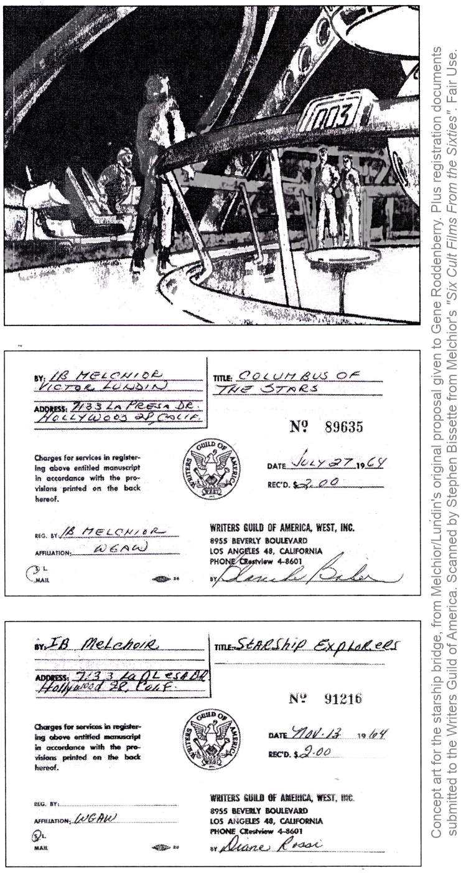
“This premise featured a stalwart captain, an alien 1st officer, a female chief officer and a cranky chief engineer who roamed deep space in huge space vehicles in search of new worlds.”
The original Star Trek pilot is a mash-up of Melchior’s then-most recent movies: The Time Travellers, “Robinson Crusoe on Mars”, and “Journey to the Seventh Planet”. Time Travellers is set in a room with a large screen, like the view screen on the Enterprise. When the people see a world that is ravaged they beam down to it and become trapped. Crusoe is about landing on the planet Mars and becoming stranded, then fighting aliens (who have underground tunnels) who want to enslave them. Journey is about space explorers having strange experiences that turn out to be illusions created by a mind-reading alien from his cave. Mix them up and you have the original Star Trek pilot, “The Cage”.
Melchior had plenty of contacts in the movies, but at that time (1964) Melchior’s other series (Lost in Space, The Time Tunnel) had yet to be been picked up by TV. So the only person he knew in the TV industry was his friend Gene Roddenberry. Melchior writes that he showed his idea to Roddenberry, who kept it for several months, then said the idea was no good. Melchior registered the idea anyway, but by then Roddenberry had apparently registered Star Trek for himself.
Roddenberry had no track record of creating science fiction but was allegedly willing to steal other people’s work. We know this because, in 1968, Roddenberry set up a company, Lincoln Enterprises, that allegedly stole Paramount Studios property:
“[A] film editor, seeking a stock shot, asking a studio guard to unlock the Star Trek film vault and finding it bare. The guard explains that ‘Mr. Roddenberry and his friend, that girl from Star Trek, Mabel something,’ had emptied the vault into a truck. Lincoln was selling film frames soon afterwards. It was a sensitive matter for the Paramount executives, as the film was owned by the studio and not Gene Roddenberry. The upshot was that everyone pretended not to know what had happened. So it continued to happen.”
Roddenberry’s attorney was infamous. It is claimed that he falsely back-dated documents to make it look Roddenberry had his ideas first. The evidence is that Roddenberry set up Lincoln Enterprises in 1968, but somehow Roddenberry’s attorney managed to have its registration backdated to 1962, to protect Roddenberry against legal action:
“By transferring title to his attorney (who, when legally registering the company, had somehow managed to antedate the company's establishing date to 6 April 1962 …) Roddenberry had thrown up a smokescreen if the studio ever decided to pursue the matter legally, which however they never did.”
This matters, because Roddenberry’s claim to have invented Star Trek relies on a single date written on a single document. To people who care about storytelling, that document is not enough to prove Roddenberry had the idea for Start Trek. Roddenberry had no track record of producing ideas like this, and he was unable to repeat the feat. A single unreliable document is not enough to change that.
Roddenberry took control of Star Trek, and changed it to make it more optimistic. But the original Star Trek was going to reflect Melchior's other stories. Melchior knew his history, and he foresaw a dystopian future (in Death Race) followed by nuclear war and an extended post-apocalyptic era (in The Time Travellers).
In summary, all great storytellers know that the future is likely to follow the patterns of the past. If we listen to great storytellers, the future is clear. But if we listen to the scholars, we place less weight on the knowledge of each storyteller. Then the future becomes a mystery.

7. Destroying 2,000 years of western civilisation
This final example argues that scholars misrepresent Jesus, and therefore seriously misrepresent western civilisation. (So do many other people — perhaps we cannot help it — but this appendix is just about scholars.)
Civilisation refers to civis (good manners), not polis (cities). The civilised person cares for others. Therefore, the history of civilisation is the history of caring for others. So the story of western civilisation is the story of people like Pelagius, Wycliffe, John Ball, and Gerrard Winstanley, and their attempt to civilise the West: that is, their fight for the rights of ordinary people against the powerful. They were all inspired by Jesus, who cared for the common man.
Secular scholars destroy the history of western civilisation by destroying the history of Jesus. Scholars argue that we do not have reliable records of what Jesus said and did, and therefore western civilisation (Pelagius etc.) has no clear shape, origin, or direction.
In this section I argue that the scholars are wrong: we do have a reliable historical account of Jesus’ life, and it supports the position of Pelagius and the rest while opposing the view of those who support hierarchies of power: Christian churches and states, the people paying the scholars. Jesus was anti-power. This is clear from the evidence, but New Testament scholars destroy that evidence.
The big picture: Bart Ehrman v Rodney Stark
The problem is best illustrated by comparing the New Testament scholar Bart Ehrman with the sociologist Rodney Stark. New Testament scholars are specialists, so they do not see the bigger picture. Ehrman is a specialist in New Testament texts, but he knows little about economics or the history of different religions. So he thinks that a new religious movement can survive for years with no written text. But sociologist Rodney Stark sees the bigger picture. Stark has shown that all new religious movements target literate people. They have to, or else the movements don’t survive. Christianity was no exception: Jesus disproportionately targeted literate middle class and wealthy people from the start.
Ehrman’s false belief, that a successful religion can start without a written text. leads to a torrent of false ideas. Here are some examples of those false ideas. They are central to dating Mark, our earliest gospel.
Example 1: was Jesus a fallible human?
For Ehrman, the key to understanding Mark is the “Messianic Secret”: the idea that Jesus was the Messiah, but he kept it secret until Mark 8:22-26, the middle of the book. So Mark 8:22-26 (where Jesus needs two attempts to heal a blind man) is the key text for Ehrman’s understanding of Mark. This is what Ehrman says about it:
“[I]t is the only miracle in the Gospel that Jesus does not perform immediately and effortlessly. ... A perceptive reader will recognize the symbolism of the account in light of its immediate context: in the very next story, the disciples themselves — those who until now have been blind to Jesus’ identity (cf. 8:21!) — gradually begin to see who he is, in stages. ... This is a climactic moment in the narrative… now, half way through the account, someone finally realizes who he is — at least in part.”
To the scholars, this is very important, because they claim that Jesus (in Mark) was supernatural. They argue that Mark 8:22-26 shows that Jesus kept this claim secret. They then argue that keeping miracles secret is impossible, and therefore the text must be fiction. This tortured chain of logic begins with this claim about Mark 8:22-26:
“[It] is the only miracle in the Gospel that Jesus does not perform immediately and effortlessly”.
But turn back three chapters, to when Jesus attempted to heal a man with an unclean spirit but failed:
“But when he saw Jesus afar off, he ran and worshipped him, And cried with a loud voice, and said, What have I to do with thee, Jesus, thou Son of the most high God? I adjure thee by God, that thou torment me not. For he said unto him, Come out of the man, thou unclean spirit.”
Pay attention to that last line. Jesus said, “Come out of the man, thou unclean spirit.” But the spirit did not come out. Instead, the man rebuked Jesus. Jesus failed! He needed two attempts to cast out the unclean spirit. So the scholars are wrong. Their chain of logic starts with a broken link.
Let’s move to the next chain in the logic. After wrongly saying that Mark 8 is the only time Jesus failed on his first attempt, Ehrman says:
“A perceptive reader will recognize the symbolism of the account in light of its immediate context”
However, a more perceptive reader will see that there are multiple possible contexts. A more immediate context is that Peter is wrong, and is always wrong. He was wrong before (e.g. wanting power), and he is wrong after (e.g., denying Jesus three times), so he is probably wrong when he says, “You are the Christ”, so Jesus tells him not to say it.
And so the Messianic Secret, and its claim that Mark is fiction, fails. Why? Because scholars do not see the big picture: they do not see know economics, they do not have experience with new religions, they do not notice passages just three chapters earlier, and they do not see alternative explanations.
Example 2: did Mark say that Jerusalem would be destroyed?
Mainstream scholars date Mark to around 70 AD, the destruction of Jerusalem, because:
“the earliest Gospels seem to presuppose the destruction of the city of Jerusalem and of the Jewish temple, as happened in 70 CE. And so, for example, in Mark’s Gospel Jesus indicates that the nation of Israel will be destroyed (12:9) and that the temple will not be left standing (13:1-2).”
This quote refers to Mark 12:9, the end of the parable of the vineyard:
“What shall therefore the lord of the vineyard do? He will come and destroy the husbandmen, and will give the vineyard unto others.”
This uses the language of Isaiah 5: Israel would be rescued from bad rulers and given to the faithful Jews. Notice that the husbandmen are not “the nation of Israel” as Ehrman says: they are the evil foreign rulers of Israel. Rather than Israel being destroyed, Jesus said Israel would be rescued from bad rulers. So this does not refer to 70 AD when the Romans destroyed Jerusalem: it refers to a time when the city would be saved from the Romans. The second part (that the Romans would destroy the temple) is also completely wrong: Jesus said that the people of God would remove the stones to purify them so the temple would be stronger than ever. We will discuss that in detail later. So when Ehrman says that all the gospel writers, including Mark, “presuppose the destruction of the city of Jerusalem” he is simply wrong.
Example 3: is the “Son of Man” supernatural?
Jesus called himself “the Son of Man”. Ehrman says this is
“an actual cosmic judge sent from God to overthrow the forces of evil and bring in God’s good kingdom”.
But there is no evidence for this belief in Mark or before. When Mark was written, “the Son of Man” always, without exception, meant “the common man”. For example, Ezekiel is often called “son of man” to show that he is ordinary and fallible. This fits the Jesus we see in Mark: he is fallible (see above) and on the same level as other men, leading by example and service, not by authority.
Jesus uses the language of Daniel 7, a dream where a son of man comes in clouds to rule Judaea. Daniel 7 then immediately explains the dream: three times Daniel explains that “The son of man” refers to “the holy people”, the ordinary followers of God.
Sometimes scholars refer to a passage in Enoch about a cosmic son of man. But this passage is labelled as a parable, and Enoch is told that the great conqueror in the parable is the common man: himself! That is, the common people must save themselves.
“Then that angel came to me, and with his voice saluted me, saying, You are the Son of man, who art born for righteousness, and righteousness has rested upon you.”
Later Christians indeed described Jesus as a cosmic being, but they had a very good reason: Jesus failed. So his followers had to either admit failure, or say that Jesus was supernatural, and could therefore come back from death. Early Christians, those writing within a couple of years of the crucifixion, had no reason to see Jesus as a cosmic being. As we will see, messiahs were not supernatural. As we will also see, Jesus planned to survive crucifixion and then lead his people to victory. For the first five years (until the disaster of 42 AD) his followers fully expected Jesus to return as a mortal messiah.
There is nothing supernatural in Mark. “Son of God” just meant “follower of God”. A “messiah” was any anointed person such as a king or priest. There is no virgin birth in Mark, and no resurrection (the earliest texts do not include the last twelve verses that show the resurrected Jesus).
Later gospels, such as Luke and Greek Matthew, change Mark to make Jesus supernatural. Anybody who studies new religious movements will see how this happens: churches start with ordinary events that feel like miracles, and as the years pass, they become interpreted as being more and more dramatic. But Jesus in Mark behaves just like an ordinary charismatic leader would behave.
Supposed examples of the supernatural in Mark
Here are passages in Mark that scholars treat as supernatural.
Let’s start with the earlier example, healing the blind man in Mark 8. Modern faith healers do this kind of thing. They rely on three facts:
- Blindness is a spectrum. Most registered blind people can see something, but not much: hence, when healed he sees “men as trees”.
- The excitement of a revival meeting creates emotional pressure.
- If healing fails, the blind person is too polite to say so. A blind person relies heavily on goodwill from strangers, and cannot afford to embarrass powerful people.
What we see in Mark 8 is exactly what we see in countless faith healings: the first attempt does not work. On the second attempt, the blind man does not want to embarrass his host. The host presents this as a miracle but tells the blind man not to make a big deal of it because he knows that any improvement is psychological and temporary.
This is typical of all Jesus’ healings in Mark. A similar example is Mark 1:30-31: Peter’s mother got off her sick bed to help out: that is what women had to do. And when there is an intense crush of people, many people with adrenalin feel better in the moment, but there is no long-term follow-up.
The remaining “healings” are mostly ritual: somebody has a problem, and they learn to live with it, but they need a priest to declare them clean. Take for example the man with the withered hand in Mark 3. The word "whole" in "restored whole" is the Greek word "hugies" or "hygies", the root of our modern word "hygiene". Hygies was the goddess of being clean, not the goddess of healing. Jesus used his status to declare the hand to be ritually clean. The watching Jewish authorities understood: they were in no doubt that Jesus could declare the man clean, so this was no miracle: the only question was whether he would say it on the Sabbath.
Most of Jesus’ healings are “unclean spirits”, literally “unclean breath”: the archetypal unclean spirit was when king Saul was angry or depressed: David played music to remove the bad spirit. Similarly, the Dead Sea Scrolls contained a jar with songs for cheering people up: for removing evil spirits. Zechariah refers to unwarranted pessimism as an evil spirit. Jesus spent much of his time doing what David did: casting out these sad or angry emotional states.
In Mark, the first man with an unclean spirit asks “What do you want with us, Jesus of Nazareth? Have you come to destroy us?” This is a reasonable question because Jesus was a messiah, a leader against the Romans. A generation earlier, a messianic revolt in 4 BC led to two thousand Jewish rebels being crucified, including a large number of Galileans. So the heckler was making a good point: by acting like “the Holy One of God” Jesus was putting everybody in danger. So Jesus told everyone not to say he was the messiah, so the Romans would not kill them all.
Another famous “miracle” is when Jesus walked “on” the water. The Greek word for “on” is “epi”, meaning “additional to”, and can be translated as “in”, “on”, “near”, etc. The story is about Jesus’ great love for his friends, following them around the lake all through the night. In the context of the story, “epi” makes more sense as walking “near” the water, or “in” it, not “on” it.
Another “miracle” is when the temple veil tore around the time of Jesus’ death. The veil was so enormously heavy and impractical that it had to be replaced twice a year, so it must have torn frequently, especially at the busiest time of year, Passover.
What about cursing the fig tree? No miracle is required: Jesus cursed it, and the next day it withered. Presumably, one of his followers interpreted Jesus’ curse as a command and returned later that evening to kill the tree.
What about when Jesus said a man of “faith” can throw a mountain into the sea? This was a reaction to the follower killing the fig tree: if followers can kill a fig tree, enough followers can move a mountain, if the leader has enough conviction. The word “pistis”, translated as “faith”, was a philosophical term meaning conviction. Alexander the Great proved that was true: his greatest act was to throw a mountain worth of rock into the sea to defeat Tyre, the island capital of Phoenicia.
What about raising the dead daughter of Jairus? Jesus said she was not dead. She was just asleep. The people in Jairus’ household did not want him to come. Was there something embarrassing about this situation? It sounds like the daughter was a follower of Jesus, and if so, the ending explains what happened. Jesus healed her simply by telling her to get up and eat. Why would a follower of Jesus not eat? Jesus was famous for his forty-day fast. This follower was twelve, the age when a girl becomes an adult. It sounds like she is trying to be holy like Jesus by starving herself.
What about the voice from heaven? “Voice from heaven” is another name for “bat kol”, meaning “the daughter of a voice”, the first spontaneous voice from a silent crowd. And who is most likely to spontaneously say, “This is my son whom I love”? Jesus’ mother was in the crowd, and immensely proud of her son.
All the so-called miracles in Mark are like this. There is no need to invoke the supernatural in Mark.
Which came first: Paul or Mark?
Some scholars deny that Mark was early, by pointing to parallels with Paul. They say that means Mark was later than Paul. But parallels are more likely to mean that Paul copied Mark. This is why:
- The supernatural: Christianity evolved from real people. In the real world, stories tend to begin as mundane but become more supernatural with the telling. So Paul, being more obviously supernatural, would be later than Mark.
- No controversy: Paul taught grace, and often refers to the alternative, works. Mark shows no awareness that an alternate to works exists. So Mark wrote before the controversy arose.
- Urgency: In Mark, everything happens “immediately”, and Jesus says he will not drink wine until the kingdom of God is here. But by the time of Paul, this has settled into weekly meetings where the kingdom of God might be many generations away.
- Language: Paul uses words like “gospel” and “mysterion” in the sense that became normal in the later church. But in Mark, “good news” means a single message and not a full theology, and “mysterion” refers to initiation given to insiders. That is, Mark uses words in the sense they had before Paul’s Christianity existed.
One time, Paul quotes Mark but is not comfortable with the teaching: 2 Thessalonians 2:4-6, says the abomination in the temple (Mark 13) is delayed longer than anyone expected. Why would Paul say that, unless people knew about it already and thought it would happen quickly? That is, Paul is trying to explain away the urgency of Mark 13. (A common rebuttal, that Paul did not write 2 Thessalonians, is based on a scholarly mistake.)
Another time (1 Corinthians 11:23-28), Paul says that he received his information “from the Lord” without mentioning Mark. Some scholars argue that this means Paul did not need to read Mark. But Paul also argues that he received his gospel “not of men, neither by man, but by Jesus Christ” (Galatians 1:1,12) and uses Abraham as proof. So Paul means he reads Abraham (or Mark) in a book, then adds his interpretation.
Should Paul quote Mark more often? Paul quotes Mark whenever he agrees, and only ignores him when he disagrees. For example, Paul mentions how Jesus was a descendant of David, with a mission to save Israel. But Paul does not refer to Jesus’ need for baptism, his central teaching of the kingdom, cleansing of the temple, and so on. That is, Paul does not remind us that Jesus was sinful and wanted to reform Judaea and the temple, because that is the opposite of Paul’s message. As another example, Paul does not quote Jesus on taxes because their teachings are opposite. Paul taught that our rulers are placed there by God, and therefore we owe them money. Jesus said that gentile rulers are not God’s way (Mark 10:42), but we can bribe them to let us do things our way (more on this later).

Could Paul have gotten his ideas elsewhere?
Scholars like to imagine that Paul could come up with his ideas without Mark. But that ignores the scale of what Paul did. Paul rejected everything he had ever been taught: he believed that the law of Moses not only failed but could not work under any circumstances. He then rejected the whole concept of movements based on ethnicity or geography or actions on Earth. He replaced a visible religion that can be observed and therefore might fail, with an invisible religion (based on Jesus in heaven) that cannot be observed and therefore cannot be tested and so can never be called a failure. As Daniel Boyarin has shown, this invisible movement is unique to Christianity. Other movements are all based in some part on the real world: on geography or ethnicity or actions. How could Paul completely reject not just Judaism but the whole concept of real-world movements?
To reject everything, Paul needed to see his religion fail so utterly and totally that he had no other choice. This realisation would need long talks with an expert on Jesus: he would need proof that Jesus kept the law perfectly, and yet failed. Paul would also need to see that Jesus’ plan could not possibly be rescued in the foreseeable future: so he must have known that the religion depended on events in the real world (e.g. on Caligula raising the abomination in the temple, or on the leaders of the movement still being alive). This complete and irretrievable failure dates the decision to 42 AD: not only was Jesus dead, but James and Peter were killed. Paul then travelled with Mark, who could answer all of Paul’s questions.

Digging deeper into Mark
We have now covered the main arguments for Mark being early and reliable. We will now look at four additional arguments:
- Are messiahs supernatural?
- Were all the early believers illiterate?
- Can certain details be dated?
- Was Mark reliable?

1. Are messiahs supernatural?
The archetypal messiah was Judas the Maccabee (“the hammerer”) who freed Judea from the Greeks after Antiochus defiled the temple in 167 BC. While Judas saw himself as inspired by God, he did not rely on supernatural miracles, he organised an army and won through military force and then negotiated with the defeated Greeks.
The next most famous messiah was Cyrus the Great, king of Persia. Isaiah 45:1 names him as God’s anointed (literally messiah), because, like Judas the Maccabee centuries later, he was the means for the Jews to return to their land and restore their temple ceremonies. Again he did not rely on miracles, he relied on armies and political organisation.
Josephus mentions four other would-be messiahs from the first century: Athronges, Judas of Galilee, Theudas, and Simon of Perea. Only one of the accounts suggests a possible supernatural claim: Athronges said he would let his people cross the river Jordan just as Joshua did. But even that could be achieved by normal means, by using stones at a time and place where the river was shallow.
So a messiah, when Jesus lived, was not a supernatural being.
The plan: how to free Israel
It might be argued that Jesus had to see himself as supernatural, because how else could tiny, weak Judea gain independence from the vast and mighty Roman empire? But Mark answers that at the beginning: Mark 1:3 quotes Isaiah 40:3, referring to Ezra or Nehemiah. Ezra and Nehemiah brought the exiles back, after gaining permission from the Persian rulers. They achieved their goal through friendly negotiation, not war. When Jesus’ mission began, in early 37 AD, Samaritan nationalists just had a big success cooperating with Rome: they tried to march on Mt Gerizim, (the mountain next to Shechem, Moses’ ancient capital), carrying weapons. Pilate stopped them. The Samaritans complained to Rome, and Pilate was immediately sent to Rome to explain himself. This was a window of opportunity for Jewish nationalists: they could make deals with Rome.
Jesus earned Pilate’s respect, and Jesus treated Pilate with respect. He famously supported Roman taxation (“render to Caesar”) and told his followers to “make friends with money”, to be shrewd and make deals with the powerful unrighteous (Luke 16:9). Five years later, when the church was in crisis, Mark understood that the solution was to go to Rome. This suggests that Jesus planned to follow the example of Moses, Ezra, and the Samaritans: work with the occupying power to gain more freedom for Israel. But how?
We saw in Appendix 1 that Daniel predicted that the temple would be defiled, and this would be the opportunity for a messiah to arise in 37 AD. When 37 AD arrived, it all seemed to be coming true. We just saw how the Samaritans had Rome’s sympathy regarding their temple site. Then the hated king Herod was defeated in battle. And then the emperor Caligula came to the throne, and he looked very likely to defile the temple. Pilate would then need local Jews to help him bring calm (he could not rely on the Syrian legions because they had to be available for a possible border dispute with Parthia). Everything was quickly falling into place, and so Jesus marched to Jerusalem to present himself as the solution to Pilate’s problems.
Jesus’ plan relied on Pilate remaining as governor, and Caligula succeeding in his intent to defile the temple. Just before Passover in AD 37, both events looked very likely to happen. It was a good plan. It could have worked. We will look at this plan in more detail later.

2. Were all the early believers illiterate?
Preachers need to eat. And travel. And compete with more powerful religions. So they either have money and writing at the start, or they fail. As noted before, Rodney Stark showed that all successful new religions target the middle class (those who can read), and Jesus was no exception.
Jesus was bankrolled by wealthy women, including:
“Joanna the wife of Chuza, the manager of Herod’s household; Susanna; and many others. These women were helping to support them out of their own means.”
One of these women anointed Jesus with oil that cost more than a year’s wages for an ordinary worker. These women had the leisure to read and write.
When Jesus began, before he chose his twelve disciples, his first followers were Simon and Simon’s family and friends, and they all met in Simon’s house. They did not need any persuading, so they were probably already friends. But after that, the first person Jesus targeted was Levi the tax collector. We then learn that tax collectors followed Jesus. So tax collectors were his priority.
“And as he passed by, he saw Levi the son of Alphaeus sitting at the receipt of custom, and said unto him, Follow me. And he arose and followed him. And it came to pass, that, as Jesus sat at meat in his house, many publicans and sinners sat also together with Jesus and his disciples: for there were many, and they followed him.”
Why tax collectors? Partly, Jesus planned to be friendly with Rome (see above). But tax collectors were also literate: they had to be able to write down names, addresses, property, etc.
Levi (better known as Matthew) collected the words of Jesus for the very first followers, the local Jews.
“And they [the Ebionites, Jewish Christians] receive the Gospel according to Matthew. For this, they too, like the followers of Cerinthus and Merinthus, use to the exclusion of others.”
These words were the “logia”, the words of Jesus in Hebrew (i.e., Aramaic), the sayings that were later used for writing the gospel. Later readers had to interpret these sayings, which suggests that they did not fit easily with the teachings of the later church.
"Matthew collected the oracles [“logia” or words of Jesus] in the Hebrew language and each one [i.e. each reader] interpreted them as best he could."
Cerinthus, who lived at the time of the apostles, used Levi’s notes. These notes taught that Jesus was an ordinary man:
“Cerinthus … [taught] that Jesus was not generated from a virgin, but that he was born son of Joseph and Mary, just in a manner similar with the rest of men”
Later writers had a copy of this gospel, but it was different from the Greek version we have. Early writers do not know how the Aramaic version became the Greek version:
“Matthew also called Levi, apostle and aforetimes publican, composed a gospel of Christ at first published in Judea in Hebrew for the sake of those of the circumcision who believed, but this was afterwards translated into Greek though by what author is uncertain.”
They call it a translation, but is clearly a complete rewrite: there are no signs of Aramaic grammar in our Greek text of Matthew, and it relies heavily on Mark. The earliest texts were not considered scripture, they were just the things people remembered, so nobody hesitated to make changes. This was true as late as the second century. For example, Tatian’s “Diatessaron” combined previous gospels into a single meta-gospel, papering over any contradictions, and people used it in meetings instead of its source gospels. Some stories jumped between different gospels before settling in one.
So we see that Jesus chose Levi to record his words at the time, but the formally structured gospels were written later. But how much later? In the rest of this appendix, we will see that the events happened in early 37 AD, and Mark wrote his gospel in early 42 AD.

3. Can certain details be dated?
Jesus’ plan relied on events that can be dated to two months before Passover in 37 AD. The plan had a serious setback when Caligula was killed in 40 AD. By 42 AD the leaders of the Jesus movement were being killed, so the plan became impossible. When Mark wrote it was still possible that Jesus could return and the plan could work. So this dates Mark to 42 AD or before. Here are the details.
We can date the events of Mark’s gospel from the very first chapter. Mark begins by outlining Jesus’ goal: Mark 1:2 quotes Malachi 3 about cleansing the temple, then Mark 1:3 quotes Isaiah 40 about bringing back the Jewish diaspora to do the job. Mark then gives the event that dates Jesus to 37 AD:
“Now after that John was put in prison, Jesus came into Galilee, preaching the gospel of the kingdom of God, And saying, The time is fulfilled, and the kingdom of God is at hand: repent ye, and believe the gospel.”
This event is mentioned by Josephus. It led to Herod Antipas killing John the Baptist. Herod was then defeated in battle. The Jews saw it as a sign:
"Now some of the Jews thought that the destruction of Herod's army came from God, and that very justly, as a punishment of what he did against John, that was called the Baptist”
Mark says that John’s death is what kicked Jesus into high gear:
"Now after that John was put in prison, Jesus came into Galilee, preaching the gospel of the kingdom of God, And saying, The time is fulfilled, and the kingdom of God is at hand: repent ye, and believe the gospel [good news].”
37 AD was the year predicted by the book of Daniel. So Herod’s defeat was the sign that Jesus needed.
Two months in AD 37
Starting at Mark 1:14 (when John is put in prison), Mark moves very quickly. He often uses words like “immediately”, so there are very few gaps in his narrative. All of Jesus' travels were as little as three hundred miles. If he averaged ten miles per day (more on the final journey to Jerusalem, less in Galilee) his mission would take around a month. We can double that to allow for minor detours and longer stops. This short timespan is confirmed because at one point Jesus picks ears of grain to eat. Grain was planted in Autumn, and most grain was harvested by the time of Shavuot (Pentecost, 50 days after Passover). The grains were large enough to pick a few weeks before Passover, but not before that.
So we are looking for two months before Passover, but in which year?
Mark 6 says that John had been beheaded sometime earlier (but after Mark 1:14, obviously). Josephus mentions this, and how Herod was then defeated, and the Jews saw it as a sign. Herod then asked for help from Vitellius of Syria, but before that help could come, the emperor Tiberius died, on March 16th, 37 AD. That was only a few days from Passover.
So Herod was defeated a few months before March 16th, 37 AD: maybe around January or February? Then Jesus began his two-month mission.
Pilate’s timeline
The events of Mark don’t make sense unless we understand what Pilate was doing. 37 AD was a race against time to be nice to the Jews. It began (presumably in 36 AD) when some Jews tries to take weapons to Mt Gerizim, the capital of Samaria. Pilate stopped them and some of them died. They complained to Pilate’s boss, Vitellius of Syria:
“Vitellius sent Marcellus, a friend of his, to take care of the affairs of Judea, and ordered Pilate to go to Rome, to answer before the emperor to the accusations of the Jews.”
Vitellius sided with the Jews because he could not spare any soldiers for a rebellion. Vitellius was responsible for the border with the mighty Parthian empire, and that was far more important. So Vitellius sided with the Jews to keep them happy for a while. After he sent Pilate to Rome, he visited the Jews and did nice things for them:
“Vitellius came into Judea, and went up to Jerusalem; it was at the time of that festival which is called the Passover. Vitellius was there magnificently received, and released the inhabitants of Jerusalem from all the taxes upon the fruits that were bought and sold, and gave them leave to have the care of the high priest's vestments”
Pilate “made haste” to Rome. He had to clear his name: he did not want the emperor to think he was incompetent. But before Pilate arrived in Rome — that is, when Pilate was somewhere between Judaea and Rome — he heard that the emperor Tiberius had died. Josephus says nothing more about Pilate, but other ancient sources indicate that Pilate was never punished, so we can infer what happened next.
When Pilate heard that Tiberius was dead, he had two choices: continue to Rome and wait months for a meeting that was now very unimportant to the Romans, or go back to Jerusalem to persuade Vitellius to drop the charges. If that failed he still had time to get to Rome. But if he went to Rome he would wait months for a trial, effectively lose his governorship, and it would look very bad. So he probably rushed back to Jerusalem.
Vitellius had nothing personally against Pilate: he was far too professional for that. His goal was simply needed to keep the Jews from rebelling. So how did Pilat prove to Vitellius that he would be nice to the Jews? He rushed back to Jerusalem, and when faced with Jesus’ rebellion, Pilate offered to release one of the prisoners and let the Jews choose which one.
And now the timeline makes sense:
  - Daniel had predicted a messiah in 37 AD, and then the abomination in the temple in 40 AD that would trigger a revolution and freedom for Israel.
  - Around January 37 AD, Herod killed a prophet (John) and was then punished by God
  - Around the same time, a minor messiah arose on Mt Gerizim (Moses’ ancient capital of Israel) and was treated leniently by Rome.
  - Rome was trying hard to be nice to the Jews, because of rumours of war with Parthia
  - There were signs that the new emperor would erect the “Abomination That Makes Desolate”, the same action that led to the uprising and Jewish freedom in 167 BC (see below).
  - So Jesus had a plan. In 40 AD there will be a crisis in Jerusalem, and extreme danger of war with Parthia, due to the crisis of the new mad emperor. Pilate will do anything to keep the peace in Jerusalem, and Jesus will be ready to make a deal.
Cleansing the temple, not destroying it
It is common to date Mark at around 70 AD because of parallels between Matthew 24 (an edited version of Mark 13) and the destruction of Jerusalem in 70 AD. Matthew indeed describes the destruction of Jerusalem. But Mark is different: Mark describes the purification of the temple after a pagan idol is erected inside it.
Mark 1 opens with Jesus’ plan: to bring back the Jewish diaspora and cleanse the temple. That is the whole plan. Follow the example of the Maccabees, bring back the diaspora and cleanse the temple. Not destroy the temple, but cleanse it.
When Jesus arrived in Jerusalem, his followers held palm branches and sang hymns of praise, copying the pattern of the Maccabees.
“Simon and his men entered the fort [Jerusalem] singing hymns of praise and thanksgiving while carrying palm branches and playing harps, cymbals, and lyres.”
Jesus then went straight to the temple to symbolically cleanse it by driving out the moneychangers. He then stood with his back to the temple treasury, a symbol of loving money more than God, and told the people that the law of Moses has been defiled. He then told his followers that every stone of the temple will have to be dismantled.
“Seest thou these great buildings? There shall not be left one stone upon another, that shall not be thrown down.”
This followed the example of the Maccabees. When Antiochus Epiphanes defiled the temple in 167 BC, the Maccabees drove out the bad guys, and purified the temple by dismantling it stone by stone, rededicating it, and rebuilding it as Moses intended:
“And they saw the sanctuary desolate, and the altar profaned. … And they cleansed the holy places, and took away the stones that had been defiled … And a good counsel came into their minds, to pull it down: lest it should be a reproach to them, because the Gentiles had defiled it; so they threw it down. … Then they took whole stones according to the law, and built a new altar according to the former: … And they offered sacrifice according to the law upon the new altar of holocausts which they had made. … And Judas ... decreed, that the day of the dedication of the altar should be kept in its season from year to year.”
In Mark, Jesus follows the Maccabees. This is nothing in Mark about the destruction of the temple in 70 AD. The temple is not to be destroyed by the ungodly but cleansed by the faithful.
Why Jesus foresaw Caligula
Jesus was a carpenter, or in Greek, a “tekton”, which could also mean stone mason. He lived in Galilee, at the time when Herod Antipas built his great palaces. Herod employed thousands of carpenters and stone masons. While working they would hear all the palace gossip. And the greatest gossip was about Herod’s nephew Herod Agrippa.
Herod Agrippa was always gambling and losing money. Luckily, he had found a very wealthy friend: Caligula, who was next in line to be Roman Emperor. One day, someone overheard Agrippa saying that he wanted the emperor Tiberius to die so that Caligula could take over. So Agrippa was thrown in jail. But Tiberius was old and had a respiratory problem, so everyone knew that he would be dead soon, and then Caligula would reign. Caligula hid his evil nature in public, so it would not stop him from becoming emperor. But palace insiders knew the truth: Caligula was an unholy monster.
“But he could not even then conceal his natural disposition to cruelty and lewdness. … [Tiberius realised that] Caius [Caligula] was destined to be the ruin of himself and all mankind; and that he [Tiberius] was rearing a hydra for the people of Rome, and a Phaeton for all the world.”
Phaeton was the legendary spoiled child who insisted on gaining power he could not control (taking control of the sun), and burned the whole world. That described Caligula. He loved to torture people, or just humiliate them in public. He slept with anyone he wanted, including all three of his sisters. He would randomly order people to be murdered, saying, “Remember that I have the right to do anything to anybody”. Allegedly, at the gladiatorial games, he once pointed to a section of the audience and had them fed to the wild beasts. Caligula was a monster, and incompetent, and palace workers like Jesus knew all knew it. Once Caligula was in power it was only a matter of time before he erected some abomination in the temple and the whole region descended into war: civil war in Judea and regular war with neighbouring Parthia.
Like Antiochus Epiphanes, Caligula believed himself to be a god. So, sure enough, in 39 AD he ordered an idol of himself to be placed in the Jerusalem temple. Philo, the great Jewish writer, heard the news. His reaction:
"'Our temple is destroyed! Gaius [Caligula] has ordered a colossal statue of himself to be erected in the holy of holies, having his own name inscribed upon it with the title of Jupiter!' And while we were all struck dumb with astonishment and terror at what he had told us ... the Jews would willingly, if it were possible, endure ten thousand deaths instead of one, rather than submit to see any forbidden thing perpetrated with respect to their [laws]”
Petronius, the new governor of Syria, was given the job of erecting this abomination. But Petronius was not mad: he knew that it would provoke a revolt, with Jews coming from all over the empire to cleanse their temple:
"[The Jewish population] had spread over the whole face of the earth; for it is diffused throughout every continent, and over every island, so that everywhere it appears but little inferior in number to the original native population of the country. Was it not, then, a most perilous undertaking to draw upon himself such innumerable multitudes of enemies? And was there not danger of allies and friends from all quarters arriving to their assistance? ... for he was aware that Babylon and many others of the satrapies of the east were occupied by the Jews … [they] might on a sudden direct their march that way and surround him ... if I comply with them [these commands] the result will very probably be war”
That is exactly what Jesus predicted. Jesus did not know it for certain (Jesus spoke in 37 AD, and Caligula ordered the statue in 39 AD) but this is exactly the kind of thing palace watchers expected.
That explains Mark chapter 13. Jesus expected Caligula to erect a pagan statue in the temple, just like Antiochus. That would cause a revolt. Jesus would lead foreign Jews to Jerusalem to get the Romans out of the temple, and then cleanse the temple by removing its stones and rebuilding the temple as Moses intended. Just like the Maccabees did.
But the abomination in the temple never happened. Petronius was not crazy: he found excuses to delay building the statue in the temple, and then Caligula was assassinated. The next emperor, Claudius, was sensible, and everything calmed down. The abomination never happened. The prediction did not come true.
How the prediction was changed to fit 70 AD
Paul, writing in the 50s, refers to the abomination from Mark 13: a lawless man standing in the temple. Paul admits that the abomination is delayed by somebody. He presumably refers to Herod Agrippa II, who had the right to appoint the temple High Priest when Paul was writing. But as time went on the prediction never came true.
Then in 70 AD something changed the church forever. The Jews rebelled, and Rome reacted by destroying the temple. Paul’s followers saw this as proof that the law of Moses was over. They remembered that Jesus foretold that the temple would be dismantled to be purified. So they changed the prophecy. This is the original version from Mark:
“But when ye shall see the abomination of desolation, spoken of by Daniel the prophet, standing where it ought not, (let him that readeth understand,) then let them that be in Judaea flee to the mountains: …[then the fighting]… And then shall he [God] send his angels, and shall gather together his elect from the four winds, from the uttermost part of the earth to the uttermost part of heaven.”
This is the changed version:
“And when ye shall see Jerusalem compassed with armies, then know that the desolation thereof is nigh. Then let them which are in Judaea flee to the mountains …[then the fighting]… they shall fall by the edge of the sword, and shall be led away captive into all nations: and Jerusalem shall be trodden down of the Gentiles, until the times of the Gentiles be fulfilled.”
“The abomination that makes desolate” never happened, so it is changed to Roman armies surrounding Jerusalem. And all of Mark’s urgency is removed: now we must wait for an indeterminate “time of the Gentiles”: this becomes a completely different prophecy.

Other ways to date Mark
There are many other ways that we can date Mark:
Aramaic studies date Mark to 27-40 AD
Maurice Casey used the Aramaic of the Dead Sea Scrolls to reverse engineer Mark into its likely original phrasing. He also analysed the phrase "son of man" in great depth. His graduate student James Crossley examined the use of the law of Moses in Mark, comparing it to the understanding in Paul and other first-century texts. Both men concluded that Mark only makes sense if dated to the early 40s or before.
"Casey's reconstructions also demonstrate that Mark had a written Aramaic source and not an oral source" … "On the basis of these observations, Casey offers a date of c. 27-40 CE for this written version of Mark's Gospel.”
Church history dates Mark to 42 AD
Eusebius, the father of Church history, dates the gospel of Mark to the reign of Claudius (41-54 AD):
"...during the reign of Claudius, the all-good and gracious Providence, which watches over all things, led Peter, that strongest and greatest of the apostles, and the one who on account of his virtue was the speaker for all the others, to Rome against this great corrupter of life [Simon Magus]. … And so greatly did the splendor of piety illumine the minds of Peter's hearers that they were not satisfied with hearing once only, and were not content with the unwritten teaching of the divine Gospel, but with all sorts of entreaties they besought Mark, a follower of Peter, and the one whose Gospel is extant, that he would leave them a written monument of the doctrine which had been orally communicated to them. Nor did they cease until they had prevailed with the man, and had thus become the occasion of the written Gospel which bears the name of Mark."
Can we be more precise than 41-54 AD?
"Eusebius of Caesarea left us two lists of the Roman bishops, one in his 'Ecclesiastical History,' the other in his 'Chronicle.' … In the 'Chronicle' St. Peter's episcopate at Rome is stated to have lasted twenty-five years. In the 'Ecclesiastical History' we read 'under the reign of Claudius by the benign and gracious providence of God, Peter that great and powerful apostle, who by his courage took the lead of all the rest, was conducted to Rome.' In other passages his martyrdom with that of Paul is represented as taking place after Nero's persecution. The interval between these two dates would roughly be about twenty-five years. Now it is evident that these figures, derived as they are from men like Irenaeus and Hippolytus, who had access to the archives and traditions in Rome itself, cannot be dismissed as pure fiction. They must have a basis of fact behind them. Eusebius tells us 'that after the martyrdom of Paul and Peter Linus was the first that received the episcopate at Rome.' Now the date of this martyrdom was according to the received tradition the fourteenth year of Nero or 67 AD; if then we deduct twenty-five years, we arrive at 42 AD."
Jerome indicates that Peter entered Rome in 42 AD:
"Simon Peter the son of John, from the village of Bethsaida in the province of Galilee, brother of Andrew the apostle, and himself chief of the apostles, after having been bishop of the church of Antioch and having preached to the Dispersion - the believers in circumcision, in Pontus, Galatia, Cappadocia, Asia and Bithynia — pushed on to Rome in the second year of Claudius [i.e. AD 42] to overthrow Simon Magus, and held the sacerdotal chair there for twenty-five years until the last, that is the fourteenth, year of Nero."
The definitive work on Peter's time in Rome is the book "Peter In Rome" by Daniel Wm O’Connor. He concludes:
"In 1953 appeared the fourth edition of the 'Manual of Christian Archeology' of Orazio Marucchi, the eminent Roman Catholic archaeologist, author of over fifty-five books and articles related to the subject of Peter and Paul in Rome. In it, he claims that all the evidence combined permits the opinion not only that Peter did live in Rome, but also that he most likely arrived during the reign of Claudius, between A.D. 41 and 44, left after the edict of Claudius A.D. 49 and did not return again until the year of his death.”
So Church history says Peter arrived in Rome in 42 AD, and then Mark wrote his gospel. But church history also says that Mark wrote his gospel after the death of Peter. Let’s take a closer look.
The death of Peter
Multiple ancient sources say Mark wrote his gospel after Peter died:
"Mark … was the interpreter of Peter. After the death of Peter himself, the same man wrote this gospel in the parts of Italy."
"Peter and Paul, however, were in Rome preaching the gospel and founding the church. After their departure, Mark, the disciple and interpreter of Peter, also delivered to us in writing the things that were then being preached by Peter."
Clement of Alexandria said Peter knew of Mark’s plan:
"The Gospel according to Mark came into being in this manner: When Peter had publicly preached the word at Rome, and by the Spirit had proclaimed the Gospel, that those present, who were many, exhorted Mark, as one who had followed him for a long time and remembered what had been spoken, to make a record of what was said; and that he did this, and distributed the Gospel among those that asked him. And that when the matter came to Peter's knowledge he neither strongly forbade it nor urged it forward."
The stories about Peter in Rome all date to the second century or later. The first-century accounts, especially the book of Acts, appear to show that Peter never visited Rome, but was killed in Jerusalem in 42 AD. But they cannot say so directly, because that would show that the church failed. So instead they talk about Peter being taken up by an angel and appearing as a spirit, then going on a long journey far away.
Much of what follows is based on "Where and When Did Peter Die?" by Donald Fay Robinson, and "Did Peter Die in Jerusalem?" by Warren M. Smaltz. Here are the main points:
The book of Acts gives the early history of Jesus’ movement. Peter dominates the book until Acts 12, and then he disappears. In Acts 12, Herod (Agrippa) kills the apostle James. This is usually dated to 41 or 42 AD, as Herod died in 44 AD. After killing James, Herod captures Peter, planning to kill him as well. Then Peter disappears. Peter’s experience in prison parallels Jesus’ experience in the tomb:
  - He is condemned to death at Passover (Easter)
  - He is placed in a tomb guarded by soldiers
  - An angel appears and raises him, surrounded by light.
  - The angel leads him out of the tomb, and he then disappears.
When Peter was in prison,
“the angel of the Lord came upon him, and a light shined in the prison: and he smote Peter on the side, and raised him up”
Smaltz points out that the same Greek words are used elsewhere (by the same author) to indicate death. After being raised by the angel, Peter appears to his friends, just as Jesus did. As with Jesus, the risen Peter is first seen by one of the women. As with Jesus, the apostles find it hard to believe:
“And they said unto her, Thou art mad. But she constantly affirmed that it was even so. Then said they, It is his angel.”
Saying “It is his angel” suggests that they think Peter is dead because an angel is a spirit: Peter’s angel is his spirit.
Acts cannot say, “Peter is dead” because Acts is a story of triumph, not defeat. But the gospel of John (written later) indicates that this is how Peter died:
“‘when you were younger you dressed yourself and went where you wanted; but when you are old you will stretch out your hands, and someone else will dress you and lead you where you do not want to go.’ Jesus said this to indicate the kind of death by which Peter would glorify God.”
Notice the order of events: (1) stretch out his hand, (2) someone else will dress him, and (3) lead him where he does not want to go (to death). This paraphrases Acts 12:
“Arise up quickly. And his chains fell off from his hands. And the angel said unto him, Gird thyself, and bind on thy sandals. And so he did. And he saith unto him, Cast thy garment about thee, and follow me. And he went out, and followed him; and wist not that it was true”.
Some people think that “stretch forth thy hand”, could mean crucifixion, but Acts 12 is a much closer match.

Do we hear of Peter after Acts 12?
At first, it looks like there is an appearance of a “Peter” after Acts 12: in Acts 15:7. But it makes no sense. Because this “Peter” says,
“a good while ago God made choice among us, that the gentiles by my mouth should hear the word of the gospel”.
“A good while ago” is “archaios hēmera” or since the beginning of days. But that describes Paul, not Peter. Paul said:
“the gospel of the uncircumcision was committed unto me, as the gospel of the circumcision was unto Peter;”
Even though Peter eventually agreed with Paul (Acts 10), that was not “archaios hēmera”, from the beginning. Peter was never the apostle to the Gentiles: Peter mostly stayed in Jerusalem. And here is another strange thing: when James thanks Peter for his words, James calls him Simeon, with an “e”, and not Simon (verse 14). Who is this Simeon?
After Peter disappears in Acts 12, we learn of the death of Agrippa, and the chapter ends saying that Saul and Barnabas return from Jerusalem. The next verse (Acts 13:1) sees them back in Antioch with a prophet or teacher called Simeon. Simeon and others lay their hands on Barnabas and Saul to separate him to preach to the Gentiles. So Simeon has great authority. After that Saul is called Paul, and for two chapters (Acts 13 and 14), Barnabas and Paul preach in various Gentile cities, then return to Simeon and the others in Antioch. In Acts 15, Christians from Judaea say the new Gentile converts should be circumcised. So Barnabas and Paul take some people from Antioch (e.g., Simeon or others) to help argue their case in Jerusalem. And after that, we have “Peter” arguing their case, and then Peter is called Simeon. It appears that a copyist saw the words “Jerusalem” and “Simeon” and assumed that Simeon must mean Simon (Peter). That became the most valuable mistake in history because it allowed the Gentile church to later argue that Peter was still alive, out there somewhere but nobody knows where, so maybe he visited Rome. That allowed Rome to claim to be the new headquarters of Christianity. All the power of the Roman church depended on that single word, writing Simeon as Peter in Acts 15:7. So nobody ever dared to correct it.

Galatians 2:11
Galatians 2:11 is sometimes used as evidence that Peter survived:
“But when Peter was come to Antioch, I withstood him to the face, because he was to be blamed.”
Paul wrote Galatians around 54 AD, but from verse 9 he was looking back to the start of his career when he first worked with Barnabas. That is the events of Acts 9.

1 Peter
1 Peter claims to be a letter written by Peter from “Babylon”, with Mark. But the language of 1 Peter is too polished to be written by either Peter or Mark.
“Babylon” could mean literal Babylon, or it could mean “Old Babylon” in Mark’s city, Alexandria, or it could mean Rome, or it could mean “the evil world”. It is conveniently vague: it gives readers the comfort that Peter is out there somewhere, and nobody can prove he isn’t.
Did Peter visit Rome?
Paul's epistle to the Romans, dated AD 57, does not mention Peter. It mentions around fifty different people in Rome, but not Peter. Acts 28 describes how Paul arrived in Rome, but again it does not mention Peter. So Peter was almost certainly not in Rome.
Ignatius’ letter to the Romans does mention Peter, but so does his letter to the Trallians (Tralles in Asia Minor) and his letter to Philadelphians. Ignatius also mentions Paul and Isaiah and others: important figures he read about from the past.
Clement describes the deaths of Peter and Paul, but only in the briefest, vaguest terms. He says Peter and Paul “belong to our generation” but this is in contrast with Moses and David, who lived over a thousand years earlier. He then refers to them being persecuted and dying: Peter “went to his appointed place of glory” and Paul “went unto the holy place”. This is all very vague. Clement was an early bishop of Rome, so if Peter and Paul had lived and died in Rome he would surely have given some details.
So the first-century evidence has little to say about Peter after 42 AD and does not give any reason to think he visited Rome.
The origin of the belief that Peter visited Rome
When the Romans destroyed Jerusalem in 70 AD, the largest group of Christians, and therefore the capital of the church, was Rome. So they needed some way to link the apostles to Rome.
The Apocalypse of Peter was written sometime between 100 and 175 AD. An “apocalypse” means it is intended as a dream or vision. In the dream, Peter is told, “you must go into the capital of corruption” to die. This could mean either Jerusalem or Rome. All the evidence points to Jerusalem.
Around 125 AD or so, Justin Martyr visited Rome and saw a statue on the River Tiber. It said, “to Semon the Holy God”. That is the Sabine god "Semon Sancus". But Justin thought it meant “Simon”, meaning Simon Magus. Justin wondered if Simon Magus had come to Rome, and therefore perhaps he fought Peter in Rome?
Around 160 AD, a shrine was built in Rome, which became a memorial to St Peter. Memorial shrines were common in Rome: many houses had a “lararium” where people could leave offerings to a god, or memories of a loved one. People came to believe that this shrine might cover the grave of Peter. Archaeologists have explored the shrine and found no grave from the period: instead, there is a wall built where any grave would have to be, plus a few human and animal bones, and two coins from a later date. So if human bones were buried there, they were probably after the shrine was built in 160. The shrine was revealed by archaeologists in 1953. In the same year, a first-century Christian tomb was discovered in Jerusalem, with a name that appears to be “Simon Bar Jonas”. So if one of these is Peter’s tomb, it is probably the tomb in Jerusalem.
Around 180 AD, two relevant texts appeared: “The Acts of Paul” and “The Acts of Peter.” They show how stories evolve. The Acts of Paul includes a mention of a woman called Thesla, who had the authority to baptise. Church leaders did not like the idea of women having authority, so they tracked down the author of the book. He was forced to confess that he wrote the book, and lost his job. But “The Acts of Peter” told how Peter definitely came to Rome, and how he fought Simon Magus there. This was exactly what the church wanted to hear, so nobody tracked down that author. People chose to believe that, yes, Peter did come to Rome, fought Simon Magus, and was buried there.
In later centuries, serious historians like Eusebius saw the evidence that Mark came to Rome in 42 AD, and that Mark got his information from Peter, and they used this as evidence that Peter also came to Rome. And so the idea began to appear in history books. And thus it became history.

4. Is Mark reliable?
Let us examine other arguments for dating Mark later than 42 AD.
Parallelomania.
Over the years, many scholars have criticised Mark by saying it is “obviously based on”…
- Homer (Dennis MacDonald's "The Homeric Epics and the Gospel of Mark")
- Aesop (Whitney Shiner's "Creating Plot in Episodic Narratives: The Life of Aesop and the Gospel of Mark")
- Virgil's Aeniad (Floyd E. Schneider's doctoral dissertation)
- Moses (R.C. Symes "Jesus' Miracles and Religious Myth")
- The Sanskrit Tathagata (the "Bible Geek" podcast).
- Apocalyptic literature (Howard Clark Kee).
- Ancient novels (Mary Anne Tolbert)
- Historical monographs (Adela Collins)
- Ancient biographies (Richard Burridge)
- The gospel of Thomas (Stevan Davies)
- Allegorical works (rationalrevolution.net)
- The Dead Sea Scrolls plus PseudoClementine literature (Robert Eisenman)
- Jesus Ben Ananias in Josephus (Theodore J. Weeden)
- The Psalms ("Forged Fiction" on YouTube)
- And so on and so on.
We can also find parallels between Mark and SpongeBob Squarepants if we care to look: Jesus spent his time with fishermen around the Sea of Galilee, he often taught from a boat, at his crucifixion he was given a sponge, and Spongebob was created by a man called Mark (O’Hare), and so on. Parallelomania is the tendency to see parallels everywhere. All it proves is that the critic has not read many books, or he would see there are parallels in every other book as well.
A very large book could be written refuting every absurd claim that a part of Mark is “obviously based on” something else. Here are just two examples:
The Gerasene swine and Legion X Fretensis?
"Many scholars see another historical allusion in Mk 5:8-13 to a 'Legion' which had a pig as its emblem and which Josephus tells us remained in Jerusalem in the war's aftermath (Wars of the Jews 7.1.3). … two thousand pigs [was] the size of the occupying Legion”
“Legion” was just a Latin loan word for “large number” in Aramaic, so does not mean Roman legion. Even if it did, the number is wrong. A Roman legion means ten cohorts of six centuries: a maximum of 6,000 men, not 2,000. A closer parallel is between the 2,000 pigs and the 2,000 Zealots who rebelled and were killed in 6 AD. The Zealots were legion (many) and were from that region (Galilee and nearby), they had an evil (angry) spirit, etc.
The event takes place in a Gentile region, so removing pigs from a gentile region is unlikely to be a metaphor for removing Romans from Judaea. Besides, Mark is always positive about the Romans: “render to Caesar”, Pilate not wanting to kill Jesus, the Roman centurion saying Jesus was the son of God, and so on. And while the tenth legion sometimes used the image of a boar, it more often used a Roman Galley, Neptune, the dolphin, because its name: “Fretensis” refers to a sea strait. Josephus simply says that Titus “permitted the tenth legion to stay, as a guard at Jerusalem”, he says nothing about pigs. Nothing about the Roman pig theory works.
Taxation and 70 AD?
Some scholars say that the question about taxes (Mark 12:14-18) must refer to the revolt of 66-73 AD because it was over taxation. But it is a closer parallel to the tax controversy of 37 AD.
Revolts are nearly always about taxation: just consider Gandhi’s rebellion in India, or the American Revolution. The rebellion of Judas of Galilee (Jesus’ home) in 6 AD was also over tax: Judas argued: “that this taxation was no better than an introduction to slavery, and exhorted the nation to assert their liberty”. So tax alone does not point us to 66 AD any more than it points to 6 AD. We need to look closer. Mark says this particular question came from the Pharisees and Herodians, the supporters of Herod:
“And they send unto him certain of the Pharisees and of the Herodians, to catch him in his words.”
Taxes paid to the Herods, appointed by Rome, would be a very hot topic in early 37 AD. This is because Herod Agrippa wasted all his money on gambling, and had to get bailed out by Herod Antipas. Then a couple of years later Antipas killed John, went to war (funded by those taxes), and was defeated: a punishment from God. How could Jesus possibly agree on paying money for gambling, killing the prophet, and angering God? There was no better time for this question than 37 AD.
Barabbas
Parallelomania is also a problem with individual words. For example, Bart Ehrman argues that it is unlikely that Pilate would release a prisoner (Ehrman apparently forgot the pressure from Vitellus in 37 AD), and points out that “Barabbas" means “son of the father”, and therefore (he writes) Barabbas probably did not exist. By the same logic, Bart Ehrman himself does not exist. Future scholars may have no evidence for Ehrman outside of New Testament studies. “Bartholomew Ehrman” means “honest son of the Ptolemies”, an obvious reference to the period he studies. And how likely is it that a New Testament scholar would be popular among atheists? Clearly, Ehrman must be a fictional character.

Mark's local knowledge
In their efforts to date Mark around 70 AD or later, some scholars argue that Mark did not know the world of 37 AD. But in each case, it is the scholars who are not paying attention.
In Mark 1:21, Jesus enters the synagogue. Some scholars argue there were no synagogues at the time: "Mark also refers to synagogues being common … which was only true decades after Jesus.” But "synagogue" is simply the Greek word for "place of assembly" ("syn" + "agein"). Was there ever a town without a place of assembly? "In Second Temple and later sources, the word synagogue often refers to a congregation and not to a building.” Sometimes they even had buildings. A fine example of a synagogue building from Galilee in the time of Jesus was recently discovered at Tel Rekhesh, near Mount Tabor in the Lower Galilee. It was built around 20-40 AD.
In Mark 2:26, we read that David “entered the house of God, in the time of Abiathar the high priest”. But in 1 Samuel 21, the event is when Abiathar's father Ahimelech was High Priest. Scholars have used this as evidence that Mark could not have been a Jew. However, it shows the opposite. 2 Samuel 8:17 says Ahimelech is said to be the son of Abiathar, but other passages say it's the other way around. So even Samuel got them mixed up. Anybody who knew the story from memory would therefore often get them mixed up. But any forger would read the primary text, 1 Samuel 21, and not make that mistake. This indicates that Mark was a Jew, working from memory of the Bible, and not a forger who had to refer to the text.
In Mark 5:2, we read, “And they came to the other side of the sea to the region of the Gerasenes”. Later gospels (written after 70 AD) change this to "Gadarenes", because the story is about pigs falling off a cliff into the sea, and the well-known Gerasene region is thirty miles away from the sea. If Mark wrote in 70 AD he would never make that mistake. But Mark shows local knowledge that was forgotten by 70 AD. Gerasa (or Gergesa) is a Greek spelling of Khersa (now known as Kursi), a village that perfectly fits the description given by Mark.
In Mark 7:31, Jesus journeyed from Tyre, through Sidon, then to Decapolis. "In the words of scholar Hugh Anderson in The Gospel of Mark (p. 192), this would be like ‘travelling from Cornwall to London by way of Manchester.’” Yes, this is exactly what itinerant preachers do. They try to reach as many locations as possible. Anyone with experience in preaching would know this: just look at the journeys of John Wesley, founder of Methodism, or any other great preacher.
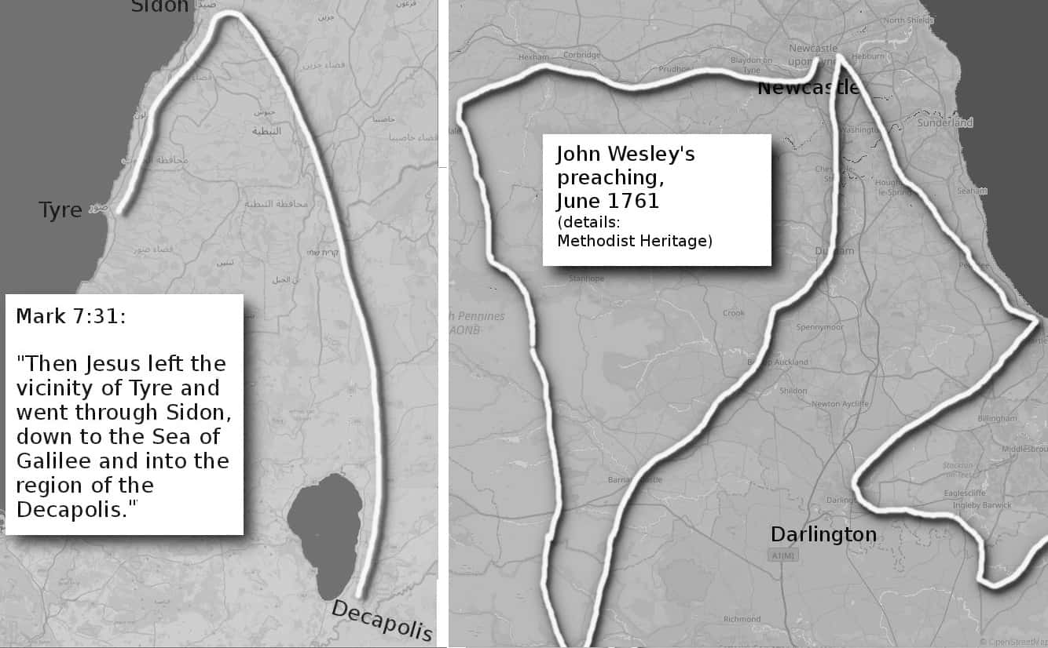
In Mark 7:2-3, we read that the Jews liked to wash their hands before eating. E. P. Sanders claims there is no direct evidence of this until after 70 AD 70. Yet we know that ritual hand washing was both mainstream and widespread before that: the translators of the Septuagint washed ritually before translating, the Qumran community and others had special pools for washing, the Samaritans did it, and so on. James Crossley goes into more detail in his book, showing why hand washing fits an early date. So Mark was right and later scholarly critics were wrong. Again.
In Mark 9:5, Peter calls Jesus “Rabbi”. Some scholars say this is anachronistic: “Mark also refers to … the title ‘Rabbi’ … which was only true decades after Jesus”. Yet “rab” just meant “leader”, hence Rab-shakeh, "chief of the princes" in 2 Kings 18-19, Rab-mag the "chief soothsayer" in Jeremiah 39:13, etc. The suffix “i” just meant “my”. Are critics seriously arguing that nobody used the word “my” until the second century AD? In every case, Mark uses rabbi as a term of flattery, not as a formal title.
In Mark 10:46-11:2, Jesus came from Jericho “to Jerusalem, unto Bethphage and Bethany”. To a scholar not familiar with the territory, this seems to be a mistake: “Anyone approaching Jerusalem from Jericho would come first to Bethany and then Bethphage, not the reverse.” But a close look at the map in Jesus’ day shows that both locations are tiny: just a few houses along the same road. So a local would naturally refer to “Bethphage and Bethany” as a single unit. This is like when John Wesley travelled north to Newcastle and reached “Tyne and Wear”. He reached the River Wear first, but “Tyne and Wear “ is the local name for the region.
In Mark 10:12 Mark refers to a woman divorcing a man. Some scholars see this as a serious error: “Verse 12 implies that Mark believed women had a right of divorce in Jewish law. They did not.” These scholars seem to think it suddenly became common in 70 AD. it did not. But in 37 AD. Herodias had just initiated a divorce against Antipas. So Jesus responded to the big news of the time. This only makes sense when 37 AD was a recent memory. It does not make sense in 70 AD.
In Mark 15:43 we meet “Joseph of Arimathea”. Modern readers cannot find “Arimathea” on any map, and some say it was “Mark's own invention”. But most Koine Greek texts indicate that the word should start with a breathing mark or "h" sound, so probably refers to ha-Ramath, the town of Ramathaim where the prophet Samuel was born. A local man would know this. Later scholars, less familiar with the region, wrongly assume it to be a mistake.
In Mark 15:46 we read of Jesus wrapped in linen and the tomb closed with a circular rock. Some have argued that only rich people used circular rocks on their tombs in this period (most used square rocks), and only poor people had simple linen (rich people used thick, heavy shrouds until Gamaliel made thin shrouds popular). But that is the whole point: Jesus entered Jerusalem as “the son of man” (the common man) so had to be buried like a pauper. But he also needed a grave that could be opened easily, because he planned to be revived after his partial crucifixion.
“Mark 14:57-58 and 15:29 slanderously attribute to Jesus the claim that he will destroy the temple and raise it again in three days. What is striking is that the controversy is over Jesus' role in bringing about the destruction -NOT whether or not the temple will actually fall.”
This is remarkable for how scholars will see what they want to see (the destruction of the temple, suggesting 70 AD) and ignore the central point of the quote because it says the opposite: that Jesus intended to dismantle the temple himself and rebuild it differently (suggesting 40 AD).
In general, Mark uses Latin terms. Layer scholars sometimes argue this means it was written after Jerusalem was destroyed as if Jews suddenly forgot their culture in the year 70! The claim is not just absurd, but irrelevant: Church historians say he wrote the text for the people of Rome.
We could explore these claims forever. For example:
- whether there were Pharisees in Galilee (there were),
- what Jesus meant by “some will taste of death” (he referred to dying in the war, not dying of old age),
- whether Nazareth existed (it did),
- whether they used the word “Caesar” (they did),
- when the term “corban” was first used (Eliezer ben Hyrcanus merely promoted it, but the idea was much older)
- whether trials happened at night (the nighttime was a mob, not a trial: the trial was before Pilate the next day)
- whether trials be that rushed or bend the rules (only armchair scholars think that all laws are always followed with perfection),
- whether Pilate would not release a prisoner (in 37 AD his job depended on being nice to the Jews: see the timeline with Vitellius, earlier).
Mark constantly refers to tiny details that only somebody who was there at the time would know. Such as Jesus taking the children in his arms in Mark 10:16, or sleeping on a cushion in Mark 4:38. Mark assumes the listeners know local people: e.g. he mentions mentioning Alexander and Rufus in Mark 15:21, without having to explain who they are. Again and again, Mark only makes sense if written near the time in question.
This has been a very long appendix, but the details are needed to establish an important point: the top scholars take reliable history and reject it as fiction. Scholars mean well, but their critical approach destroys more history than it preserves.

Appendix 3:
The last Great Disaster
Egypt, Mesopotamia, India and China all trace their history to a starting point in 39,000 BC. This is the date when the previous human race was wiped out. It was the Great Disaster that Kirby used as inspiration for Kamandi.
Chapter 12 shows how Kirby’s Great Disaster is modelled on the Laschamp event, dated to between 40,200 BC and 39,500 BC. Earth’s liquid interior shifted, briefly flipping the magnetic poles, allowing large amounts of solar radiation to reach the Earth. This caused dramatic lights in the sky, disaster-movie-like weather, and widespread death. This was not the only global cataclysm of course: we see lesser cataclysms, such as the Younger Dryas, roughly every ten thousand years. But 39,000 BC was the last big one.

The 41,000-year cycle
The Laschamp event was 41,000 years ago. This may be linked to changes in the Earth’s axial tilt. These changes, known as Milankovitch cycles, used to repeat every 41,000 years. We thought that cycle had stopped, but lately, the magnetic poles seem to be changing again:
“From 1999 to 2005, Earth’s magnetic north pole went from shifting nine miles at most each year to as much as 37 miles in a year.”
The physics is not well understood, so maybe nothing will happen. But the rest of this appendix is about the last time it happened.

The previous human race
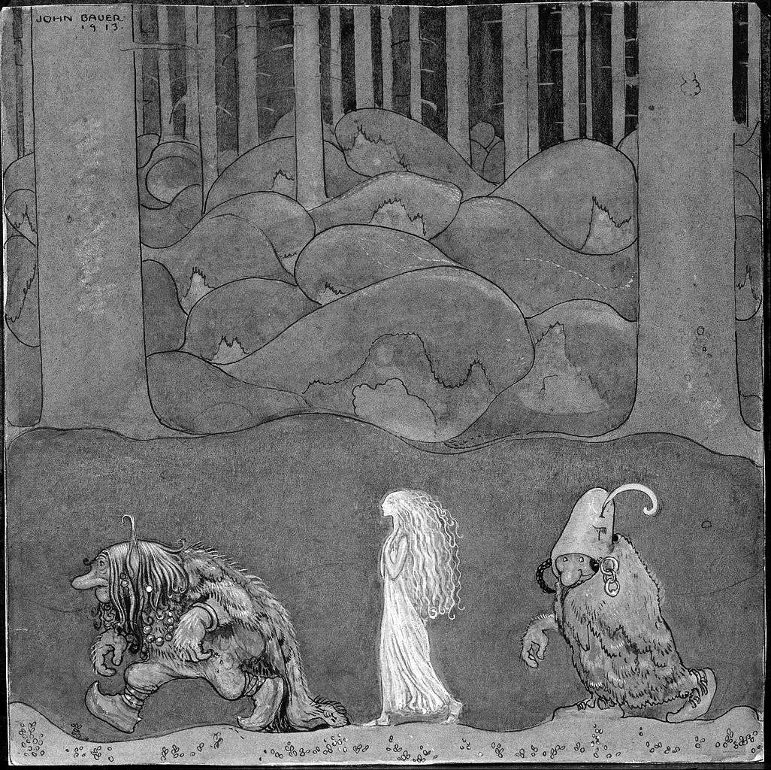
The Laschamp event marked the end of the previous human race, which storytellers remember as the “trullan”, and Kirby called the Deviants. The trullan are remembered as demons living in forests and caves. They ruled the world for 360,000 years.
Image: "The Princess and the Trolls" by John Bauer, Public Domain
A few trullan may have survived long past 39,000 BC in remote northern forests: their bodies were designed for cold climates and restricted spaces. Forests are not good for preserving archaeological remains, so we cannot be sure when the last ones died out, but there are stories about them across northern Europe. Trullan were generally shorter but bulkier and stronger than us, with larger foreheads (and larger brains) and big noses. So they looked ugly to us. They lived in forests and caves. Occasionally they would interbreed with us, leading us to share some of their DNA. This image of trullen leading away a Homo sapiens princess is from the “Princess and The Trolls”:
“The story is about a troll father who is so taken with the little princess Bianca Maria that he steals her from her cradle and replaces her with his own troll child instead.”
Modern scientists rediscovered trullan remains in a beautiful valley near Düsseldorf. The poet Joachim Neander (best known for his hymn, “Praise to the Lord, the Almighty, the King of creation!”) often went to this valley to be inspired by nature. So the valley became known as the Neander Valley, or in German, Neander Tal. So the trullan became known as “Neanderthal man”.
Trullan filled Europe and north and central Asia and probably reached America around 130,000 BC. When our ancestors left Africa around 70,000 BC we could not safely enter Trullan territory.
“The best evidence that Neanderthals not only fought but excelled at war, is that they met us and weren’t immediately overrun. Instead, for around 100,000 years, Neanderthals resisted modern human expansion.”
So we mostly stayed around Arabia and southern Asia, reaching Australia around 60,000 BC. But after the Great Disaster, our ancestors defeated the trullan and took over their territory.
“All traces of Neanderthals disappeared by about 40,000 years ago. The most recently dated Neanderthal fossils come from small areas of western Europe and the Near East, which was likely where the last population of this early human species existed.”
Homo sapiens were now free to become rulers of the world. Every major northern civilisation traces its origin to this time:

Egypt and 39,000 BC
The Turin Papyrus gives a list of Egyptian kings from the very beginning. Some parts are missing, but luckily we have a summary at the end:
"Venerables Shemsu-Hor, 13,420 years;
Reigns before the Shemsu-Hor, 23,200 years;
Total 36,620 years."
Those are the kings up to the reign of Menes, the king who united Egypt in 3050 BC. So the first kings began in 3050 + 36,620 = 39,670 BC.
A scholar in the fifth century AD confirms the 39,000 BC start date when he refers to "matters which over the vast span of ages have been reposited in the sanctums of Egyptian priests ... for almost forty thousand years"
“Shemsu-Hor” just means “followers of Horus”: that is, followers of the god of kingship and the sky. So the followers of Horus began 23,200 years after Egypt began. That is, Egypt began around 39,000 BC, and then began following Horus around 16,000 BC. Manetho said the reign of demigods began around 14,000 BC, but the difference is explained by archaeology. Around 16,000 BC: the semi-sedentary Halfans replace the nomadic Khormusans. Then around 14,000 BC: Qadan culture began to experiment with settled farming. So 16,000 BC saw the first landlords (the first people who made rules as a condition of living in a certain place) and 14,000 BC saw the first workers (the first time people had to slave in the fields for these lords).

China and 39,000 BC
Chinese records state that creation took place in 39,000 BC, but nothing much happened for the first 18,000 (i.e., until 21,000 BC). They then had 18,000 years of growth until the first emperor, 3,000 BC. These numbers are confirmed by archaeology, “modern humans” entered China around 40,000 BC, from the direction of Siberia or Mongolia. This group struggled to establish itself permanently until a new wave of people brought “microblade” technology around 21,000 BC: this eventually led to the farming revolution, and the first emperors, 3000 BC.

India and 39,000 BC
India has the oldest records of all. They record not just one creation, but a repeated 12,000-year cycle of creation and destruction (see chapter 5). The current cycle began in 3102 BC, with the rise of cities. So the previous cycle began in 15,000 BC, with the rapid expansion of Caucasians. The cycle before that began in 27,000 BC when the world population began to suddenly expand. The cycle before that takes us to 39,000 BC, the Laschamp event and the defeat of the trullan. The cycle before that is 51,000 BC when we drove the trullan out of the Levant (Israel).
Serious long-term timekeeping probably did not begin until 39,000 BC: see “Recording time in 39,000 BC” below. So the 39,000 BC Yuga cycle is probably the real start of Indian history. Cycles before that can be inferred from how legends refer to particular parts of the sky.

The Jews and 39,000 BC
Orthodox Jews say the world began with Adam, but Kabbalistic Jews may preserve hints of the older teaching. Talmud Chagigah says there were 974 generations before Adam. These were non-Jews, so we can take a generation as being 36 years. 974 x 36 = 35,064. 35,000 years before Adam (4,000 BC) is 39,000 BC. The Kabbalists teach of seven 7,000 year cycles of history or “sh’mitahs”. “In his Drush Ohr HaChaim, the author of Tifres Yisroel [on Mishnayos] mentions that we are in the fourth sh’mitah…” This could be a garbled memory of how we are in the fourth 12,000 year cycle. The same source also says that between each cycle are great upheavals, that throw up new mountains. This is just what Kirby suggests with his “Great Disaster”.
This is all highly speculative and there is much dsaagrement between different Jews. For more certainty we need to return to the source of the Jewish religion: Mesopotamia.

Mesopotamia and 39,000 BC
Western civilisation traces back to Gobekli Tepe, Harran, and other sites near the source of the Tigris and Euphrates. The same people still live there today. They are called the Yazidis, meaning the “people of God”.
Countless nations have tried to remove the Yazidis, but they refused to leave. This led to countless genocides: recent examples are by Saddam Hussein and later by “Islamic State”. But the Yazidis always survive and refuse to leave their lands or give up their traditions.
“‘Yazidis often say they have been the victim of 72 previous genocides, or attempts at annihilation,’ says Matthew Barber, a scholar of Yazidi history at the University of Chicago who is in Dohuk interviewing Yazidi refugees. ‘Memory of persecution is a core component of their identity,’ he says.”
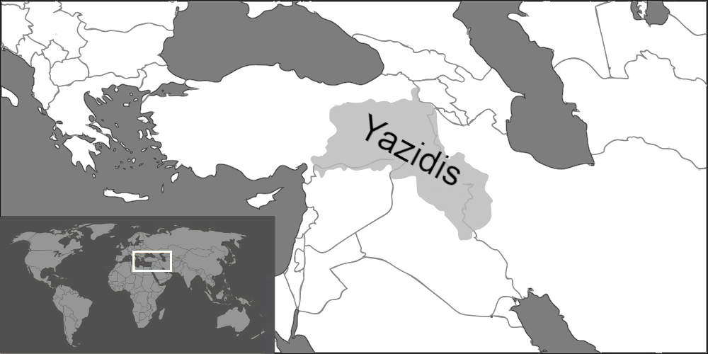
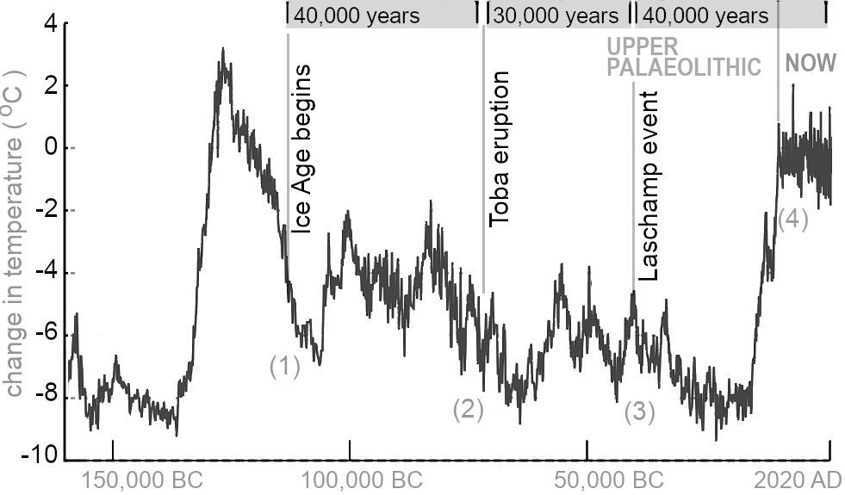
Has any group ever worked harder to preserve their history? So the modern belief, that the Yazidis copied their teachings from other cultures, is unlikely. The closer we look at their belief, the older they appear to be. For example, they worship the sun and teach that gods were originally humans, and their capital was a Sumerian city. To find the true age of Yazidi culture we need to look much further back. For some context, here is a summary of human history since we became anatomically modern 200,000 years ago. (This omits the first 50,000 years when the climate had fewer spikes.)
Image: by 'Vilagris' via Wikimedia, CC-BY-SA-4.0
Image: adapted from Vostok ice core data, NOAA, via ‘Autopilot’, Wikimiedia, CC-BY-SA-3.0
Notice the four big changes after the great warming of 125,000 BC:
- The start of the ice age (the Last Glacial Period) is usually dated to “around 115,000” years Before Present: i.e., 113,000 BC.
- 40,000 years later, the Toba volcano erupted. This caused temporary but very sudden climate change. Humans almost became extinct. The survivors left Africa in search of food. This would be temporary (perhaps a few centuries), but after 70,000 BC North Africa became even drier than it is today, so the migration became permanent.
- About 30,000 years later, the Laschamp event coincided with the death of the Neanderthals, allowing our ancestors to colonise Europe.
- Another 40,000 years brings us to the present. The biggest recent change is the Younger Dryas event, leading to our ten thousand years of stability, allowing the rise of settled agriculture.
The Yazidi creation story covers this entire history:
“[O]ne of the seers I met expounded how in the sacred Black Book (which she claimed was hidden in Syria) ‘all history is contained,’ not only that of the Yezidis, but of all nations.”
The account is incredibly condensed. We would need a thousand pages to explore every line and nuance, but here are some highlights:
“In the beginning God created the White Pearl out of his most precious essence.”
The White Pearl is the gnostic symbol of a journey to find wisdom. Contrast that image with the violent symbol of later gods: Adar was a bull, Yahweh was the “lord of armies”, the seal of the American president is an eagle carrying arrows, and so on. But the Yazidi god was peaceful. This is how the peaceful god began:
“Before heaven and earth existed, God was on the sea, as we formerly wrote you. He made himself a vessel and traveled in it in kunsiniyat of the seas, thus enjoying himself in himself. He then created the White Pearl and ruled over it for forty years.”
Those forty years must have been lonely, and so:
“He also created a bird named Angar. He placed the White Pearl on the back of the bird, and dwelt on it for forty-thousand years.”
“Angar” is probably Ankar, the Yazidi Satan. Satan is the servant of God who travels the world (hence the form of a bird) to test and discover the truth. God and Angar are alone for 40,000 years God then creates seven angels, and after that comes the creation:
“After this God made the form of the seven heavens, the earth, the sun, and the moon. But Fahr-ad-Dîn [the seventh angel] created man and the animals, and birds and beasts.”
The seven angels (junior gods) then rule for 10,000 years each:
“They believe that there are seven gods, and that each god administers the universe for ten thousand years.”
The total, 70,000 years, is compared to seven days, making it easy to remember. The 70,000 years is made of 30,000 before the Yazidis appear and settle at Lalish, and then 40,000 afterwards. That is, the Yazidis are created at the start of day four of seven. So Yazidis always celebrate New Year on a Wednesday.
When Homo sapiens left Africa around 70,000 BC they met new kinds of animals, and would need radically new ideas: this was a new beginning for mankind.
“Then he created Gabriel and the image of the bird. He sent Gabriel to set the four corners. He also made a vessel and descended in it for thirty-thousand years.”
“Gabri-el” means “strong man of God”. For 30,000 years the strong humans travelled out of Africa. Mongolian myths also talk about God sending out a bird for 30,000 years.
“In the beginning, an infinite expanse of water covered the entire universe. Quormusta Tengri sent Galbingaa bird, which had a lifespan of thirty thousand years.”
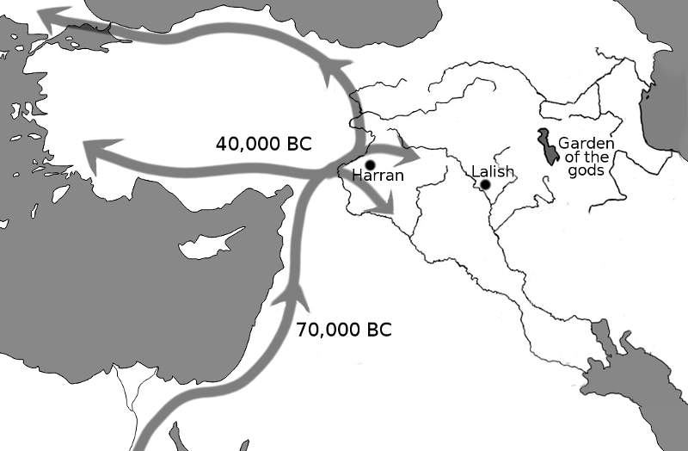
And one version of Prometheus says he was pecked by the eagle while trapped for 30,000 years, reminding us of Neanderthals stopping Homo sapiens for 30,000 years. That brings us to 40,000 BC, when we moved into Europe.
We naturally followed the fertile land, where we could find food. This led us to the great rivers. There we reached “Harran”, the natural crossroads for fertile land in all directions (“Harran” is Akkadian for “crossroads”). From here they could travel to the four corners of the world. But some people decided to stay, and settled at Lalish, near the fertile land where the rivers begin, and called it “the garden of the gods” (see appendix 5).
“After this he came and dwelt in Mount Lališ.”
Other people travelled north and spread through Europe. This was the height of the ice age, where large bodies of freshwater solidified into ice — something they had never seen in Africa.
“Then he [God] cried out at the world, and the sea became solidified and the land appeared, but it began to shake.”
The shaking may be a reference to the Ciomadul volcano northwest of the Black Sea: it was erupting at the time, just at the point where people were entering Europe. It might also refer to the much larger Phlegraean supervolcano near Naples: it didn’t erupt until 37,000 BC but threw 120 cubic miles of rock into the sky:
“(From him) there was a cry, the stones fell on the world (dust), dust rose. The world turned into soil and began to shake.”
Ice sheets and stones falling from the sky are something Homo sapiens had never seen before. It was something they never forgot!
So the While Pearl - the wisdom of God - was now split in two. Some explored the world, and others stayed at Lalish, the shrine that linked Earth and heaven (i.e., the “gate of heaven”):
“At this time he commanded Gabriel to bring two pieces of the White Pearl; one he placed beneath the earth, the other stayed at the gate of heaven.”
For the next 40,000 years, people spread out into 30,000 different tribes:
“Then the Lord came down to the Black Mountain. Shouting, he created thirty-thousand Meleks [tribal rulers], and divided them into three divisions. They worshiped him for forty-thousand years, when he delivered them to Melek Tâ’ûs who went up with them to heaven.”

Adam and Eve
Toward the end of the last 40,000 years, the Younger Dryas led to the Lalish people planting wheat. That was hard work, so they imported hunter-gatherers as slaves to work the fields. In return, the slaves could hunt and gather in the gods’ paradise, but could not eat the wheat.
“Then he [The Lord] commanded Gabriel to escort Adam into Paradise, and to tell him that he could eat from all the trees but not of wheat.”
The bosses debated whether they should let the slaves eat wheat as well so that slaves would have more children (more slaves):
“Melek Tâ’ûs asked God how Adam could multiply and have descendants if he were forbidden to eat of the grain. God answered, "I have put the whole matter into thy hands." Thereupon Melek Tâ’ûs visited Adam and said "Have you eaten of the grain?" He answered, "No, God forbade me.’ Melek Tâ’ûs replied and said, "Eat of the grain and all shall go better with thee.”
People who are not adapted to wheat can easily develop celiac disease. Symptoms include constipation and swelling of the belly:
“Then Adam ate of the grain and immediately his belly was inflated. But Melek Tâ’ûs drove him out of the garden, and leaving him, ascended into heaven. Now Adam was troubled because his belly was inflated, for he had no outlet. God therefore sent a bird to him which pecked at his anus and made an outlet, and Adam was relieved.”
These are memorable images. Oral history is designed to be remembered.

Recording time in 39,000 BC
How could Yazidis preserve records for 40,000 years or longer? First, let’s look at how the Egyptians probably did it.
Herodotus recorded what he heard from Egyptian priests. Herodotus was an outsider and seems to get the oldest Egyptian history mixed up, but one thing he remembers is especially interesting. He asked about the great age of Egyptian records and was told:
“Four times in this period (so they told me) the sun rose contrary to his wont; twice he rose where he now sets, and twice he set where now he rises;”
The stars rotate completely every 26,000 years, so it takes 13,000 years for the sun to rise where it previously set. Herodotus tells us that the sun moved to this opposite position twice. To move there once would take 13,000 years. To do it again would require an additional complete cycle of 26,000 years, making a total of 39,000 years. (Herodotus wrote in the 400s BC). It also hints that Egyptians used the precession of the equinoxes. The beauty of the precession method is that it can survive even if people forget the method for a thousand years. Everybody uses the sun, moon, and stars to measure time. Anyone who watches the stars at fixed locations for decades will notice how they start to slip away from the landmark in question. That is, anyone with a fixed temple will discover precession. They might not have the mathematics to calculate fine differences, but drawing a circle will let the work out the rough idea: 26,000 years for a complete rotation. For example, today the sun is in Pisces, This means that the sun rises in front of the Pisces during the spring equinox, and would do the same 26,000 years ago.
Did Yazidis know precession? Yazidis might have lost the original methods, but we know that Yazidis have many parallels with the more famous Mithra. The central Mithraic ceremony is the story of Mithra killing a great bull, surrounded by the sun, moon and stars. Many researchers have noted the obvious parallel with the end of the age of Taurus, dating the triumph of Mithra (or whatever Mithra evolved from) to around 2000 BC. So it is likely that the Mithraists and hence the ancient Yazidis used precession.
What do Yazidis say about ancient astronomy? They say that God created the “image” of the sun and moon around 70,000 BC, but the sky first took on a detailed reality when they settled at Lalish, in 39,000 BC:
“He then placed in them [the earth, and the gate of heaven] the sun and the moon; and from the scattered pieces of the White Pearl he created the stars which he hung in heaven as ornaments.”
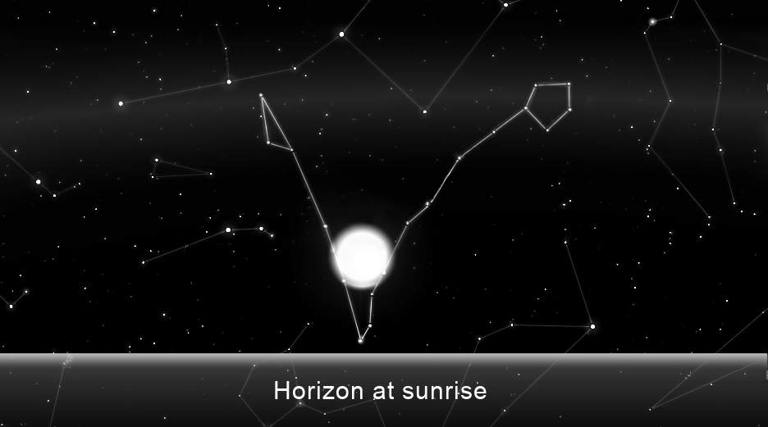
Humans were nomads, so we used the stars for finding our way around. Even birds, seals, and dung beetles do it. But before 73,000 BC we lived in Africa, near the equator, so the seasons were not important. Then in 73,000 BC, the Toba Eruption caused a sudden and devastating famine. As we moved north in search of food, seasons mattered more and more. Luckily, in 73,000 BC the sun rose in spring in a pattern that was easy to see: the “V” shape of Pisces. They seem to have thought of it as an oyster containing a pearl.
Image: Stellarium, Fabien Chereau et al., GNU General Public License
In 73,000 BC astronomy was not advanced, so the precise date of the March equinox was probably not noticed. But they would notice that as the pearl approaches the oyster the plants grow, and when the pearl was in the oyster (April in 73,000 BC) plants were ready to harvest.
Many people think that hunter-gatherers did not care for farming, so would not have monuments for watching the skies, and so, would not notice precession. But the book The Dawn of Everything shows that nomads have always moved between farming and hunting, since the dawn of time. Another writer gives the example of Australia:
“As I read these early journals [of the first Europeans in Australia] I came across repeated references to people building dams and wells, planting, irrigating and harvesting seed, preserving the surplus and storing it in houses, sheds or secure vessels, creating elaborate cemeteries and manipulating the landscape — none of which fitted the [old] definition of hunter-gatherers.”
It was not just in Australia. In the Old World, there were bread-making ovens from 14,400 BC, which means that hunter-gatherers had systematic harvesting of grain. Systematic harvesting implies a knowledge of the seasons. So, some of the groups would have monuments to watch the skies, and therefore some of these would notice precession. This must have been true ever since we left the equator and the seasons became important.
The wave of migration after 73,000 BC was not the first wave. A previous wave of Homo sapiens left Africa over 40,000 years earlier.
“Recent paleoanthropological studies have suggested that modern humans migrated from Africa as early as the beginning of the Late Pleistocene, 120,000 years ago.”
Remains of this earlier group were found in Israel, so they lived in the same region as the Yazidi ancestors. So, sometime after the Yazidis arrived after 73,000 BC they would have shared their sacred origin stories. This explains why the Yazidis knew that the gods existed for 40,000 years before the earliest Yazidi date. This earlier group might have said something like the Egyptians told Herodotus, “Twice the sun rose where he now sets, and twice he set where now he rises”. From this, the Yazidis could deduce that the earlier group was there for 40,000 years before the Yazidis arrived. So, recorded history takes us back to 110,000 BC. This date, or something like it, was also preserved by the Egyptians, according to Augustine:
“Egypt has understood the reckoning of the stars for more than a hundred thousand years.”

Kirby and lost civilisations
Kirby's stories often feature lost civilisations from previous eras. For example, “Captain 3D” was the last of his people, of high intelligence, and had been at war with the “cat people” since 50,000 BC. As the dominant non-human species in Kirby’s writing, “cat-people” are a natural fit for neanderthals. Did a highly intelligent hominid group live alongside them?
As usual, Kirby’s guesses were prescient. In 2010 we discovered the Denisovans. They lived alongside the Neanderthals but had remarkably large brains. Denisovan cranial capacity was typically 1800 cc, compared with modern human cranial capacity of around 1400 cc. In Captain 3D’s people are only preserved through books, just as we can only hear from our ancient ancestors through stories. The cat people look human until are only seen through special glasses — a good metaphor for how Neanderthal DNA survives in us.
Kirby stories often feature artefacts from lost civilisations. These work as fictionalised versions of the most advanced technology we know, which is social technology. They show that our Golden Age ancestors were more advanced than us. Here are four examples of advanced Golden Age technology from a single story, the Challengers of the Unknown origin:
- The dragon's seed is a Cadmus story. An unbeatable giant strides through the sea to conquer the world, but he is maintained by belief. This is an example of the invention that let our ancestors conquer the world: the god. Noah Harari, in his book “Sapiens”, explains why gods matter. Primates can only keep track of 50-100 other people, but if the people all follow a god, then you only need to know the god to keep track of millions of his followers. Love them or hate them, gods create a unity that nations and corporations cannot. So they are the most powerful social technology. According to Manetho, the first god was Hephaestus (Ptah), the metalworker, before 28,000 BC.
- The freezing sun made us strong. The crazy swings in and out of ice age conditions made us creative and tough. These climate changes forced us to invent technology: like "Red" in the story, we had to become fast and flexible to survive. But ten thousand years of pleasant climate has made us soft. Many of us will not survive if agriculture collapses. But hunter-gatherers will: they still have the flexibility that comes from living with unreliable climates: they still have freezing-sun social technology.
- The "whirling weaver" is a communication device: it connects people. “Ace” does not know how it works, so accidentally turns it to the maximum setting, and the weaver ties everybody together so that they have no freedom. Communication technology is like that: we have to follow the clock, we have to follow the boss, and we have to be close to our telephones at all times. Our ancient ancestors had better communications technology because it was slower: they tuned their communication technology (proto-writing, no electronics) to a very manageable human level.
- The diamond of immortality is the greatest lost technology. Modern man resists death, believing there is nothing beyond. But ancient man saw himself as part of nature. And gnostics saw themselves as beings of light who reincarnate in different forms. Kirby symbolises immortality as a diamond ring: a ring symbolises eternity, and diamonds in classical mythology were “adamant”: symbols of what cannot be changed. In the Bible, diamond refers to facing up to hard truths. The ring is accompanied by the message "I am danger -- I am death -- also find contained in me eternal immortality". In the story, Morelian guarantees his immortality by being so flamboyant that he will never be forgotten. He then embraces his end, excitedly moving on to the next part of his eternal adventure (see chapters 15-16). But the modern people around him do not understand what just happened, so they think that death means failure.
A whole book could be written on Kirby's lost civilisations and their artefacts. For example, the “ancient vials” story has parallels with ancient drugs and fire use, and the “Star Stone” story opens the world of astronomy and sky-god kingship. The bottom line is that Kirby’s lost civilisation stories have a core of truth.

Appendix 4:
Atlantis
Atlantis is the classic example of storytellers remembering what historians forget. This appendix explores the evidence for Atlantis. It ends with different versions of Atlantis in Kirby's stories.

The most common mistakes about Atlantis
The most common mistake when studying Atlantis is to only read Plato. The best way to understand Atlantis is to read the accounts from before Plato. Plato did not invent Atlantis. If we think he did, then we need to read more mythology.
The next most common mistake is to use the modern meaning of word “island”. The fact that Atlantis was an island simply meant travellers would cross water to reach it. The water might be just a river.
Another common mistake is to forget the scale of the ancient Greek world. Most Greeks did not even know where Libya was. Yet Libya was an enormous coastline just 250 miles away! The Greek world was the eastern Mediterranean. Everything they describe was there, or nearby.
Another common mistake, especially amongst scholars, is to ignore what Plato said. Plato said that Atlantis was real. He used the story because it was real history. Plato had just described a theoretical society. Now he wanted to test his theory against a real-world example. He did this to distinguish himself from the wandering Sophists. The Sophists created theories without any basis in real events.
"I am aware that the Sophists have plenty of brave words and fair conceits, but I am afraid that being only wanderers from one city to another, and having never had habitations of their own, they may fail in their conception of philosophers and statesmen…”
So Plato found a real historical example to test his theory:
"Then listen, Socrates, to a tale which, though strange, is certainly true, having been attested by Solon, who was the wisest of the seven sages."
Socrates agreed that Atlantis was a good test for Plato’s theory. Because Atlantis was real history.
“this ancient famous action of the Athenians, which Critias declared, on the authority of Solon, to be not a mere legend, but an actual fact"
A final common mistake is to confuse two different eras: around 9,000 BC and around 360 BC. 9,000 BC is the famous date:
“Many great deluges have taken place during the nine thousand years, for that is the number of years which have elapsed since the time of which I am speaking … there occurred violent earthquakes and floods; and in a single day and night of misfortune all your warlike men in a body sank into the earth.”
Plato then explains why the city cannot be visited in his day (360 BC). Because in Plato’s day (360 BC) there is a shoal of mud in the way
“And the island of Atlantis in like manner disappeared in the depths of the sea. For which reason the sea in those parts is impassable and impenetrable, because there is a shoal of mud in the way; and this was caused by the subsidence of the island.”
Plato introduced the 9,000 BC war in Timaeus, then described Atlantian society in Critias. He describes the Bronze Age. He said that Atlantis took “many generations” and “long ages” before it became that Bronze Age city:
“…the eldest son handing it on to his eldest for many generations”
“…they continued to ornament [Atlantis] in successive generations, every king surpassing the one who went before him
“…fashioned by nature and by the labours of many generations of kings through long ages”
Some translations make it sound like the two periods are close in time, but the original Greek does not say that. Accounts from before Plato show that these are two entirely different eras.

The location of Atlantis
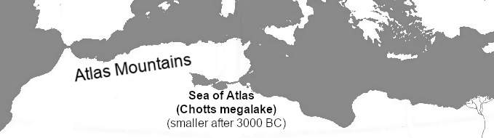
Atlantis is the city of the people of Atlas. The people of Atlas are the people of the Atlas Mountains. Herodotus called them “Atlantians”. They lived around the Sea of Atlas.
Before 3,000 BC, the people of Atlas covered a much larger area. We know this from DNA and archaeology. The people of the Atlas Mountains are not, as some suppose, descended from Phoenician immigrants. They are the original people of the entire Sahara. They call themselves the “Amazigh”, or “the free peoples”. The Greeks called them barbarians, or “Berbers”. Before 3,000 BC the Sahara was not a desert but had lakes and forests. Back then, the lands of Atlas were the rich hunting lands of West Africa. Plato said the land beyond the Sea of Atlas was larger than Libya and Asia Minor combined.

“Island” just meant “over water”
To the Greeks and Egyptians, an “Island” was anywhere that was reached by crossing water. Some “islands” were just peninsulas: parts of the mainland that stuck out into the sea. The Greeks and Egyptians did not have a separate word for “peninsula” until the 400s BC. Other “islands” were just parts of the mainland that were on the other side of a river. For example, take the land of Meroe, the capital of the kingdom of Nubia (Egypt’s southern rival). Mero is part of the mainland, but we call it an “island” because it is on the other side of the Nile.
Today we still call this site “the Island of Meroe”. It is now a United Nations world heritage site.
Continents were also called “islands”. This is because rivers separated them. It is possible to walk on dry land between Europe, Asia and Libya, but it was normal to cross rivers to do so. And so the continents were called islands. This was definitely true when Solon described Atlantis. We know this because the Anaximander map dates to Solon’s time. It calls the continents islands.

Two hundred years after Plato some people still used this definition of “island”:
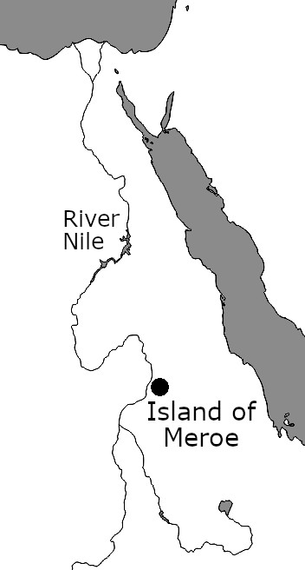
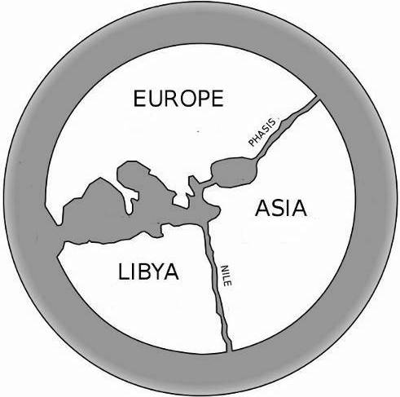
"There has been much deliberation about the continents, and that some divide them by the rivers, the Nile and the Tanais, describing them as islands"
Anaximander (610-546 BC). Bibi Saint-Pol, public domain
So in Plato’s day, an island was anywhere that was reached by crossing water. It did not matter if there was also a land route to the island. Most travellers reached West Africa by crossing the sea of Atlas, so West Africa was an island.
When the Sahara dried up, most people stopped travelling to West Africa. The Greeks forgot that the land existed. They began to assume that there was no land south west of Libya. West Africa became lost to Greek history.

The Atlantic Seas (“Seas of Atlas”)
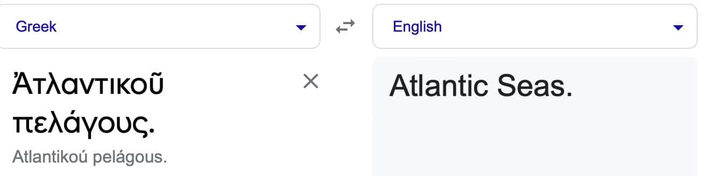
The city of Atlantis was the gateway to the continent of Atlantis, The city was situated in the “Atlantic Seas.” That is, the Seas of Atlas.
The Seas of Atlas should not be confused with the ocean. “Sea” and “ocean” were different words with different meanings. “Ocean” was Okeanos, the Greek Titan of the world river. Okeanos was a single body of water that flows around all nations. The Greeks had no concept of different oceans (Atlantic, Pacific, Indian, etc.). There was one Titan: one ocean. In contrast, a sea was a local area of water. For example, the Adriatic Sea was that part of Okeanos that flowed between Greece and Italy. And the Gallic Sea was the part of Okeanos near to Gaul. The Seas of Atlas were the seas near to the Atlas Mountains.
The Atlas Mountains once guarded a large inland sea. It was exactly as described in the stories of Atlantis. This sea was once very large, but shrank as the Sahara dried up (around 3,000 BC). By the time of Herodotus (450 BC) the shrunken became known as Lake Tritonis. Today it called the Chott el Djerid, and only has water in the brief rainy season. The locals still call it the Sea of Atlas (“Bahr Atala”).
Atlas held up the sky at the edge of the world, so the lands of Atlas were all the lands at the edge of the world. He divided these lands among his daughters. So when passing the city of Atlantis we reach the first daughter of Atlas. “Atlantis” is the Greek word for “daughter of Atlas”.
The Sea of Atlas was divided by a peninsula in the middle. This was the natural place to build a city to control access to the lands beyond. The city became the gateway to the fertile Sahara. Even today, cities like Douz, on the southern edge of the Chott el Djerid, are still known as “The gateway to the Sahara”.

The rivers dry up and become mud
Plato describes the location of Atlantis:
“[T]he sea in those parts is impassable and impenetrable, because there is a shoal of mud in the way; and this was caused by the subsidence of the island.”
So mud blocked the way to the Sea of Atlas. The story of the Argonauts also talks about this mud:
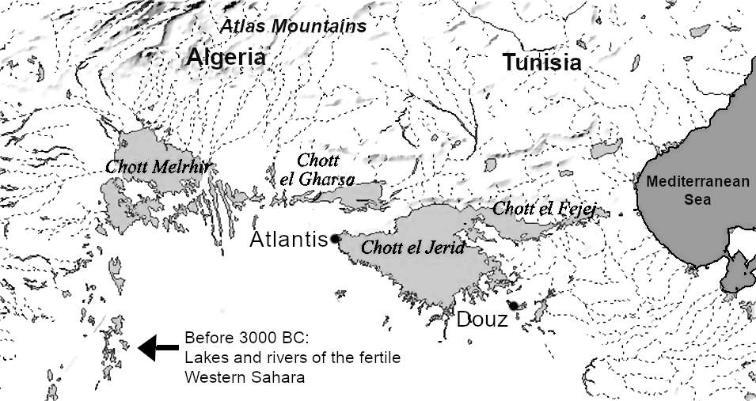
”[The wind] swept them towards the Libyan sea nine nights and as many days, until they came far within Syrtis, wherefrom is no return for ships, when they are once forced into that gulf. For on every hand are shoals, on every hand masses of seaweed from the depths; and over them the light foam of the wave washes without noise; and there is a stretch of sand to the dim horizon; and there moveth nothing that creeps or flies.”
Image: ‘Laurens’ via Wikimedia, GNU Free Documentation License.
Today, Syrtis is called the Gulf of Sidra. It is the coast between Tunisia and modern Libya. Syrtis includes the “Lesser Syrtis”, where the Sea of Atlas once emptied into the Mediterranean.

The Pillars of Heracles
Atlantis was past the Pillars of Heracles. The “Pillars” are “stelae” (“στήλας.”), meaning inscribed stone monuments. Whenever a people conquered a new land they would build a shrine or temple. The temple included a monument (stela) to declare their presence. Take for example, the temple of Heracles at Tyre, capital of the Phoenician world. It had two priceless pillars. The pillars did not support the temple, but sent a message of Phoenician wealth. Herodotus recalls:
“I took ship for Tyre in Phoenicia, where I had learned by inquiry that there was a holy temple of Heracles. There I saw it, richly equipped with many other offerings, besides two pillars, one of refined gold, one of emerald: a great pillar that shone at night…”
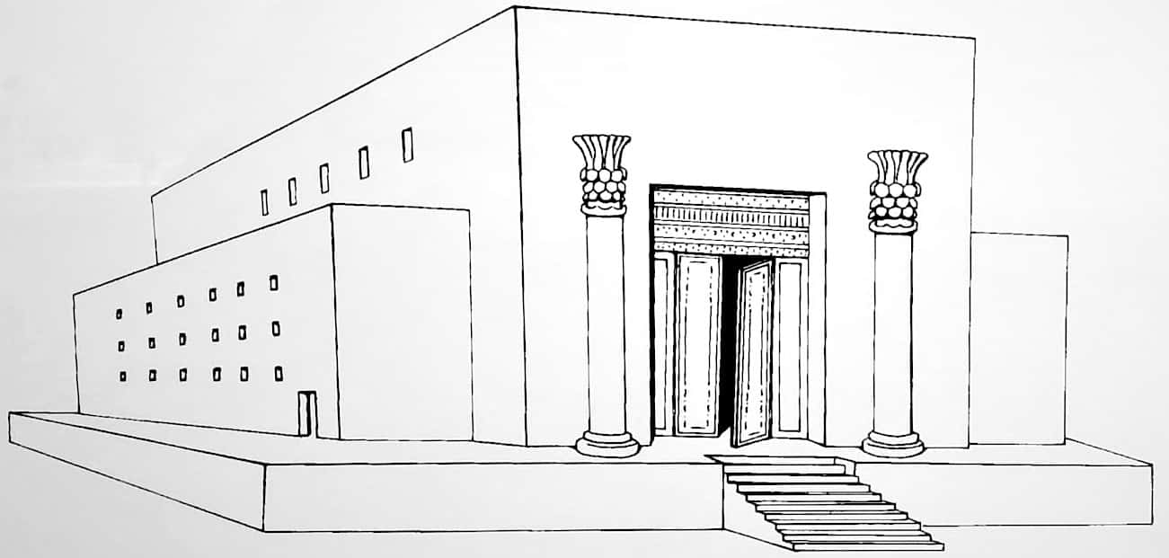
Phoenician temples always had two free-standing pillars in front. A famous example is the temple of Jerusalem built for Solomon by Hiram, king of Tyre. It had enormously expensive brass pillars at its entrance.
Image: Tom Baher, via Wikimedia, CC-BY-SA-4.0
As the centuries passed, the Phoenicians became less powerful. So their free-standing pillars fell out of fashion. In 265 BC, defeated the Phoenicians of Carthage. That gave them control of the entire Mediterranean. The temple of Heracles at the entrance of the Mediterranean (at Cadiz) then became a symbol of Roman power. But most Romans never visited the temple or saw its pillars. So they assumed that the pillars referred to the mountains at the Straits of Gibraltar.

More than one set of pillars
Iosocrates, a contemporary of Plato, describes Pillars of Heracles in the East:
“When Heracles saw that Hellas was rife with wars ... he made an expedition against Troy, which was in those days the strongest power in Asia ... and with a small expedition, easily took the city by storm. ... When he had done these things, he set up the Pillars of Heracles, as they are called, to be a trophy of victory over the barbarians, a monument to his own valor and the perils he had surmounted, and to mark the bounds of the territory of the Hellenes.”
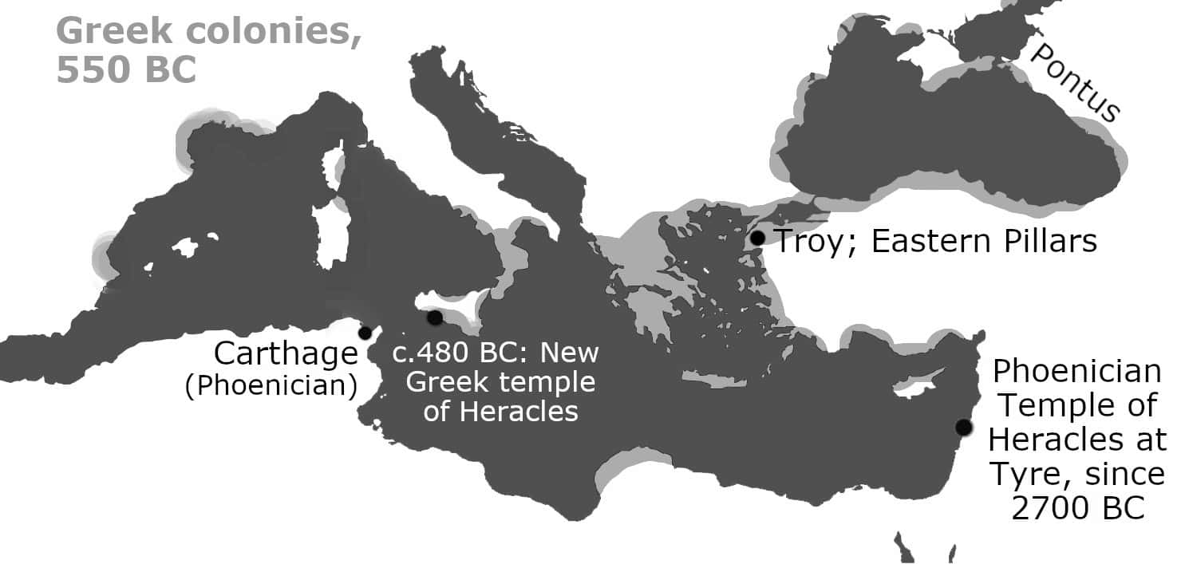
Heracles defeated Troy, a city in the East, and then set up his Pillars as a trophy of his victory. So they must be in or near Troy. (This is not the famous Trojan War, but an earlier one.)
Herodotus also mentions Pillars of Heracles in that region. These were near Pontus on the Black Sea:
“Such is the Scythians' account of themselves and the country north of them. But the story told by the Greeks is as follows. Heracles, driving the kine of Geryones, came to this land, which was then desert, but is now inhabited by the Scythians. Geryones dwelt westward of the Pontus,​ being settled in the island called by the Greeks Erythea, on the shore of the Ocean near Gadira, outside the pillars of Heracles. As for the Ocean, the Greeks say that it flows from the sun's rising round the whole world, but they cannot prove that this is so. Heracles came thence to the country now called Scythia.”
Scythians are the people of Siberia who settled on the eastern coasts of the Black Sea. Pontus is the kingdom on the edges of the eastern half of the Black Sea. The Island of the Geryones (Erytheia) is said to be west of that, but still outside the Pillars of Heracles. The Scythians (from the East) settled there, near the rising of the sun. And Heracles came from there to Scythia. So this all takes place in the East, not the West as later stories say.
It was the custom to build a temple, with its stela or pillars, whenever a land was conquered.
“[I]t was a custom in early times to set up landmarks like that. For instance, the people of Rhegium set up the column — a sort of small tower — which stands at the strait; and opposite this column there stands what is called the Tower of Pelorus. And in the land about midway between the Syrtes [i.e. east of Tunisia] there stand what are called the Altars of the Philaeni. And mention is made of a pillar placed in former times on the Isthmus of Corinth … Again, Alexander set up altars, as limits of his Indian Expedition, in the farthermost regions reached by him in Eastern India, thus imitating Heracles and Dionysus. So then, this custom was indeed in existence.”

Where were Plato’s Pillars of Heracles?
Plato says that Atlantis was beyond the pillars of Heracles at the western edge of the Greek world. In Plato’ day, Greece was at war with Carthage, so the western edge of Greek power was the temple of Heracles on Sicily. This temple was built to celebrate defeating the armies of Carthage in Sicily at the Battle of Himera, in 480 BC. The temple marked the limits of Greek power until Carthage was fully defeated in 265 BC. Another temple of Hercules was on nearby Malta. It was mentioned by Ptolemy in his Geography. But nothing more is known of it. When people said “The Pillars of Heracles” in Plato’s day, they evidently meant one of those temples. We know this from the book "On the Cosmos”, by Plato’s student, Aristotle:
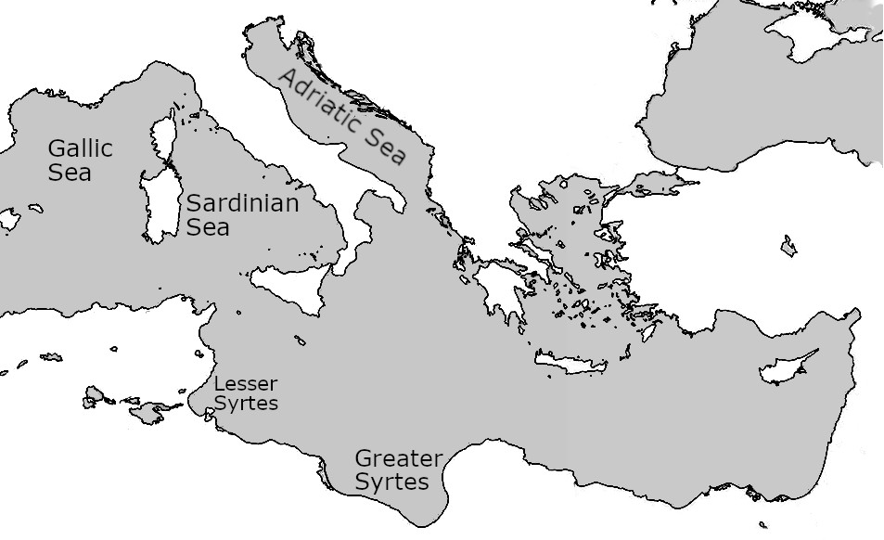
"First, then, on the right as one sails in through the Pillars of Heracles it is said to form two bays, the so-called Syrtes, the Greater and the Lesser as they are called; on the other side it does not make such bays, but forms three seas, the Sardinian, the Gallic, and the Adriatic."
A look at the map shows that the Pillars must be somewhere near Sicily or Malta. Sailing “through” them may mean between the pillars at Sicily and the pillars at Malta, but it is more likely a poor translation of “sailing by” them. The word translated as “through” (είσπλεοντι, “espleonti”) is usually translated as “sailing in” in the sense of coming home, in contrast to sailing around some distant coast (“peripleonti” or “periplus”). Other early descriptions say that sailors travelled “epi” the Pillars of Heracles. Some English translations translate “epi” as “through” the pillars, but the best translations say they sailed “past” them. “Epi” just meant “near” or “in addition to”. Translating “espleonti” as “through” is misleading, but it became common in later centuries when the Pillars became identified with the Strait of Gibraltar, and so it was then possible to sail between or through them.
This location of the pillars near Sicily is confirmed by Herodotus, writing in the 400s BC:
“Thus then have been mentioned those nomad Libyans who live along the sea-coast: and above these inland is the region of Libya which has wild beasts; and above the wild-beast region there stretches a raised belt of sand, extending from Thebes of the Egyptians to the Pillars of Heracles.”
This passage is from Herodotus’ description of Tunisia (see below). When Herodotus reached Tunisia the sand ended and fertile farmland began:
“[I]n the region to the West of lake Tritonis the Libyans cease to be nomads … On the West of the river Triton next after the Auseans come Libyans who are tillers of the soil … This country and the rest of Libya which is towards the West is both much more frequented by wild beasts and much more thickly wooded than the country of the nomads: for whereas the part of Libya which is situated towards the East, where the nomads dwell, is low-lying and sandy up to the river Triton, that which succeeds it towards the West, the country of those who till the soil, is exceedingly mountainous and thickly-wooded and full of wild beasts…”
So The Pillars of Heracles were at the end of the sand: somewhere near Tunisia. A modern map confirms that the sand ends and the good soil begins in Tunisia. (On the map the dark areas are good soil, and the white areas are sand.) Herodotus places the Pillars of Heracles at the point where the sand ends and the good soil begins: that is, southern Tunisia.
Image: ISRIC – World Soil Information, 2013. www.isric.org Low resolution, Fair Use.
Herodotus has no idea of what was west of the sand, so he did not know about the Straits of Gibraltar.
“As far as these Atlantians I am able to mention in order the names of those who are settled in the belt of sand; but for the parts beyond these I can do so no more.”
Herodotus cannot have travelled beyond Tunisia, because he reports impossible stories about fantastic beings in the West:
“…the monstrous serpent and the lion and the elephant, and bears and venomous snakes and horned asses, besides the dog-headed men, and the headless men with their eyes set in their breasts (at least so say the Libyans about them)…”
At that time the people of Atlas (the Carthaginians) were at war with the people of Greece, so it was not safe for Greeks to travel further west. Before turning back, Herodotus mentions a mountain called Atlas near the last oasis:
“Near this salt hill is a mountain named Atlas, which is small in circuit and rounded on every side; and so exceedingly lofty is it said to be, that it is not possible to see its summits, for clouds never leave them either in the summer or in the winter. This the natives say is the pillar of the heaven.”
The mountain was “small in circuit and rounded on every side”. That does not describe the Mount Atlas we know today, which is simply a jagged ridge connected to other high mountains. It is not small in circuit or rounded on every side, so Herodotus’ guide must have spoken of a different mountain. Some people confuse the pillars of Heracles with this mountain, the “the pillar of heaven”, but the Greek Greek words are different: “Pillar” of heaven is “kiona” (“κίονα”), meaning a column that holds up a building, but the pillars of Heracles are stela, stones with writing on.

Another boundary marker, from before 8000 BC
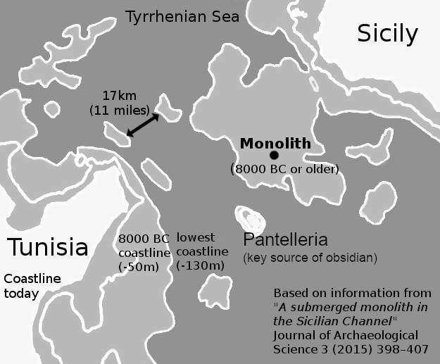
Between Tunisia and Sicily is another ancient boundary market, dating to the era of the Atlantis war. In 2015, archaeologists announced that they had found an ancient stone monolith in the middle of this critical region, on land that was last above water in 8000 BC. This was the ideal place for a boundary pillar, announcing that the seas to the West belong to Atlas, and the seas to the West belong to Zeus. Near the pillar is the tiny island of Pantelleria, a vital source of obsidian, the material used for blades of all kinds. Blades found nearby date to 7,500 BC, showing that this was an important centre for weapons just after the time of the Atlantis war.

Rewriting legends to move the Pillars west
After 265 BC, Greeks could travel freely west of Sicily. So the temples of Heracles in Sicily and Malta were no longer the western edge of Greek power. So the legends about the western boundary of the Greek world were updated. Take for example the story of the garden of the Hesperides. In the Argonaut story, when the heroes arrive at the sandbanks of Tunisia, they refuse to be defeated and carry their ship overland to Lake Tritonis. There they find the garden of the Hesperides:
“How forward and how far they bore her [the ship] gladly to the waters of the Tritonian lake! How they strode in and set her down from their stalwart shoulders! Then, like raging hounds, they rushed to search for a spring; for besides their suffering and anguish, a parching thirst lay upon them, and not in vain did they wander; but they came to the sacred plain where Ladon, the serpent of the land, till yesterday kept watch over the golden apples in the garden of Atlas; and all around the nymphs, the Hesperides, were busied, chanting their lovely song.”
Strabo confirms that the lake of the Hesperides was near Lake Tritonis. But in later stories, as Greek power pushed west, the Hesperides was moved west, to beyond the Straits of Gibraltar. By the first century BC, Gibraltar was no longer the edge of the known world, and the garden was pushed far up past the Celtic European coast, to Hyperboria, the frozen lands of the North. Atlas was also pushed up north:
“These apples [of the Hesperides] were not, as some maintain, in Libya, but rather were with Atlas among the Hyperboreans.”
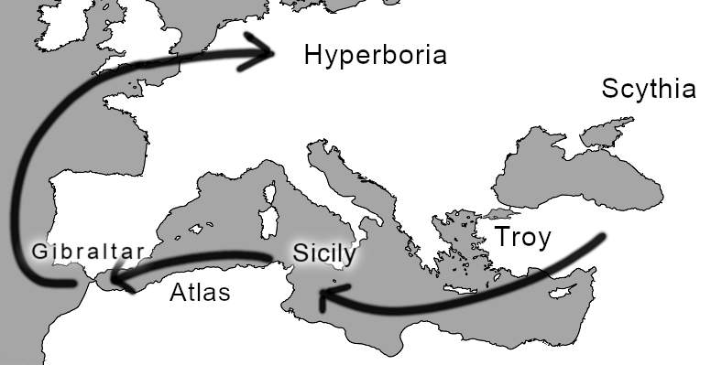
By moving everything north, the storytellers could once again link the edge of the world to the Black Sea, where the eastern Pillars of Heracles were once located. And so the Pillars came full circle.

Herodotus on the Atlantians
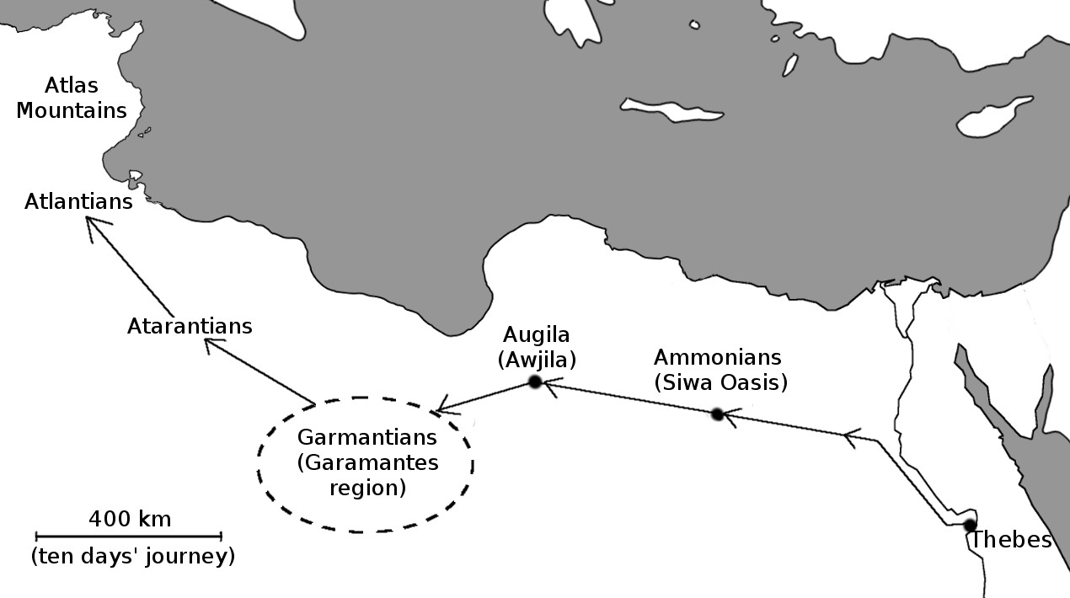
Herodotus, writing around the same time as Plato, describes his journey from Egypt to the Atlantians. Herodotus describes a journey between specific oases. These are each ten days’ journey (400 km) apart. So we can trace this journey on a map. This leaves no doubt that Lake Tritonis, home of the Atlantians, must be the old Sea of Atlas in Tunisia.

Lake Tritonis is very important because Herodotus describes a prophecy from the story of the Argonauts: if the Greeks place their temple there, they will control the whole region. The account begins:
“[A]long the sea-coast are the Machlyans, … These extend to a great river named the river Triton, and this runs out into a great lake called Tritonis, in which there is an island named Phla.”
“Phla” (or “Phlha”) could mean “crush”. That is a good name for an island that was once crushed, like the city of Atlantis. Or it could mean “burnt” or “flame”. Herodotus then introduces the prophecy (the oracle):
“About this island they say there was an oracle given to the Lacedemonians that they should make a settlement in it.”
The Lacedemonians are the Spartan descendants of the Argonauts. Here is the prophecy in more detail, with another reference to the famous shoals of mud, the entrance to the land of the Atlantians:
“The following moreover is also told, namely that Jason, when the Argo had been completed by him under Mount Pelion, put into it a hecatomb and with it also a tripod of bronze, and sailed round Pelopponese, desiring to come to Delphi; and when in sailing he got near Malea, a North Wind seized his ship and carried it off to Libya, and before he caught sight of land he had come to be in the shoals of the lake Tritonis. Then as he was at a loss how he should bring his ship forth, the story goes that Triton appeared to him and bade Jason give him the tripod, saying that he would show them the right course and let them go away without hurt: and when Jason consented to it, then Triton showed them the passage out between the shoals and set the tripod in his own temple, after having first uttered a prophecy over the tripod and having declared to Jason and his company the whole matter, namely that whensoever one of the descendants of those who sailed with him in the Argo should carry away this tripod, then it was determined by fate that a hundred cities of Hellenes should be established about the lake Tritonis. Having heard this the native Libyans concealed the tripod.”
There are several points to note in this passage:
- Herodotus chooses to begin his description of Libya with this story: it is the key to understanding the known world west of Egypt. That is, it is the key to knowing who the Atlantians are.
- The tripod is a portable temple: this is a three-legged bronze object, either a cauldron for offerings or a stool for the oracle. When you want to establish your power in a new land, the tripod becomes your makeshift temple, and you add the pillars and altars later.
- The god Triton says that a hundred Greek cities will be built around Lake Tritonis, showing that the Greeks will conquer the region. (A “city” in ancient times was any camp that had permanent defensive walls.)
- The native Libyans feared this prophecy was true: Greece was expanding in power. So they hid the tripod, hoping to delay it.
Herodotus continues to tell us about Lake Tritonis:
“These [the tribes north and south of Tritonis] dwell round the lake Tritonis, and the river Triton is the boundary between them. … They say moreover that Athene is the daughter of Poseidon and of the lake Tritonis, and that she had some cause of complaint against her father and therefore gave herself to Zeus, and Zeus made her his own daughter.”
So this is the story of the decline of the Atlantians: Their island is crushed, their sea is no longer navigable due to mud, and the goddess of war has deserted them for the Greeks. That is Plato’s story in a nutshell.

Diodorus on Atlantis
The location of Atlantis is confirmed by the Greek historian Diodorus Siculus. He writes of an era “many generations” before the Trojan War (c.1200 BC). This is an era when Lake Tritonis is a marsh. So it is after 3,000 BC when the Sahara dried up. At this date, a race called the Amazons occupies Tritonis, and the Atlantians used to live there but now live nearer to the coast. Diodorus’ description is like that of Herodotus. It is about a great lake (now a marsh) called Tritonis. It containing a large peninsula that houses a great city. The lake empties into the sea by the River Tritonis. The lake (the marsh) is next to Libya, with the Atlas Mountains on one side, and Ethiopia on the other. (Ethiopia then meant all of Africa south of Libya.) Like Plato, he says the city was destroyed in an earthquake.
“[The Amazons’] home was on an island which, because it was in the west, was called Hespera, and it lay in the marsh Tritonis. This marsh was near the ocean which surrounds the earth and received its name from a certain river Triton which emptied into it; [i.e. the ocean refers to the open sea, the Mediterranean] and this marsh was also near Ethiopia and that mountain by the shore of the ocean which is the highest of those in the vicinity and impinges upon the ocean and is called by the Greeks Atlas. … they subdued many of the neighbouring Libyans and nomad tribes, and founded within the marsh Tritonis a great city which they named Cherronesus​ [peninsula] after its shape. The first people against whom they advanced, according to the tale, were the Atlantians, the most civilized men among the inhabitants of those regions … The story is also told that the marsh disappeared from sight in the course of an earthquake, when those parts of it which lay towards the ocean were torn asunder.”

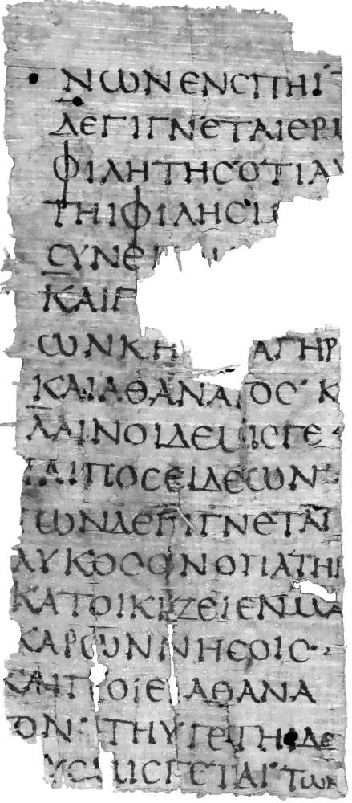
The name and story predate Plato
Image: Papyrus Oxyrhynchus 1084, Public Domain via Wikimedia
This image is a fragment from “Atlantis” by Hellanicus. Hellanicus lived in the 400s BC, before Plato was born. We do not have the complete book, but it clearly dealt with the daughters of Atlas (Atlantis means “daughter of Atlas”). This implies their lands, and the people of those lands. We have a more complete account of the daughters of Atlas from Diodorus. Diodorus wrote after Plato, but he summarised earlier writers. He described the daughters of Atlas in the same way that Hellanicus did, so we are on the same topic. Diodorus showed how these daughters founded the geographical region we call Atlantis. Diodorus gave other details that agree with Plato’s account.
So Hellanicus’ Atlantis covers the origins of the region of Atlantis, as Plato did.
Diodorus also gave the origin myth of the Atlantians, and their later history. He quoted from the Atlantians themselves. He did not quote from Greeks like Plato. He compares the Atlantian origin myth with the Greek origin myth to see if they are different. He begins:
“But since we have made mention of the Atlantians, we believe that it will not be inappropriate in this place to recount what their myths relate about the genesis of the gods, in view of the fact that it does not differ greatly from the myths of the Greeks.”
So both Diodorus and Hellanicus cite histories off Atlantis that do not depend on Plato. Hellanicus’ account definitely predates Plato. Diodorus’ account probably does as well.
Hesiod’s Theogony also features Atlantis before Plato, as we will see.
Soon we will see much older accounts of Atlantis from the Egyptians and from the Greeks and from archaeology.

How an earthquake caused the flood
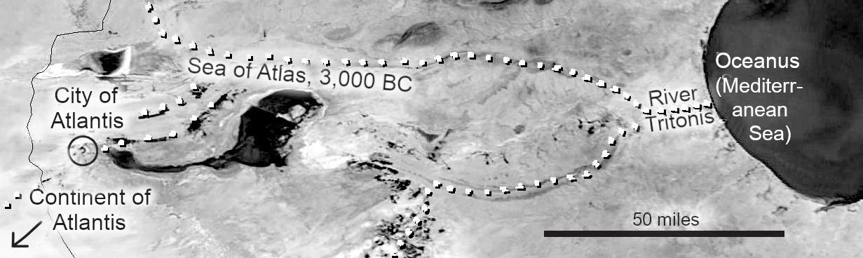
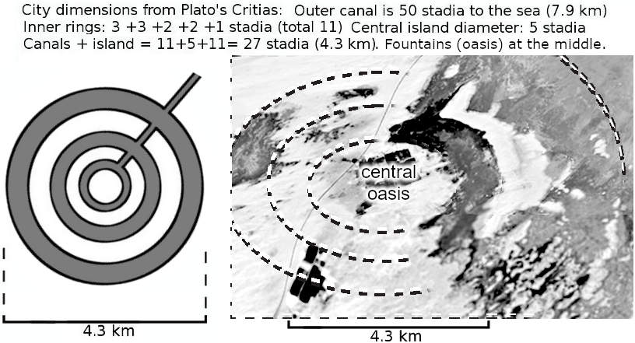
For the precise location of the city of Atlantis, and how it sank, see the research by professor Hong-Quan Zhang in the International Journal of Hydrology. Here is a quick visual summary.
Image: adapted from Landsat image of Tunisia, NASA, Public Domain
Image: adapted from Landsat image of Tunisia, NASA, Public Domain
By comparing Diodorus, Plato, and others, we see that the city of Atlantis is on a peninsula in the Sea of Atlas (Lake Tritonis). The sea was fed by rivers from the Sahara and emptied into the Mediterranean via the River Tritonis. This is an earthquake zone, so at some point, the River Tritonis became blocked. The Sahara rivers continued to flow in, so the water level rose, flooding the city.
As the Sahara dried, the sea shrank. The final earthquake and mudslide was probably around 1,200 BC. See the discussion of the Late Bronze Age collapse later in this appendix.

A fun coincidence is that Star Wars (the 1977 movie) begins in Atlantis. The movie set for the Luke Skywalker home is inside what was once the outer harbour of the city of Atlantis. To find it, search for “Lars family homestead exteriors” on Google maps, then look one mile to the west.
After the Collapse, Phoenicians moved westward to fill the power vacuum. Dido, the Phoenician queen founded Carthage in 814 BC. She needed permission from the local people of Atlas (i.e. from Atlantians).
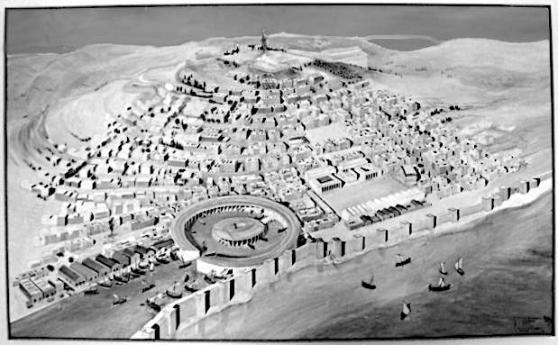
As shown earlier, the common people of Carthage were not Phoenician. They were from the Sahara. That is, they were local people: they were Atlantians. So the design of Carthage is not surprising. Carthage was on a peninsula, mostly surrounded by water. It had a roughly circular design, with an iconic circular harbour. Carthage looks like a memory of Atlantis.
Image: Carthage National Museum, photo taken by ‘Shoestring’ at Wikitravel. Fair Use.

The Atlantis War in archaeology
Let’s go back to where it all began before 9,000 BC. The greening of the Sahara began around then. This would naturally cause the people of Atlas to grow in numbers, and to spread out. Meanwhile, the people of the fertile crescent were developing farming. They were also expanding in numbers and spreading out. They would naturally meet around the River Nile, This was the start of the conflict.
After that, the same culture occupied the same lands until the present day (see map). So Egypt was Egypt back to 8,700 BC, and before that as hunter-gatherers.
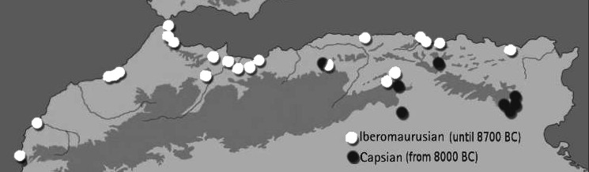
At this time, before 8700 BC, the Atlantians are known to scientists as "Ibero-maurusians". They were expert hunters with the bow and arrow. But then a crisis hit: the “Younger Dryas” event caused a sudden drought. This was climate chaos caused by the end of the ice age. It affected different parts of the world at different times, due to local ocean currents and so on. The Atlantians felt the effects later than most, perhaps protected for a while by the opposite effect of the greening Sahara. But by 8700 they were forced to move. All the Ibero-Maurusian sites disappear after 8700 BC, and for seven hundred years there is nothing. Then they reappear further west around 8000 BC. Scientists call these new Atlantian sites “Capsians”.
Map based on The Oxford Handbook of African Archaeology, 2013, Fair Use
So the Atlantians left their home in the Atlas Mountains around 8700 BC, then went somewhere, then came back to the eastern edge of their old homeland around 8000 BC. Where did they go in the missing 700 years? The drought was forcing them Eastward, so there was only one place to go: toward the Nile: to Egypt.
At that time we call the Egyptian empire “Natufian”, but they are the same people, the same culture, occupying the same lands.

Egypt, 9,000 BC
The Capsians moved toward Egypt, around 8,700 BC. This coincided with a big change in Egypt. This change looks exactly like somebody invaded and killed or drove out the previous inhabitants.
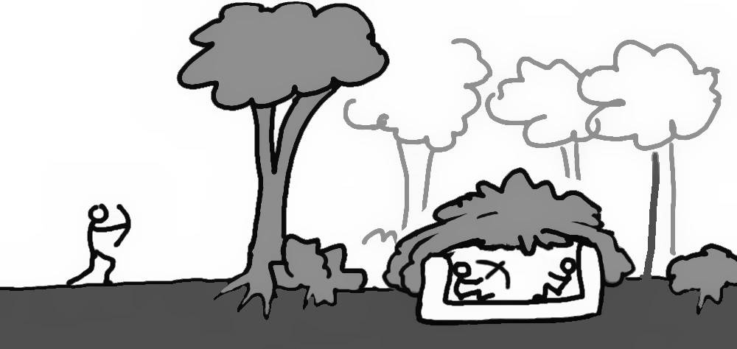
The original inhabitants of Egypt were called Natufians. They lived in regular villages and did not use bows and arrows. But Capsians used bows and arrows. Around 8,700 BC, archaeology shows that the Natufians disappeared from Egypt. They were replaced by a new people, who seem to be the same as Natufians, except they now use bows and arrows, and they began living in forests, in half-buried homes.
The change to using bows and arrows and living in hiding, suggests an invasion of people who used arrows. The arrow-less Natufians were killed or driven out, and the survivors had to adopt the new technology or die.
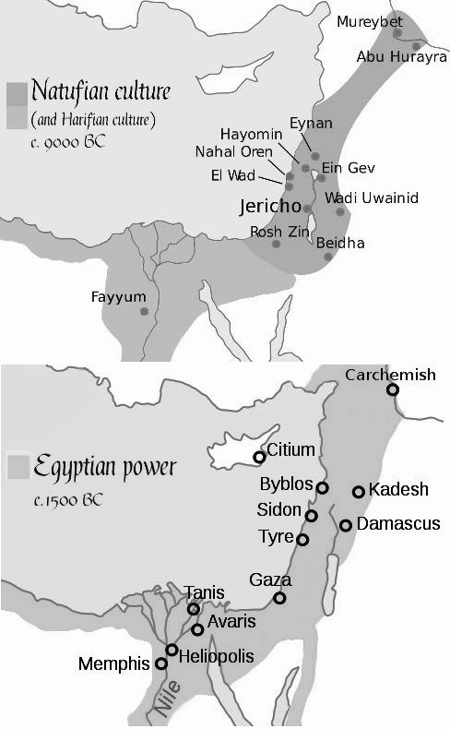
Around this time, 8,700 BC, the “Pre-Pottery Neolithic” (PPN) culture arrived from the fertile crescent. They were closely related to the Harifians, but changed their culture as well: from “PPN-A” to “PPN-B”. PPN-A was nomadic, but PPN-B settled into permanent villages and also spread out to conquer new territories. PPN-B built the defensive tower and wall at Jericho in 8,000 BC. PPN-B was the start of our ten thousand-year civilisation based on land ownership.

The first constitution of Egypt (and of Athens)
The biggest change in Egyptian history was not the first Pharaoh. That was just when one king beat the other kings. The biggest change was when they stopped being nomads and settled in permanent farms and villages, around 8,700 BC. A nomad (like the PPN-A) needs to be able to hunt and gather and build shelters. But settled people need specialist builders, specialist farmers, and so on. That division of labour is what Plato called a “constitution” in Timaeus:
“[The Egyptian] constitution was recorded in our sacred registers to be eight thousand years old. … In the first place, there was the caste of priests, which was separated from all the others; next, there are the artificers, who ply their several crafts by themselves and do not intermix; and also there was the class of shepherds and of hunters, as well as that of husbandmen; [etc]”
So gaining a constitution just means they stopped being hunter-gatherers. That is, they started having laws about who did what. This took place around 8,700 BC in Egypt.
Plato said that Egypt’s constitution dates to just before 8,000 BC (and Athens’ dates to 9,000 BC):
“Many great deluges have taken place during the nine thousand years, for that is the number of years which have elapsed since the time of which I am speaking … [the goddess Neith, equivalent to Athena] founded your city [Athens] a thousand years before ours, receiving from the Earth and Hephaestus the seed of your race, and afterwards she founded ours, of which the constitution is recorded in our sacred registers to be eight thousand years old.”
Egyptian records confirm that Egypt traces its first kings to 9000 BC. Recall Manetho’s history from chapter 5:
- 28000 BC: gods rule
- 14000 BC: demi-gods (half god, half-human) rule
- 9000 BC: the demi-gods die. The next 5800 years is the era of “the spirits of the dead”, indicating that many people died. Gods were no longer in charge, so ordinary people were fighting to become kings.
- 3200 BC: the first Pharaoh unites Egypt.
The date of around 9000 BC is also supported by Herodotus:
“Thus far went the record given by the Egyptians and their priests; and they showed me that the time from the first king to that priest of Hephaestus [he was speaking of around 700 BC], who was the last, covered three hundred and forty-one generations…”
Herodotus took a generation to be 33 years, but a more realistic number is 25 years or less, meaning the first king was (341 x 25) + 700 BC = 9,200 BC or later.

The origin of Athens
Athens is just the city of Athena, goddess of war. The goddess (and therefore her followers) existed before the city.
When Plato spoke of the Athenians, he included the nomads in the surrounding mountains:
“[t]he survivors in your country are herdsmen and shepherds who dwell on the mountains, but those who, like you, live in cities are carried by the rivers into the sea.”
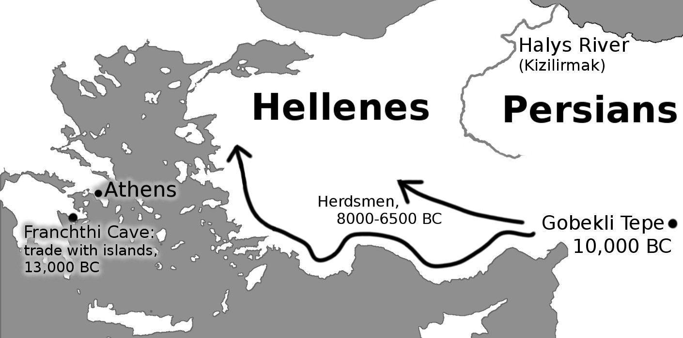
These nomadic herdsmen, followers of Athena, are the same Hellenic people who herded cattle in Anatolia until around 6,000 BC.
Herdsmen data: Benjamin S. Arbuckle: "Data Sharing Reveals Complexity in the Westward Spread of Domestic Animals across Neolithic Turkey" (vol 9, e99845, 2014) researchgate.net/figure/Map-of-Turkey-showing-the-location-of-sites-mentioned-in-this-analysis-Arrows-indicate_fig1_295807459
Even after Athens was settled, Hellenes still lived in Anatolia (modern-day Turkey): the city of Athena (Athens) was merely their ruling shrine. We know this because Herodotus said the Hellenes of Phrygia needed permission to rule from the oracle at Delphi, near Athens.
“He [Croesus] obtained the kingdom however and was strengthened in it by means of the Oracle at Delphi”
So Anatolians and Athenians are the same people. (And distinct from the Persians: Herodotus places the border at the Halys River). The Anatolians became settled farmers around 9,000 BC, a thousand years after building Gobekli Tepe in 10,000 BC. That is, their division of labour — their constitution — began around 9,000 BC.
The Egyptians, who date their constitution to 8000 BC (and their kings to 9000 BC), knew that the Anatolians came first. They considered the Phrygians (Anatolians) to be the very first humans. After the Phrygians came the Egyptians, and after them, everyone else:
“Now the Egyptians […] suppose that the Phrygians came into being before themselves, but they themselves before all other men.”
It is true that the Hellenes did not settle the “city” of Athens in 9,000 BC, but Plato’s word for “city” of Athens means “community” of Athens. Because most people did not live within the relatively small city walls. The community of Athens simply means the followers of Athena, goddess of war. Herodotus noted that Athena was born in Lake Tritonis. Lake Tritonis is the site of Atlantis, where the Athenians were swallowed by the sea.

The Earthquake that stopped the Hellenes
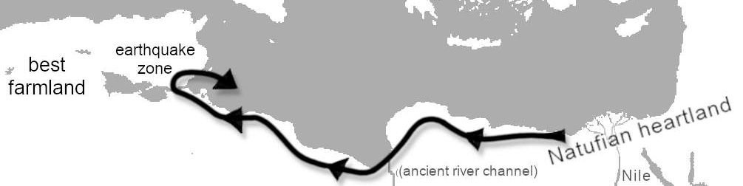
Skirmishes between the Capsian hunter-gatherers and the Natufian farmers lasted a thousand years, and the farmers won. But for some reason, the Natufian farmers never expanded across North Africa into the rich farmland of the Atlas Mountains. Why not? In the wet Sahara era, this was the easy and obvious direction with vast potential. But their slow expansion took them through the Tunisian earthquake zone. Sometime in that thousand years, an earthquake probably blocked the River Triton and flooded their farms. This was devastating for farmers but much less important for hunter-gatherers. So the Capsians maintained control of Tunisia. Plato recalls how the Greeks were killed in an Atlantian earthquake. To this day, the Greeks remember Poseidon (the god of Atlantis) as the god of earthquakes.

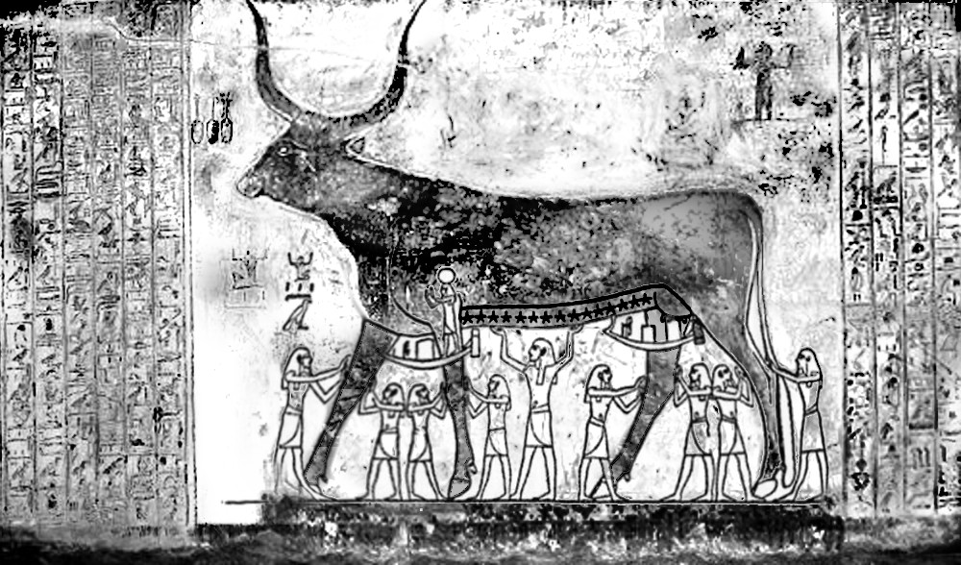
How Egypt remembered the Atlantis war
Image: adapted from Edward Piercy and Wallace Budge, via Wikimedia (public domain)
Plato said that the Atlantis War was recorded on the walls of the temples. We can see it in the tomb of Seti I. The story is commonly called “The Destruction of Mankind”, or “The Myth of the Heavenly Cow”.
This is a very important story, not just because multiple copies survive, but because it is “one of the few coherent narrative accounts of the deeds of the gods of ancient Egypt.” The story tells how the people of Egypt felt that their god (Ra) was growing old and weak. So Ra became angry and decided to kill them. The blasphemers fled to the mountains. Ra searched for them with his eye, in the form of the cow goddess:
“And Ra said, ‘Lo, they have fled to the mountains, for their hearts are afraid because of what they have said.’ The gods replied, ‘Let thine Eye go forth and destroy those who blasphemed thee, for no eye can resist thine when it goeth forth in the form of Hathor.’ Thereupon the Eye of Ra, or Hathor, went in pursuit of the blasphemers in the mountains, and slew them all. On her return Ra welcomed her, and the goddess said that the work of vanquishing men was dear to her heart. Ra then said that he would be the master of men as their king, and that he would destroy them. For three nights the goddess Hathor-Sekhmet waded about in the blood of men…
Hathor enjoyed killing, wading in the blood of her enemies. Ra was afraid that she would kill everybody else as well. So Ra had an idea: filled the land with blood-coloured beer. Hathor then waded in the beer, thinking it was blood, and became drunk and happy.
Ra then took control and established order in the land. He set the stars in heaven, established the land of the dead, and generally created Egypt as we know it.
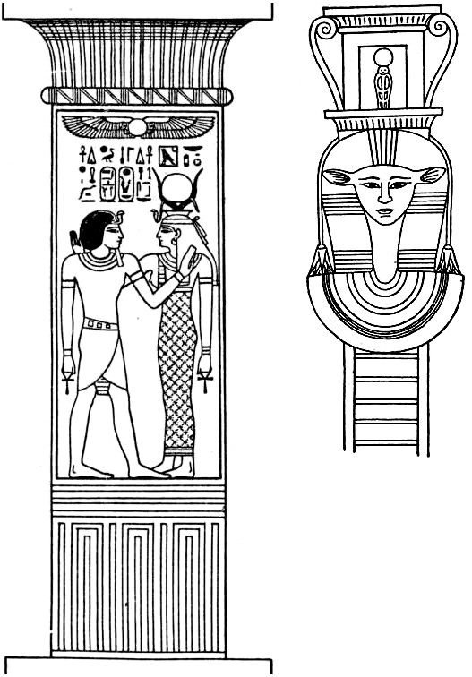
So this is the Egyptian State origin myth. But why a cow? And when did it happen?
Image: out of copyright books, via Project Gutenberg

The people of the cow
Cows reached Egypt around 8,000 BC. The Egyptian cow goddess, Hathor, was seen as the mother of Egypt. Pharaohs were often shown suckling on cows. This is not some minor detail. Hathor is on the pillars of the temples: she literally supports the kingdom.
Where did Hathor the cow come from? Cows were first domesticated around Anatolia about 10,500 BC. So Hathor came from Anatolia, northeast of Egypt.
All the myths agree that cows came from Anatolia. This is where Adam domesticated the first oxen.

Anatolians were the first to develop settled farming, and this enabled them to domesticate large animals for the first time. Cows (oxen) were huge and powerful, with great horns. Never before had humans ever enslaved such large and powerful beasts. It must have been thrilling! Hunter-gatherers had often planted crops before and had made temporary houses and permanent shrines before, but this was new. Never before had humans had such power over great animals!
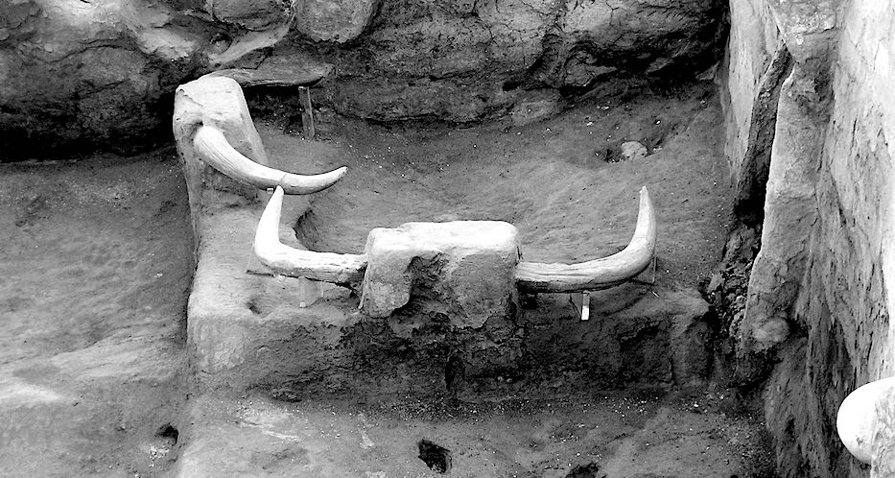
The Anatolians were crazy about cows. Their best-preserved town of the period, Catalhoyuk (7000 BC) even has cow horns in the living areas!
Image: Verity Cridland, via Wikimedia, CC-BY-2.0
So Hathor, the cow, the creator of Egypt, came from Anatolia. But if she is a motherly, supportive cow, how do we explain her extreme violence in “The Destruction of Mankind”?
The “Destruction of mankind” is about when Ra (Egypt) was weak because of “blasphemers”. So the Anatolian cow people came in, killed the blasphemers and drove the remainder out to the mountains, and then settled. Ra was then strong. Egypt became the land of both Ra (the desert sun) and Hathor (the cow). The cow people loved violence, but it was finally ended with beer. Beer always follows farming, because when excess grain gets old and rots, it ferments. Beer festivals (with their associated debauchery) gave hunter-gatherers a reason to join the system that otherwise had little to offer except hard work and fighting over land. Beer and debauchery were the selling points, as we see in Gilgamesh.

Who were the “blasphemers" and why did they make Ra weak?
It is extremely rare for a god to admit weakness, so this must have been extremely serious. These blasphemers were a threat that Ra could not survive because he had to invite in the warlike cow people, who then drove the blasphemers out to the mountains.
Which mountains? So far, the story reflects real history: the arrival of cow-based farming from Anatolia in the northeast. So we are looking for a real massacre in real mountains. Are these mountains the mountains of Anatolia? No, because the Anatolians became Egypt’s allies. Are these mountains the mountains of southern Egypt and Arabia? That is unlikely, as the story says they fled away from Ra: that is, they ran away from Egyptian lands, which is why Ra had to send Hathor away to seek them out. That leaves the mountains of the West as the most likely site of the massacre.

The blasphemers came from the West
Cows came to Egypt from the northeast, and Hathor was the god of giving birth to Egypt because Anatolian cows gave Egypt her famous agriculture. However, Hathor was also associated with death in the western mountains. Hathor was called “the lady of the West” where the sun sets and the land of the dead begins. The Egyptians called this land “the land of Manu”. So the Book of the Dead calls Hathor “The Lady of the Headland of Manu” meaning “the lady of the western mountains”. These are the mountains where the sky meets the ground at the edge of the world: the mountain that Athenians call the mountains of Atlas. So when the “Destruction of Mankind” says that Hathor was chosen to seek out the blasphemers in the mountains, and to kill them all, it almost certainly means the western mountains, the mountains of death, the mountains of Atlas, the entrance to the land of the dead.
This is important: in the Egyptian origin myths, the Atlas Mountains are the lands of death. Remember this when we look at the Greek origin myths.

Summary
Here is the Book of the Heavenly Cow in summary. Long ago, Egypt was weak. The people of Atlas moved in and killed a lot of Egyptians. Then the PPN people from the fertile crescent moved in with their cow-based culture. They drove the blasphemers away and killed them in the Atlas Mountains. The bottom line is that the ancestors of the Athenians saved Egypt from the Atlantians.

How Athens remembered the Atlantis War
We saw in Appendix 2 how the ancestors of the Athenians (the PPN) had uninterrupted records on pillars back as 9000 BC. Their records were largely destroyed, but we can still detect a glimpse of the Atlantis war in the Greek origin story: the Titanomachy.
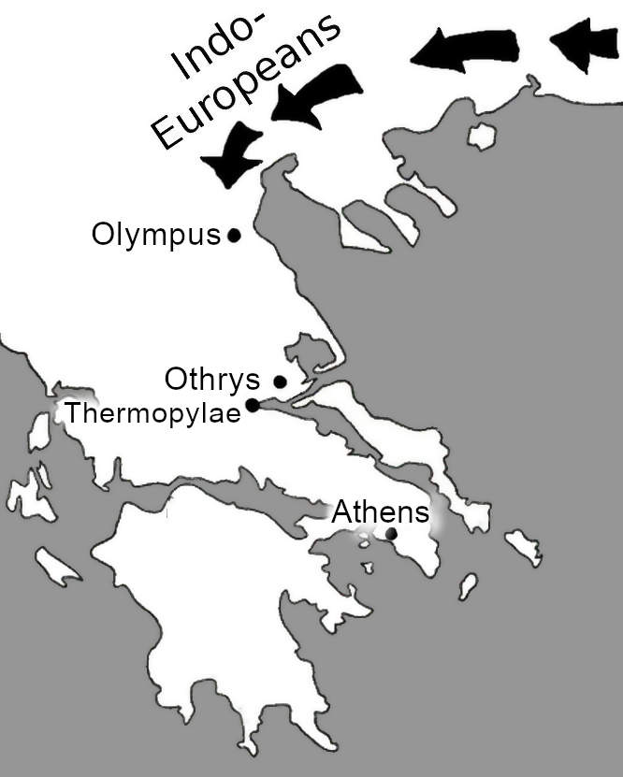
The Titanomachy is the story of the battle between the Greek gods (based at Olympus) and the Titans (based at Othrys). According to Diodorus Siculus and others, the Titans were the first inhabitants of the land. The gods were new invaders. A glance at the map shows what probably happened. The invaders were Indo-Europeans from Anatolia. Othrys was near Thermopylae, which controlled access to the rich lands to the south. (300 Spartans later made this location very famous.) By establishing a base at Othrys, the native people prevented the invaders from reaching the best lands further south. So the invaders established their base at Olympus instead.
The invaders could not move south, so they went back around the Mediterranean. They fortified Egypt. (They were Pre-Pottery Neolithic, so this was already friendly territory.) Then they took control of Libya:
“Jupiter [Zeus, king of Olympus] bade Epaphus, whom he begat by Io, fortify the towns in Egypt and rule there. First of all he founded Memphis, and then many others. By Cassiopia his wife he begat a daughter, Libya, from whom the land is named.”
Libya ends at the Mountains of Atlas. So the Titans (the original people of the Mediterranean) still controlled the Atlas Mountains.
Hera, the wife of Zeus, felt that Zeus had too much power. She disliked Zeus because he was always raping women — perhaps a symbol of expanding and conquering other lands, instead of being happy with his own land (his own wife). So Hera encouraged the Titans to fight back. The people of Atlas (i.e., the Atlantians) tried to regain control of Libya and Egypt. They moved west.
But the Greeks won They pushed the Titans back to the West:
“WAR WITH THE TITANS: After Juno [Hera, wife of Zeus] saw that Epaphus, born of a concubine, ruled such a great kingdom, she saw to it that he should be killed while hunting, and encouraged the Titans to drive Jove [Zeus] from the kingdom and restore it to Saturn [Cronus, king of the Titans]. When they tried to mount heaven, Jove with the help of Minerva, Apollo, and Diana, cast them headlong into Tartarus [see below for its location]. On Atlas, who had been their leader, he put the vault of the sky; even now he is said to hold up the sky on his shoulders.”
This is essentially the same as the origin myth of the Egyptians. The people of Atlas (the Titans) invaded Egypt. The ancestors of the Athenians then drove them out. There was mass death in the lands of Atlas. The people of Atlas could never again leave the mountains of Atlas. That is the story of the Atlantis war.

A 9,000-year pattern
This story simplifies 9,000 years. But the pattern will have repeated many times. Because the myth reflects deep realities.
- The Pre-Pottery Neolithic brought agriculture. This brought change. They always wanted to expand.
- North Africa had a large population. They could fight back.
- Tunisia was the strategic crossroads on both land and sea.
- The climate changed massively, affecting points 1 and 2.
Therefore conflicts like this will have happened many times. Mythology combines similar events. For example, Diodorus found then-recent wars that fitted the old pattern. He found multiple candidates for Hercules, Dionysus, etc. That is just how mythology works: it combines similar events to make them more memorable. As long as the general myth is remembered, future generations can decode the details.

Atlantis and the origin of the gods
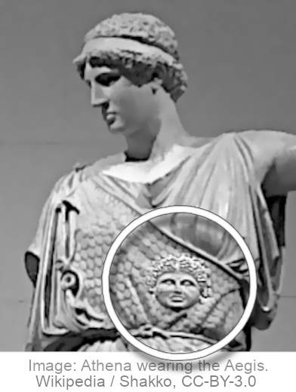
Hesiod's Theogony ("the origin of the gods") is the story of the Atlantis war. It predates Plato. It shows how the Greek gods gained their power by defeating Atlantis.
The source of Greek power is Zeus, head of the gods. The proof of Zeus' power is that he wears the Aegis. The Aegis is an item of clothing (or a shield) worn by the leader of the Greeks. It showed an image of Medusa, the leader of the Gorgons, the matriarchal conquerors of Atlantis. Diodorus placed them at Lake Tritonis. When people saw the Gorgons they froze in fear, as if they turned to stone. The first and greatest Greek hero, Perseus, killed Medusa. Carrying the image of Medusa proved that the Greeks could defeat the most fearsome enemy in the world.
The Aegis (symbol of the Gorgon tribes) dates to at least 6,000 BC in Anatolia, and probably much earlier. It terrorised or burnt the following regions of the world: first Anatolia, then the nearby mountains, then the fertile crescent as far as India, then Egypt, then Libya, and finished in the northwest coast of Greece. This matches the spread of the matriarchal Indo-European tribes.
Hesiod records how the Greek gods rose to power by defeating the Titans. He shows how they were based in the land of the Gorgons, the region we now call Tunisia. He refers to an island belonging to Atlantis. Here are the details.

Early Greek geography
As noted earlier, the Greek world before the time of Plato was very small. Most Greeks did not know even where Libya was. The other side of Okeanos meant the other side of the Mediterranean. Even Herodotus did not know anything west of Sicily. To Herodotus, “Mount Atlas” was a lone mountain in Tunisia, and not the long ridge of mountains further west.
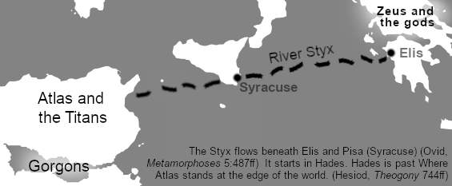
To the Greeks, the sun went down near Mt Atlas in Tunisia. This was the land of sleep, and the land of the dead (The Egyptians agreed.).
"There stands the awful home of murky Night wrapped in dark clouds. In front of it the son of Iapetus [i.e. Atlas] stands immovably upholding the wide heaven... There, in front, stand the echoing halls of the god of the lower-world, strong Hades..."
The Greeks imagined an underground river taking the dead from Greece to Hades in the West, past Mt Atlas in Tunisia. The route took it past Syracuse in Sicily.
The Gorgons lived in the same region. They "dwell beyond glorious Ocean in the frontier land towards Night where are the clear-voiced Hesperides".
The Hesperides ("of the evening”) are the seven daughters of Atlas. Naturally they would live near Atlas. They have a beautiful garden. Herodotus said that the Argonauts crossed Lake Tritonis to reach it: it is the garden of the evening, where the sun goes down. The daughters also have an island called Erytheia, meaning the "red island" in the sense of sunset. All of these clues suggest that the island of the Hesperides was in Lake Tritonis. It belonged to all the seven daughters, but the oldest daughter would be in charge. Herodotus calls this daughter Maia. Maia is a daughter of Atlas or in Greek “Atlantis”. So Erytheia was the island of Maia who was “Atlantis”.
The Titans were based in the same region. The Theogony tells how Zaus and Athena defeated the Titans. It tells us that Athena was born on Lake Tritonis. We also learn that Triton (the god and presumably also the river) was born out of the earthquake aspect of Poseidon. This could be a memory of the earthquake that blocked the River Triton, causing Atlantis to flood, ending its power forever.

The Titans were sent back to Tartarus. Specifically, they were sent to a city near Mt Atlas (i,e., in or near Tunisia): "In front of it the son of Iapetus [Atlas] stands immovably upholding the wide heaven". The city has a wall and gates of bronze, encircled "in triple line", watched over by Poseidon.
"Round it runs a fence of bronze, and night spreads in triple line all about it like a neck-circlet, while above grow the roots of the earth and unfruitful sea. ... Poseidon fixed gates of bronze upon it, and a wall runs all round it on every side."
Compare Plato's description of the city of Atlantis:
"The entire circuit of the wall, which went round the outermost zone, they covered with a coating of brass ... [the city was] regulated by the commands of Poseidon which the law had handed down."
Hesiod imagines that once inside the walls you fall down a great pit. But he has never been there: the story is simply to scare people away.
"...if once a man were within the gates, he would not reach the floor until a whole year had reached its end, but cruel blast upon blast would carry him this way and that. And this marvel is awful even to the deathless gods."
But the place of the dead was not always scary. Before 600 BC it was described in pleasant terms. Homer refers to the dead going to “the fortunate isles”. Stesichorus refers to "The beautiful island of the gods, where the Hesperides have their homes of solid gold." Solon (soon after 600 BC) admired the description of Atlantis with its golden buildings. But after 600 BC, Greece began colonising the Mediterranean. From that time, Carthage became the enemy. Tunisia became enemy territory. So the island to the west became thought of as a dark and scary place to visit.
And then, as the Greeks pushed further west, their idea of the western edge of the world also pushed further west.

Summary
In summary, Hesiod names Atlantis, he says she had an island, and he places that island in Lake Tritonis in Tunisia. This is the island of the dead, where the sun goes down. It was once considered to be a glorious place. But as the Greeks moved westward everything changed. Carthaginians became enemies, and the place of sundown moved west. So the myth became muddled. But originally it was simple.

Measuring the city (and continent)
Plato gave precise measurements for the circular harbours and described the chariots and boats. But the city had been mostly buried for at least five hundred years. Where did he get those measurements? He gives us a big clue: he said that the continent of Atlantis was “larger than Libya and Asia combined” and was the route to the continent beyond the ocean. This tells us that Plato (or rather, his source, Solon) had information from the Phoenician sailors who circumnavigated Africa in 600 BC.
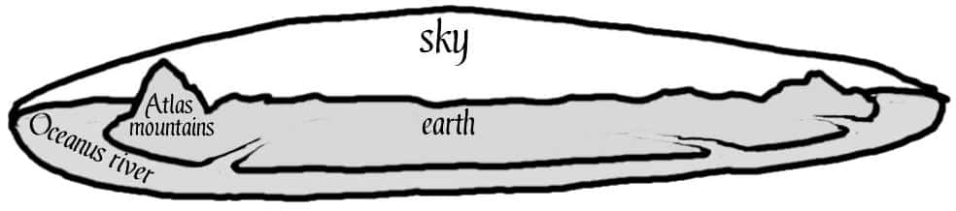
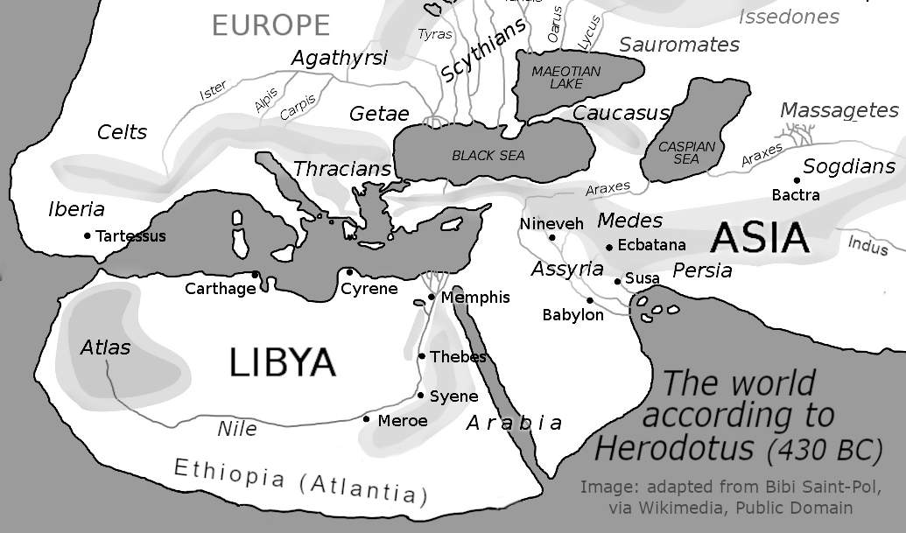
Atlantis was Africa south of the Sea of Atlas. In Plato’s day, Africa was called Libya and was thought to extend no further south than modern Ethiopia.
In Plato’s day, Ethiopia just meant the edge of Africa, from east to west. “Ethiop” meant “burnt face”: The Greeks reasoned that Ethiopians had dark skin because it was burnt by the sun: they lived at the very edge of the world, where the sky came close to the ground. Beyond the edge of the land (beyond Ethiopia) was the ocean that circles the world, and beyond the ocean is a continent where sky and ground meet. The Atlas Mountains are at the edge of the world, holding up the sky.
Ethiopia was previously called Atlantia because it is the land of Atlas, at the edge of the world.
So Plato knew of a land bigger than Libya and Asia combined, which was a route to more distant lands. But how did he know? And how did he know the precise dimensions of the city of Atlantis? Our next clue is the date.
Plato got this information from Solon. Solon learned of Atlantis when in Egypt, probably in 594 BC. That was probably the year when Phoenician sailors returned to Egypt after circumnavigating Africa.
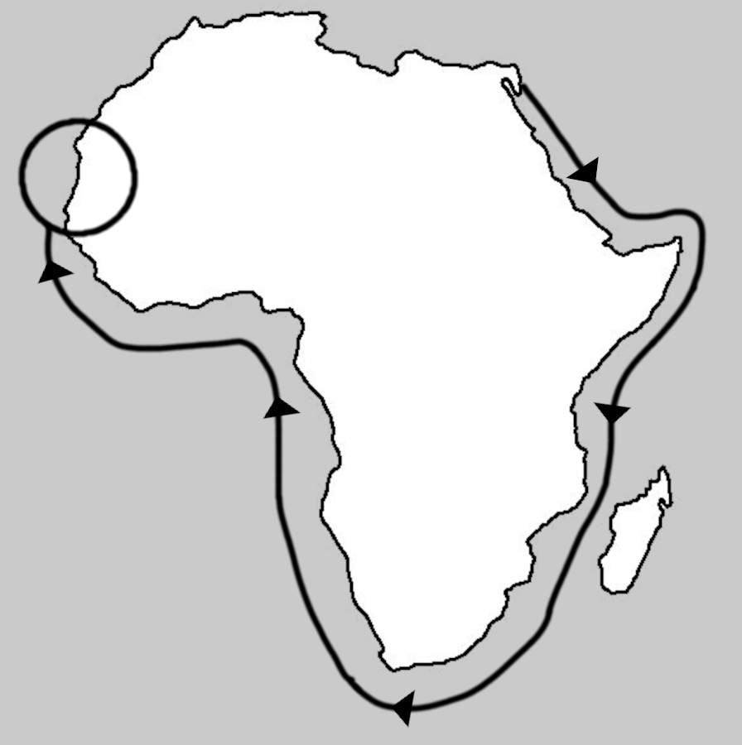
Pharaoh Necho had just lost the Egyptian empire in the East. This was the greatest disaster in Egypt’s long history (from his perspective). So he needed new lands to conquer, or at least trade with. As the Herodotus map shows, everybody thought that Libya extended only to the West and that the Nile began at the Atlas Mountains (in the West). So Necho sent out his Phoenicians to see what they could find. The best thing would be the source of the Nile in the Atlas Mountains: that would allow Necho to easily send his navy throughout Libya. They would need to build canals or some other way to bypass the Cataracts, but Necho was a canal builder, so that would be no problem.
The mission took three years. Along the way, they stopped to plant crops, and while the crops grew they explored inland. One place they would have landed was the Bay of Arguin: a natural harbour, with excellent fertile soil, and the first time they would hear familiar languages. Later the Phoenicians created an important outpost here.
“[T]hey must have landed somewhere on the coast of modern Mauritania, maybe at Bay of Arguin, where their Carthaginian compatriots were to build the trading post of Kerne in the not too distant future.”
As they explored for months looking for inland routes to Egypt, and anything of value, questioning local guides, what would they find?
Today we know that the only features of interest are the wadis (seasonal streams) that lead toward the high ground, Ben Amera (Africa’s version of Ayers Rock), the Adrar (“mountain”) plateau, possibly some villages, and the famous Richat Structure.
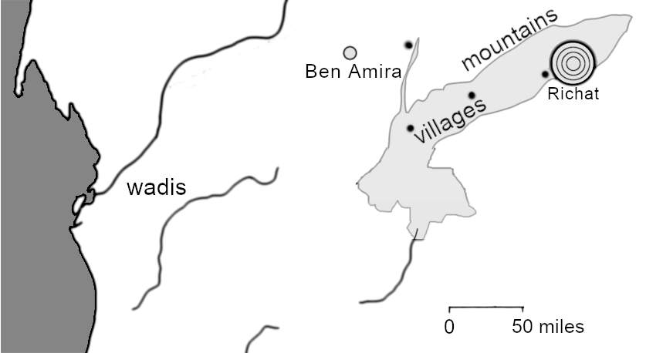
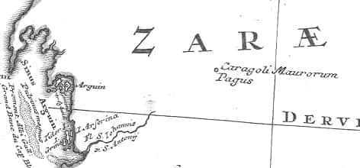
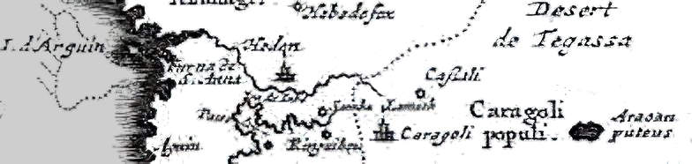
We don’t have local maps from 600 BC, but we do have maps from the first European explorers around 1700 AD. These maps show one site more than any other: they called it “Caragoli”, meaning “spiral shape”. Or, “Caragoli Maurorum Pagus” (“spiral shape Moorish site”)
Image: 1743 map by Homann Heirs, Public Domain
Image: detail, 1713 map by Pieter van der Aa, Public Domain
Other maps of the early 1700s show just “Caragoli”, plus “Caragoli Populi” (the people of the spiral) and also “Araoan puteus” (the Araoan well), meaning there is water there. Other maps show a large seasonal river leading straight to the Caragoli.
Mercator’s 1569 map shows a line of mountains pointing from the islands to the Caragoli. These should run parallel to the coast. But Mercator draws them as if they are the route to the Caragoli. Mercator lived before the Europeans explored inland, so he relied on much older sources. His map of West Africa looks like a guide for how to reach the Caragoli: travel down the coast until you are near the Fortunate Islands [the Canaries]. Then travel inland, following the Mountains.
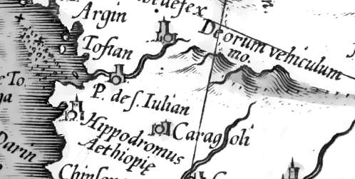
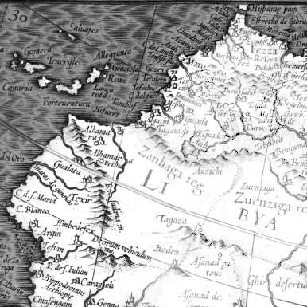
The mountains lead to the “Chariot of the Gods” (“Deodorum Vehiculum”). (This should not be confused with the volcano of the same name in far-away Cameroon.) A river then takes the traveller to the Caragoli. Near to the Caragoli is the “African Hippodrome”. These names suggest gigantic chariot races. Plato describes the city of Atlantis as having a gigantic chariot race track.
Image: 1609 copy of Mercator’s 1569 map. Public domain.
Why does the map imply that travellers should follow the mountains down to the Caragoli? Today the coastal route is easier. But in ancient times (before 3,000 BC) a great river flowed in that region. The Tamanrasett River had feeder rivers throughout West Africa. These tributaries connected all the western mountains to the Caragoli and to the ocean.
The Phoenicians knew the area was once wet. Their own Lake Tritonis, near their capital Carthage, was once a huge inland sea. So it was not hard to guess that the Caragoli was once connected to a river system.
The Caragoli has long since dried up. But the area is full of rock art, showing chariots and boats. So the Phoenicians knew about ancient chariot races and ancient rivers.
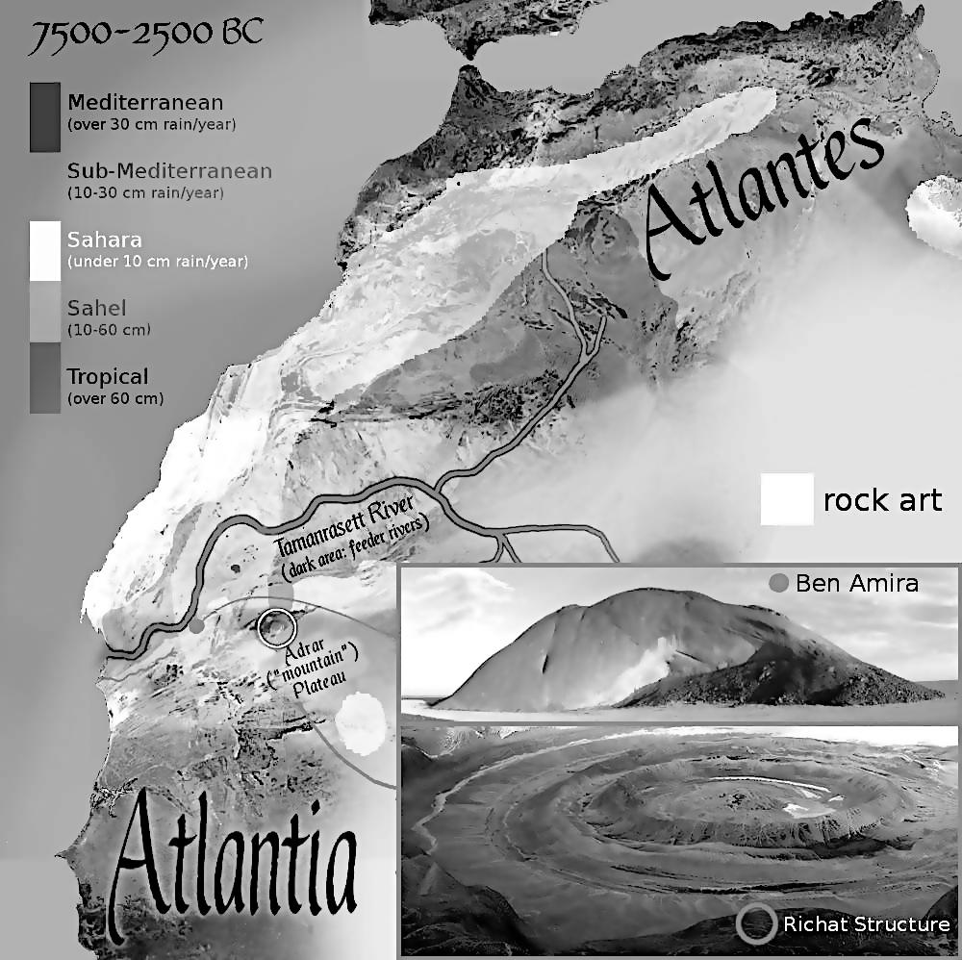
When the Sahara was wetter, water gathered in the circles of the Caragoli. This formed gigantic harbours. So the Caragoli was a gigantic natural fortress. It was linked to the ocean and to the rivers of the western Sahara.
Image: own work. Rock art and climate data from "Saharan Rock Art: Local Dynamics and Wider Perspectives" by Marina Gallinaro. Tamanrasett data from "African humid periods triggered the reactivation of a large river system in Western Sahara" by Skonieczny et al.
Most exciting of all, these harbours had the same dimensions as the ruins of Atlantis on Lake Tritonis.
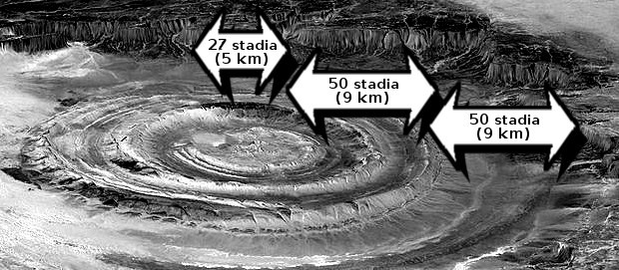
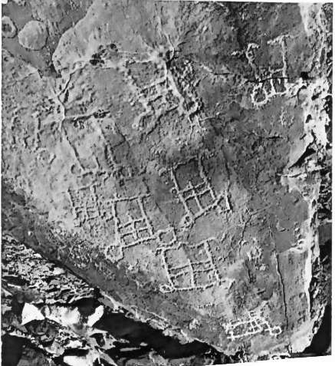
So it looks like Atlantis was modelled on the ancient Caragoli. By the time of Solon, Atlantis was long ago destroyed. The discovery of the Caragoli must have brought back memories. It must have reminded people of the dimensions of the city. So the Phoenicians returned to the city of Sais, then the capital of Egypt. Solon visited soon after. He heard the full story of Atlantis.
Image: NASA, public domain
Image: Source: Susan Searight's PhD thesis, Prehistoric Rock Art of Morocco. Fair Use.
Eventually, Plato heard the story. Being a philosopher, he drew many inferences. One of the harbours would surely be used as a race track. Harbours of that size would imply a certain number of ships. A city of that size, in that region, would be like Carthage but scaled up. A fertile plain of that size would support this many people. And so Plato inferred more and more detail. And the rest is history.

The Amazons defeat the Atlantians
Diodorus said that the Amazons replaced the Atlantians in Lake Tritonis. At this time Tritonis was marshland, so this was well after 3,000 BC. They still had a “great city” on the peninsula, until “the marsh disappeared from sight in the course of an earthquake”, “many generations” before the fall of Troy around 1200 BC. Their old lands were becoming desert, so the Amazons left Libya, and relocated to the Black Sea. Archaeology confirms the existence of female warriors on horseback, just as Diodorus describes:
“About one-third of armed Scythian skeletons unearthed in such [archaeological] digs were women.”
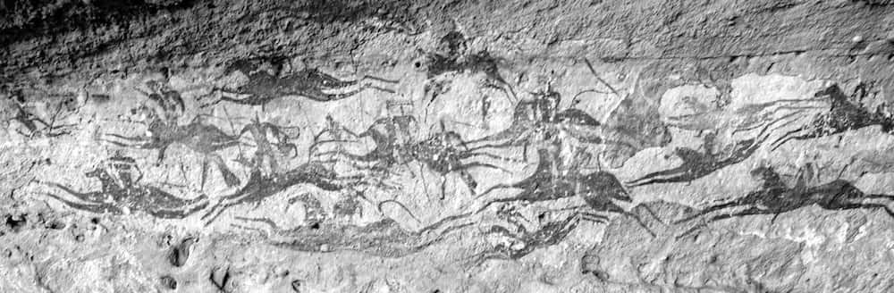
All that remains of the Amazons in the Sahara is the history by Diodorus and multiple examples of Sahara rock art showing warriors carrying spears and riding charging horses. This example dates from 4,000 BC.
Image: Valerian Guillot, via Flickr, CC-BY-2.0
Diodorus said the Amazons were female warriors, and they would remove one breast. So it is notable that, “among the rock paintings of Tassili N’Ajjer [nar the other horse paintings] are one-breasted female archers.”
And so we see how every detail in Plato is derived from older sources: temples in Egypt, Phoenician explorers, and the stories of the people of Lake Tritonis. And these sources are all confirmed by archaeology.

How the end of Atlantis may have caused the Late Bronze Age Collapse
The Late Bronze Age Collapse can be traced to the decline and fall of Atlantis. The collapse began with the attack of western Libya (i.e, the people of Atlas) against the eastern Libyans and Egypt in 1208 BC. After the war, Libya attacked again, and was defeated again. Then the Sea Peoples attacked and defeated all the old empires. This coincided with widespread famine, and an earthquake in Greece in 1200 BC (in the Tiryns citadel). There may have been other earthquakes, as “virtually all” of the Late Bronze Age sites that collapsed were in earthquake zones. So the earthquake that finally destroyed Atlantis may have also destroyed the other ancient powers. This dates the end of Atlantis to 1200 BC.

The collapse according to mythology
The Trojan war began because both Zeus (top god of Greece) and Poseidon (top god of the sea, e.g., of Atlantis) wanted Thetis (top goddess of the sea). This led to a series of events, centring on who would get the golden apple from the garden of the Hesperides (Atlantis). This was the great concern of the time: who would inherit Atlantis? Three years before the Trojan war, (1197 BC), the argonauts (greatest heroes of Greece) went in search of the Golden Fleece, a symbol of power over the world. They ended up at the garden of the Hesperides (Atlantis) with a prophecy that the Greeks would rule that region. After the fall of Troy, Odysseus, the hero of the Trojan war, ended up on the island of Ogygia (Atlantis). Odysseus was previously one of these who failed to defeat Egypt, but successfully attacked other cities: he was one of the seafaring peoples. So the Greeks remembered the Late Bronze Age Collapse (the Trojan War) as a battle over who inherits the lands of Atlas.

Other ancient civilisations that sank
Atlantis has become a shorthand for many cities and islands that sank beneath the waves. For example:
Dwarka or Dvaraka (“gateway”) was a great city on the northwest coast of India, founded by Sri Krishna. The Mahabharata describes how it sank beneath the waves. Remains of the sunken city have now been found, and are allegedly 9,000 years old, when the land was above sea level.
“Some of the samples were sent to Manipur and Oxford University for carbon dating, and the results created more suspicion since some of the objects were found to be 9000 years old.”
Kásskara was the original home of the Hopi Indians, the oldest of the native American people. The Hopi Clan of the Flute has a ceremony that preserves a memory of how they once lived in the Pacific, before sea levels rose after the ice age. Their island sank so they had to journey to the mainland. “Easter Island is the only island on our way which did not sink completely in the ocean after our passage.” Modern Hopis have nicknamed it Atlantis. This is technically correct, as all lands west of Libya were the lands of Atlas (i.e. Atlantic lands).
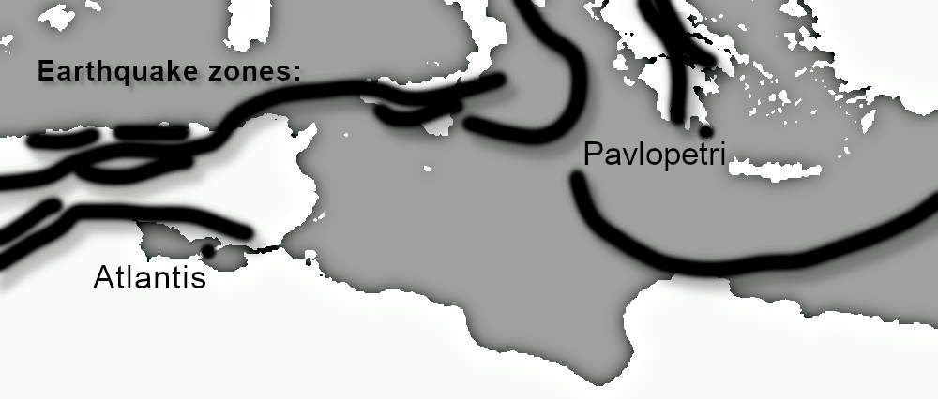
Pavlopetri was a Greek city that sank round 1,000 BC. The date is only approximate, so it could be around the same time that Atlantis finally sank (1200 BC). Pavlopetri was on the same tectonic plate system.
Tectonic plate boundaries from "Earthquakes, phase changes, fold belts..." by G. Scalera
Other great ancient floods include Doggerland (flooded 6,500-6,200 BC), the Black Sea Deluge (5,600 BC) and many more.

Jack Kirby’s Atlantis
Kirby was not interested in Natufians or the hydrology of Tunisia. He was happy to mix Atlantis with other sunken civilisations. He focused on what matters: that an advanced civilisation, with its origins before 9,000 BC, was destroyed by flooding. And it could happen again.
Here are some of Kirby’s stories about Atlantis:

“Tuk, the Cave Boy”
Tuk is Kirby's foundational story about the human race. It is all about man’s search for Atlantis, for the lost Golden Age, the original home of the gods. This is Kirby’s first story of the gods, and he stayed on that theme his whole career. Just before he died he tried to interest publishers in “Descendants of Atlantis”, about the return of Atlantis in the modern-day. Sadly, no publisher picked it up. Kirby’s last work, completed by others after Kirby died, was The Secret City, a variation on the theme.

The City of Atlan
Kirby shows the city of Atlan, a predecessor to Atlantis, in 70,000 BC. This is a reminder that the golden age covers many ten thousand-year civilisations: our present ten thousand years is just a temporary blip.

“Atlas the Mighty”
This was to be the definitive story of Atlas, the first king of Atlantis, but sadly never made it past the first issue. It tells the story of our first civilisation, around 8,000 BC. For details, see The Lost Jack Kirby Stories.

“The City at the Centre of the Earth”
“Tens of thousands of years ago” a city sank to the ocean floor. This theme is also seen in “The Sunken World"
Atlantis survived through Carthage. It is also possible that Phoenicia has survived for over a million years: ever since humans first used tools and fire. The oldest Phoenician city is Sidon. The name Sidon means “fish” in Phoenician: that is, this is where fishermen lived, so they probably had boats. Human artefacts in Sidon date back to the Acheulean period, 1,760,000 to 130,000 years ago. Phoenicia before Moses might be the original lost civilisation.
“Kala, Queen of the Netherworld”
In Kirby’s Kala story, Atlantis is sunk beneath the ground and wishes to invade the regular world. Again this reflects Phoenician history. Babylon laid siege to Tyre in 586 BC, and then Greece began to threaten the southern Phoenician towns in 580, which would then cut off trade from West to East. So Carthage had no choice but to use military force. That began the famous Punic Wars. In Kirby's story, the Netherworld probably felt threatened by the surface world’s rapidly accelerating military technology, hence they kidnapped Tony Stark, the weapons manufacturer.

“I Found the City Under the Sea”
In this story, aliens hide in the oceans, waiting to invade the land. This reflects real history. “Alien” just means strange and foreign. In 9,000 BC, Atlantians were aliens who suddenly invaded from the western seas.

"Titan, the Amphibian from Atlantis”
In this story, population growth leads sea monsters to plan to colonise the surface. This reminds us that the Atlantis War was perfectly reasonable to the Atlantians: they needed food. In the story, the global threat forces mankind to finally work together, just like Athens and Egypt became friends thanks to the threat from Atlantis.

"The Coming of the Sub-Mariner" and later stories
Here, Kirby revives a character created by Bill Everett, but with a new twist: undersea Atlantis, having survived for ten thousand years, is accidentally destroyed by modern nuclear tests. There are hints that it was not an accident: Atlantis was more advanced and had a base in Cuba, just off the coast of the USA. So the USA accidentally performed nuclear tests there. In the story, Kirby foreshadows the Cuban Missile Crisis that would appear two years later. The story reminds us that, in the original Atlantis story, we only hear the Athenian and Egyptian versions. Possibly, as Diodorus said, the Atlantians were the real victims.

"The Coming of Galactus”
Attilan is a city like Atlantis but was relocated (just like the Atlantians relocated to Carthage). Power-mad Maximus creates a protective dome that sinks Attilan into the Earth, then calls the space gods to destroy all other life. Maximus plans to then remerge and rebuild, with his people as the only occupants of the world. This is essentially a story about believing that we can survive a war, and watch our enemies die. The ancient Atlantians thought they could, and ended up losing everything.
The published version of this story changes Kirby’s original plot, and he was not able to finish Maximus’ story in any meaningful way. But he told a very similar story in “The Eternals”.

"The Eternals" and later stories
In this story, long ago on the continent of Lemuria, Deviants (an unstable sister species to humans) wanted to become like the space gods. The space gods saw them as a threat and destroyed Lemuria. A junior god took pity on humans and saved some of them. Some Deviants lived underground, and so they survived, and live on in the underwater ruins of their city. Kirby presents this as the story of Noah's ark, and it does indeed parallel the story of Shuruppak, At Shuruppak, some commoners began to mix with the gods (the rulers), so the rulers saw them as a threat and killed them all with fire then flooding. One of the gods took pity on a friend and warned him. As a good storyteller, Kirby presents it as it would have felt at the time, as a cosmic disaster that ended civilisation.
In conclusion, storytellers remember the most important facts of history. The details, like the exact location and date of the Atlantis flood, are far less important than the fact that it happened. We must never forget that civilisations end. Kirby uses larger-than-life images to impress the truth on our minds. Civilisations end! Dramatically! Often with flooding! We must never forget. Because it will happen again.

Appendix 5:
Genesis
”I believe the Bible.”

Kirby treated Genesis as history. But is it?

In the Beginning
Genesis shows why the universe exists. Reality begins with the void. “The Earth was without form”. But what is without form? What is emptiness? What is nothing? If form-less has any meaning, it implies that the idea of form must exist. So two ideas exist: form and not form. So two concepts must exist: the number two exists. Something is created from nothing! The gnostic Sethian Jews had similar arguments, as did Pythagoras.
Who or what creates? A concept called connectedness. Or we could call it logic: that thing that enables us to connect ideas. Kirby called it God. God is that which connects things.
“I thought I saw God when I was standing there on Omaha Beach ten days after D-Day. It was only ten days after but I still could feel all the horror that you can imagine. Why? Because that is the nature of things, the nature of God and the spirit of people.”
So God (logic, connectedness) creates something out of nothing. If “nothing” exists then it implies the possibility of “something”. Or as Genesis puts it, “darkness” implies the concept of light. “God [logic] divided the light from the darkness”. These two concepts imply that a third concept exists: the concept of “concepts”. So logic (god) took nothing, created a second concept from it, and then a third. That creates a fourth concept: counting! And so we go on. Each concept creates new concepts. And so the universe fills with concepts. Genesis was right: logic (God) fills the universe with stuff

Evolution or human intervention?
Kirby wrote about how the Celestials created man from ape-like creatures. But Kirby did not believe in evolution. How is that?
KIRBY: “I don't think Man evolved from a monkey. A lot of people don't believe Man evolved from a monkey. I believe the Bible.” …
INTERVIEWER: “You had the Celestials come and take the ape creatures and turn them - !”
KIRBY: “Yes, but the Celestials can do it. The Celestials looked human, didn't they? They had human form.”
Kirby’s stories describe the many steps that made us what we are today. He has stories about coming down from the trees, mastering fire, creating tools, and so on. Each of these was caused by humans (hominids) making choices. So humans created humans.
Later generations honoured these people as gods. Sanchuniathon, our earliest historian, explains. He gave Hephaestus as an example:
“Hephæstus, exercised himself in words, and charms and divinations; and he invented the hook, and the bait, and the fishing-line, and boats of a light construction; he was the first of all men that sailed. Wherefore he was worshipped after his death as a God”
Rulers claimed to carry on the traditions of these gods. This blurred the line between a god and his human representative. So the rulers came to be seen as gods. When there was disagreement, they would meet in a tribal council. The Hebrew word for the council of the gods was the same as the word for human judges: “Elohim”. So originally, humans created humans and they were the gods of Genesis.

Genesis 1: the seven-day training course
Genesis 1 is the creation of the world. In Mesopotamia, this was traditionally taught at the seven-day New Year festival.
“The New Year agricultural festival lasted up to seven days, depending on the locale and historical period in which it took place.”
Genesis 1 follows the same pattern, with creation taught across seven days. There is no reason to think the events themselves took seven days.
On days 1-3, people were taught about the chaos before the gods brought order. On days 4-7, the people hear the Enuma Elis, the story of how Marduk (or your local god) brings order to the world. In later years, the Babylon version added several days of celebrations, bringing the total to eleven or twelve days.
“Days eight to twelve are less well attested, and some believe that only days four to seven were the core of the festival.”
So to understand Genesis 1, it helps to first understand the seven tablets of the Enuma Elis.

Enuma Elis, Tablet 1: How the world began
The Earth became habitable because of water: freshwater (Apsu) and seawater (Tiamat). Science confirms this. The planet was once bare rock, but water vapour escaped from the rock. This evaporated, fell as rain, and then ran through the rocks, picking up minerals, to become seawater. That created the conditions for life. The Babylonians did not know the exact chemistry, but they could see that fresh water and salt water were the starting point for life.
The waters created helpful spirits: Lahmu, male, and Lahamu, female. “Spirit” just means life force. The Babylonians did not know about precise chemical reactions, but they knew that chemicals react to create new chemicals, just as males and females react to make new life.
These interactions created two fields of activity: the planet below (“Kishar”) and everything above it (“Anshar”). Anshar (above) creates Anu (the sky and everything above it). Anu (the sky) creates Ea (freshwater). This led to irrigation, which upset the natural order. Apsu (natural groundwater) gave anted to end irrigation, so he gave knowledge (“Mummu”) to the sea, suggesting some great cataclysm (a flood or ice age?). This failed, so Apsu (groundwater) decided to do the job himself. The Younger Dryas caused drought and famine. Then the new gods put Apsu to sleep, and the climate stabilised after 8000 BC. Irrigation won. So Ea (water) and Ninhursag (mother goddess of the mountains of Eden, where irrigation began) took control away from Apsu (groundwater). Ea now wears Apsu’s crown. Ea chained Mummu (knowledge): irrigation gives humans knowledge of farming. This led to the creation of Marduk (god of Babylon: In the Assyrian version it’s Ashur, god of Assyria). Tiamat (the sea traders, Phoenicians) did not like this, so fought back. She had kingu (unskilled labourers) and the “tablet of destinies” (knowledge of the cycles of history). The future of mankind depended on this coming battle.
Tablet 2: Empires rise
Everyone was worried. Because in future wars, only empires can win.
Tablet 3: Nobody liked it
The local kings (the Igigi) did not like this situation at all. But they got drunk and eventually accepted it. This is the classic way that empires defeat free people: get them drunk. We see it in Gilgamesh, in the story of Destruction of Mankind, and every Friday night when unhappy people get drunk and party to forget their unpleasant life.
Tablet 4: Marduk (Babylon) versus Tiamat (the sea: Phoenicia)
This is the story of how Babylon defeated Phoenicia: how brutal kingship defeated the teachings of Moses. For details, see the Baal cycle in Appendix 6. At first, Phoenicia won, but was fatally weakened by the disease of kingship (Saul, David, Solomon, etc.). Phoenicia became vassals to Assyria after 858 BC, so copies of the Enuma Elis after that date are the most triumphant.
Tablet 5: Empires control us
Empires renamed the constellations: they now controlled everything, including how we saw the sky above.
Tablet 6: Most humans are now slaves
A new class of servant humans was created to serve the Igigi (the local kings). Most of us have to work for a living, so we are in the servant class.
Tablet 7: rest
Finally, Marduk is given numerous flattering titles: those with power can rest and enjoy life, while ordinary people do all the unpleasant work.

Now here is the Israelite version.
Appendix 6 shows how the Jewish god was originally Ea, the personification of fresh water. So the Jews’ seven-day festival was about Ea (water) and not about Marduk (the city god):
Day one is the spirit of the gods moving over the waters, ready to create life.
Day two is the water cycle: water evaporates into the sky, falls as rain, and settles on and under the ground.
Day three is the result of the water cycle: plant life. Water is the great creator.
Day four is about time keeping. so they know when the rains will come:
“And God said, Let there be lights in the firmament of the heaven to divide the day from the night; and let them be for signs, and for seasons, and for days, and years”
Day five is the oceans: the large-scale accumulations of water.
Days six and seven are the result: a world fit for humans.
So the god of Genesis 1 is water, Ea. Ea was pronounced “Yah” or “Yahweh” by the Israelites. Most people don’t notice this because words change over thousands of years: in the Hebrew of Genesis 1, the word for water has evolved from “Ea” to “Mayim”. The ending “im” leads some people to think this is plural, like “Elohim”, but there is no evidence of the singular word “may”. “Mayim” is more likely “ma-yim”, meaning “from yim”. Hebrew did not write vowels, which depend on the local pronunciation anyway, so “yim” was probably “Yam”, the Canaanite word for the sea. Hence water, in general, is “ma-yim”, “from the sea”. Originally, “Yam” was probably equivalent to “Ea”:
“Yam, also called Nahar, is the mythical deified seas, rivers, lakes, and the subterranean abyss –- that is, the terrestrial water sources. As such, he controlled the cosmic waters and the rivers with which he fertilised the earth … Yam’s complete title is ‘Prince Yam, Judge Nahar’. When taking away the name Yam from [this] definition of that deity, the majority of scholars familiar with the mythology of the Ancient Near East would probably be certain that the god described is Enki/Ea.”
For how Yam and Yahweh later became enemies, see Appendix 6.

Sanchuniathon in Genesis 1
Genesis 1 brilliantly combines the Enuma Elis with the ancient Phoenician teachings preserved by Sanchuniathon:
- The universe begins with just darkness and gas, the breath of the gods. Breath, wind and spirit were generally the same word in ancient times.
- The gas began to mix in different ways, forming a kind of watery mud.
- Sanchuniathon said that water created “every germ of creation”. The watery mud leads to plant life.
- Genesis simply says that the stars can be used to tell the time: “let them be for signs, and for seasons, and for days, and years.” Sanchuniathon imagines the first life forms who could see the sky: egg-shaped "observers of heaven”. We would call them microbes.
- Next was an explosion of animal life on land and sea.
- Finally, man appeared. The more about the two kinds of Adam in Genesis 1 and 2, see Appendix 2 on Eichhorn and the documentary hypothesis.

Genesis 2: the Golden Age, 10,000 BC
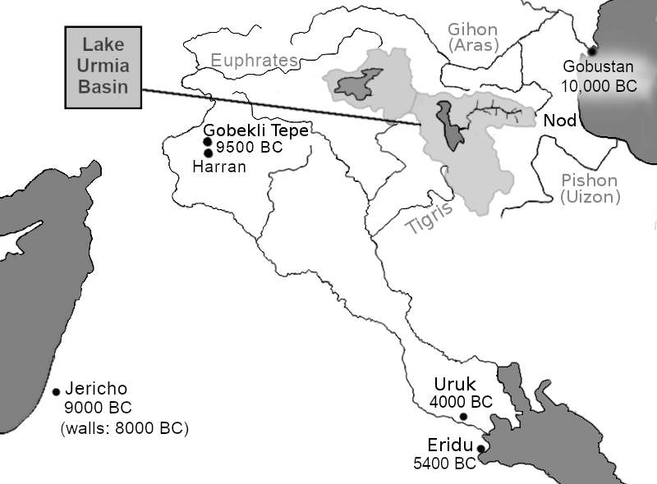
We end Genesis 1 with humans looking like gods, having dominion over the world. Genesis 2 focuses on the ancestors of the Israelites. In 10,000 BC they lived between Lake Urmia and the Caspian Sea.
Gobustan (10,000 BC) is an archaeological site, famous for its art. It shows how people lived in the golden age: hunting, fishing and playing, or travelling in large boats. The local climate was far better than today, so this area with its rivers and mountains and seas was a paradise.
Gobekli Tepe (9,500 BC) is where we began to farm on a larger scale, to cope with the Younger Dryas climate disaster. This created a class of land overseers. Power over land gives power over life. And so the twelve thousand year age of power began.
Jericho (8,000 BC) is where we first built great towers and walls.
Eridu (5,400 BC) is where we perfected irrigation, allowing farming to expand beyond the rivers and watering holes.
Uruk (4,000 BC) is the first modern city: that is, with a complex hierarchy.
The Eden, or “Edin” was the Sumerian name for the endless plains beyond the settled areas. A “garden” of Edin just meant an enclosed piece of land (Latin “gardinus”, “enclosure”, hence “to guard”). It is similar to the word “paradise” (Persian “pairi-diz”, “surround-wall”). In this case, the wall is the mountains that enclose the land where the rivers begin. The garden of the Edin in Genesis is at the source of the Tigris, Euphrates, Gihon and Pishon rivers. Genesis also describes the surrounding lands, such as Havilah and Nod, so we can identify this Edin as the Miandoab plain, east of Lake Urmia. This region was highly fertile in the past and is rich in gold and jewels.
A river runs out of the garden of Eden — or rather, a river system. Water is crucial to hunting and gathering: Hunter-gatherers know how each river involves numerous feeder streams, and underground flows leading to springs. Where water is, there are plants and animals and a good life. No wonder they worshipped water (“Ea”, which became “Yahweh”: see Appendix 6). The River Aji Chay runs westward out of the garden to the Lake Urmia / Lake Van river basins. At the edge of these basins the single river system breaks becomes four separate river systems. All of this is described in Genesis 2, so there can be no doubt about the location. When Adam was driven out of Eden, his descendants returned to the crossroads of the world, Harran, where he invented farming with the ox around 8,500 BC.

Genesis 3: the first landowners
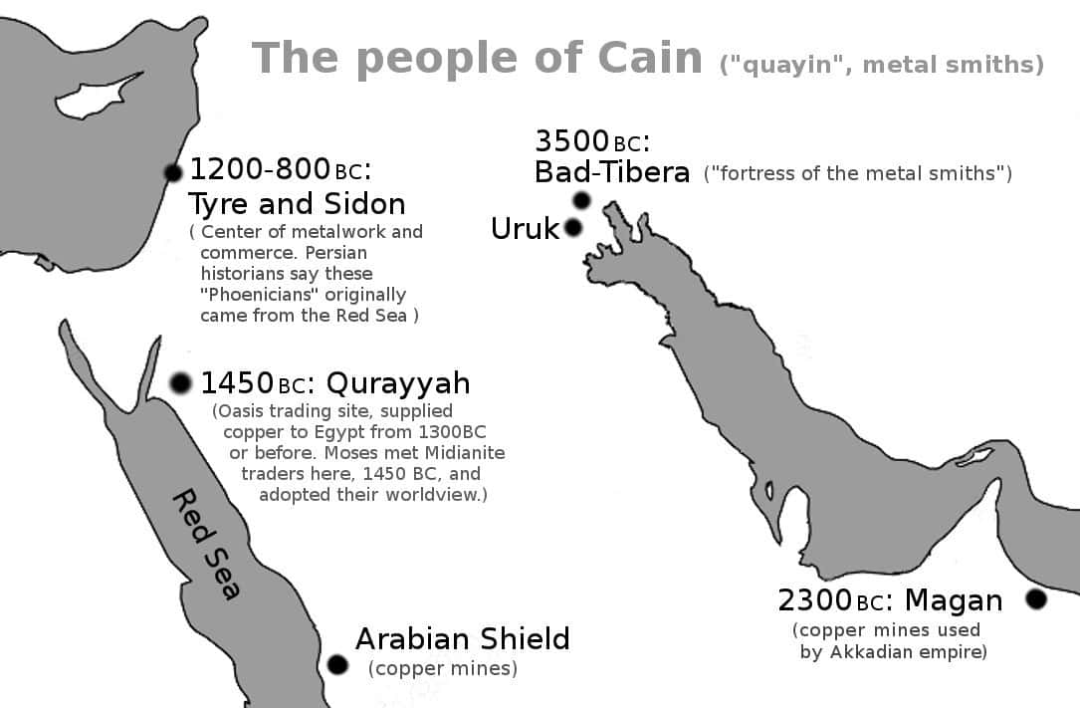
In Genesis 3, the god Yahweh is human: he walks in the garden and does not know where Adam is hiding. This is clear in all the ancient creation stories: the higher Elohim (gods) personify the forces of nature, like water or the sky, but the junior gods are just human elites. In the Atrahasis version of Genesis, the junior gods complain about having to dig irrigation ditches for their farms, and that is why they create a new class of people, slaves, to work for them.
Genesis is built on human gods: human elites who claim to own the land. For example, when Jacob is promised his own land, he travels back to the region of Harran (near Gobekli Tepe) where our civilisation began and dreams of seeing Yahweh. Yahweh is on top of a “ladder” with “angels” ascending and descending. The word for “ladder” is an Akkadian word for steps, such as the steps up a temple ziggurat (like the White Temple of Anu at Uruk). “Angel” just means “messenger”: the messengers climb the ziggurat to speak to the king or priest. Later, Jacob wrestles with an angel — clearly a human — and defeats him. He then says he has wrestled with God, and changes his name to “Israel”, meaning “Isra-el”, and “fights with God”. These are the events that create Israel as a land and a people: Israel is created to fight against human gods.

Genesis 4: the Bronze Age
After the first landowners, Genesis jumps forward to the next major change in history: the Bronze Age. The Bronze Age was the age of the metalsmith. The word for metalsmith was “quayin”, or in English, “Cain”.
Bronze allowed tools, which allowed humans to create larger farms and larger cities. This created a natural conflict between the people of the countryside (who distrusted this new technology) and the people of the cities. Genesis 4 describes this conflict between Abel, the shepherd, and the Cain, the metalworker. Metalworkers separated from the shepherds, and created the city of the metal workers, “Bad-Tibera”. They felt like gods, so Genesis calls this city “Enoch”, meaning “tastes godhood”.
“And Cain knew his wife; and she conceived, and bare Enoch: and he builded a city, and called the name of the city, after the name of his son, Enoch.”

Genesis 5: the history of Sumer
The expansion of cities meant more record keeping. So from this point, we have precise dates that record the history of the cities like Uruk and Bad-Tibera: together called Sumer. For example, the Atrahasis epic records how the gods had to dig their own canals for 3,600 years, and then it was a little under 600 years until the Great Flood. Canals probably began around 6,500 BC. 3,600 BC years takes us to 2,900 BC, the start of the Early Dynastic period of Sumer, the triumph of the kings. A little under 600 years more takes us to 2350 BC, when the chief city of Sumer (Shuruppak) flooded, after which Sumer collapsed. So these mythological dates are accurate.
Genesis 5 begins by reminding us that “Adam” refers to people, plural: “male and female created he them”. This is normal in mythology: real history is far too complicated to follow, so we create composite individuals. For example, the movie Forrest Gump tells the story of Baby Boomers through a fictional character. No real person did all the things Gump did, but he represents ho real Baby Boomers saw rapid change, could not control events, and yet things worked out well for them. As another example, the “Instructions of Shuruppak”, a set of proverbs from 2600 BC, refers to the city of Shuruppak as a person. This person is said to be the son of Ubara-Tutu (the last king before the Flood) and father of Ziusudra (the Flood hero). The character talks about the values of the real people in the real city.
Genesis 5 records the birth of modern cities as if it was a series of people. The attached graphic shows the different stages: it starts with ditch digging, a new system where slaves dig canals to irrigate the desert. That leads to a new kind of polity: the city state. That leads to conflict with existing polities. The conflict ends with agreements, leading to increased trade, and so on.
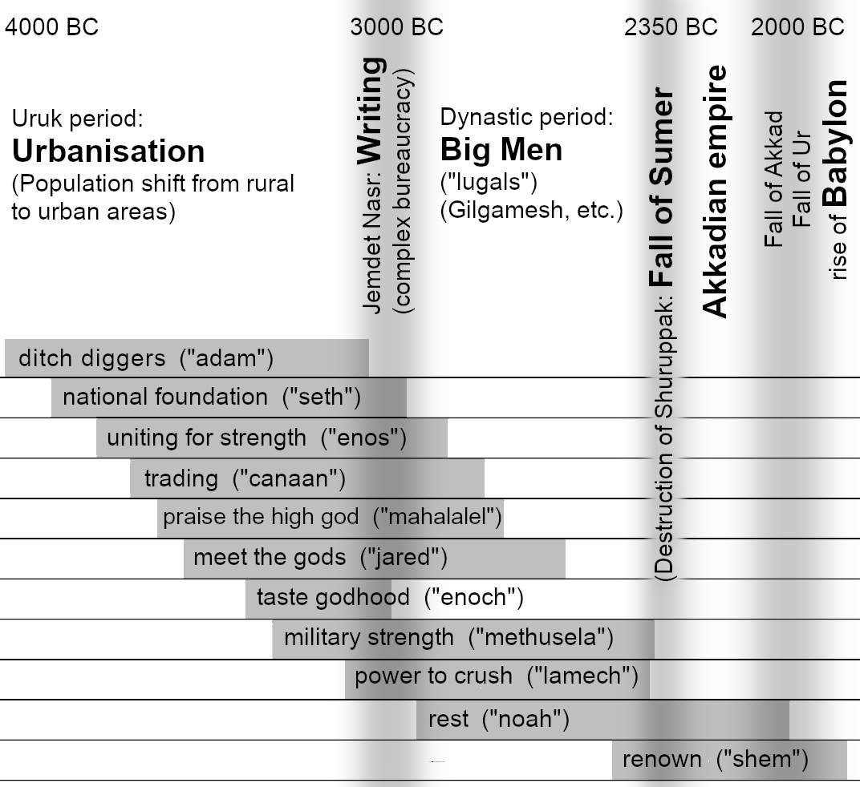
Let us look at each composite person: each historical era.

The era of ditch diggers: 4004-3074 BC
“Adam” means the people (“male and female”) “from the soil” (Hebrew “adamah”). They dug canals and tended the gardens of the lord of the land (“the lord”, the one who claimed to represent Ea, Yahweh). This simple arrangement continued until around 3000 BC. At that point the invention of modern writing allowed bureaucracy, a far more complex system of property and reporting and institutions. Instead of a man with stick standing over a man digging a ditch, slaves have more autonomy and can be integrated into the city, knowing that a reporting system plus a powerful state means they can never rebel. Jewish legends recall this as the start of a more relaxed era when work became easier. So the “adam” period lasted about a thousand years.
This is confirmed by archaeology. 4000 BC to about 3100 BC is what archaeologists call the “Uruk” period. This is when mankind first became urbanised: when people moved from the countryside to the city.

National foundation: 3874-2962 BC
Genesis says that after 130 years the “adam” people had a son and called his name “Seth”. But the word “a son” is not in Hebrew, Hebrew did not write vowels, and the Hebrew word translated as “his name” literally means “position”. So the verse literally says this:
“And the ditch digger lived an hundred and thirty years, and begat in his own likeness, and after his image; and positioned ‘STH’”
What did STH mean? Let’s try the possible vowels:
“The verb שית (shyt) means to give, set or place firm. Noun שית (shyt) refers to occupational garb, the dress upon which the profession stands. Noun שת (shat) describes a national foundation; whatever a nation is set on.“
So “STH” appears to mean setting a national foundation. So in 4000 BC some free people became slaves, and in 3870 BC the slaves were recognised as a separate nation. This is supported by linguistic studies. The Semitic language first broke away from its parent language at this time. Linguistics cannot give a precise date, but it was around 3750 BC, give or take a few hundred years:
“We estimate an Early Bronze Age origin for Semitic approximately 5750 years ago in the Levant”
This foundational period was an era of separation: the classes had to be divided for a new language to evolve. The separation period ended with the invention of writing, which created more complex institutions and networks. Genesis records how the lineage of Cain (the metalworkers and city builders) merged back into the lineage of Seth (the farmers in the fields) in the era of Lamech (military power). Put crudely, after 3000 BC, slaves could mix more freely with their masters because society was no longer based on a supervisor with a big stick. Scoeity was now based on complex property ownership and networks of obligations that maintained the class system more efficiently than a stick ever could. So the period of separation, the national foundation, ended soon after 3,000 BC.

Uniting for strength: 3769-2864 BC
The next group in Genesis is called “Enos”, or in Hebrew “anash”, meaning “the people”. We are now 250 years into urbanisation. The urban people now see themselves as different from rural people. This leads to conflicts. In this period, archaeologists find mass graves at Tell Brak, between the Tigris and Euphrates: the rise of cities is causing a rise in conflict. This period ended a thousand years later, when “big men” like Gilgamesh found used writing to issue more efficient military commands and more efficient propaganda. At that point the era of “the people” ended and the era of “the big men” began.

Trading: 3679-2769 BC
The next era, Cainan, means “trading”. Archaeologists call this the "Middle Uruk” period. It was defined by expanding trade. Again, this would last around a thousand years until the era of “big men”. The big men used writing to organise much larger armies. So they began to rely a little more on conquest and a little less on trade. There is a natural cycle to these things. Trade increases after people separate so can no longer share, but also cannot afford constant war. Trade decreases when better communications make war more efficient. So the “Cainan” era is roughly the same length as the “Adam” era but lags by a few hundred years.

Praise the high god: 3609-2714 BC
The next era, Mahalalel, means “praise the high god”. Trade (Cainan) caused a big increase in riches entering the temples. The priests could not catalogue it fast enough. So they invented new systems of writing.
"The earliest known written texts were found in Uruk and date to ca. 3600-3500 BC. They amount to little more than temple inventories detailing the assets, the labor force, and the stored resources at the disposal of a priestly establishment. Temple priests attempted to catalogue these resources using pictographic representations of items such as sheep or measures of grain."
This marked the start of the good times: the times to “praise the high god” because the temples are overflowing with wealth.

Descend from the holy mountain: 3544-2582 BC
The next era is Jared, meaning “descend from the holy mountain”. Around 3500 BC sees the building of the White Temple in Uruk. This is the beginning of the spectacular stepped temples or ziggurats. The great ziggurat was a holy mountain that connected heaven and Earth. The king would ascend this mountain to sacrifice to the gods and receive their words or blessings.

Taste godhood: 3382-3017 BC
(For more about Enoch see appendix 7.)
Enoch means “taste godhood”. Archaeologists call this the “Late Uruk” period: when we see distinctive advances in pottery, writing, and other artefacts. Uruk was the most advanced of any city: kings of Uruk must have felt like kings of the world. But by around 3000 BC, all the other cities had adapted Uruk’s culture to such an extent that they no longer needed Uruk itself. The Uruk elite found they were no longer wanted. Their taste of godhood ended.
“At the end of this gradual process of cultural homogenisation, around 3000 BC, both the economic centralisation and the Uruk-type material culture, which constituted the essence of the so-called late Uruk culture in the north, rapidly disappeared throughout the whole region.”

Military strength: 3317-2348 BC
This is the era of expansion through military strength:
”(ca 3300-3100 BC) the so-called Uruk Expansion involved the direct colonization of Northern Mesopotamia and Syria and the imposition of purely Sumerian urban enclaves into the existing rural culture."
Methuselah means “military strength”.

Power to crush others: 3130-2353 BC
Lamech means “power to crush others”. This was the high point of Uruk’s power. This is the period of submission when other cities accepted that the Uruk elite were gods.
"The second 'wave' of expansion in the Jemdet Nasr Period (ca 3100-29/800 BC) derived from the initial 'enculturation' of the societies of the Susiana Plain (Elam) just to the east of Sumer in extreme southwestern Iran. These societies adopted most aspects of Sumerian culture to their own local uses during the earlier Uruk period then in the Jemdet Nasr extended their own version of southern Mesopotamian culture far across the Iranian Plateau in the Proto-Elamite expansion."
This is the era of “big men” like Gilgamesh who felt they could do anything and old laws did not apply to them. The old traditions began to fail. Around 2,500 BC the famous death pits began: mass humans sacrifice when a Big Man died. Also around 2500 BC, Ur-Nanshe became ruler of Lagash. His parents were commoners, not kings. The sons of God mixed with the daughters of men! Lacking the priestly heritage and sense of ancient duty, Ur-Nanshe immediately set out on a career of conquest. The famous "Stele of the Vultures" comes from this period. This era of unprecedented violence was caused by mixing gods and men, just as Genesis said.

Rest: 2948-1998 BC
Noah means “to rest”, Hebrew “nuah". Archaeologists call this the “Early Dynastic Period”: when stable dynasties began. Before this era (the era of writing), kings were never secure. They were expected to deliver good times for the city, or the people would rebel. But writing allowed complex institutions and propaganda, so a king’s extended family could rule no matter how badly they performed. Kings could finally rest! 2900 to 2334 was the Early Dynastic Period. 2334-1998 was the rise and fall of Akkad, the first empire (where one king directly ruled all the cities).

Renown: 2450-1846 BC
Shem means “fame or renown”. Big men like Gilgamesh (who dominated the region around Uruk) led to even bigger men like Lugul-Anne-Mundu (“big man of heaven who sacrifices the dead”). Civilisation then ended in the Great Flood at Shuruppak (see chapter 5), allowing all the cities of Sumer to be conquered by the most famous “big man” of all, Sargon of Akkad.

c.2230 BC: the Tower of Babel
To round off this appendix, we may as well look beyond the fall of Sumer (the Great Flood) and mention the fall of the Akkadian Empire (the Tower of Babel).
After the flooding of Shuruppak, Sargon of Akkad conquer Sumer by 2334 BC. Toward the end of his reign, 2286 BC, king Belus founded the city of Bab-el, “gate of the gods”, with its famous temple ziggurat at its centre. Around the same time, Sargon introduced a new language to help him administer his empire: Akkadian.
Sargon’s grandson, Naram-Sin, was the first emperor to call himself a god. At that point (2230 BC) the empire was conquered by the Guti, barbarians with no interest in writing. They left no records, they allowed the canals and temples to decay, and the whole empire descended into chaos. This was the era when the famous Sumerian king lists were compiled, and they are a confusing mess, indicating that good record-keeping was impossible. The Akkadians explained the defeat of Naram-Sin as due to his pride. And so Enki (= Ea = Yahweh) “took away its [the temple’s] wisdom”. Genesis plays on the similarity between the words “babel” (“gate of the gods”) and “balal” (Hebrew for “confused”). So our text says that Yahweh punished the people for the pride of trying to unite the people with a single language to build a temple that the gods did not request. As a result the Guti invaded, the language failed, and the people dispersed. Genesis was right again.

Appendix 6:
Moses
Chapter 14 relies on Moses. But Moses is often dismissed as an imaginary character who promoted sexism and genocide. This appendix argues that:
- Kings changed the story of Moses
- Moses was real
- Moses caused dramatic economic growth
- Moses hated kings, loved people
- Moses was moral
- Moses was a feminist

1. Kings changed the story of Moses
If we believe the kings of Israel then we cannot believe Moses. This is because Moses was anti-king. That was his whole purpose: to escape Pharaoh, and ensure that a Pharaoh could never arise in Israel. The promised land belonged to God, not any man. Moses guaranteed that kings could not arise, by giving everyone a share of land, and forbidding them to sell it (in Leviticus 25:33): no nobody could own more land than somebody else, thereby making unearned wealth almost impossible.
But what if a king built a large temple? He could centralise the movement, gaining power that way, even without owning land. So the first thing that Moses taught the people, after giving them the ten commandments, was not to build temples. Look at the very first commandment after the famous ten commandments:
‘Ye shall not make with me gods of silver, neither shall ye make unto you gods of gold. An altar of earth thou shalt make unto me, and shalt sacrifice thereon thy burnt offerings, and thy peace offerings, thy sheep, and thine oxen: in all places where I record my name I will come unto thee, and I will bless thee. And if thou wilt make me an altar of stone, thou shalt not build it of hewn stone: for if thou lift up thy tool upon it, thou hast polluted it. Neither shalt thou go up by steps unto mine altar, that thy nakedness be not discovered thereon.’
Moses told the people to make altars out of piles of earth. They were not to cut stones. They were not to build temples like in Egypt! And notice his sense of humour: “Neither shalt thou go up by steps unto mine altar, that thy nakedness be not discovered thereon.” In those days people did not wear underwear: if one person climbed some steps, to be above the other people, then the other people would see his nakedness. That is how Moses thought of temples: they are stupid and embarrassing.
For four hundred years, the nation kept this rule. They had no temple: and therefore no centralised power. Whenever they needed to unite, the people decided on the best man or woman for the job. (One of the greatest leaders was Deborah, who brought peace for forty years.) Democracy works.

How kings changed the Law of Moses
The first king was Saul. Like Deborah, he was elected to save Israel in a time of war. But unlike Deborah, Saul said that he could save the people better if they made him king. But it was a lie of course: Israel made him king, and then he failed to protect them. Because as the prophet Samuel stated, by choosing a king, Israel rejected Yahweh.
“But the thing displeased Samuel [the prophet], when they said, Give us a king to judge us. And Samuel prayed unto the Lord. And the Lord said unto Samuel, Hearken unto the voice of the people in all that they say unto thee: for they have not rejected thee, but they have rejected me, that I should not reign over them.”
The next king was David. David rejected the law of Moses not just by being a king, but by wanting a temple. He did not even want it on Mount Ebal, where Moses decreed the centre place to be. David broke the ten commandments as well: stealing (through taxes), coveting his neighbour's wife, committing adultery after killing her husband, and so on. But he wrote some songs to say how sorry he was and how he was God’s special friend.
The next king was even worse. David’s son Solomon taxed the people so heavily that he split the nation in two. The nation then declined for another two hundred years until the Assyrians invaded and destroyed the largest part of the nation (Israel). Then a hundred years later, Babylon invaded the remaining parts (Judah) and finished the job. The law of Moses (democracy and good economics) made Israel strong. Rejecting that law (through kings and taxes) weakened and destroyed the nation.

How the kings changed Yahweh
The kings rejected Moses’ god, who hated kings like Pharaoh and created a brand new god who loved kings. This god was the only god, so everybody had to come to his temple in Jerusalem, and that made the Jerusalem kings rich. It also made Israel very easy to conquer, and very enticing: just destroy that one temple and take all its gold. But the kings didn’t care.
How did the kings create a new god? Let’s start with Moses’ original god. The name of the god “yahweh” translates to “Y is” or “Y exists/creates”. The “Y” could be pronounced “ee-a”. Ea was the word for water, and hence the god of water: the behaviour of water. Moses was a desert leader: in the desert, water (Ea) creates life. So to a desert tribe, Ea is the creator god. “Ee-a” was “water creates” or “water is”. A close look shows that the original name for water, “Ea” could mean “to live”, and westerners (e.g, in Canaan) may have pronounced it “yahweh”:
“Ea, written 'e-a' is conjectured to derive from the Proto-Semitic root for 'to live' ... it is now possible to show that Ea's name was pronounced either 'haya' or 'haway' ... it means 'he is/exists'. It is feasible, therefore, that the earliest articulation of the West's ['to live'] deity was ‘yahway'"
So it looks like Yahweh was the Israelite name for Ea, life-giving water.
Kings later destroyed this link with Ea. Turning Yahweh into the private god of Jerusalem meant only the Jerusalem temple priests could say what he wanted. They had a simple method to forget Ea: they discouraged people from saying the name of Ea out loud. Instead, when people came to the letters YHWH (Yahweh) they just said, “the lord”, or something similar. Within a few generations, nobody could remember that YHWH was how people used to pronounce Ea.

Moses was a polytheist
If Yahweh was once Ea, that means Moses was a polytheist. He worshipped Elohim: the gods, plural. “No other gods before me” simply meant “Ea is the top god”. Once Yahweh became the new private god of Jerusalem kings (c. 1000 BC), towns that opposed kings would naturally switch to Yahweh’s twin brother Baal Hadad instead (see below).
“For a people devoted to Yehouah [Yahweh] only one of 502 local place names in Israel and Judah had Yehouah in it. Yet Canaanite gods and goddesses, such as Baal, Shamash, Anath and Mot, anathema to the Jews of the bible, are common.”
King David’s family (before he became king) had household idols. Moses himself had a graven image (two cherubim) over the Ark of the Covenant. Even Israel’s kings, like Solomon and Manasseh, often returned to polytheism.
Then why did Moses command to not have idols? Because Moses was leading the Israelites out of Egypt. So the Israelites had to follow Moses and his god. But he was fairly relaxed about the rule. The only time when Moses ever acted against an Israelite worshipping another god was in a case where a young man with an Egyptian father was insulting Yahweh, and fighting an Israelite:
“Now an Israelite woman's son, whose father was an Egyptian, went out among the people of Israel. And the Israelite woman's son and a man of Israel fought in the camp, and the Israelite woman's son blasphemed the Name, and cursed. ... And they put him in custody, till the will of the Lord should be clear to them.”
Egypt was a very sensitive topic: the people had just escaped Egypt and some of the people wanted to go back. But even here, there was no established policy: they had to put the man in custody until Moses could decide how to handle this difficult case. Eventually, Moses decided that this was too much. The people were allowed to stone the man. And if something like it happened again, the precedent was set. But the fact that there was no established rule, even when attacking Yahweh in favour of Egyptian gods, indicates that other gods were not a problem: the problem was only if Yahweh was in danger of being replaced as the top god.

2. Moses was real
Moses was the most remarkable and important figure of the last ten thousand years. He is also one of the best attested in historical documents. This section will look at the written accounts of Moses and the Exodus: from the Bible, Egyptian history, and Phoenician history. The Phoenician account predates the Bible account as we have it, so that is probably the most useful.
Moses (or somebody from that place and time) gave us the alphabet. He revolutionised the Phoenician city-states, and through them gave us western civilisation. He was the high point of the Heroic Age that lasted until the fall of Troy, which in turn led to the triumph of Greece, the founding of Rome and Carthage. And of course, Moses gave us Judaism, which gave us Christianity, the dominant force in western civilisation for the past two thousand years.
Let’s look at the Bible accounts to see how the kings of Israel distorted history, causing modern scholars to reject Moses as fiction. The clearest example of how kings ruined the Bible is how they changed the word “aleph”.
“And the children of Israel journeyed from Rameses to Succoth, about six hundred ‘aleph’ on foot that were men, beside children.”
“Aleph” is usually translated as “thousand”. This creates absurd stories where the smallest disease kills ten thousand people, or a single man kills twenty-thousand people. It also implies millions of people in the exodus. Kings of Israel liked big numbers because it made them look very important: kings do not care about history, only about power. If scholars want to be paid by kings (or official universities) they had better interpret history in a way that suits the kings. But these big numbers do not show up in the archaeological record. They also contradict other parts of Exodus. For example, Exodus 1:15 says that the children of Israel only needed two midwives (presumably one was on call while the other one slept), so this was not a large population. So what did aleph mean?
Aleph (written as “ ‘lp ” (Hebrew was written without vowels) meant “leader”, such as the leader of a family or clan. Clans did the fighting, so aleph came to also mean the leader of a military unit. As nations grew in size and began to employ full-time soldiers, aleph came to mean the leader of a thousand soldiers. So we read aleph as “thousand” when it originally meant just “leader of a family”. So the Exodus involved six hundred families. But later kings read it as six hundred thousand men and similar numbers of women and children! So the kings paid scholars to destroy history, turning it into nonsense propaganda.

The Egyptian account
Exodus makes more sense when we combine it with the Egyptian account. First, let’s recall the Bible version:
Genesis tells how the family of Israel went to live in Egypt due to a famine. Exodus tells how, hundreds of years later, they grew so numerous that Pharaoh, king of Egypt, felt they might rebel. So he put the Israelites to work under Egyptian taskmasters. Moses told Pharaoh:
“[I]f thou refuse to let him go, behold, I will slay thy son, even thy firstborn.”
After that, there was a series of diseases (the ten plagues): various animals died, leading to maggots and more diseases, and finally, humans died. So Pharaoh then let the Israelites go. The Israelites then snatched the Egyptians’ gold and silver, and escape over the marshes that chariots could not cross. They then spent forty years in the desert while the first generation died. The second generation then entered the land of Canaan. They fought the enemies of Shechem (Canaan’s capital city) and did not fight Shechem’s allies, indicating that they had an agreement with Shechem to let them settle if they helped in the war.
Egypt’s version of the story highlights important details that are only hinted at in the Biblical version: that this was a war, and Moses got help from Shechem. Egyptian history also reminds us that Moses’ people were Egyptians: remember, they had lived in Egypt for centuries. Most importantly, the reason why Pharaoh set them to work, and made them live in an isolated city, but did not let them leave, is that he wanted to isolate people with “leprosy, and other distempers”:
“[He wanted to] clear the whole country of the lepers, and of the other impure people: ... and got together all that had any defect in their bodies out of Egypt: … Whom he sent to those quarries which are on the east side of the Nile, that they might work in them.”
Combining both accounts, it looks like some Egyptians had some disease, or maybe the Pharaoh just thought they did. These “diseased” people were placed in an isolated camp and given unpleasant work. They realised that they might be killed at any time: they no longer felt safe in Egypt. Where could they escape? They were on the borders next to Canaan and Midian (Arabia), so they would have some Canaanite and Midianites among the “diseased” Egyptians. So they could escape to Midian or Canaan and claim it as an ancestral home.
Moses converted to the Midianites’ ways, and they helped him to escape: they used their knowledge of water (Yah), their superior knowledge of marshes and storm patterns, to help Moses escape across the marsh with his six hundred families. But the Israelites were not allowed into Canaan until the first generation, the people who might have an infectious disease, all died.

The Phoenician account
When looking for Moses in ancient Israel we need to remember that the land was Canaan, and the whole of Canaan was Phoenician:
“"E Stern recognizes what he calls the Phoenician 'koine' that 'dominated all of Phoenicia and Palestine'. 'Koine' is Greek for common, so he means that the common culture of the whole region was AhInician. The Phoenicians called themselves Canaanites."
We also need to remember that ancient historians consider Moses to be extremely important to world history.
“And this Moses, they said, was the teacher of Orpheus; and when grown up he taught mankind many useful things. For he was the inventor of ships, and machines for laying stones, and Egyptian arms, and engines for drawing water and for war, and invented philosophy.”
Eusebius says that Orpheus gave the Greeks the secrets of the Egyptians. Orpheus is dated to 1398 BC, and the Exodus is dated to the 1400s, so the dates match.
So we need to look for the biggest and most important figure in the history of Canaan/Phoenicia, and he should be at the time of the Israelite entry to Canaan. Lucky we have a document that fits both requirements. An accidental discovery near the Phoenician port of Ugarit gave us a cycle of stories about Baal Hadad, from around 1200 BC. The battle must date to later than 1700 BC, because it does not feature in Marduk’s list of triumphs in Hammurabi’s law, but is important to the Enuma Elis after the Ugarit texts. So it dates to around the time of the conquest of Canaan. Baal, as we will see, is the equivalent of Yahweh, the god of Moses (though later Israelite kings tried to deny it). So the Baal cycle is the story of the triumph of Yahweh over the land of Canaan: the triumph of the god of Moses.

How Yahweh became Baal Hadad
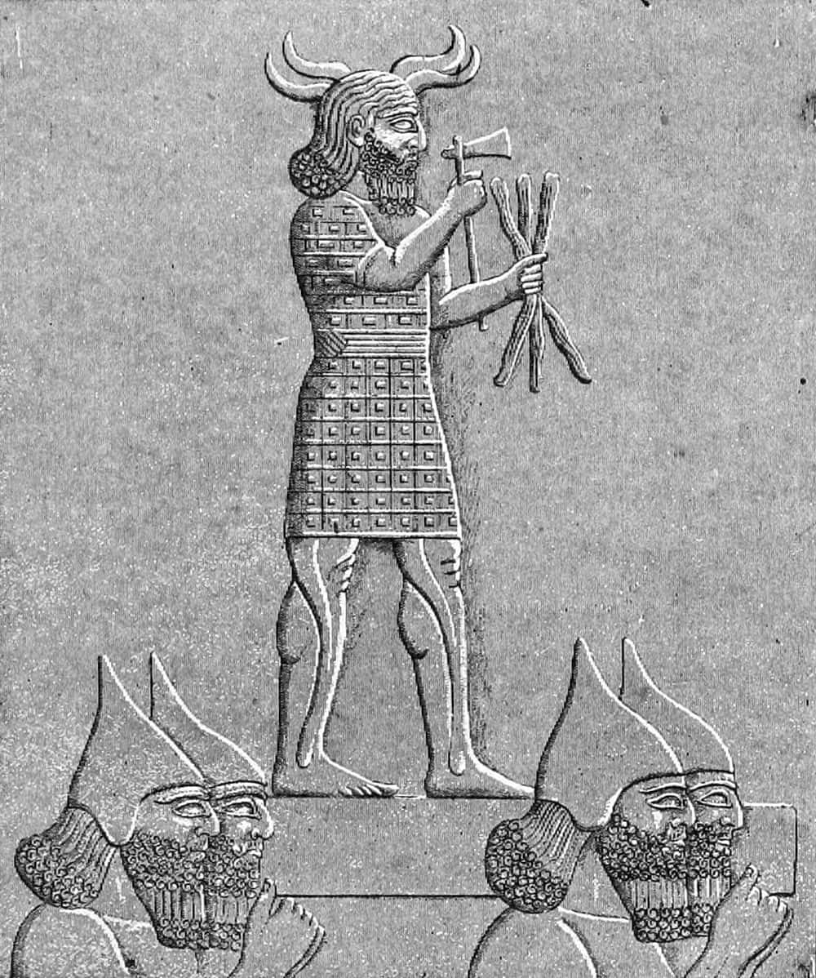
“Baal” just means “Lord”. Hence the name Baalyah, “the Lord is Yahweh”. The Canaanites’ favourite lord was Hadad, a name meaning “thunder”. Hadad was originally the twin brother of Yahweh, but by the time of Moses they were interchangeable names for the god of storms who threw lightning bolts:
Image: Hadad, Public Domain via Wikimedia.
“He shot his arrows and scattered the enemy, with great bolts of lightning he routed them.”
“He unleashes his lightning beneath the whole heaven and sends it to the ends of the earth.”
“lightning and hail, snow and clouds, stormy winds that do his bidding,”
“When he thunders, the waters in the heavens roar; he makes clouds rise from the ends of the earth. He sends lightning with the rain and brings out the wind from his storehouses.”
Yahweh/Hadad was the Lord of thunder and rain, the favourite god of Canaan, he created life (because rain creates life), required the sacrifice of the firstborn (see below), etc.
The Bible confirms that this Lord (this Baal) was Yahweh:
“It was you who split open the sea by your power; you broke the heads of the monster in the waters. It was you who crushed the heads of Leviathan”
The Baal cycle contains the intriguing line (in Phoenician), “sm . bny. yw. ilt”, meaning:
“my son by the name of Yaw, O goddess Elat [Asherah]”.
“Yaw” can be pronounced “Yah”, meaning Yahweh. The surrounding text is too broken to be clear, but either Yam (the sea) or Hadad is called Ya. That only makes sense for Hadad: Yam is being prepared for the fact that Hadad will win.

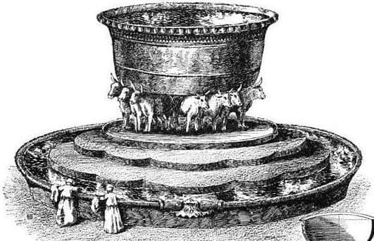
The symbol of the bull
Image: twelve brass bulls in the Jerusalem temple. Public domain, via Wikimedia
Yahweh/Hadad used the symbol of the bull. The priests of Yahweh ritually cleansed themselves in a great brass bath before twelve bulls. Aaron, the high priest of Yahweh, created a golden calf as a symbol of Israel’s gods. The Midianite priests had forbidden any images that might be interpreted as sympathetic to Canaan (you can’t go to war carrying the enemy flag) but Moses defended the calf makers. A close reading of Judges 6 suggests that a golden calf was set on the hillside by worshippers of Yahweh, and the priest’s metal breastplate probably had the image of a calf. Jeroboam filled Israel with golden calves, symbols of Yahweh. By that point the Jerusalem priests wanted Yahweh, and his bulls, to only be in Jerusalem, so they condemned Jeroboam’s act, but everybody knew that bulls were the symbol of Jahweh.
So by the time Moses entered Canaan, Hadad and his twin, Yahweh, were interchangeable. People just called them The Lord (“Baal”). But by 600 BC the Jerusalem authorities wanted to stop using the word Baal for Yahweh:
“In that day, declares the Lord [Yahweh], you will call me ‘my husband’; you will no longer call me ‘my master.[Baal]’ I will remove the names of the Baals from her lips; no longer will their names be invoked.”

How Jerusalem split Yahweh from Hadad
The kings at Jerusalem wanted all the power for themselves. So they demonised the Baals (the Lords) of other towns. They said that the other Baals wanted child sacrifice, but their Baal (Lord) did not. This was just propaganda. In fact, child sacrifice was originally part of Yahweh’s laws:
“I gave them other statutes that were not good and laws through which they could not live; I defiled them through their gifts—the sacrifice of every firstborn—that I might fill them with horror so they would know that I am the Lord.”
As Moses put it:
“You must give me the firstborn of your sons. Do the same with your cattle and your sheep. Let them stay with their mothers for seven days, but give them to me on the eighth day.”
Moses was moral (see below), so would not like child sacrifice. So he tried to make people sacrifice a sheep instead, as a substitute for their child, just like Abraham did when Yahweh told him to sacrifice his firstborn son. This was central to Moses’ new law: when God sacrificed the firstborn of Egypt, the Israelites were told to sacrifice a lamb instead, and the angel of death would pass them by. This was “the Passover”, the moment that began the start of the new nation: a rejection of child sacrifice. But everyone understood that sacrificing children was the old way, even though they now felt it was excessive:
“With what shall I come before the Lord and bow down before the exalted God? Shall I come before him with burnt offerings, with calves a year old? Will the Lord be pleased with thousands of rams, with ten thousand rivers of olive oil? Shall I offer my firstborn for my transgression, the fruit of my body for the sin of my soul?”
So Yahweh was essentially the same as Hadad. The Jerusalem priests wanted to pretend that they were different, so they pretended that Yahweh’s twin brother Hadad was his enemy.
Now let’s look at the Baal cycle, to see how Yahweh conquered the key cities in Canaan, under his new name Hadad.

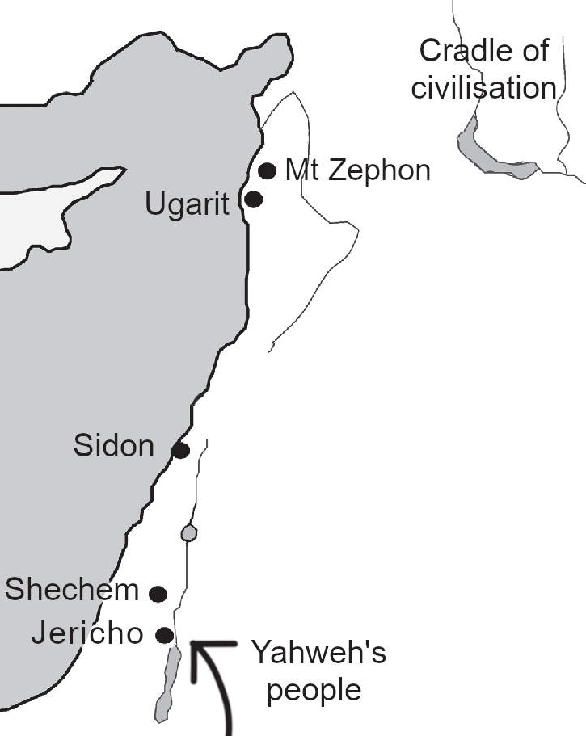
The Baal Cycle (the Lord Cycle)
The Baal cycle is the Lord cycle: the cycle of stories about how Baal-Hadad (i.e. Yahweh) became the lord of Canaan. it is the story of Yahweh’s people invading further and further north so that the ancient cradle of civilisation grows worried.
Most summaries of the Baal Cycle use the Phoenician names for their gods, which makes the story seem obscure. But if we translate the names into English then the story becomes much clearer.:
Mount Zephon: This is modern-day Jebel Aqra. Whoever controlled the mountain controlled Ugarit, the northern coast of the Levant: this is the ancient Phoenician heartland.
Baal: Baal is Lord Hadad, or Yahweh (see above). Yahweh wants control of Mount Zephon. Yahweh needs real soldiers to control a real mountain, so where the text says Baal we can read “Yahweh’s people”.
Yam: the sea. The Baal cycle is about the control of a real-world location so these are real-world people: sea people. That is, Phoenician sailors.
El: The highest god. We are dealing with real people in real history, so this must be the highest authority: the elders of the tribes in the cradle of civilisation. They decide who controls the region.
The gods: All the gods: public opinion among people who matter.
Asherah is the wife of El and mother of the gods: the queen of heaven, the most popular gods in Canaan/Phoenicia. So Asherah is just “the queen”.
Athtar: “Supreme god of Ancient South Arabia. God of the thunderstorm and provider of rain.” That is, this god is the Arabian version of Hadad or Yahweh. So we can read ‘Athtar” as “Midianites”.
Anath: war goddess, wife of Baal. So she is the one urging Hadad to go to war. So we can read “Anath” as “Yahweh’s War Hawks”.
Mot: death.
Kothar-wa-Khasis: craftsmen.
Shapash: The sun. Her role in the story is to give advice that is held in high regard, so we can call her the adviser.
Qodesh-wa-Amrur: He is called a fisherman and delivers messages, so we can call him the fisherman messenger.
Sheger and Ithm: They represent cattle and sheep. That is, they are shepherds.
Craftsmen: These are the key to Yahweh’s success. Recall how Moses is remembered as a bringer of technology.
Here is a summary of the Baal cycle, using the more familiar names:

The elders of the tribes summon craftsmen to build a palace for the Phoenicians. That is, the Phoenicians are growing in power, and want a place among the elders. The elders want the palace built quickly, as the Phoenicians can be aggressive. When the Midianites hear of this, they take a torch to fight, but the adviser tells them to do nothing: the elders have decided that the Phoenicians rule here. The Midianites complain that they don’t like this (the Phoenicians can be dangerous). But the Midianites don’t have a voice on the council. The adviser says that is because they are new to the area (literally, they “have no wife”: they are young and have no connections).
[The story is missing some parts.] Everyone is concerned that the Phoenician palace problem must be resolved, or there could be a war. But to gain the palace, they will have to drive Yahweh’s people away.
The craftsmen warn the Phoenicians that Yahweh’s people won’t just stand by if the Phoenicians take control of the region, and the craftsmen have weapons.
The Phoenicians send a message to the elders of the tribe, demanding that Yahweh’s people surrender. Yahweh’s people attack the messengers, but Yahweh’s War Hawks and Midianites hold them back.
[The next part is missing, then we re-enter the story:] Yahweh’s people are fighting the Phoenicians, and the Phoenicians are winning. This is the famous battle between Yahweh and the sea monsters. The craftsmen provide Yahweh’s people with special weapons and assure Yahweh’s people that they will be victorious and will win “a kingdom without end” — a Biblical phrase. Using the weapons they defeat the Phoenicians. The Midianites tell Yahweh’s people to thoroughly defeat the Phoenicians, which they do. Yahweh’s people will now rule the region!
Triumphant, Yahweh’s people feast on Mount Zephon. Yahweh’s people War Hawks give Yahweh’s people the secret of lightning. (Weapons? Military tactics?). Together they will find the secret of the royal mountain.
Yahweh’s people still do not have permission to settle in the region. They threaten war with the elders of the tribe unless they are allowed to permanently settle. The queen sends a messenger to the craftsmen of Egypt, in the hope that they will support Yahweh’s people.
[After more missing text], the queen sees the war tribe approaching. She fears they will kill her sons (the other tribes). But then she sees the many gifts from the craftsmen of Egypt and realises she is safe. After more persuasion, she agrees that Yahweh’s people can settle.
Now settled, Yahweh’s people march out and defeat many other cities. He seems to love killing: he invites Death to the feast! But Death tells Yahweh’s people that he (Death) is like a lion in the desert, always hungry for human flesh and blood. Yahweh’s people realise that if they carry on this way, everyone could die.
The adviser has a plan. He advises the elders of the tribes to find a fake version of Yahweh’s people. This decoy tribe will be killed so that Death seems to be triumphant. The plan works. The decoy tribe is killed, and everybody mourns the death of Yahweh’s people. The decoy tribe is buried on Mount Zephon. The Midianites try to take over and take the place of Yahweh’s people, but they are not tall enough for the throne: that is, they are not strong enough to rule.
Meanwhile, Yahweh’s War Hawks search for Yahweh’s people. Death says he has eaten Yahweh’s people. Angry, the War Hawks smash Death to pieces.
Finally, the elders of the tribes have a dream that Yahweh’s people still live, and then they return. Death returns and they fight on Mount Zephon. The adviser arrives and warns Death that fighting Yahweh’s people is futile because the elders of the tribes are now on Yahweh’s side. Death gives in. Yahweh is now king.

The Baal Cycle as history
These stories were written around 1200 BC, two hundred years after the Israelites entered Canaan. The Midianites already had a presence in Canaan, as they worked the long trade route between Arabia and Phoenicia. They converted Moses to their ways and helped Moses to make a deal with the Canaanites (based at Shechem), resulting in the Israelites living in the hills of Canaan. They worshipped the rain god Yahweh in the form of his aggressive son, the storm god Hadad.
Seeing the conquests of neighbouring tribes, the Canaanites (Phoenicians) off the ancient heartland (Ugarit), demanded assurances that other tribes would support them. The other tribes were hesitant. Inevitably there was war between the Israelites and Phoenicians. This seemed beneficial to the Egyptians, and they provided technical help with weapons. The Israelites won. At some point, they were then defeated by other tribes and seemed to be destroyed. But they came back, and the other tribes accepted that they were now the permanent rulers of the Phoenician cities. Or at least, it seemed that way in 1200 BC.

3. Moses caused dramatic economic growth
Chapter 14 shows how Moses designed a system where no Pharaoh can ever arise again: land can never be sold, and ground rent replaces taxation. In principle this is far superior to monarchies and taxation, but did it work in real life, in Canaan, after 1450 BC?
When we think of Canaan, we usually think of the hill country. This is no accident: when kings took over, around 1000 BC, they could not control the coastal cities, Tyre and Sidon. Those cities then evolved in a different direction: we call them Phoenicia. But before 1000 BC, Tyre and Sidon were culturally the same as the rest of Canaan: archaeology shows that they were ethnically the same people. The only differences are the differences we would expect between city traders and country farmers.
“It is argued that there are significant differences between specific aspects of the material culture of Philistia and that on the coast to its north, but that these do not stem from some ethnic distinction between Philistines, SKL [the sea people mentioned by the Egyptians], SHRDN [Sardinia], and Phoenicians, but from different socioeconomic matrices at the various locales in which new populations were absorbed.”

Moses changes everything
Phoenician cities had been occupied for thousands of years, and they already had trade. But the Persian historians say the explosion of trade began with the arrival of people from the Red Sea:
“The Persian learned men say that the Phoenicians … came to our seas from the sea which is called Red,​ and having settled in the country which they still occupy, at once began to make long voyages.”
The Red Sea meant the region of the Midianites. Moses was a Midianite. When the Midianites arrived in Phoenicia, Phoenicia became the world’s top trading nation.
Moses’ big idea was to live without a Pharaoh: live by trade, not force. In a trading nation, wealth tends to concentrate in coastal cities, so Canaan’s principal trading cities, Tyre and Sidon, grew very rich. They became the economic powerhouses of the ancient world. The timeline makes this very clear: before Moses, Canaan is poor and weak. After Moses, Canaan becomes stronger and stronger, until the tiny nation conquers mighty Egypt itself!

4. Moses hated kings, loved people

Deuteronomy is the problem
When modern people attack Moses, they are usually attacking Deuteronomy. Moses hated kings. Deuteronomy loves kings.
In Appendix 2, we saw how Hilkiah destroyed the old records of Israel. After doing that, Hilkiah came up with a brand new book of Moses: “Deuteronomy”, meaning “repetition of the law”. In Deuteronomy, “Moses” teaches the opposite of what he taught before.
The old Moses did not want a king. We know this from the book of Judges, and from how Samuel reacted to the idea of a king. But in Deuteronomy, the new Moses likes kings. The old Moses challenged the gods. He embraced the tribe of Israel, which means “fights with God”, the tribe of the trickster Jacob who wrestled with angels and forced them to see things his way. But Deuteronomy invented the idea of loving God, and of always obeying him, no matter what.
The Moses of Exodus told the people to make small altars of stones wherever they are. But Deuteronomy tells people to only sacrifice in one central place, with the priests in charge. The Kings then built a great temple. Josiah finished the job by destroying all the other altars. Deuteronomy is how the kings defeated the law of Moses, by pretending to embrace it.

Mixing fabrics
As an example of how Deuteronomy ruins everything consider its teaching on not mixing fabrics. Leviticus 19 teaches people to love each other and not cheat other people. Verse 19 gives an example of not tricking anybody: e.g., if you make a cotton shirt, don’t mix it with cheaper linen. And if your field has one thing, do not mix another: this matters if you let someone else harvest plants and they get inferior plants they did not expect.
But Deuteronomy changes the meaning. It adds a line that if you do it wrong, the temple gets to keep everything. By linking it to the temple, and giving the temple power over the person, it makes readers link the command with the fact that the high priest wears mixed fabrics. So it changes the law, from not cheating others, to promoting unequal wealth and unequal rules. So a good law becomes evil. But if we reject Deuteronomy and stick to what Moses said, everything makes sense.

What did Moses really teach?
In Exodus 4, Moses does not circumcise his son, despite identifying with the Midianites for years. This supports the Egyptian account that he saw himself as Egyptian, not Hebrew. So when he supported the Hebrews, it was due to a belief in justice, not because he was a Hebrew himself.
After he killed the Egyptian, Moses escaped to the desert and saw some men treating women badly. He drove the men away and helped the women, again showing his belief in fairness. This is Moses’ defining feature. Moses then became a Midianite. The word “Midianite” comes from the Sumerian word “mid” meaning law. Midianites were long-distance traders: they traded with foreigners, meaning they had to establish trust without relying on force. This became Moses’ way: the way of the Midianites, the way of trade between equals, without needing kings to enforce the law.
Moses’ turning point was seeing a lone bush on a mountain. This implies a hidden spring underground, as there was not enough rain for a bush to grow. The Sumerians (and later) understood this: bushes implied Ea, the god of water. This particular bush had survived burning. It reminded Moses of the Israelites: they could be alone, in a desert, and be burned, but they could survive as long as they had a hidden source of water. We do not need power in order to live: no matter how weak we are, as long as we have some hidden Ea (water, the most basic need), we can survive and thrive, like that bush.
The fact that Ea spoke to Moses did not make him special. This was long before 550 BC, so every time a person had an important idea, they saw it as the gods speaking to them. Moses was musing about water, realising that water (Ea) is all we need. What made Moses special was his belief in the god of water, not the gods of violence. Water does not use overwhelming force (except in very rare times, in a flood). It changes shape, it adapts to whatever happens. As Bruce Lee famously said, “Be water, my friend!”Moses did not need kingship (Osiris), or violence (Seth). He just needed a tiny drop of water in the desert, and the skill to use it. Water was life! Water was wisdom! Water was the message! Moses’ message was simple: “Ea is!” Or in the dialect of the Canaanites, “Yahweh!”

5. Moses was moral
We already saw how Moses opposed child sacrifice. But the real proof of Moses’ morality is in his results. He created a just society, with democracy and wealth for all. Everything else is details.
Moses is often criticised for genocide against various Canaanite tribes. But look closer, and they only fought the enemies of Shechem, the Canaanite capital. This was just the price of being allowed to settle in the land. Also recall the problem with numbers: killing “a thousand from each tribe” is more likely “a leader from each tribe”.
One of the greatest criticisms arises from Moses’ dislike of the plague. Recall that the people were diseased and leprous. After escaping Egypt, they spent forty years in the desert while potential plague carriers died. The last stop before entering Canaan was Mount Peor, famous for its shrine that involved prostitution. Some of Moses’ soldiers had sex with the enemy’s prostitutes. After having sex, the plague spread in the camp:
“These caused the children of Israel, through the counsel of Balaam, to commit trespass against the Lord in the matter of Peor, and there was a plague among the congregation of the Lord.”
Desert travellers had to live close together for survival, so any disease could spread quickly. And being at war, that could fatally weaken the whole tribe. So Moses told the judges to kill all the potentially infected men:
“and the people began to commit whoredom with the daughters of Moab. ... And Moses said unto the judges of Israel, Slay ye every one his men that were joined unto Baalpeor.”
The risk of plague was so serious that anything that touched infected people had to be quarantined and thoroughly cleaned:
“Anyone who has killed someone or touched someone who was killed must stay outside the camp seven days. … Gold, silver, bronze, iron, tin, lead and anything else that can withstand fire must be put through the fire, and then it will be clean. But it must also be purified with the water of cleansing. And whatever cannot withstand fire must be put through that water. On the seventh day wash your clothes and you will be clean. Then you may come into the camp.”
The danger was so great that Moses ordered the deaths of everyone who might possibly be infected. The only ones who could prove they were not infected were female virgins because only they could prove they had not had sex. The males could not.
“Now kill all the boys. And kill every woman who has slept with a man, but save for yourselves every girl who has never slept with a man”
What does “for yourselves” mean? Similar phrasing is in Genesis:
“Hamor said to them, ‘My son Shechem has his heart set on your daughter. Please give her to him as his wife. Intermarry with us; give us your daughters and take our daughters for yourselves. You can settle among us; the land is open to you. Live in it, trade in it, and acquire property in it.’”
So he says they should marry. The women were Midianites, and that was Moses’ adopted tribe: they were his people. But some scholars assume, without evidence, that Moses just wanted sex slaves. For example, in a post entitled “Is This a God You Want to Worship? Some Horrors of Scripture”, Bart Ehrman can only imagine that the women are sex slaves. This says more about Ehrman than it says about Moses.

6. Moses was a feminist
Moses was a feminist. That is, he thought women should have as much power as men. As proof, under Moses’ system of judges, Deborah defeated Israel’s enemies and ruled for forty years, like Moses. The “Song of Deborah” is arguably the oldest part of the Bible: it has the oldest grammar. It is our best clue to the original Moses. But then the religion changed. Prophets like Isaiah then felt it was a sin for women to rule.
Moses’ religion had female goddesses who were as powerful as Yahweh. We know this because when Josiah destroyed the shrines of the old religion of Israel, he missed one. The surviving shrine shows both male and female gods as equals. Canaanites routinely had dual male and female gods. Their female god, Asherah, was the most popular. The shrine has images of “Yahweh and his Asherah”, “Yahweh of Teman and his Asherah”, and “Yahweh of Samaria and his Asherah”. In one image, Asherah is in the form of a cow (like Hathor in Egypt). Yahweh is drawn smaller, suckling from her, just as Pharaohs suckle from Hathor.
Moses’ feminism was better than anything we have today. Why? Because it created economic justice. Today, millions of women are trapped in horrible situations because of low wages. That was not possible under Moses’ law. Every family had roughly equal land, and ground rent created more wealth. Wealth brings a tendency toward city life. Experience shows that cities tend to give more freedom to women. Freedom plus wealth is more than many women have today.
There are hints in the text that Moses was a feminist in his personal life. He joined Zipporah’s tribe and accepted her tribe’s rules. He let women could change his mind. He said that women (as well as men) are in the image of the gods. He changed the creation story to give women a bigger role. In the Gilgamesh, the male heroes cut down the sacred trees to defy the gods. That was a powerful act. But in Moses’ version, a woman takes the initiative and the man follows.
It is true that Moses gave the priesthood to men, but the role of the priesthood was to organise animal sacrifices. The purpose of animal sacrifices was for families to prove their commitment to the tribe, and to meet together at regular festivals. In other words, the priesthood existed to improve social networking for men. Priesthood could not give political power as long as families had equal land. Because a family with equal land has equal power to every other family.
Moses is sometimes attacked for Exodus 21:7-11, which deals with selling women into slavery. The practice re-dated Moses. Critics usually ignore verses 10-11. These imply that female slaves must either be treated as wives or returned to their parents. More importantly, this would be a temporary measure because Moses’ economic rules make slavery impossible. In contrast, in the modern world, one in every 200 people is a slave. Many of them make cheap products for the West. Moses had a better solution: equal land for every family. Then slavery becomes impossible.
Sadly, the rise of kings shows that Moses’ economic rules were abandoned. So instead of Moses and his wealth and feminism, we had three thousand years of sexism, inequality, and poverty. We had a blueprint for a better world. We just never followed it.

Appendix 7:
Enoch
The Book of Enoch shows how mythology can be self-correcting. A later version, 2 Enoch, is the best-known source for the 7,000-year teaching mentioned in the introduction to this book.
In the stories, Enoch lived around 3,000 BC, and predicted the Great Flood of 2350 BC. The Book of Enoch (part of the Ethiopian Bible) records how Enoch travelled to Mt Hermon (“sacred or forbidden mountain”) and had a vision of the gods. In the most ancient texts, the gods lived on mountains. Later they could be contacted from the top of a ziggurat, a man-made mountain. Mr Hermon was home to the old gods of Ugarit (founded before 6,000 BC), and was the gateway to the ancient northern lands (Harran, Gobekli Tepe, the Garden of Eden, etc.) Mt Hermon famously split in two when Gilgamesh defied the old gods and cut down their forests.
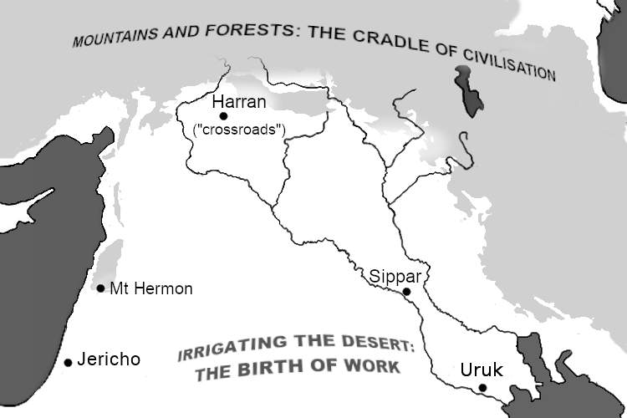
While at Hermon, Enoch had a vision in which he met the Lord of Spirits (the Monad, The One, the force behind all things: he cannot be seen directly), and the Ancient of Days (a symbol of very ancient people). They taught him the patterns of nature, and hence, the future of the world.

The original Enoch
Enmeduranki was the seventh name in the Sumerian King List, ruling Sippar, the city of the sun god Shamash, for (probably) 360 years. His name means lord (“en”) of the power (“me”) that links (“dur”) Heaven (“an”) and Earth (“ki”). He was “the beloved of Anu, Enlil and Ea.” (Anu was the god of the heavens, Enlil was the god of the air, and chief god of Sumer, and Ea was the god of water). Shamash and Adad (Hadad, god of storms) took Enmeduranki “to their assembly” (the assembly of the gods), where they sat him “on a large throne of gold”. They then taught him all the secrets of the universe, including how to predict the future, gave him the tablets of destiny (the written secrets), and showed him how to write them. Thousands of years later the great king Nebuchadnezzar I claimed his authority from Enmeduranki:
“…offspring of Enmeduranki, king of Sippar, [who saw the future], who sat in the presence of Shamash and Adad, the divine adjudicators, foremost son, [….], king of justice, reliable shepherd, who keeps the land’s foundations secure.”
Enmeduranki“brought the men of Nippur, Sippar and Babylon into his presence” and taught them his secrets. That is, the assembly of the gods was somewhere that ordinary people could visit if they had permission. This is further evidence that the assembly of the gods was somewhere on Earth, e.g. at Mt Hermon.

Enmeduranki and the flood
The gods taught Enmeduranki how to write with the tablet and stylus. That is, they taught him cuneiform: the first modern writing. This dates the story to 3100-2900 BC. Before that time, writing was only a memory aid: a person would make marks to remember what they already knew. New information could only be shared in person, so the other person could ask questions. But full cuneiform stopped that. Now Kings could send information very rapidly, and nobody could question a tablet to see if it was lying. Writing made propaganda much easier.
So writing was powerful and dangerous. At first, you could only use it if you were bound with an oath to not to misuse its power:
“The learned savant [Enmeduranki], who guards the secrets of the great gods, will bind his son whom he loves with an oath before Shamash and Adad by tablet and stylus and will instruct him.”
But writing inevitably spread. Writing allows bureaucracy: the semi-automated control of large, complex cities. Six hundred years later this led to a lot of noise, and that worried the rulers:
“6oo years, less than 6oo, passed, And the country became too wide, the people too numerous. The country was as noisy as a bellowing bull. The God grew restless at their racket…”
What does that mean? This was the second time that the text describes noise worrying the gods. The first time has more details. The first time was the era of the gods (and junior gods), when every human was effectively a god: anybody could defy anybody else, and there were no human slaves. But that meant everybody had to help with the work. These god-men complained about having to dig irrigation canals for the city. They noted that the king and his friends, who claimed access to higher gods, did not have to dig ditches. So the ditch-digging god-men encircled the house of the king. They had weapons. They made a lot of noise. They threatened a revolution.
The king (representing the higher gods) finally agreed that most of the people (representing lower gods) could stop digging ditches. But then who would do the work? One unlucky god (and more importantly his followers, probably perhaps immigrants) was demoted to become a slave. Atrahasis describes this as a god being killed, then their blood was mixed with the dirt, and that created a new class of man: the ditch digger. That took place around 4000 BC.
So the “noise” that scared the gods before the Flood was probably another worker rebellion. How would the gods respond? At first, they tried to starve the ditch diggers, to teach them a lesson:
“Cut off food supplies to the people!”
Starvation led to sickness. Atrahasis was the leader of the ditchdiggers. He complained to his supervisor, the man who represented Ea:
“Atrahasis made his voice heard and spoke, Said to Ea his master, 'Oh Lord, people are grumbling! Your [sickness] is consuming the country!”
Ea (who later became Yahweh) sympathised with Atrahasis, and told him what to do to: tell the workers to withhold their labour!
“Call the [elders, the senior men], Start an uprising in your house, Let heralds proclaim … Let them make a loud noise in the land: Do not revere your god(s)!”
So the gods (bosses) faced a rebellion, just as they had in 4,000 BC. They reacted in the same way: kill some, appease others. They killed all the workers in the chief city of Shuruppak. They bribed Atrahasis: they helped him escape, and let him live in luxury far away, in the paradise of Dilmun.
The rebellion depended on help from Ea: on the gods mixing with men. Later versions of the story could not admit the real problem, that the gods were parasites. So they blamed the Flood on gods mixing with men.

Enoch in Genesis
Genesis compressed the lengthy name “lord of the power that links Heaven and Earth” (Enmeduranki) into the much shorter “tastes godhood” (Enoch). He was still the seventh mythological figure before the Flood, but his 360-year reign became 365 years because he ruled the city of the sun (Sippar) and the solar year has 365 days. Myth writers are free to adjust less important details if it helps them to preserve the important ones. The story was compressed as follows:
“And Enoch lived sixty and five years, and begat Methuselah: and Enoch walked with God after he begat Methuselah three hundred years, and begat sons and daughters: and all the days of Enoch were three hundred sixty and five years: and Enoch walked with God: and he was not; for God took him.”
Notice how Genesis is a very careful history. Enoch’s 365 years are split into a typical human lifespan (65 years) and then another 5 old Sumerian sars (300 years). Tasting godhood (“Enoch”) leads directly to military strength (“Methuselah”) which ends in the precise year of the Great Flood. (Just as Enmeduranki is followed by Ubara-Tutu and the Flood.) The next chapter of Genesis is about the sons of God mixed with the daughters of men. These names and numbers are not random.
The Genesis version preserves the most important facts about Enmeduranki. He walked with the gods (elohim, plural) and ended up living with them. This mixing led to the rise of Big Men who saw no limits and rejected the old rules. That led to the Great Flood that ended civilisation. This is confirmed by archaeology: the invention of more advanced writing led to economic and military expansion. This led to Big Men like Gilgamesh who thought they had no limits. This led to the destruction of the chief Sumerian city, Shuruppak. This destroyed the alliance of cities. Then another Big Man (Sargon of Akkad) conquered and ruled all the cities. This destroyed the first modern civilisation.

Big Men (“giants”)
Stone reliefs showed kings as larger and stronger than anybody else. They also built bigger homes (palaces and towers). Their ceilings were higher, their doors were larger. The Jerusalem temple had thirty-foot high ceilings. The gate to Babylon (the Ishtar gate) was fifty feet high. Even their beds were larger. The temple of Marduk in Babylon had a jewel-encrusted bed that was thirteen feet long. Og, king of Bashan had a bed of the same size, overlaid with precious metal (iron, which was very precious at the time). The Book of Enoch describes these Big Men as 3000 cubits (4,500 feet). That is the height of the mountains where the gods lived. However, many stone reliefs show Big Men to be only slightly taller than other people. So the scale indicates wealth and power, not body size.
In ancient Sumer, rulers were often called “lugal”, literally Big Men. For example, Lugal-Anne-Mundu (“big man of sky god [an] and temple wealth [mundu]”) briefly conquered all of Mesopotamia. Big Men caused the chaos that destroyed Sumer. Looking back, Genesis calls them “fallen ones” (“nephilim”), sometimes translated as “giants”. Their descendants survived in Canaan until the conquest by the people of Moses. Genesis, like Manetho, calls these remnants “the spirits of the dead” (“rephaim” in Hebrew).

End-of-civilisation timeline
Here is a timeline of how Big Men destroyed civilisation:
- 6500 BC: canals allow the rise of city-states in Mesopotamia
- 4000 BC: a new class system develops. A designated class of ditch diggers needs a class of middle managers (igigi) to watch them.
- 3000 BC: a new kind of writing allows:
  - much faster (and shallower) communication
  - the expansion of cities around the world
  - colonial wars
  - a new class of Big Men who reject old ideas.
- 2500 BC: Ur-Nanshe (a non-priest) becomes ruler of Lagash: this marks a complete rejection of the old religion.
- 2350 BC: civilisation collapses
We follow the same timeline today:
- 2000 BC: the first empires
- 500 BC: a new class system develops (manorialism). The fall of the centralised Roman system creates a new class of middle managers (manorial barons) to watch the workers. This allows a greater variety of local conditions in western Europe, which creates competition, leading to new polities and technologies.
- 1450 AD: a new kind of writing (the printing press) allows:
  - much faster (and shallower) communication
  - the expansion of cities around the world
  - colonial wars
  - a new class of Big Men who reject old ideas.
- 1950 AD: ancient tradition is rejected as a guiding principle.
- 2100 AD: ??
The same pattern is seen throughout history at every scale. Power creates inequality. That creates conflict. That creates technology. Big Men use technology in unrestrained ways, and the system collapses. The Great Flood is just the most famous example.

The self-correcting Book of Enoch
The Books of Enoch (Enoch and 2 Enoch) expand the story of Enoch. They focus on “The Watchers”. The Watchers are overseers sent by the gods to watch over workers. Today we call that role “management”. The development of writing (3,000 BC) greatly increased the power of management. So does the development of modern information technology.
Kirby also wrote about the Watchers. His Watchers were of the same race as Galactus, the world killer. Their technology was well-intentioned but caused the destruction of worlds. Kirby’s Watchers learned their lesson. They stopped pretending that they knew better than the people beneath them. They became content to spend their lives in study and contemplation.
Enoch implies that history will end around the year 1900 AD. 2 Enoch implies 2100 AD, followed by a final thousand-year Millennium. Where did they get that idea? Both books describe natural cycles, but neither show any knowledge of cycles lasting more than one year. The authors want to promise that God will triumph. But why did they place that triumph almost two thousand years away? The author of 2 Enoch seems aware of the problem. He backdates Adam, to bring the end date closer to his present. But he must have known that he was cheating: no Bible gives Adam such an early date. So the authors of Enoch and 2 Enoch did not invent those dates. And they were not a natural part of Jewish cycles. So who invented those dates?
Jewish texts from this era show the influence of Persian (Zoroastrian) teachings. The end dates in Enoch fit the Zoroastrian 12,000-year cycle. This shows how mythology is self-correcting. The authors of Enoch and 2 Enoch did not change the old stories to suit their needs. They changed the stories to fit new evidence as it arose.
We see this self-correcting mechanism again in the cause of the flood. The initial story was accurate, but later versions added errors. Those errors were then corrected. In the oldest Sumerian account of Enoch and Noah, the gods were the aggressors and the humans were the victims. In the later Genesis version, the humans share some of the blame. In the even-later Book of Enoch, the humans share more of blame. Finally, in 2 Enoch, the humans caused the flood by not obeying the gods! So the original story had bad gods and innocent humans. But the later story had innocent gods and bad humans. A serious mistake crept in. But it would not stay.
This is how the mistake corrected itself. 2 Enoch appeared around the year 200 AD. The most educated readers examined the text. These readers were “the knowledgeable ones”, or in Greek, “gnostics”. They saw that 2 Enoch made no sense. How can gods be helpless victims? So the educated readers wrote a new version of Enoch, called “The Reality of the Rulers” (or in Greek, “The Hypostasis of the Archons”). The new version explains how the gods caused corruption and the flood. It reasons that the god that made the physical world (and caused the flood) must be ignorant and flawed. The Reality of the Rulers reconstructed the original story by using logic.
Kirby did the same with The Eternals. The Eternals re-tells the story of the Creation and the Flood in a creative way. Like Enoch, The Eternals uses an ancient flood as a model for the Day of Judgement. It shows how the gods (the Celestials) always fail in their attempt to create a perfect world. And so the gods always destroy their creation. So the gods are eviler than their creations. Kirby did not need to read The Reality of the Rulers to know that. Kirby worked it out from his knowledge of history and human nature. When people act like gods, they destroy civilisation.
How could it be otherwise? Civilisation means to be civil: to treat other people as equals. So to act like a god is to end civilisation. God-men (kings and billionaires) delay the destruction of humans by destroying animals and nature first. They control information technology to promote themselves and smear enemies. This makes the god-men look strong for a while. They attract followers. But they weaken society. They destroy civilisation.
The great storytellers understand. They see the process all around them. God-men look clever and strong. But god-men destroy more than they create. It has always been this way.

Bibliography
Kirby wrote around 1000 stories. The precise number depends on how we divide long-running serials that contain many parts. This selected list is based on the one by Ray Owens, at marvelmasterworks.com/resources/kirby_chronology.html
Some of Kirby’s earlier work can be read for free at comicbookplus.com/ Just search for “Jack Kirby”.

1937 | Facts you never knew
1938 | The Count of Monte Cristo  The Diary of Dr. Hayward  Wilton of the West  Lightnin' & The Lone Rider
1940 | The Solar Legion  Blue Bolt  The Vision  The Black Owl
1941 | Captain America  (includes Tuk, and Hurricane, son of Thor)
1942 | Sandman  The Newsboy Legion  The Boy Commandos
1946 | Stuntman  Boy Explorers
1947 | Headline  Real Clue Crime  Justice Traps the Guilty  Black Cat  Young Romance
1949 | Young Love
1950 | Boys' Ranch  The Frog Prince (screenplay, actual date unknown)
1952 | Strange World of Your Dreams  Young Brides
1953 | Captain 3-D
1954 | Fighting American  Bulls-Eye  In Love  Police Trap  Foxhole
1955 | Western Tales
1956 | Black Cat Mystic  Yellow Claw
1957 | Challengers of the Unknown (began in "Showcase")  House of Secrets  Tales of the Unexpected  My Greatest Adventure  Alarming Tales
1958 | Race for the Moon  House of Mystery  Gunsmoke Western  Sky Masters (newspaper strip about the space race)
1959 | Tales to Astonish  Strange Tales  Journey into Mystery (later renamed Thor)  Tales of Suspense  Double Life of Private Strong (aka The Shield)  Two-Gun Kid  Adventures of the Fly  Battle  Love Romances  Kid Colt Outlaw
1960 | Rawhide Kid
1961 | Amazing Adventures  Classics Illustrated  The World Around Us  Fantastic Four
1962 | Teen-Age Romance  Incredible Hulk
1963 | Amazing Spider-Man  Sergeant Fury  X-Men  Avengers
1970 | Chamber of Darkness  Jimmy Olsen
1971 | Forever People  New Gods  Mister Miracle  In the Days of the Mob  Spirit World
1972 | The Demon  Kamandi
1974 | Our Fighting forced  OMAC
1975 | Atlas the Great
1976 | 2001: A Space Odyssey  The Eternals
1977 | Black Panther
1978 | Devil Dinosaur  Machine Man
1979 | The Horde (unpublished)
1981 | Captain Victory  Destroyer Duck
1983 | Silver Star
1993 | The Secret City

Interviews with Kirby
“JKC” is "The Jack Kirby Collector”
available from twomorrows.com
1969: Mark Hebert. Reprinted in The Comics Journal Library #1
1970: San Diego comic con. JKC #57 kidr77.blogspot.com/ 2019/06/jack-kirby-interview-at-san-diego-comic.html
1970: Train of Thought, part 1. JKC #17
1970: Train of Thought, part 2. JKC #52
1971: Carmen Infantino. Reprinted in Comic Book Artist #1 kirbymuseum.org/blogs/effect/2013/06/28/kirby-and-infantino/
1972: Jim Steranko. JKC #8
1972: Jonathan Bacon. Fantasy Crossroads #1, reprinted in TJKC #80
1975: Steve Sherman and Mark Evanier. JKC #8, ohdannyboy.blogspot.com/2012/04/jack-kirby-1975-i-love-fans-even-if.html
1976: Journal of Popular Culture. JKC 44 black-wellpublishing.com/journal.asp?ref=0022-3840
1976: Nessim Vaturi. In Lucca, Italy. JKC #12
1976: Peter Hansen. In Lucca, Italy. JKC #48
1978: PhD student Annie Baron-Carvais. JKC #32
1982: Howard Zimmerman. Comics Scene #2 forbushman.blogspot.com/ 2013/03/kirby-took-on-comics-1982.html
1983: James Van Hise. JKC #25
1984: Juanie Lane. JKC #16
1984: Ray Zone. JKC #45
1985: Greg Theakston (1). Volume 1 of "Jack Magic" (now out of print)
1986: Comics Feature. Comics Feature, May 1986, “A Talk With the King”
1986/7: Leonard Pitts. JKC #66 kirbymuseum.org/ blogs/effect/2012/08/06/19867-kirby-interview/
1987: Greg Theakston (2). kirbymuseum.org/blogs/effect/2012/06/30/ 1987-jack-kirby-the-king-of-comics/
1987: Earth Watch radio show. comicbookcollectorsclub.com/jack-kirby-and-stan-lee-radio-interview-earth-watch-wbai-1987/
1987: Ken Viola. JKC #7
1987: Ben Schwartz. JKC #23
1989-1992: Ray Wyman
(1): JKC #45
(2): JKC #26
(3): JKC #32 (about The Horde)
1989: Gary Groth. The Comics Journal #134 tcj.com/ jack-kirby-interview/
1990: Hour 25 radio. kirbymuseum.org/ blogs/effect/2012/06/27/19900413-interview/
1990: Paul Duncan. JKC 61
1992: Mondo 2000. JKC #21. kirbymuseum.org/blogs/effect/2012/06/09/19920814-interview/
1992s: Glenn Danzig. JKC #22. twomorrows.com/ kirby/articles/22danzig.html
1995: Roz Kirby. (Interview with Jack’s wife, Roz, after Jack’s death)
JKC #10.
twomorrows.com/ kirby/articles/10roz.html

Other books and resources

The Lost Jack Kirby Stories
The companion to this book. It began as a very long appendix to this book. Kirby’s 1960s work was heavily edited before publication. This book attempts to recover the original stories.
lulu.com/en/gb/shop/chris-tolworthy/the-lost-jack-kirby-stories/paperback/product-yed8q9.html

According to Jack Kirby
“Insights drawn from interviews with comics' greatest creator”
by Michael Hill, 2021.
The definitive work on Kirby's relationship with his editor in the 1960s.
lulu.com/en/us/shop/michael-hill/according-to-jack-kirby/paperback/product-v7dnyy.html

The Jack Kirby Museum and Research Centre
Includes three biographies, various blogs, and much more.
kirbymuseum.org/

Jack Kirby: A Personal Look
by his son, Jeremy Kirby, 2014. Includes many photos, and the complete text of Kirby’s screenplay, "The Frog Prince”

Jack Kirby Dialogue
A discussion group focusing on Kirby’s writing
facebook.com/groups/1131507896866990/

Against the Grain: a Deep History of the Earliest States
by James C Scott, 2017
The first modern book to show that the neolithic revolution made life worse for ordinary people: so civilisation before 8000 BC was better.

The Dawn of Everything: a New History of Humanity
by David Graeber and David Wengrow, 2021
The definitive text on the richness of world history, showing that farming and cities are not progress.

The Digital Comic Museum (digitalcomicmuseum.com)
For more public domain Kirby stories

Copyrights

The following stories (reprinted in this book) were first published before 1950, but their copyright was not renewed. So they entered the public domain before the new laws came into place in 1978.
- “The Diary of Dr Hayward”: September 1938
(in “Jumbo Comics” #1 published by “Fiction House”, Credited to “Universal Phoenix Feature Syndicate”)
- “Blue Bolt”: July 1940 (in “Blue Bolt” #2, published by “Novelty Comics”)
- “Gun Moll”: January 1948 (in “Justice Traps the Guilty” #2, published by “Prize”)
These stories were published after 1950, but before 1978. Their copyright was not renewed, so they entered the public domain twenty-eight years after publication.
- “Monsters on the Lake”: March 1953 (in “Black Magic” #22 / vol 3: #4, published by “Crestwood”)
- “The Demon Wind”: September 1953 (in Black Magic #26 / volume 4 #2)
- “The Cat People”: November 1953 (in Black Magic #27 / volume 4 #3)
- “The Emissary”: February 1955 (in “Win a Prize” #1, published by “Charlton”)
- “Mysteryvision”: September 1956 (in “Black Cat Mystic” #58, published by “Harvey”)
- “Today I Am A”: September 1957 (in Black Cat Mystic #59)
- “The Fourth Dimension is a Many Splattered Thing”, “The Last Enemy”, ”The Cadmus Seed”, ”Logan’s Next Life”, and “Donnegan’s Daffy Chair”: September 1957 (in “Alarming Tales” #1, published by Harvey)
- “Hole in the Wall”: November 1957 (in Alarming Tales #2)
- “The Garden of Eden”: November 1958 (in “Race for the Moon” #3, published by Harvey)
Stories published since 1964, with a copyright notice, are automatically renewed, and remain in copyright for at least 95 years from publication. Stories published since 1978 are automatically in copyright for at least 95 years, regardless of whether or not they contain a copyright notice.

The law
The United States Copyright Office summarised the relevant law, in its circular "Duration of Copyright":
“Under the 1909 act, federal copyright was secured on the date a work was published or, for unpublished works, on the date of registration. A copyright lasted for a first term of 28 years from the date it was secured. The copyright was eligible for renewal during the final, that is, 28th year, of the first term. If renewed, the copyright was extended for a second, or renewal, term of 28 years. If it was not renewed, the copyright expired at the end of the first 28-year term, and the work is no longer protected by copyright.”
Cornell university summarised the law as follows:
“Works Registered or First Published in the U.S.:
Date of publication:
1926 through 1963
Conditions:
Published with [a copyright] notice but copyright was not renewed:
Copyright term:
None. In the public domain due to copyright expiration”
This is clear and unambiguous. Even if a title was in its original 28 year copyright in 1978 (i.e., it was published after 1950) it still had to renew the copyright after 1978. Unless it was published after 1963, but that does not apply to these stories. Stanford University summarises the law:
"Works originally copyrighted between January 1, 1950, and December 31, 1963: Copyrights in their first 28-year term on January 1, 1978, still had to be renewed to be protected for the second term. If a valid renewal registration was made at the proper time, the second term will last for 67 years. However, if renewal registration for these works was not made within the statutory time limits, a copyright originally secured between 1950 and 1963 expired on December 31 of its 28th year, and protection was lost permanently."
There could also be legal protection in two other ways:
- If the stories are based on other stories which are themselves under copyright: for example, a comic strip version of a cartoon. But that does not apply here.
- If the characters are trademarked.

The copyrights were not renewed
The Copyright office clearly stated that, “copyright was eligible for renewal during the final, that is, 28th year, of the first term." That is, when searching records for renewals, we only need to look in the final year, and the year each side of that, in cases where the cover date was too soon, or a December renewal was not processed until January. Renewals can be checked online at the following sites:
For books published after 1950 (i.e., renewed after 1978, electronically):
cocatalog.loc.gov
For books published before 1950 (i.e., renewed before 1978, on paper: these are scans of the paper summaries):
onlinebooks.library.upenn.edu/cce/
A combined source of both datasets, covering only books and only renewals: it includes transcriptions of the pre-1950 scans, so some errors are possible, and if books are wrongly categorised they might not show up:
exhibits.stanford.edu/copyrightrenewals
Searching these databases reveals no mention of the stories in this book (e.g., “Last Enemy”) or the books where they appeared (e.g., “Alarming Tales”). So these stories are in the public domain.
Regarding trademarks, these must be renewed every ten years, paying a substantial fee each time. And if a trademark is not used in commerce for three years it can be disputed and cancelled. So it is extremely unlikely that a character who only appeared in one story would be trademarked, decade after decade. But the United States trademark database can be searched here:
uspto.gov/trademarks/search
The only character in this book who appears in more than one story is Blue Bolt, and he faded away in 1951 and was never used again (except in reprints of his public domain stories). Sure enough, he does not appear in the trademark database.
We should not be surprised that the copyrights were not renewed. Very few books renewed their copyrights in this period:
“A 1961 Copyright Office study found that fewer than 15% of all registered copyrights were renewed. For books, the figure was even lower: 7%.”
This number was likely far lower for comic books, as profit margins at the time were extremely low, and each monthly issue required a separate renewal. Occasionally, comic books were renewed, and this shows that the database does work. (It shows that we are not looking in the wrong place or in the wrong way.) For example, under the title “Black Magic”, the following copyrights were renewed:
“Vol. 5, no. 2, Sept.-Oct 1954 (no 32)"
"Through v. 5, no. 3, Nov.-Dec 1954 (no 33)"
Why these particular issues? We can only guess, but the start date is the same month that Fredric Wertham published his infamous book “Seduction of the Innocent”, causing great damage to the comics industry. The end date is around the time that Kirby left the title, so stories after that time would have less commercial value. Because of this, the Digital Comic Museum, a reputable source for public domain comics, offers Black Magic up to volume 4 #4 (also known as #28) and from volume 6 #1 (also known as #34), but not in between. Indeed, it includes this warning to users: "NOTE #29-33 are not PD, Do not upload them!”

Acknowledgements
Thanks to Jack Kirby, obviously.
And to Roz Kirby, for making it all possible.
And to Rose Kurtzberg, for starting it all.
Thanks to James Newton, for many of the best insights.
Thanks to Michael Hill for "According to Jack Kirby". At last we can move past claims of authorship, and focus on what matters: the stories.
Thanks to Patrick Ford, the voice in the wilderness. For decades, most people didn't even know that Kirby was a writer. And Patrick was always there, gathering every piece of documentary evidence, patiently quoting the documents, and being hated for it.
Thanks to Abraham Riesman, for "True Believer”: the first book to show a mainstream audience that Kirby was a writer, not just an artist.
Thanks to ComicBookPlus.com and the Digital Comics Museum, for hosting some of Kirby's best work, legally, and for free.
Thanks to Ray Owens, for the invaluable bibliography, in date order, at marvelmasterworks.com/resources/kirby_chronology.html
Thanks to Stephen Bissette for the Melchior book scan.
Thanks to Sanchuniathon (c.2000 BC) for preserving our oldest records before they were destroyed.
Thanks to David Graeber for showing that civilisation is far older and more varied than the Power People pretend.
And finally, thanks to Stephanie, for supporting my crazy obsession.
Don’t forget

2026: The end of democracy

2040: Privatised travel to other planets

2065: Machines replace skilled humans

2072: War with China due to global warming

2090: First successful humanoid robot

2121: The Great Disaster
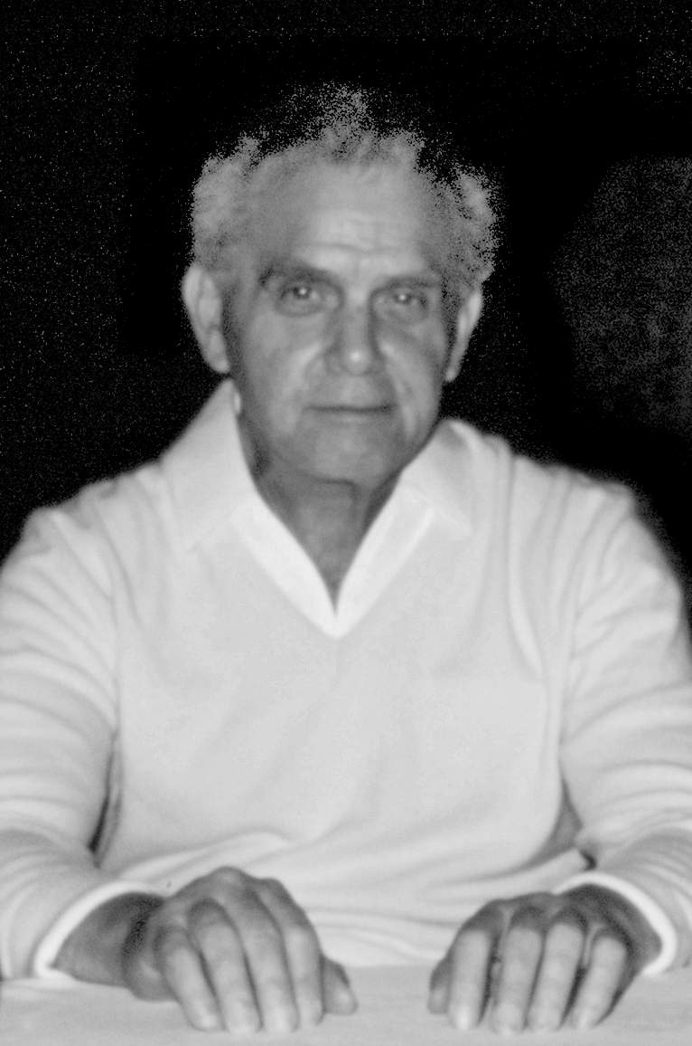
Image: Marc Hempel, CC-BY-SA-3.0

“My stories were true.”

Jack Kirby, from the Ray Wyman interview (3). See the bibliography
“Past Extinctions of Homo Species Coincided with Increased Vulnerability to Climatic Change” by Pasquala Raia et al, One Earth 3:4, p.480-90, Oct 23,2020 cell.com/one-earth/fulltext/S2590-3322(20)30476-0
Genevieve Von Petzinger, The First Signs, introduction (p.3)
God traveled the world for 40,000 years (1st wave out of Africa), then created a strong man for 30,000 years (2nd wave out of Africa), then modern man filled the world for 40,000 years (upper palaeolithic). See Appendix 3.
“Researchers determine age for last known settlement by a direct ancestor to modern humans” now.uiowa.edu/2019/12/researchers-determine-age-last-known-settlement-direct-ancestor-modern-humans
See Appendix 3.
Roz Kirby (Jack’s other half), from the Roz Kirby interview. See the bibliography for details.
See Appendix 2 for how scholarship destroys more history than it preserves..
See chapter 10
See Appendix 1 for the dates, and Appendix 7 for Enoch in general
Sanhedrin.97a. For more details, search sefaria.org
See Appendix 7 (Enoch) for how the idea came via Persia.
See Appendix 1 for the Anakites, and Appendix 5 for leaving Eden.
See Appendix 3
I.e., in the Kabbalah. See ”Shemita Cycle and Creation" by Nydle and Avraham bnaiavraham.net/9421.html Also see "The Age of the Universe A Torah-True Perspective” by Aryeh Kaplan
Kirby, “The Great Earth Cataclysm Syndrome” , Kamandi #1
From the Mondo 3000 interview
See chapter 5 and Appendix 3, for Manetho and the Turin Papyrus.
See chapter 5 for Manetho and the age of spirits of the dead.
The Flood that caused the collapse of Sumer (see chapter 5) and the collapse of the Old Kingdom of Egypt.
See Appendix 6
See chapter 13 for how kings in Israel rejected the law of Moses.
The four craftsmen of Zechariah 1:18-21. "Rabbi Shimon Ḥasida said: They are Messiah ben David, Messiah ben Yosef, Elijah, and the righteous High Priest" - Talmud Sukkah 52b
See Appendix 2, part 7 for the original meaning of “son of man”.
The most popular first-century Jewish writer
Philo does not use the word messiah — he was not a political revolutionary — but he applies all the messianic imagery to the logos. vridar.org/2010/07/29/philos-spiritual-messiah-allegorical-and-personal/
E.g. “On The Giants” 24-27 earlyjewishwritings.com/text/philo/book9.html Compare John chapter 1: Jesus was special because he embodied the logos.
See Appendix 7
See Chapters 11 and 13.
From the Theakston interview.
From the Mondo 2000 interview
From the Peter Hansen interview
From the Peter Hansen interview
Roz Kirby, from the Paul Duncan interview
2077 individual comic books (marvelessentials.com/resources/kirby_chronology1.html) averaging over 300,000 copies each: much more in the 1940s. "Young Romance topped 1 million sales per issue, as did its companion title, Young Love.” (From the Guardian obituary of Kirby's business partner. theguardian.com/books/2011/dec/16/joe-simon ) "All of our books sold well over six hundred thousand to eight hundred thousand a month." (From the James Van Hise interview.)
Most top selling writers only master of one or two genres. But Kirby wrote in a dozen genres. In at least six genres his work became the model for others to follow. That is, he was the recognised master of each genre.
See Appendix 7
In the Pitts interview
From the Steranko interview
From the Train of Thought interview. See chapter 6, the Power People
From the Juanie Lane interview
From the Zimmerman interview
From the Zimmerman interview
"Comparative phylogenetic analyses…" by da Silva and Tehrani, royalsocietypublishing.org/doi/10.1098/rsos.150645
See Appendix 5
See chapter 5 and Appendix 3
See the earliest Yazidi stories in Appendix 3
For Kirby on religion, see chapter 3, value 10. For the earliest Jewish religion, see Appendices 5 and 6. For the soul, see chapter 14.
See The Lost Jack Kirby Stories
From the Groth interview
Writer Walter Geier, interviewed by Jim Amash in Alter Ego #30
From the Ben Schwartz interview
For more details, see “According to Jack Kirby” by Michael Hill.
From the Earth Watch interview
From the Roz Kirby interview, talking about Kirby’s novel, “the Horde”
Especially “Bond of Union” from 1956, the year before this story.
Compare the geometric shapes to Malevich’s “Supremo” series
From the Mark Hebert interview
For details, see chapters 14-16
From the Mark Hebert interview
E.g."A Martian walked among Us" (Strange Tales #78), or "Behold Him, He was the Martian" (Tales to Astonish #25) or the Skrulls (Fantastic Four #2: they look like the Martians in “Robot X”, Amazing Adventures #4)
E.g., “Devil Girl From Mars” (1954), “Fire Maidens from Outer Space” (1956), “Invasion of the Body Snatchers” (1956), etc.
E.g. see the book by the same name, by Richard Coyne
From the Pitts interview
From the Juanie Lane interview
From the Ray Wyman interview (3)
From the Paul Duncan interview
From the Mark Hebert interview
From the Juanie Lane interview
From the Roz Kirby interview
From the Neal Kirby interview
From the Gary Groth interview
Deposition of Susan Kirby, October 25, 2010. Ohdannyboy. blogspot.co.uk/2011/04/marvel-worldwide-inc-et-al-v-kirby-et_11.html
The care packages (now at jackkirbycomics.com) originally included magazines owned by Kirby.
These scans were tracked down by Alex Jay for his “Tenth Letter of the Alphabet” blog, alphabettenthletter.blogspot.com/ 2017/08/comics-jack-kirbys-facts-you-havent-seen.html
See “The Lost Jack Kirby Stories”, under Fantastic Four #52
See “The Eternals”, or “The Great Stone Face” (Black Cat Mystic #59)
From the Paul Duncan interview
Forever People #6, page 4
hoodedutilitarian.com/2013/01/peter-sattler-on-what-influenced-kirby/
npr.org/2018/02/24/587809173/billy-graham-walked-a-line-and-regretted-crossing-over-it-when-it-came-to-politi
“It would also have destroyed countless villages, sending as many as a million civilians to their deaths.” politico.com/magazine/ story/2018/02/21/billy-graham-death-richard-nixon-217039/
harvardpress.typepad.com/hup_publicity/2018/02/billy-grahams-vietnam-grant-wacker.html
E.g., removing the implied criticism of nuclear testing in Fantastic Four #1: see “The Lost Jack Kirby Stories”
“The Lost Jack Kirby Stories” on Fantastic Four #52
From the 1990 Ark interview
He referenced King Richard, who reigned 1189-1199
From the Danzig interview
E.g. Prester John, or the tradition of exchanging babies in New Gods
Quasimodo, Sinbad (Boy Explorers), Kalibak, Sprite (Eternals), etc.
From Jumbo Comics #2 (page 15), 1938
“Wing Turner”, Mystery Men #10, May 1940
Racism was such a problem that after Kirby left the strip, Otembi was changed to be white.
Mentioned in the Groth interview
Some have attempted to argue that the offensive ‘Whitewash Jones” in Young Allies was a Kirby character, but it appears that Kirby only provided the initial concept outlines, and these did not include the Whitewash character.
From the 1985 Theakston book
From the Nessim Ventura interview
From the 1985 Theakston book
Confirmed in an email exchange with the Kirby family
This is from the first story, in Black Cat Mystic #58, September 1957. Sadly the publisher delayed the next issue for a whole year (#59, September 1957), and by that time Kirby was committed to other projects.
Fantastic Four #15. See “The Lost Jack Kirby Stories”
e.g., Fantastic Four #67, or The DNA Project in Jimmy Olsen #136-146
The Face on Mars, from Race to the Moon #2
From the Juanie Lane interview
See chapter 15 for details
Kirby wrote in 1957. Rosen published his theory in 1958.
"Can Self-Replicating Species Flourish in the Interior of a Star?" By Luis A. Anchordoqui and Eugene M. Chudnovsky, doi.org/10.31526/lhep.2020.166
From “Disgrace”, in Young Romance #6
From the Groth interview
Thanks to Harry Mendryk for tracking this down. kirbymuseum.org/blogs/simonandkirby/archives/3673
From the James Van Hise interview
From the 1977 Shel Dorf interview
“Killer in the Kitchen”, Headline #23, based on the “Bermondsey Horror”
quoteinvestigator.com/2011/08/12/just-a-cigar/
See the Roz Kirby interview
cbr.com/marie-severin-marvel-tribute-jack-kirby/
As revealed in his written proposal, intended for later issues of Atlas.
See Appendix 4, Atlantis
From the Mark Hebert Interview
From the Peter Hansen interview
“I Talked With My Dead Wife”, from Strange World of Your dreams #1
In Spirit World
It is possible that Kirby found this prediction in one of the many books about Nostradamus. Such books make countless claims, and they almost never come true. But this claim felt right to Kirby, and it came true.
Spirit World page 49
By the OAS, a far right organisation opposed to Algerian independence
Lord of flight. The Eternals mixes Incan traditions (returning gods) with Mayan imagery (especially the Pacal "astronaut"). Tecumotzin, who became dust, reminds us of the "tecumbalam" bird from the Poul Vuh. Tecumbalam helped to end a previous civilisation: "the Tecum-balam broke and bruised their bones to powder." "Balam" means jaguar, indicating its power. "Tecum" was the ruler of the Maya whose defeat marked the end of their civilisation. See "Tecum, the Fallen Sun" by Oswaldo Chinchilla Mazariegos. "Otzin" is "young one", so Tecumotzin, lord of flight, means something like "ageless thunderbird of the end of civilisation"
Icarus flew too close to the sun. Ajax killed his friends when he was angry, then realised what he had done and killed himself.
Eternals #2, pp.11-14
Eternals #7, pp.4-5
Eternals #12, cover and pp.11-17
Eternals #17, cover and pp.11-12
See Appendix 5 for the long-lived patriarchs in Genesis 5
Technically he ruled over god (gods were human), but translators cannot admit that. “Isra” (yiz-rah) is from “sara” (saw-raw), to rule, hence “sar” (prince), “sarah” princess, etc. Genesis 32:28
Daniel 12:2
E.g. Daniel 12:2 “sleep in the dust” refers to idleness, not death: “I was in a deep sleep on my face toward the ground” (Daniel 8:18, 10:9)
See Ezekiel 6 for the destruction of Israel, leaving just bones. See Ezekiel 37 for how the flesh metaphorically returns to those bones.
E.g., Job 19:25-27: Job knew that after he died, a redeemer would sort his problems out. A redeemer was a family member who pays your debts when you are gone. To Job that was the same as him being physically present.
From the Hour 25 radio interview.
For Kirby's attitude to religion, see eternal law 10, later in this chapter
Kirby survived the depression, fought in the war, raised baby boomers, made himself a huge success, etc. but always treated others as equals. He redefined the most American art form, the superhero comic book.
From the “Train of Thought” interview.
Plato’s Republic, toward the end of book 2.
Cumulative deaths per million ourworldindata.org/covid-deaths#what-is-the-cumulative-number-of-confirmed-deaths
bmj.com/content/371/bmj.m4425, transparency.org.uk/track-and-trace-uk-PPE-procurement-corruption-risk-VIP-lane
bmj.com/company/newsroom/politicians-and-governments-are-suppressing-science-argues-the-bmj/
E.g. settled societies cannot move on to better lands in a famine, large populations cannot avoid contagious disease, powerful people do not share food, and so on. See chapter 4 for good versus bad social systems, and chapter 5 for examples of bad systems causing civilisational collapse.
From the Carmen Infantino interview
See Appendix 2 part 2 (on Sanchuniathon and Phoenician pillars), and Appendix 7 part 3 (on gods as the causes of things)
See Appendix 5
Fantastic Four #10
From the Paul Duncan “Ark” interview
See chapter 7
Vader’s master, Palpatine, speaks of the goal of cheating death in Lucas’ “Revenge of the Sith”. In the expanded universe, some Sith lords take over younger bodies.
See “The Lost Jack Kirby Stories” for how the stories fit together.
From the Zimmerman interview
See Appendix 6 for how Judaism traces its origins to 4,000 BC. It changes every thousand years or so (e.g. with Abraham, Moses, Ezra and then the rabbis), but preserves its tribal identity, history, etc.
See Appendix 4 for how the gods replaced the Titans.
See chapter 5 and Appendix 3.
How do individual gods become the capital “G” God? See Appendices 5 and 7 for “the elohim”, the divine hive mind, the council of the gods.
From the Ray Wyman interview
From the Paul Duncan interview
From the Paul Duncan interview
Humans are enslaved by machines, and a mad scientist in his laboratory creates an artificial human to replace a real one
Hephaestus, the first metalworker, metaphorically stole fire from the gods, creating modern humans: see chapter 5 for how humans became gods.
E.g. "The Three Prophecies" (House of Secrets #3), "The Face behind the Mask" (Tales of the Unexpected #13), "3 wishes to Doom" (Tales of the Unexpected #15), "The cat who knew too much" (House of Secrets #8), "Mysterious Mr. Vince" (Tales of the Unexpected #21)
As “boy steals ogre’s treasure” "Comparative phylogenetic analyses uncover the ancient roots of Indo-European folktales" doi.org/10.1098/rsos.150645
From the Ken Viola interview
See chapter 5 and Appendix 3.
Defined by Hesiod: see chapter 13 for the ages of mankind.
Marshall Sahlins, “The Original Affuent Society” in “Stone Age Economics”
See Appendix 2, and ”The Dawn of Everything” (in the bibliography)
See "The Okanisi: A Surinamese Maroon Community" by Marcel Van Der Linden
See "Micronesia—Past and Present" in "The Congress of Micronesia" by Norman Meller jstor.org/stable/j.ctvp2n5bt.5
peacefulsocieties.uncg.edu/societies/tahitians/
Lee Clare and Hans Gebel, “Introduction: Conflict and Warfare in the Near Eastern Neolithic” in Neo-Lithics 1(10):3-5 researchgate.net/profile/Lee-Clare/publication/278156932 Some scholars still believe Thomas Hobbes’ view that prehistoric humans loved war. But more evidence supports Rousseau’s view that we preferred peace: “it is the latter of these paradigms [Hobbes v Rousseau] which proved prevalent"
ibid
“[T]hey continued to depend on trade … tied to sedentary communities along rivers where they traded horses, milk products, and other livestock in return for metals and wood. … Scythian weapons included composite reflex bows, armor-piercing arrowheads…” — "Ancient Horse-Cultures of the Eurasian Steppes" by Kathleen Guler, referring to archaeologist Timothy Taylor
people.vcu.edu/~mreimers/Personal/early.human.ethics.html
“Hunter-gatherers have less famine than agriculturalists" ncbi.nlm.nih.gov/pmc/articles/PMC3917328/
See The Great Disaster in chapter 12 and Appendix 3.
For examples see “This World is Ours”, “Toxl”, “Captain 3D”, “The Eternals”, and most importantly, “Kamandi”.
The First Signs: Unlocking the Mysteries of the World's Oldest Symbols” by Genevieve von Petzinger; ”Code hidden in Stone Age art may be the root of human writing" Alison George, New Scientist, 9 Nov 2016
La Pasiega Cave, Spain. "U-Th dating of carbonate crusts reveals Neandertal origin of Iberian cave art" in the journal Science, 23 Feb 2018
sciencedirect.com/science/article/abs/pii/S0278416505000103
classics.mit.edu/Plato/phaedrus.html
danielkilov.com/2017/03/13/dr-lynne-kelly-on-cracking-the-memory-code/
Thanks to Henrey Bradley at Quora for pointing this out
See Appendix 5
nationalgeographic.com/science/article/100217-crete-primitive-humans-mariners-seafarers-mediterranean-sea
sciencemag.org/news/2018/05/ancient-humans-settled-philippines-700000-years-ago-new-fossils-reveal
siberiantimes.com/science/casestudy/features/is-this-the-worlds-oldest-secret-code/
For example, in 8000 BC a series of stones in Scotland allowed people to track the phases of the moon nationalgeographic.com/science/article/130715-worlds-oldest-calendar-lunar-cycle-pits-mesolithic-scotland
See Appendix 6 for how Moses wanted to share the land equally
See Appendix 2 (Hilkiah). For Moses, see chapter 14 and Appendix 6.
See the Pitts interview for the quote. See chapter 14 and Appendix 6 for how Moses‘ idealism was rejected.
Bombast #1, p.6. Dialogue by Gary Friedrich, but it sums up the contrast nicely. Kirby created the characters and basic scenario.
Appendix 2
koshertorah.com/PDF/shemitot.pdf
From the Zimmerman interview
For more advanced human civilisations in recent history, see “The Dawn of Everything”, in the bibliography.
See Margaret Bruchac, "Indigenous Knowledge and Traditional Knowledge” repository.upenn.edu/cgi/viewcontent.cgi?article=1172&context=anthro_papers
Dominion theology is based on Genesis 1:26: the first Adam is the first king
String Figures and Shamanism, by Lois Stokes huna.org/html/string.html
http://www.isfa.org
Marcela Garrido Díaz, “The Kaikai of Rapanui”, garlandmag.com/article/the-kaikai-of-rapanui/
According to the Annales Cambriae
From ‘The Elucidation’, a prologue for Chrétien de Troyes’ “Perceval, le Conte du Graal”. Modern text by Sharon Blackie in her book “If Women Rose Rooted”
Procopius, History of the Wars, Book II.22 (Dewing translation)
See chapter 14 and Appendix 6 for Moses’ law that everyone has land
See Appendix 6 for the Egyptian version of the Moses story
Gildas, “On the Ruin of Britain”, II.21-22
John of Ephesus, quoted in roger-pearse.com/weblog/2017/05/10/john-of-ephesus-describes-the-justinianic-plague/
See the Promethean Galaxy in New Gods #5, or the godlike beings chained to rocks in "Giants Walk The Earth" in Journey Into Mystery #104, "And One Shall Save Him" in Fantastic Four #62, and "Space Garbage" in Race for the Moon #3. Or the Prometheus rocket in "Test Pilot", Strange Tales #68. Or all the mad scientist stories that mirror Frankenstein, "The Modern Prometheus”.
i.e. 810 years before 753 BC. Orosius, Historiae Adversus Paganos 1:9
"Genetic origins of the Minoans…" nature.com/articles/nature23310
Gilgamesh, tablet 11, ancienttexts.org/library/mesopotamian/gilgamesh/tab11.htm Also see Appendix 7 for notes on the Atrahasis version
See "Eev" in Devil Dinosaur #6, Or "The Last Rocket" in Tales of Suspense #39. Or see the original pencil notes to what became Fantastic Four #108. That story was based on Cain and Abel, and began with a two faced statue from 4000 BC, the traditional date for Adam and Eve.
From the Epic of Atrahasis. See Appendix 7 for more details.
The “5.9 kiloyear event”
See the discussion of Delambre in Appendix 2.
The cooling began 10,900 BC and ended 11,700 BC.
The later Surya Siddhanta took this to mean each year is 360 years. But it is probably just a figure of speech meaning the gods deal in long time periods. Other traditions say a day to the gods is like 1000 years: e.g. Psalm 90:4
Manusmriti [laws of Manu] 1:67-71. See also Mahabharata CLXXXVII
icecores.org/indepth/spring-2014/blown-past-dust-found-antarctic-ice-cores-offers-clues-ancient-
technologyreview.com/2010/03/30/205017/how-sandstorms-generate-spectacular-lightning-displays/
notalotofpeopleknowthat.wordpress.com/2014/02/06/storminess-of-the-little-ice-age/
"GAZA, now call'd Gazra, was in ancient Times most Famous, for the wonderful Performances of Sampson's Strength” - "A full and just account of the present state of the Ottoman empire" By Aaron Hill (1685-1750)
Discussed in Appendix 2
loebclassics.com/view/manetho-history_egypt/1940/pb_LCL350.3.xml
Manetho, the History of Egypt (from loebclassics.com). Christian copyists sometimes change “years” into “months”, but Manetho wrote “years”.
Herodotus Histories, 2.142
A good summary: youtu.be/VSsYxk3NDOI
See “Against the Grain” in the bibliography
See Appendix 4, Atlantis
“Why Do Genes Suggest Most Men Died Off 7,000 Years Ago?” livescience.com/62754-warring-clans-caused-population-bottleneck.html
ibid
See Appendix 3 for how we finally defeated the Neanderthals
The City of God, opening words to the preface
livescience.com/29130-toba-supervolcano-effects.html
indonesianbigtourism.blogspot.com/ 2012/11/lake-toba-largest-lake-in-south-east.html
“Hunger Myths”, newint.org/features/1992/12/05/hunger
Kirby’s “2001: A Space Odyssey” issues #3 and #4
This period is known as the “Marine Isotope Stage 6 period”. See “When Humans Almost Died Out”: scientificamerican.com/ podcast/episode/when-humans-almost-died-out-earthy-10-08-12/
From the Groth interview
From the Ray Wyman interview
ibid
From the James Van Hose interview
From the Juanie Lane interview
From the Juanie Lane interview
From the Train of Thought Interview, part 1
ibid
Lahontan, "New Voyages to North America", volume II p. 170. babel.hathitrust.org/cgi/pt?id=mdp.39015071156965&view=page&seq=170 In the book, Kondiaronk is called Adario. “The Dawn of Everything” shows how these quotations are genuine: the Huron were more skilled in oratory than were the French.
From the Ray Wyman interview
From Train of Thought part 2
See The Lost Jack Kirby Stories for reverse engineering the changes.
References to super herbs were probably exaggerated by the editor, who used hyperbole wherever possible. See The Lost Jack Kirby Stories.
From the James Van Hise interview
Tales to Astonish #32
See The Lost Jack Kirby Stories
See The Lost Jack Kirby Stories for the original New Gods ending
Super Powers, 1984. Kirby plotted the first four issue, and fully wrote the climactic issue #5
Super Powers, 1985, issue #5 page 21
See The Lost Jack Kirby Stories
(1) Paul can travel in the fourth dimension. Or, (2) Paul literally erases himself — kills himself, — to prevent the army from studying him. This protects other mutants, thus giving Paul’s DNA the best chance of survival. Or, (3) Paul and the other mutants decide that they do not belong, so choose to move to the next life (see chapter 15).
Metamorphoses, book 1, fable 3, Riley translation, via Gutenberg
Atlas (DC “First Issue Special”), p.11. The serpent people presumably link the enemy to the garden of Eden: the Pre-Pottery Neolithic.
New Gods #7, The Pact, page 1: “In The Beginning…”
Hesiod, Works and Days, ll. 121-139, Evelyn-White edition via Gutenberg
Charles Champlin, The Los Angeles Times review of Star Wars
According to comics historians Greg Theakston and Michael Hill.
Lucas released THX 1138 in March. It was small and serious and lost money. Something in that month made Lucas want to do a big space opera instead. audiori.net/starwars/timeline1974.html/
newyorker.com/books/double-take/took-kael-on-star-wars
washingtonpost.com/wp-dyn/content/article/2005/04/06/AR2005040601186.html
In his 1999 memoir, "A Positively Final Appearance"
Jimmy Olsen #135 p.14
See the opening double page spread in Mr Miracle #9
New Gods #7, p.17
The 1975 third draft gives hints (similarities between Darth Vader and Luke’s supposedly dead father), but does not say explicitly. But in late 1975, Lucas told Alan Dean Foster, who wrote the novelisation, “Han splits at the end of the second book and we learn who Darth Vader is.” See J.W.Rinzler’s “The Making of Star Wars”. So Lucas did not say explicitly, but what else could the reveal be? quora.com/Did-George-Lucas-know-that-Darth-Vader-was-Lukes-father-during-the-production-of-Episode-4
ibid
twomorrows.com/kirby/articles/28hamill.html
Fantastic Four #87 p.15: this arc turned Doom into a majestic villain.
Fantastic Four was still the flagship title and this issue was the first to have one of the new generation of artists: the biggest change since Kirby left.
The issue was overprinted in expectation of high sales: Ten years later I still found multiple copies piled up in a comics shop.
The “Rough Draft” begun Winter 1973, finished May 1974. It did not have the reveal, but Vader was on a gas giant planet that eventually became Bespin, starwars.fandom.com/wiki/The_Star_Wars:_Rough_Draft
See the Star Wars “Behind the Magic” CD-ROM, according to Jack Bohn, New Gods FAQ fastbak.tripod.com/ngfaq.htm
See the original New Gods ending in The Lost Jack Kirby Stories
See Appendix 3 for the similar history of the Yazidi
For examples, see Mills' "Colonial Spanish America: A Documentary History" p.39
For a lengthy discussion of how the Incas saw the prophecies, see "Pachacuti" by Sabine MacCormack, doi.org/10.2307/1863531
From the Mondo 2000 interview. Kirby says something similar in “Eternal Utterings” in Eternals #1: these “so-called gods” are human.
Speaking at the Ignatius Forum in Washington DC, 10 November 2021 youtu.be/67KZfeZyw_U
“Crude Soviet-source disinformation was eagerly picked up and given credibility by the American mainstream media.” - spacelegalissues.com/the-crazy-history-of-the-space-otrag-company-and-space-law-aspects/
medium.com/dish/75-years-of-innovation-internetworking-60bae174216e
sri.com/hoi/internetworking/
"Cold War Armory: Military Contracting in Silicon Valley" by Thomas Heinrich jstor.org/stable/23699688
In 1975, America and Russia cooperated in space (see chapter 10). But in 1976, in Bicentennial Battles, Cap is shocked by the future return of space warfare.
See Fred Turner’s classic “From Counterculture to Cyberculture”
This is all made clear in the closing pages of issue #7.
See the Hour 25 interview, mentioning China, and the Ben Schwartz interview about young people being more understanding to other nations
From the Theakston book
"The separation nozzle process was developed in Germany, and it relied on a high-speed gas stream, comprising UF6 highly diluted by hydrogen or helium": "Uranium conversion and enrichment" by Murchie and Reid, Advances in Nuclear Fuel Chemistry, 2020. Referring to circa 1940. sciencedirect.com/topics/engineering/gaseous-diffusion
Kirby sometimes referred to the story as being about the atom bomb, but in the PhD interview, he specifies that the story featured an atomic cannon, so this is the story he meant.
From the Hour 25 interview
From the Zimmerman interview
Captain Victory #8, p.7
Captain Victory #5 p.20
The scientific study: pnas.org/content/115/25/6506 Popular version: globalcitizen.org/en/content/humans-destroyed-83-of-wildlife-report/
From Destroyer Duck. Kirby helped on the book as a favour, to help Gerber fight to gain ownership of a character he created. Kirby added plenty of his own ideas, including the Godcorp logo and motto.
2001: A Space Odyssey # 5
Weird Mystery Tales # 2
Race for the Moon # 2
Kamandi #26 page 18.
Kirby’s Orion, speaking in New Gods #1
See “Why Did Crime Drop” in the academic journal “Crime and Justice” #43 (1). p.421-490.
“Depression and Other Common Mental Disorders: Global Health Estimates” World Health Organisation, 2017
"Depression as a disease of modernity: explanations for increasing prevalence” by Brandon Hidaka ncbi.nlm.nih.gov/pmc/articles/PMC3330161/
weforum.org/agenda/2018/10/where-the-water-wars-of-the-future-will-be-fought
A look at Kirby's novel The Horde, by John Morrow, from Jack Kirby Collector #32 twomorrows.com/kirby/articles/32horde.html
Win A Prize #1, April 1955
In July and August, both nations announced plans for satellite.
"Arresting hospitality" by Debbora Battaglia, Journal of the Royal Anthropological Institute, jstor.org/stable/41506671
Boy Commandos #17
lib.uchicago.edu/e/scrc/findingaids/view.php?eadid=ICU.SPCL.ECAS
nobelprize.org/prizes/peace/1962/ceremony-speech/
Tales of Suspense #6, cover date November 1959
en.wikipedia.org/wiki/Project_Horizon
Strange Tales #91, December 1961
en.wikipedia.org/wiki/Mars_landing#Mars_probe_program, nssdc.gsfc.nasa.gov/nmc/spacecraft/display.action?id=1971-049A
nasa.gov/mediacast/the-danger-of-going-to-mars
Strange Tales #99, August 1962
John Lewis Gaddis (2005), "The Cold War: A New History". London: Penguin. p.190
Tales of the Unexpected #17, September 1957
by Racaniello and Baltimore. nytimes.com/1981/11/13/us/polio-virus-made-with-artificial-genetic-material.html
Journey into Mystery #56, January 1960
On July 20, 1989, president Bush announced the Space Exploration Initiative (SEI), that would lead to a mission to Mars. In December 1990 the detailed plans showed a pice tag of 450 billion dollars, so the government cancelled the idea.
Journey into Mystery #81, June 1962
archive.org version of rbth.com/science_and_tech/2014/09/24/computers_in_the_ussr_a_story_of_missed_opportunities_40073.html
World of Fantasy #16, February 1959
fs.blog/filter-bubbles/
jsl.marketing/history-of-google-major-algorithm-updates/
cs.stanford.edu/people/eroberts/cs181/projects/2010-11/FreedomOfInformationChina/the-great-firewall-of-china-background/index.html
Strange Tales #72, December 1959
edelman.co.uk/research/losing-faith-uks-faltering-trust-tech
pewresearch.org/internet/2017/08/10/theme-6-trust-will-diminish-because-the-internet-is-not-secure-and-powerful-forces-threaten-individuals-rights/
bcs.org/articles-opinion-and-research/the-public-dont-trust-computer-algorithms-to-make-decisions-about-them-survey-finds/
scientificamerican.com/article/the-antiscience-movement-is-escalating-going-global-and-killing-thousands/
technologyreview.com/2018/06/21/141718/why-robots-helped-donald-trump-win/
ecuadortimes.net/paho-warns-that-there-will-be-three-months-of-intense-heat-in-ecuador/
theguardian.com/global-development/poverty-matters/2010/sep/22/vidal-equador-climate-change
dw.com/en/ecuadors-guayaquil-showed-resilience-in-the-face-of-adversity/g-50979967
industryleadersmagazine.com/billionaire-entrepreneurs-who-support-universal-basic-income/ medium.com/@Vishen/how-robots-and-universal-basic-income-will-cause-an-explosion-of-personal-growth-c4a0480a854b
The British Empire was shocked to find that it almost lost the Boer war, because its soldiers were so weak and sickly. This led to the 1904 Fitzroy Report to increase public health. history.port.ac.uk/?p=2264
See “Capital in the Twentieth Century” by Thomas Picketty.
comparisun.com/resources/the-trillion-dollar-club/
approve.com/the-trillion-dollar-club/
World Economic Forum, “Now Is The Time For A Great Reset” weforum.org/agenda/2020/06/now-is-the-time-for-a-great-reset
The first industrial revolution was steam power, the second was rapid communication (telegraphs and railways), the third was computers to assist humans, and the fourth is computers manufacturing with very little human control. The term comes from the German government's "Industrie 4.0" strategy in 2011.
World Economic Forum, ibid
World Economic Forum, ibid
Like most countries, the coefficient was historically high (around 60% in 1875), and gradually went down after World War I. It is now going up again.
Source: CIA World Factbook, and wolframalpha.com/input/?i= gini+coefficient+denmark
This article disappeared from the World Economic Forum site, but is preserved at the Internet Archive: web.archive.org/ web/20210221014749/ weforum.org/ agenda/2016/11/ how-life-could-change-2030/
twitter.com/wef/status/849459333486317568
"Testing Theories of American Politics” Cambridge University Press, 2014. Summary: bbc.co.uk/news/blogs-echochambers-27074746
bbc.co.uk/news/av/election-us-2020-54696386
The most famous billionnaire campaigners ensure that their candidate gets chosen: cnbc.com/2020/09/26/koch-network-campaign-for-support-trump-supreme-court-nominee.html
“Corporations write the law”: oxford.universitypressscholarship.com/view/10.1093/acprof:oso/9780195391916.001.0001/acprof-9780195391916-chapter-6 "When Lobbyists Literally Write The Bill": npr.org/sections/itsallpolitics/2013/11/11/243973620/when-lobbyists-literally-write-the-bill?t=1643795317943
"Investor-state dispute settlement" (ISDS). Overview: bbc.co.uk/news/business-32116587 Example: "Fossil fuel firms sue governments across the world for £13bn as climate policies threaten profits" news.sky.com/story/fossil-fuel-companies-are-suing-governments-across-the-world-for-more-than-18bn-12409573
oxfam.org/en/press-releases/ten-richest-men-double-their-fortunes-pandemic-while-incomes-99-percent-humanity
thisismoney.co.uk/money/mortgageshome/article-9601221/The-18-year-property-cycle-tips-house-price-boom-crash-2026.html
fortune.com/2021/01/18/chinas-2020-gdp-world-no-1-economy-us/
Tom Wolf, Bonfire of the Vanities, preview at Bernes and Noble
Elon Musk, 2020 Axel Springer Awards showed in Germany. bloomberg.com/news/videos/2020-12-03/musk-was-highly-confident-we-ll-get-to-mars-in-six-years-video
space.com/artemis-moon-landing-likely-slip-to-2026
fortune.com/2021/01/18/chinas-2020-gdp-world-no-1-economy-us/
who.int/heli/risks/climate/climatechange/en/
who.int/news-room/fact-sheets/detail/climate-change-and-health
R. Daniel Bressler, "The mortality cost of carbon” nature.com/articles/s41467-021-24487-w
catalog.libraries.psu.edu/catalog/23480917, ncbi.nlm.nih.gov/nlmcatalog/7608574
The Eternals, issue #2
See chapter 5, on Noah and the destruction of Shuruppak, 2350 BC.
“If there were one person in all of history you would like to talk to, who would it be?” KIRBY: “Probably Noah - Noah was a guy like me. He looked forward to things, he prepared, he forewarned.” — from Theakston’s "Jack Magic"
OMAC #1 p.15, panel 1, just before OMAC first appears
1 Corinthians 15:26
Crash comics #5, November 1940
The Grand Comics Database lists this as written by Kirby. Kirby definitely wrote and drew the first three Solar Legion stories, and this fits his style and content.
SpaceX Chief Operating Officer Gwynne Shotwell, speaking in May 2022 euronews.com/next/2022/05/09/elon-musk-s-spacex-coo-says-manned-missions-will-reach-mars-by-2030-nasa-says-otherwise
“2001, a Space Odyssey” #5, April 1977
Tales to Astonish #11, September 1960
e.g., in Thor and the Tomorrow Man
Tales of Suspense #29, May 1962
Quoted in the Jack Kirby Collector #56 p.43. The novel was never finished, but this part is copyrighted “1970, 1972, 1976 and 1977” and refers to Nixon's 1972 visit to China being one hundred years earlier.
Tales of Suspense #29, May 1962
The meteor approached at close to the speed of light, and the monster used radioactive breath, so presumably it beamed gamma rays to heat the rock while still in space, causing material to boil off one side, exerting force.
Strange Tales #68, April 1959
Strange Tales #99, August 1962
From the Mondo 2000 interview
Alarming Tales #4, March 1958
Kirby, “The Great Earth Cataclysm Syndrome” , Kamandi #1
livescience.com/magnetic-flip-42000-years-ago.html
usgs.gov/faqs/it-true-earths-magnetic-field-occasionally-reverses-its-polarity
by Bonhommet and Babkine in 1967 and Smith and Foster in 1969 booksite.elsevier.com/brochures/geophysics/PDFs/00095.pdf
Weird Mystery Tales #2, October 1972
Robert Smith first noticed the land was sinking in 1973, and then developed the hypothesis. But Kirby wrote Kamandi in 1972.
Kamandi #15, on the splash page to the Watergate chapter.
"Boom-bust population dynamics" by Michael Doebeli et al. nature.com/articles/s42003-021-02021-4
See “The Lost Jack Kirby Stories” for how the stories fit together.
Crash Comics #1, May 1940
Red Raven #1, August 1940
Strange Worlds #3, April 1959
See “Goom” (Tales of Suspense #15) and the discussion of Fantastic Four #7 in “The Lost Jack Kirby Stories”
Crash #3, July 1940
Journey into Mystery #86, November 1962
Journey into Mystery #52, May 1959
Strange Worlds #3, April 1959
From the Hour 25 Radio interview
Tales of Suspense #4, July 1959
Alarming Tales #1, September 1957
The text essay in The Eternals #2, August 1976
Tales of the Unexpected #17, September 1957
Fantastic Four #19, October 1963
Challengers of the Unknown #4, October 1958
Fighting American #4, October 1954
Tales to Astonish #11, September 1960
Boy Commandos #17
The animated cartoon developed by Kirby and Steve Gerber in 1980
Avengers #8, September 1964
Strange Tales #97, June 1962
Strange Tales #92, January 1962
See the chapter on Ant Man in The Lost Jack Kirby Stories
Tales of Suspense #23, November 1961
Black Panther #2, March 1977
Captain Victory – in nearly every issue.
Hesiod, "Works and Days", lines 11-20, Translated by Christopher Kelk
Ovid, "Metamorphoses", Fable IV
Hesiod, "Works and Days", lines 187-189, Translated by Christopher Kelk
hellenicaworld.com/Greece/Mythology/en/Cadmus.html
“The Plague of Thebes, a Historical Epidemic in Sophocles’ Oedipus Rex" ncbi.nlm.nih.gov/pmc/articles/PMC3310127/
See “The Lost Jack Kirby Stories” on Fantastic Four #15
Tales of Suspense #78, Strange Tales #146-149. The title, “The Man Called Death” was rejected by the editor, so Kirby changed it to “Agent of Shield”. See “The Lost Jack Kirby Stories”.
Fantastic Four #66-67 in “The Lost Jack Kirby Stories”.
Jimmy Olsen #133-137. For how the story was interrupted — why Kirby stopped publishing his best material between 1967 and 1970 — see Fantastic Four #66-67 in “The Lost Jack Kirby Stories”.
Jimmy Olsen #135, p.8
Kirby’s essay on “The Hairies” in Jimmy Olsen #135
The whole of Thor is about the road to Ragnarok (nuclear war): see “The Lost Jack Kirby Stories”. The war itself is alluded to in 157, 163-5, and 177. Note the emphasis on Galactus the planet killer, how he is born on a satellite, and how he is attracted by ego. Especially note the significance of the Norns and Balder in Norse myth. Also note the use of Rigel as a warning to Earth in science fiction, e.g. the Lensman series, and note the use of Sif as a stand-in for Persephone.
See “The Lost Jack Kirby Stories” for the original ending. Also note the connection with Balder: “it was my choice to have [the Norn Queen] pregnant by Balder, the genetic seeder of New Genesis.” — from the Jonathan Bacon interview.
E.g. Eternals #11 foreshadows nuclear war.
Note the parallel between Kamandi hiding in the earth, and Persephone (retold as Sif), and how Zeus saved the unborn son of Semele, and how Kamandi’s new world is more Dionysus and less Cadmus.
oxfam.org/en/press-releases/just-8-men-own-same-wealth-half-world
pwc.ch/en/publications/2020/UBS-PwC-Billionaires-Report-2020.pdf
historic-uk.com/HistoryUK/HistoryofScotland/The-Highland-Clearances/
Silver Star #4 p.5
Silver Star #6 p.2-3
Silver Star #2 p.12
Silver Star #2 p.13
Silver Star #2 p.15: his father preached abstinence, but wore expensive suits and worked on a lavish office for an oil company
Silver Star #1 p.17
Silver Star #2 p.17
Scott Fresina, recalling a visit to Kirby's house in 1983. Kirby is of course paraphrasing the quote usually attributed to Sinclair Lewis. facebook.com/chris.tolworthy/posts/6529759983708394:0
“Jesus and John Wayne” by Kristin Kobes Du Mez. Her Dig interview is superb: podcasts.apple.com/gh/podcast/dig-jesus-and-john-wayne-w-kristin-kobes-du-mez/id791564318
E.g. in Daniel 2:28
From the Ben Schwartz interview
From the Juanie Lane interview. Emphasis added.
From the San Diego comic con
penguin.co.uk/books/285/285465/the-mind-is-flat/9780241208779.html
"Success and luck in creative careers" by Janosov et al. arxiv.org/abs/1802.07068
For how Einstein made his discoveries, see "How Einstein Did Not Discover" by John D. Norton, sites.pitt.edu/~jdnorton/papers/Einstein_Discover_final.pdf and “Can We Trust Einstein’s Accounts of the Genesis of Special Relativity” by Olivier Darrigol hal.archives-ouvertes.fr/hal-03467475/file/Einstein%27s%20recollections%20and%20reconstructions%20pdf.pdf
J.B.Straubel of Tesla, time.com/person-of-the-year-2021-elon-musk/
time.com/person-of-the-year-2021-elon-musk/
From “The Secret History of Western Philosophy” podcast #4
It is difficult to place exact dates on early Zoroastrian beliefs because the surviving documents are from much later.
Cyrus said they could return in 537 BC, but they did not hurry. Ezra, the great reformer, returned around 450 BC
N. F. Gier, Theology Bluebook, chapter 12 webpages.uidaho.edu/ngier/309/zorojud.htm
Interview with Neal Kirby, Jack Kirby Collector #45
In return for fighting Shechem’s enemies biblearchaeology.org/research/conquest-of-canaan/2608-the-role-of-shechem-in-the-conquest-of-canaan
Leviticus 25:33, New Living Translation
In economics, land refers to any natural resource, including water, air, and the electromagnetic spectrum.
1 Samuel 8:6-7
Judges 18:1-2 “in those days the tribe of the Danites was seeking a place of their own where they might settle, because they had not yet come into an inheritance among the tribes of Israel.”
Judges 21:25
Leviticus 27:30, New Living Translation
Numbers 18:24
From book 5, of The Wealth of Nations, by Adam Smith
celebritynetworth.com/richest-celebrities/authors/stan-lee-net-worth/
See True Believer by Abraham Riesman
From the Mark Hebert Interview
Socrates, in Plato’s Apology 21d
From the Peter Hansen interview
From the “Hour 25” radio interview
Genesis 3:19
“Living atoms” that become Ajak and his friends, Eternals #2
Paraphrasing Ecclesiastes 12:7, “The dust returns to the ground it came from, and the spirit returns to God who gave it.” Note that the Previous Black Racer turns to dust, as in Ecclesiastes.
See “House of Horror” in Spirit World #1, and various stories about “The Vision” (Marvel Mystery Comics #13-#27)
See Blue Bolt #6, or Captain Victory #8-9, etc.
“The Fourth Dimension is a Many Splattered Thing”
See “The Screaming Woman” in Spirit World, or “Logan’s Next Life” in Alarming Tales #1.
See various monster stories from 1958-1961.
“Fireballs”, Alarming Tales #2
Actually 39.15 bits/second. science.org/content/article/human-speech-may-have-universal-transmission-rate-39-bits-second
Test yourself by dropping a ruler: how far does it fall before you can react?backyardbrains.com/experiments/reactiontime
Steven Poole, reviewing Nick Chater’s “the Mind is Flat” theguardian.com/books/2018/mar/22/mind-is-flat-nick-chater-review-hidden-depths
According to Quantum Field Theory, the Standard Model of physics.
From the Mark Hebert interview
See Lovaleen, in Captain Victory #2, p.9, and back cover.
Fantastic Four annual #5 and #76
tagalab.berkeley.edu/how-and-why-do-microbes-rely-each-other
The Odyssey, the book of Enoch, Shamanic journeys, etc.
Fantastic Four #50, p.7
Fantastic Four #29, p.16
2 Corinthians 12:2-4
From the Norse "daufr" which also became "deaf", originally the proto-Germanic "d'ewb", "to whisk or be obscured".
At least, that is how Esak understands where Metron tries to go, and Metron appears to agree: New Gods #4, p.4
Captain Victory #7 p,13
From the Groth interview
From the Peter Hansen interview
James Tabor, commenting on his book "Paul's Ascent into Paradise" jamestabor.com/if-i-ascend-to-heaven-pauls-journey-to-paradise/
"Hunter-Gatherers and the Origins of Religion" by Hervey C. Peoples, et al. ncbi.nlm.nih.gov/pmc/articles/PMC4958132/
“I Am The Gorilla Man”, Tales to Astonish #28
See A Podcast of Biblical Proportions, episode 25 (I think)
2001, #7, last page. After that climax, the series switches to focus on Machine Man, a series examining what counts as being human.
e.g. farming aphids for their honeydew, or leaf cutter ants growing fungus
nature.com/scitable/blog/student-voices/ants_change_the_rules_of/
askabiologist.asu.edu/explore/secrets-superorganism
sciencedaily.com/releases/2021/04/210407135746.htm
Ants have a brain to body mass ratio of 1:7. Humans only have 1:40
“Bacteria Work Together to Build a Biofilm Civilization”, jonlieffmd.com/blog/bacteria-work-together-to-build-a-biofilm-civilization
ibid
Fantastic Four #75-77. We need to deduce the original story from the art — see The Lost Jack Kirby Stories for why.
E.g. molecules, hallucinations, and a spaceship in the shape of a tablet
From the Hour 25 interview
A.J.P. Taylor, “Bismarck” (published by Knopf, 1969) p. 264
Quoted by M. Makovsky, in "Churchill’s Promised Land: Zionism and Statecraft" (2007)
See Appendix 6
Obituary by David V. Barratt, The Independent, 30 August 1995
The Book of the Secrets of Enoch, XXXIII:1 sacred-texts.com/bib/fbe/fbe140.htm
Sanhedrin.97a. For more details, search sefaria.org
Revelation 16:16-18 (KJV)
Revelation 20:2-3 (KJV)
Revelation 21:1-2 (KJV)
chabad.org/library/article_cdo/aid/607585/jewish/Significance-of-the-year-6000.htm
Sanhedrin 97b
According to scholars like Thomas Walter Manson and Louis Finkelstein
See the Bundahishn chapter 34. avesta.org/mp/bundahis.html
Numbers 13:33
Robert Graves, "The Greek Myths" (1955), p.88.3
See “Etruscan cosmogony” at etruscancorner.com
Simon Martin, “Time, Kingship, and the Maya Universe” www.penn.museum/sites/expedition/time-kingship-and-the-maya-universe-maya-calendars/
Daniel 9:1-3
Jeremiah 25:11-12
Daniel 9:16
Daniel 9:24 (NIV)
For example, “The Book of Jubilees”. Critics say this was written at the same time as Daniel - the mid 2nd century BC.
Daniel 9:25 (NIV)
or possibly 538 BC
2 Chronicles 36:22–23, Ezra 1:1–4, 6:1-12
Nehemiah 1:3-4
Nehemiah 2:1-4
465 BC + 19 years. The 1st year starts on the 1st day: so “In 1st year” means “add 0 years”, “In 2nd year” means “add 1 year”, etc.
Daniel 9:26-27 (NIV)
For convenience we will assume there was a year zero. In reality, 1 BC jumps forward to 1 AD, so calculated 37 AD becomes calendar year 38. Greater precision is impossible due to debates over months: coronation and year start dates may be different, nations use different calendars, etc
Sarah Dry, “The Newton Papers”. The remaining words are on alchemy and on his day job at the mint. wired.com/2014/05/newton-papers-q-and-a/
From notes quoted at openculture.com/2015/10/in-1704-isaac-newton-predicts-the-world-will-end-in-2060.html The original was very rough, with obvious typos that are corrected here, e.g. writing 1374 instead of 2374.
Arthur C. Parker, “The Code of Handsome Lake”, section 49. handsomelake.net
Parker, section 39
Parker, section 77
crystalinks.com/cherokeeprophecy.html
youtu.be/qxs8T_RW0I4
See chapter 5, The Ancient Historians. Mythology tends to merge all the greatest floods together. The greatest floods of all relate to sea levels rising at the end of the ice age.
crystalinks.com/hopi2.html
crystalinks.com/cherokeeprophecy.html
From the Mark Hebert Interview
“ig” means “eye”, so “Ig ig” is “many eyes”: they watch you. “Gi” means to penetrate sexually. The imagery describes kings like Gilgamesh: Gilgamesh was “one third man, two thirds god”, he loved to stand on the walls of Uruk, or in his high temple tower, and look down on everybody. Everyone had to serve him, and he could rape anyone he wanted: “His lust leaves no virgin to her lover, neither the warrior's daughter nor the wife of the noble” (near the start of the epic of Gilgamesh)
E.g. they complain about having to dig ditches, and they have positions as rulers of the city of Shuruppak (minister of canals, chamberlain, etc.) in Gilgamesh. Gilgamesh himself is an example: two thirds god, and able to cut down the gods’ trees with impunity (whereas Enkidu must die for the same crime)
Daniel 4:13,17,23; 1 Enoch 6-36 and elsewhere. Enoch’s watchers are referenced in Jude 1:6
In that case it was because of upward mobility: the poor began to marry into rich families, which threatened their elite status (Genesis 6:1-3).
Jane C. Beck, "The Giant Beaver: A Prehistoric Memory?" in Ethnohistory 19:2 p. 109-122 frontiersofzoology.blogspot.com/2013/01/giant-beaver-document-provided-by-scott.html
Cynthia J. Wiley, "Collective Memory of the Prehistoric Past and the Archaeological Landscape”. See also the oral history of the ice age Missoula floods in “Comparing Native Oral History…” by Gail J. Woodside
texasbeyondhistory.net/adaes/worlds.html
Michael Wok, of the Society for Rights of Indigenous People of Sarawak (Scrips) landportal.org/news/2018/12/sarawak-natives-document-oral-histories-use-drones-map-traditional-lands
sacredland.org/monument-hill/
Angela Cavender Wilson, "American Indian History or Non-Indian Perceptions of American Indian History?" in American Indian Quarterly 20:1 jstor.org/stable/1184936
There were of course exceptions. For example, when the Europeans forced the Iroquois out their ancestral lands, they moved into Wendat lands and the two groups fought.
For details, see “The Dawn of Everything: A New History of Humanity” by David Graeber and David Wengrow.
Most of this is based on Graeber and Wengrow’s “The Dawn of Everything”. For an overview, see Wengrow’s interview with The Dig podcast, 11 November 2021.
Rousseau: Discourse on the Arts and Sciences, 1750 stmarys-ca.edu/sites/default/files/attachments/files/arts.pdf
He begins his new essay, the “discourse on inequality” by admitting that he is now embarrassed by the first essay, “discourse on arts”.
His history is now lost, but key parts are quoted by Eusebius in “Preparation for the Gospel” book 1, tertullian.org/fathers/eusebius_pe_01_book1.htm
According to various quotes by Eusebius, our main source.
phoenicia.org/theomythology.html
2 Kings 22, 2 Chronicles 34
2 Kings 21:23, and chapter 22
2 Chronicles 34:3-7, NIV
science.org/content/article/aboriginal-tale-ancient-volcano-oldest-story-ever-told
See chapter 5
Dr. Frederick Forbes copied down the teachings as “The Black Book”
"Religious Oral Tradition and Literacy among the Yezidis of Iraq" by Eszter Spät. jstor.org/stable/40467419
Spät gives several examples of modern Yazidis preferring the simple and popular written texts to the old slow exoteric methods.
Spät, "Religious Oral Tradition and Literacy…”
Spät, "Religious Oral Tradition and Literacy…”
Atlantis, Wikipedia., the article is locked, indicating that is very controversial, and great care has been taken to reflect the scholarly consensus.
The key points:. Strabo 3.2.6 defends Atlantis against the claim that it was fiction. He said we should NOT say it was like the fictional wall of the Achaeans (in Homer’s Iliad). Strabo 13.1.26 quotes Aristotle as saying the wall of the Achaeans might be fictional. Franke shows, in detail, that Aristotle considered Atlantis to be real.
"Aristotle and Atlantis" by Thorwald C. Franke. youtu.be/inWb6IVNWFQ
See the end of chapter 11, “Can anything stop the super-rich?”
mythcreants.com/blog/podcasts/336-star-trek-optimism/
E.g. Harlan Ellison, who wrote the episode “City on the Edge of Forever”, credited with saving the series, also wrote the post apocalyptic novel series “A Boy and His Dog”. Richard Matheson, who wrote the episode “The Enemy Within”, also wrote “I Am Legend”
E.g. in ”The Accidental Apotheosis of Gene Roddenberry" by Dave Hipple, in "The Influence of Star Trek on Television, Film and Culture"
The studio didn’t want to pay what Melchior asked, because he was new, so they denied his involvement. But the evidence is overwhelming: the original pilot is beat for beat the same as Melchior's earlier script.
bogscifi.forumotion.com/t1104-star-trek-history
In the preface to his 2009 book, “Six Cult Films from the Sixties”
For why he was infamous, see Hipple in ”The Accidental Apotheosis….”
memory-alpha.fandom.com/wiki/Leonard_Maizlish
memory-alpha.fandom.com/wiki/Lincoln_Enterprises retrieved 7 April 2022
Ib Melchior Registered his idea with the Writers Guild of America (WGA) on 27 July 1964: see attached image. Roddenberry allegedly registered on 24 April 1964. art-now-and-then.blogspot.com/2017/06/gene-roddenberry.html
The British monk who opposed Augustine. Pelagius said people are born good (no original sin), must always be free to choose (i.e. not forced to do anything), and money corrupts us (e.g. see his Letter to Demetrius).
The priest who preached social equality, and translated the Bible into English so that ordinary people could decide for themselves what it meant.
The priest who inspired the Peasants Revolt. He was inspired by Wycliffe.
Founder of the Diggers. They wanted each person to have access to land, just as Moses taught. They dug the common land, hence the name.
ehrmanblog.org/how-do-we-know-when-the-gospels-were-written/
“Early Christianity: Opiate of the Privileged? in “Faith & Economics” 54 (Fall 2009)
See for example, Bart Ehrman’s “The New Testament: A Historical Introduction to the Early Christian Writings”, quoted here: ehrmanblog.org/jesus-in-mark-who-knew/
See for example, Bart Ehrman’s “The New Testament: A Historical Introduction to the Early Christian Writings”, quoted here: ehrmanblog.org/jesus-in-mark-who-knew/
Mark 5:6-8
Bart Ehrman, “The New Testament: A Historical Introduction to the Early Christian Writings”, sixth edition, quoted here: ehrmanblog.org/new-boxes-oral-traditions-and-the-dates-of-the-gospels/
Mark 12:1-9
ehrmanblog.org/jesus-and-the-son-of-man/
Mark 10:42-43, etc.
Enoch 70:17, emphasis added. qbible.com/enoch/70.html
There is some evidence that the original Matthew was in Aramaic, but in this book I refer to the familiar version, which is translated from Greek.
“Spirit” is the Greek “pneuma”, air, as in “pneumatic tyres”
1 Samuel 16:23
11QApocryphal Psalms
Zechariah 13:3-5
Josephus, Antiquities, XVIII, chapter 10
Harris, Hebraic Literature: Translations from the Talmud, Midrashim and Kabbala: M. Walter Dunne, 1901, pp. 195-96
What happened might depend on the word translated as “Laughing to scorn”. That is a very rare Greek word, so might not mean what we think.
E.g. Mark Dykstra in “Mark, Canonizer of Paul”
1 Corinthians 15:51 “I tell you a mystery: We will not all sleep, but we will all be changed”
Mark 4:11
1 Thess. 5:2-3 says that Jesus will come very quickly. In response, 2 Thess. 2:2 says there will be “apostasia” first. This meaning a breaking of Moses law (compare Acts 21:21), such as removing temple objects (“apostasia” in 2 Chr. 29:19, LXX). Bart Ehrman argues that this “apostasia” must be a slow process: ehrmanblog.org/the-inauthenticity-of-2-thessalonians-the-simple-reason/ However, “apostasia” in the temple only takes a minute.
Such as Richard Carrier richardcarrier.info/archives/15934
Romans 11:26. Jason Staples writes extensively on this.
Romans 13:6-7
See Daniel Boyarin’s excellent lecture, “No Judaism in Josephus”, on the Bible Scholarship Podcast, 29 June 2014
The date of Peter’s death is discussed in detail later
Josephus, “Antiquities of the Jews”, 20:97-98
Comtrast how Jesus dealt with the rulers of the Jews at his trial: either ignoring them or condemning them
see the later discussion of the death of Peter
Luke 8:2-3
Mark 14:3-5
Mark 2:14-15
Epiphanius, Panarion: 30.13.1-8. earlychristianwritings.com/text/gospelebionites.html See also earlychristianwritings.com/text/gospelhebrews-mrjames.html and hebrewgospel.com.
Quotes by Eusebius, The Ecclesiastical History, III, XXXIX, 16
Hippolytus, Refutation of Heresies, 7, ch. 21. earlychristianwritings.com/text/hippolytus7.html
Jerome, Lives of Illustrious Men, Ch.3. Jerome himself translated Aramaic Matthew into Greek (Jerome On Matthew 12.13), so that cannot be the Greek version he means: that author is not unknown. So he is probably referring to the much earlier translation into our present Greek text.
E.g., the woman taken in adultery: it began in the Hebrew Matthew, was briefly in Luke, and ended up in later copies of John (but not earlier ones).
Mark 1:14-15
Josephus' Antiquities of the Jews, Book 18, chapter 5.
Mark 1:14-15
19 March, 37 AD, according to hebcal.com. The site does not take into account the ten days or so lost when the Gregorian calendar began, but ten days either way makes little difference.
Josephus, Antiquities, book 18, chapter 4: gutenberg.org/files/2848/2848-h/2848-h.htm
Josephus, Antiquities, book 18, chapter 4: gutenberg.org/files/2848/2848-h/2848-h.htm
Tacitus mentions Pilate, but does not mention a meeting with the new emperor. Philo hated Pilate, but did not mention any punishment. Celsus said that the fact nothing bad happened to Pilate is evidence against the Christian is not real. And new emperors were generally lenient, so seeing Caligula was just a formality.
When a governor was released he had three months to present himself in Rome. A fast trading ship would take 25 days between Jerusalem and Rome, according to the Orbis ancient Rome website. A military ship in a hurry could of course be quicker.
1 Maccabees 13:51
Mark 13:2
1 Maccabees 4:36-59, emphasis added
Tacitus, Annals, book 6, 50: Tiberius moved between several villas while his health declined, so the palace gossip would know about this before Jesus two month mission began.
Seutonius, “The Twelve Caesars”
Seutonius and Cassius Dio are the best sources for Caligula’s crimes.
Philo, on the Embassy to Gaius. earlyjewishwritings.com/text/philo/book40.html The Engish translation says “religion” but as Brent Nongri shows in ”Before Religion”, that translation is anachronistic.
Philo, on the Embassy to Gaius
Mark 13:14,27
Luke 21:16,24
“Aramaic Sources of Mark’s Gospel”. Society for New Testament Studies Monograph Series, 102 bmcr.brynmawr.edu/1999/1999.12.03/
Eusebius, Ecclesiastical History 2, 14:6-15:1
"The Church in Rome in the First Century" by George Edmundson ccel.org/ccel/edmundson/church.v.html
Jerome, De Viris Illustribus, chapter 1
Peter In Rome, Columbia University Press 1969, p.5
From the “Anti-Marcionite Prolog (the introduction to Gospel of Mark in numerous early New Testament manuscripts)
Irenaeus, Against Heresies 3.1.1–2
Clement of Alexandria, from Eusebius, Ecclesiastical History 6.14.5–6
Journal of Biblical Literature Vol. 64, No. 2, pp. 255-267
Journal of Biblical Literature Vol. 71, No. 4, pp. 211-216
Acts 12:7-8, emphasis added
John 21:18-19
Galatians 2:7
1 Clement 4:12-5:1
1 Clement 5:3-6
Justin Martyr, First Apology, 26
Tertullian, "On Baptism", 17
earlychristianwritings.com/mark.html
“My Name Is Legion: Palestinian Judaic Traditions in Mark 5:1-20 and Other Gospel Texts”, Studies in Judaism (Lanham, Md.: University Press of America, 2003), 15-17
Josephus, Antiquities XVIII:1.1
Mark 12:13
ehrmanblog.org/did-the-gospel-writers-invent-barabbas-readers-mailbag/
The Bible Geek podcast for 9/17/13 @19:00
UNESCO, "Early Synagogues in the Galilee"
Times of Israel, 19 Aug 2016
"Why Scholars Doubt the Traditional Authors of the Gospels" by Matthew Wade Ferguson
Source: the 2nd century AD letter of Aristeas
"Ablution, Initiation, and Baptism" edited by David Hellholm, Tor Vegge, p.233
Reinhard Pummer, ”The Samaritans”, p.15
"The Date of Mark's Gospel: Insight from the Law in Earliest Christianity" Bloomsbury, 2004, p. 183-205
The Bible Geek podcast for 9/17/13 @19:00
Peter is surprised by Jesus’ power in 9:5 and 11:21, the blind man flatters Jesus in 10:51, and Judas identifies Jesus in 14:45.
Randel Helms, "Who Wrote the Gospels?" p.6
biblicalcatholic.com/apologetics/ShreddingTheGospels.htm
Josephus, Antiquities, book XVIII
biblicalcatholic.com/apologetics/ShreddingTheGospels.htm
User “zeichman” on reddit AcademicBiblical
The listeners were shocked that Jesus would build it “without hands” like Moses intended, i.e. a simple altar of uncut stones. Exodus 20:25-26
Presumably, this shift included the Pacific Low Sheer Velocity Province (LLVP), the presumed remains of planet Theia.
"On the coherence between changes in biota and geomagnetic reversals in the Phanerozoic" by Pechersky et al. doi.org/10.1134/S1069351311120081
The 41,000-year cycle appeared to stop 800,000 years ago, but nobody knows if it will return. climate.nasa.gov/news/2948/milankovitch-orbital-cycles-and-their-role-in-earths-climate/
popularmechanics.com/science/environment/a32496561/why-magnetic-north-pole-moving/
Proto-germanic “*trullan”: demon, fiend, etc. Later became “troll”. Also called fauns, Elves, Firbolg, etc. norwegianamerican.com/neanderthals-scandinavian-trolls-and-troglodytes/ See also newscientist.com/letter/mg19325971-100-troll-tales/
400,000-40,000 BC. humanorigins.si.edu/evidence/human-fossils/species/homo-neanderthalensis
Trullan bodies were designed for heat retention and close fighting. Contrast Homo sapiens, designed for heat loss and running with throwing spears.
Due to “cultivation, desiccation, root damage (both tree and other vegetation), visitor erosion, burrowing animals, chemical changes to the surrounding environment.” — forestresearch.gov.uk
artsandculture.google.com/asset/the-princess-and-the-trolls-john-bauer/3wHHQpiWp8BkMw?hl=en
newscientist.com/article/2129042-first-americans-may-have-been-neanderthals-130000-years-ago/
"Did Neanderthals go to war with our ancestors?" bbc.com/future/article/20201102-did-neanderthals-go-to-war-with-our-ancestors
From the Smithsonian Museum, “What does it mean to be human?” humanorigins.si.edu/evidence/human-fossils/species/homo-neanderthalensis
As quoted in Wikipedia, “Dating Creation”, citing “Scholars such as Wilkinson (1851), Bunsen (1845) and Meyer (1904) all came to the same conclusion independently.” For Meyer’s discussion, see Turin King List Reference Library 22, "Egyptian chronology" by Eduard Meyer, pharaoh.se/library-vol-22
Martianus Capella, De Nuptiis, part 812. (Stahl and Johnson translation)
The story of Pangu and the creation, in Xu Zheng’s "Three Five Historic Records" (referring to three august ones and five emperors)
“An Innovative 40,000-Year-Old Culture in China”, Max Planck society mpg.de/18370987/innovative-40-000-year-old-culture-in-china
“History, Chronology and Techno-Typology…" link.springer.com/article/10.1007/s10963-019-09129-w
They do not make a big impact across the region. Upper Palaeolithic changes do not appear across China until 35,000-30,000 BC.
The technology began around 21,000 but did not spread to all of northern China until the start of the farming revolution, 8,000 BC. "The Chinese Upper Paleolithic: Geography, Chronology…", jstor.org/stable/42635574
According to Xu Zheng. But Modern scholars only know back to 2000 BC.
“Margaryan et al. (2017) analysing South Caucasian ancient mitochondrial DNA found a rapid increase of the population at the end of the Last Glacial Maximum, about 18,000 years ago” — from the Wikipedia summary
There are three eras of population growth: 2 million BC to 27,000 BC, 27,000 BC to Roman times, and Roman times to 1950. Since 1950 growth has slowed, but it is too soon to know the long term trend. See “The Late-Pleistocene extinction of megafauna compared …" arxiv.org/pdf/1309.3002
"[T]he Boker Tachtit Upper Paleolithic culture, from 52,000 to 50,000 BC, with humans at Ksar Akil XXV level being modern humans. This culture bears close resemblance to the Badoshan Aurignacian culture of Iran, and the later Sebilian I Egyptian culture of c. 50,000 BC. Stephen Oppenheimer suggests that this reflects a movement of modern human (possibly Caucasian) groups back into North Africa, at this time." - Wikipedia, History of the ancient Levant
On the basis that God “held back” 1000 generations before the Torah, and Adam to Moses is only 26.
jewishencyclopedia.com/articles/6579-generation-length-of
"The Age of the Universe A Torah-True Perspective" by Aryeh Kaplan
“Who Are the Yazidis” by Avi Asher-Schapiro nationalgeographic.com/history/article/140809-iraq-yazidis-minority-isil-religion-history
In journals like Nature. E.g., nature.com/articles/d43978-020-00034-x
sciencedaily.com/releases/2017/10/171004151231.htm
“The Apocalyptic Visions of Yezidi Seers” by Eszter Spat archive.org/stream/spat2020/spat2021_djvu.txt The hidden book in Syria might refer to the expanded oral understanding of the short written text: Spat explores how Yazidis often us “book” to refer to a person’s understanding and not a text.
The Black Book. “Devil Worship: The Sacred Books and Traditions of the Yezidiz” by Joseph Isay. jasoncolavito.com/yazidi-revelation-and-black-book.html pages.uoregon.edu/sshoemak/102/texts/Black%20Book.htm
E.g., see The Hymn of the White Pearl in The Acts of Thomas
See the book of Job for the original idea of Satan, servant of God.
From the Appendix to the Black Book (missing from some online editions). There is also a 7,000 year cycle within 10,000 year “day”.
For the Wednesday creation, see “Wednesday and its Festival in the Religious Tradition of the Yezidis” by Artur Rodziewicz. See “also The Yezidi Wednesday and the Music of the Spheres" by Artur Rodziewicz doi.org/10.1080/00210862.2019.1654287
Tushigee Bold, “Mongolian myths…” tushigeebold.medium.com/mongolian-myths-and-folktales-creation-myths-c2818f0c6e04
Pseudo-Hyginus, Fabulae 144
eziin.org/eng/sacred-writings
Herodotus, Histories, Book 2, chapters 99-182. See especially chapters 99 and 142, where he refers to the first king and tries to calculate numbers.
He appears to confuse Menes (first king of united Egypt 3000 BC) with the first demigod-king 11,000 years earlier, and then thinks the 11,000 years starts with Menes instead of finishing with him.
Herodotus, Histories, 2:142
This was pointed out by R. A. Schwaller de Lubicz. See "Genesis of the Cosmos” by Paul A. LaViolette.
nationalgeographic.co.uk/animals/2019/11/dung-beetles-seals-these-animals-navigate-stars
In Mesopotamia the best time to harvest was April. penn.museum/sites/expedition/sumerian-harvest-time/
Bruce Pascoe, in Dark Emu, quoted by Robyn Moore, who independently confirmed the claim. (Other claims are not confirmed.) utas.edu.au/news/2020/8/3/1043-the-enduring-myth-of-the-hunter-gatherer/
"Archaeobotanical evidence reveals the origins of bread 14,400 years ago in northeastern Jordan" pnas.org/doi/epdf/10.1073/pnas.1801071115
science.org/doi/10.1126/science.aap8369
St Augustine, The City of God, book XVIII, chapter 40
E.g. from skulls found at Xuchang, China. science.org/content/article/ancient-skulls-may-belong-elusive-humans-called-denisovans
Ezekiel 3:9
Showcase #12
Challengers #5
Herodotus, Histories, 1:4.150: the oracle told the king of Thera to build a city in Libya. The king did not know where Libya was. He had to ask fishermen throughout the cities of Crete before he found somebody who knew.
In “the Republic”
Plato, Critias.
Plato, Critias
Timaeus, 25c-25d, Benjamin Jowett translation
Critias 120d. The Jowett translation says “afterwards”, but the Lamb translation just says, “this power the God set in array and brought against these regions of ours” without saying when. The DeepL.com AI translation is similar to Lamb.
e.g. the Egyptian account of the war, and Herodotus’ account of the mud
“A Genetic History of Continuity and Mobility in the Iron Age Central Mediterranean,” reported at amazighworldnews.com/carthage-is-amazigh-and-no-link-to-phoenician-settlers-in-north-africa-study-shows/
Stavros Papamarinopoulos, "A Bronze Age Catastrophe in the Atlantic Ocean?”, quoted here: atlantipedia.ie/samples/tag/peninsula/
Strabo, quoting Eratosthenes: Strabo 1.4.7, Erat., fragment 33
According to Paul Borchardt atlantipedia.ie/samples/borchardt-dr-paul/
atlasobscura.com/places/chott-el-djerid
From the Argonautica, by Apollonius Rhodius. gutenberg.org/files/830/
Herodotus, Histories, 2:44
1 Kings 5:1-6, 7:13-22
For a summary of the confusion see Strabo, Geography, 3.5.3-5
Iosocrates, To Philip
Herodotus, Histories, 4.8
Strabo, Geography, 3.5.5
Scholars often doubt whether Aristotle wrote it, because it has a more evolved theology, and also refers to the British isles as described by Pythias, c.325 BC. Aristotle died just 3 years later, c. 322 BC. If this was written at the end of his life, it would explain the evolved theology. The book cannot be written later than that, because in other texts of the time “Pillars of Heracles” was ere already beginning to refer to the Straits of Gibraltar: see Pseudo-Skylax, written around the same time, in an effort to map the Mediterranean.
"On the Cosmos" ("De Mundo”) 393a.22 , Tr. E.S.Forster, emphasis added ia800901.us.archive.org/3/items/demundoarisrich/demundoarisrich.pdf
E.g. Herodotus, Histories 4:42” Pharaoh Necho sent Phoenician sailors to circumnavigate Africa: they ended near the Pillars of Heracles
in its variant form “opiso” (ὀπίσω)
e.g. Macauley, used by hellenicaworld.com
e.g. Godley, used by the Perseus library at Tufts
Herodotus, ibid, 181
Herodotus, ibid, 191
Herodotus, ibid, 185
Herodotus, ibid, 191
Herodotus, ibid, 184
"Atlantis: a Grain of Truth Behind the Fiction?" by Massimo Rapisarda preprints.org/manuscript/201807.0310/v1
From the Argonautica, by Apollonius Rhodius. gutenberg.org/files/830/
Strabo, Geographies, 17.207-8
Pseudo-Apollodorus, Bibliotheca 2. 114
Klaus Geus, "A Day's Journey in Herodotus' Histories” in “Common Sense Geography and Mental Modelling”
Herodotus, Histories, book IV, part 178. Macauley translation, hellenicaworld.com/Greece/Literature/Irodotos/en/Histories4.html
morphological_el.en-academic.com/523537/φλᾷ
“φλάω”, phlégō "I scorch, kindle"; phlégma "flame, inflammation"
Herodotus, Histories, book IV, part 178. Macauley translation, hellenicaworld.com/Greece/Literature/Irodotos/en/Histories4.html
Herodotus, Histories, book IV, part 179. Macauley translation, hellenicaworld.com/Greece/Literature/Irodotos/en/Histories4.html
Herodotus, ibid, 180
Diodorus Siculus, Histories, 3:53.4
Diodorus, Histories, 3.56.1
"Is Atlantis related to the green Sahara?" by professor Hong-Quan Zhang, University of Tulsa, International Journal of Hydrology, vol.5,3:2021 medcraveonline.com/IJH/IJH-05-00275.pdf
Plato, Timaeus
Herodotus 2.142
"Atlantis: A Grain of Truth Behind the Fiction?" by Massimo Rapisarda, in Heritage 2019, 2(1), 254-278. mdpi.com/2571-9408/2/1/18/htm
From Timaeus, explaining destructive Athenian floods.
Herodotus, histories, near the start (1:13)
Herodotus, “An Account of Egypt”
escholarship.org/content/qt2vh551hn/qt2vh551hn.pdf
from “The Literature of the Ancient Egyptians” by Wallis Budge, gutenberg.org/files/15932/15932-h/15932-h.htm
The tops of pillars use Hathor’s styling and nobody else’s. “Why, out of all the multitude of Egyptian gods and goddesses, was Hathor alone selected for such a distinction?” - A History of Art in Ancient Egypt gutenberg.org/files/40149/40149-h/40149-h.htm Images from “The Nile: Notes for Travellers in Egypt.” By Wallace Budge, 1902
See Appendix 5.
Hyginus says Zeus is from Lydia (i.e., Phrygia).
Hyginus, Fabulae, #148
Hyginus, Fabulae, #149. Pindar and Nicander say the climax of the war was when Zeus battled Typhon and all the other gods hid in Egypt. Other writers say that Zeus won because he got help from the Cyclopes, the legendary wall builders. This agrees with history: the hunter gatherers could not win once the great wall of Jericho was built.
Diodorus Siculus, Library, book 3, chapters 52-55
Marija Gimbutas, “The Living Goddesses” p.25
Diodorus Siculus, Library, book 3, chapter 70
See Marija Gimbutas, “The Living Goddesses”, and her Kurgan hypothesis.
Hesiod, Theogony, 744-767
"And of Amphitrite [sea, fish, dolphins] and the loud-roaring Earth-Shaker was born great, wide-ruling Triton, and he owns the depths of the sea"
Plato's Critias
Stesichorus, Geryoneis Fragment S8 (from Oxyrhynchus Papyrus 2617)
Pliny the Elder, The Natural History, chapter 35, "Ethopia".)
Herodotus, Histories 1.29-30
Herodotus, Histories 4.42. The journey took three years. No mention was made of it outside Herodotus, and this is usually taken as evidence that the sailors returned after Necho died (in 595 BC) and the next pharaoh was not interested. But intellectuals like Solon would be very interested.
livius.org/sources/content/herodotus/herodotus-on-the-first-circumnavigation-of-africa/
washingtonpost.com/science/2019/12/31/amazons-were-long-considered-myth-these-discoveries-show-warrior-women-were-real/
livius.org/articles/mythology/amazons/
"Earthquake and the Catastrophic End of the Late Bronze Age…” by Amin Nur. ui.adsabs.harvard.edu/abs/2009EGUGA..11.3280N/abstract
theoi.com/articles/what-was-the-cause-of-the-trojan-war/
The Hesperides are the Atlantides, daughters of Atlas, plural of Atlantis. The garden was past Lake Tritonis, i.e., in Atlantis, pushed further west with time.
See the timeline by Jerome, based on Apollodorus and Diodorus Siculus
See Herodotus’ account discussed earlier
Ogygia is a beautiful island far to the west somewhere. As with Atlantis, later Greeks were unsure of its location, and each generation pushed it further to the west. Strabo and Plutarch both take jt as being Atlantis, or very similar.
“Odysseus’ declaration that he led nine successful maritime raids prior to the Trojan War; his description of a similar, though ill–fated, assault on Egypt” chs.harvard.edu/jeffrey-p-emanuel-cretan-lie-and-historical-truth-examining-odysseus-raid-on-egypt-in-its-late-bronze-age-context/
mahabharata-research.com/about%20the%20epic/the%20lost%20city%20of%20dwarka.html
According to other tribes. See “Hopi” by Suzanne and Jake Page.
White Bear, quoted here: grahamhancock.com/hamiltons3/
See “Underworld” by Graham Hancock.
Adventure Comics #100, cover only
Boy Commandos #29
Boy Commandos #23
Tales of Suspense #43, see "The Lost Jack Kirby Stories" for the original version.
My Greatest Adventure #15
Tales of Suspense #28
Fantastic Four #4, see "The Lost Jack Kirby Stories” for the original version
Fantastic Four #48, see "The Lost Jack Kirby Stories" for the original version
See "The Lost Jack Kirby Stories"
The Eternals #2
See chapter 5 and Appendix 5 for Noah as history
from the Mondo 2000 interview
Compare “the One” creating “Barbelo” (in The Secret Book of John) with the “Monad” creating the “duad” in Pythagoras (See Diogenes Laetrtius’ “Lives”)
From the Ray Wyman interview (part 2)
From the Mondo 2000 interview
Mainly in his continuation of 2001
Sanchuniathon, quoted by Eusebius in his first book of church history, “The Preparation for the Gospel” sacred-texts.com/cla/af/af01.htm
Exodus 21:6; 22:8-9; 1 Samuel 2:25 (KJV)
Ichiro Nakata, “problems of the Babylonian Akitu Festival” janes.scholasticahq.com/article/2224.pdf
Exodus 20:11 is often translated with “in six days the Lord made heaven and Earth”, but two verses earlier the same word (“asa”) is translated “show” (Exodus 20:9, “showing mercy”). So it could mean in six days the Lord showed people heaven and Earth. Lords work by speaking and showing, not by working wity their hands. The difference is trivial, as the seven day festival acted out what happened, so was also doing the thing it described.
oldeststories.wordpress.com/2020/03/27/mesopotamian-new-year-akitu-festival-and-you/
oceanservice.noaa.gov/facts/why_oceans.html
Genesis 1:14, KJV
See Appendix 6 on Moses and polytheism
abarim-publications.com/Dictionary/m/m-y-mfin.html
"The God Enki in Sumerian Royal Ideology and Mythology" by Peeter Espak, quoting "The Storm-God in the Ancient Near East" (2003), p. 181 researchgate.net/publication/47937602
For full details, see David Rohl’s book “Legend”
For the legend see “Traveller’s Guidebook of Sanliurfa Province” p.135, a part of the official ‘Revitalization of History in Sanliurfa Project’.
Genesis 28:10 - Jacob went to Harran, near at least eight sites like Gobekli Tepe (i.e., with T-shaped pillars from around 9000 BC) and no doubt more undiscovered. dainst.blog/the-tepe-telegrams/2016/05/08/the-current-distribution-of-sites-with-t-shaped-pillars/ By then the older sites were abandoned, but Harran, from 6000 BC, was still inhabited.
Genesis 28:10-15
As discussed in the “Podcast of Biblical proportions” #25
Genesis 32:22-23
Genesis 4:17
As people moved down the Euphrates from Harran, they reached Halaf (just south of Harran) around 6,500 BC, then Choca Mami (near the gulf) around 6,000, where we first see canals. Presumably, they also dug ditches in Halaf.
Ginzberg’s “Legends of the Jews”, about the start of the Noah period. The timeline shows that this began soon after the “Adam” period ended. The transition was dominated by’Enoch” and the invention of writing.
E.g. abarim-publications.com/Meaning/Seth.html
ncbi.nlm.nih.gov/pmc/articles/PMC2839953/
The Hebrew “qanan" is not used elsewhere in the Bible, but "qana" means to obtain through commerce, and “qinyan” means something bought or made. Outside the Bible, “qyn” is a common word for making things (e.g. metal things), and “quayin” means spear, which has connotations of being a free man, one who can obtain private wealth.
“Mahalal" means praise, and “el" is the generic name for a high god.
Purdue course materials, "The Bronze Age Near East"
Hebrew “yarad" is to descend and is often used in the sense of coming down from a holy mountain.
It is usually translated as “dedicated” or “trained” but comes from a root meaning to taste something for the first time. The two ideas are closely linked in Hebrew thought, e.g. Isaiah 6:6-8 (Isaiah’s calling: hot coals in the mouth).
researchgate.net/profile/M-Frangipane/publication/282733483_Rise_and_collapse_of_the_Late_Uruk_Centres_in_Upper_Mesopotamia_and_Eastern_Anatolia/
University of New Mexico, “the Uruk Expansion” unm.edu/~gbawden/328-exp/328-exp.htm
Hebrew “mat" means man, and “shalah" means send, or “shelah", missile. This is usually translated as "man of the javelin" but that misses the implication of power and status: javelin throwers were high-status fighters.
Hebrew "le" means “push toward”, and "muk", means “bring low” in a socio-economic sense. The name of the letter "le" is "lamed", meaning a cattle prod.
University of New Mexico, “the Uruk Expansion” unm.edu/~gbawden/328-exp/328-exp.htm
E.g., at the Royal Cemetery of Ur
Hebrew “shem" is “name” in the sense of making a name for yourself: gaining reputation and fame.
According to Diodorus Siculus. Some later sources say a few years later.
see The Curse of Agade
see The Wiedner Chronicle
Exodus 20:13-26, KJV
1 Samuel 8:6-7, KJV
Joshua 8:30-33. Ebal is near Shechem, the natural centre of Israel.
“Pre-Hebraic traces of the term YHWH” jstor.org/stable/27908039
"To Be or Not to Be, That Is the Question: Yhwh and Ea" muse.jhu.edu/article/718758
“Jerusalem and Judaism before the Return…” academia.edu/22615235/Jerusalem_and_Judaism_before_the_Return_Canaanite_in_Culture
1 Samuel 19:12-13
Leviticus 24:10-12
Exodus 22:37
“The Number of People in the Exodus from Egypt” by Colin J, Humphreys. jstor.org/stable/1585502
Exodus 4:22
Exodus 12:36, the Hebrew word is “natsal”, to snatch away
"The Role of Shechem in the Conquest of Canaan" by Bryant G. Wood PhD biblearchaeology.org/research/chronological-categories/conquest-of-canaan/2608-the-role-of-shechem-in-the-conquest-of-canaan
Recorded by Manetho, reported by Josephus in “Against Apion”. penelope.uchicago.edu/josephus/apion-1.html Josephus dislikes Manetho’s history, and prefers to link Moses to the Hyksos at an earlier date.
Against Apion. penelope.uchicago.edu/josephus/apion-1.html
Ephram Stern, prominent archaeologist and professor at the Hebrew University, Jerusalem
“Jerusalem and Judaism before the Return…” academia.edu/22615235/Jerusalem_and_Judaism_before_the_Return_Canaanite_in_Culture
Eusebius, quoting Artapanus. Preparation for the Gospel (Praeparation Evangelica) 9:27.1 jewishchristianlit.com/Texts/OT/Artapanus.html
In the Parian Marble chs.harvard.edu/chapter/2-text-and-translation/
One of King David’s thirty heroes in 1 Chronicles 12:5
i.e. the twin of Enki oracc.museum.upenn.edu/amgg/listofdeities/enki/ See above for how Enki was Ea, and Ea became yahweh.
2 Samuel 22:15
Job 37:3
Psalm 148:8
Jeremiah 10:13
Psalm 74:13-14
According to a lengthy debate in the “talk” section of the Wikipedia page on “Ugarit” (the original source link is now dead).
1 Kings 7:23–26; 2 Chronicles 4:2–5
Exodus 32:11-14
“Bull-Worship in Israel”, by Leroy Waterman examines this in great detail. jstor.org/stable/528741
1 Kings 12
Hosea 2:16-17
Ezekiel 20:25-26
Exodus 22:29-30. See also Exodus 13:1-2
e.g. Judges 11:29-31 (sacrificing a child to Yahweh)
Micah 6:6-7
The name is on a number of inscriptions from Yemen. britishmuseum.org/collection/term/BIOG61833
Based on Wikipedia, en.wikipedia.org/wiki/Baal_Cycle
Copies exist from 1200 BC. It must be written after 1750 BC, because the Code of Hammurabi was written then. It begins with a long list of Marduk’s achievements, but never mentions this, his most important battle, cdli.ucla.edu/search/search_results.php?SearchMode=Text&ObjectID=P464358
"Sea Peoples and Phoenicians along the Southern Phoenician Coast: A Reconciliation: An Interpretation of Šikila (SKL) Material Culture" journals.uchicago.edu/doi/abs/10.1086/BASOR25066874
penelope.uchicago.edu/Thayer/E/Roman/Texts/Herodotus/1a*.html
1 Samuel 8:6-7
Deuteronomy 17:14-18
E.g. Deuteronomy 6:5, 10:12, 30:16, etc.
Exodus 20:24-26, and the discussion in Appendix 5
Deuteronomy 12:13-14,21:5
Deuteronomy 22:9, compare Numbers 18:19 for what it means
Also see the Armana letters, biblearchaeology.org/research/conquest-of-canaan/2608-the-role-of-shechem-in-the-conquest-of-canaan
Numbers 31:15-16
Numbers 25:1,5
Numbers 31:19,22-24
Numbers 31:16
Gewnesis 34:8
ehrmanblog.org/is-this-a-god-you-want-to-worship-some-horrors-of-scripture/
Isaiah 3:12
In Kuntillet Ajrud, northern Sinai. haaretz.com/israel-news/.premium.MAGAZINE-a-strange-drawing-could-undermine-our-entire-idea-of-judaism-1.5973328
See “Did God Have a Wife?” by William Dever
The daughters of Zelophehad in Numbers 27
Genesis 1:26
theguardian.com/news/2019/feb/25/modern-slavery-trafficking-persons-one-in-200
5 sars and 5 ners. Sumerians numbering used units of 1, 12, 60, 360, 600, 3600, etc. A sar (“totality”) was later defined as 60x60 (=3600). This gives (5x3600)+(5x600) =21000, which contradicts archaeology. In a base 60 system. “totality” makes more sense as meaning 60, at least until the increase of writing post 3000 BC led to routine large numbers. Sar also meant a garden area of 60 “gin” (surface shekels: see sumer.grazhdani.eu). If sar was 60 (so ner is the next unit down), (5x60)+(5+12)=360. This broadly agrees with Genesis 5, which agrees with archaeology (see Appendix 5). 360 also fits with Sippar being dedicated to Shamash (who moves around a 360-day Sumerian year).
Most of this material is from a tablet from Nineveh published by Wilfred Lambert, “Enmeduranki and Related Matters,” in the Journal of Cuneiform Studies 21 (1967) 126–38, esp. 132. See also H. S. Kvanvig, “Roots of Apocalyptic: the Mesopotamian Background of the Enoch Figure and of the Son of Man” in WMANT 61. For details and discussion, see jewishrootsofchristianmysticism.com/roles-and-titles-of-the-seventh-antediluvian-hero-in-mesopotamian-traditions-the-case-of-king-enmeduranki/ Also note tablet III of the omen series Bīt Mēseri (“House of Confinement”) the apkallū (wise man) called Utu-abzu “ascended to heaven" and is taught all things about heaven and Earth. He is elsewhere associated with Enmeduranki. See Rykle Borger, "Die Beschwörungsserie Bīt mēseri und die Himmelfahrt Henochs", Journal of Near Eastern Studies 33:2 jstor.org/stable/544732 Translated at therealsamizdat.com/tag/enmeduranki/
Lambert, “Enmeduranki and Related Matters,” JCS 21, p.130
From the Nineveh tablet published by Wilfred Lambert, above.
From Atrahasis geha.paginas.ufsc.br/files/2017/04/Atrahasis.pdf
See Appendix 5 on the era of ditch diggers, 4000-3000 BC.
Unless stated, quotes are from Stephanie Dalley’s translation of Atrahasis
See Appendix 6
Genesis 5:21-24, KJV
See the earlier footnote discussing the Sumerian number 360.
See Appendix 5 for how these are descriptions of historical eras.
religionnews.com/2014/01/27/great-decline-religion-united-states-one-graph/ This is not like previous declines in religion, where a particular church or practice is rejected. The elites now openly reject tradition in principle. That is, they reject the lessons of long-term history (mythology).
See chapter 5 of this book for examples.
See The Lost Jack Kirby Stories
10 x 490 years (derived from the 49 year jubilee) from the time of Enoch. Enoch was taken to heaven in 3017 BC. A thorough analysis of this argument would need its own appendix.
7000 years from Adam.
2 Enoch 72 says there are 3432 years from Adam to Abraham. But the most reliable Bible text (the Masoretic) implies about 2000 years. The Septuagint (the basis of the official Jewish calendar) implies around 1600 years.
E.g. dualism (God v Satan), resurrection, etc.
“Duration of Copyright” page 2. copyright.gov/circs/circ15a.pdf
copyright.cornell.edu/publicdomain
exhibits.stanford.edu/copyrightrenewals
copyright.gov/circs/circ15a.pdf
mandourlaw.com/trademark-renewal/
From the Cornell University summary, footnote 8. “See Barbara Ringer, "Study No. 31: Renewal of Copyright" (1960), reprinted in Library of Congress Copyright Office. Copyright law revision: Studies prepared for the Subcommittee on Patents, Trademarks, and Copyrights of the Committee on the Judiciary, United States Senate, Eighty-sixth Congress, first [-second] session. (Washington: U. S. Govt. Print. Off, 1961), p. 220.”
digitalcomicmuseum.com/index.php?dlid=5094
From the Glenn Danzig interview

